Step 1: Set up environment

1. <https://huggingface.co/docs/diffusers/en/training/dreambooth>
2. Follow the instructions to clone the repo and install the requirement until

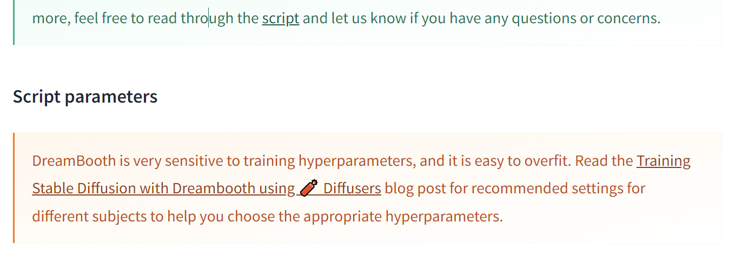

Step 2: Fine Tuned model

1. Enter the folder /diffusers/examples/dreambooth
2. Create a script for example (train.sh)

exec >logfile.txt 2>&1 # Log the script for debugging

export MODEL_NAME='stabilityai/stable-diffusion-2-1'

export INSTANCE_DIR="./input_imageset" # The folder for training image dataset

export CLASS_DIR="./class_glass" # The folder that store Class image for Prior preservation loss

export OUTPUT_DIR="./model_2_glasses_of_wine" # The folder that store the fine tuned model

accelerate launch train_dreambooth_lora.py \

--pretrained_model_name_or_path=$MODEL_NAME \

--instance_data_dir=$INSTANCE_DIR \

--class_data_dir=$CLASS_DIR \

--output_dir=$OUTPUT_DIR \

--with_prior_preservation --prior_loss_weight=1.0 \

--instance_prompt="2 glasses of wine" \

--class_prompt="glasses of wine" \

--resolution=768 \

--train_batch_size=1 \

--gradient_accumulation_steps=2 --gradient_checkpointing \

--use_8bit_adam \

--learning_rate=5e-6 \

--lr_scheduler="constant" \

--lr_warmup_steps=0 \

--num_class_images=20 \

--max_train_steps=50\

--checkpointing_steps=25 \

1. The learning_rate and max_train_steps affect the result significantly
2. Change the instance_prompt and class_prompt accordingly to your task

Step 3: Inference

1. Write a python script for inference (inference.py)
2. Here is a example

from diffusers import StableDiffusionPipeline

import os

model_id = "stabilityai/stable-diffusion-2-1"

pipe = StableDiffusionPipeline.from_pretrained(model_id).to("cuda")

pipe.load_lora_weights("./fined_tuned_model/checkpoint-50") # Choose a checkpoint

prompt = "2 glasses of wine"

prefix = "fine_tuned_2_glasses_of_wine"

if not os.path.exists(prefix):

os.mkdir(prefix)

for i in range(10):

pipe(prompt, num_inference_steps=50, guidance_scale=7.5).images[0].save(prefix+"/"+str(i)+".png")

1. Check the generated image with the original image
   1. You can generate image using original diffusion model (ie. stable-diffusion-2-1) by commenting out this pipe.load_lora_weights("./fined_tuned_model/checkpoint-")