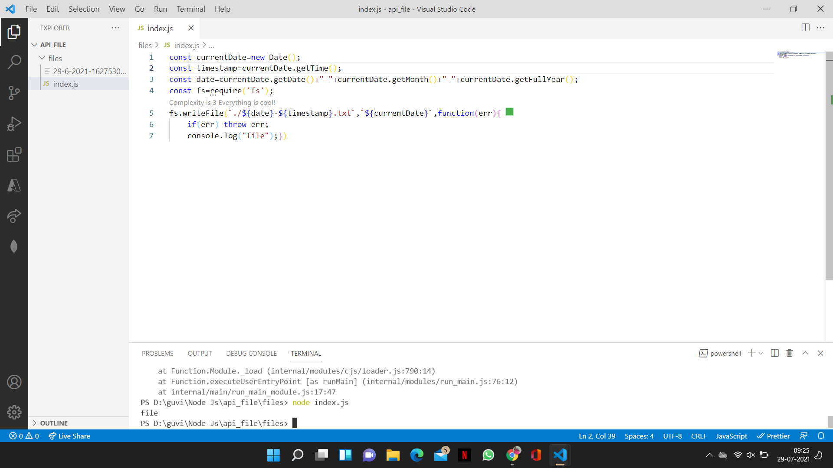

File has been inserted with fille b=name date-time.txt

File create with current date as input

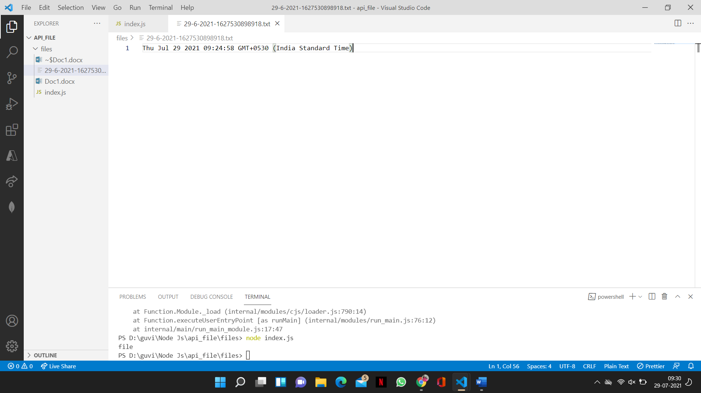

Getting the files name in browser using express API endpoint

