# Jar

### 非整合

<**dependency**>  
 <**groupId**>org.apache.dubbo</**groupId**>  
 <**artifactId**>dubbo-spring-boot-starter</**artifactId**>  
 <**version**>2.7.1</**version**>  
</**dependency**>  
<**dependency**>  
 <**groupId**>org.apache.dubbo</**groupId**>  
 <**artifactId**>dubbo</**artifactId**>  
 <**version**>2.7.1</**version**>  
</**dependency**>  
<**dependency**>  
 <**groupId**>org.apache.dubbo</**groupId**>  
 <**artifactId**>dubbo-dependencies-zookeeper</**artifactId**>  
 <**version**>2.7.1</**version**>  
 <**exclusions**>  
 <**exclusion**>  
 <**groupId**>org.slf4j</**groupId**>  
 <**artifactId**>slf4j-log4j12</**artifactId**>  
 </**exclusion**>  
 </**exclusions**>  
 <**type**>pom</**type**>  
</**dependency**>

### 整合(速度快)

<dependency>

<groupId>com.alibaba.boot</groupId>

<artifactId>dubbo-spring-boot-starter</artifactId>

<version>0.2.0</version>

</dependency>

# properties

**dubbo.application.name**=**user-service  
dubbo.registry.address**=**127.0.0.1:2181  
dubbo.registry.protocol**=**zookeeper  
dubbo.protocol.name**=**dubbo  
dubbo.scan.base-packages**=**com.jishixin.user**

**(整合不需要)**

# [3.@Service](mailto:3.@Service)

**import** org.apache.dubbo.config.annotation.Service;

# [4.@EnableDubbo](mailto:4.@EnableDubbo)

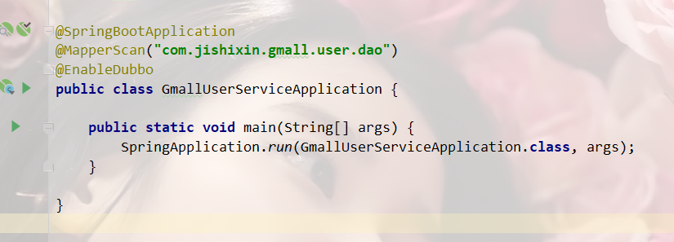

# 5.Controller配置

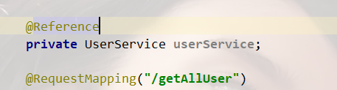

# 6.所有的pojo类要实习序列化

# 7.每个提供者最好指定Zookeeper端口号

(避免端口冲突)

**dubbo.protocol.port**=**12345**