SSM整合

# 创建项目

创建普通的maven工程

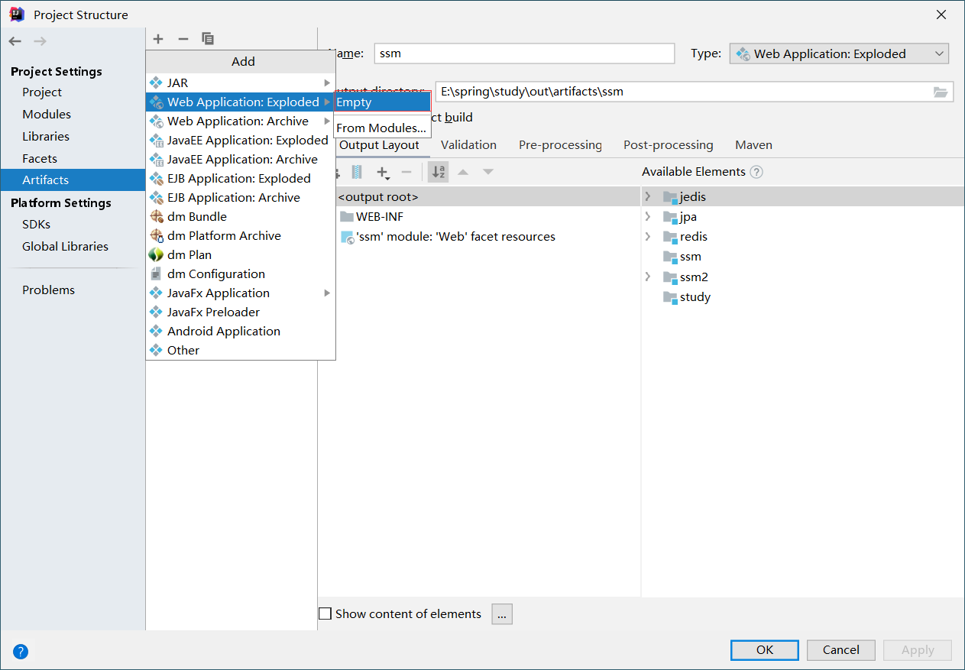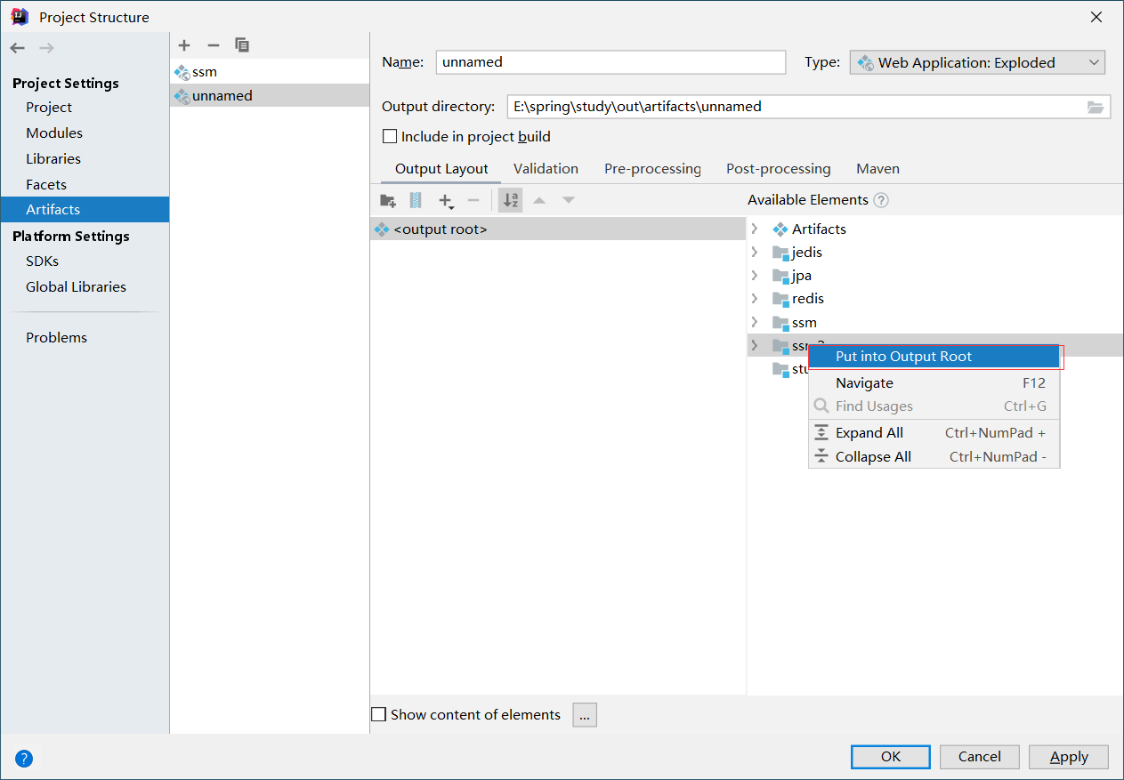

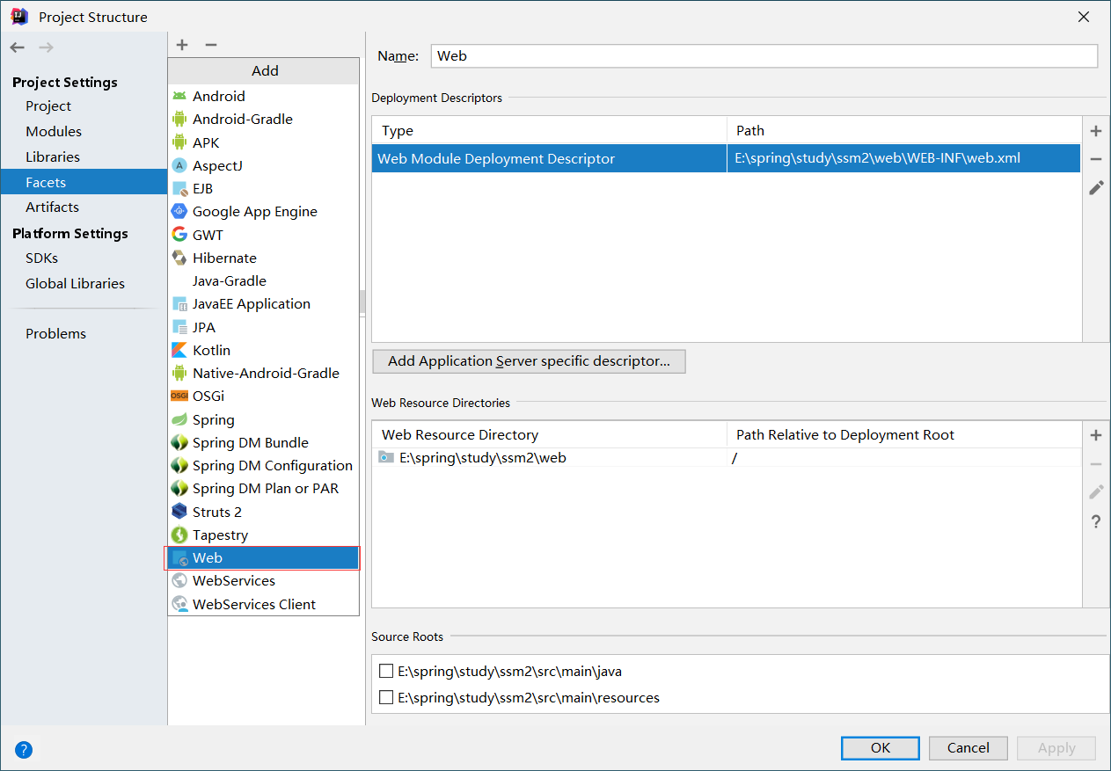

将WEB移入main包下更名为webapp

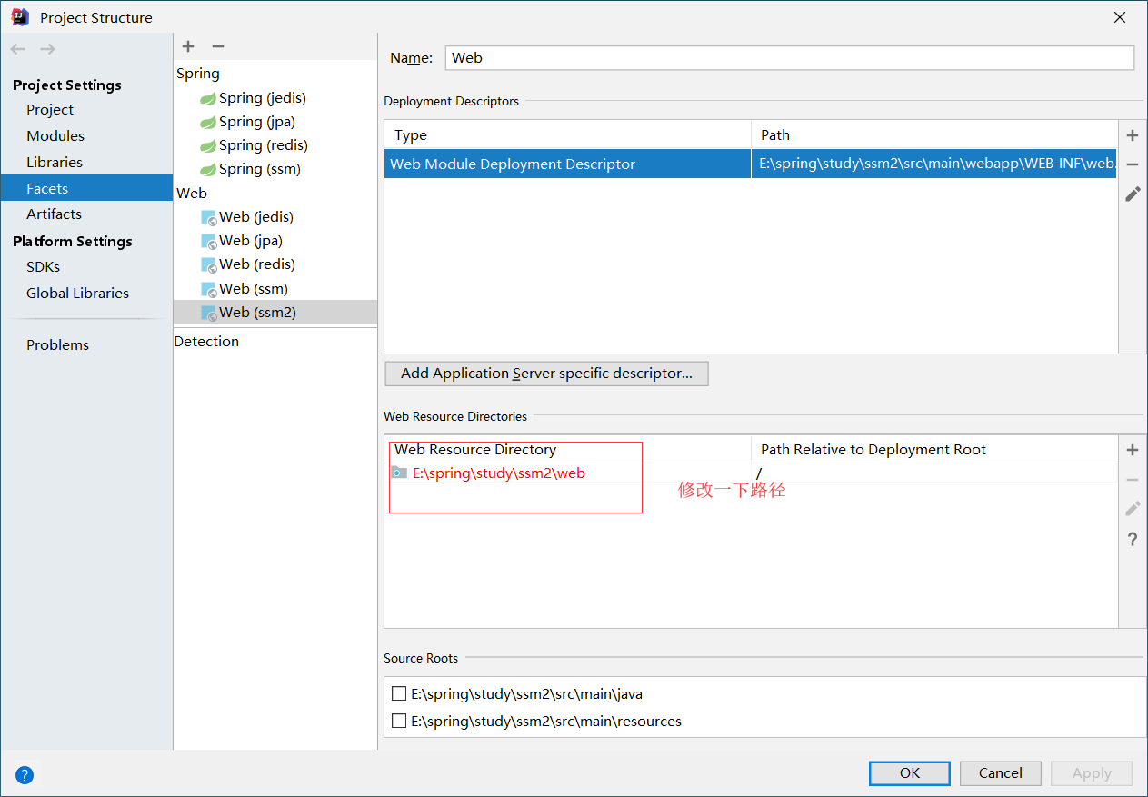

# 依赖:

<**dependency**>  
 <**groupId**>junit</**groupId**>  
 <**artifactId**>junit</**artifactId**>  
 <**version**>4.12</**version**>  
 <**scope**>test</**scope**>  
</**dependency**>  
  
*<!--配置日志相关,日志门面使用slf4j,日志的具体实现由logback实现-->*<**dependency**>  
 <**groupId**>ch.qos.logback</**groupId**>  
 <**artifactId**>logback-classic</**artifactId**>  
 <**version**>1.1.7</**version**>  
</**dependency**>  
<**dependency**>  
 <**groupId**>org.slf4j</**groupId**>  
 <**artifactId**>slf4j-api</**artifactId**>  
 <**version**>1.7.21</**version**>  
</**dependency**>  
<**dependency**>  
 <**groupId**>org.apache.logging.log4j</**groupId**>  
 <**artifactId**>log4j-core</**artifactId**>  
 <**version**>2.6.1</**version**>  
</**dependency**>  
  
*<!--数据库相关依赖-->  
<!--首先导入连接Mysql数据连接-->*<**dependency**>  
 <**groupId**>mysql</**groupId**>  
 <**artifactId**>mysql-connector-java</**artifactId**>  
 <**version**>5.1.39</**version**>  
</**dependency**>  
  
*<!--导入数据库连接池-->*<**dependency**>  
 <**groupId**>c3p0</**groupId**>  
 <**artifactId**>c3p0</**artifactId**>  
 <**version**>0.9.1.2</**version**>  
</**dependency**>  
  
*<!--导入mybatis依赖-->*<**dependency**>  
 <**groupId**>org.mybatis</**groupId**>  
 <**artifactId**>mybatis</**artifactId**>  
 <**version**>3.4.2</**version**>  
</**dependency**>  
<**dependency**>  
 <**groupId**>org.mybatis</**groupId**>  
 <**artifactId**>mybatis-spring</**artifactId**>  
 <**version**>1.3.1</**version**>  
</**dependency**>  
  
*<!--导入连接redis的JAR包-->*<**dependency**>  
 <**groupId**>redis.clients</**groupId**>  
 <**artifactId**>jedis</**artifactId**>  
 <**version**>2.9.0</**version**>  
</**dependency**>  
  
*<!--添加序列化依赖-->*<**dependency**>  
 <**groupId**>com.dyuproject.protostuff</**groupId**>  
 <**artifactId**>protostuff-core</**artifactId**>  
 <**version**>1.1.1</**version**>  
</**dependency**>  
<**dependency**>  
 <**groupId**>com.dyuproject.protostuff</**groupId**>  
 <**artifactId**>protostuff-runtime</**artifactId**>  
 <**version**>1.1.1</**version**>  
</**dependency**>  
  
*<!--导入Servlet web相关的依赖-->*<**dependency**>  
 <**groupId**>taglibs</**groupId**>  
 <**artifactId**>standard</**artifactId**>  
 <**version**>1.1.2</**version**>  
</**dependency**>  
<**dependency**>  
 <**groupId**>jstl</**groupId**>  
 <**artifactId**>jstl</**artifactId**>  
 <**version**>1.2</**version**>  
</**dependency**>  
  
*<!--spring默认的json转换-->*<**dependency**>  
 <**groupId**>com.fasterxml.jackson.core</**groupId**>  
 <**artifactId**>jackson-databind</**artifactId**>  
 <**version**>2.8.5</**version**>  
</**dependency**>  
<**dependency**>  
 <**groupId**>javax.servlet</**groupId**>  
 <**artifactId**>javax.servlet-api</**artifactId**>  
 <**version**>3.1.0</**version**>  
</**dependency**>  
  
*<!--导入spring相关依赖-->*<**dependency**>  
 <**groupId**>org.springframework</**groupId**>  
 <**artifactId**>spring-core</**artifactId**>  
 <**version**>4.3.6.RELEASE</**version**>  
</**dependency**>  
<**dependency**>  
 <**groupId**>org.springframework</**groupId**>  
 <**artifactId**>spring-beans</**artifactId**>  
 <**version**>4.3.6.RELEASE</**version**>  
</**dependency**>  
<**dependency**>  
 <**groupId**>org.springframework</**groupId**>  
 <**artifactId**>spring-context</**artifactId**>  
 <**version**>4.3.6.RELEASE</**version**>  
</**dependency**>  
<**dependency**>  
 <**groupId**>org.springframework</**groupId**>  
 <**artifactId**>spring-jdbc</**artifactId**>  
 <**version**>4.3.7.RELEASE</**version**>  
</**dependency**>  
<**dependency**>  
 <**groupId**>org.springframework</**groupId**>  
 <**artifactId**>spring-tx</**artifactId**>  
 <**version**>4.3.6.RELEASE</**version**>  
</**dependency**>  
<**dependency**>  
 <**groupId**>org.springframework</**groupId**>  
 <**artifactId**>spring-web</**artifactId**>  
 <**version**>4.3.6.RELEASE</**version**>  
</**dependency**>  
<**dependency**>  
 <**groupId**>org.springframework</**groupId**>  
 <**artifactId**>spring-webmvc</**artifactId**>  
 <**version**>4.3.7.RELEASE</**version**>  
</**dependency**>  
  
*<!--导入springTest-->*<**dependency**>  
 <**groupId**>org.springframework</**groupId**>  
 <**artifactId**>spring-test</**artifactId**>  
 <**version**>4.2.7.RELEASE</**version**>  
</**dependency**>  
*<!--导入commons-collections-->*<**dependency**>  
 <**groupId**>commons-collections</**groupId**>  
 <**artifactId**>commons-collections</**artifactId**>  
 <**version**>3.2.2</**version**>  
</**dependency**>

# 目录结构

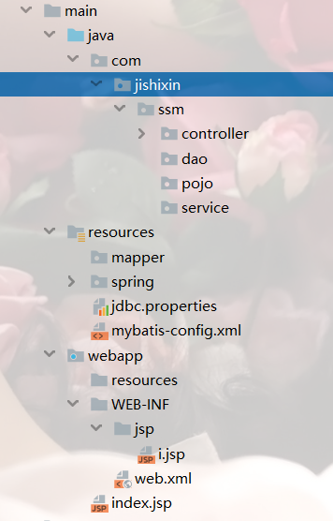

# 配置文件

可以统一成一个文件

## applicationContext-dao.xml

*<?***xml version="1.0" encoding="UTF-8"** *?>*<**beans xmlns="http://www.springframework.org/schema/beans"  
 xmlns:xsi="http://www.w3.org/2001/XMLSchema-instance"  
 xmlns:context="http://www.springframework.org/schema/context"  
 xsi:schemaLocation="http://www.springframework.org/schema/beans  
 http://www.springframework.org/schema/beans/spring-beans.xsd  
 http://www.springframework.org/schema/context  
 http://www.springframework.org/schema/context/spring-context.xsd"**>  
  
 <**context:property-placeholder location="classpath:jdbc.properties"**/>  
  
 *<!--配置数据库连接池-->* <**bean id="dataSource" class="com.mchange.v2.c3p0.ComboPooledDataSource"**>  
 *<!--配置基本的数据库连接-->* <**property name="driverClass" value="${jdbc.driver}"**/>  
 <**property name="jdbcUrl" value="${jdbc.url}"**/>  
 <**property name="user" value="${jdbc.username}"**/>  
 <**property name="password" value="${jdbc.password}"**/>  
 *<!--c3p0私有属性-->* <**property name="maxPoolSize" value="30"**/>  
 <**property name="minPoolSize" value="10"**/>  
 *<!--关闭连接后不自动commit-->* <**property name="autoCommitOnClose" value="false"**/>  
 *<!--获取连接超时时间-->* <**property name="checkoutTimeout" value="1000"**/>  
 *<!--当获取连接失败时的重试次数-->* </**bean**>  
  
 *<!--配置sqlSessionFactory对象-->* <**bean id="sqlSessionFactory" class="org.mybatis.spring.SqlSessionFactoryBean"**>  
 *<!--注入数据库连接池-->* <**property name="dataSource" ref="dataSource"**/>  
 *<!--配置mybatis全局配置文件-->* <**property name="configLocation" value="classpath:mybatis-config.xml"**/>  
 *<!--配置entity包,也就是实体类包，自动扫描,用于别名配置-->* <**property name="typeAliasesPackage" value="com.jishixin.ssm.pojo"**/>  
 *<!--配置需要扫描的mapper.xml文件-->* <**property name="mapperLocations" value="classpath*:mapper/*.xml"**/>  
 </**bean**>  
  
 *<!--配置mapper接口包,动态实现mapper接口，注入到Spring容器-->* <**bean class="org.mybatis.spring.mapper.MapperScannerConfigurer"**>  
 *<!--注入sqlSessionFactory,请注意不要使用sqlSessionFactoryBean，否则会出现注入异常-->* <**property name="sqlSessionFactoryBeanName" value="sqlSessionFactory"**/>  
 *<!--给出要扫描的mapper接口-->* <**property name="basePackage" value="com.jishixin.ssm.dao"** />  
 </**bean**>  
</**beans**>

## applicationContext-service.xml

*<?***xml version="1.0" encoding="UTF-8"***?>*<**beans xmlns="http://www.springframework.org/schema/beans"  
 xmlns:xsi="http://www.w3.org/2001/XMLSchema-instance"  
 xmlns:context="http://www.springframework.org/schema/context" xmlns:tx="http://www.springframework.org/schema/tx"  
 xsi:schemaLocation="http://www.springframework.org/schema/beans  
 http://www.springframework.org/schema/beans/spring-beans.xsd  
 http://www.springframework.org/schema/context  
 http://www.springframework.org/schema/context/spring-context.xsd http://www.springframework.org/schema/tx http://www.springframework.org/schema/tx/spring-tx.xsd"**>  
 <**import resource="applicationContext-dao.xml"**/>  
  
 *<!--配置自动扫描service包下的注解-->* <**context:component-scan base-package="com.jishixin.ssm.service"**/>  
  
 *<!--配置事务-->* <**bean id="transactionManager" class="org.springframework.jdbc.datasource.DataSourceTransactionManager"**>  
 *<!--注入数据库连接池-->* <**property name="dataSource" ref="dataSource"**/>  
 </**bean**>  
  
 *<!--开启基于注解的声明式事务-->* <**tx:annotation-driven transaction-manager="transactionManager"**/>  
  
</**beans**>

## applicationContext-web.xml

*<?***xml version="1.0" encoding="UTF-8"** *?>*<**beans xmlns="http://www.springframework.org/schema/beans"  
 xmlns:xsi="http://www.w3.org/2001/XMLSchema-instance"  
 xmlns:context="http://www.springframework.org/schema/context"  
 xmlns:mvc="http://www.springframework.org/schema/mvc"  
 xsi:schemaLocation="http://www.springframework.org/schema/beans  
 http://www.springframework.org/schema/beans/spring-beans.xsd  
 http://www.springframework.org/schema/context  
 http://www.springframework.org/schema/context/spring-context.xsd  
 http://www.springframework.org/schema/mvc  
 http://www.springframework.org/schema/mvc/spring-mvc.xsd"**>  
  
 *<!--配置spring mvc-->  
 <!--1,开启springmvc注解模式  
 a.自动注册DefaultAnnotationHandlerMapping,AnnotationMethodHandlerAdapter  
 b.默认提供一系列的功能:数据绑定，数字和日期的format@NumberFormat,@DateTimeFormat  
 c:xml,json的默认读写支持-->* <**mvc:annotation-driven**/>  
  
 *<!--2.静态资源默认servlet配置-->  
 <!--  
 1).加入对静态资源处理：js,gif,png  
 2).允许使用 "/" 做整体映射  
 -->* <**mvc:default-servlet-handler**/>  
  
 *<!--3：配置JSP 显示ViewResolver-->* <**bean class="org.springframework.web.servlet.view.InternalResourceViewResolver"**>  
 <**property name="viewClass" value="org.springframework.web.servlet.view.JstlView"**/>  
 <**property name="prefix" value="/WEB-INF/jsp/"**/>  
 <**property name="suffix" value=".jsp"**/>  
 </**bean**>  
  
 *<!--4:扫描web相关的controller-->* <**context:component-scan base-package="com.jishixin.ssm.controller"**/>  
</**beans**>

## Jdbc.properties

**jdbc.driver**=**com.mysql.jdbc.Driver  
jdbc.username**=**root  
jdbc.password**=**root  
jdbc.url**=**jdbc:mysql://localhost:3306/test?useUnicode=true&characterEncoding=utf-8&useSSL=false**

## mybatis-config.xml

*<?***xml version="1.0" encoding="UTF-8"** *?>***<!DOCTYPE configuration PUBLIC  
 "-//mybatis.org//DTD MyBatis Generator Configuration 3.0//EN"  
 "http://mybatis.org/dtd/mybatis-3-config.dtd" *>***<**configuration**>  
 *<!--首先配置全局属性-->* <**settings**>  
 *<!--开启自动填充主键功能，原理是通过jdbc的一个方法getGeneratekeys获取自增主键值-->* <**setting name="useGeneratedKeys" value="true"**/>  
 *<!--使用别名替换列名，默认就是开启的-->* <**setting name="useColumnLabel" value="true"**/>  
 *<!--开启驼峰命名的转换-->* <**setting name="mapUnderscoreToCamelCase" value="true"**/>  
 </**settings**>  
</**configuration**>

## Web.xml

*<?***xml version="1.0" encoding="UTF-8"***?>*<**web-app xmlns="http://xmlns.jcp.org/xml/ns/javaee"  
 xmlns:xsi="http://www.w3.org/2001/XMLSchema-instance"  
 xsi:schemaLocation="http://xmlns.jcp.org/xml/ns/javaee http://xmlns.jcp.org/xml/ns/javaee/web-app_3_1.xsd"  
 version="3.1"**>  
  
 *<!--配置DispatcherServlet-->* <**servlet**>  
 <**servlet-name**>seckill-dispatcher</**servlet-name**>  
 <**servlet-class**>org.springframework.web.servlet.DispatcherServlet</**servlet-class**>  
 *<!--  
 配置SpringMVC 需要配置的文件  
 applicationContext-dao.xml，applicationContext-service.xml，applicationContext-web.xml  
 Mybites -> spring -> springMvc  
 -->* <**init-param**>  
 <**param-name**>contextConfigLocation</**param-name**>  
 <**param-value**>classpath:spring/applicationContext-*.xml</**param-value**>  
 </**init-param**>  
 </**servlet**>  
 <**servlet-mapping**>  
 <**servlet-name**>seckill-dispatcher</**servlet-name**>  
 *<!--默认匹配所有请求-->* <**url-pattern**>/</**url-pattern**>  
 </**servlet-mapping**>  
  
</**web-app**>

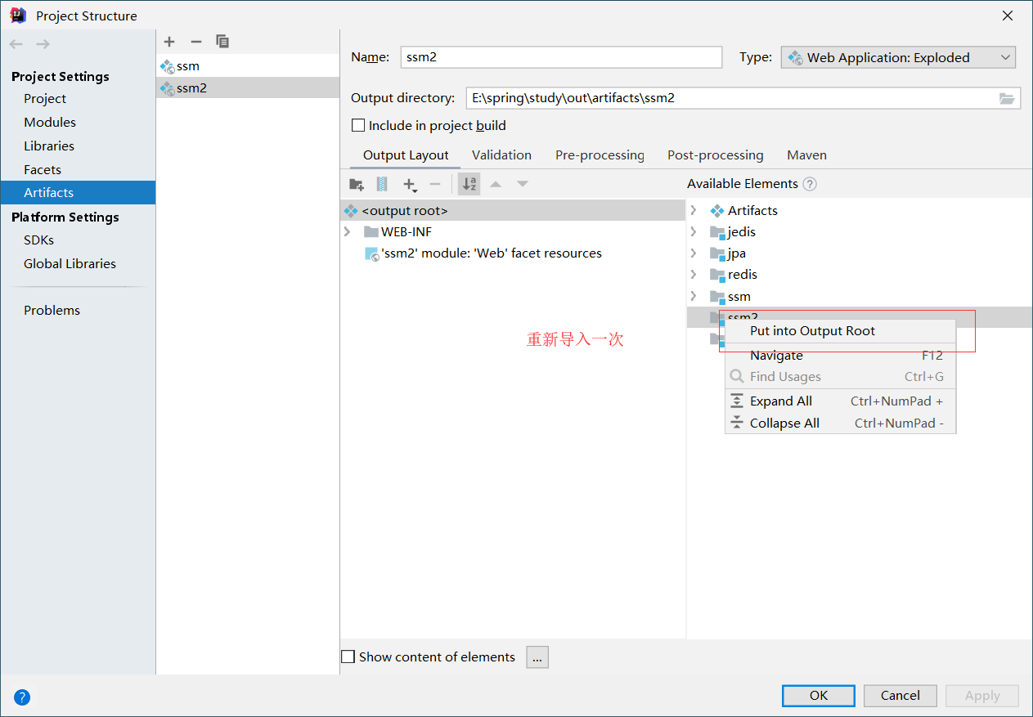

要出现了以下情况才能正常运行,否则会报404

