
Mini project report on

PROPFIND: SEMANTIC PROPERTY SEARCH & RENTAL MANAGEMENT SYSTEM
Submitted in partial fulfilment of the requirements for the award of degree of

Bachelor of Technology
in
Computer Science & Engineering
UE23CS351A – DBMS Project
Submitted by:
KANISHQ SURENDRAN  JISHNU SIVAKUMAR | PES2UG24CS214  PES2UG24CS204
under the guidance of

Dr. Shilpa S
Assistant Professor
PES University

AUG - DEC 2026
DEPARTMENT OF COMPUTER SCIENCE AND ENGINEERING
FACULTY OF ENGINEERING
PES UNIVERSITY
(Established under Karnataka Act No. 16 of 2013)
Electronic City, Hosur Road, Bengaluru – 560 100, Karnataka, India

PES UNIVERSITY

(Established under Karnataka Act No. 16 of 2013)
Electronic City, Hosur Road, Bengaluru – 560 100, Karnataka, India

CERTIFICATE

This is to certify that the mini project entitled

PropFind: Semantic Property Search & Rental Management System

is a bonafide work carried out by

KANISHQ SURENDRAN  JISHNU SIVAKUMAR | PES2UG24CS214  PES2UG24CS204

In partial fulfilment for the completion of fifth semester DBMS Project (UE24CSS351A) in the Program of Study -Bachelor of Technology in Computer Science and Engineering under rules and regulations of PES University, Bengaluru during the period AUG. 2026 – DEC. 2026. It is certified that all corrections / suggestions indicated for internal assessment have been incorporated in the report. The project has been approved as it satisfies the 5th semester academic requirements in respect of project work.

Signature
Dr. Shilpa S
Assistant Professor

DECLARATION

We hereby declare that the DBMS Project entitled PropFind: Semantic Property Search & Rental Management System has been carried out by us under the guidance of Dr. Shilpa S, Assistant Professor and submitted in partial fulfilment of the course requirements for the award of degree of Bachelor of Technology in Computer Science and Engineering of PES University, Bengaluru during the academic semester AUG – DEC 2026.

KANISHQ SURENDRAN | PES2UG24CS214 | <Signature>
JISHNU SIVAKUMAR | PES2UG24CS204 | <Signature>
ACKNOWLEDGEMENT

We would like to express our gratitude to Dr. Shilpa S, Department of Computer Science and Engineering, PES University, for her continuous guidance, assistance, and encouragement throughout the development of this UE23CS351A - DBMS Project.
We take this opportunity to thank Dr. Sandesh B J, C, Professor, ChairPerson, Department of Computer Science and Engineering, PES University, for all the knowledge and support we have received from the department.
We are deeply grateful to Prof. Jawahar Doreswamy, Chancellor – PES University, Dr. Suryaprasad J, Vice-Chancellor, PES University for providing us various opportunities and enlightenment every step of the way. Finally, this DBMS Project could not have been completed without the continual support and encouragement we have received from our family and friends.
ABSTRACT
PropFind is a rental-property discovery and management platform built for the DBMS Level 3 mini-project using Option 2: a SQL database combined with a vector database. Tenants describe what they want in plain language, for example "house where I can keep my dog" or "pet friendly 2BHK in Pune under 25k". Every listing is converted into a 384-dimension embedding with the all-MiniLM-L6-v2 sentence model and stored in PostgreSQL using the pgvector extension. A query is embedded the same way and the closest listings are retrieved by cosine distance through an HNSW index. Because vector similarity cannot compare numbers, constraints written in the sentence (budget, bedrooms, city) are parsed and enforced as exact SQL filters, so "homes under rent 20k" returns only homes that really cost under Rs. 20,000.
The same PostgreSQL database holds the relational core: users with roles (owner, tenant, admin), properties, bookings, reviews, payments and a booking audit log. Integrity is enforced inside the database with ENUM types, CHECK, UNIQUE and FOREIGN KEY constraints and seven triggers (double-booking prevention, booking state machine, payment validation and timestamping, audit logging, automatic refund on cancellation and timestamp maintenance). Bookings run as ACID transactions with row-level locking (SELECT ... FOR UPDATE).
The Next.js 14 application provides authentication (bcrypt password hashes, JWT in an httpOnly cookie), role-based access control in middleware and in every API route, owner and tenant dashboards, and a payment flow. The repository contains a 58-listing dataset across 15 cities, labelled SQL demonstrations, a self-checking SQL test script (23 checks, all passing) and parser tests (12 cases).

TABLE OF CONTENTS

Chapter No. | Title | Page No.
1. | INTRODUCTION | 11
2. | PROBLEM DEFINITION | 14
3. | ER MODEL | 16
4. | ER TO RELATIONAL MAPPING | 19
5. | DDL STATEMENTS | 21
6. | DML STATEMENTS | 30
7. | QUERIES (SIMPLE QUERY, UPDATE AND DELETE OPERATION, CORRELATED AND NESTED QUERY) | 33
8. | STORED PROCEDURES, FUNCTIONS AND TRIGGERS | 43
9. | FRONT END DEVELOPMENT | 53
 | REFERENCES / BIBLIOGRAPHY | 69
 | APPENDIX A: DEFINITIONS, ACRONYMS AND ABBREVIATIONS | 70
 | APPENDIX B: DATA DICTIONARY | 71
 | APPENDIX C: EVALUATION RUBRICS - COMPLETION STATUS | 74
LIST OF TABLES

Table No. | Title | Page No.
1.1 | Data in PropFind and why it is stored where it is | 12
1.2 | Technology stack | 12
1.3 | Team members and responsibilities | 13
2.1 | Functional requirements | 14
2.2 | Roles and permissions | 15
3.1 | Entities | 16
3.2 | Relationships and cardinalities | 16
3.3 | How listings are represented as vectors | 17
4.1 | ER to relational mapping steps applied to PropFind | 19
5.1 | Indexes | 25
5.2 | Primary key, foreign key, unique and check constraints in the database | 28
6.1 | Rows in the database | 32
8.1 | Stored functions | 43
8.2 | Triggers | 45
9.1 | Tests performed | 67
LIST OF FIGURES

Figure No. | Title | Page No.
3.1 | Entity-relationship diagram of PropFind (7 entities) | 17
4.1 | Relational schema of PropFind with primary keys (underlined) and foreign keys (italic) | 20
5.1 | Executing db/schema.sql (extensions, types, tables, indexes, views, functions and triggers) | 22
5.2 | The seven tables created (\dt) | 22
5.3 | CREATE TABLE users and properties with CHECK constraints | 23
5.4 | Structure of the users table (\d users): primary key, unique and CHECK constraints | 23
5.5 | Vector table property_embeddings, HNSW index and semantic search function | 24
5.6 | Structure of property_embeddings (\d property_embeddings) | 24
5.7 | Structure of bookings (\d bookings): foreign keys, CHECK constraint and triggers | 24
5.8 | CREATE TABLE payments and its trigger | 25
5.9 | Structure of payments (\d payments) | 25
5.10 | ALTER TABLE, CREATE VIEW, DROP VIEW and DROP TABLE (rolled back) | 28
6.1 | Table users (owners, tenants and one admin) | 30
6.2 | Table properties (first 12 of 58 rows) and summary | 31
6.3 | Table property_embeddings: 384-dimension vectors (preview) | 31
6.4 | Table bookings: all statuses | 31
6.5 | Table reviews (first 10 rows) | 31
6.6 | Tables payments and booking_audit (the audit rows were written by a trigger) | 32
7.1 | GROUP BY with COUNT, AVG, MIN, MAX and SUM | 33
7.2 | HAVING and an aggregate over an array column | 34
7.3 | UPDATE with a subquery; the timestamp trigger fires; the transaction is rolled back | 34
7.4 | DELETE with a condition, then ROLLBACK restores the rows | 35
7.5 | Correlated subqueries: comparison with the city average, EXISTS, NOT EXISTS and a scalar subquery | 36
7.6 | Nested subqueries: scalar, IN, derived table and ALL | 37
7.7 | INNER JOIN of four tables, LEFT JOIN and an anti-join | 38
7.8 | RANK() window function, WITH query and UNION | 40
7.9 | Nearest neighbours with the <=> operator and the semantic search function | 41
7.10 | Hybrid query (vector ranking with relational filters) and the HNSW index | 41
7.11 | Full-text search with tsvector and tsquery, and a payments query | 42
8.1 | fn_update_timestamp and fn_check_booking_conflict | 43
8.2 | fn_search_properties_semantic: pgvector cosine search with filters | 44
8.3 | Functions installed in the database (\df fn_*) | 44
8.4 | Views and fn_check_booking_conflict in use | 45
8.5 | Double-booking trigger and booking state machine | 46
8.6 | Audit trigger and automatic refund trigger | 47
8.7 | All triggers installed in the database | 47
8.8 | Triggers in action: audit row written, payment timestamp stamped, ROLLBACK | 48
8.9 | SAVEPOINT, atomicity of a failed transaction and the automatic refund | 49
8.10 | The overlap trigger rejects an approval and the message is shown in the Owner Portal | 50
8.11 | Transactional booking creation with a row lock (lib/services/booking-service.ts) | 51
8.12 | Integrity tests: 22 rejected statements and one accepted control, 23 of 23 passed | 52
9.1 | System architecture | 53
9.2 | Role-based protection of pages (middleware.ts) | 54
9.3 | JWT session helpers and role check (lib/jwt.ts, lib/auth.ts) | 55
9.4 | Login page | 55
9.5 | Registration page (owner or tenant) | 56
9.6 | Home page | 56
9.7 | Search "homes under rent 20k": 23 results, all under Rs. 20,000, with the understood constraint shown | 57
9.8 | Search "house where I can keep my dog": semantic ranking puts pet-friendly homes first | 57
9.9 | Search "pet friendly 2BHK in Pune under 25k": bedrooms, city and budget parsed into SQL filters | 58
9.10 | Extracting budget, bedrooms and city from the sentence (lib/query-parser.ts) | 59
9.11 | Hybrid search service (lib/services/property-service.ts) | 59
9.12 | Generating a 384-dimension embedding (lib/embeddings.ts) | 60
9.13 | Listing details | 60
9.14 | Booking request form (runs as a PostgreSQL transaction) | 61
9.15 | Tenant dashboard: own bookings only, Pay, Cancel and status history from the audit table | 62
9.16 | Listing form (the embedding is created in the same transaction) | 63
9.17 | Owner Portal: four clickable cards (from view_owner_analytics) and booking tabs | 64
9.18 | My Properties | 65
9.19 | Pending requests | 66
9.20 | Confirmed bookings | 66
9.21 | Confirmed revenue: collected and outstanding, per property | 67

1. INTRODUCTION
1.1 OVERVIEW
PropFind is a rental property discovery and management system. A tenant types what they are looking for in everyday language ("house where I can keep my dog", "pet friendly 2BHK in Pune under 25k") and the system returns the listings that match the meaning of the request, not just the words. Owners publish and manage listings, tenants request, pay for and cancel bookings, and every important rule (no overlapping bookings, valid status changes, valid payments) is enforced inside the database itself.
The project follows Option 2 of the course brief: a SQL database (PostgreSQL) together with a vector database (the pgvector extension of the same PostgreSQL server). A Next.js web application provides the interface and talks to the database only through an API layer.
1.2 MOTIVATION
Checkbox and keyword filters fail when a person only has a vague need, and ordinary booking code fails when two requests for the same dates arrive together. These are exactly the places where database design matters: the first needs semantic retrieval, the second needs transactions, locking and triggers. The project was chosen to connect those database concepts to a realistic application and to go beyond simple create, read, update and delete operations.
1.3 OBJECTIVES
• Design a normalised relational schema with strong integrity rules and document it (ER diagram, relational mapping, data dictionary).
• Add semantic search with embeddings stored and queried inside PostgreSQL and combine it with exact relational filters.
• Prevent double booking and invalid state changes at the database level, independent of application code.
• Provide a working Next.js interface with authentication and at least two roles.
• Demonstrate DDL, DML, joins, grouping, subqueries, views, functions, triggers, indexes, transactions and vector search with reproducible SQL files and tests.
1.4 SCOPE
• In scope: registration and login (owner, tenant), listing creation with automatic embedding, natural-language and filtered search, booking request, approval, rejection, cancellation, payment recording, audit history, owner dashboards.
• Out of scope: a real payment gateway (a payment is recorded, no money moves), a dedicated admin screen, image upload (images are URLs), e-mail notifications.
1.5 DATABASE PARADIGM AND JUSTIFICATION
The brief allows SQL plus either NoSQL or a vector database. PropFind uses PostgreSQL with pgvector. Listings are structured data (price, city, bedrooms, status) and text-heavy data (descriptions, amenities), so one engine can filter exactly with SQL and rank by meaning with vectors, in the same transaction and with the same foreign keys. A separate NoSQL store such as MongoDB would add a second system without helping the semantic-search requirement.
Table 1.1: Data in PropFind and why it is stored where it is
Data | Stored as | Reason
Users, properties, bookings, reviews, payments | Relational tables in PostgreSQL | Strict structure, relationships, constraints and transactions are required
Booking history | Table booking_audit written by a trigger | Append-only log that must not depend on application code
Listing meaning (embedding) | Column vector(384) in property_embeddings (pgvector) | Similarity search by cosine distance with an HNSW index
Amenities | Array column text[] in properties | Small multivalued attribute that is always read with its property
Sessions | Signed JWT in an httpOnly cookie | Stateless authentication, nothing extra stored in the database

1.6 TECHNOLOGY STACK
Table 1.2: Technology stack
Layer | Technology | Role in PropFind
Frontend | Next.js 14 (App Router), React 18, TypeScript, Tailwind CSS | Pages, forms, dashboards, search interface
Backend / API | Next.js Route Handlers on Node.js 24 | REST endpoints, validation, role checks
SQL database | PostgreSQL 16.15 | Tables, constraints, views, functions, triggers, transactions
Vector database | pgvector 0.8.7 (HNSW index, cosine distance) | Embedding storage and similarity search inside PostgreSQL
Embedding model | all-MiniLM-L6-v2 through @huggingface/transformers (ONNX), 384 dimensions | Turns listings and queries into vectors; runs locally without an API key
Database driver | node-postgres (pg) | Parameterised queries, connection pool, transactions
Authentication | bcryptjs, jose (JWT HS256), httpOnly cookie | Password hashing, sessions, role-based access
Infrastructure | Docker Compose (image pgvector/pgvector:pg16) | Runs the database locally; a hosted option (Supabase, Neon) is documented
Version control | Git and GitHub with feature branches and pull requests | Individual contributions are visible in the history

1.7 TEAM AND CONTRIBUTIONS
Table 1.3: Team members and responsibilities
Name | SRN | Responsibility
KANISHQ SURENDRAN | PES2UG24CS214 | Authentication and roles, booking life cycle and concurrency control, payments and audit triggers, real embeddings, number-aware search, dataset, owner and tenant dashboards, SQL demonstrations and tests, documentation (55 commits, 3,673 lines added)
JISHNU SIVAKUMAR | PES2UG24CS204 | Database schema and constraints, pgvector storage and HNSW index, semantic search function, search page, property cards and listing form, initial seed pipeline (2 commits, 4,120 lines added)

Line and commit counts were measured with git log on the main branch, excluding merge commits and package-lock.json. The work was merged through pull requests from separate feature branches.

2. PROBLEM DEFINITION
2.1 PROBLEM STATEMENT
Design and implement a rental platform in which tenants can discover homes by describing their needs in natural language, owners can list and manage properties, and the complete booking life cycle (request, approval, payment, cancellation, audit) is consistent even when several users act at the same time.
2.2 LIMITATIONS OF EXISTING APPROACHES
• Keyword search and rigid filters cannot answer "somewhere quiet where I can keep a pet"; a listing that says "pet friendly" is missed if the user types "dog".
• Vector similarity alone is poor with numbers: the sentences "under 20k" and "under 50k" produce almost identical embeddings, so budget cannot be left to the vector part.
• Application-only checks for double booking are unsafe: two simultaneous requests can both pass the check before either is saved (a race condition).
• Rules kept only in application code can be bypassed by another client, a script or a manual edit of the data.
2.3 PROPOSED SOLUTION
• Store a 384-dimension embedding of every listing in PostgreSQL (pgvector) and rank by cosine distance through an HNSW index.
• Parse budget, bedrooms and city from the sentence and apply them as exact SQL conditions; embed only the descriptive remainder.
• Lock the property row (SELECT ... FOR UPDATE) inside a transaction, check conflicts with a stored function, and back everything up with triggers that reject overlapping approvals and invalid status changes.
• Enforce validity with ENUM types and CHECK, UNIQUE and FOREIGN KEY constraints so the database rejects bad data whatever the client.
2.4 FUNCTIONAL REQUIREMENTS
Table 2.1: Functional requirements
ID | Requirement
FR-1 | A visitor can register as an owner or a tenant and log in; passwords are stored only as bcrypt hashes.
FR-2 | An owner can publish a listing; its embedding is created and stored in the same transaction.
FR-3 | Anyone can search listings in natural language and with filters (city, bedrooms, maximum budget).
FR-4 | The system extracts budget, bedrooms and city from the sentence and shows what it understood.
FR-5 | A tenant can request a booking for a date range; invalid or conflicting requests are rejected.
FR-6 | An owner can approve or reject requests for his own properties only.
FR-7 | A tenant can cancel a pending or approved booking.
FR-8 | A tenant can pay once for an approved booking; cancelling a paid booking refunds the payment automatically.
FR-9 | Every booking status change is logged with time and user.
FR-10 | The owner dashboard shows properties, pending requests, confirmed bookings and revenue (collected and outstanding).
FR-11 | Pages and API routes are protected by role; a tenant cannot use owner functions and vice versa.

2.5 DATA INTEGRITY REQUIREMENTS
• No two APPROVED bookings of one property may overlap in time (trigger trg_validate_booking_overlap).
• Booking status may change only along PENDING to APPROVED, REJECTED or CANCELLED and APPROVED to CANCELLED (trigger trg_validate_booking_transition).
• A payment is accepted only for an APPROVED booking, for the exact booking total, once (trigger and partial unique index).
• Prices, areas, ratings, dates, e-mail and phone formats are validated by CHECK constraints.
2.6 USER ROLES
Table 2.2: Roles and permissions
Role | Created by | Permissions
TENANT | Self-registration | Search, request bookings, cancel own bookings, pay for own approved bookings, view own history
OWNER | Self-registration | Everything a visitor can do, publish listings, view own properties, approve or reject requests for own properties, view revenue
ADMIN | Seeded only (not self-registered) | Passes owner and tenant route checks; a dedicated admin screen is not implemented

3. ER MODEL
3.1 ENTITIES AND ATTRIBUTES
Table 3.1: Entities
Entity | Attributes (key attributes in bold) | Notes
User | id, full_name, email (unique), password_hash, role, phone, avatar_url | Role is an ENUM: OWNER, TENANT, ADMIN
Property | id, title, description, property_type, price_per_month, security_deposit, bedrooms, bathrooms, area_sqft, address, city, state, pincode, status, amenities, image_url | Status ENUM: AVAILABLE, RENTED, MAINTENANCE; amenities is multivalued
Property_Embedding | property_id, embedding (384 numbers), model_name, indexed_content | One row per property; the vector part of the design
Booking | id, start_date, end_date, total_amount, status, special_requests | Status ENUM: PENDING, APPROVED, REJECTED, CANCELLED
Review | id, rating (1 to 5), comment | One review per tenant per property
Payment | id, amount, method, status, transaction_ref (unique), paid_at | Method ENUM: UPI, CARD, NET_BANKING
Booking_Audit | id, booking_id, old_status, new_status, changed_by, changed_at | Written only by a trigger

3.2 RELATIONSHIPS
Table 3.2: Relationships and cardinalities
Relationship | Entities | Cardinality | Implemented as
owns | User (owner) - Property | 1 : N | properties.owner_id (FK)
has vector | Property - Property_Embedding | 1 : 1 | property_embeddings.property_id is both PK and FK
requests | User (tenant) - Booking | 1 : N | bookings.tenant_id (FK)
receives | Property - Booking | 1 : N | bookings.property_id (FK)
writes | User (tenant) - Review | 1 : N | reviews.tenant_id (FK)
is rated by | Property - Review | 1 : N | reviews.property_id (FK)
is paid by | Booking - Payment | 1 : N (at most one PAID) | payments.booking_id (FK) plus partial unique index
is logged in | Booking - Booking_Audit | 1 : N | booking_audit.booking_id (no FK, by design)

3.3 ER DIAGRAM
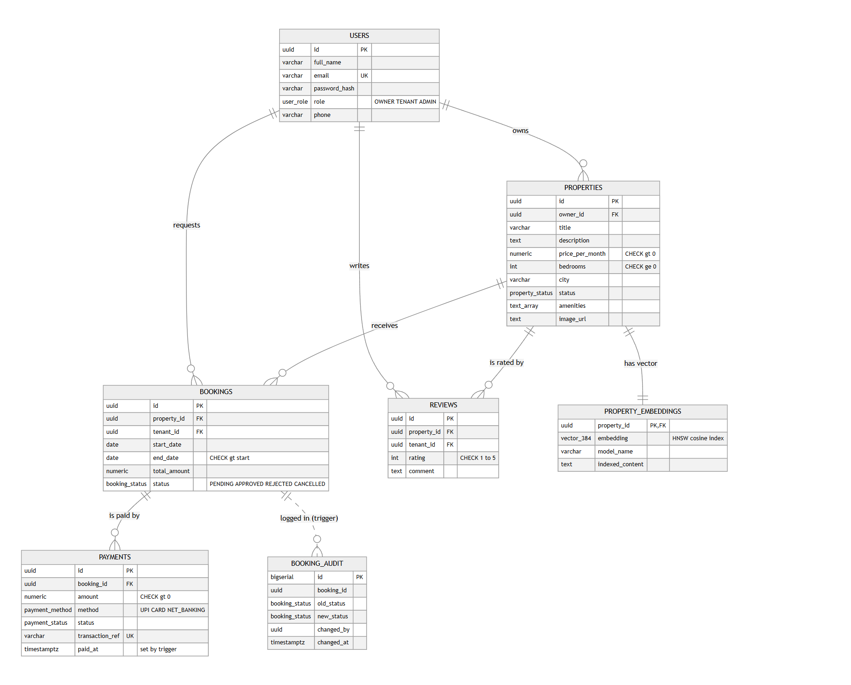
Fig. 3.1: Entity-relationship diagram of PropFind (7 entities)
3.4 BUSINESS RULES CAPTURED BY THE MODEL
• A review is allowed once per tenant per property (UNIQUE on property_id and tenant_id).
• A property with bookings cannot be deleted (ON DELETE RESTRICT); deleting a property removes its embedding and reviews (ON DELETE CASCADE).
• The total amount of a booking is price_per_month multiplied by the number of 30-day months (minimum one).
• A booking end date must be later than its start date.
3.5 VECTOR DATA MODEL
Table 3.3: How listings are represented as vectors
Question | Answer
What is converted to an embedding? | For each listing: title, amenities and description joined into one text (amenities are placed right after the title so short facts such as "Pet Friendly" are not diluted). Each search sentence is embedded too.
Which model? | all-MiniLM-L6-v2 (sentence-transformers) through @huggingface/transformers: mean pooling and L2 normalisation, 384 dimensions, runs locally.
How are vectors stored? | Table property_embeddings: embedding vector(384), model_name and the exact indexed_content text; one row per property.
Similarity metric | Cosine distance with the <=> operator; similarity = 1 - distance.
Index | HNSW (m = 16, ef_construction = 64) with vector_cosine_ops.
How are results retrieved? | Function fn_search_properties_semantic orders by cosine distance after relational filters (city, price, bedrooms, status).

4. ER TO RELATIONAL MAPPING
4.1 STEPS OF ALGORITHM FOR CHOSEN PROBLEM
The ER diagram was converted to relations with the standard ER-to-relational mapping algorithm (Elmasri and Navathe). Table 4.1 shows each step and how it applies to PropFind.
Table 4.1: ER to relational mapping steps applied to PropFind
Step | Rule | Applied to PropFind
1 | Map each regular entity type to a relation; choose a primary key | users, properties, bookings, reviews, payments become relations with a UUID primary key (generated by uuid_generate_v4())
2 | Map weak entity types | None. booking_audit is a log and keeps its own surrogate key
3 | Map 1:1 relationships | Property - Property_Embedding: property_embeddings.property_id is the primary key and also a foreign key to properties
4 | Map 1:N relationships with a foreign key on the N side | owns: properties.owner_id; requests: bookings.tenant_id; receives: bookings.property_id; is paid by: payments.booking_id
5 | Map M:N relationships with a relationship relation | User - Property through reviews (tenant, property, rating, comment) with UNIQUE(property_id, tenant_id); User - Property through bookings (dates, amount, status)
6 | Map multivalued attributes | amenities is stored as a PostgreSQL text[] array column; a separate table was not needed because amenities are only read with their property
7 | Map n-ary relationships | None
8 | Map categorical attributes | role, status, method, payment status become ENUM types so invalid values are impossible

Normalisation check
Every relation is in third normal form. All non-key attributes depend only on the primary key: for example properties holds owner_id (a foreign key) rather than the owner name, bookings holds tenant_id and property_id rather than copies of their details, and payment details live in payments instead of bookings. The two deliberate redundancies are total_amount in bookings (a snapshot of the price at booking time, which must not change if the owner later changes the rent) and indexed_content in property_embeddings (the exact text that was embedded, kept for traceability).
4.2 COMPLETE DIAGRAM OF RELATIONAL MAPPING
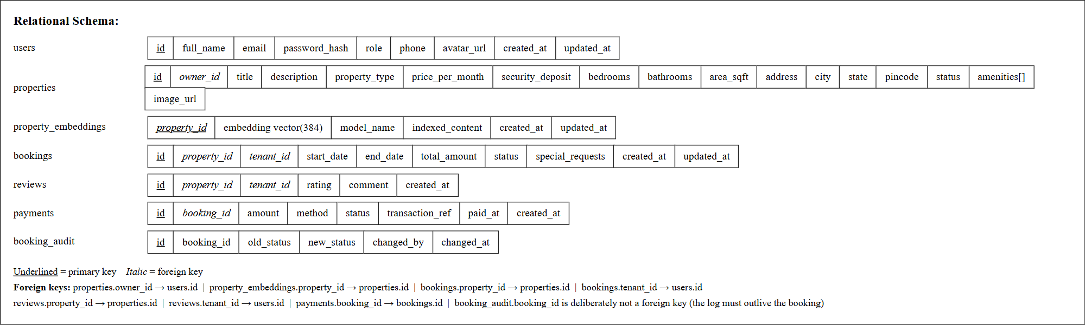
Fig. 4.1: Relational schema of PropFind with primary keys (underlined) and foreign keys (italic)
The resulting database has seven relations, eight foreign-key relationships (the audit log is intentionally unlinked), the constraints listed in Section 5.6 and the indexes listed in Section 5.3.

5. DDL STATEMENTS
STATEMENTS WITH SCREEN SHOTS OF THE TABLE CREATION
5.1 EXTENSIONS AND ENUMERATED TYPES
-- 1. Enable pgvector extension
CREATE EXTENSION IF NOT EXISTS vector;
CREATE EXTENSION IF NOT EXISTS "uuid-ossp";
-- 3. Custom Enumerations / Domain Types
CREATE TYPE user_role AS ENUM ('OWNER', 'TENANT', 'ADMIN');
CREATE TYPE property_status AS ENUM ('AVAILABLE', 'RENTED', 'MAINTENANCE');
CREATE TYPE booking_status AS ENUM ('PENDING', 'APPROVED', 'REJECTED', 'CANCELLED');
CREATE TYPE payment_method AS ENUM ('UPI', 'CARD', 'NET_BANKING');
CREATE TYPE payment_status AS ENUM ('PAID', 'FAILED', 'REFUNDED');
5.2 TABLE CREATION
The complete script is db/schema.sql. It is written to be re-runnable: it drops existing objects first and then creates everything. Figure 5.1 shows the script being executed in psql against a new database and Figure 5.2 lists the seven tables that were created.
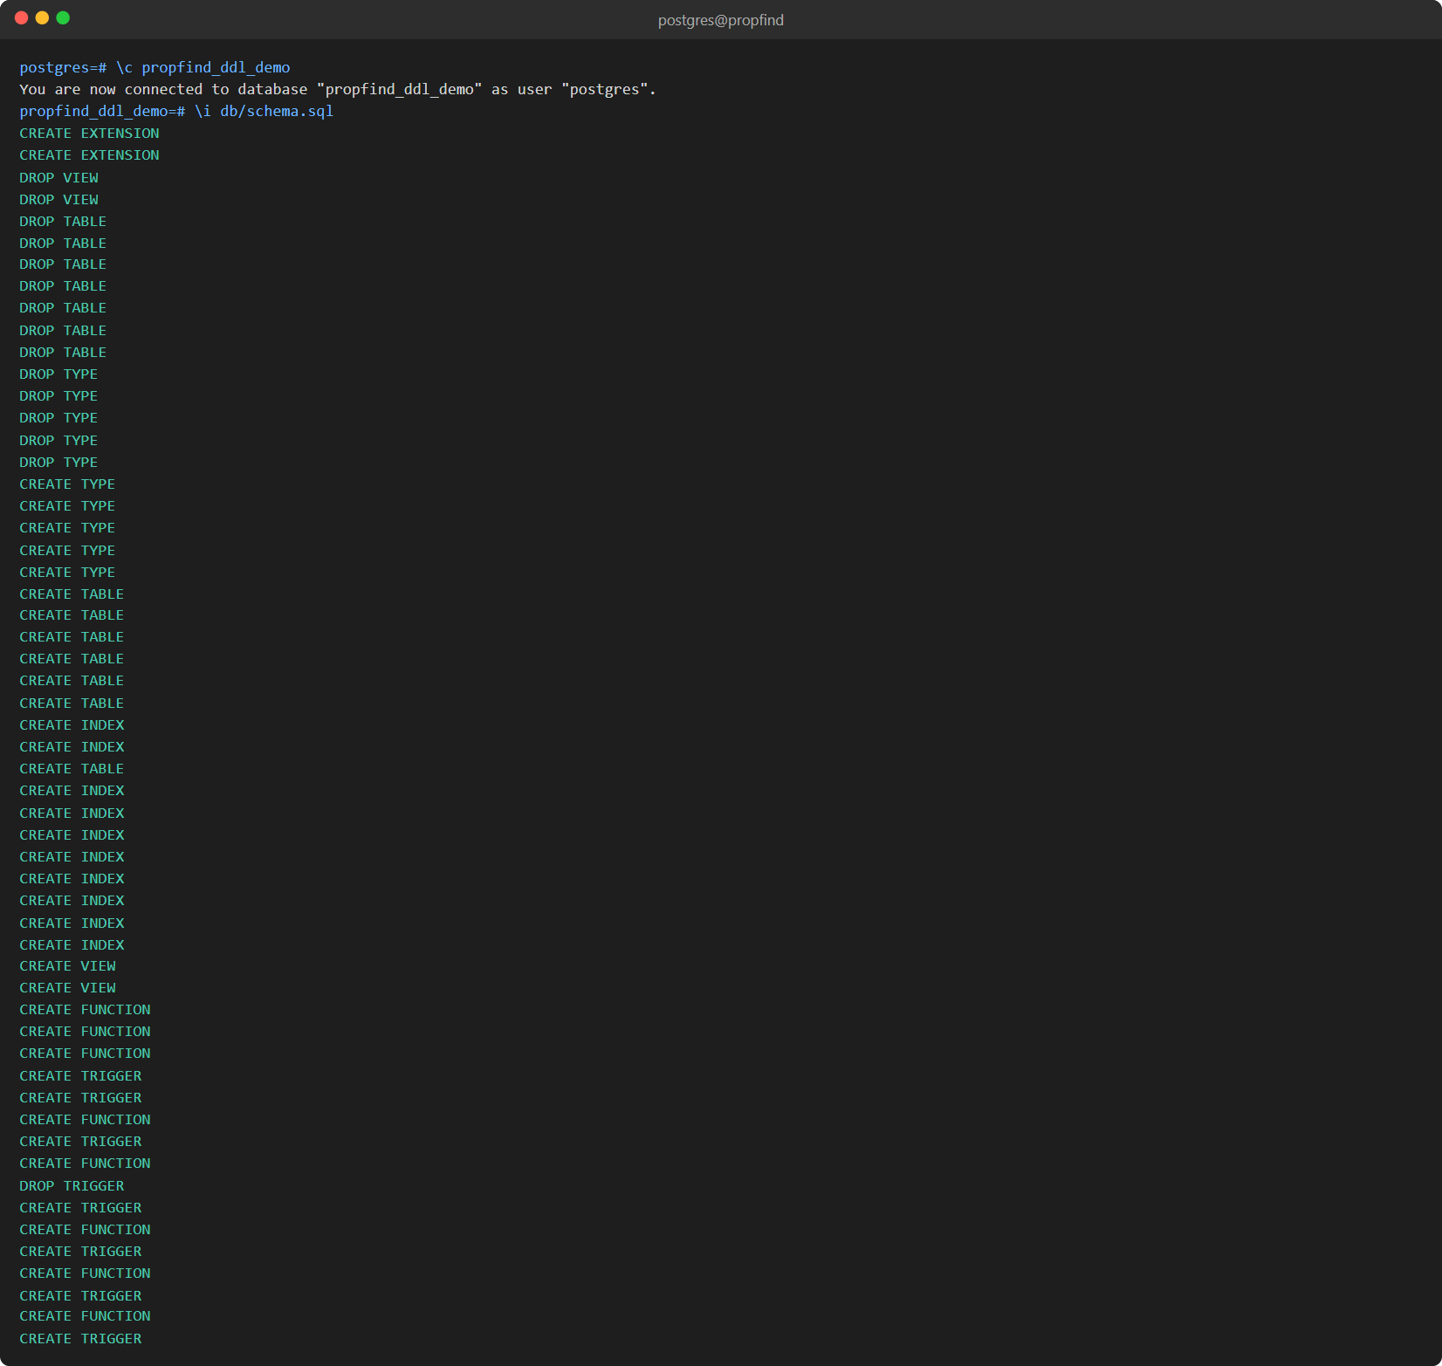
Fig. 5.1: Executing db/schema.sql (extensions, types, tables, indexes, views, functions and triggers)
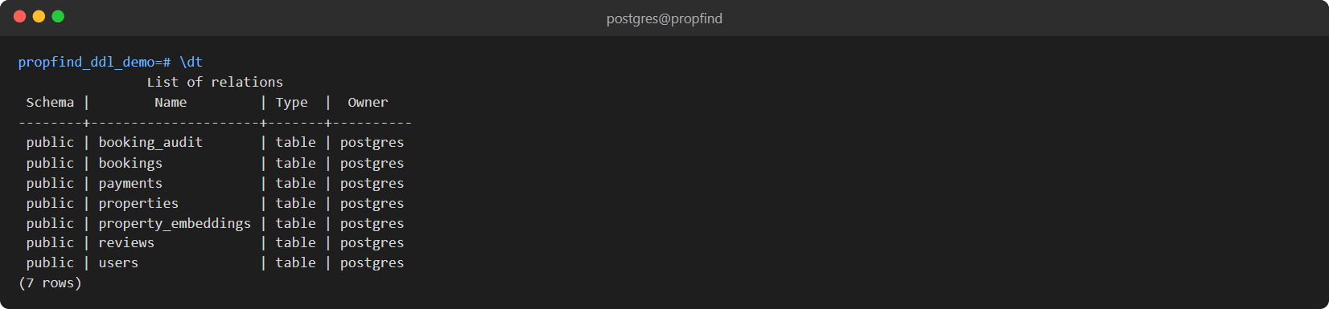
Fig. 5.2: The seven tables created (\dt)
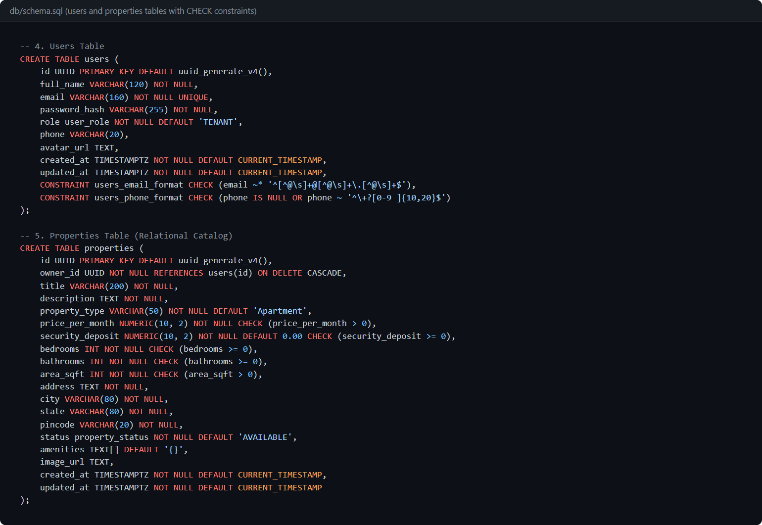
Fig. 5.3: CREATE TABLE users and properties with CHECK constraints
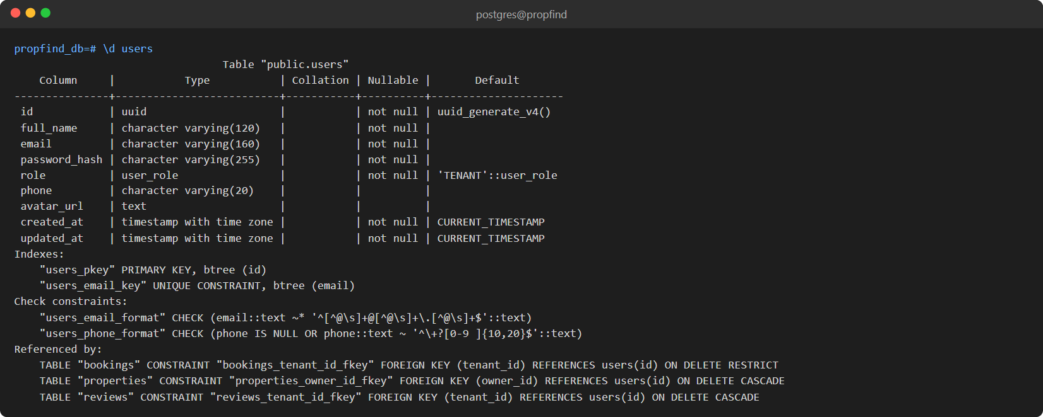
Fig. 5.4: Structure of the users table (\d users): primary key, unique and CHECK constraints
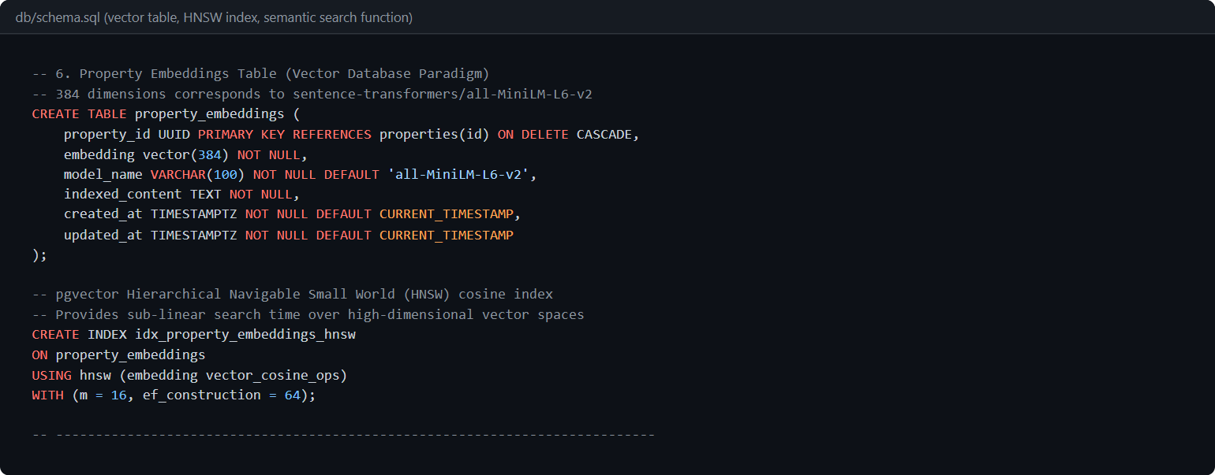
Fig. 5.5: Vector table property_embeddings, HNSW index and semantic search function
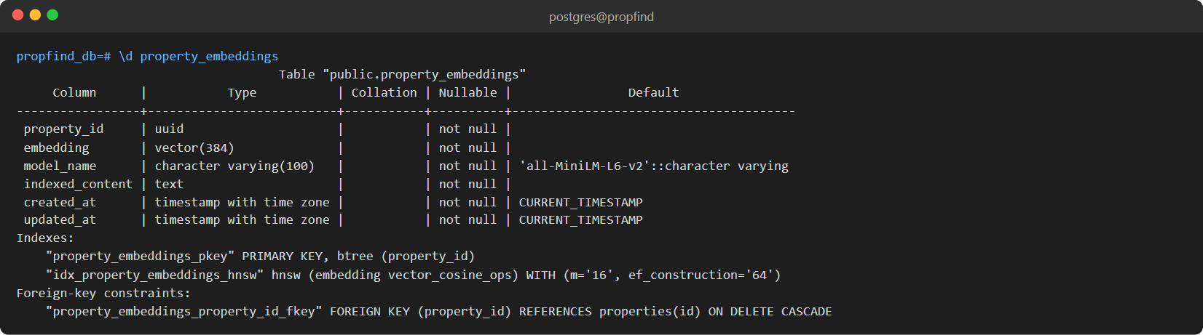
Fig. 5.6: Structure of property_embeddings (\d property_embeddings)
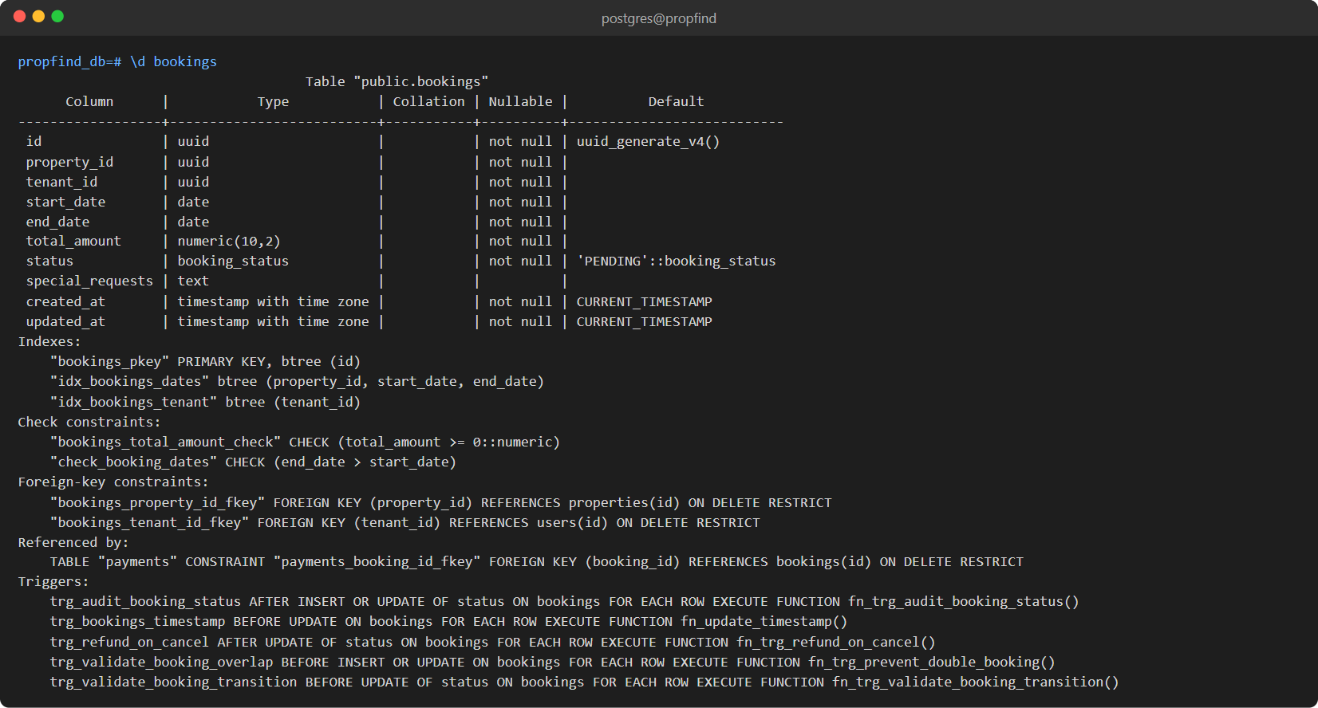
Fig. 5.7: Structure of bookings (\d bookings): foreign keys, CHECK constraint and triggers
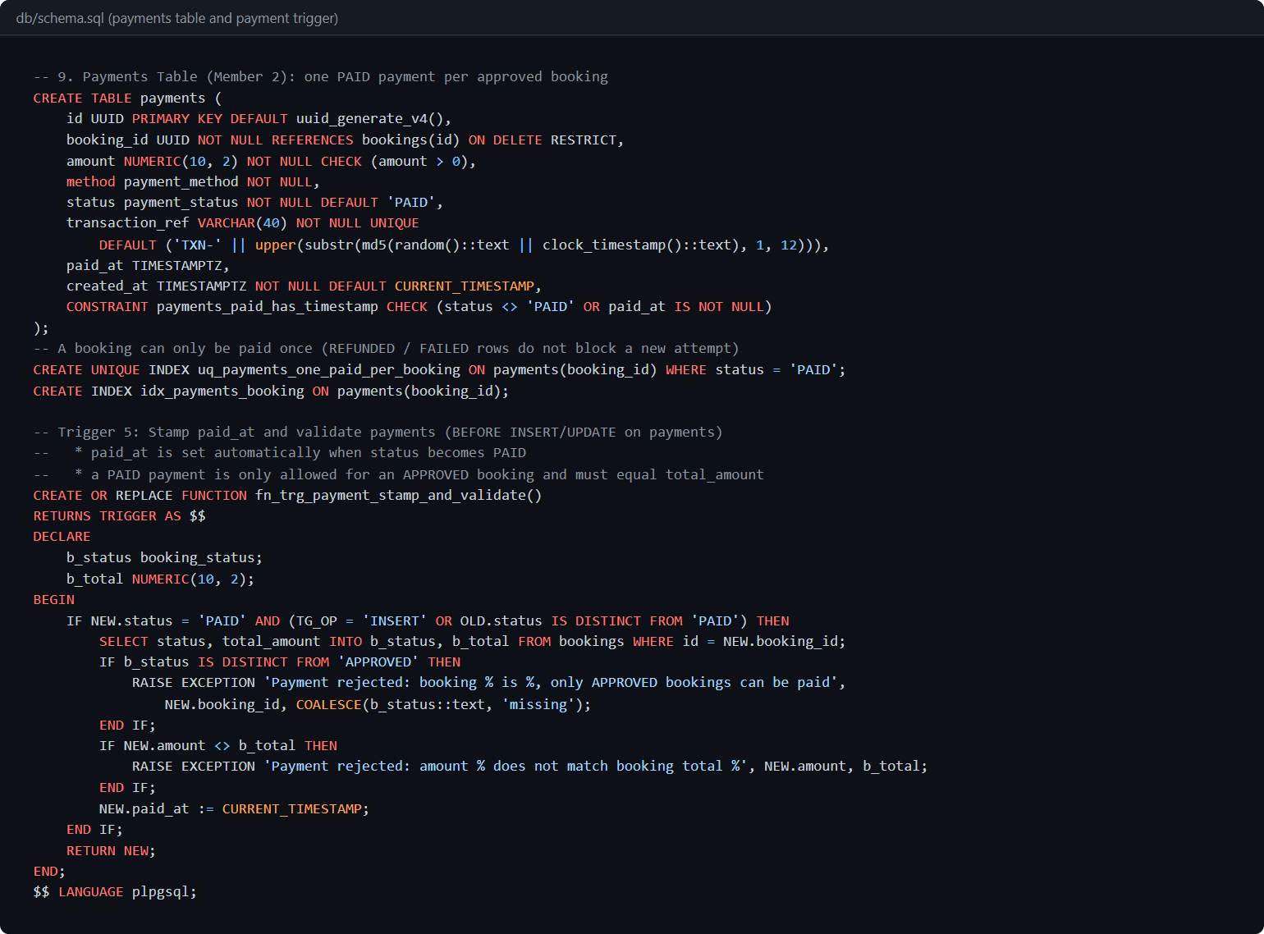
Fig. 5.8: CREATE TABLE payments and its trigger
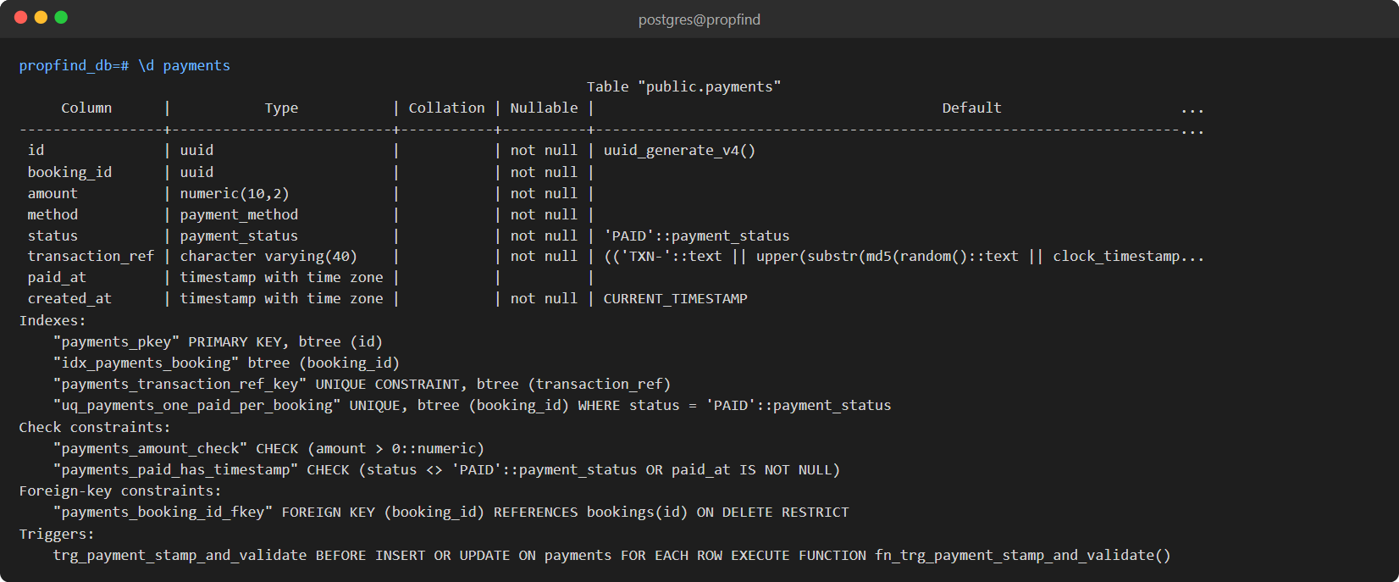
Fig. 5.9: Structure of payments (\d payments)
5.3 INDEXES
Table 5.1: Indexes
Index | Table and columns | Purpose
idx_properties_owner_id | properties(owner_id) | List an owner's properties
idx_properties_city | properties(city) | City filter
idx_properties_price | properties(price_per_month) | Budget filter and price ordering
idx_properties_status | properties(status) | Only AVAILABLE listings are searched
idx_bookings_dates | bookings(property_id, start_date, end_date) | Date-conflict checks
idx_bookings_tenant | bookings(tenant_id) | Tenant booking list
idx_payments_booking | payments(booking_id) | Payments of a booking
idx_booking_audit_booking | booking_audit(booking_id, changed_at) | Booking history
uq_payments_one_paid_per_booking | payments(booking_id) WHERE status = 'PAID' (partial unique) | A booking can be paid only once
idx_property_embeddings_hnsw | property_embeddings USING hnsw (embedding vector_cosine_ops) | Approximate nearest-neighbour search

5.4 VIEWS
-- 1. Property Catalog View (Relational Join + Rating Aggregates)
CREATE OR REPLACE VIEW view_property_catalog AS
SELECT
p.id,
p.title,
p.description,
p.property_type,
p.price_per_month,
p.security_deposit,
p.bedrooms,
p.bathrooms,
p.area_sqft,
p.address,
p.city,
p.state,
p.pincode,
p.status,
p.amenities,
p.image_url,
p.created_at,
u.id AS owner_id,
u.full_name AS owner_name,
u.email AS owner_email,
u.phone AS owner_phone,
COALESCE(ROUND(AVG(r.rating)::numeric, 1), 0.0) AS avg_rating,
COUNT(r.id) AS review_count
FROM properties p
JOIN users u ON p.owner_id = u.id
LEFT JOIN reviews r ON p.id = r.property_id
GROUP BY p.id, u.id;
-- 2. Owner Analytics View (Aggregate Functions, GROUP BY, HAVING)
CREATE OR REPLACE VIEW view_owner_analytics AS
SELECT
u.id AS owner_id,
u.full_name AS owner_name,
u.email AS owner_email,
COUNT(DISTINCT p.id) AS total_properties,
COUNT(DISTINCT CASE WHEN p.status = 'AVAILABLE' THEN p.id END) AS available_properties,
COUNT(DISTINCT CASE WHEN p.status = 'RENTED' THEN p.id END) AS rented_properties,
COALESCE(ROUND(AVG(p.price_per_month)::numeric, 2), 0.00) AS avg_monthly_rent,
COUNT(DISTINCT b.id) AS total_booking_requests,
COUNT(DISTINCT CASE WHEN b.status = 'APPROVED' THEN b.id END) AS confirmed_bookings,
COALESCE(SUM(CASE WHEN b.status = 'APPROVED' THEN b.total_amount ELSE 0 END), 0.00) AS total_confirmed_revenue
FROM users u
LEFT JOIN properties p ON u.id = p.owner_id
LEFT JOIN bookings b ON p.id = b.property_id
WHERE u.role = 'OWNER'
GROUP BY u.id
HAVING COUNT(p.id) >= 0;
-- ----------------------------------------------------------------------------
5.5 ALTER AND DROP STATEMENTS
ALTER and DROP are demonstrated inside a transaction that is rolled back, so the real schema is not changed. A new column and a CHECK constraint are added, the column is renamed, a bad value is rejected by the new constraint, and the column is dropped again; a view and a table are created and dropped.
-- L1. ALTER TABLE: add a column, add a CHECK constraint, rename, set NOT NULL, drop
BEGIN;
ALTER TABLE properties ADD COLUMN furnishing VARCHAR(20) DEFAULT 'UNFURNISHED';
ALTER TABLE properties
ADD CONSTRAINT properties_furnishing_check
CHECK (furnishing IN ('UNFURNISHED', 'SEMI_FURNISHED', 'FULLY_FURNISHED'));
UPDATE properties SET furnishing = 'FULLY_FURNISHED' WHERE 'Fully Furnished' = ANY(amenities);
UPDATE properties SET furnishing = 'SEMI_FURNISHED' WHERE 'Semi-Furnished' = ANY(amenities);
SELECT furnishing, COUNT(*) AS properties FROM properties GROUP BY furnishing ORDER BY properties DESC;
ALTER TABLE properties RENAME COLUMN furnishing TO furnishing_level;
ALTER TABLE properties ALTER COLUMN furnishing_level SET NOT NULL;
SAVEPOINT before_bad_value;
\set ON_ERROR_STOP off
UPDATE properties SET furnishing_level = 'PARTLY' WHERE id = (SELECT id FROM properties LIMIT 1); -- violates the new CHECK, error expected
\set ON_ERROR_STOP on
ROLLBACK TO SAVEPOINT before_bad_value;
ALTER TABLE properties DROP COLUMN furnishing_level; -- also drops its CHECK constraint
ROLLBACK;
SELECT COUNT(*) AS furnishing_columns_left
FROM information_schema.columns WHERE table_name = 'properties' AND column_name LIKE 'furnishing%';
-- L2. CREATE VIEW / DROP VIEW / DROP TABLE (rolled back)
BEGIN;
CREATE VIEW view_budget_listings AS
SELECT id, title, city, price_per_month FROM properties WHERE price_per_month < 20000;
SELECT COUNT(*) AS budget_listings, MIN(price_per_month) AS cheapest, MAX(price_per_month) AS dearest FROM view_budget_listings;
DROP VIEW view_budget_listings;
CREATE TABLE demo_scratch (id INT PRIMARY KEY, note TEXT);
INSERT INTO demo_scratch VALUES (1, 'temporary');
DROP TABLE demo_scratch;
ROLLBACK;
SELECT to_regclass('view_budget_listings') AS view_exists, to_regclass('demo_scratch') AS table_exists;
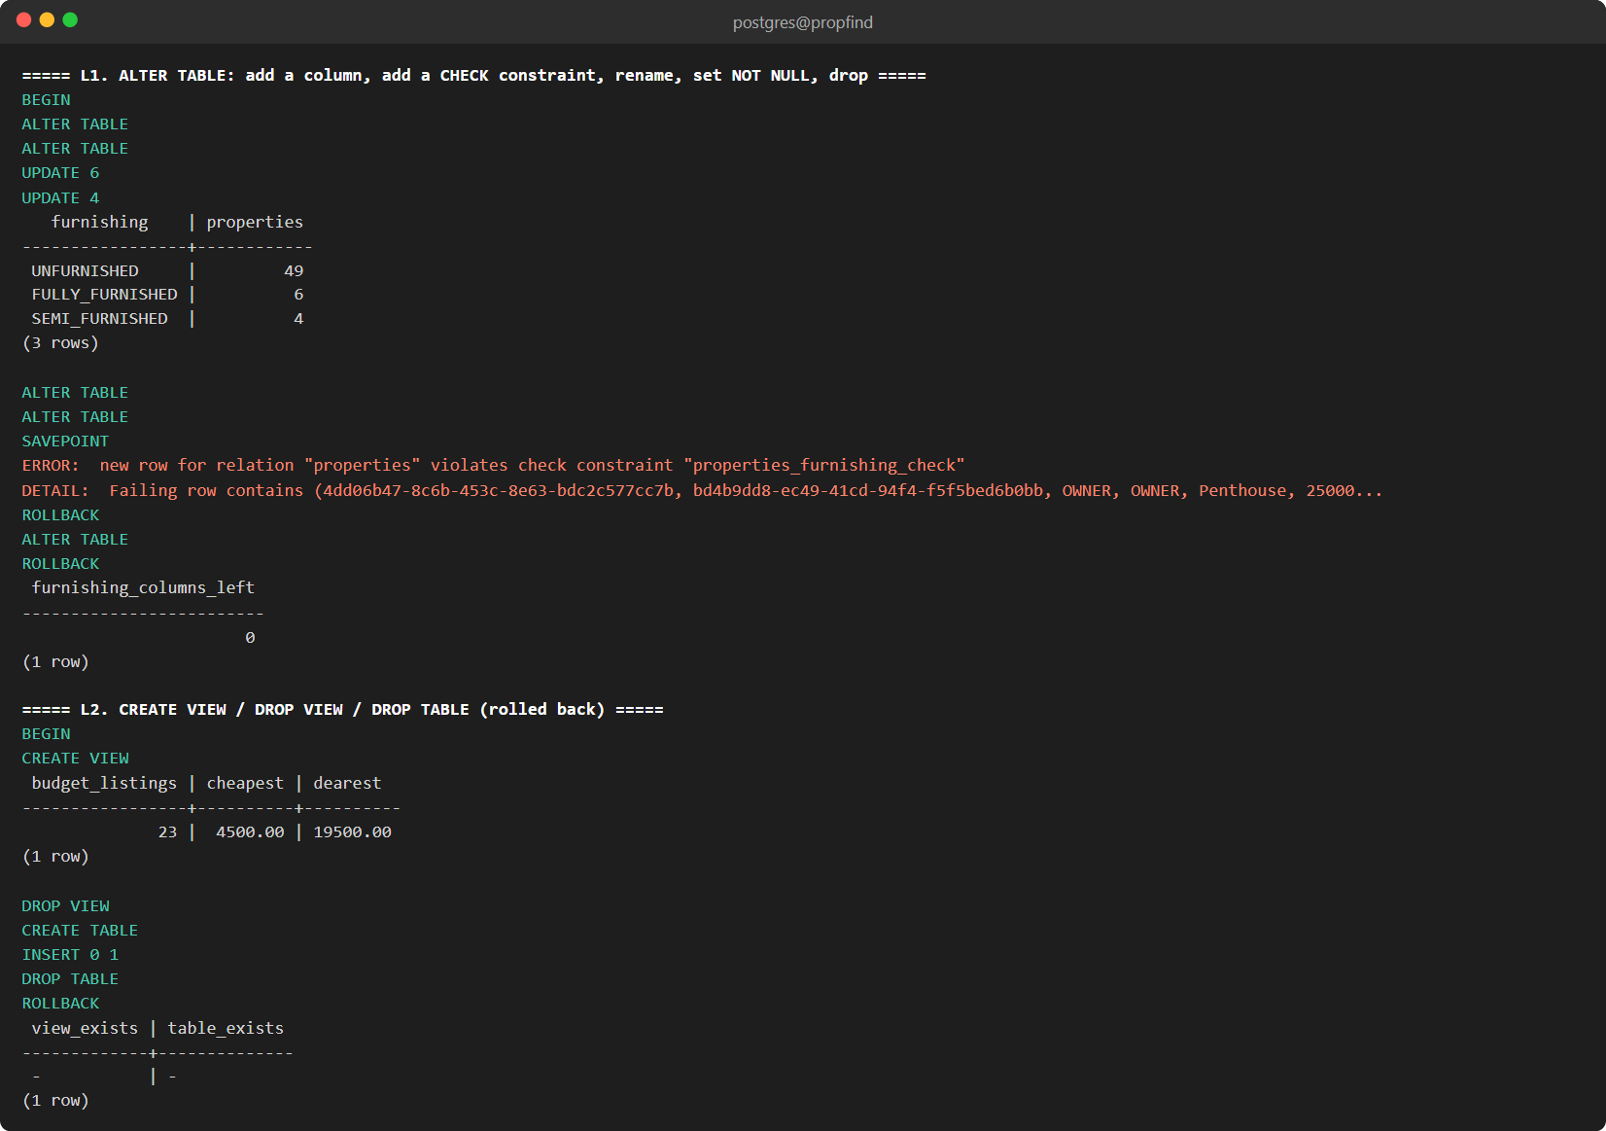
Fig. 5.10: ALTER TABLE, CREATE VIEW, DROP VIEW and DROP TABLE (rolled back)
5.6 CONSTRAINTS SUMMARY
Table 5.2: Primary key, foreign key, unique and check constraints in the database
Table | Constraint | Type | Definition
users | users_email_format | CHECK | CHECK (((email)::text ~* '^[^@\s]+@[^@\s]+\.[^@\s]+$'::text))
users | users_phone_format | CHECK | CHECK (((phone IS NULL) OR ((phone)::text ~ '^\+?[0-9 ]{10,20}$'::text)))
users | users_pkey | PRIMARY KEY | PRIMARY KEY (id)
users | users_email_key | UNIQUE | UNIQUE (email)
properties | properties_area_sqft_check | CHECK | CHECK ((area_sqft > 0))
properties | properties_bathrooms_check | CHECK | CHECK ((bathrooms >= 0))
properties | properties_bedrooms_check | CHECK | CHECK ((bedrooms >= 0))
properties | properties_price_per_month_check | CHECK | CHECK ((price_per_month > (0)::numeric))
properties | properties_security_deposit_check | CHECK | CHECK ((security_deposit >= (0)::numeric))
properties | properties_owner_id_fkey | FOREIGN KEY | FOREIGN KEY (owner_id) REFERENCES users(id) ON DELETE CASCADE
properties | properties_pkey | PRIMARY KEY | PRIMARY KEY (id)
property_embeddings | property_embeddings_property_id_fkey | FOREIGN KEY | FOREIGN KEY (property_id) REFERENCES properties(id) ON DELETE CASCADE
property_embeddings | property_embeddings_pkey | PRIMARY KEY | PRIMARY KEY (property_id)
bookings | bookings_total_amount_check | CHECK | CHECK ((total_amount >= (0)::numeric))
bookings | check_booking_dates | CHECK | CHECK ((end_date > start_date))
bookings | bookings_property_id_fkey | FOREIGN KEY | FOREIGN KEY (property_id) REFERENCES properties(id) ON DELETE RESTRICT
bookings | bookings_tenant_id_fkey | FOREIGN KEY | FOREIGN KEY (tenant_id) REFERENCES users(id) ON DELETE RESTRICT
bookings | bookings_pkey | PRIMARY KEY | PRIMARY KEY (id)
reviews | reviews_rating_check | CHECK | CHECK (((rating >= 1) AND (rating <= 5)))
reviews | reviews_property_id_fkey | FOREIGN KEY | FOREIGN KEY (property_id) REFERENCES properties(id) ON DELETE CASCADE
reviews | reviews_tenant_id_fkey | FOREIGN KEY | FOREIGN KEY (tenant_id) REFERENCES users(id) ON DELETE CASCADE
reviews | reviews_pkey | PRIMARY KEY | PRIMARY KEY (id)
reviews | unique_tenant_property_review | UNIQUE | UNIQUE (property_id, tenant_id)
payments | payments_amount_check | CHECK | CHECK ((amount > (0)::numeric))
payments | payments_paid_has_timestamp | CHECK | CHECK (((status <> 'PAID'::payment_status) OR (paid_at IS NOT NULL)))
payments | payments_booking_id_fkey | FOREIGN KEY | FOREIGN KEY (booking_id) REFERENCES bookings(id) ON DELETE RESTRICT
payments | payments_pkey | PRIMARY KEY | PRIMARY KEY (id)
payments | payments_transaction_ref_key | UNIQUE | UNIQUE (transaction_ref)
booking_audit | booking_audit_pkey | PRIMARY KEY | PRIMARY KEY (id)

6. DML STATEMENTS
STATEMENTS WITH SCREEN SHOTS OF THE TABLE WITH INSERTED VALUES
6.1 INSERT STATEMENTS
Data is inserted by the seed script (scripts/seed.mjs, data in scripts/seed-data.mjs) and by the application. All values are passed as bind parameters, never concatenated into the SQL text. Bookings are inserted as PENDING and then moved through the real state machine, so the audit and payment triggers run exactly as they do for a real user.
-- users (password stored as a bcrypt hash)
INSERT INTO users (full_name, email, password_hash, role, phone)
VALUES ($1, $2, $3, $4::user_role, $5) RETURNING id;
-- properties
INSERT INTO properties (owner_id, title, description, property_type, price_per_month,
security_deposit, bedrooms, bathrooms, area_sqft, address, city, state, pincode,
status, amenities, image_url)
VALUES ($1, $2, $3, $4, $5, $6, $7, $8, $9, $10, $11, $12, $13, 'AVAILABLE', $14, $15) RETURNING *;
-- vector embedding of a property (384 numbers passed as a vector literal)
INSERT INTO property_embeddings (property_id, embedding, model_name, indexed_content)
VALUES ($1, $2::vector, $3, $4);
-- reviews, bookings, payments
INSERT INTO reviews (property_id, tenant_id, rating, comment) VALUES ($1, $2, $3, $4);
INSERT INTO bookings (property_id, tenant_id, start_date, end_date, total_amount, special_requests)
VALUES ($1, $2, $3, $4, $5, $6) RETURNING id;
INSERT INTO payments (booking_id, amount, method, status) VALUES ($1, $2, 'UPI', 'PAID');
6.2 TABLES WITH INSERTED VALUES
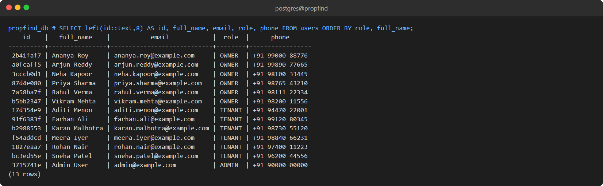
Fig. 6.1: Table users (owners, tenants and one admin)
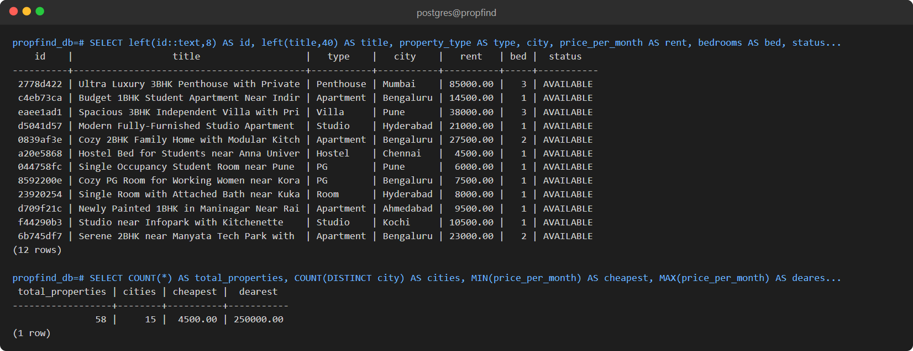
Fig. 6.2: Table properties (first 12 of 58 rows) and summary
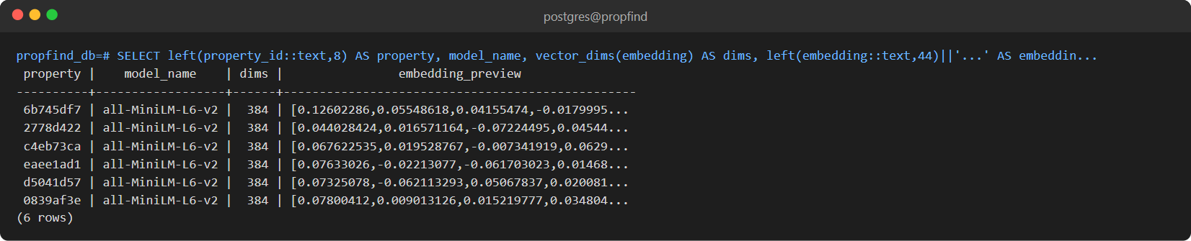
Fig. 6.3: Table property_embeddings: 384-dimension vectors (preview)
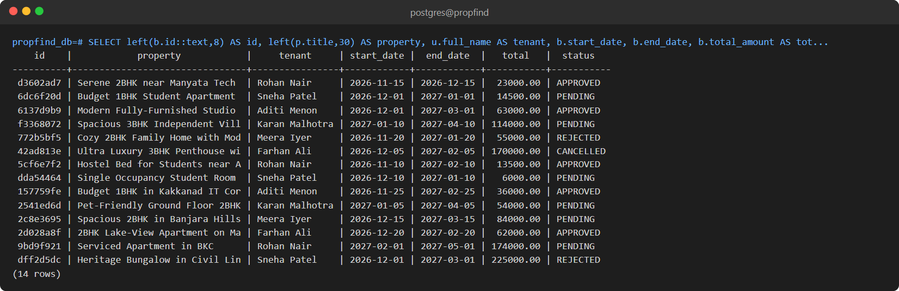
Fig. 6.4: Table bookings: all statuses
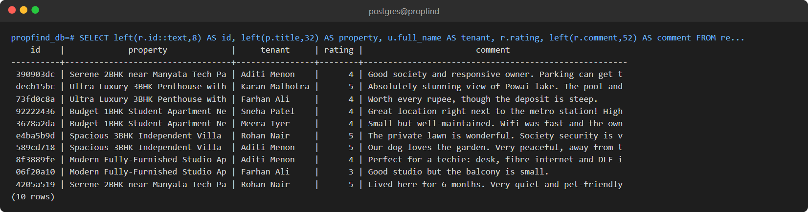
Fig. 6.5: Table reviews (first 10 rows)
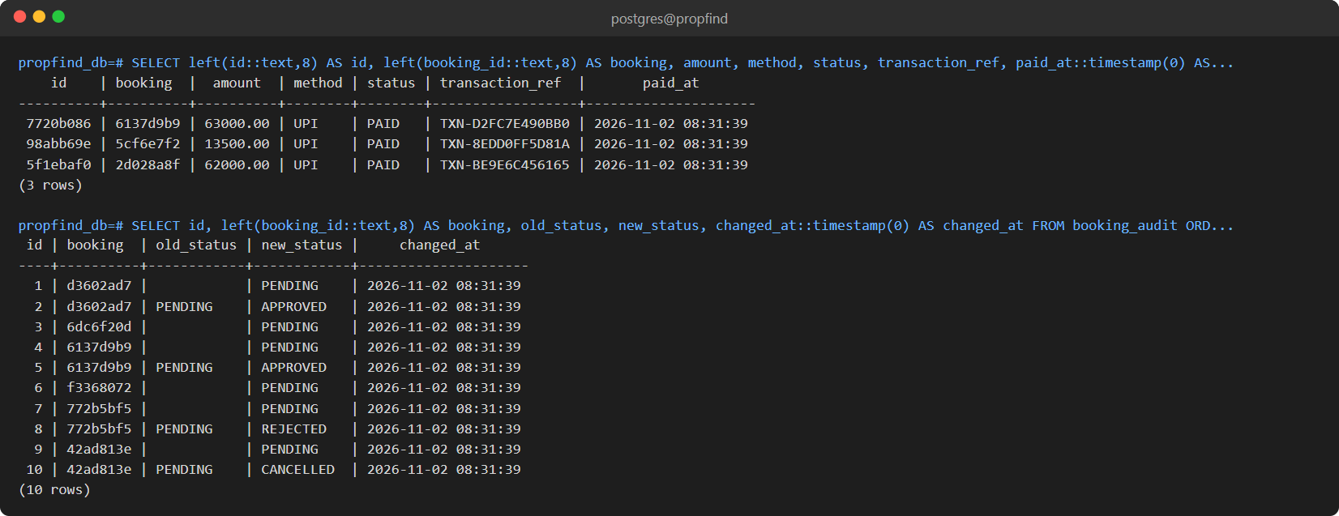
Fig. 6.6: Tables payments and booking_audit (the audit rows were written by a trigger)
6.3 DATA VOLUME
Table 6.1: Rows in the database
Table | Rows
users | 13
properties | 58 (in 15 cities)
property_embeddings | 58
reviews | 44
bookings | 14
payments | 3
booking_audit | 22

7. QUERIES
7.1 SIMPLE QUERY WITH GROUP BY, AGGREGATE
-- B1. GROUP BY + COUNT / AVG / MIN / MAX: price statistics per city
SELECT city,
COUNT(*) AS properties,
ROUND(AVG(price_per_month), 2) AS avg_rent,
MIN(price_per_month) AS min_rent,
MAX(price_per_month) AS max_rent
FROM properties
GROUP BY city
ORDER BY avg_rent DESC;
-- B2. HAVING: cities with at least 2 listings and average rent above 20,000
SELECT city, COUNT(*) AS properties, ROUND(AVG(price_per_month), 2) AS avg_rent
FROM properties
GROUP BY city
HAVING COUNT(*) >= 2 AND AVG(price_per_month) > 20000
ORDER BY avg_rent DESC;
-- B3. GROUP BY with SUM: revenue and count per booking status
SELECT status, COUNT(*) AS bookings, SUM(total_amount) AS total_value
FROM bookings
GROUP BY status
ORDER BY bookings DESC;
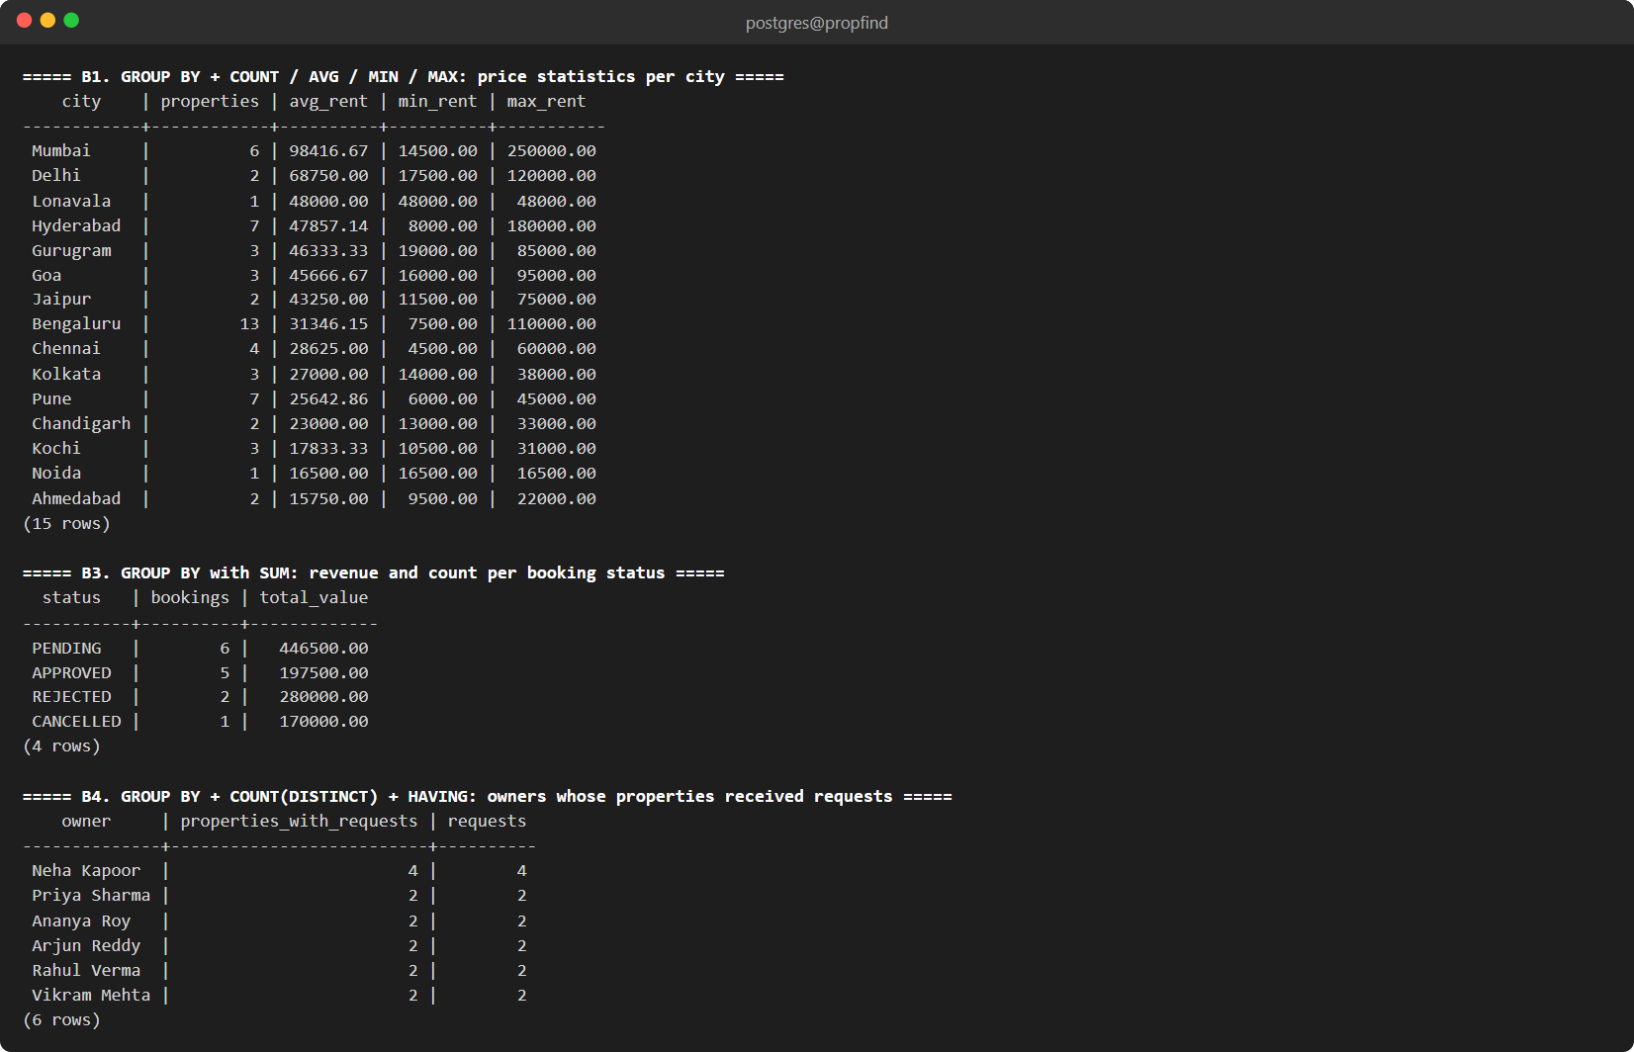
Fig. 7.1: GROUP BY with COUNT, AVG, MIN, MAX and SUM
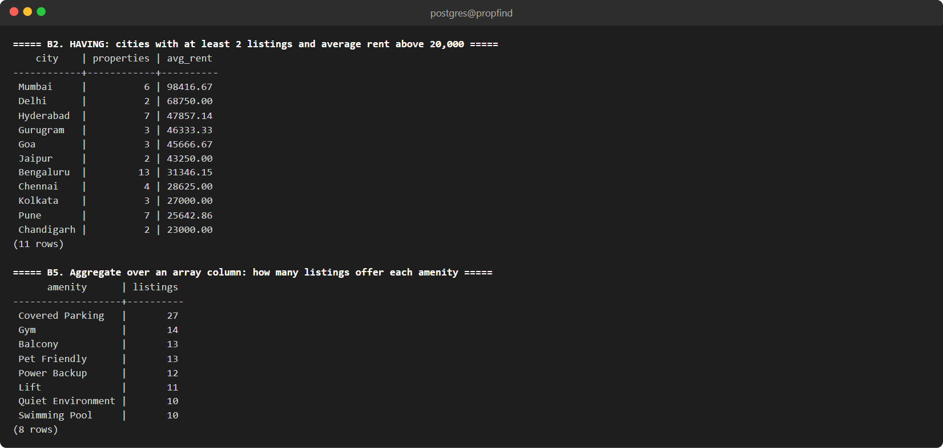
Fig. 7.2: HAVING and an aggregate over an array column
7.2 UPDATE OPERATION
-- F1. UPDATE with a subquery: raise rent 5% for owners with an APPROVED booking
BEGIN;
SELECT title, price_per_month AS before FROM properties WHERE city = 'Bengaluru' ORDER BY title;
UPDATE properties
SET price_per_month = ROUND(price_per_month * 1.05, 2)
WHERE id IN (SELECT property_id FROM bookings WHERE status = 'APPROVED');
SELECT title, price_per_month AS after, updated_at > created_at AS timestamp_trigger_fired
FROM properties WHERE id IN (SELECT property_id FROM bookings WHERE status = 'APPROVED');
ROLLBACK;
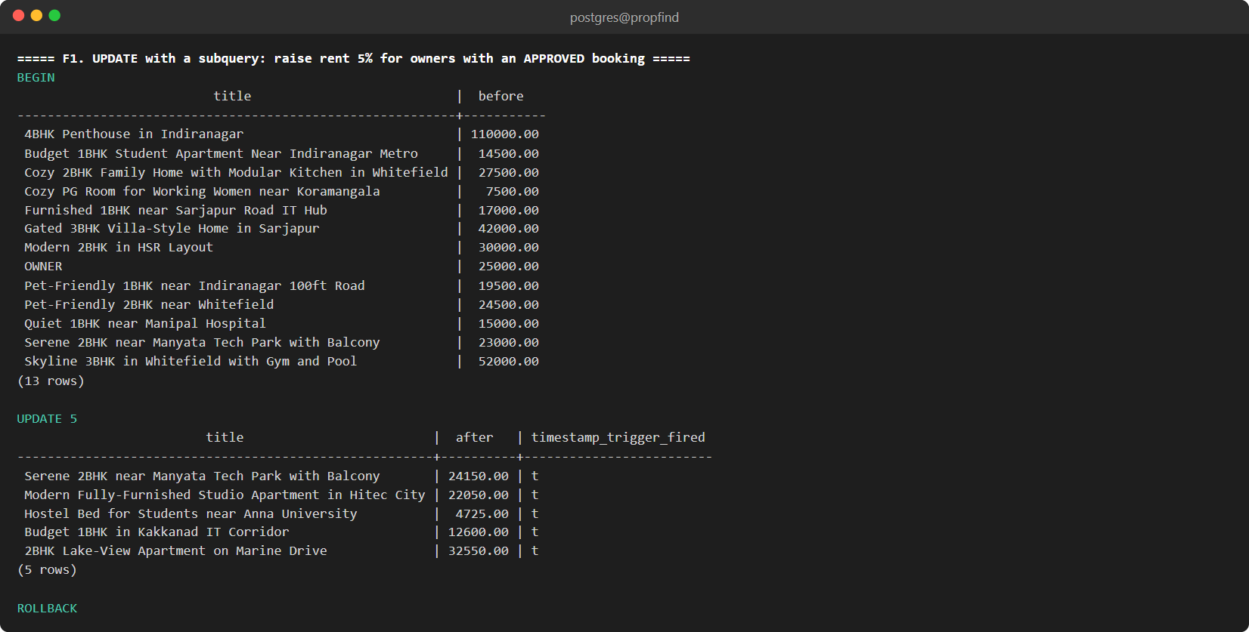
Fig. 7.3: UPDATE with a subquery; the timestamp trigger fires; the transaction is rolled back
7.3 DELETE OPERATION
-- F2. DELETE with a subquery: remove PENDING requests (audit table keeps the history)
BEGIN;
SELECT COUNT(*) AS pending_before FROM bookings WHERE status = 'PENDING';
DELETE FROM bookings WHERE status = 'PENDING' AND start_date > CURRENT_DATE;
SELECT COUNT(*) AS pending_after FROM bookings WHERE status = 'PENDING';
ROLLBACK;
SELECT COUNT(*) AS pending_restored FROM bookings WHERE status = 'PENDING';
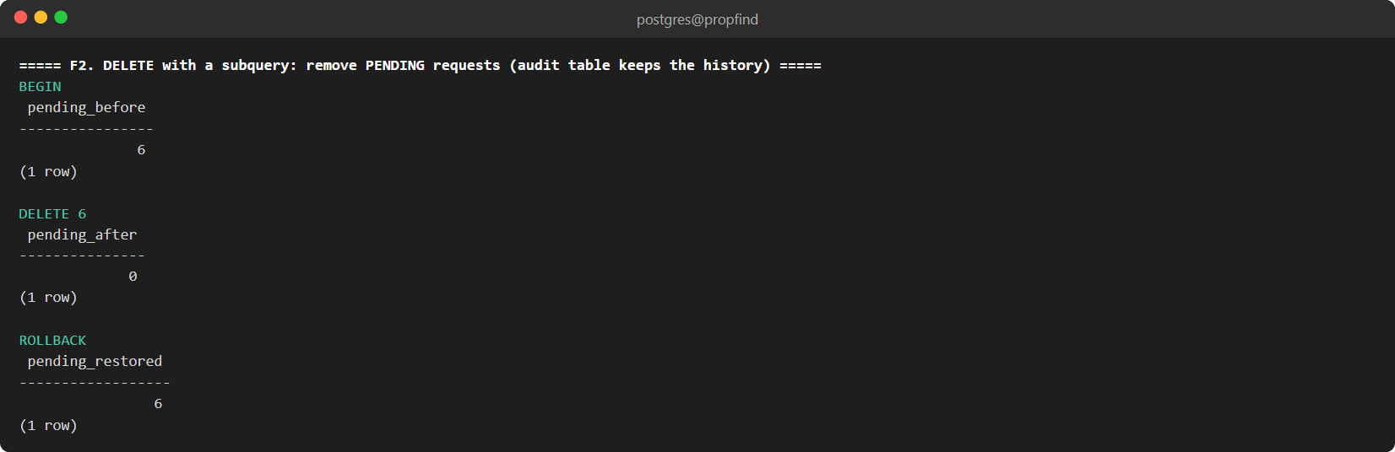
Fig. 7.4: DELETE with a condition, then ROLLBACK restores the rows
7.4 CORRELATED QUERY
-- D1. Correlated: properties priced above the average of THEIR OWN city
SELECT p.title, p.city, p.price_per_month
FROM properties p
WHERE p.price_per_month > (
SELECT AVG(p2.price_per_month)
FROM properties p2
WHERE p2.city = p.city
)
ORDER BY p.city, p.price_per_month DESC;
-- D2. Correlated EXISTS: properties that have at least one 5-star review
SELECT p.title
FROM properties p
WHERE EXISTS (
SELECT 1 FROM reviews r WHERE r.property_id = p.id AND r.rating = 5
);
-- D3. Correlated NOT EXISTS: properties nobody has requested yet
SELECT p.title, p.city
FROM properties p
WHERE NOT EXISTS (
SELECT 1 FROM bookings b WHERE b.property_id = p.id
);
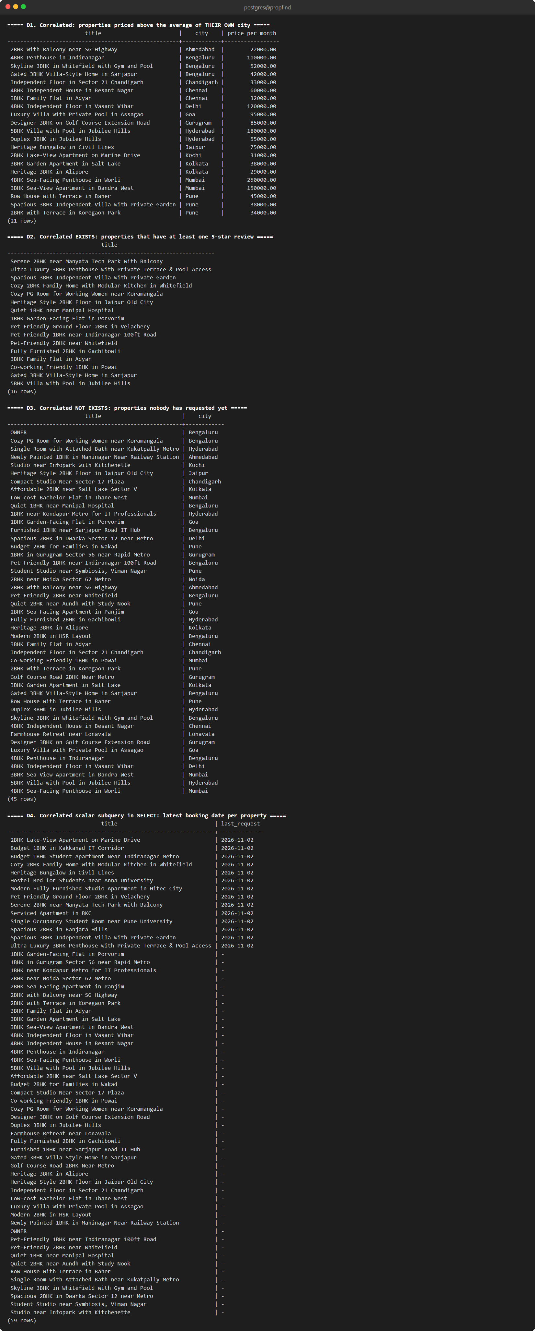
Fig. 7.5: Correlated subqueries: comparison with the city average, EXISTS, NOT EXISTS and a scalar subquery
7.5 NESTED QUERY
-- C1. Scalar subquery: properties priced above the overall average
SELECT title, price_per_month
FROM properties
WHERE price_per_month > (SELECT AVG(price_per_month) FROM properties)
ORDER BY price_per_month DESC;
-- C2. IN subquery: tenants who have at least one APPROVED booking
SELECT full_name, email
FROM users
WHERE id IN (SELECT tenant_id FROM bookings WHERE status = 'APPROVED');
-- C3. Subquery in FROM (derived table): city with the highest average rent
SELECT city, avg_rent
FROM (
SELECT city, AVG(price_per_month) AS avg_rent
FROM properties
GROUP BY city
) AS city_avg
ORDER BY avg_rent DESC
LIMIT 1;
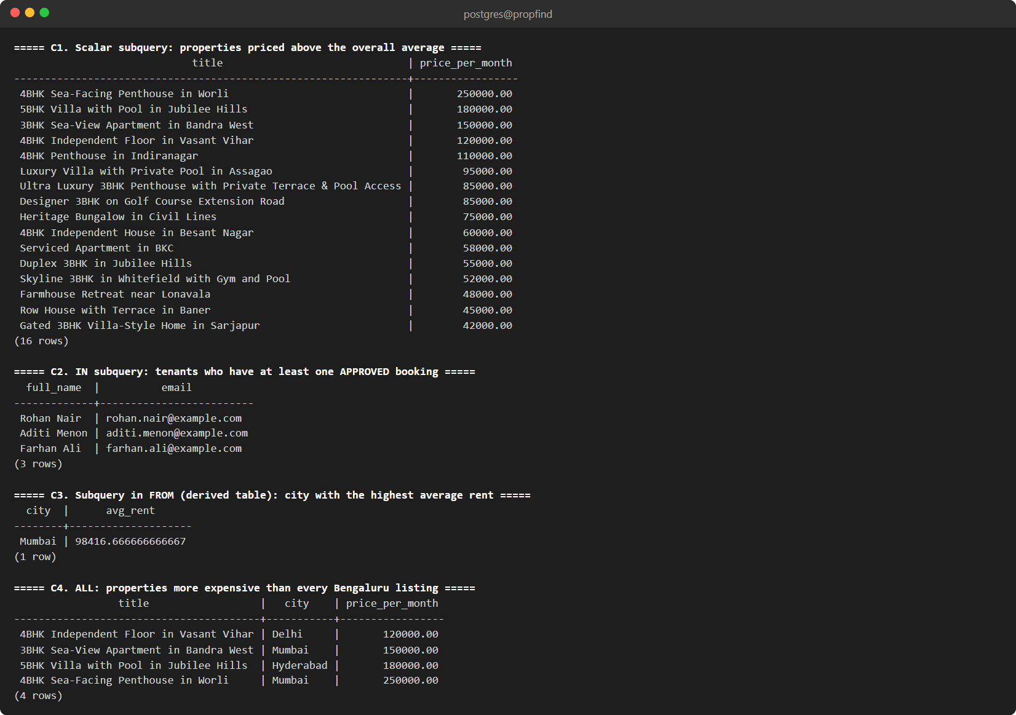
Fig. 7.6: Nested subqueries: scalar, IN, derived table and ALL
7.6 JOIN QUERIES
-- A1. INNER JOIN (4 tables): every booking with property, tenant and owner
SELECT b.start_date, b.end_date, b.status,
p.title AS property,
t.full_name AS tenant,
o.full_name AS owner
FROM bookings b
JOIN properties p ON p.id = b.property_id
JOIN users t ON t.id = b.tenant_id
JOIN users o ON o.id = p.owner_id
ORDER BY b.start_date;
-- A2. LEFT JOIN: every property with its booking count (0 if never booked)
SELECT p.title, p.city, COUNT(b.id) AS bookings
FROM properties p
LEFT JOIN bookings b ON b.property_id = p.id
GROUP BY p.id, p.title, p.city
ORDER BY bookings DESC, p.title;
-- A3. LEFT JOIN + IS NULL (anti-join): properties that have no reviews
SELECT p.title
FROM properties p
LEFT JOIN reviews r ON r.property_id = p.id
WHERE r.id IS NULL;
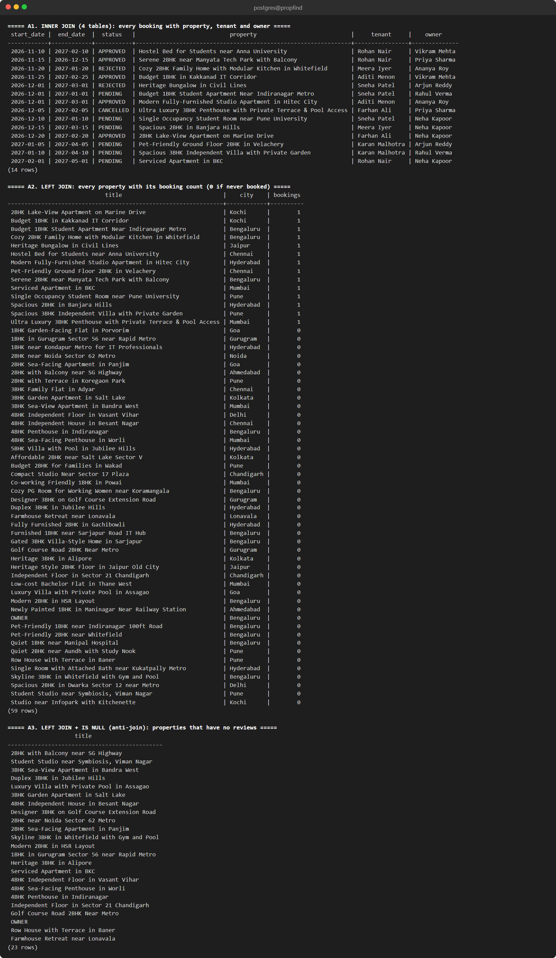
Fig. 7.7: INNER JOIN of four tables, LEFT JOIN and an anti-join
7.7 WINDOW FUNCTION, CTE AND SET OPERATION
-- E1. WINDOW function: rank every property by rent within its city
SELECT city, title, price_per_month,
RANK() OVER (PARTITION BY city ORDER BY price_per_month DESC) AS rank_in_city
FROM properties
ORDER BY city, rank_in_city;
-- E2. CTE: owners ranked by confirmed revenue
WITH revenue AS (
SELECT p.owner_id, SUM(b.total_amount) AS confirmed_revenue
FROM bookings b
JOIN properties p ON p.id = b.property_id
WHERE b.status = 'APPROVED'
GROUP BY p.owner_id
)
SELECT u.full_name, COALESCE(r.confirmed_revenue, 0) AS confirmed_revenue
FROM users u
LEFT JOIN revenue r ON r.owner_id = u.id
WHERE u.role = 'OWNER'
ORDER BY confirmed_revenue DESC;
-- E3. UNION: everyone who is either an owner of a listing or has made a booking
SELECT u.full_name, 'owner' AS involvement
FROM users u WHERE u.id IN (SELECT owner_id FROM properties)
UNION
SELECT u.full_name, 'tenant'
FROM users u WHERE u.id IN (SELECT tenant_id FROM bookings)
ORDER BY involvement, full_name;
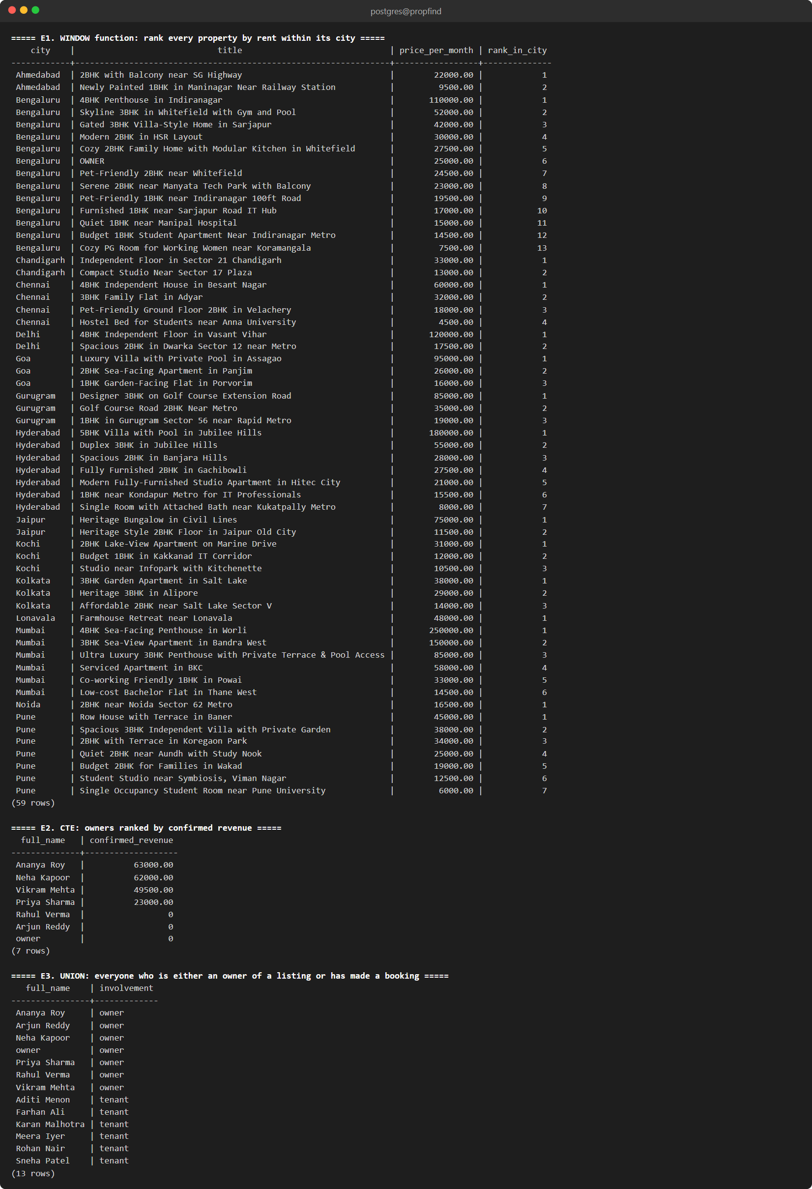
Fig. 7.8: RANK() window function, WITH query and UNION
7.8 VECTOR SIMILARITY AND HYBRID QUERIES
-- I1. Listings most similar to the Manyata Tech Park apartment (nearest neighbours)
SELECT p.title,
ROUND((1 - (e.embedding <=> ref.embedding))::numeric, 3) AS cosine_similarity
FROM property_embeddings e
JOIN properties p ON p.id = e.property_id
CROSS JOIN (
SELECT pe.embedding
FROM property_embeddings pe JOIN properties pp ON pp.id = pe.property_id
WHERE pp.title LIKE 'Serene 2BHK%'
) AS ref
WHERE p.title NOT LIKE 'Serene 2BHK%'
ORDER BY e.embedding <=> ref.embedding
LIMIT 3;
-- I2. Stored function fn_search_properties_semantic with a stored vector as the query
SELECT title, city, ROUND(similarity_score::numeric, 3) AS similarity
FROM fn_search_properties_semantic(
(SELECT pe.embedding FROM property_embeddings pe JOIN properties pp ON pp.id = pe.property_id
WHERE pp.title LIKE 'Budget 1BHK Student%'),
0.20, 3
);
-- I3. Hybrid: vector ranking + relational filters (city and price)
SELECT p.title, p.city, p.price_per_month,
ROUND((1 - (e.embedding <=> ref.embedding))::numeric, 3) AS similarity
FROM property_embeddings e
JOIN properties p ON p.id = e.property_id
CROSS JOIN (
SELECT pe.embedding FROM property_embeddings pe JOIN properties pp ON pp.id = pe.property_id
WHERE pp.title LIKE 'Modern Fully-Furnished Studio%'
) AS ref
WHERE p.city = 'Bengaluru' AND p.price_per_month <= 30000
ORDER BY e.embedding <=> ref.embedding
LIMIT 3;
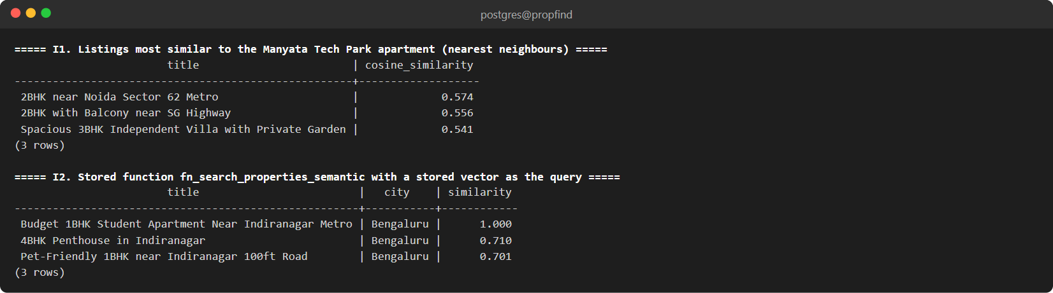
Fig. 7.9: Nearest neighbours with the <=> operator and the semantic search function
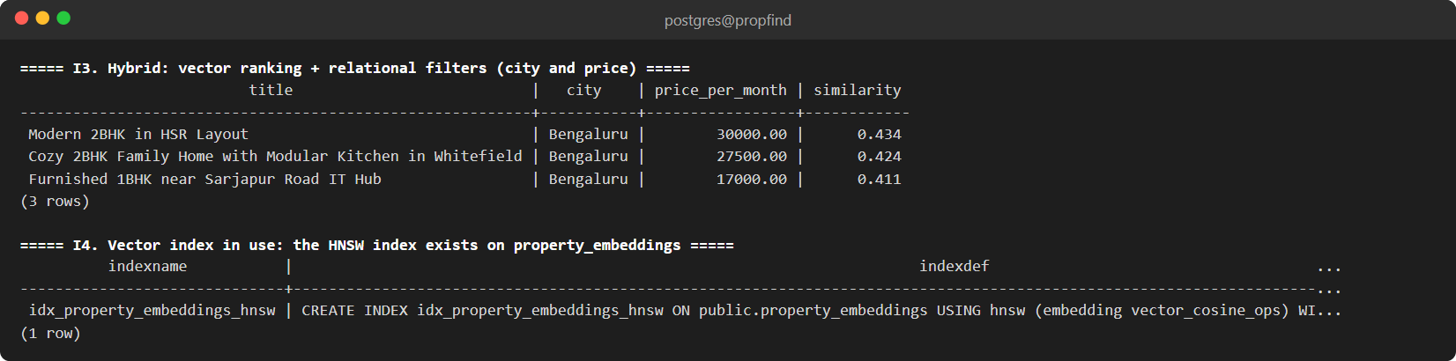
Fig. 7.10: Hybrid query (vector ranking with relational filters) and the HNSW index
7.9 FULL-TEXT SEARCH
-- J1. Full-text search: listings mentioning quiet AND garden (ranked)
SELECT title,
ROUND(ts_rank(to_tsvector('english', title || ' ' || description),
to_tsquery('english', 'quiet & garden'))::numeric, 4) AS rank
FROM properties
WHERE to_tsvector('english', title || ' ' || description) @@ to_tsquery('english', 'quiet & garden')
ORDER BY rank DESC;
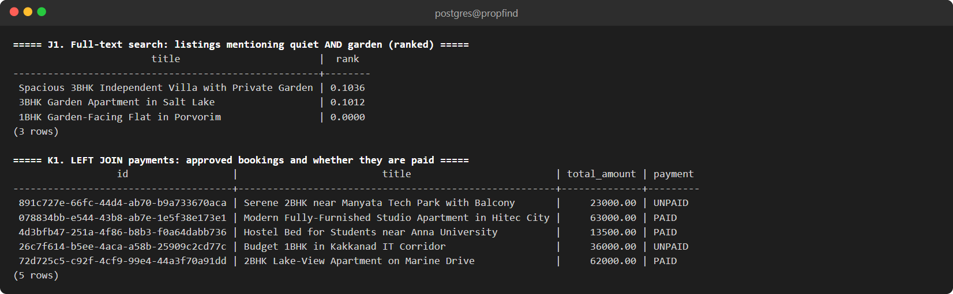
Fig. 7.11: Full-text search with tsvector and tsquery, and a payments query

8. STORED PROCEDURES, FUNCTIONS AND TRIGGERS
8.1 STORED PROCEDURES OR FUNCTIONS
The database logic is written as PL/pgSQL functions. PostgreSQL functions are used in place of CALL-style stored procedures; the multi-step booking transaction is executed by the application service inside BEGIN and COMMIT with a row lock (Section 8.3).
Table 8.1: Stored functions
Function | Returns | Purpose
fn_update_timestamp() | trigger | Sets updated_at on every update
fn_check_booking_conflict(property, start, end, exclude_booking) | boolean | True if an APPROVED booking overlaps the dates (uses OVERLAPS)
fn_search_properties_semantic(vector, threshold, count, city, max_price, bedrooms) | table | Cosine-similarity search with relational filters
fn_trg_prevent_double_booking() | trigger | Rejects overlapping APPROVED bookings
fn_trg_validate_booking_transition() | trigger | Allows only valid booking status changes
fn_trg_payment_stamp_and_validate() | trigger | Validates a payment and stamps paid_at
fn_trg_audit_booking_status() | trigger | Writes the audit log
fn_trg_refund_on_cancel() | trigger | Refunds the payment when a paid booking is cancelled

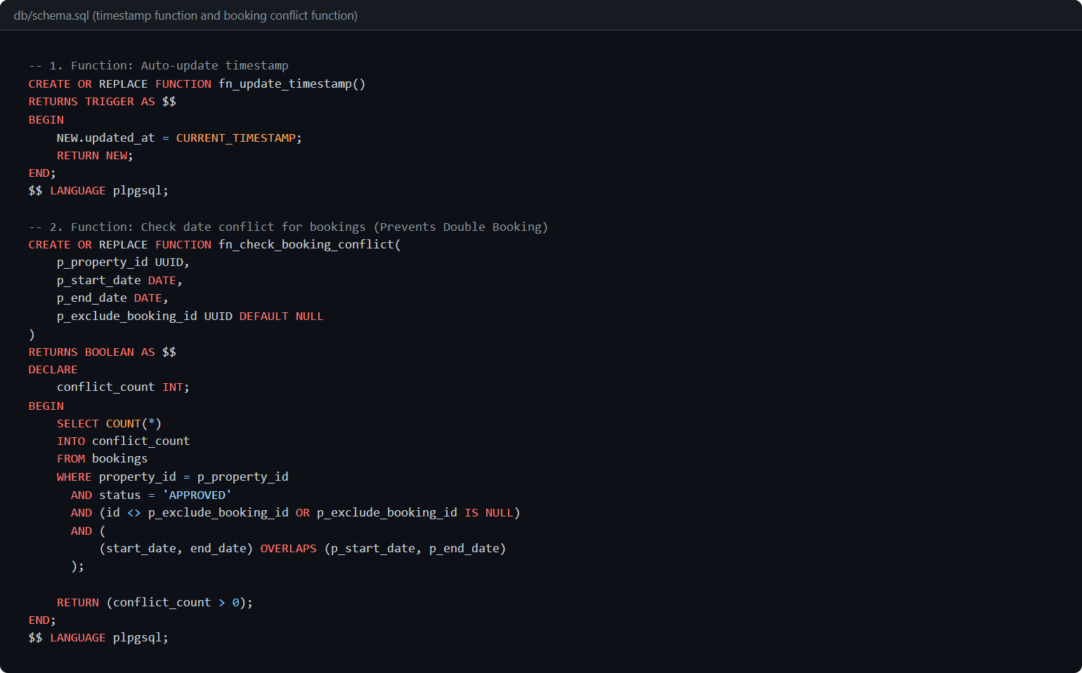
Fig. 8.1: fn_update_timestamp and fn_check_booking_conflict
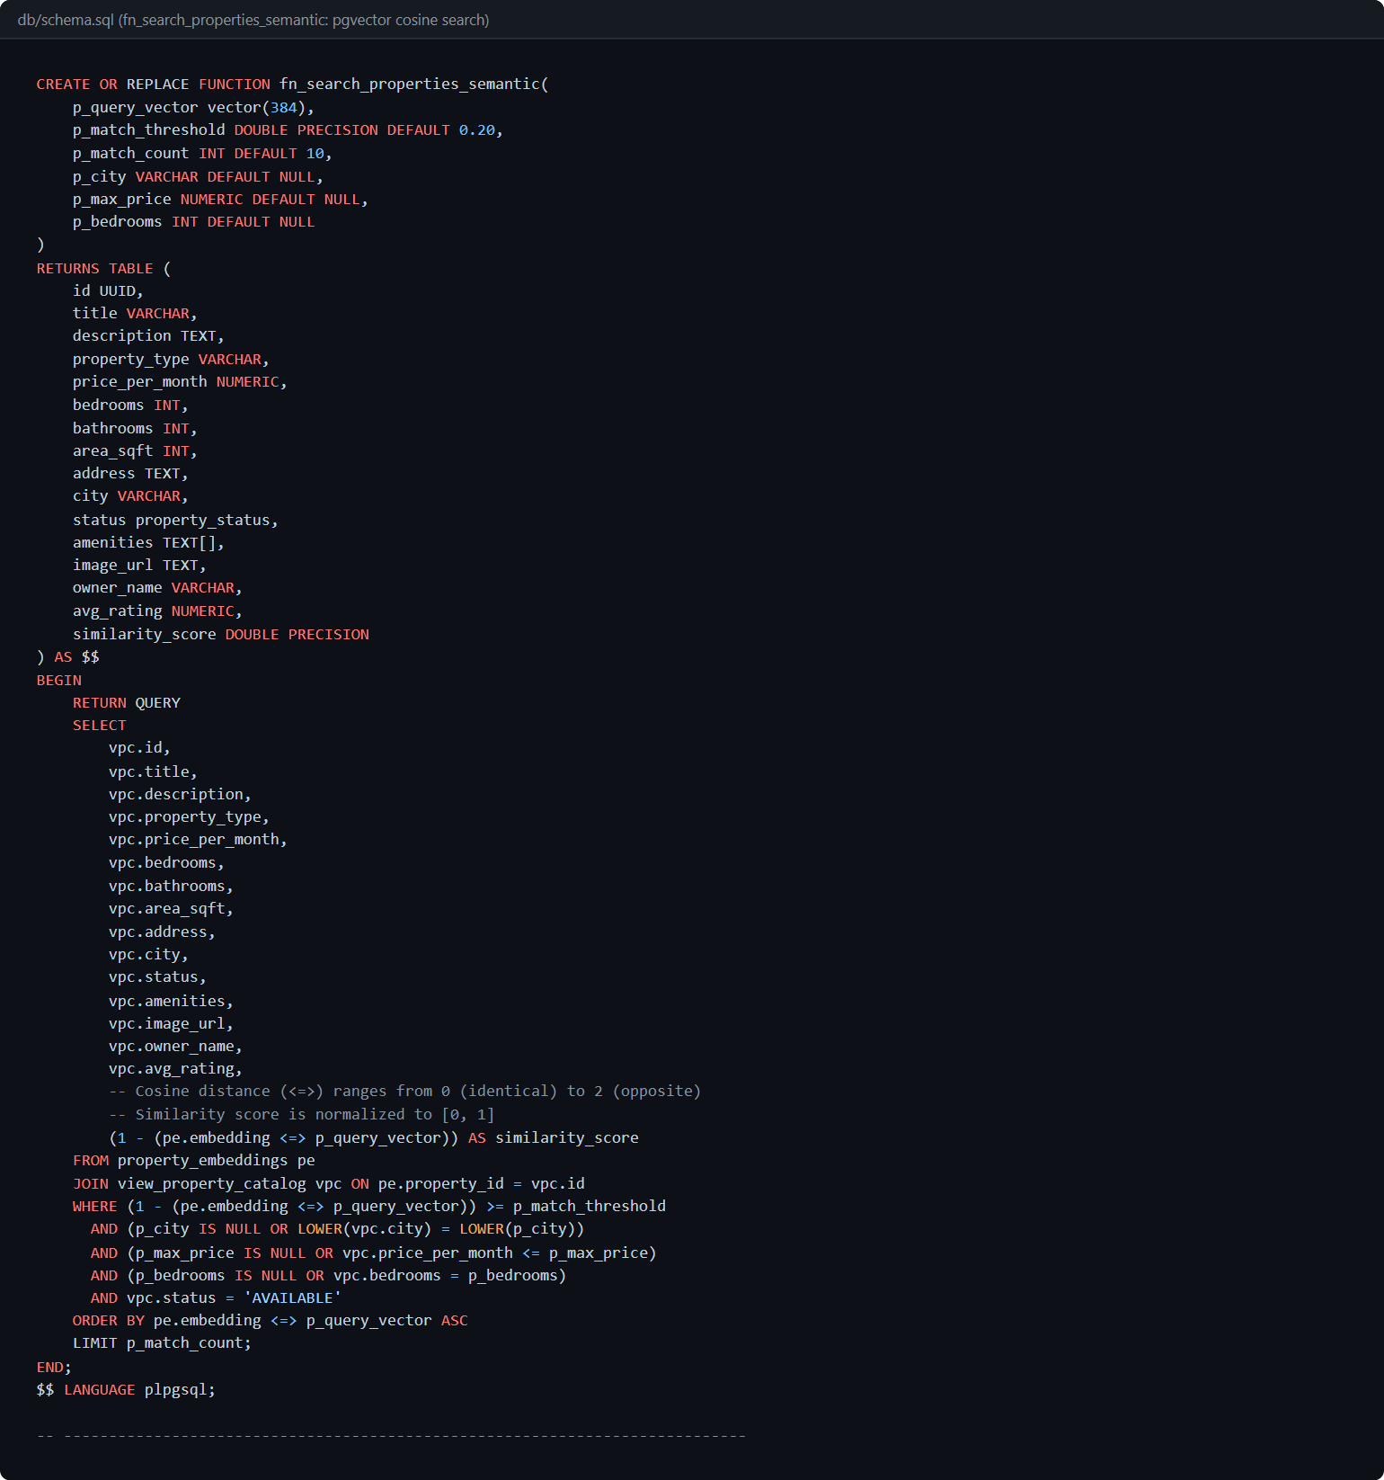
Fig. 8.2: fn_search_properties_semantic: pgvector cosine search with filters
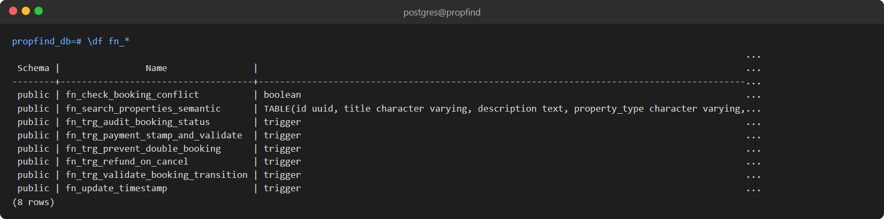
Fig. 8.3: Functions installed in the database (\df fn_*)
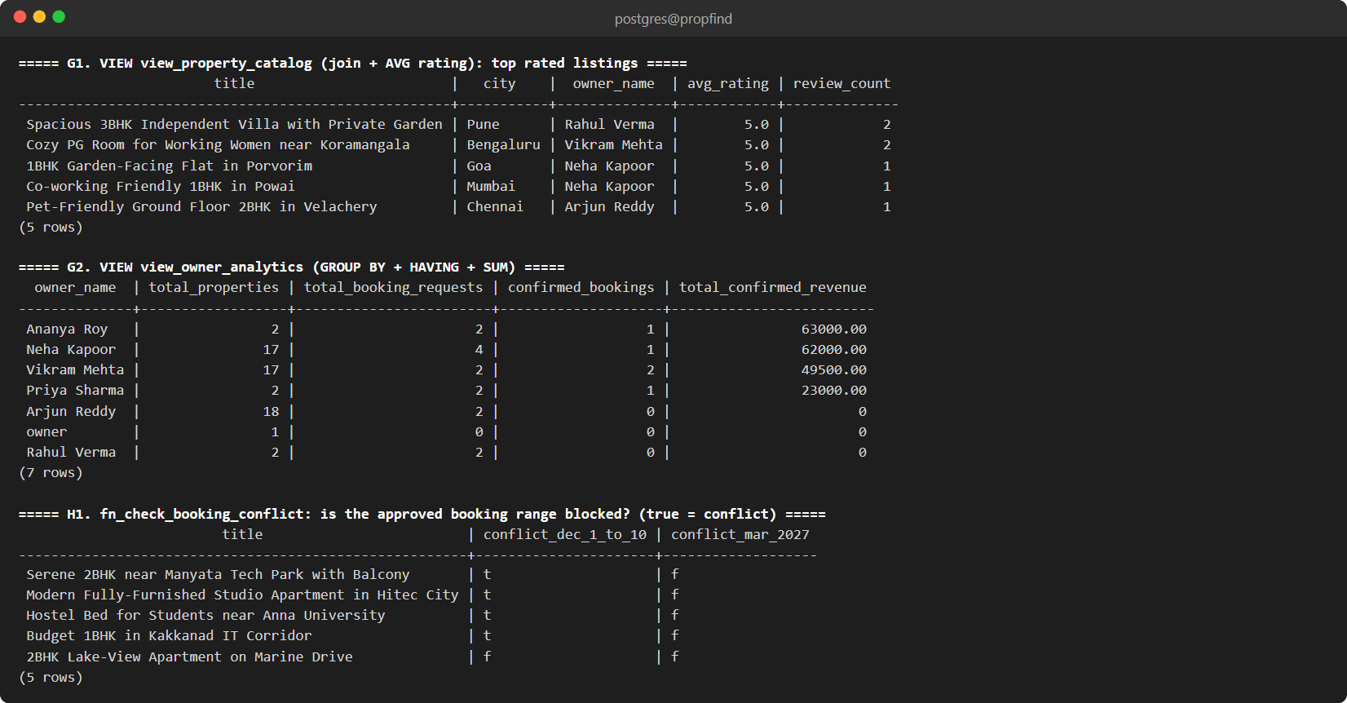
Fig. 8.4: Views and fn_check_booking_conflict in use
8.2 TRIGGERS
Table 8.2: Triggers
Trigger | Table | Event | Effect
trg_properties_timestamp | properties | BEFORE UPDATE | Maintains updated_at
trg_bookings_timestamp | bookings | BEFORE UPDATE | Maintains updated_at
trg_validate_booking_overlap | bookings | BEFORE INSERT OR UPDATE | Raises an exception if an APPROVED booking would overlap another
trg_validate_booking_transition | bookings | BEFORE UPDATE OF status | Allows only PENDING to APPROVED / REJECTED / CANCELLED and APPROVED to CANCELLED
trg_payment_stamp_and_validate | payments | BEFORE INSERT OR UPDATE | Payment only for an APPROVED booking and for the exact total; stamps paid_at
trg_audit_booking_status | bookings | AFTER INSERT OR UPDATE OF status | Writes old and new status and the acting user to booking_audit
trg_refund_on_cancel | bookings | AFTER UPDATE OF status | Marks a PAID payment REFUNDED when the booking is cancelled

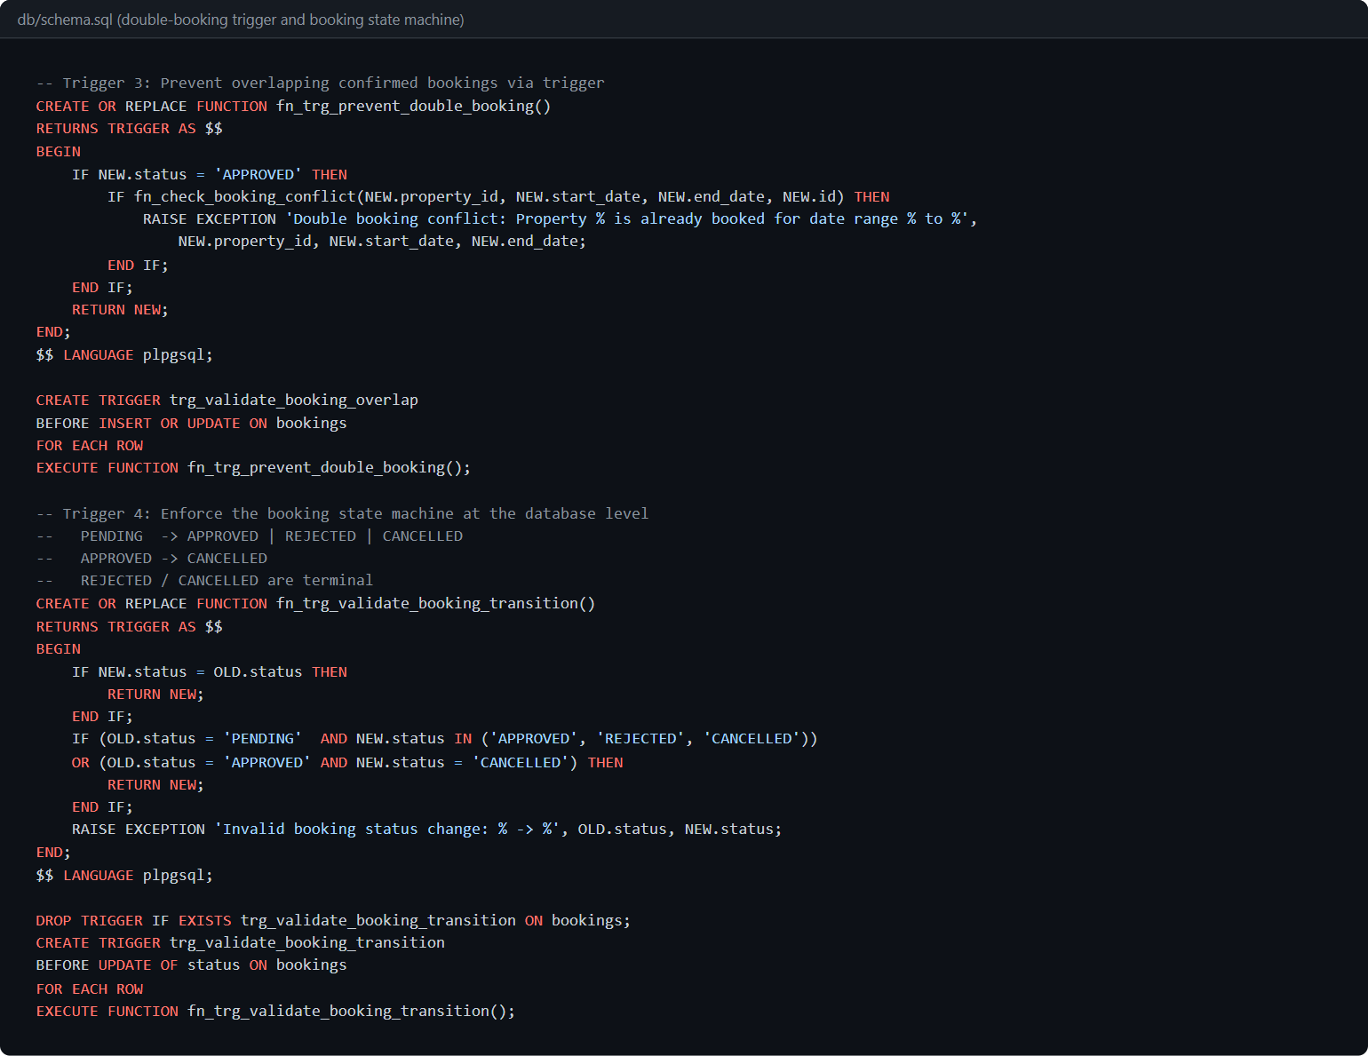
Fig. 8.5: Double-booking trigger and booking state machine
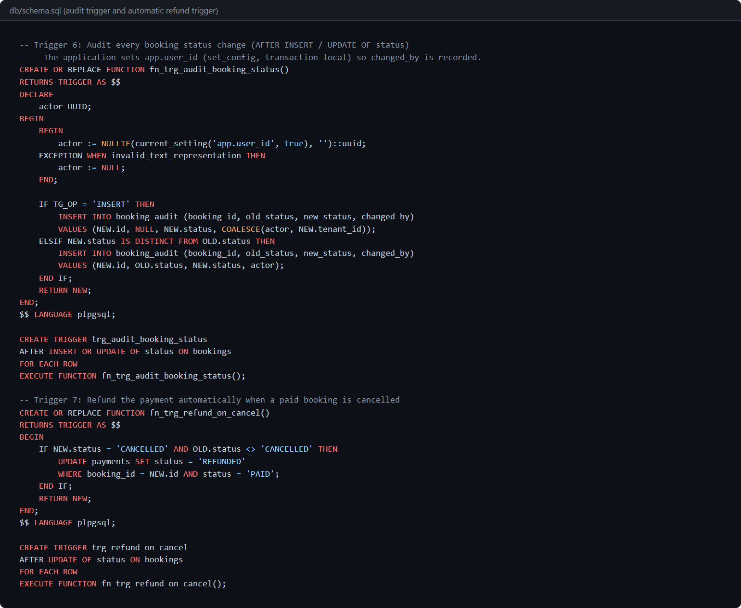
Fig. 8.6: Audit trigger and automatic refund trigger
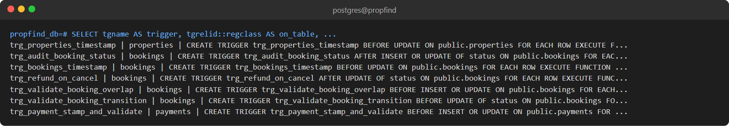
Fig. 8.7: All triggers installed in the database
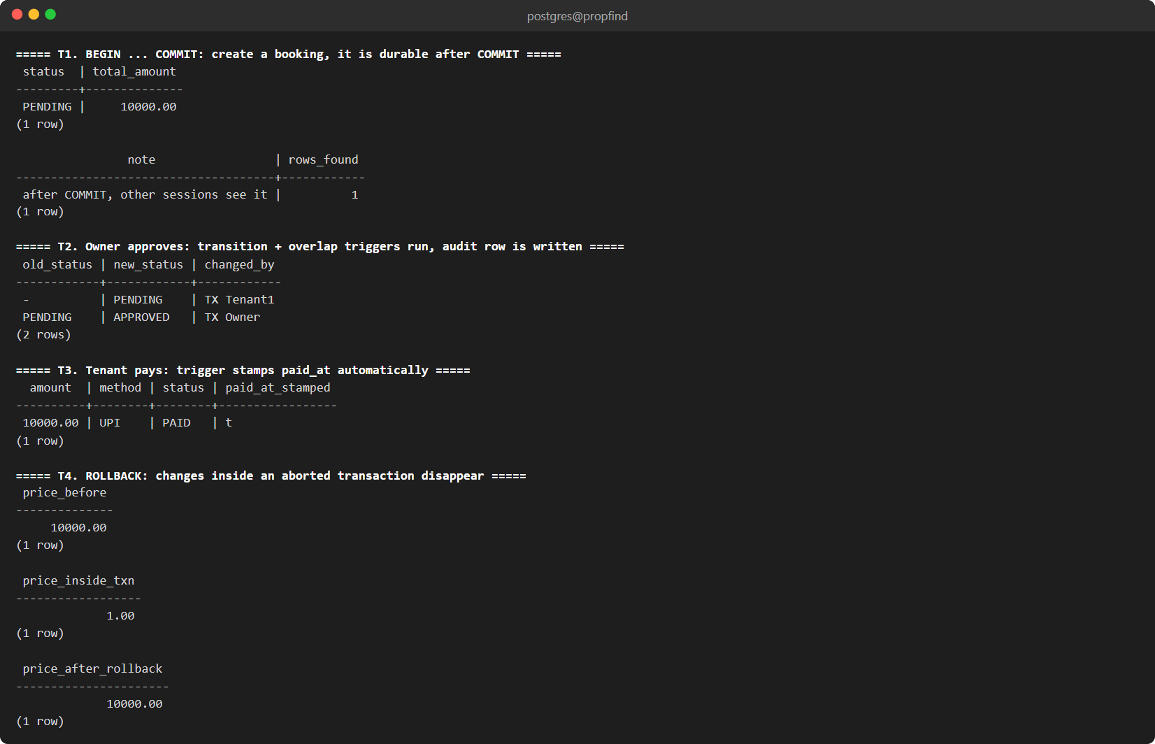
Fig. 8.8: Triggers in action: audit row written, payment timestamp stamped, ROLLBACK
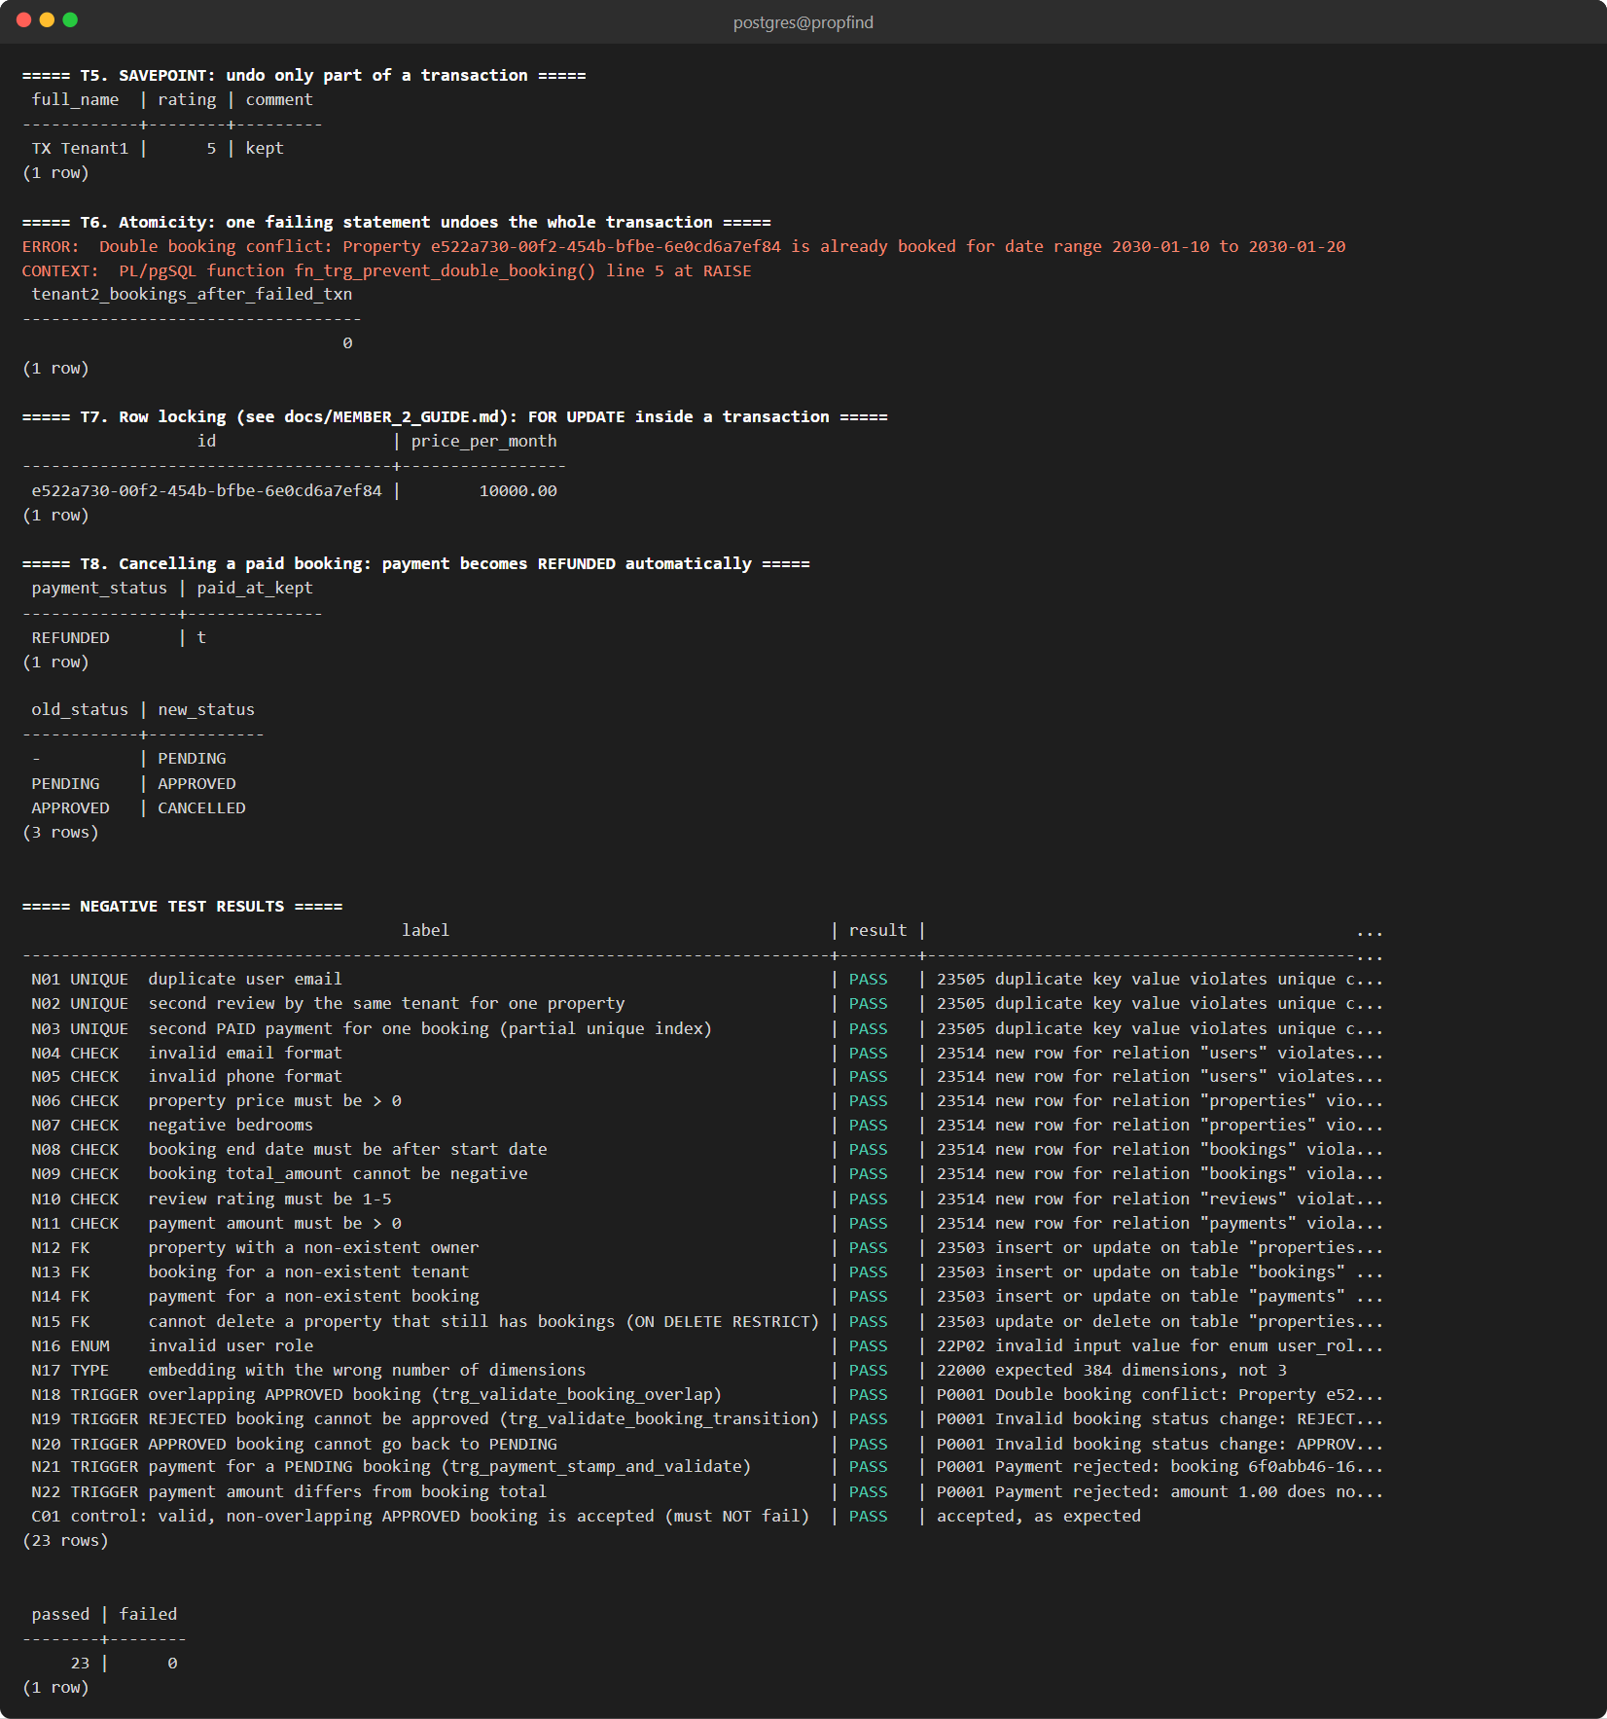
Fig. 8.9: SAVEPOINT, atomicity of a failed transaction and the automatic refund
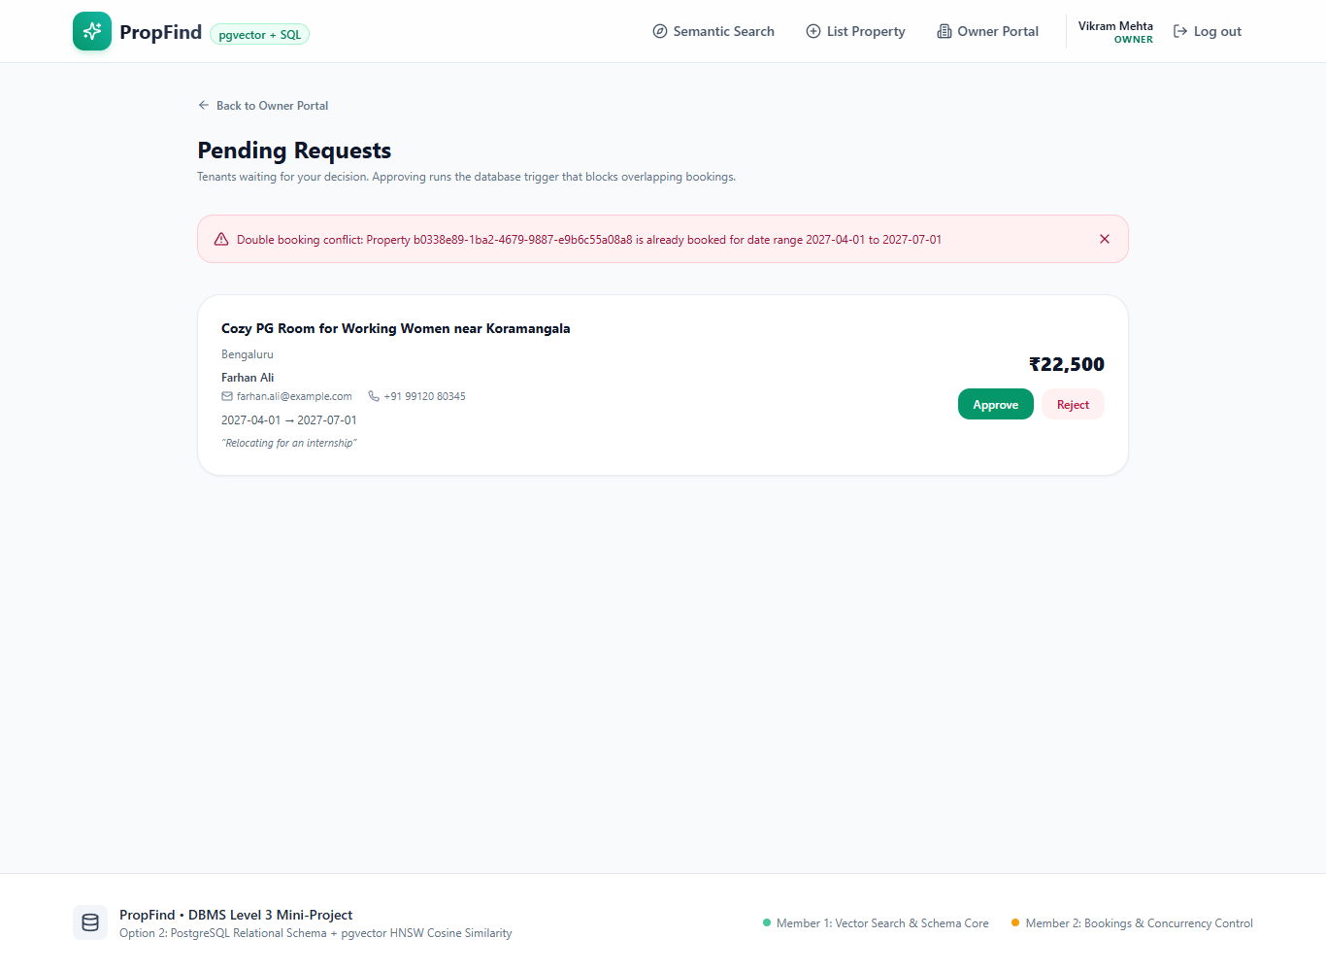
Fig. 8.10: The overlap trigger rejects an approval and the message is shown in the Owner Portal
8.3 TRANSACTIONS AND CONCURRENCY CONTROL
Creating a booking is one ACID transaction. The property row is locked with SELECT ... FOR UPDATE so concurrent requests for the same property wait for each other, then the conflict function is called, the total is computed and the booking is inserted. The same transaction sets the acting user for the audit trigger. If any step fails the whole transaction is rolled back.
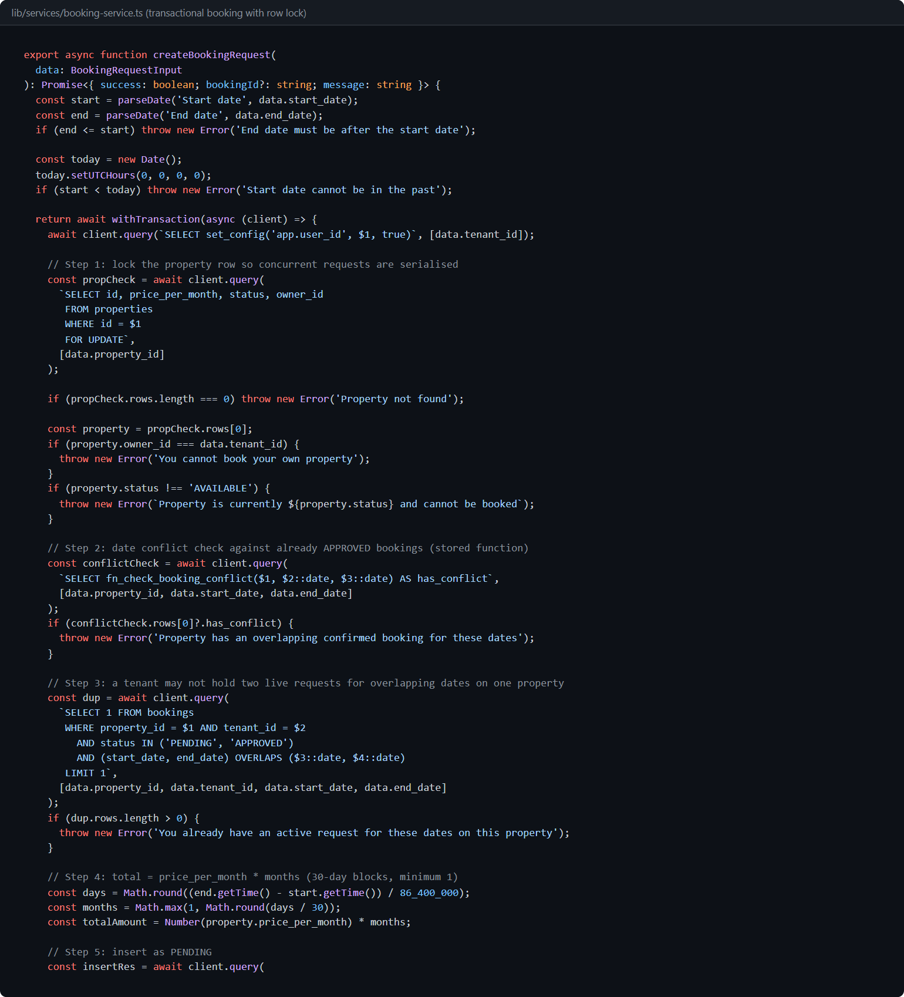
Fig. 8.11: Transactional booking creation with a row lock (lib/services/booking-service.ts)
8.4 INTEGRITY TEST RESULTS
db/transactions_tests.sql runs 22 negative tests, each of which must be rejected by the database (UNIQUE, CHECK, FOREIGN KEY, ENUM, vector dimension and trigger violations), plus one positive control that must succeed. The script exits with an error if any check fails. Result: 23 passed, 0 failed.
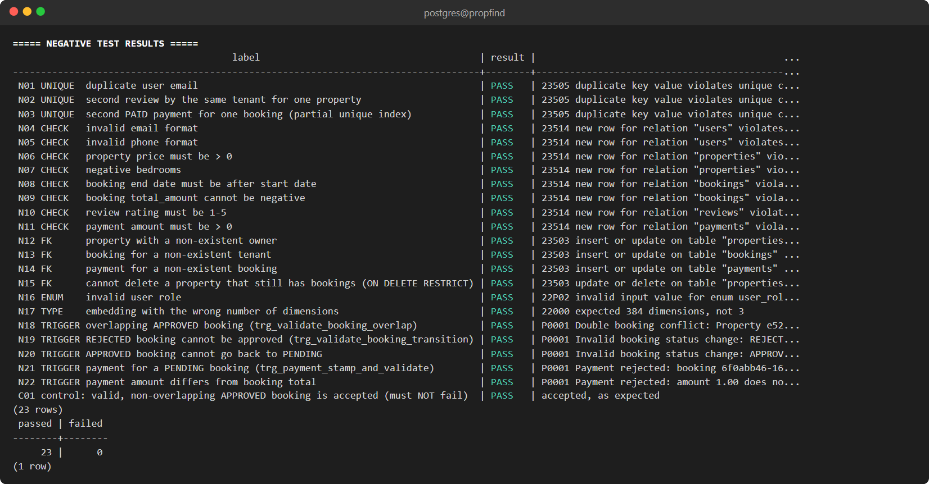
Fig. 8.12: Integrity tests: 22 rejected statements and one accepted control, 23 of 23 passed

9. FRONT END DEVELOPMENT
9.1 ARCHITECTURE
The interface is a Next.js 14 application. Pages call route handlers under /api, which call a service layer that runs parameterised SQL through a connection pool. Role checks happen in middleware (for pages) and again in every route handler. Database credentials and the JWT secret come only from environment variables (.env is not committed).
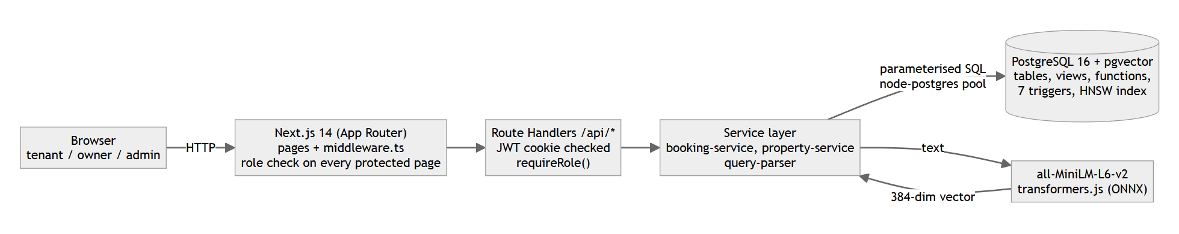
Fig. 9.1: System architecture
9.2 PROJECT STRUCTURE
propfind/
├── app/ # pages and API route handlers
│ ├── api/ # REST API
│ │ ├── auth/ # register, login, logout, me
│ │ │ ├── login/route.ts
│ │ │ ├── logout/route.ts
│ │ │ ├── me/route.ts
│ │ │ └── register/route.ts
│ │ ├── bookings/ # bookings, status, pay, history
│ │ │ ├── [id]/
│ │ │ │ ├── pay/route.ts
│ │ │ │ └── route.ts
│ │ │ └── route.ts
│ │ ├── owner/properties/route.ts
│ │ ├── properties/route.ts
│ │ └── search/route.ts
│ ├── dashboard/
│ │ ├── owner/ # owner portal and detail pages
│ │ │ ├── confirmed/page.tsx
│ │ │ ├── properties/page.tsx
│ │ │ ├── requests/page.tsx
│ │ │ ├── revenue/page.tsx
│ │ │ └── page.tsx
│ │ └── tenant/page.tsx
│ ├── login/page.tsx
│ ├── properties/new/page.tsx
│ ├── register/page.tsx
│ ├── globals.css
│ ├── layout.tsx
│ └── page.tsx
├── components/ # shared React components
│ ├── Footer.tsx
│ ├── Navbar.tsx
│ ├── OwnerSubpageHeader.tsx
│ ├── PropertyCard.tsx
│ └── PropertyModal.tsx
├── db/ # schema, demo queries, tests
│ ├── queries.sql
│ ├── schema.sql
│ └── transactions_tests.sql
├── docs/ # documentation and report
│ ├── report/
│ │ ├── images/ (screenshots)
│ │ ├── PropFind_Project_Report.docx
│ │ └── PropFind_Project_Report.pdf
│ ├── ARCHITECTURE.md
│ ├── DATABASE_DESIGN.md
│ ├── DEV_LOGS.md
│ ├── HOSTED_DATABASE.md
│ ├── MEMBER_2_GUIDE.md
│ └── TEAM_DIVISION.md
├── lib/ # server-side libraries
│ ├── services/ # booking and property services
│ │ ├── booking-service.ts
│ │ └── property-service.ts
│ ├── auth.ts
│ ├── db.ts
│ ├── embeddings.ts
│ ├── jwt.ts
│ └── query-parser.ts
├── scripts/ # db:init, db:seed, seed data
│ ├── init-db.mjs
│ ├── seed-data.mjs
│ ├── seed.mjs
│ └── test-parser.mjs
├── .env.example
├── .gitignore
├── DBMS Level 3 Mini_Project Requirements draft.docx
├── README.md
├── docker-compose.yml
├── middleware.ts # role-based route protection
├── next.config.mjs
├── package.json
├── postcss.config.mjs
├── tailwind.config.ts
└── tsconfig.json
9.3 AUTHENTICATION AND ROLE-BASED ACCESS
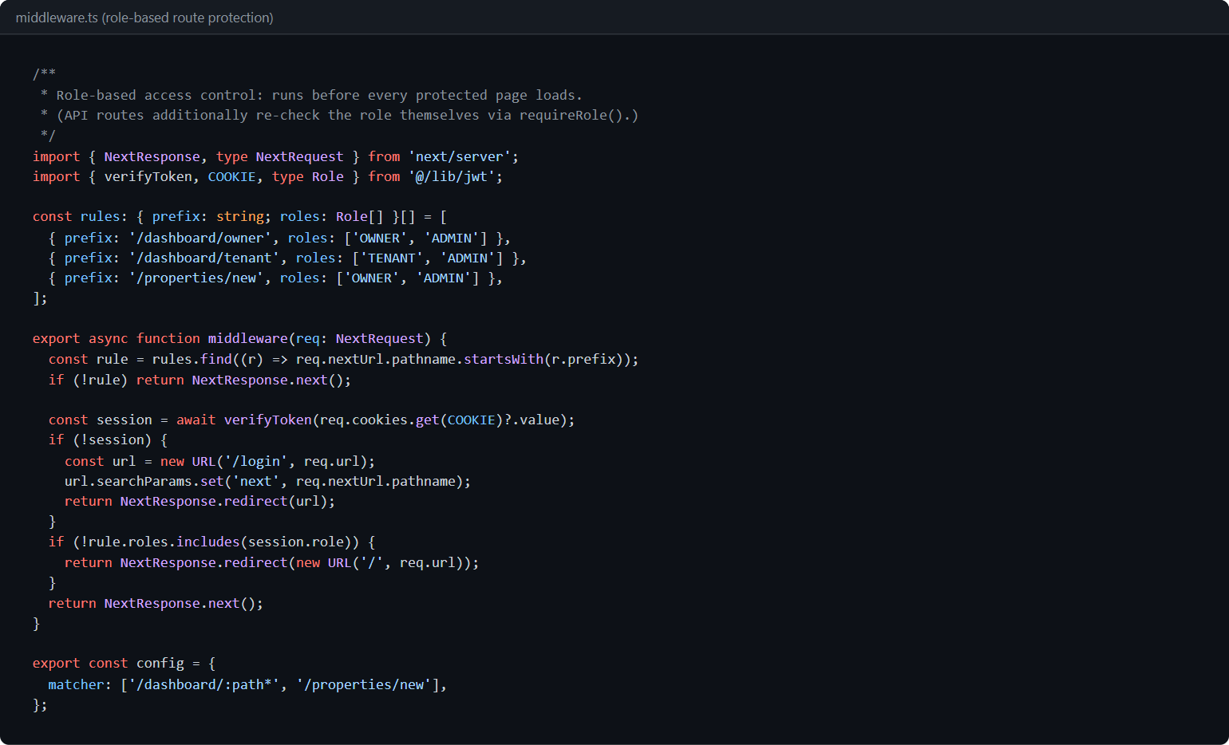
Fig. 9.2: Role-based protection of pages (middleware.ts)
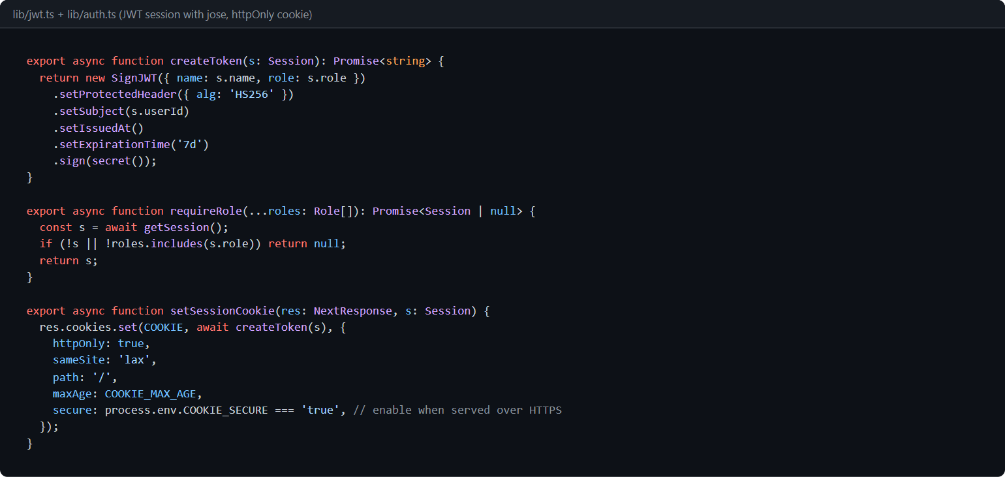
Fig. 9.3: JWT session helpers and role check (lib/jwt.ts, lib/auth.ts)
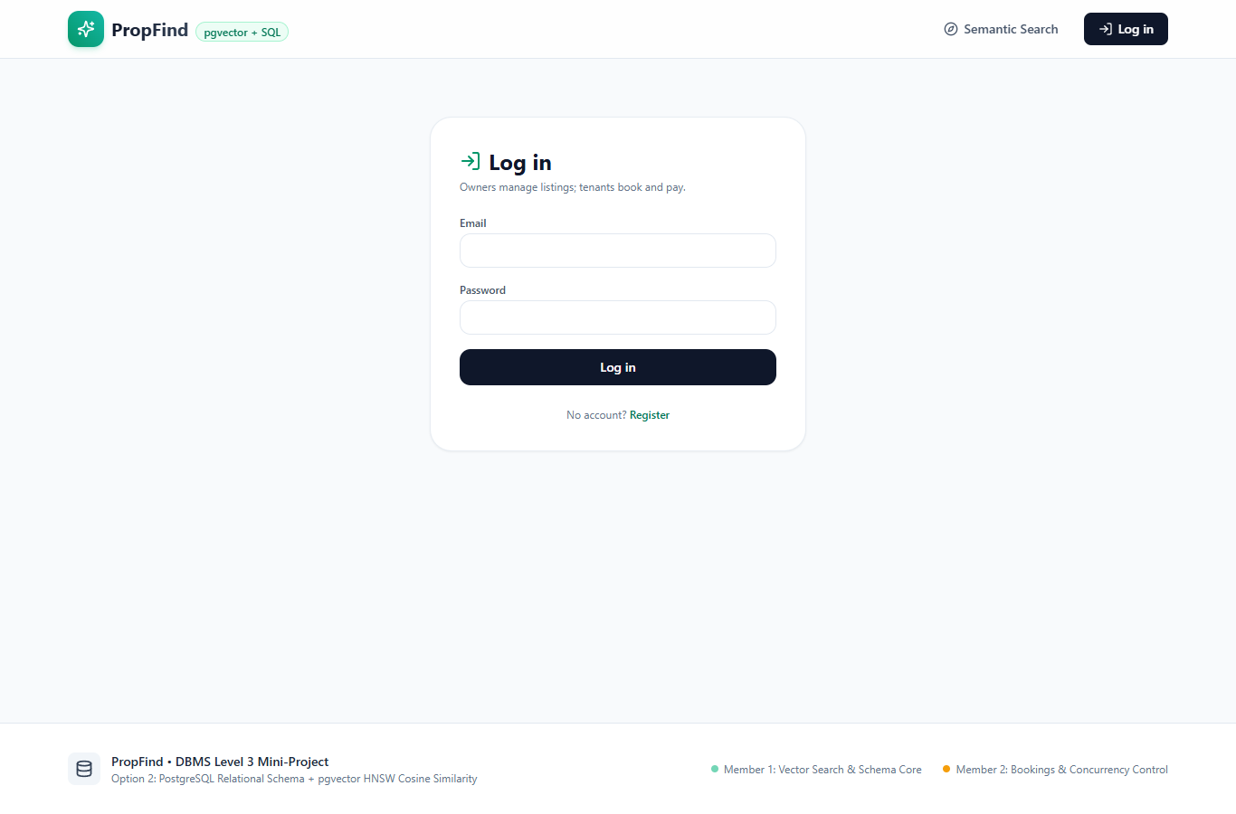
Fig. 9.4: Login page
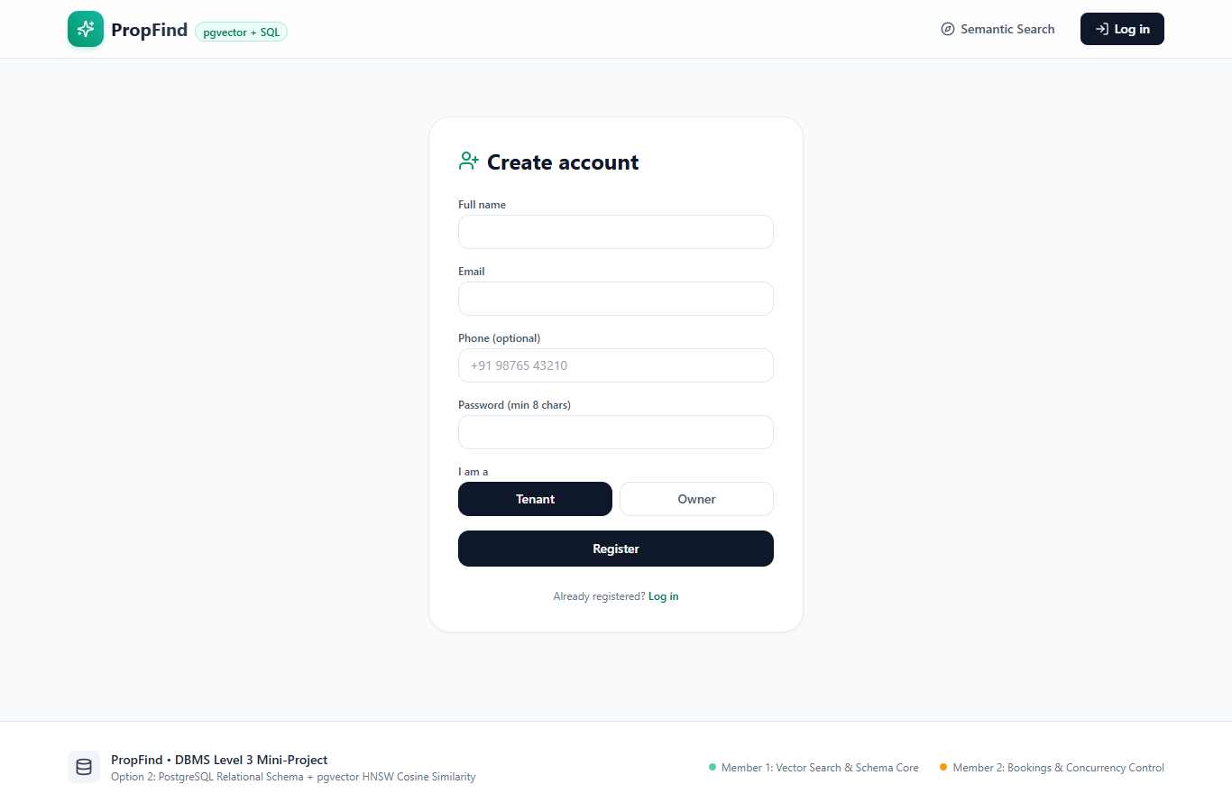
Fig. 9.5: Registration page (owner or tenant)
9.4 SEARCH PAGES

Fig. 9.6: Home page
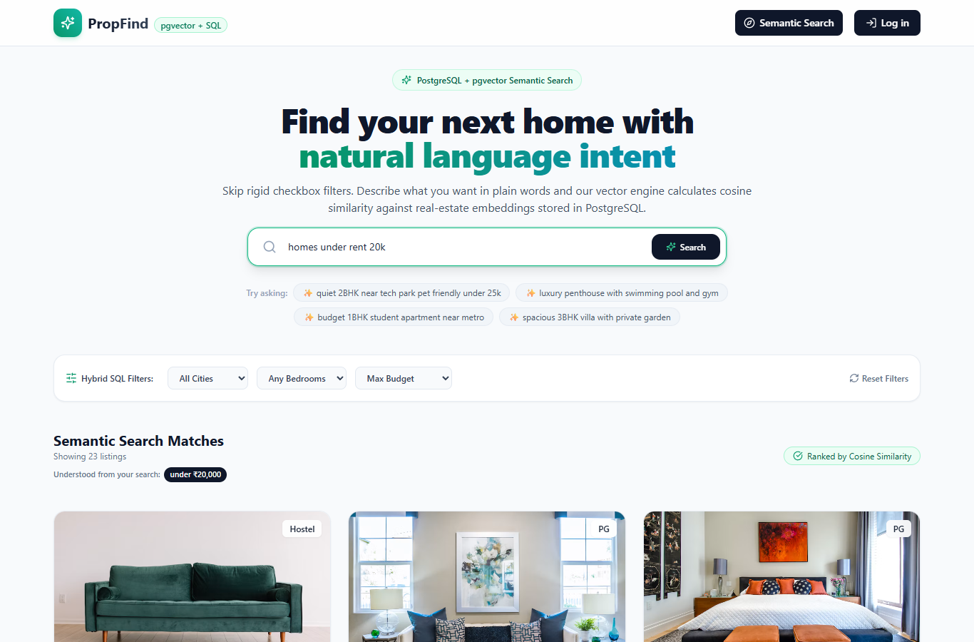
Fig. 9.7: Search "homes under rent 20k": 23 results, all under Rs. 20,000, with the understood constraint shown
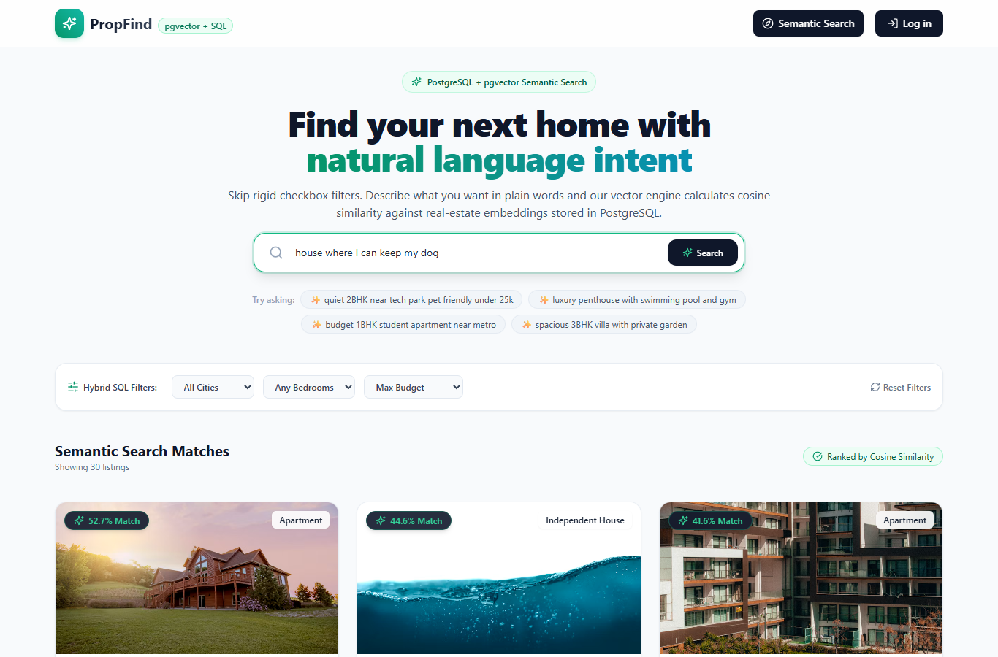
Fig. 9.8: Search "house where I can keep my dog": semantic ranking puts pet-friendly homes first
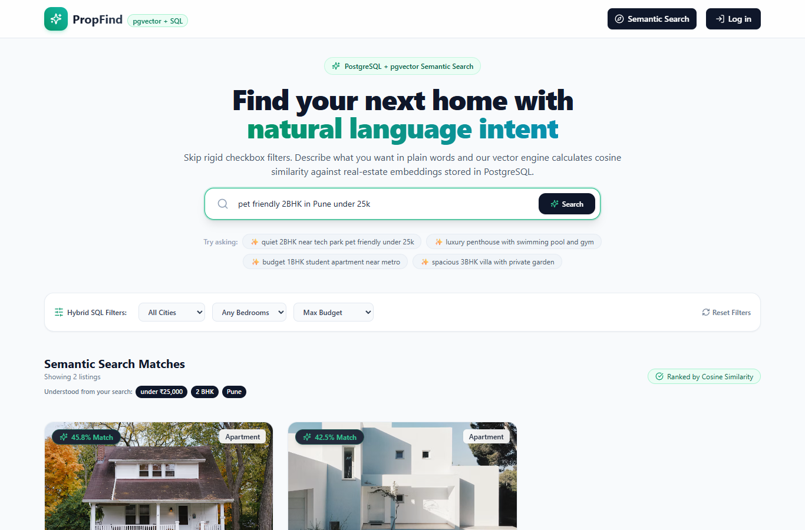
Fig. 9.9: Search "pet friendly 2BHK in Pune under 25k": bedrooms, city and budget parsed into SQL filters
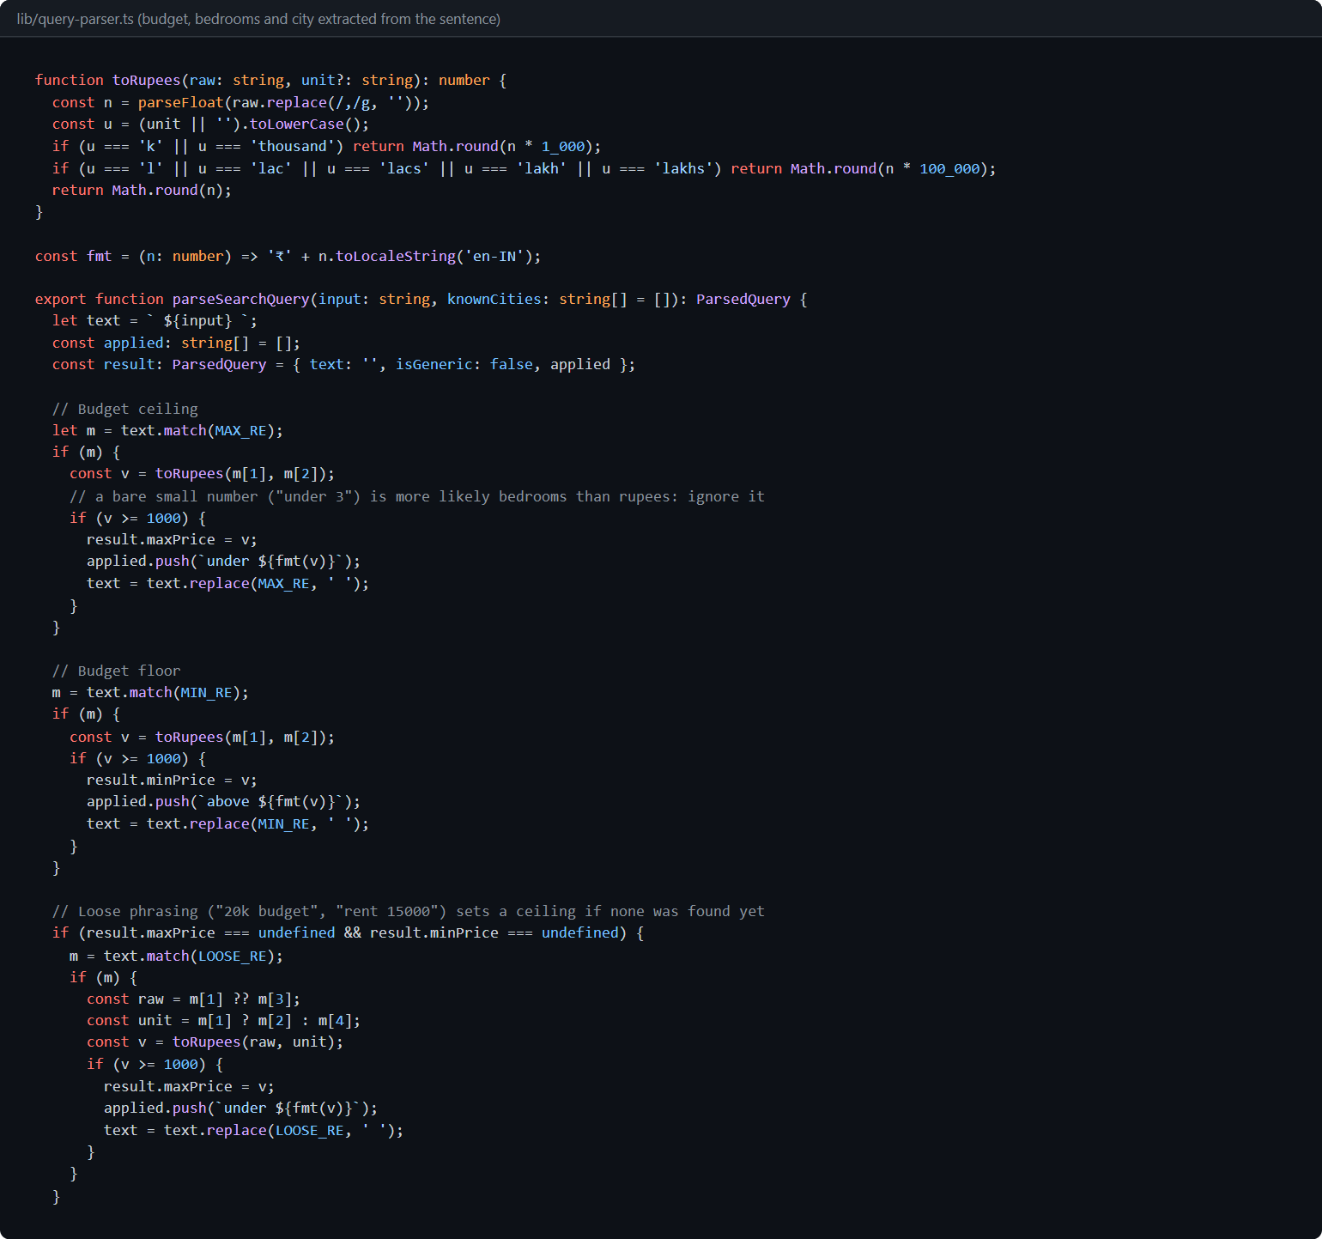
Fig. 9.10: Extracting budget, bedrooms and city from the sentence (lib/query-parser.ts)
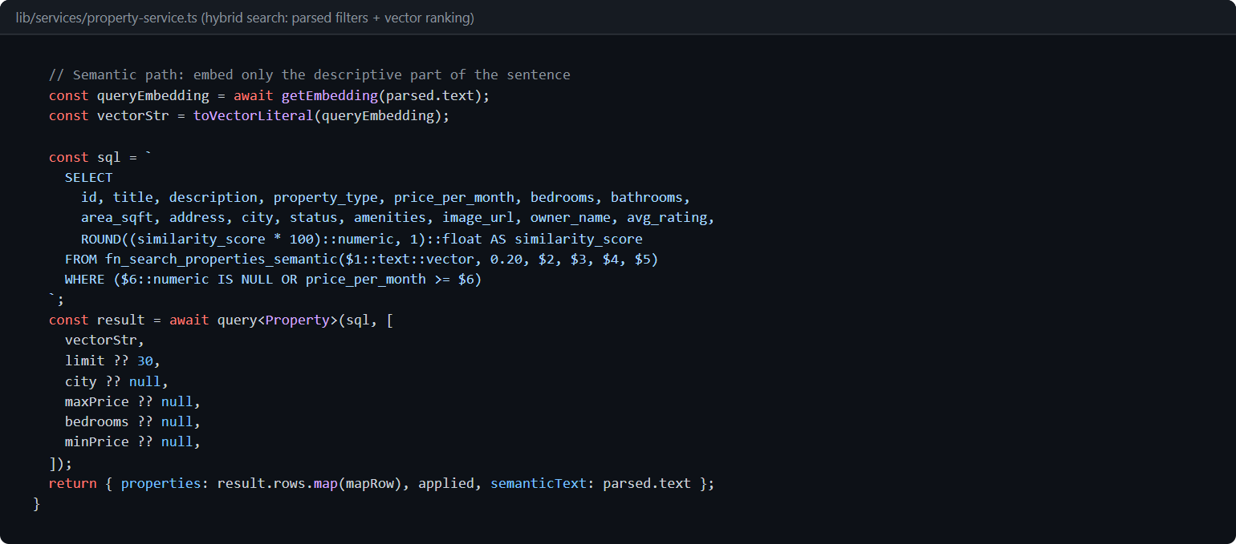
Fig. 9.11: Hybrid search service (lib/services/property-service.ts)
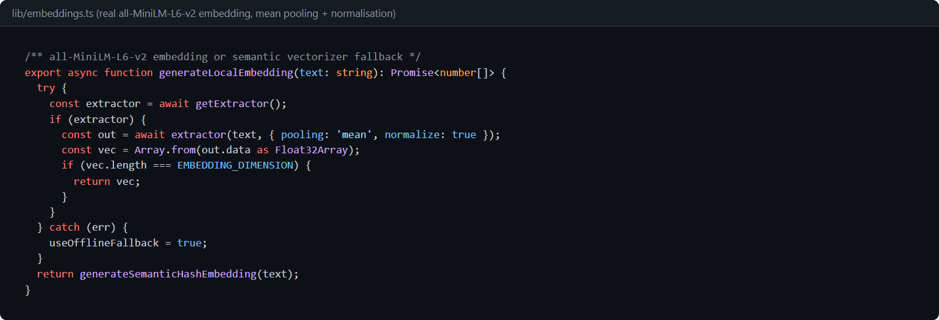
Fig. 9.12: Generating a 384-dimension embedding (lib/embeddings.ts)
9.5 TENANT SCREENS
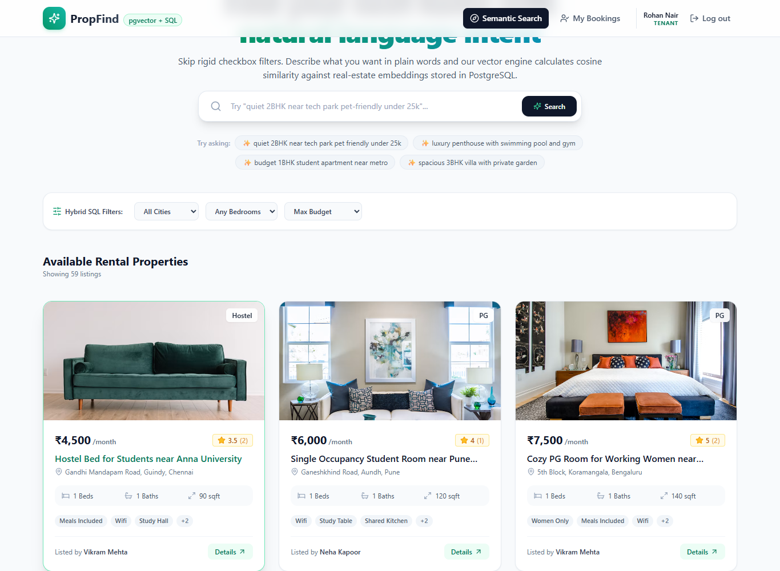
Fig. 9.13: Listing details
Fig. 9.14: Booking request form (runs as a PostgreSQL transaction)
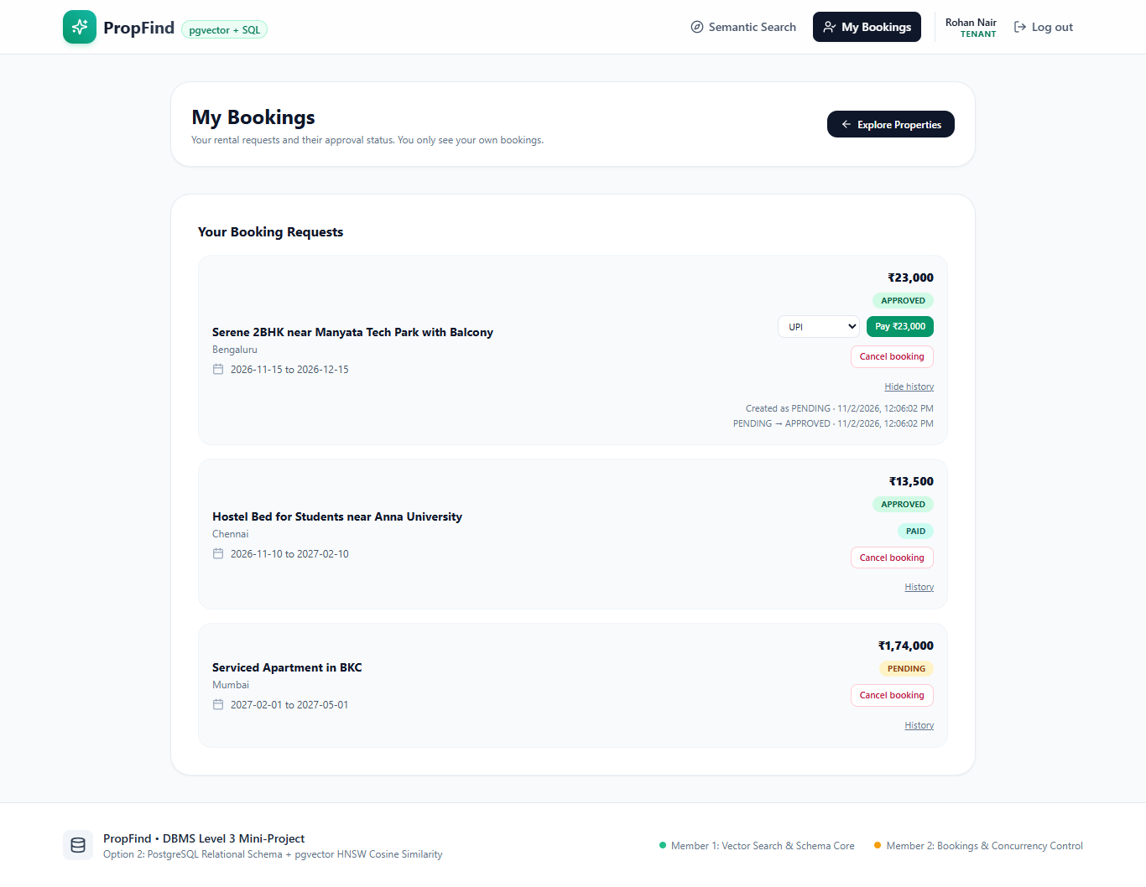
Fig. 9.15: Tenant dashboard: own bookings only, Pay, Cancel and status history from the audit table
9.6 OWNER SCREENS
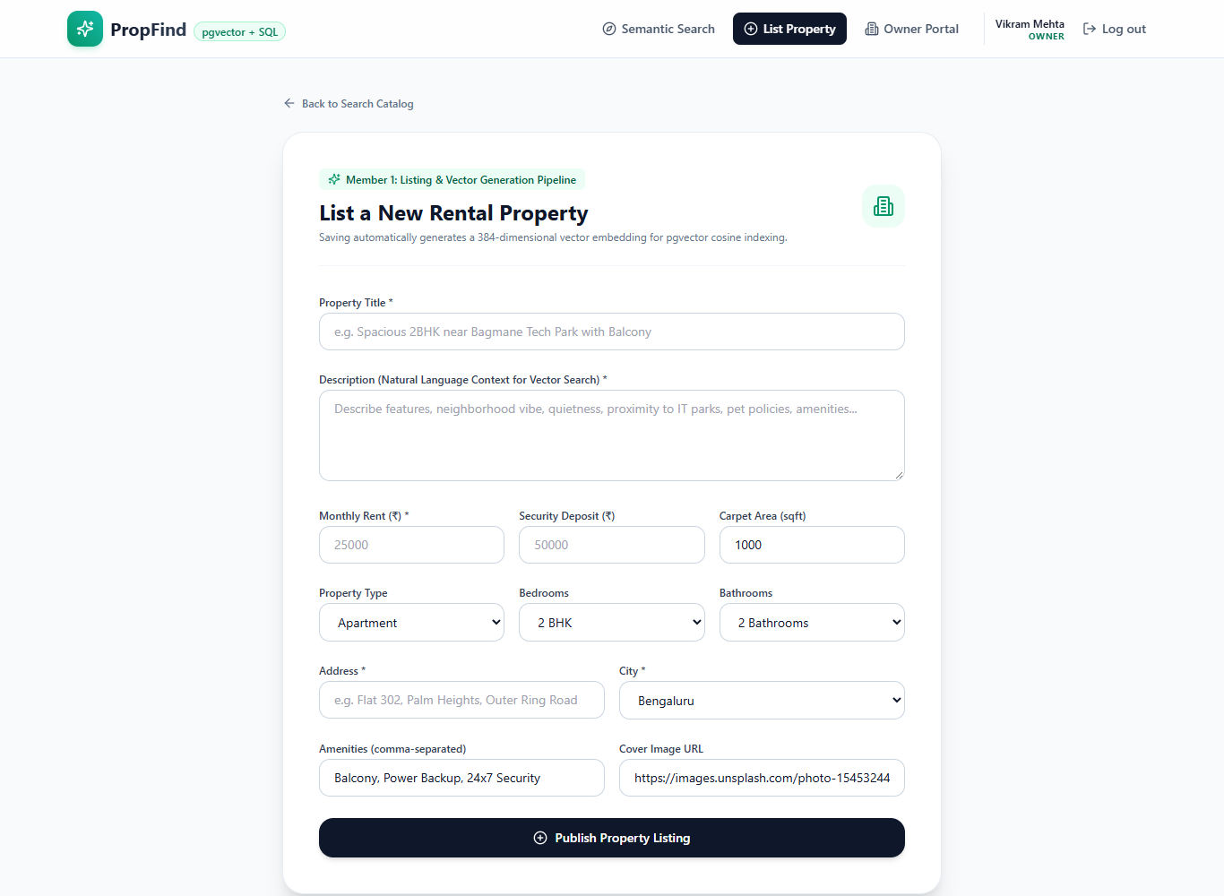
Fig. 9.16: Listing form (the embedding is created in the same transaction)
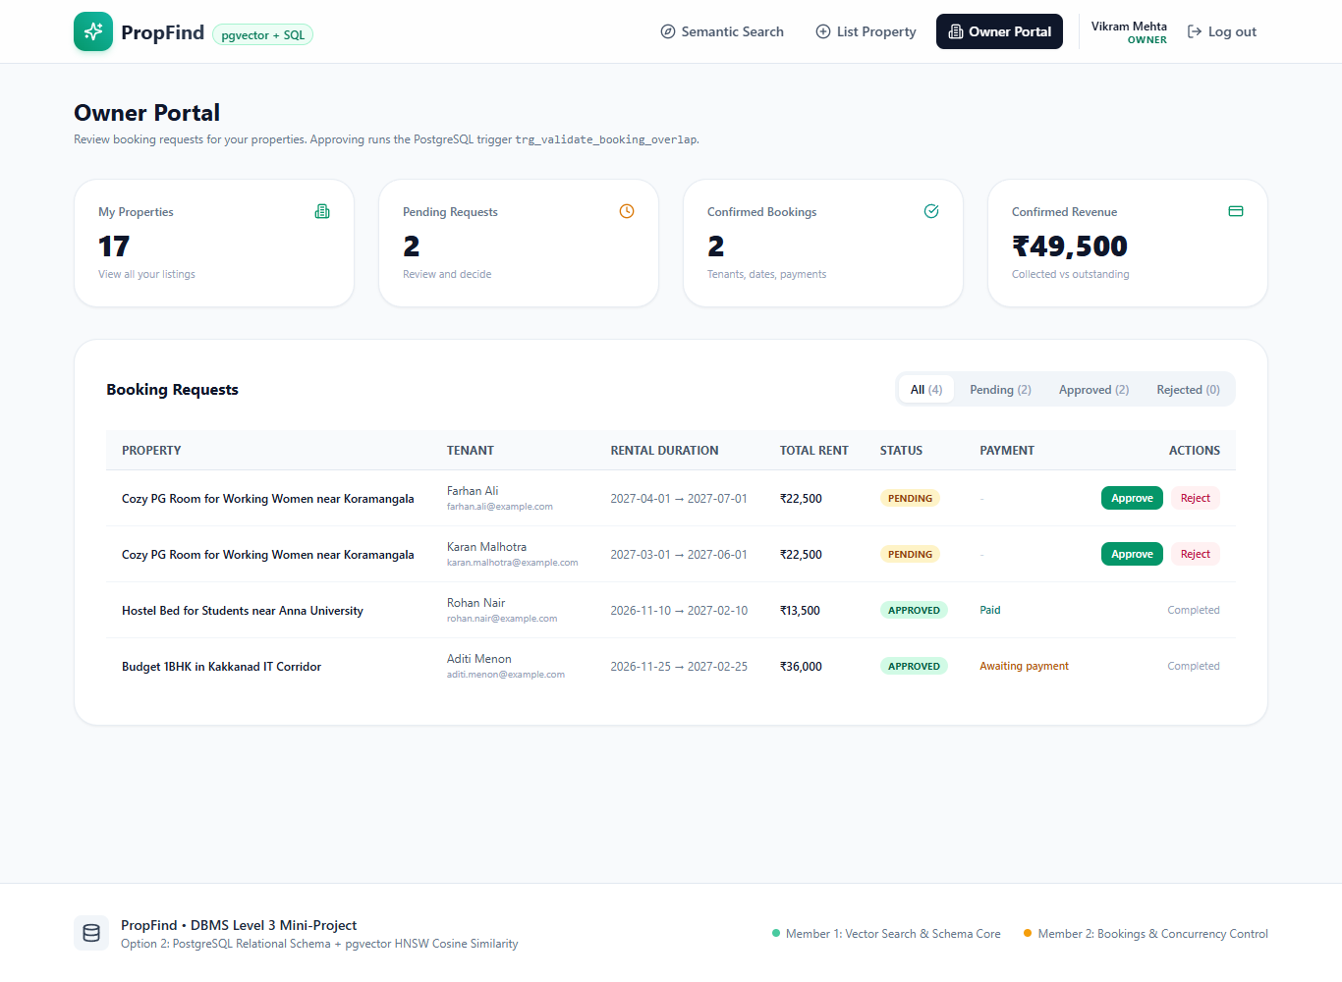
Fig. 9.17: Owner Portal: four clickable cards (from view_owner_analytics) and booking tabs
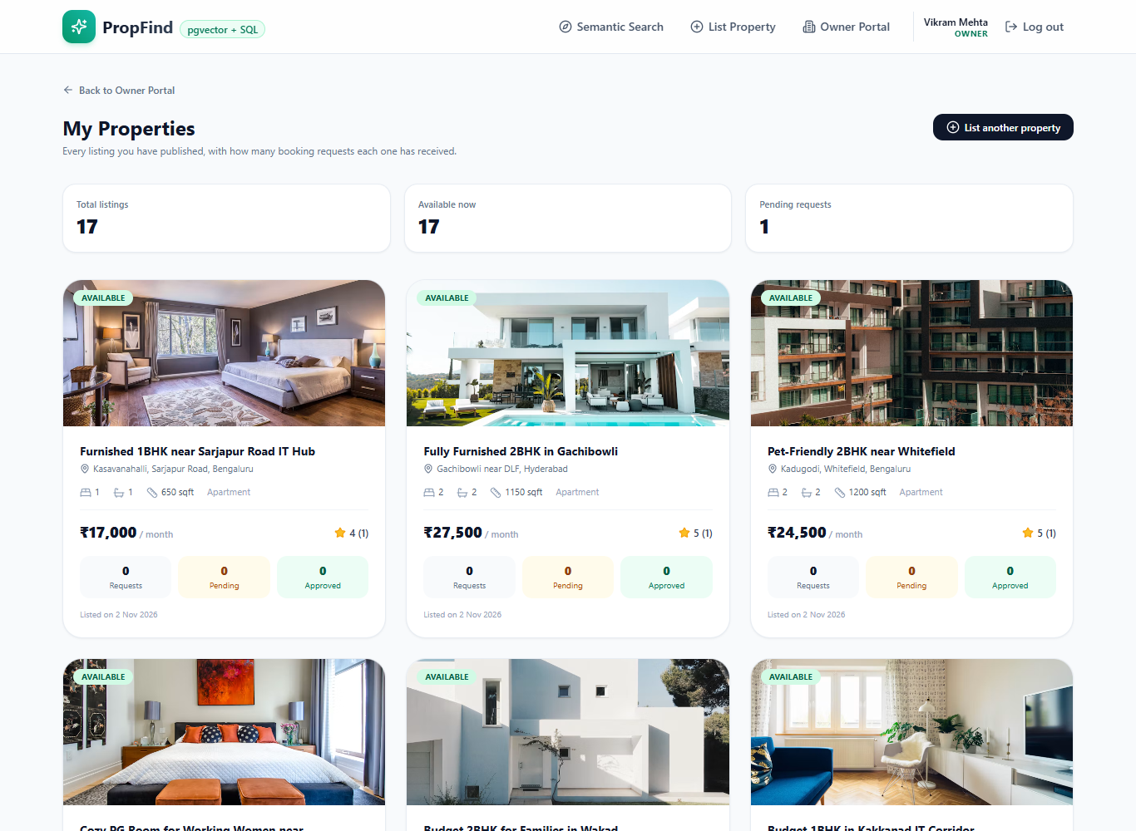
Fig. 9.18: My Properties
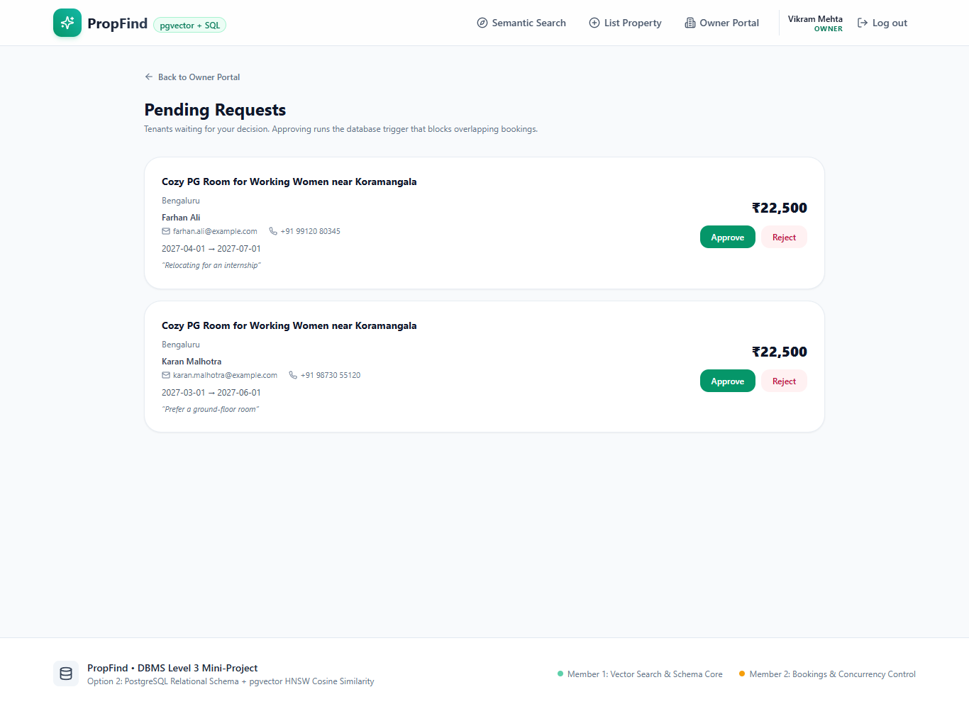
Fig. 9.19: Pending requests
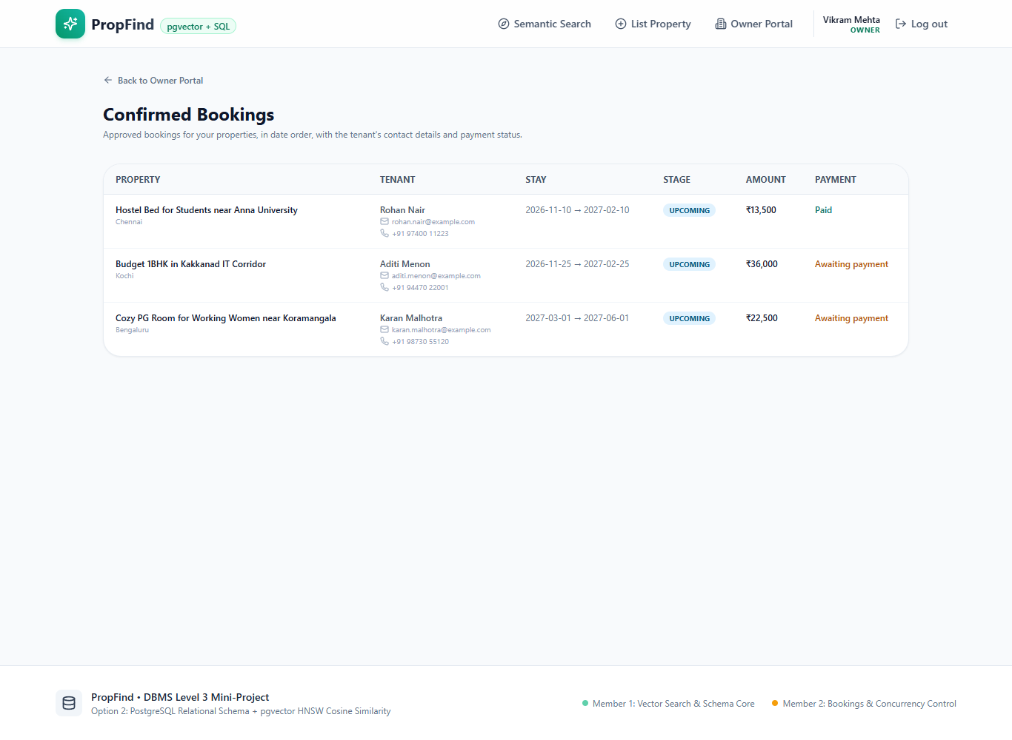
Fig. 9.20: Confirmed bookings
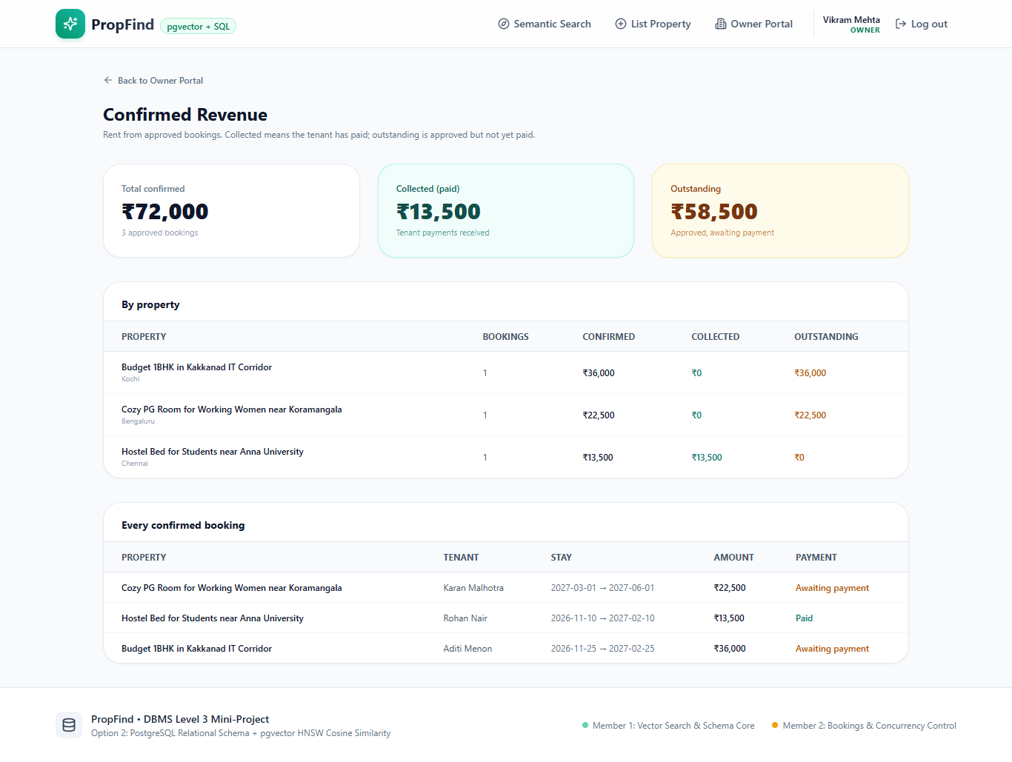
Fig. 9.21: Confirmed revenue: collected and outstanding, per property
9.7 TESTING RESULTS
Table 9.1: Tests performed
Test | How to run | Result
Database integrity and transactions (23 checks) | psql -f db/transactions_tests.sql | 23 passed, 0 failed
Labelled SQL demonstrations | psql -f db/queries.sql | Exit code 0; data unchanged afterwards
Natural-language parser (12 cases) | npm run test:parser | 12 of 12 passed
Production build | npm run build | Passes (13 routes)
End-to-end flow with scripted requests | register, login, search, book, approve, pay, double-booking rejection, role redirects | All behaved as expected
Access control | Anonymous, tenant and owner calls to protected pages and APIs | 401 / 403 or redirect as required

9.8 CONCLUSION AND FUTURE ENHANCEMENTS
PropFind shows how one PostgreSQL database can serve both paradigms required by the project: a relational core whose integrity is guaranteed by constraints, transactions and triggers, and a vector layer that matches meaning instead of keywords. The most important design decision was to keep hard numeric constraints in SQL and to use vectors only for what vectors do well. The application is backed by SQL scripts and tests that can be re-run from the repository.
Future enhancements
• A real payment gateway and e-mail notifications.
• An admin screen, property editing and deletion, image upload.
• A dedicated GIN index for full-text search, an availability calendar, lease extensions and saved listings.
• Automated browser tests, rate limiting and CSRF tokens for production use.
• A hosted database (the configuration option and guide are already in the repository).

REFERENCES
[1] PostgreSQL Global Development Group, "PostgreSQL 16 Documentation". https://www.postgresql.org/docs/16/
[2] pgvector: open-source vector similarity search for PostgreSQL. https://github.com/pgvector/pgvector
[3] N. Reimers and I. Gurevych, "Sentence-BERT: Sentence Embeddings using Siamese BERT-Networks", EMNLP 2019. https://arxiv.org/abs/1908.10084; model card: https://huggingface.co/sentence-transformers/all-MiniLM-L6-v2
[4] Y. Malkov and D. Yashunin, "Efficient and robust approximate nearest neighbor search using Hierarchical Navigable Small World graphs", IEEE TPAMI, 2020. https://arxiv.org/abs/1603.09320
[5] Hugging Face, "Transformers.js documentation". https://huggingface.co/docs/transformers.js
[6] Vercel, "Next.js Documentation". https://nextjs.org/docs
[7] node-postgres documentation. https://node-postgres.com
[8] R. Elmasri and S. Navathe, "Fundamentals of Database Systems", Pearson (ER to relational mapping algorithm).
[9] jose (JSON Web Token library) https://github.com/panva/jose and bcryptjs https://github.com/dcodeIO/bcrypt.js

GitHub Link: https://github.com/jishnu-sivakumar/DBMS_mini

APPENDIX A: DEFINITIONS, ACRONYMS AND ABBREVIATIONS
Table A.1: Definitions and abbreviations
Term | Meaning
ACID | Atomicity, Consistency, Isolation, Durability: the guarantees of a database transaction
API | Application Programming Interface (here: the /api route handlers)
bcrypt | Password hashing function that stores a salted, slow hash instead of the password
CHECK | SQL constraint that rejects rows that do not satisfy a condition
Cosine distance | Measure of the angle between two vectors; 0 means identical direction. pgvector operator <=>
DDL / DML | Data Definition Language (CREATE, ALTER, DROP) / Data Manipulation Language (INSERT, UPDATE, DELETE, SELECT)
Embedding | A list of numbers (here 384) that represents the meaning of a text
ENUM | Column type restricted to a fixed list of values
ER | Entity-Relationship (diagram)
FK / PK | Foreign key / primary key
HNSW | Hierarchical Navigable Small World: an index for approximate nearest-neighbour search
JWT | JSON Web Token: a signed token used here for login sessions
pgvector | PostgreSQL extension that adds a vector type, distance operators and vector indexes
RBAC | Role-based access control
SRN | Student registration number
Trigger | Function that the database runs automatically before or after INSERT, UPDATE or DELETE
UUID | Universally unique identifier used for primary keys

APPENDIX B: DATA DICTIONARY
Generated from information_schema on the running database (PostgreSQL 16.15, pgvector 0.8.7).
Table B.1: Table users
Column | Type | Null | Default
id | uuid | NOT NULL | uuid_generate_v4()
full_name | character varying(120) | NOT NULL
email | character varying(160) | NOT NULL
password_hash | character varying(255) | NOT NULL
role | user_role | NOT NULL | 'TENANT'::user_role
phone | character varying(20) | NULL
avatar_url | text | NULL
created_at | timestamp with time zone | NOT NULL | CURRENT_TIMESTAMP
updated_at | timestamp with time zone | NOT NULL | CURRENT_TIMESTAMP

Table B.2: Table properties
Column | Type | Null | Default
id | uuid | NOT NULL | uuid_generate_v4()
owner_id | uuid | NOT NULL
title | character varying(200) | NOT NULL
description | text | NOT NULL
property_type | character varying(50) | NOT NULL | 'Apartment'::character varying
price_per_month | numeric(10,2) | NOT NULL
security_deposit | numeric(10,2) | NOT NULL | 0.00
bedrooms | integer | NOT NULL
bathrooms | integer | NOT NULL
area_sqft | integer | NOT NULL
address | text | NOT NULL
city | character varying(80) | NOT NULL
state | character varying(80) | NOT NULL
pincode | character varying(20) | NOT NULL
status | property_status | NOT NULL | 'AVAILABLE'::property_status
amenities | text[] | NULL | '{}'::text[]
image_url | text | NULL
created_at | timestamp with time zone | NOT NULL | CURRENT_TIMESTAMP
updated_at | timestamp with time zone | NOT NULL | CURRENT_TIMESTAMP

Table B.3: Table property_embeddings
Column | Type | Null | Default
property_id | uuid | NOT NULL
embedding | vector | NOT NULL
model_name | character varying(100) | NOT NULL | 'all-MiniLM-L6-v2'::character varying
indexed_content | text | NOT NULL
created_at | timestamp with time zone | NOT NULL | CURRENT_TIMESTAMP
updated_at | timestamp with time zone | NOT NULL | CURRENT_TIMESTAMP

Table B.4: Table bookings
Column | Type | Null | Default
id | uuid | NOT NULL | uuid_generate_v4()
property_id | uuid | NOT NULL
tenant_id | uuid | NOT NULL
start_date | date | NOT NULL
end_date | date | NOT NULL
total_amount | numeric(10,2) | NOT NULL
status | booking_status | NOT NULL | 'PENDING'::booking_status
special_requests | text | NULL
created_at | timestamp with time zone | NOT NULL | CURRENT_TIMESTAMP
updated_at | timestamp with time zone | NOT NULL | CURRENT_TIMESTAMP

Table B.5: Table reviews
Column | Type | Null | Default
id | uuid | NOT NULL | uuid_generate_v4()
property_id | uuid | NOT NULL
tenant_id | uuid | NOT NULL
rating | integer | NOT NULL
comment | text | NULL
created_at | timestamp with time zone | NOT NULL | CURRENT_TIMESTAMP

Table B.6: Table payments
Column | Type | Null | Default
id | uuid | NOT NULL | uuid_generate_v4()
booking_id | uuid | NOT NULL
amount | numeric(10,2) | NOT NULL
method | payment_method | NOT NULL
status | payment_status | NOT NULL | 'PAID'::payment_status
transaction_ref | character varying(40) | NOT NULL | ('TXN-'::text || upper(substr(md5(((ra
paid_at | timestamp with time zone | NULL
created_at | timestamp with time zone | NOT NULL | CURRENT_TIMESTAMP

Table B.7: Table booking_audit
Column | Type | Null | Default
id | bigint | NOT NULL | nextval('booking_audit_id_seq'::regcla
booking_id | uuid | NOT NULL
old_status | booking_status | NULL
new_status | booking_status | NOT NULL
changed_by | uuid | NULL
changed_at | timestamp with time zone | NOT NULL | CURRENT_TIMESTAMP

APPENDIX C: EVALUATION RUBRICS - COMPLETION STATUS
Status key: Done = implemented and demonstrated; Partial = implemented with a stated limitation; Prepared = ready but not deployed.
Table C.1: Completion status against the project brief
Requirement | Status | Evidence / note
Two-member team with defined responsibilities; both database and application work | Done | Section 1.7; both members have SQL and application commits
Option 2: SQL (PostgreSQL) + vector database (pgvector) | Done | Chapters 3 to 8
ER diagram converted to relational schema; entities, attributes, keys, relationships, constraints | Done | Fig. 3.1, Chapter 4, Appendix B
Vector data model documented (embeddings, metadata, index, retrieval) | Done | Section 3.5
DDL: CREATE, ALTER, DROP, keys, constraints, indexes, views | Done | Chapter 5
DML: INSERT, UPDATE, DELETE, SELECT | Done | Chapters 6 and 7
JOIN, GROUP BY, HAVING, ORDER BY, aggregates, subqueries | Done | Sections 7.1 to 7.7 (30+ labelled queries in db/queries.sql)
At least four advanced concepts | Done | Transactions, views, functions, 7 triggers, indexing, vector similarity search
Full-text search | Partial | Shown as an ad-hoc tsvector query (Section 7.9); no dedicated GIN index or UI
Explanation of embeddings (what, model, storage, metric, retrieval) | Done | Section 3.5
Functional Next.js interface with forms, tables, search, filters, dashboards | Done | Chapter 9
Backend / API layer between Next.js and the database | Done | Section 9.1
No hard-coded credentials; environment variables | Done | .env and .env.example; the app does not start without DATABASE_URL. The seed script has a documented demo-password fallback for demo accounts only
Authentication and at least 2 roles | Done | Owner and tenant with checks in middleware and in every API route
Admin features | Partial | An admin account is seeded, but there is no dedicated admin screen
Validation at the database level | Done | ENUM, CHECK, UNIQUE, FK and triggers; 22 negative tests
Security basics | Done | bcrypt, httpOnly JWT cookie, parameterised SQL. Not done: rate limiting and CSRF tokens (SameSite=Lax only)
Documentation (problem, objectives, scope, ER, schema, DB choice, dictionary, queries, architecture, screenshots, tests, conclusion) | Done | This report, README and docs/
Git/GitHub with individual contributions and README with setup | Done | Pull requests from feature branches; 55 commits (Kanishq) and 2 commits (Jishnu) excluding merges
Testing results | Partial | SQL 23 of 23, parser 12 of 12, scripted API flows; no automated browser tests
Originality; beyond CRUD | Done | Semantic and hybrid search, concurrency control, trigger-enforced state machine, audit log, refunds
Hosted database (optional) | Prepared | DATABASE_SSL option and docs/HOSTED_DATABASE.md; the demo database runs locally in Docker

