**Week 6 – React HandsOn**

**React 1**

Creating the first React App

**App.js**

*import* logo *from* './logo.svg';

*import* './App.css';

function App() {

*return* (

    <h1>Welcome to first react session</h1>

  );

}

*export* *default* App;

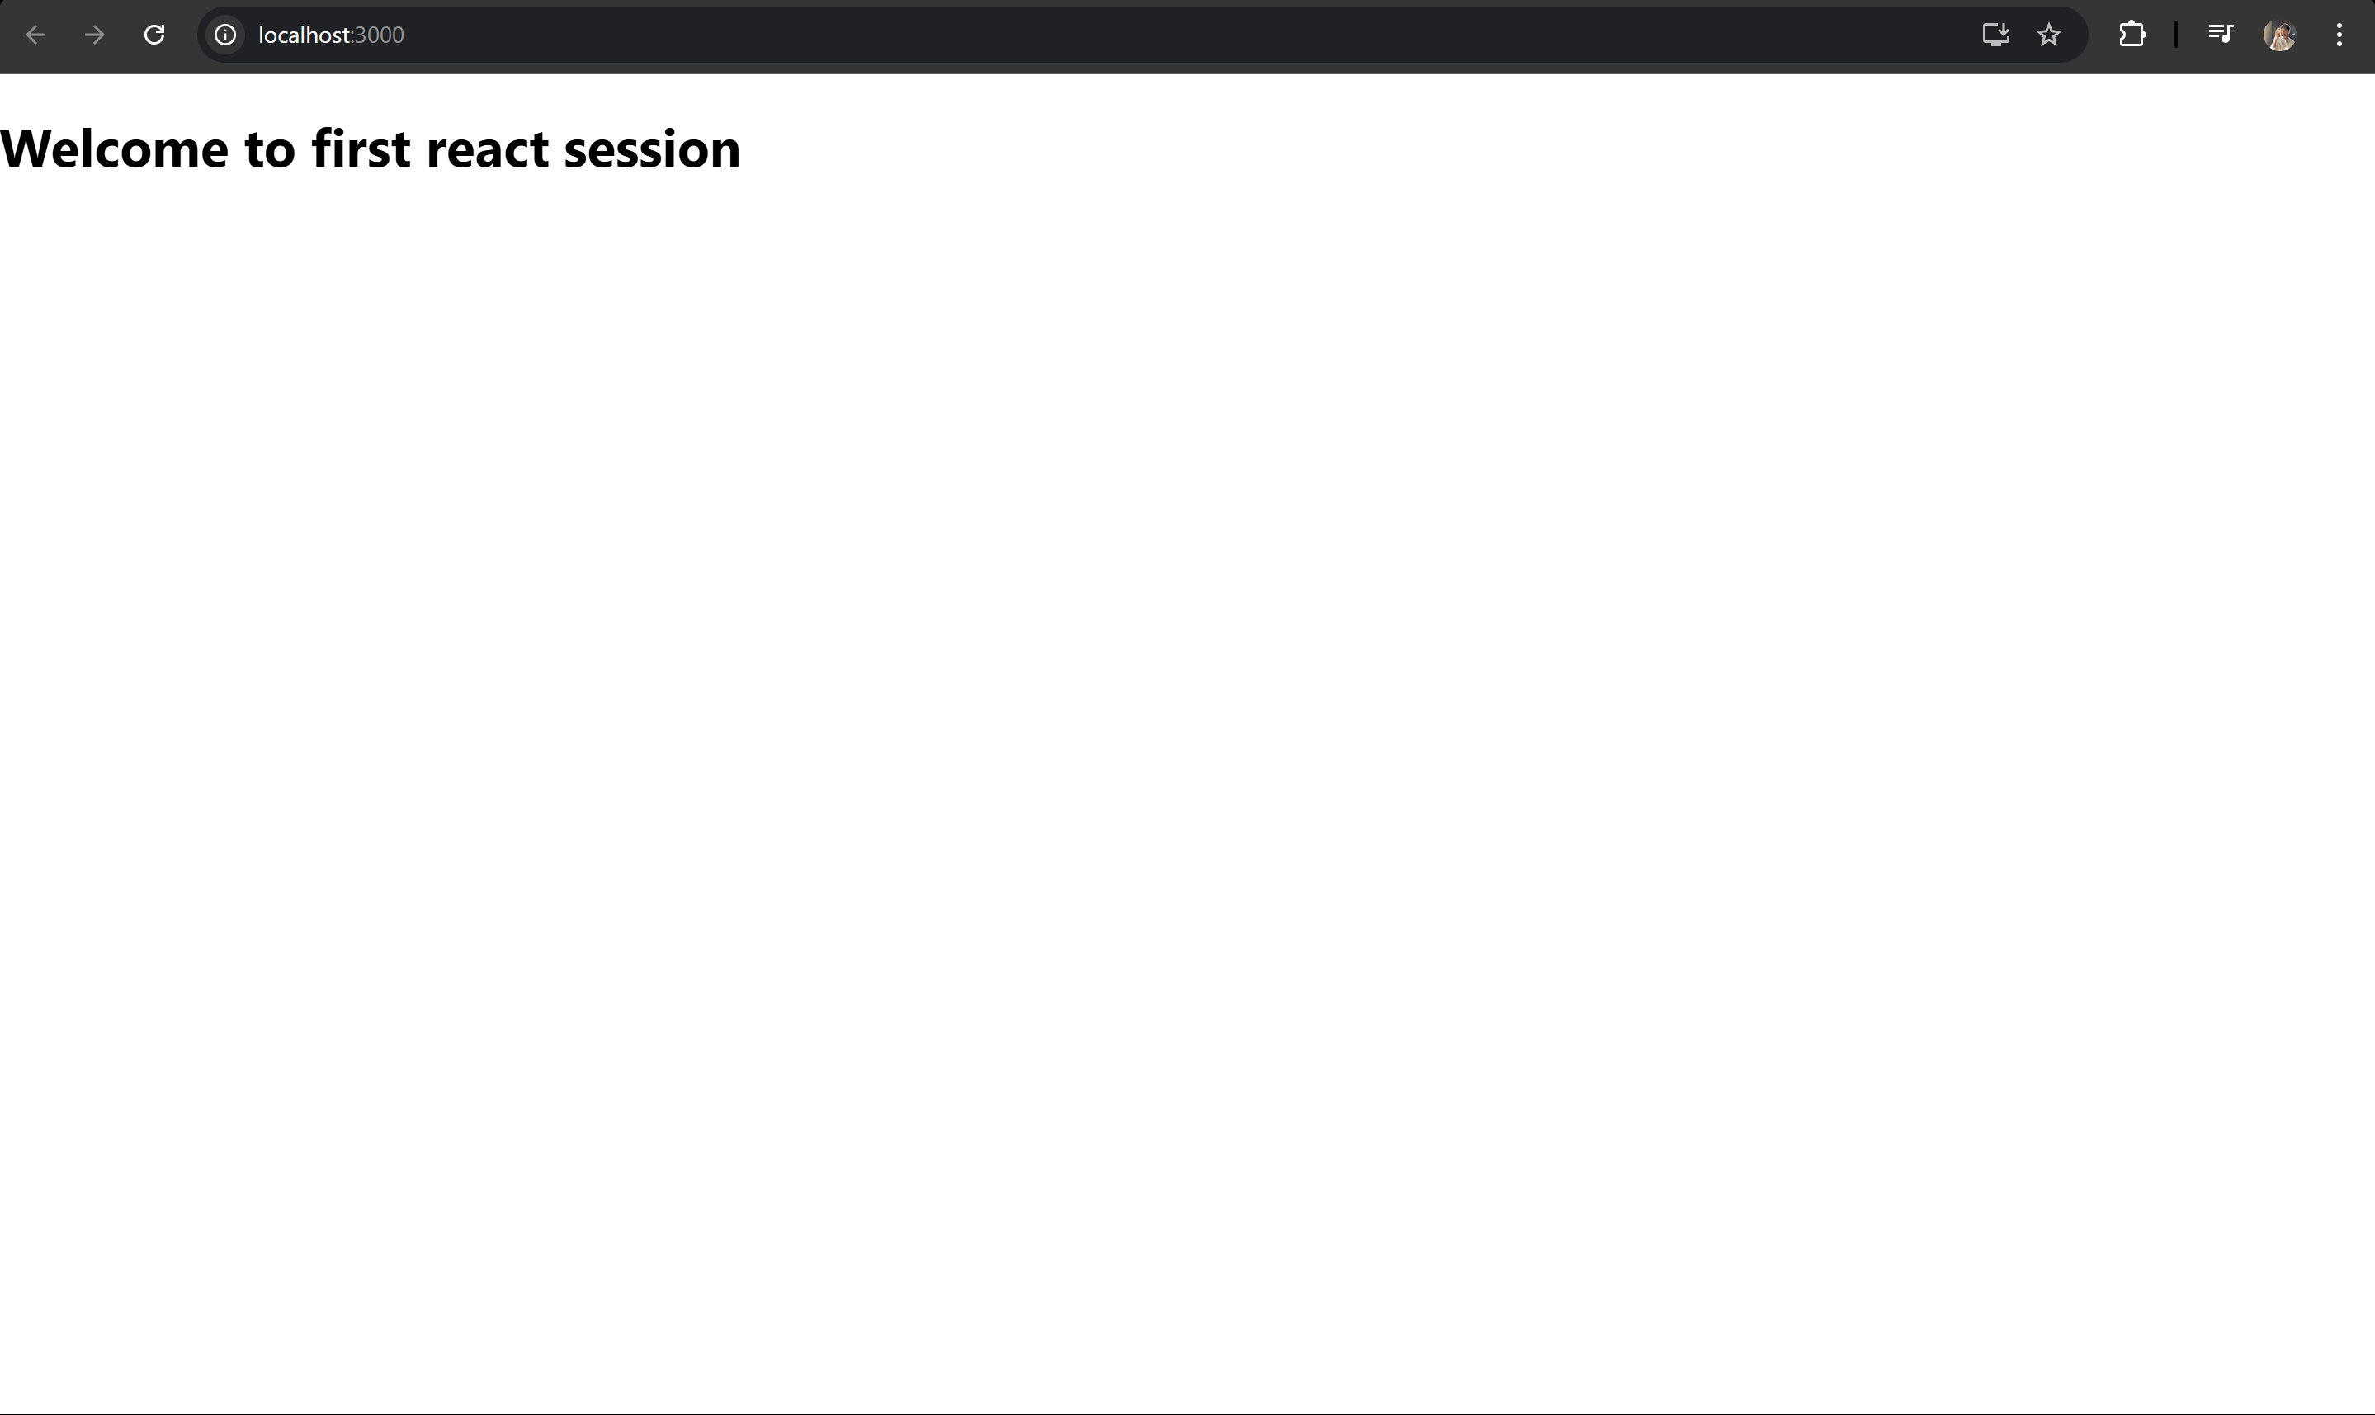

**React 2**

Creating a Student management portal

**Home.js**

*import* React *from* 'react';

function Home() {

*return* (

    <div>

      <h2>Welcome to the Home page of Student Management Portal</h2>

    </div>

  );

}

*export* *default* Home;

**About.js**

*import* React *from* 'react';

function About() {

*return* (

    <div>

      <h2>Welcome to the About page of Student Management Portal</h2>

    </div>

  );

}

*export* *default* About;

**Contact.js**

*import* React *from* 'react';

function Contact() {

*return* (

    <div>

      <h2>Welcome to the Contact page of Student Management Portal</h2>

    </div>

  );

}

*export* *default* Contact;

**App.js**

*import* React *from* 'react';

*import* './App.css';

*import* Home *from* './Components/Home';

*import* About *from* './Components/About';

*import* Contact *from* './Components/Contact';

function App() {

*return* (

    <div *className*="App">

      <Home />

      <About />

      <Contact />

    </div>

  );

}

*export* *default* App;

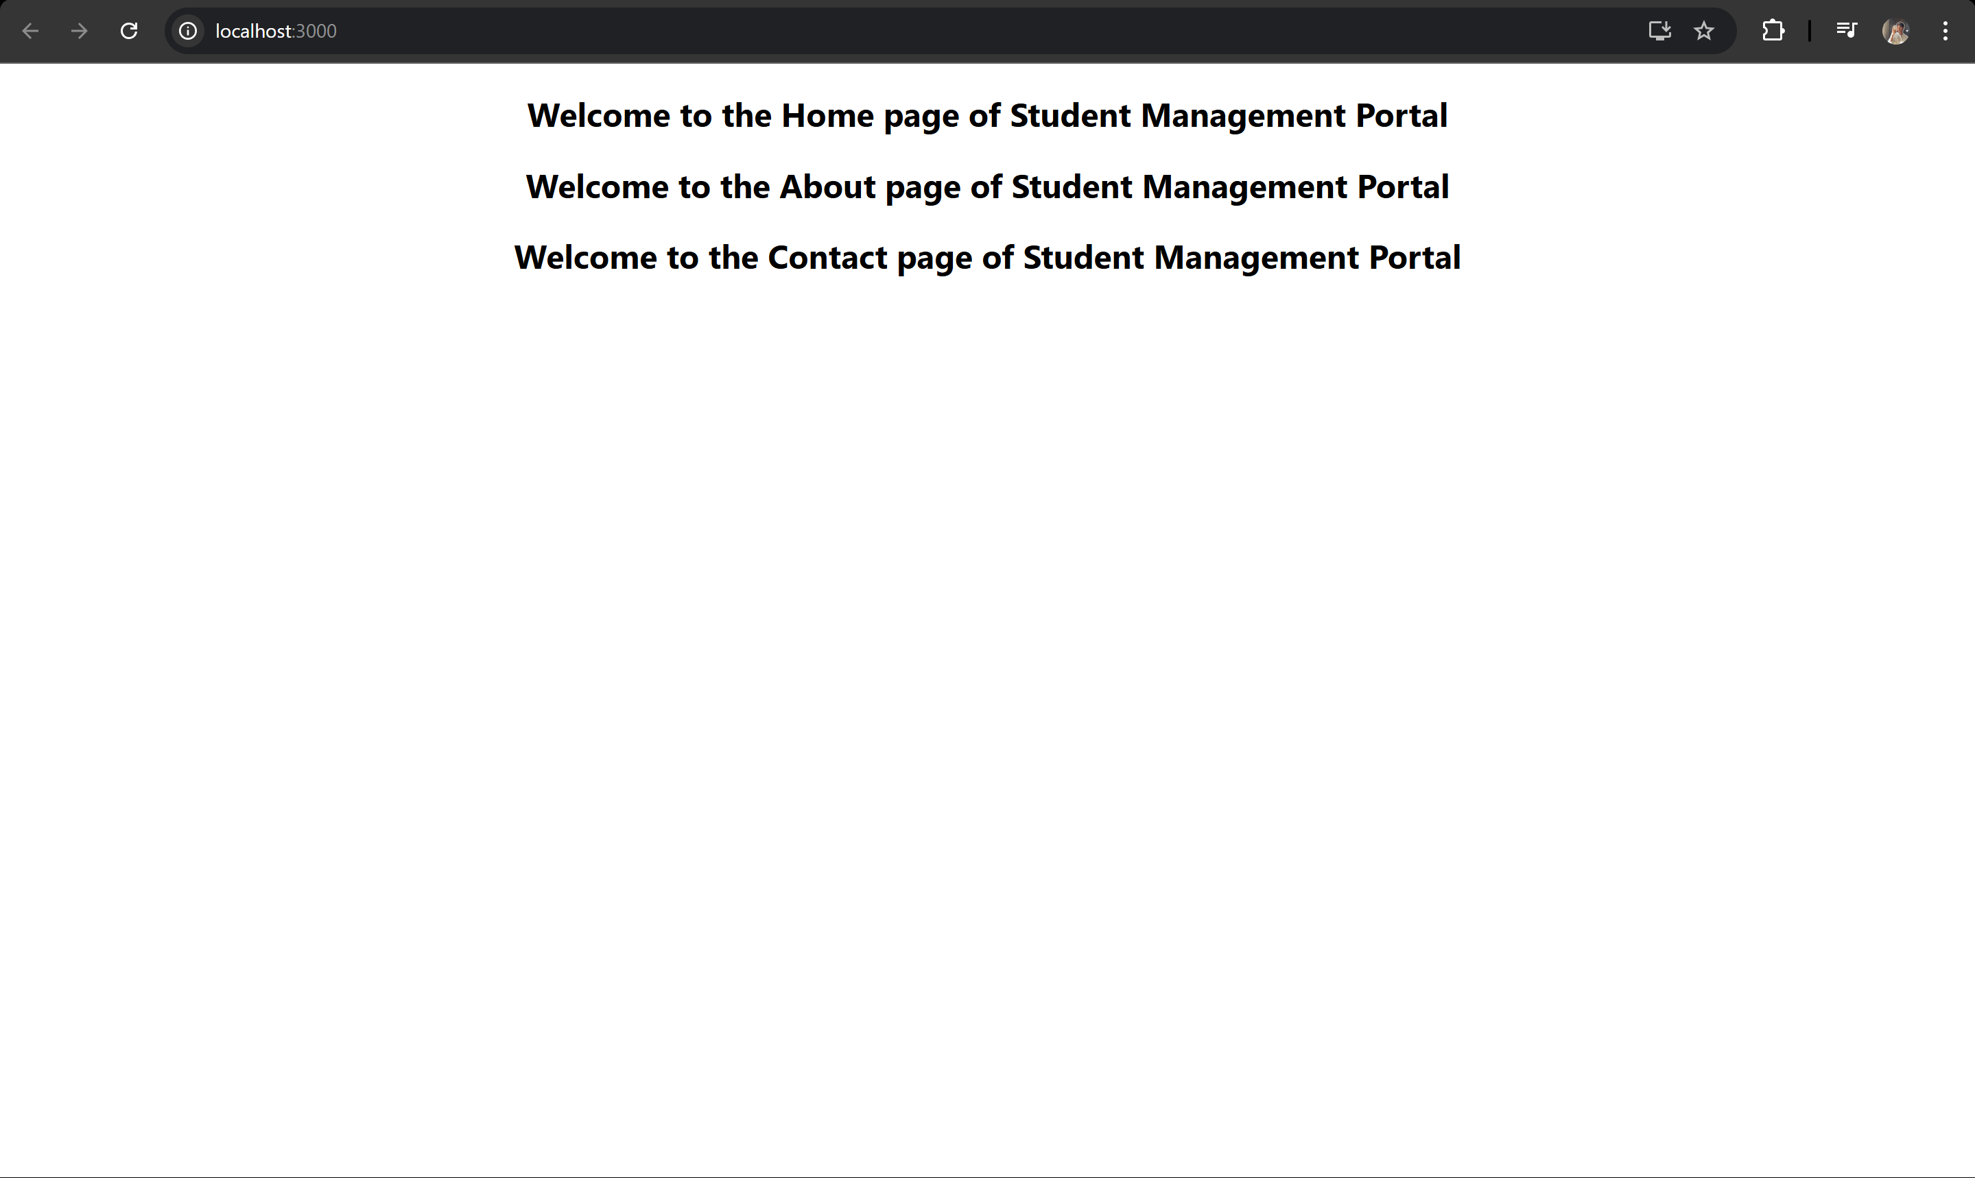

**React 3**

Creating a Score Calculator App

**CalculateScore.js**

*import* React *from* 'react';

*import* './Stylesheets/mystyle.css';

function CalculateScore({ name, school, total, goal }) {

  const average = total / goal;

*return* (

    <div *className*="card">

      <h2>Student Score Calculator</h2>

      <p><strong>Name:</strong> {name}</p>

      <p><strong>School:</strong> {school}</p>

      <p><strong>Average Score:</strong> {average.toFixed(2)}</p>

    </div>

  );

}

*export* *default* CalculateScore;

**App.js**

*import* React *from* 'react';

*import* './App.css';

*import* CalculateScore *from* './Components/CalculateScore';

function App() {

*return* (

    <div *className*="App">

      <CalculateScore *name*="Jishnu" *school*="ABC High School" *total*={450} *goal*={5} />

    </div>

  );

}

*export* *default* App;

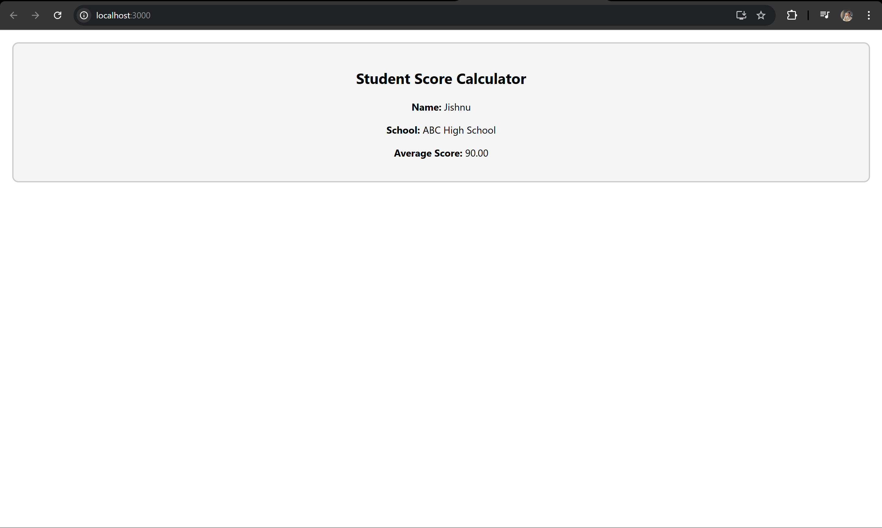

**React 4**

Creating a Blog Post App

**Post.js**

*export* *default* class Post {

  constructor(id, title, body) {

*this*.id = id;

*this*.title = title;

*this*.body = body;

  }

}

**Posts.js**

*import* React, { Component } *from* 'react';

*import* Post *from* './Post';

class Posts extends Component {

  constructor(props) {

*super*(props);

*this*.state = { posts: [] };

  }

  loadPosts = async () => {

*try* {

      const response = *await* fetch('https://jsonplaceholder.typicode.com/posts');

      const data = *await* response.json();

      const postList = data.map(p => new Post(p.id, p.title, p.body));

*this*.setState({ posts: postList });

    } *catch* (err) {

*throw* new Error("Failed to load posts");

    }

  }

  componentDidMount() {

*this*.loadPosts();

  }

  componentDidCatch(error, info) {

    alert("Something went wrong: " + error.message);

  }

  render() {

*return* (

      <div>

        <h1>Blog Posts</h1>

        {*this*.state.posts.map(p => (

          <div *key*={p.id} *style*={{ border: "1px solid gray", padding: "10px", margin: "10px" }}>

            <h3>{p.title}</h3>

            <p>{p.body}</p>

          </div>

        ))}

      </div>

    );

  }

}

*export* *default* Posts;

**App.js**

*import* React *from* 'react';

*import* './App.css';

*import* Posts *from* './Posts';

function App() {

*return* (

    <div *className*="App">

      <Posts />

    </div>

  );

}

*export* *default* App;

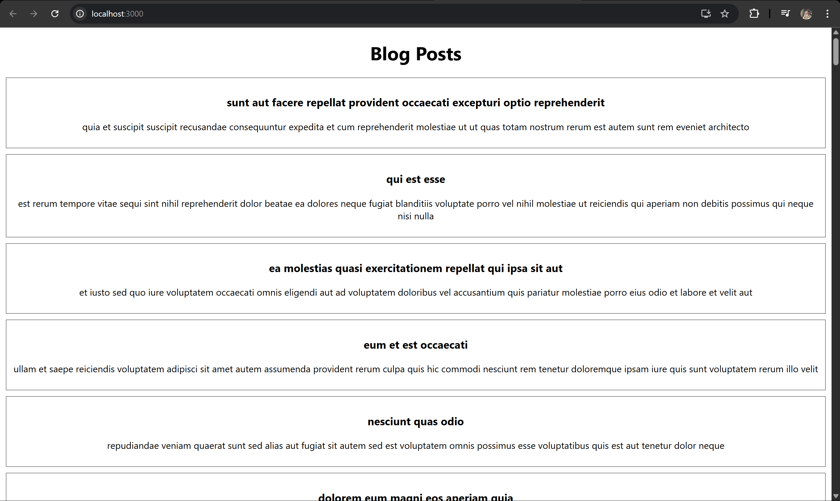

**React 5**

**CohortDetail.module.css**

.box {

width: 300px;

display: inline-block;

margin: 10px;

padding: 10px 20px;

border: 1px solid black;

border-radius: 10px;

}

dt {

font-weight: 500;

}

**CohortDetails.js**

import React from 'react';

import styles from './CohortDetails.module.css';

function CohortDetails(props) {

return (

<div className={styles.box}>

<h3 style={{ color: props.status === "ongoing" ? "green" : "blue" }}>

Cohort: {props.name}

</h3>

<dl>

<dt>Mentor:</dt>

<dd>{props.mentor}</dd>

<dt>Status:</dt>

<dd>{props.status}</dd>

</dl>

</div>

);

}

export default CohortDetails;

