CHAPTER 1

INTRODUCTION

Free space optics (FSO) communication involves the use of modulated optical or laser beams to send telecommunication information through the atmosphere. It is an atrractive technology for point to point communication of audio and video signals.Free space optics is being successfully implemented for satellite communication, and for terrestrial applications also we are looking forward to reliable audio,video and data communication which will result to fast network connectivity as well.

OVERVIEW

In recent years, there has been a migration of computing power from the desktop to portable, mobile formats. Devices such as digital still and video cameras, portable digital assistants and laptop computers offer users the ability to process and capture vast quantities of data. Although convenient, the inter- change of data between such devices remains a challenge due to their small size, portability and low cost. High performance links are necessary to allow data exchange from these portable devices to established computing infrastructure such as backbone networks, data storage devices and user interface peripherals. Also, the ability to form ad hoc networks between portable devices remains an attractive application. The communication links required can be categorized as short-range data interchange links and longer-range wireless networking appli- cations.

One possible solution to the data interchange link is the use of a direct electrical connection between portable devices and a host. This electrical connection is made via a cable and connectors on both ends or by some other direct connection method. The connectors can be expensive due to the small size of the portable device. In addition, these connectors are prone to wear and break with repeated use. The physical pin-out of the link is fixed and incompatibility among various vendors solutions may exist. Also, the need to carry the physical medium for communication makes this solution inconvenient for the user.

Wireless radio frequency (RF) solutions alleviate most of the disadvantages of a fixed electrical connection. RF wireless solutions allow for indoor and short distance links to be established without any physical connection. However, these solutions remain relatively expensive and have low to medium data rates. Radio frequency wireless links require that spectrum licensing fees are paid to federal regulatory bodies and that emissions are contained within strict spectral masks. These frequency allocations are determined by local authorities and may vary from country to country, making a standard interface difficult. In addition, the broadcast nature of the RF channel allows for mobile connectivity but creates problems with interference between devices communicating to a host in close proximity. Containment of electromagnetic energy at RF frequencies is difficult and if

improperly done can impede system performance.

So the optimal solution for speed,bandwidth and reliability lies in the optical domain.It is immune to electromagnetic interferences,provides high data security and offers much higher bandwidth over radio links.FSO may sound new and experimental but in fact it predates optical fiber and has its roots in wartime efforts to develop secure communication systems that did not require cable and could withstand radio jamming. FSO has been around for more than a decade, but it is only recently that interest in this technology has started to grow.

FSO is an optical technology and simple concept involving the transmission of voice, video and data through the air using lasers. It is not a disruptive technology; it is more of an enabling technology that promises to deliver that ever-eluding high-speed optical bandwidth to the ultimate end users. FSO offers many advantages when compared to fiber. It is a zero sunk-costs solution. The principle advantages of free space optics (FSO) are:

1. Significantly lower cost on average than the build out of a new fiber optical solution, or leased lines.

2. FSO can be deployed in days to weeks vs. months to years.

3. Bandwidth can easily be scaled (10 Mbps to 1.25 Gbps) per link As opposed to fiber, FSO can be redeployed if the customer moves or cancels service. It is also a fraction of the cost and time, allowing carriers to generate revenue, while also taking advantage of the high capacity of optical transmissions. FSO allows service providers to accelerate their deployment of metro optical networks as well as extend the reach of such optical capacity to anyone who needs it.

ADDRESSING THE LAST MILE PROBLEM

In the "the last-mile" problem studies show that fewer than 5% of all buildings in the United States have a direct connection to a high-speed (above 2.5 Gbit/s) fiberoptic backbone, yet more than 75% of businesses are within one mile of the fiber backbone. Most of these businesses are running some high-speed data network within their building, such as fast Ethernet (100 Mbit/s), or Gigabit Ethernet (1.0 Gbit/s). Yet their Internet access is provided by the significantly lower-bandwidth technologies available though the existing infrastructure such as copper wire (T1 at 1.5 Mbit/s), cable modem (5 Mbit/s shared), and digital subscriber line (DSL; 6 Mbit/s one way). The last-mile problem is the connection of the high bandwidth from the fiberoptic backbone to all of the businesses with high-bandwidth networks.

Free-space optical (FSO) communications systems can provide a line-of-sight, wireless, high-bandwidth communications link between remote sites. The FSo communications are similar to fiberoptic communications in that data is transmitted by modulated laser light. Instead of containing the pulses of light within a glass fiber, they are transmitted in a narrow beam through the atmosphere. Because free-space and fiber use similar optical transmitters and detectors, they can achieve comparable high-bandwidth capabilities (up to gigabit speeds). Wavelength-division multiplexing (WDM) technologies will work in free-space, further increasing the bandwidth potential of wireless optical links.

Along with significantly increased data rates, FSO has many advantages over other wireless technologies such as microwave or RF-spread-spectrum. These include license-free operation, and increased security due to the laser's narrow beam, which makes detection, interception, and jamming nearly impossible. In addition, FSO terminals are mobile and quickly deployable, making them ideal for disaster recovery and temporary installations.

The advantages of FSO over fiberoptic cabling are primarily economic. Free-space communications offer an attractive alternative to the prohibitive cost of trenching the streets to lay fiber, the logistical complexity of obtaining right-of-way permits, and the recurrent costs associated with leasing fiber lines.

OBJECTIVE OF WORK

The principal purpose of the project is to design and analyse a free space optical communication link over short distance to transmit real-time audio-video signals through a LASER.

REPORT ORGANISATION

The work is organized as: chapter 1 deals with the introduction regarding a brief idea of what free space optics is and how can it help to mitigate last mile bottlenecks. Chapter 2 is about the literary reviews made in course of the project. Chapter 3 gives a detailed insight on audio,video and television signals. Chapter 4 is all about how an audio-video signal can be transmitted optically over free space. Chapter 5 holds the results and finally the conclusion is being drawn in chapter 6.

CHAPTER 3

AUDIO-VIDEO SIGNAL

AUDIO SIGNAL

An **audio signal** is a representation of sound, typically as an electrical voltage. Audio signals have frequencies in the audio frequency range of roughly 20 to 20,000 Hz (the limits of human hearing). Audio signals may be synthesized directly, or may originate at a transducer such as a microphone, musical instrument pickup, phonograph cartridge, or tapehead. Loudspeakers or headphones convert an electrical audio signal into sound. Digital representations of audio signals exist in a variety of formats.

VIDEO SIGNALS

COMPOSITE VIDEO

Composite Video is a single signal which carries both the chrominance (color) and luminance (brightness) components of a video signal, along with sync information, on a single wire. Unlike an RF signal, a composite video signal does not need to be demodulated to be understood by a video display. Like other baseband video formats, a composite video signal does not carry any audio content, which must be handled separately. A composite video signal combines on one wire the video information required to recreate a color picture, as well as line and frame synchronization pulses. The color video signal is a linear combination of the *luminance* of the picture, and a modulated subcarrier carries the *chrominance* or color information, a combination of hue and saturation. Details of the encoding process vary between the NTSC, PAL and SECAM systems.

The frequency spectrum of the modulated color signal overlaps that of the baseband signal, and separation relies on the fact that frequency components of the baseband signal tend to be near harmonics of the horizontal scanning rate, while the color carrier is selected to be an odd multiple of half the horizontal scanning rate; this produces a modulated color signal that consists mainly of harmonic frequencies that fall between the harmonics in the baseband luma signal, rather than both being in separate continuous frequency bands alongside each other in the frequency domain. In other words, the combination of luma and chroma is indeed a frequency-division technique, but it is much more complex than typical frequency division multiplexing systems like the one used to multiplex analog radio stations on both the AM and FM bands.

The original "component video" was RGB, which appears in three principal varieties, each requiring a different number of connections. The most common type is RGBHV, with five lines: one for red, one for green, one for blue, one for the horizontal sync and one for the vertical sync. RGBHV is the standard used in VGA and other types of analogue PC computer monitors. DVI-A is the same signal format but using a different connector. RGBS, having four connections, differs from RGBHV in having the vertical and horizontal sync combined on a single channel. RGsB, or "sync-on-green," places the sync information on the green channel--not unlike, but still not

compatible with, Y/Pb/Pr component video.

S-video (Super Video) is a format which splits the chrominance (color) and luminance (brightness) separately onto two lines, "C" and "Y," each requiring its own coaxial cable with the sync pulses carried on the luminance line. Typically uses a 4-pin Mini DIN plug/socket.

AUDIO-VIDEO SIGNAL

RF, or Radio Frequency, is the type of signal that comes through the air by antenna or through a cable TV connection. In standard-definition broadcast and analogue cable, a composite video signal and accompanying audio are mixed, at the transmitting end, with high-frequency radio waves, and are broadcast through the air or distributed through a cable system. To be viewed on a display, these signals have to be separated from the other channels in the line and converted to unmodulated

"baseband" video and audio signals using a television tuner (found in any conventional television set or VCR). RF is used as a distribution medium because (1) it propagates through the air very well, making it suitable for over-the-air broadcast, and (2) many video signals can be modulated at many different frequencies, it's possible for us to have many "channels" available simultaneously without having them interfere with one another.

CONVENTIONAL AUDIO-VIDEO SIGNAL SPECTRUM

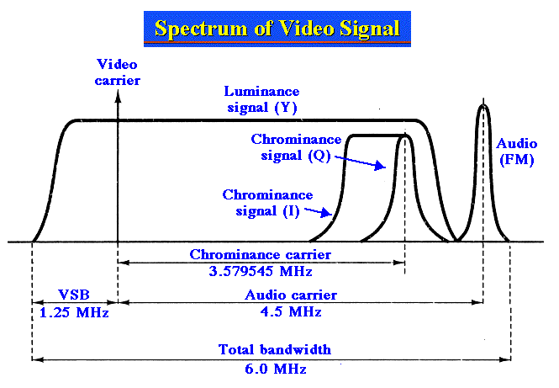

CHAPTER 4

A/V SIGNAL OVER FSO

SYSTEM MODEL

TRANSMITTER

RECEIVER

The system model in figure no. gives an overview of what is happening in various blocks of the model.It is being divided into the transmitter and the receiver part. In the transmitter section the audio and the video signal is being picked up and are combined or mixed in the RF domain. Then the pre modulated audio and the video is modulated to form the baseband signal for the laser driver,which is finally converted from electrical to optical domain and transmitted.

In the receiving section,the signal is transferred back to electrical domain by optical to electrical converter in the form of a photodiode,which is then demodulated,passed through filters to split the audio and the video part,amplified and then fed to the display unit.

THE transmitter can be again classified into two subsections:

RF SECTION

The first part of the system preceding the optical part is in RF domain. The audio signal is being picked up by an external microphone and the video is captured a cctv camera.They are to be combined and modulated to form the audio-video baseband signal to be optically modulated over the Laser driver circuit.

TV MODULATOR CIRCUIT

The MC1374 chip includes an FM audio modulator, sound carrier oscillator, RF oscillator, and RF dual input modulator. It is designed to generate a TV signal from audio and video inputs. The MC1374’s wide dynamic range and low distortion audio make it particularly well suited for applications such as video tape recorders, video disc players, TV games and subscription decoders.

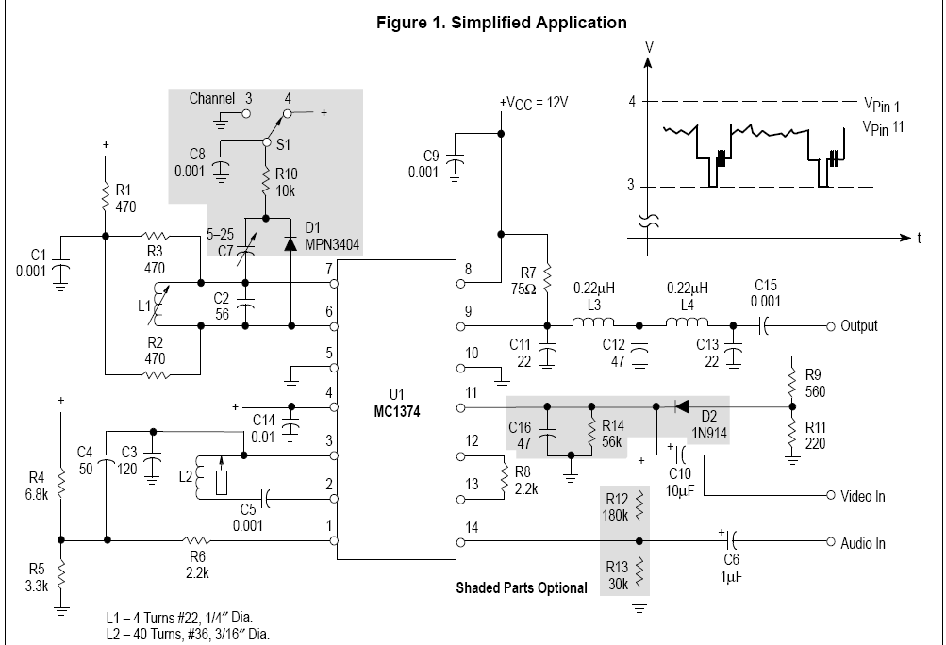

The MC1374 contains an RF oscillator, RF modulator, and a phase shift type FM modulator, arranged to permit good printed circuit layout of a complete TV modulation system. The RF oscillator is similar to the one used in MC1373, and is coupled internally in the same way. Its frequency is controlled by an external tank on Pins 6 and 7, or by a crystal circuit, and will operate to approximately 105 MHz. The video modulator is a balanced type as used in the well known MC1496. Modulated sound carrier and composite video information can be put in separately on Pins 1 and 11 to minimize unwanted crosstalk. A single resistor on Pins 12 and 13 is selected to set the modulator gain. The RF output at Pin 9 is a current source which drives a load connected from Pin 9 to VCC.

The FM system was designed specifically for the TV intercarrier function. For circuit economy, one phase shift circuit was built into the ship. Still, it will operate from 1.4 MHz to 14 MHz, low enough to be used in a cordless telephone base station (1.76 MHz), and high enough to be used as an FM IF test signal source (10.7 MHz). At 4.5 MHz, a deviation of ± 25 kHz can be achieved with

0.6% distortion (typical).

In the circuit above, devices Q1 through Q7 are active in the oscillator function. Differential amplifier Q3, Q4, Q5, and Q6 acts as a gain stage, sinking current from input section Q1, Q2 and the phase shift network R17, C1. Input amplifier Q1, Q2 can vary the amount of “in phase” Q4 current to be combined with phase shifter current in load resistor R16. The R16 voltage is applied to emitter follower Q7 which drives an external L–C circuit. Feedback from the center of the L–C circuit back to the base of Q6 closes the loop. As audio input is applied which would offset the stable oscillatory phase, the frequency changes to counteract. The input to Pin 14 can include a dc feedback current for AFC over a limited range.

The modulated FM signal from Pin 3 is coupled to Pin 1 of the RF modulator and is then modulated onto the AM carrier.

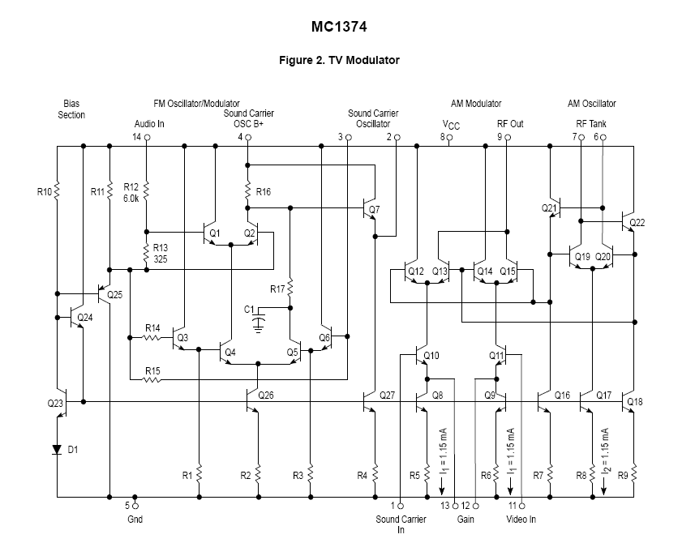

AM SECTION

The AM modulator transfer function infers that the video input can be of either polarity (and can be applied at either input). When the voltages on Pin 1 and Pin 11 are equal, the RF output is theoretically zero. As the difference between VPin 11 and VPin 1 increases, the RF output increases linearly until all of the current from both I1 current sources (Q8 and Q9) is flowing in one side of the modulator. This occurs when ±(VPin11 – VPin1) = I1 RG, where I1 is typically 1.15 mA. The peak–to–peak RF output is the 2I1 RL. Usually the value of RL is chosen to be 75 Ω to ease the design of the output filter and match into TV distribution systems. The theoretical range of input voltage and RG is quite wide, but noise and available sound level limit the useful video (sync tip) amplitude to between 0.25 Vpk and 1.0 Vpk. It is recommended that the value of RG be chosen so that only about half of the dynamic range will be used at sync tip

level.

The operating window is a cross–hatched area where Pin 1 and Pin 11 voltages must always be in order to avoid saturation in any part of the modulator. The letter φ represents one diode drop, or about 0.75 V. The oscillator Pins 6 and 7 must be biased to a level of VCC – φ – 2I1 RL (or

lower) and the input Pins 1 and 11 must always be at least 2φ below that. It is permissible to operate down to 1.6 V, saturating the current sources, but whenever possible, the

minimum should be 3φ above ground.

The oscillator will operate dependably up to about 105 MHz with a broad range of tank circuit component values. It is desirable to use a small L and a large C to minimize the dependence on IC internal capacitance. An operating Q between 10 and 20 is recommended. The values of R1, R2 and R3 are chosen to produce the desired Q and to set the Pin 6 and 7 dc voltage as discussed above. Unbalanced operation, i.e., Pin 6 or 7 bypassed to ground, is not recommended. Although the oscillator will still run, and the modulator will produce a useable signal, this mode causes substantial base–band video feedthrough. Bandswitching, as Figure 1 shows, can still be accomplished economically without using the unbalanced method. The oscillator frequency with respect to temperature in the test circuit shows less than ±20 kHz total shift from 0° to 50°C . At highertemperatures the slope approaches 2.0 kHz/°C. Improvement in this region would

require a temperature compensating tuning capacitor of the N75 family.

Coupling of output RF to wiring and components on Pins 1 and 11 can cause as much as 300 kHz shift in carrier (at 67 MHz) over the video input range. A careful layout can

keep this shift below 10 kHz. Oscillator may also be inadvertently coupled to the RF output, with the undesired effect of preventing a good null when V11 = V1. Reasonable care will yield carrier rejection ratios of 36 to 40 dB below sync tip level carrier.

In television, one of the most serious concerns is the prevention of the intermodulation of color (3.58 MHz) and sound (4.5 MHz) frequencies, which causes a 920 kHz signal to appear in the spectrum. Very little (3rd order) nonlinearity is needed to cause this problem. Acceptable results can be obtained either by reducing standard signal level or by reducing gain.

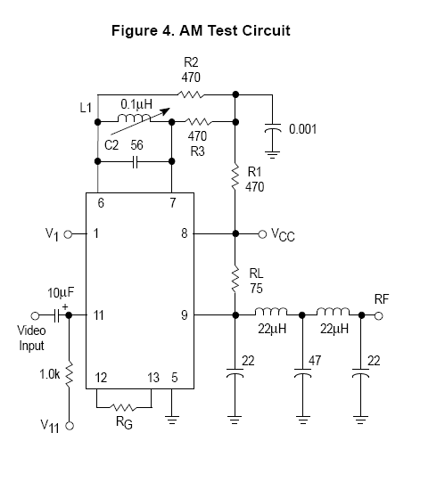

VESTIGIAL SIDEBAND MODULATION

Generally VSB-SC is used in analog tv signal broadcasting.The prime reason is that it saves bandwidth requirement over DSB-SC and it performs better in the receiver side than SSB-SC.In the early days of TV, SSB was produced by post modulation filters. Producing a SSB signal in this way results in some phase distortion at the filter edges. This would have been unaceptible and so VSB was a solution. Also, by choosing to pass the portion of the truncated sideband that is passed, the signal to noise ratio of the field and line sync signals is improved.

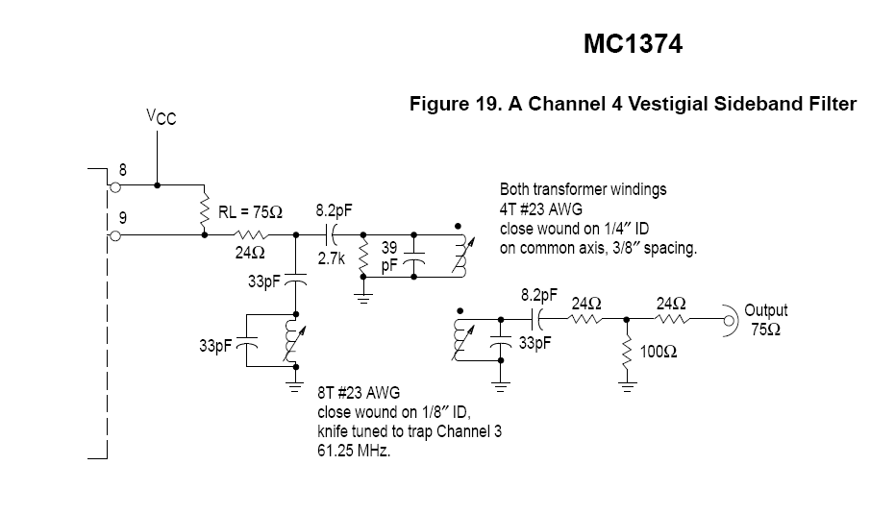

FM SECTION

The oscillator center is approximately the resonance of the inductor L2 from Pin 2 to Pin 3 and the effective capacitance C3 from Pin 3 to ground. For overall oscillator stability, it is best to keep XL in the range of 300 Ω to 1.0 Kω.

Most applications will not require DC connection to the audio input, Pin 14. However, some improvements can be achieved by the addition of biasing circuitry. The unaided device will establish its own Pin 14 bias at 4 θ, or about 3.0 V. This bias is a little too high for optimum modulation linearity. Pulling Pin 14 down to 2.6 V to 2.7 V. This can be accomplished by a simple divider, if the supply voltage is relatively constant.

The impedance of the divider has a bearing on the frequency versus temperature stability of the FM system. A divider of 180 kΩ and 30 kΩ (for VCC = 12 V) will give good temperature stabilization results. However, a divider is not a good method if the supply voltage varies. The designer must make the decisions here, based on considerations of economy, distortion and temperature requirements and power supply capability. If the distortion requirements are not stringent, then no bias components are needed. If, in this case, the temperature compensation needs to be improved in the high ambient area, the tuning capacitor from Pin 3 to ground can be selected from N75 or N150

temperature compensation types.

Another reason for DC input to Pin 14 is the possibility of automatic frequency control. Where high accuracy of inter–carrier frequency is required, it may be desirable to feed back the DC output of an AFC or phase detector for nominal carrier frequency control. Only limited control range could be

used without adversely affecting the distortion performance, but very little frequency compensation will be needed. One added convenience in the FM section is the separate Pin “oscillator B+” which permits disabling of the sound system during alignment of the AM section. Usually it can be

hard wired to the VCC source without decoupling. Standard practice in television is to provide pre–emphasis of higher audio frequencies at the transmitter and a matching de–emphasis in the TV receiver audio amplifier. The purpose of this is to counteract the fact that less energy is usually present in the higher frequencies, and also that fewer modulation sidebands are within the deviation window. Both factors degrade signal to noise ration. Pre–emphasis of 75 μs

is standard practice.

The application circuit of Figure 1 shows the recommended approach to coupling the FM output from Pin 3 to the AM modulator input, Pin 1. The input impedance at Pin 1 is very high, so the intercarrier level is determined by the source impedance of Pin 3 driving through C4 into the video

bias circuit impedance of R4 and R5, about 2.2 k. This provides an intercarrier level of 500 mV pp, which is correct for the 1.0 V peak video level chosen in this design. Resistor R6 and the input capacitance of Pin 1 provide some decoupling of stray pickup of RF oscillator or AM output which

may be coupled to the sound circuitry.

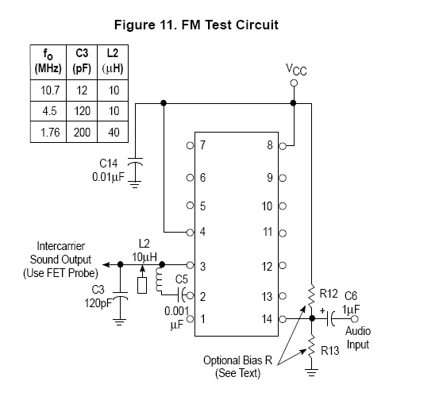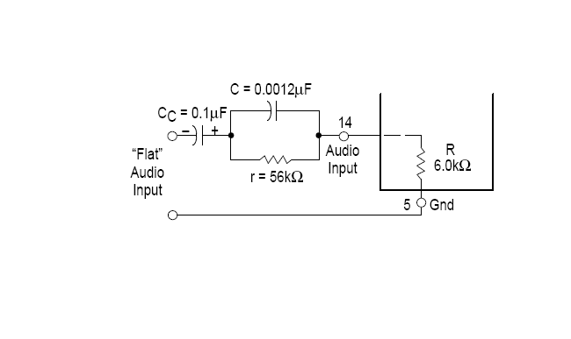

A pre-amplifier circuit is also used in the FM section to reduce the effects of noise or interference,if any,and to boost the signal strength,hence ensuring that the SNR does not get degraded.The noise performance of a preamplifier is critical; according to Friis' formula, when the gain of the preamplifier is high, the SNR of the final signal is determined by the SNR of the input signal and the noise figure of the preamplifier.

**OPTICAL SECTION**

LASER DRIVER CIRCUIT

In the most ideal form, LASER driver a constant current source, linear, noiseless, and accurate, that delivers exactly the current to the laser diode that it needs to operate for a particular application.Laser driver draws huge amount of current,heat up,and will eventually die.Hence for regulating the current drawn by the laser,regulating the power supply and maintaining the laser lifetime,driver circuit is a requirement.

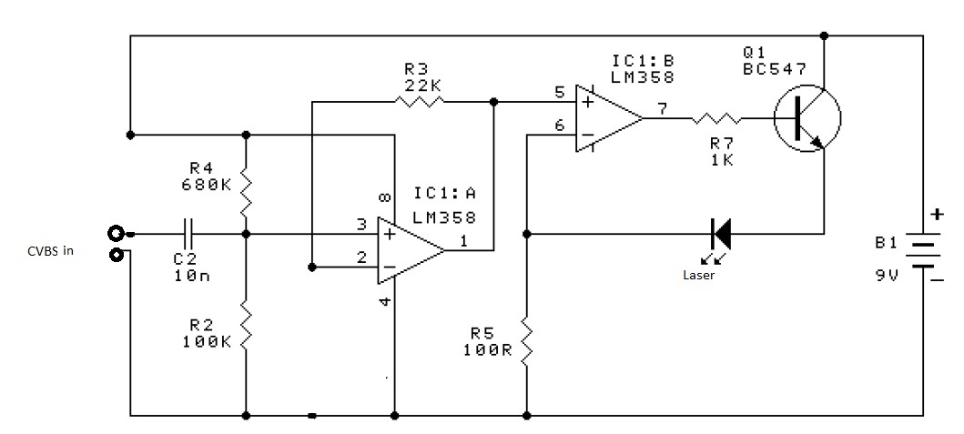

INTENSITY MODULATION

In optical communications, **intensity modulation** (**IM**) is a form of modulation in which the optical power output of a source is varied in accordance with some characteristic of the modulating signal. The envelope of the modulated optical signal is an analog of the modulating signal in the sense that the instantaneous power of the envelope is an analog of the characteristic of interest in the modulating signal.The amplitude of optical power change of the LD varies periodically with the increase of the injection current.

RATE EQUATIONS OF LASER

CIRCUIT OPERATION

The audio-video signal is coupled via C2 and amplified by two LM358 op amps (both contained in one package), and converted to an optical signal by the LED emitter, driven from transistor Q1.R3and R6 set the gain of IC1A to 1+R3/R6, or 221. Since IC1A is direct coupled, R4/R2 determine the DC input and thus the DC output level. IC1B is also direct coupled and provides both the DC base current for Q1 and the AC modulation current. R7 determines the DC bias current for Q1. The modulated collector current drives the LASER LED emitter.

CHAPTER 5

RESULTS AND DESCRIPTIONS

The system is initially simulated in OPTISYSTEM with a test signal of speed 1Gbps for a distance of 1 km to check the performance of the transmission system using a Red Light Laser of 635nm wavelength. The performance of the test system is obtained from the Eye Pettern diagram which yielded satisfactory results.

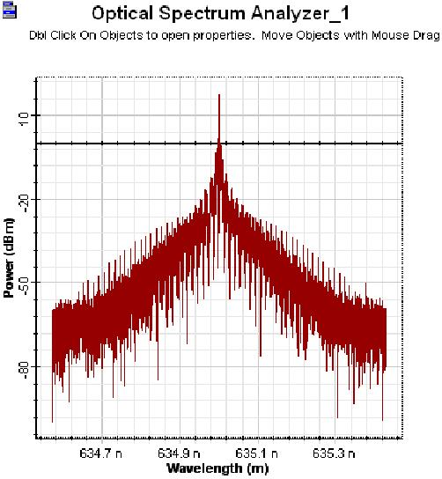

The figure shows the power spectrum of a red light laser of wavelength 635 nm with the peak of the power being at 635 nm with a value of 10 dbm.

Eye pattern

The eye opening in the figure interprets very low intersymbol interference and additive noise for the signal transmitted while the width of the eye ensured timing synchronization.

HARDWARE CIRCUITRY

The hardware implementation of the proposed system model are tested practically and the results are given below:

In figure the audio and the video signal are captured by a cctv camera with inbuilt microphone and the signal is fed separately to a tv modulator circuit where the audio and video signal gets combined and rf modulated to form the baseband signal for the laser driver circuit where the audio-video signal is intensity modulated and converted into optical domain by the Laser.

OUTPUT WAVEFORMS

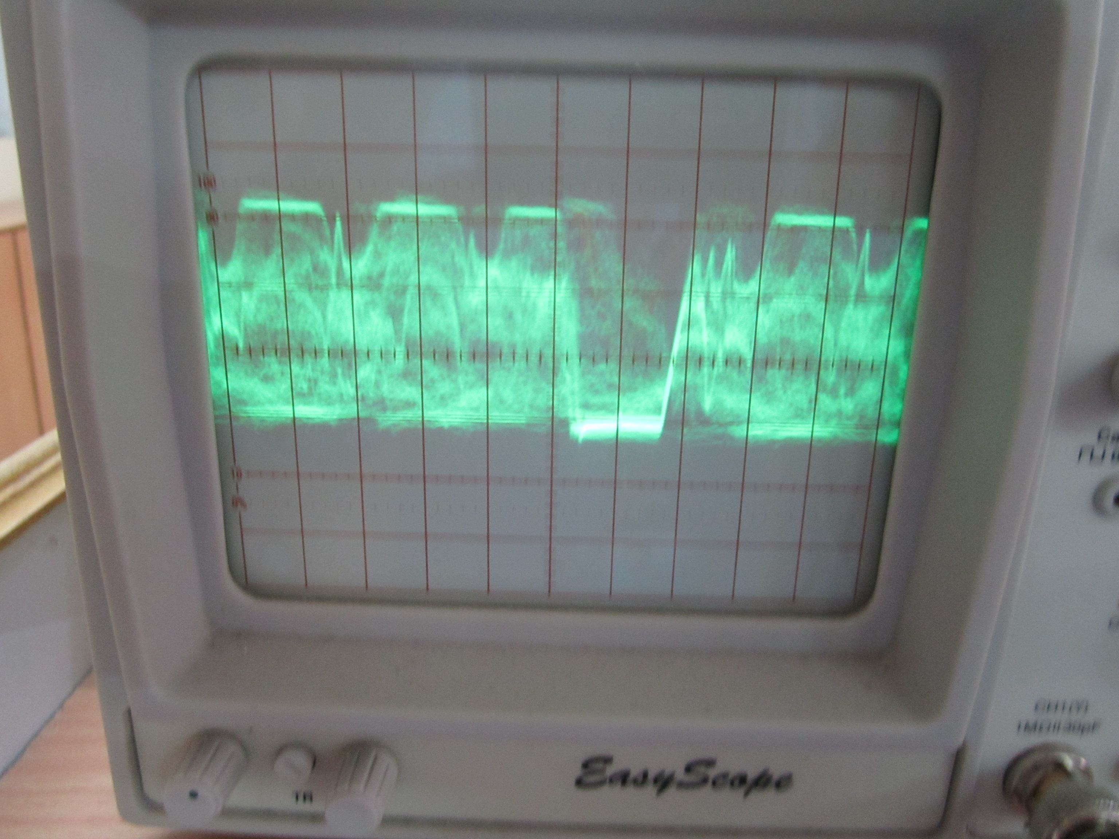

**CHAPTER-6**

**CONCLUSION**

This project gives an idea about how free space optics can be put into effect for transmission of audio-video signals for various purposes.Some of the common purposes could be video-conferencing and even for monitoring of a particualar area without the use of any sort of cables.The Phase-1 succesfully dealt with the transmission of the audio-video signal through a lser using intensity modulation in the optical domain. Careful considerations and succesful completion of the project can make it an attractive alternative to introduce in the market as well.In addition,since the system has extremely high immunity to EMI,it is also suitable for using in some inferior electro-magnetic environment.

**FUTURE SCOPE**

The main intention is to come-up with a simple,portable set-up to deploy audio-video communication over short range for point-to-point devices in a wireless environment through light and address various commercial applications with low cost and better transmission bandwidth.