SNEHAL TOGARI
COMPUTER SCIENCE STUDENT

CONTACT

Phone:
8767764906

Email Address:
snehaltogari25@gmail.com

PROFILE
Aspiring Data Scientist and Machine Learning enthusiast seeking an entry-level role to apply analytical skills, machine learning knowledge, and data visualization expertise to solve real-world problems. Strong communicator with confidence to present insights effectively and collaborate in a team environment.

Address:
Main Road Gijavane

Website
www.linkedin.com

SOFT SKILLS
EDUCATION

Teamwork
Diploma In Computer Engineering
Sant Gajanan Maharaj Rural Polytechnic,Mahagaon
percent: 92%
Sadhana High School
High school(10th)

Time Management Leadership
Effective Communication Critical Thinking
Percent : 85.40%

PROJECTS

Smart Health Disease Prediction

SEPT 2025 - MARCH 2026

TECH SKILLS
Python (Expert) C++ (Intermediate) Data Structures SQL, MySQL
Led the development of a disease prediction system using machine learning.
Enabled users to select symptoms and choose an algorithm for prediction.
Generated detailed reports including disease description and precautions.
Implemented multiple ML models (Decision Tree, Random Forest, SVM, KNN, Naive Bayes) for accurate predictions.

Machine Learning Web Development

Technologies Used:
Html,Css,Django,Python,ML

ACHIEVEMENTS & HACKATHONS

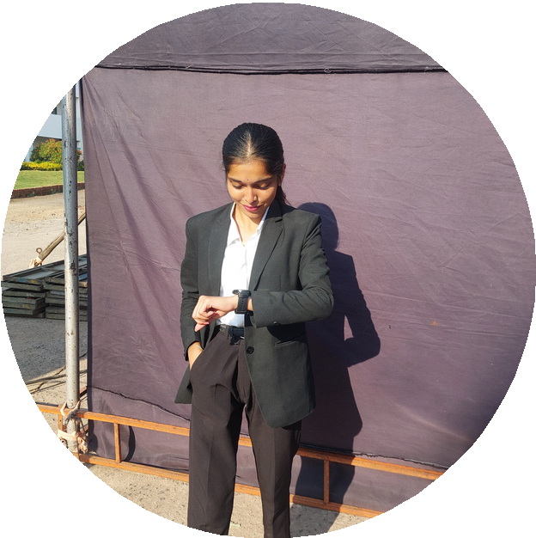

LANGUAGES

English (Fluent) Hindi
Ranked 11 in MSBTE Examination in college and I got 92%

Runnerup and winner in Codefiesta & paper presentation in Annutara National level Technical event organized by Our College.

Won Third prize for the Extempore Speech Competition.

