Unraveling Telangana’s Path to Inclusive Development
A Proposal report for the BDM capstone Project

Submitted by

Name : Jishnu S G
Roll Number : 21f1006877@ds.study.iitm.ac.in



IITM Online BS Degree Program,
Indian Institute of Technology, Madras, Chennai
Tamil Nadu, India, 600036
Contents

1 Executive Summary and Title 3
2 Organisation Background 3
3 Problem Statement 4
3.1 Problem statement 1
3.2 Problem statement 2
3.3 Problem statement 2
4 Background of the Problem 4
5 Problem Solving Approach 5
6 Expected Timeline 6
7 Expected Outcome 7

Declaration Statement
I am working on a Project titled “Unraveling Telangana’s Path to Inclusive Development”. I extend my appreciation to Open Data Unit, Government Of Telangana for providing the necessary resources that enabled me to conduct my project.
I hereby assert that the data presented and assessed in this project report is genuine and precise to the utmost extent of my knowledge and capabilities. The data has been gathered from primary sources and carefully analyzed to assure its reliability.
Additionally, I affirm that all procedures employed for the purpose of data collection and analysis have been duly explained in this report. The outcomes and inferences derived from the data are an accurate depiction of the findings acquired through thorough analytical procedures.
I am dedicated to adhering to the principles of academic honesty and integrity, and I am receptive to any additional examination or validation of the data contained in this project report.
I understand that the execution of this project is intended for individual completion and is not to be undertaken collectively. I thus affirm that I am not engaged in any form of collaboration with other individuals, and that all the work undertaken has been solely conducted by me. In the event that plagiarism is detected in the report at any stage of the project's completion, I am fully aware and prepared to accept disciplinary measures imposed by the relevant authority.
I understand that all recommendations made in this project report are within the context of the academic project taken up towards course fulfillment in the BS Degree Program offered by IIT Madras. The institution does not endorse any of the claims or comments.

Signature of Candidate :

Name : Jishnu S G
Date : 08-03-2025

1. Executive Summary
The state of Telangana has emerged as a leader in data-driven governance through Open Data Telangana, an initiative that provides access to datasets across sectors for the general public and industries. The programs like TS-iPASS streamline industrial approvals while T-Hub incubates tech innovations, and Rythu Bandhu assures farmer welfare. This dictates the state's commitments towards balancing industrial growth with its agricultural legacy.
The purpose of this study is to comprehend how Telangana's economic growth influences its major industries, such as agriculture, manufacturing and real estate. The project aims to determine district-wise trends in investments, vehicle sales, land registrations and climate conditions; the project seeks to understand how economic progress aligns with agricultural robustness. Additionally, the study will explore disparities between urban and rural development to examine whether rapid investments are influencing climate patterns.
Through the data-driven analysis across multiple data tables, the project will provide actionable insights to the policymakers and stakeholders. The findings will help to prioritize districts for agro-processing investments, optimize infrastructure planning for high-growth urban areas and create a faster, streamlined approval process for industries. By harmonizing industrial efficiency and agricultural productivity, the study will aim to guide the government of Telangana towards inclusive growth by ensuring sustainable economic development throughout the state.

2. Organization Background
Telangana is a state in the south-central part of the Indian subcontinent adorned with rich history, diverse culture and rapid growth. It is the eleventh largest and twelfth most populated state in India as per the 2011 census.
The state is notable for its progressive approach to data accessibility and transparency through its initiative Open Data Telangana. With an Open Data Policy in place, the government ensures that data related to various domains is made easily accessible to the public. This also aligns with the Digital India mission and Digital Telangana, where the aim is to empower the people and stakeholders digitally literate.
Open Data Telangana is testament to the state's commitment towards the growth of the state by leveraging the digital infrastructure. It empowers citizens, researchers and business stakeholders by providing valuable information, thereby encouraging social and economic development with citizen-centric governance by ensuring the ethos of transparency.

3. Problem Statement

- How can Telangana prioritize districts for agro-processing investments by increasing agricultural productivity with industrial growth and climate resilience to maximize economic growth ?
- How the employment growth influences the demand for commercial and personal vehicles sales, and what infrastructure might optimize the economic activity in high-growth districts ?
- How does the industrial approval timeline vary across the sectors and districts, are these delays correlated with investment size or due to the marginalized group of applicants ?

4. Background of the Problem
Telangana is a semi-arid climate area with hot and dry conditions. These conditions positioned Telangana’s strong agricultural outputs and positioned it as a leading producer of rice, maize, and grains. But from the recent past the state is well known for the foreign and domestic investments, in the fiscal year 2021-22 alone the state attracted Rs 17,867 core worth investments.
The state initiated various projects like TS-iPASS (Telangana State Industrial Project Approval and Self-Certification System), T-Hub (Technology Hub), Rythu Bandhu, Telangana Electric Vehicles and Energy Storage Policy from 2015 onwards to help both the industrial and agricultural parties. In November, 2015 at the inauguration ceremony of T-Hub Sri K T Rama Rao mentioned “our government slogan has been innovate, incubate and incorporate”, and years downline investments in the state is increasing day by day.
This project will explore the various aspects of the growth starting from the road transport sales, TS-iPASS and land registrations across the state to interpret the revenue growth and the influence of weather in socio-economic activity of state’s industrial and agricultural sectors. According to the media houses, the state's major investments and rapid growth are on the Hyderabad side, being known for agricultural robustness, we will be trying to figure out the Urban-Rural Divide (if any) and the impact of rapid development on climate change (if any) from the available data.

5. Problem Solving Approach
TS-iPASS was introduced for speedy processing of applications for the various clearances required for setting up industries. Even with this, we can see that not all the sectors are having the same lead time. Also the industrial areas could be the crowd pullers for the investments that are happening in the state. Being known for agricultural dominance, it is mandatory to identify climate change and socio-economic impact along the industrial growth.
Methods Used :
- Time Series Analysis :
  - Given the time dependent nature of the problem statement, the time series analysis might help in identifying the growth in district wise investments and the climate change.
  - Similarly, evaluation of the adoption of online services in industrial registration and land registrations.
Intended Data :
- TS-iPASS registration Data : Collect industrial data for district wise registrations on the portal and need at-least information about sector, line of activity, investment amount, number of employees, application date, approval date and application mode to check whether online or offline.
- Weather Data : Gather information about district wise weather reports, the data must have cumulative rainfall, minimum and maximum temperatures recorded in an interval and similarly humidity and wind speed data also.
- Land Registration Data : This could help in identifying the revenue generated in each district via the land related operations. District wise document registration count and revenue from the registrations required for both offline and eChallan methods.
- Vehicle Sales Data : This data set might help us in analyzing the economic activity of industrialization. To record the trend we need to have vehicle class to identify transport and non-transport, the fuel type of vehicle, make year, registration date and the information about pre-owned vehicle registration.
Analysis Tools
- Python with Pandas : For preliminary data processing and cleaning and analysis python might be required due to the volume of data, and Pandas can handle data more comprehensively for data cleaning.
- Python with Matplotlib/Seaborn : It will be useful to create visual representations, also, might use the Plotly to have interactive visual plots.
Since we have multiple data related to multiple sectors, we have to analyze them separately. Also we have the district name or location name as common actress the data, combining them might fetch much more insights over uni-sector analysis.

6. Expected Timeline

6.1 Work Breakdown Structure :
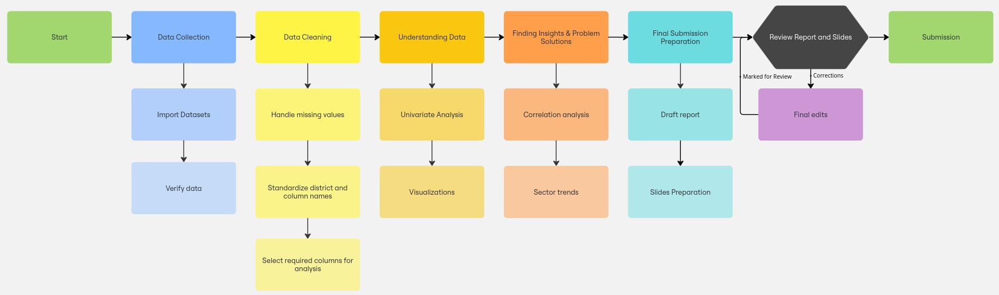
Figure 1 Work BreakDown Structure for completion of project.

6.2 Gantt chart :
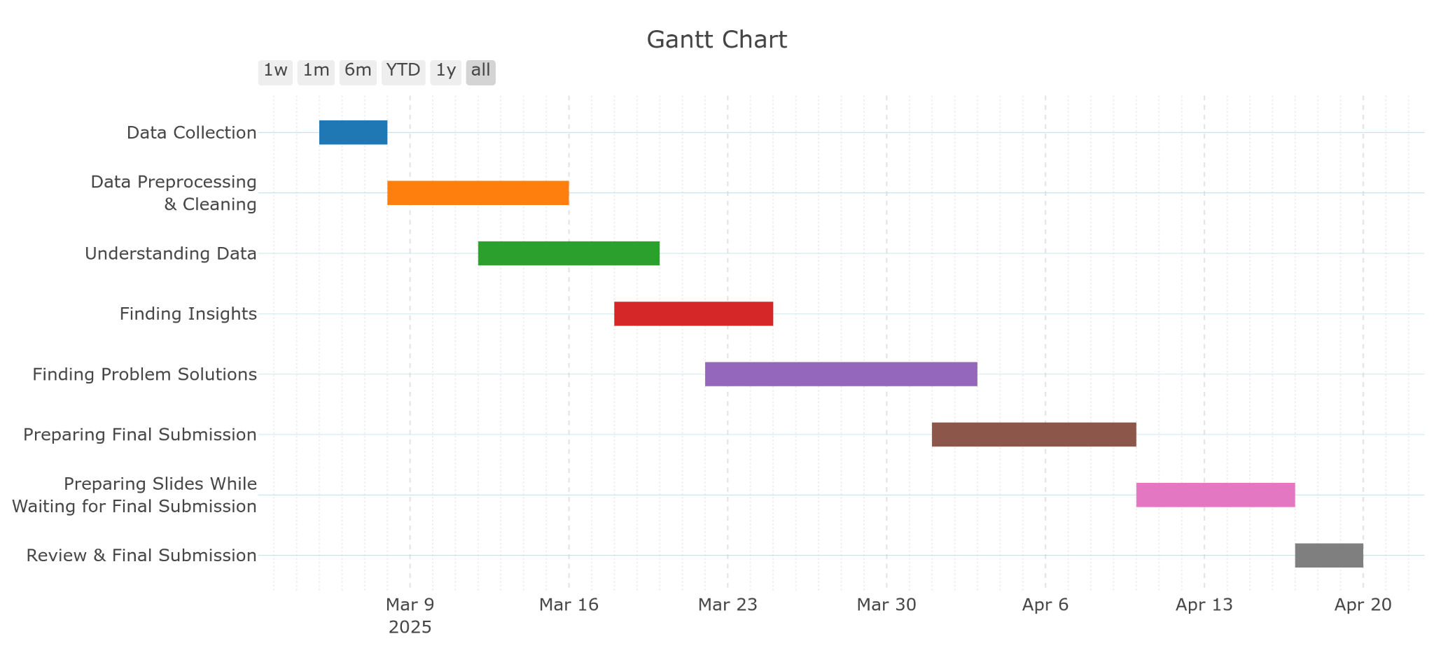
Figure 2 Expected timeline for completion of project.

7. Expected Outcome
- A better idea for food processing and infrastructure industries to be aligned with specific districts, based on climate and economic conditions for better growth.
- Help the governments to allocate subsidies or infrastructure to support farmers and their crops using schemes like Rythu Bandhu,for having higher agricultural productivity.
- Identifying the districts that need better vehicle infrastructure, more EV charging stations and logistic hubs to keep up with the economic development.
- To assist the government to prioritize districts needing road updates or public transport expansion based on the vehicle sales trends.
- Evidence based policy recommendations to fast-track approval for small investments to reduce the delays and boost equitable industrial developments.
- Identify the sectors and business activities that are facing longest approval delays, investigate links to investment size and district specificity.

