Unraveling Telangana’s Path to Inclusive Development
Final report for the BDM capstone Project

Submitted by

Name : Jishnu S G
Roll Number : 21f1006877



IITM Online BS Degree Program,
Indian Institute of Technology, Madras, Chennai
Tamil Nadu, India, 600036
Contents
1. Executive Summary 2
2. Proof of Originality 2
3. Meta Data and Descriptive Statistics 3
3.1. Weather Data 3
3.2. TS-iPASS Data 3
3.3. RTA Registration Data 4
3.4. Land Registration Data (Non-Agricultural) 5
4. Detailed Explanation of Analysis Process / Methods 6
4.1. Data Collection and Preparation 6
4.2. Data Cleaning and Preprocessing 6
4.3. Exploratory Data Analysis (EDA) 7
5. Results and Findings 8
5.1 Findings from Exploratory Data Analysis 8
5.2 Insights and Plots from Problem Statements 12
6. Interpretation of Results and Recommendation 18
6.1 Small Investments Face Systemic Approval Delays 18
6.2 E-Stamp Adoption Efficiency Over Document Registration 19
6.3 Rainfall-Mechanization Mismatch Inflates Farm Costs 20

1. Executive Summary
Telangana leads in data-driven governance by actively balancing industrial expansion and agrarian resilience through initiatives like Open Data Telangana, TS-iPASS, and Rythu Bandhu. This detailed analysis is built upon carefully collected and cleaned district-level data and will provide a foundation for understanding the state’s socio-economic dynamics.
Despite these advancements, challenges remain in achieving the state’s expansion. This systematic study reveals numerous small-scale businesses are struggling to achieve their full economic potential, including the systematic barriers that limit local entrepreneurship and slow down the wider economy. Furthermore, there is a significant mismatch in agriculture since machinery investments don't always match up with the unpredictable rainfall patterns in the areas, which might result in inefficient capital expenditure and inflated farming costs.
Digital land registrations saw remarkable success overall, but the early stages highlighted the inefficiencies in the digital adoption. These problems, when together, could threaten economic growth and climate resilience and also may even increase the gap between urban and rural areas, requiring focused solutions.
This project utilizes data-driven methodologies, applying time-series and comparative analytics to the district-level data from 2019 to 2024. Python as a tool helped in generating clear insights on business growth, digital transformation, and climate-influenced agricultural expenses. The findings provide practical recommendations for the government to focus on supporting small businesses, matching farmers requirements with changing climatic conditions, and expanding the digital governance to encourage balanced and sustainable growth.

2. Proof of Originality
All the data for this project was taken directly from the Telangana government's public platform, Open Data Telangana, which is known for sharing governmental info openly. The data was spread across multiple files; thus, this project used a Python program to gather this data, focusing on industries (TS-iPASS), vehicle sales (RTA), and weather information, covering from January 2019 all the way to December 2024. After collecting it, this metadata went through careful cleaning and organizing to make sure the analysis is based on accurate and trustworthy data.
Dataset Link : Google Drive | TS-iPASS Data | RTA Data
Analysis Notebook : Analysis NoteBook
Note, Weather data is spread across multiple pages, links/APIs are in the data collection notebook.

3. Meta Data and Descriptive Statistics
The analysis relies on four datasets, all of which are aggregated to a monthly district level and cover the period from January 2019 to December 2025. The common columns across all the datasets are month of observation and district name and this helps in cross-data analysis.

3.1. Weather Data
This dataset provides monthly average weather conditions and rainfall variability for each district.
Column Name | Description | Data Type | Range
Month | The specific month of data collection | DateTime | Date from 2019-01-01 to 2024-12-01 (YYYY-MM-DD)
District | Name of the district. | String | Text / categorical district names
RainFall | Average monthly rainfall in millimeters (mm). | Float | Can be any positive number. [0, ∞)
Min_Temp | Average monthly minimum temperature in Celsius (°C). | Float | Typically within [11.2, 33.9] °C
Max_Temp | Average monthly maximum temperature in Celsius (°C). | Float | Typically within [13.2, 43.7] °C
Min_Humidity | Average monthly minimum humidity in percentage (%). | Float | Usually between [13%, 84%]
Max_Humidity | Average monthly maximum humidity in percentage (%). | Float | Usually between [36%, 100%]
Std_Rainfall | Standard deviation of daily rainfall within the month | Float | Can be any positive number. [0, ∞)

3.2. TS-iPASS Data
This dataset summarizes monthly industrial investment and employment generation, which is categorized by sector and applicant's social status.
Column Name | Description | Data Type | Range
Month | The specific month of approval. | DateTime | Date from 2019-01-01 to 2024-12-01 (YYYY-MM-DD)
District_Name | Name of the district where the industry is located. | String | Text / categorical district names
Sector | The industry sector | String | Text like Food Processing, Pharmaceuticals, …
Investment | Total investment amount in millions | Float | Non-negative values. [0, 17,793.35]
Number_Of_Employees | Total number of employment expected to be generated | Int | Non-negative integers. [0, 57,000]
social_status_General | Count of applicants from the General social category. | Int | Integer count. [0, 40]
social_status_OBC | Count of applicants from the Other Backward Classes | Int | Integer count. [0, 24]
social_status_SC_ST | Count of applicants from the Scheduled Caste/Tribe | Int | Integer count. [0, 5]

3.3. RTA Registration Data
This dataset aggregates monthly vehicle registration counts by district, broken down by vehicle class, fuel type, and new/pre-owned status.
Column Name | Description | Data Type | Range
Month | The specific month of registration. | DateTime | Date from 2019-01-01 to 2024-12-01 (YYYY-MM-DD)
District | Name of the district where the vehicle was registered. | String | Text / categorical district names
vClass_Agriculture | Count of agricultural vehicle registrations. | Int | Non-negative integer. [0, 1099]
vClass_Motor_Cycle | Count of motorcycle registrations. | Int | Non-negative integer. [0, 35,432]
vClass_Auto_Rickshaw | Count of auto-rickshaw registrations. | Int | Non-negative integer. [0, 2290]
vClass_Motor_Car | Count of motor car registrations. | Int | Non-negative integer. [0, 9014]
vClass_Goods_n_Others | Count of goods vehicles and other specialized vehicles | Int | Non-negative integer. [0, 2151]
fuel_Petrol | Count of petrol-fueled vehicle registrations. | Int | Non-negative integer. [0, 39,703]
fuel_Diesel | Count of diesel-fueled vehicle registrations. | Int | Non-negative integer. [0, 5268]
fuel_Electric | Count of electric vehicle registrations. | Int | Non-negative integer. [0, 2954]
fuel_Others | Count of vehicles using other fuel types (e.g., LPG/CNG). | Int | Non-negative integer. [0, 2374]
fuel_Non_Fuel | Count of non-fueled vehicles (e.g., trailers). | Int | Non-negative integer. [0, 1087]
Brand_new_Vehicle | Count of brand-new vehicle registrations. | Int | Non-negative integer. [0, 4537]
Pre_owned_Vehicle | Count of pre-owned vehicle registrations. | Int | Non-negative integer. [8, 42,089]
category_Transport | Count of vehicles registered for transport (commercial) | Int | Non-negative integer. [0, 5956]
category_Non_Transport | Count of vehicles registered for non-transport (private) | Int | Non-negative integer. [6, 42,076]

3.4. Land Registration Data (Non-Agricultural)
This dataset tracks monthly document registrations, associated revenue, and e-stamp usage by district.
Column Name | Description | Data Type | Range
Month | The specific month of registration. | DateTime | Date from 2019-01-01 to 2024-12-01 (YYYY-MM-DD)
Dist_Name | Document registered district name | String | Text / categorical district names
Documents_Registered_Cnt | Total count of documents registered. | Int | Non-negative integer. [0, 33,786]
Documents_Registered_Rev | Total revenue generated from registrations | Int | Non-negative integer. [0, 5,068,863,000]
Estamps_Challans_Cnt | Total count of e-stamp challans issued. | Int | Non-negative integer. [0, 30,526]
Estamps_Challans_Rev | Total revenue generated from e-stamp challans | Int | Non-negative integer. [0, 5,239,561,000]
Slot_Booking_Cnt | Total count of slots booked for registration. | Int | Non-negative integer. [0, 11,575]
Approval_Delay | Number of days from submission to approval | Float | Non-negative integer. [0, 1820]

4. Detailed Explanation of Analysis Process / Methods
This study employed a detailed data-driven methodology to uncover the key trends and relationships within Telangana’s socio-economic landscape. The process involved data collection and intensive data cleaning before the comprehensive exploratory analytics to target the defined problem statements.

4.1. Data Collection and Preparation
The foundation to the analysis is built on unique district-level datasets spanning from January 2019 to December 2024. In order to obtain this vast quantity of data, I used a custom Python web-scraping script for the official Open Data Portal using the provided API. This ensures the originality and the authenticity of the data I used.
Throughout the analysis, utilized four primary datasets :
- Telangana Industries TS-iPASS Data : This contains records of industrial investment applications, including details on investment amounts, employee numbers, industry sectors, and the applicant category.
- Telangana Regional Transport Authority (RTA) Vehicle Sales Data : This provides detailed information on vehicle registrations, categories of vehicles (e.g., motorcycles, cars, agricultural vehicles), fuel type, vehicle seat capacity, and the ownership information.
- Telangana Registration and Stamps Data : The data details property and document registrations, including the number of documents, revenue generated, e-stamp challan counts, and revenue for non-agricultural property transactions.
- Telangana Weather Data : This one offers records of rainfall across the state on a district level; it contains minimum/maximum temperatures and humidity levels and the deviation of rain across the district.

4.2. Data Cleaning and Preprocessing
Like most real-world datasets, the metadata we gathered had a number of inconsistencies. A comprehensive cleaning and preprocessing pipeline was implemented using Python and its Pandas library to ensure the uniformity and quality of the data.
- Standardizing District Names : The district names across the datasets were inconsistent with spellings and naming conventions; these were unified to allow cross-dataset comparisons.
- Date Handling : All data columns were converted into a consistent datetime format and aggregated to generate monthly summaries to facilitate the time-series analysis.
- Handling Missing Values : Missing entities mostly appeared in the vehicle dataset, and those were manually imputed using research on the data on the available resources.
- Feature Engineering : New, more insightful features like standard deviation and average rainfall were derived using the weather dataset, and vehicles were categorized using the seating capacity of RTA dataset.
- Categorical Encoding : The text-based categorical data, like social status or fuel types, were converted into numerical formats to make those suitable for analysis.
- Data Aggregation : The collected metadata were in daily records; these were meticulously grouped into district-wise monthly data to create the preprocessed datasets for the main analysis.

4.3. Exploratory Data Analysis (EDA)
Following preprocessing, an extensive Exploratory Data Analysis (EDA) was conducted to understand the characteristics of each dataset and their initial patterns to gain insights into the defined problem statements.
- Descriptive Statistics : Summaries like mean, median, mode, and standard deviation of numerical properties were generated for all numerical columns to understand the data distribution and the central tendencies.
- Distribution Analysis : Histograms and box plots were plotted to visualize the spread of the data to identify the skewness and to detect outliers.
- Time-Series Trends : Line plots were employed to observe the key metrics changes over the months and years, and this revealed the seasonality and shift from decline to growth or vice versa.
- Categorical Variable Breakdowns : Used bar charts and pie charts to illustrate the distribution across the categorical variables like sectors, vehicle classes, and applicant social status to highlight the dominant categories.
- Correlation Analysis : Heatmaps were used to visualize the linear relationship between various numerical features to extract the potential insights from the dependencies.

5. Results and Findings

5.1 Findings from Exploratory Data Analysis
In this section, we present a foundational understanding of key trends and characteristics across the datasets we have. These findings highlight overall patterns before diving into problem-statement-specific ones.

5.1.1 Weather Data : Monthly Average Rainfall
This line plot illustrates how average rainfall changes each month across the state, revealing seasonal patterns.
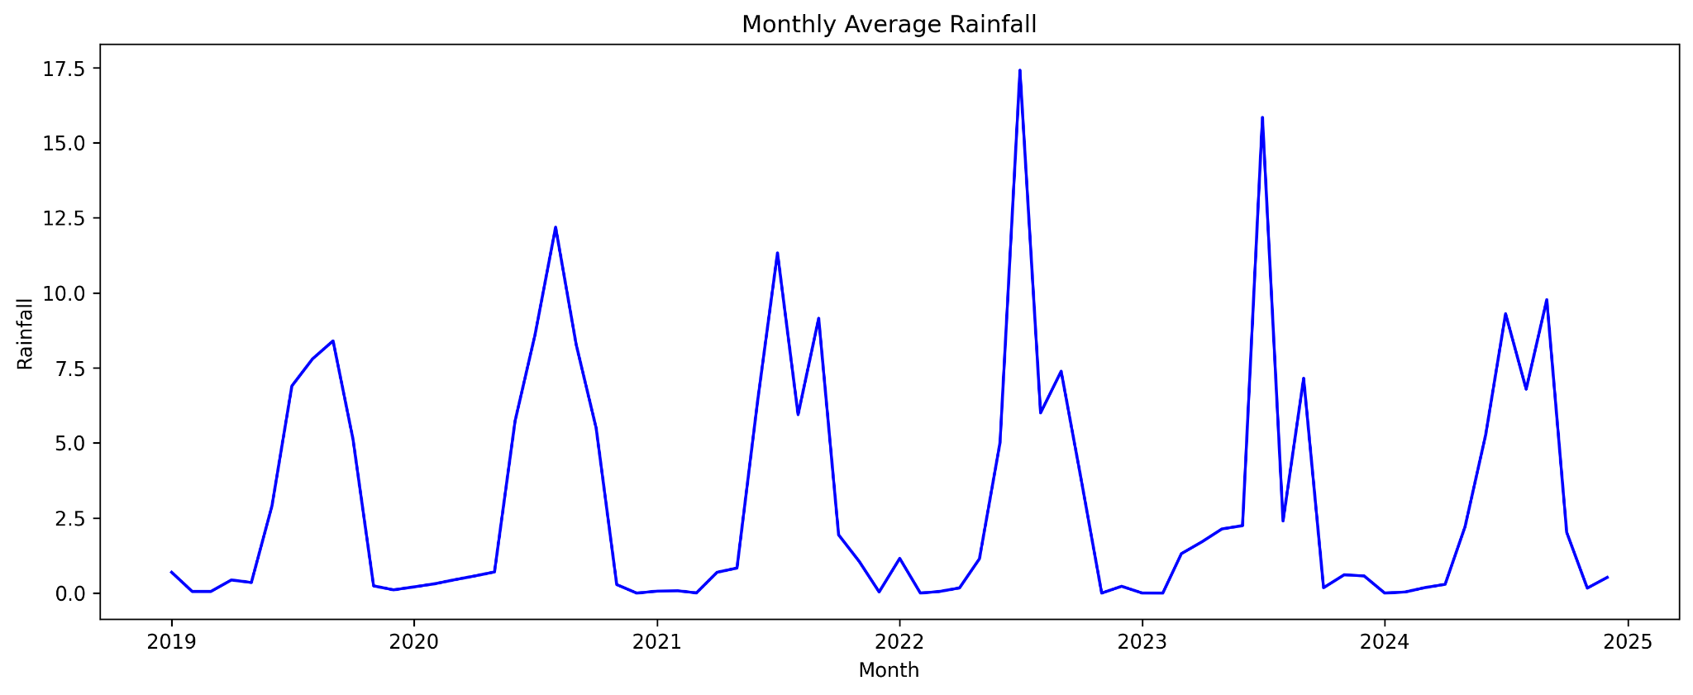
Figure 5.1 : Monthly Average Rainfall across the state
- Clear Seasonal Patterns : Rainfall clearly follows distinct seasonal cycles with predictable peaks and troughs throughout the year
- Monsoon Dominance : Plot also highlights periods of heavy monsoon rainfall, which are crucial for the state's agriculture.

5.1.2 Weather Data : Correlation Plot
The below heatmap shows how different weather features relate to each other, with warmer colors indicating stronger connections.
- Weak Temperature Correlation : It indicates that on a monthly, a high average minimum temperature does not necessarily guarantee a high average maximum temperature.
- Temperature and Rainfall : A negative correlation between Max_Temp and RainFall, quantifying the cooling effect of rain.
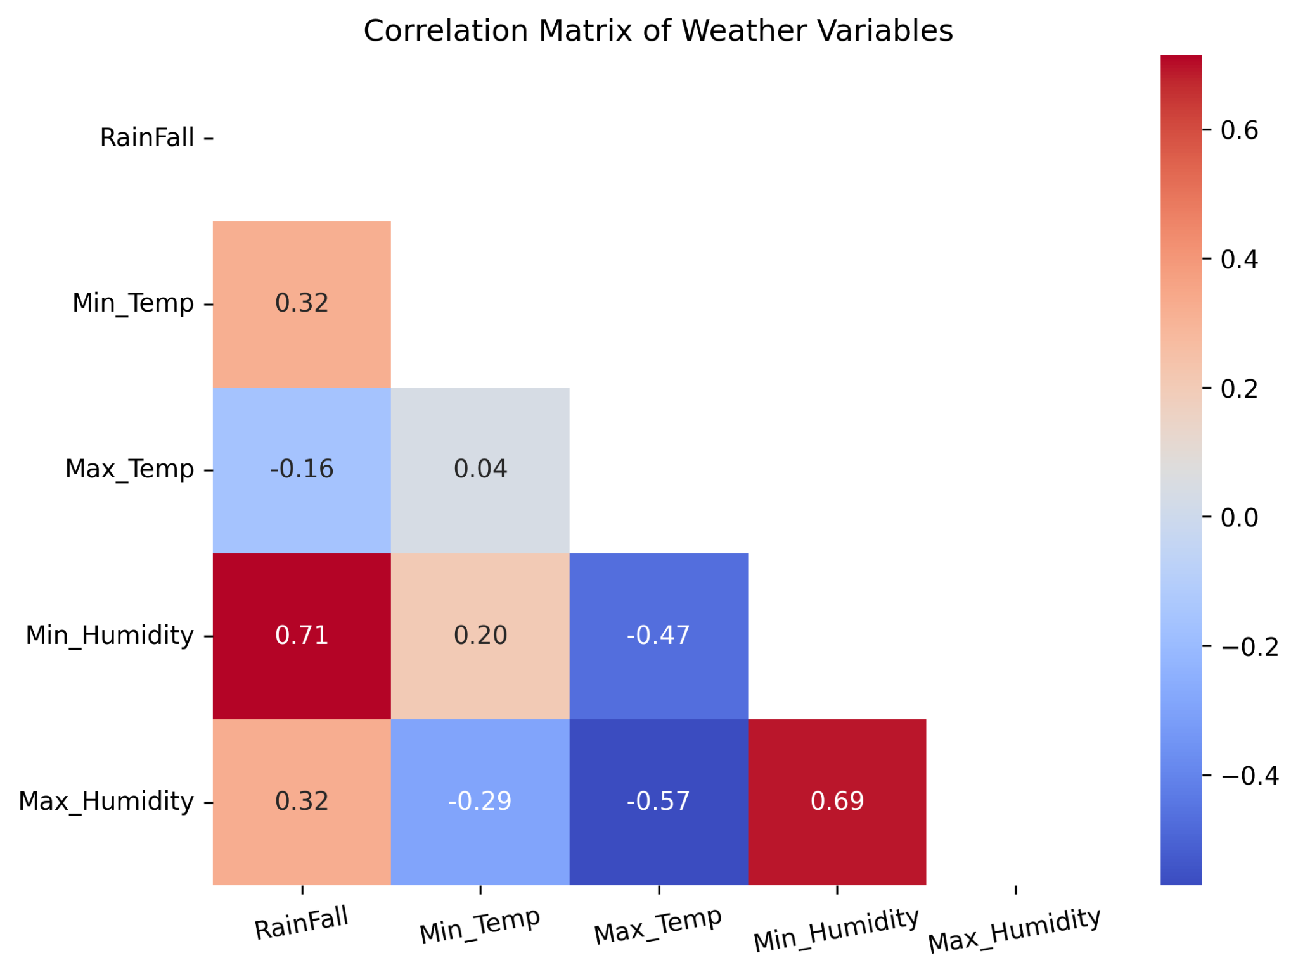
Figure 5.2 : Correlation Matrix of Weather Variables
- Rainfall Drives Humidity : Rainfall has a strong positive correlation with minimum humidity, meaning the rainy season keeps the air consistently moist.

5.1.3 TS-iPASS Data : Top 10 Sectors by Total Investment
This bar chart identifies which industry sectors have attracted the most investment through the TS-iPASS initiative.
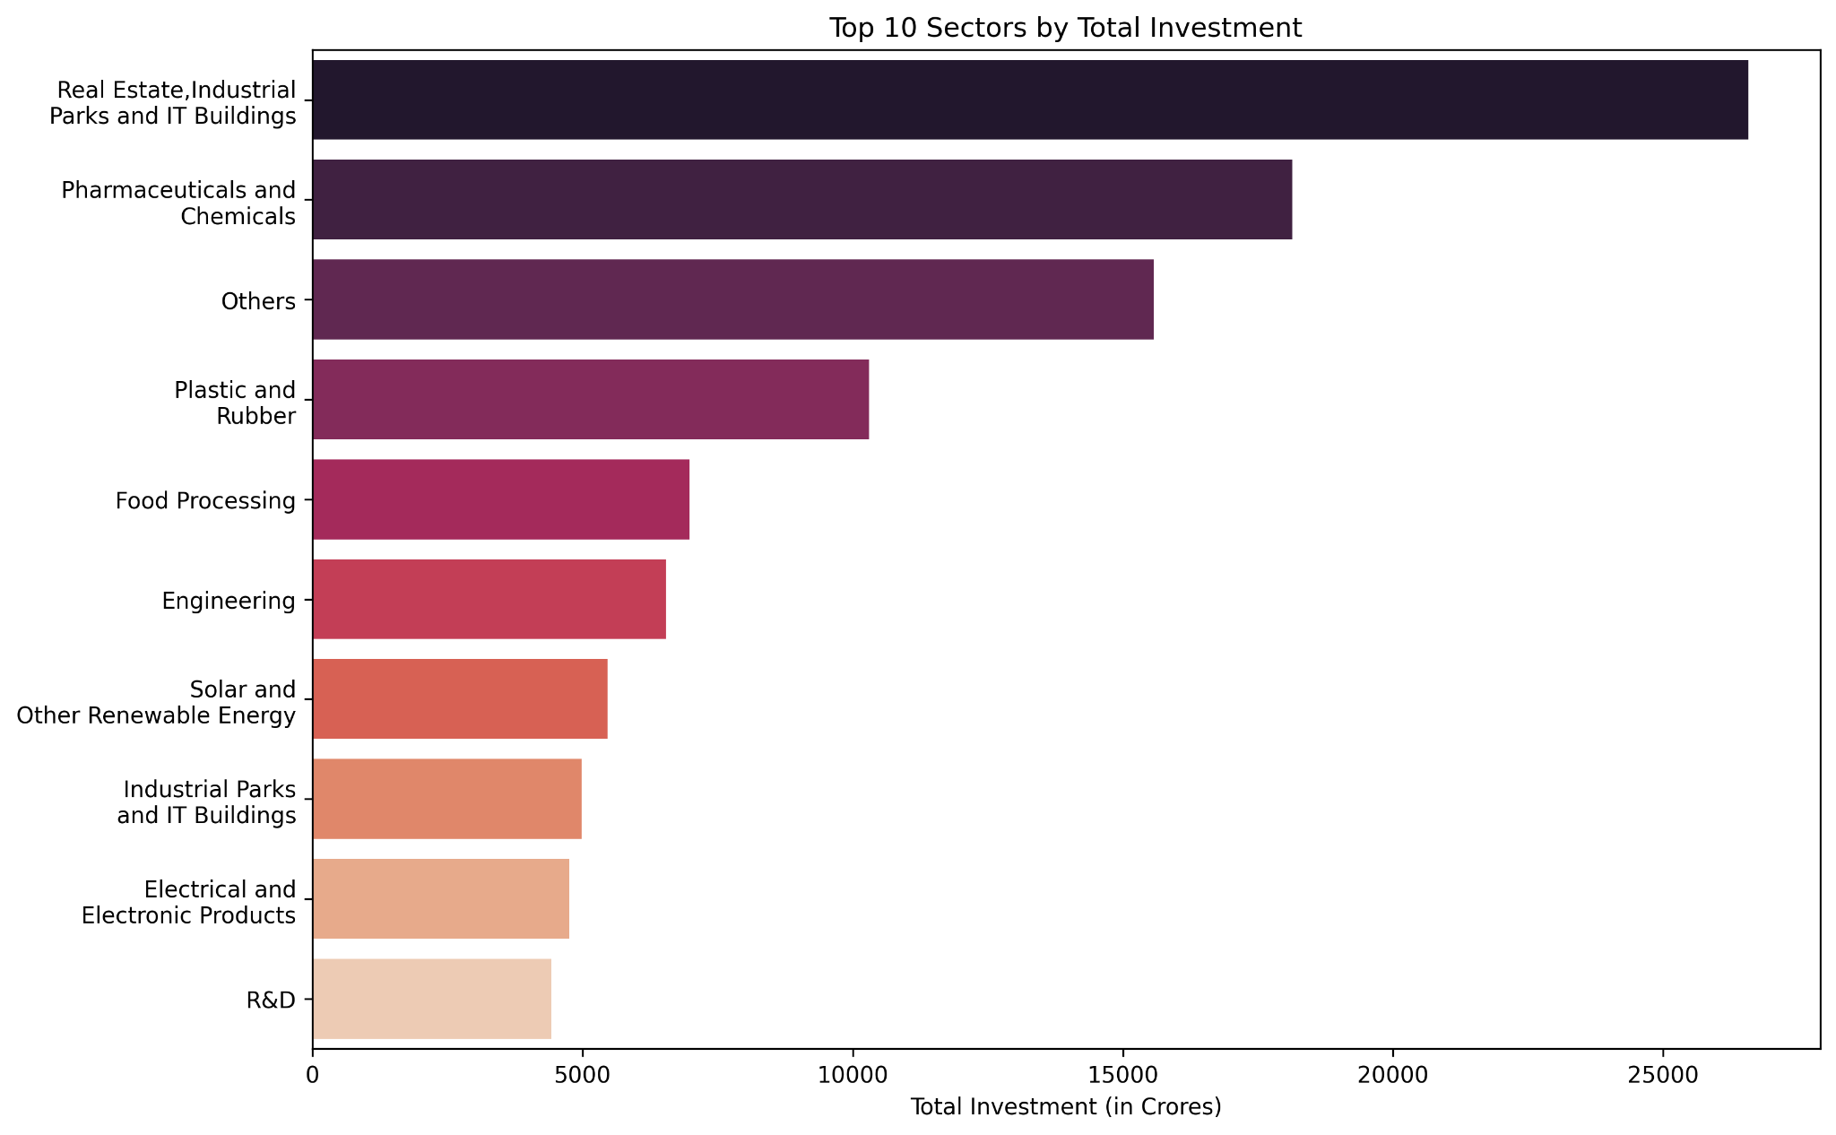
Figure 5.3 : Top 10 Sectors by Total Investment through TS-iPASS
- Targeted Industrial Growth : The concentration in plot suggests that the state focused on developing specific high-growth industries like Real Estate and IT Infrastructure.
- Key Investment Drivers : A few sectors, such as Pharmaceuticals & Chemicals and Food Processing, consistently attract the largest volume of industrial investments

5.1.4 TS-iPASS Data : Top 10 Districts by Total Investment
This bar chart highlights the top 10 districts that have received the most of the industrial investment during the period.
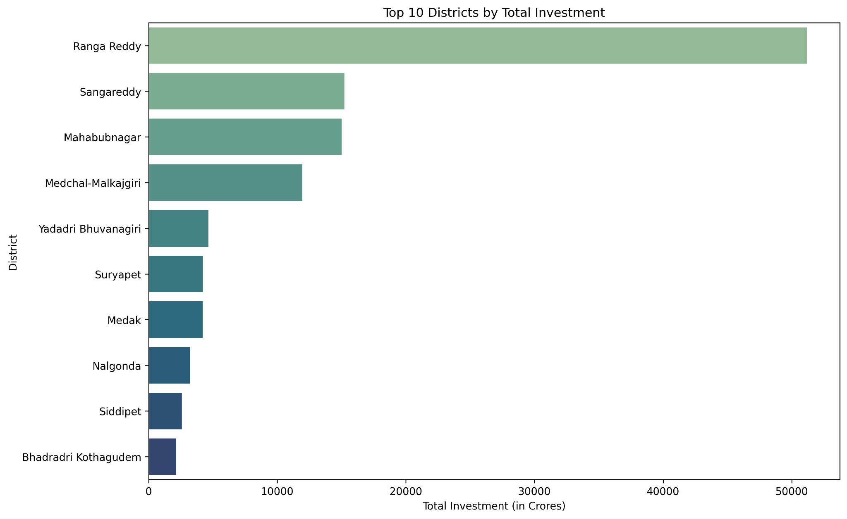
Figure 5.4 : Top 10 Districts by Total Investment through TS-iPASS
- Urban Investment Hubs : Districts like Rangareddy, Medchal Malkajgiri, and Hyderabad consistently attract the vast majority of investments.
- Geographic Concentration : This indicates a significant concentration of economic development in a few key urban and peri-urban centers, which all are located near to Hyderabad.

5.1.5 RTA Registration Data : Monthly Agricultural Vehicle Registrations
The below line plot shows how the number of registered agricultural vehicles has changed in the state over the period of time.
- Fluctuating Sales : Agricultural vehicle registrations show high monthly fluctuations, with some higher activity periods in the post COVID era and declining later.
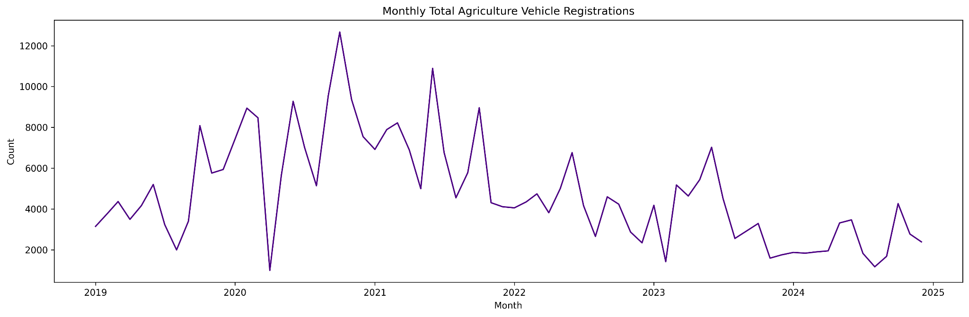
Figure 5.5 : Monthly Total Agricultural Vehicle Registrations
- Overall Downward Trend : Despite having some spikes, there is an observable general downward trend in agricultural vehicle registrations over the period.

5.1.6 RTA Registration Data : Monthly Total Electric Vehicle Registrations
This line plot specifically tracks the growth of electric vehicle registrations each month and will provide the growth of this sector with government subsidies for net zero carbon emission goal.
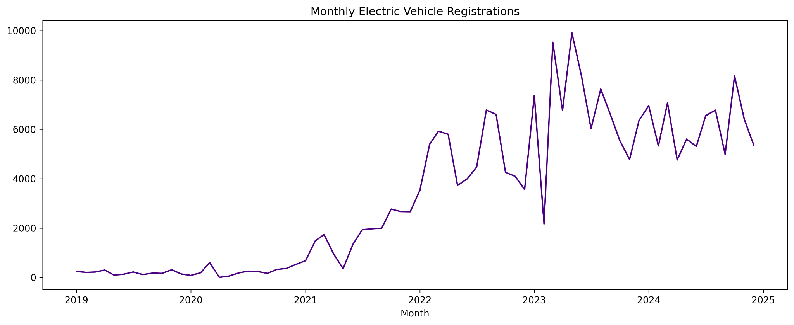
Figure 5.6 : Monthly Total Electric Vehicle Registrations
- Accelerating EV Adoption : Electric vehicle registrations shows a clear and consistent upward trend, indicating increased electric mobility adoption..
- Accelerated Growth : The government subsidies and carbon reduction policies accelerated rapid growth, the overall numbers are still relatively small compared to traditional fuel vehicles.

5.1.7 Registration Data: Monthly Total Revenue from Registrations
The below line plot illustrates the overall revenue generated from land and document registrations each month across the state for the time period.
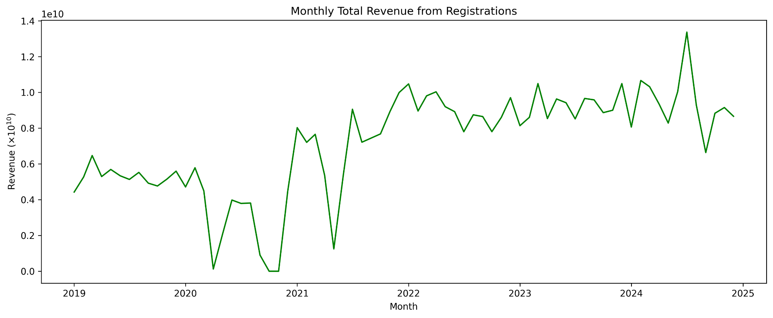
Figure 5.7 : Monthly Total Revenue from Registrations
- Strong Revenue Growth : Total revenue from registrations shows a clear and consistent upward trend, particularly after mid-2020.
- Strong Real Estate Market : This indicates a healthy and growing real estate market that significantly contributes to state revenue.

5.2 Insights and Plots from Problem Statements
This analytics project provides key critical insights to Telangana government governance and economic activities. This section concentrates on presenting insights to the problem statement, using the support of visual evidence from our data exploration.

5.2.1 Problem 1 : Small Investments Face Systemic Approval Delays
For initial analysis we focused on the project and their economic impact to realize the importance of the small-scale projects. As shown in the below plots, we found the majority of industrial projects are small-scale, but a few large projects drove the bulk of investments and job creation. This led to an initial assumption of existence of systematic delay or friction for small-scale projects initiation and approvals.

5.2.1.1 Number of Projects by Investment Category
The below plot Figure 5.8 clearly shows the dominance of MSME (Micro, Small & Medium Enterprises) activities across the state. The most number of the projects registered under the TS-iPASS window are MSME and particularly those having investments under 5 Cr. This indicates a high volume of small-scale entrepreneurial activity across the state and the impact might be fueled because of innovative initiatives like T-Hub. As per various news reports, the MSME’s are struggling to attract talent, location for expansion and lack of financial support from the government.
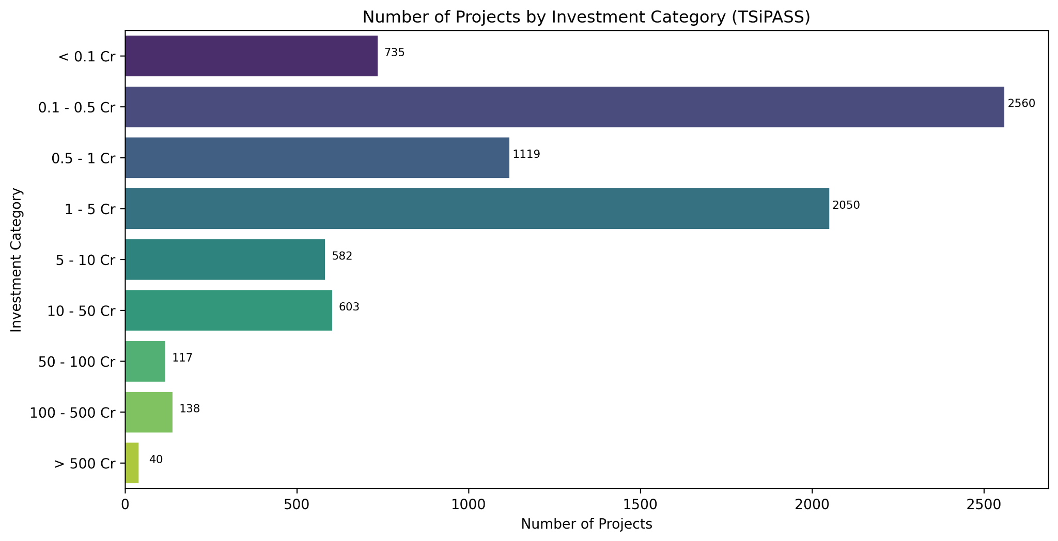
Figure 5.8 : Number of Projects by Investment Category (TSiPASS)

5.2.1.2 Total Investment by Investment Category
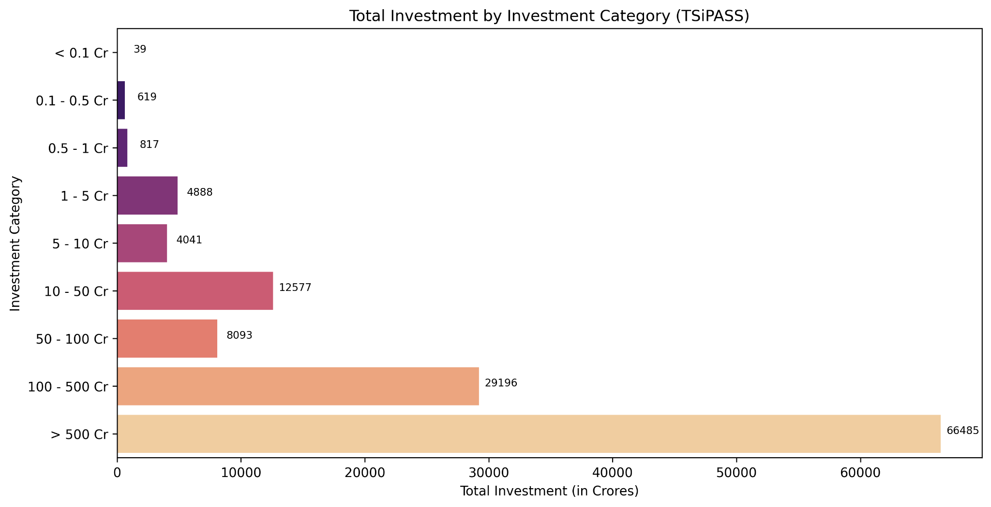
Figure 5.9 : Total Investment by Investment Category (TSiPASS)
The plot Figure 5.9, provides a stark contrast between the number of project applications and the total investments to those projects. Despite the high number of small projects, the vast majority of total investments are driven by a very small number of large/mega–scale (>500 Cr) projects. But comparing the job creation, larger the investment doesn’t mean greater the employment rate, instead the industries that made investments less than 500 Cr dominates the space.

5.2.1.3 Average Approval Delay by Project Investment Size
- This plot directly compares the size of an investment with the average approval time for those.
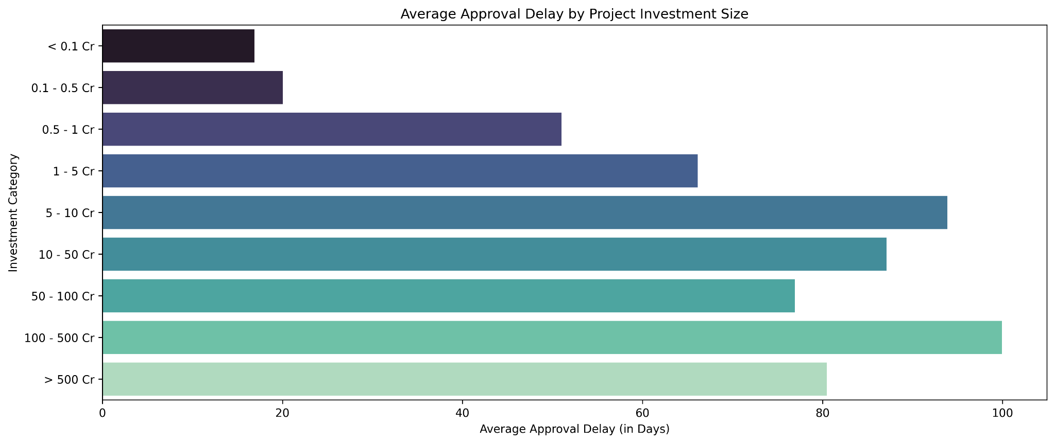
Figure 5.10 : Average Approval Delay by Project Investment Size
- The data reveals a clear and unexpected relationship between the project size and approval delays, contradicting the initial assumption that “small investments face systemic approval delays”.
- For small projects under 1 Cr are fast-tracked with an average delay of around 25 days, meanwhile the larger projects of greater than 100 Cr face a delay up to 100 days on average irrespective of the sector.
- The finding from the plot directly contradicts the initial hypothesis, and data proves small businesses are not having huge approval delays. Instead, the longest approval delays are faced by the large projects, likely due to more extensive regulation and scrutinies.

5.2.1.4 Top 10 Sectors with Longest Average Approval Delays
- The below plot shows the sectors that are taking more approval delays and the average time taken by those industries.
- The sectors that take the longest approval delays are typically the capex heavy industries like Real Estate, Industrial Parks and Textiles.
- This shows the nature of the industry is the significant factor in approval time and not the project investment size. Projects requiring land acquisition and environmental clearances are the most time consuming for the approval due to the higher scrutiny.
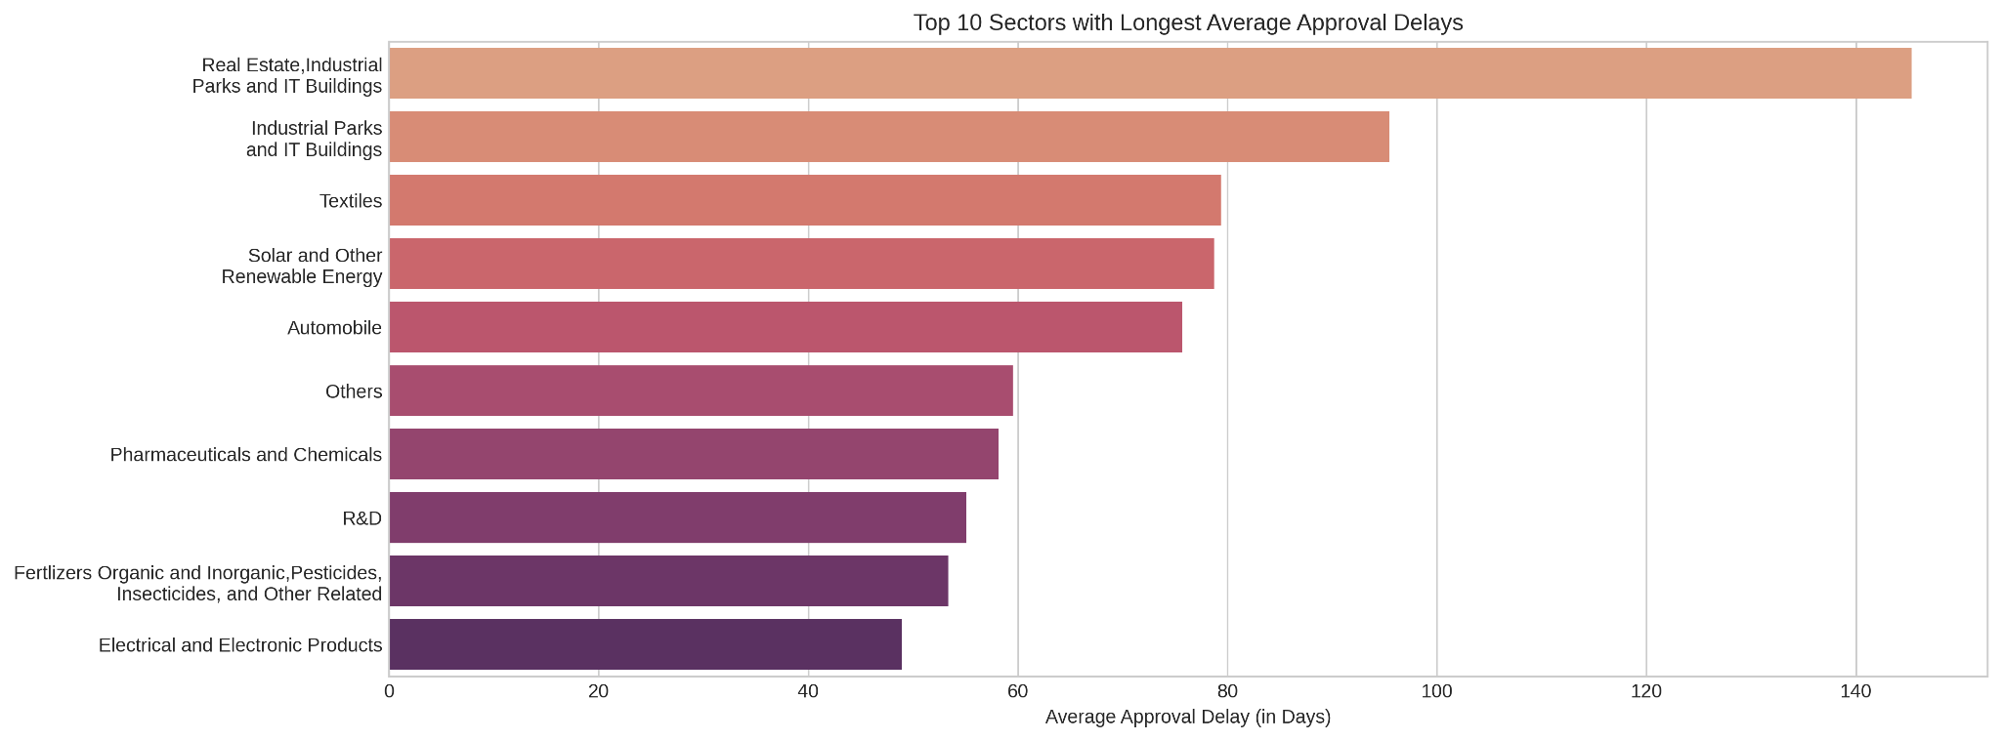
Figure 5.11 : Top 10 Sectors with Longest Average Approval Delays

5.2.2 Problem 2: E-Stamp Adoption Efficiency Over Document Registration
This problem statement explores the adaptation of digital infrastructure over the traditional methods. In India the digital transactions exploded from 2017, with the introduction of UPI and related transactions. Here we are analyzing the momentum of adaptation of digital transactions in registrations, the scalability and transparency of the governance.

5.2.2.1 Top 10 Districts by Overall Revenue from Registration
- This bar chart identifies the districts that generate the most revenue from document registrations.
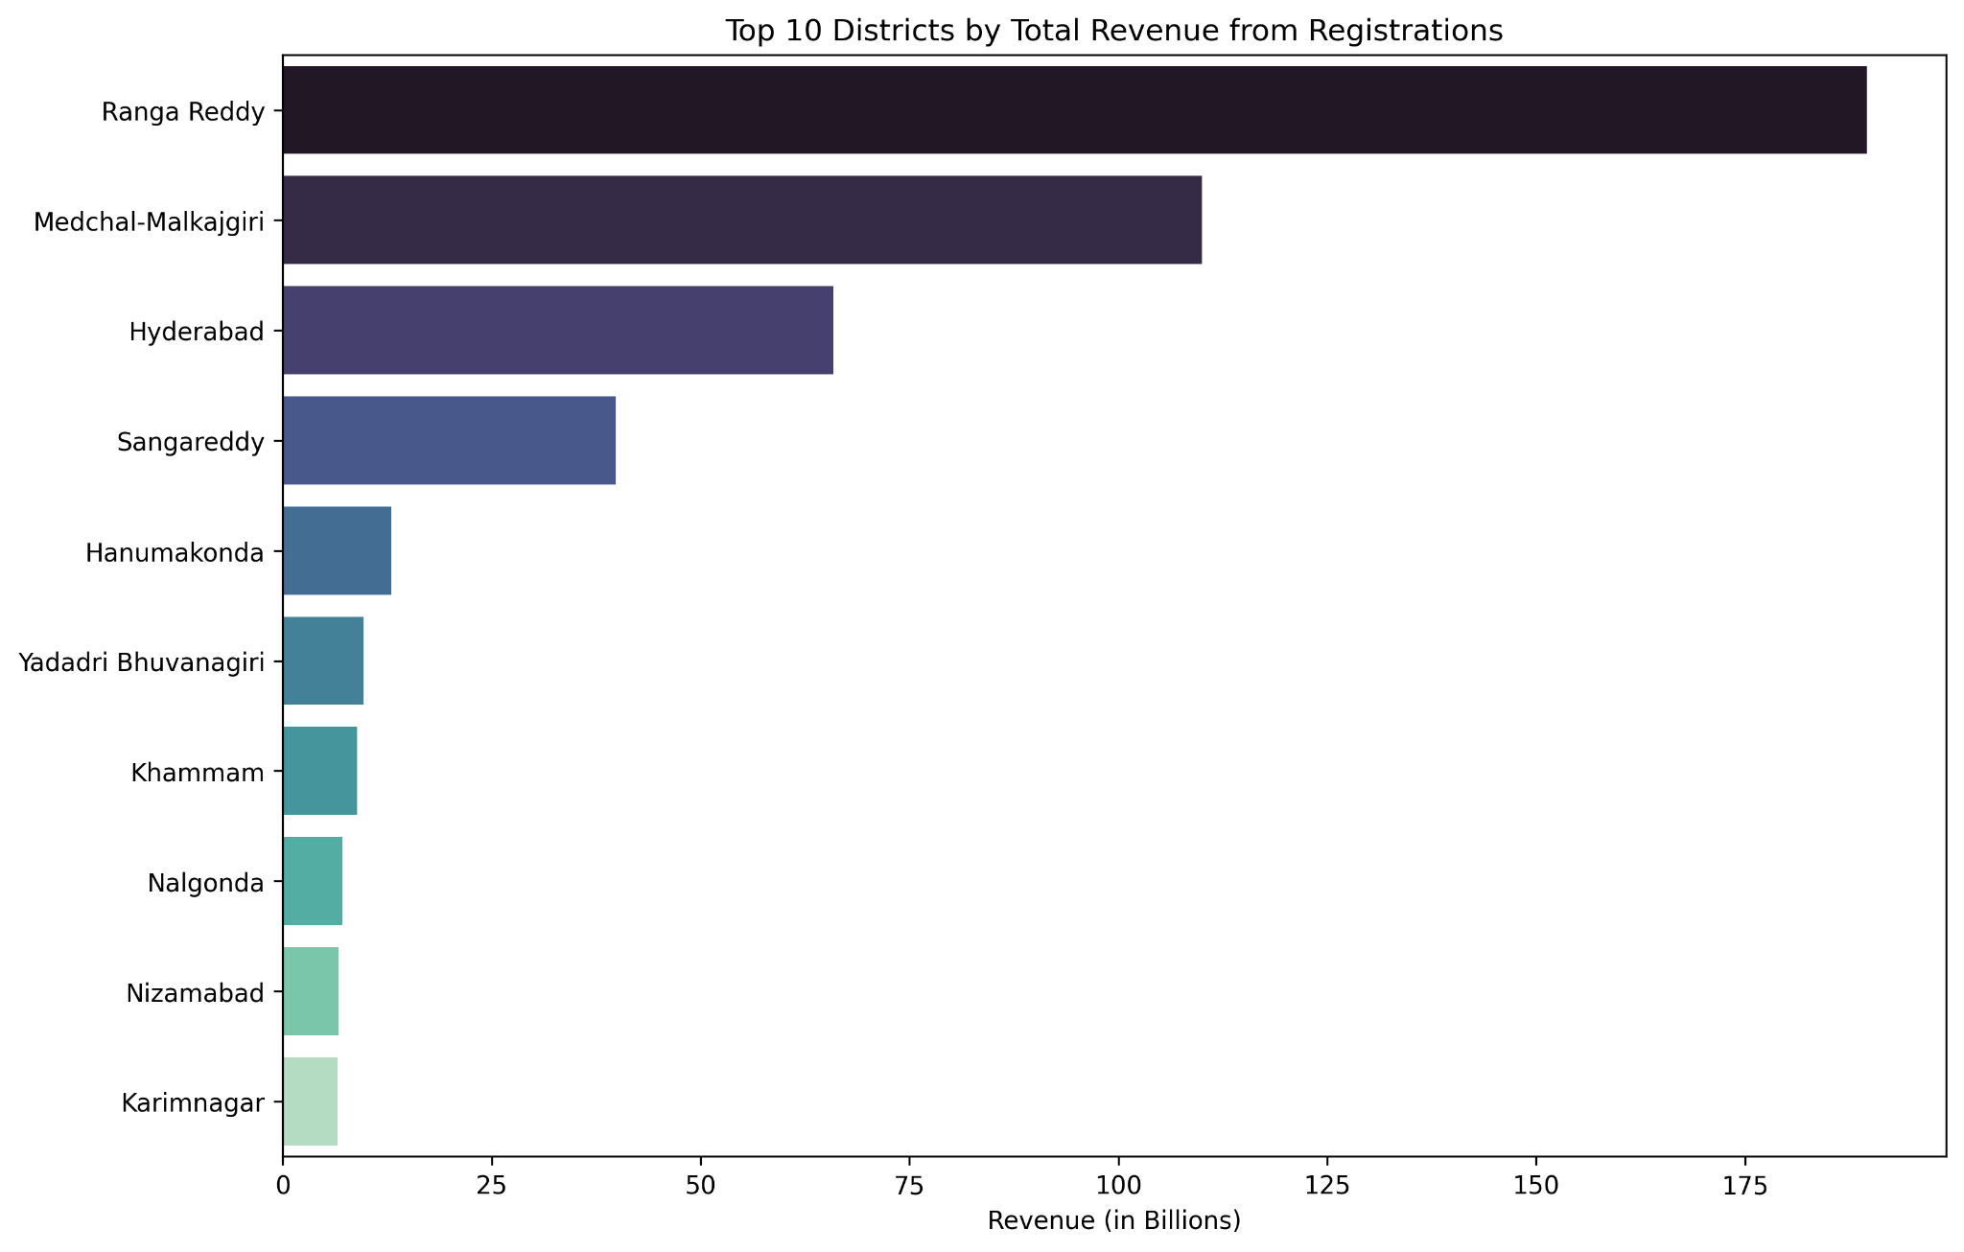
Figure 5.12 : Top 10 Districts by Overall Revenue from Registration
- Districts generating most of the total registration revenue are consistently led by major urban and peri-urban districts. This increased revenue from these districts might be due to the industrial investments these districts are bridging up.
- This highlights the digital efficiency of the e-stamp system has been successfully implemented and scaled in the state’s highest volume and revenue generating regions.
- The districts that generate most revenue and districts with most investment are highly overlapped and this might fasten the urban-rural division.

5.2.2.2 Monthly Total Revenue vs. E-Stamps Revenue
- This overlapping line plot shows the transition of revenue collection from traditional methods to the e-stamp system.
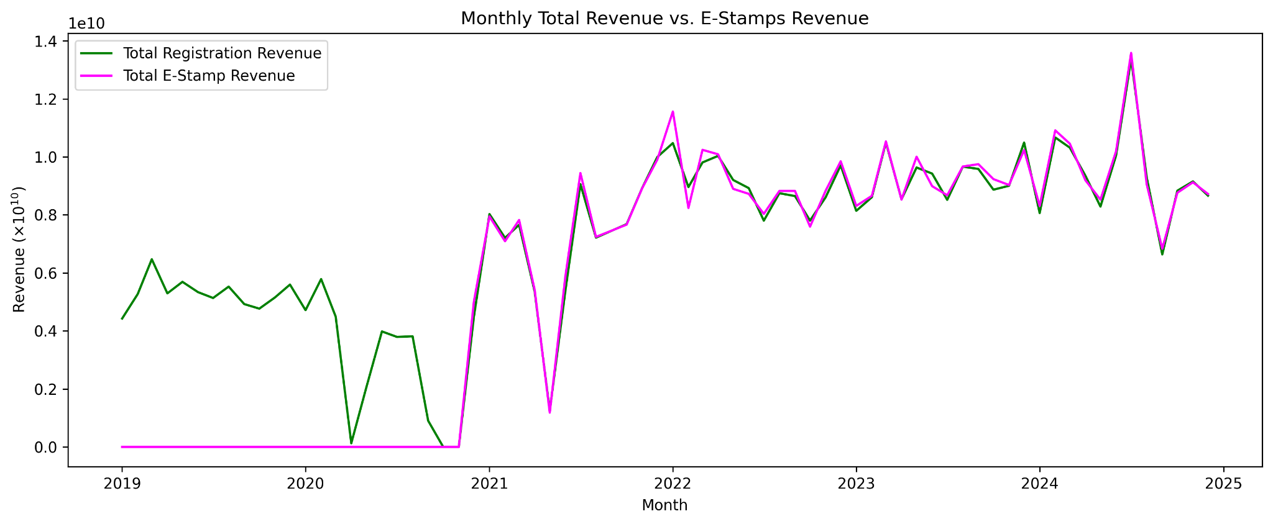
Figure 5.13 : Monthly Total Revenue vs. E-Stamps Revenue
- The plot shows that e-stamp revenue was zero until late 2020, and then made an exponential adaptation and then almost overlapped with the total registration revenue.
- This indicates the faster adaptation and transition from traditional methods to the digital infrastructure for fast and convenient processes.
- The dominance of digital adaption will help to scale the process, reduce the registration time and hustle free land transactions.

5.2.3 Problem 3: Rainfall-Mechanization Mismatch Inflates Farm Costs
This problem statement tries to highlight how inconsistent and erratic rainfall, with limited irrigation options might create inefficient machinery investments and thereby overall increased farm costs. This analysis provides strong visual and statistical evidence for this complex relationship between rainfall and mechanization.

5.2.3.1 Agricultural Vehicles vs. Rainfall Variability
This dual-axis plot tries to compare agricultural vehicle sales with rainfall variability for the top 10 agri-mechanization districts during a time period from 2019 to 2024.
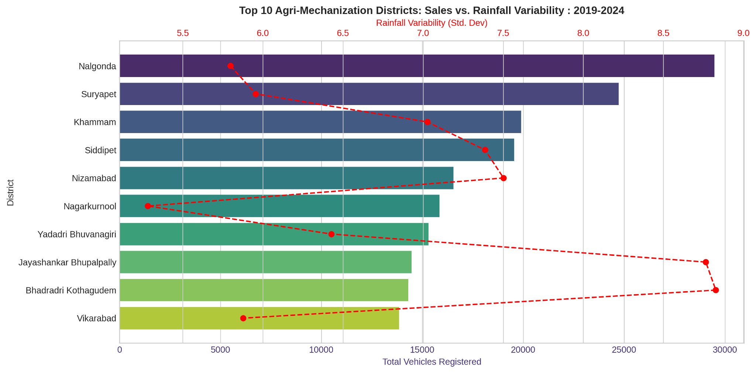
Figure 5.14 : Top 10 Agri-Mechanization Districts: Sales vs. Rainfall Variability : 2019-2024
- The plot shows that districts with the highest agricultural vehicle sales (e.g., Nalgonda, Suryapet, Khammam) tend to have moderate rainfall variability but not the highest.
- No districts among the top agri-mechanizations exhibit a high rainfall unpredictability, suggesting that investment in machinery is concentrated in these areas.
- Districts that are having rain variability range 5-7 shows the most vehicle sales, and these are not urban or peri-urban districts. Of these Nalgonda and Suryapet were the 2 districts that got recorded in the top 15 districts for investment value.
- This visualization provides clear evidence of a mismatch or a more complex relationship between rainfall and agri-mechanization. The agricultural mechanization is primarily occurring in areas that have manageable climate risk and these are the districts that are getting more investments from various industrial projects.

5.2.3.2 Rainfall Variability vs. Agricultural Vehicle Registrations with Regression Line
This below scatter plot shows the overall relationship between rainfall variability and agricultural vehicle registrations across all districts, with a regression line indicating the general trend of it.
- The regression line in this plot clearly shows, for the entire period it remained relatively flat or slightly negative with a wide confidence interval. This indicates the weakness or negligible linear relationship between rainfall variability and the agricultural sales.
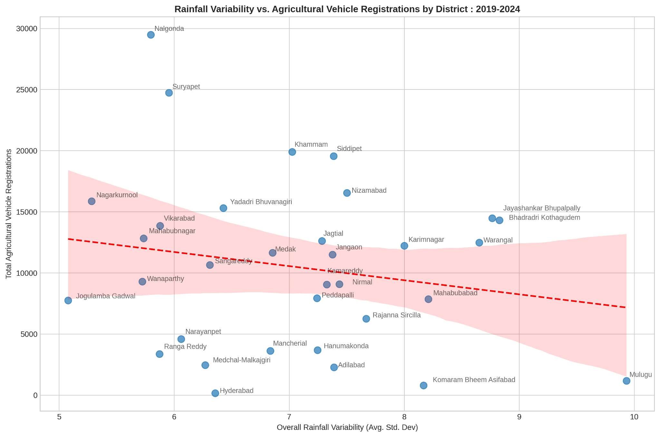
Figure 5.15 : Rainfall Variability vs. Agricultural Vehicle Registrations with Regression Line
- Like in the previous plot Jayashankar Bhupalpally and Bhadradri Kothagudem are two districts who are having higher rain variability and moderate agri-vehicle sales. While Mulugu showed higher rain variability and almost lowest vehicle sales.
- Districts that attracted more industrial investment fall in the confidence interval region and have comparatively less number of agri-vehicle sales. Districts that are nearer to Hyderabad, also have lower total agri-vehicle sales indicating the urbanization effects.
- The plot provides robust statistical evidence that across the state and over time, the agricultural mechanization is not proportionally higher in the regions where the erratic rainfall happens.

6. Interpretation of Results and Recommendation
The analysis provides critical insights into the key areas of Telangana's growth and offers evidence based interpretations and actionable recommendations.

6.1 Small Investments Face Systemic Approval Delays
The study showed a significant imbalance in the volume of applied small-scale and large projects through the TS-iPASS initiative for swift approval timelines. The analysis showed longest approval delays are faced by the largest projects and in some specific sectors and not the small-scale once. This discovery forces us to reframe the problem from ‘small projects facing barriers’ to ‘complex large-scale projects facing approval bottlenecks’.

6.1.1 Interpretation of Results
- Small ventures are fast tracked : The analysis clearly showed the small projects (under 1 Cr) having low average delay time of roughly 25 days. This shows the system is highly effective for the small projects for faster project implementation.
- Approval delays are a function of Sector and Scale : A delay of up to 100 days is common for large projects (> 100 Cr) and these are heavily concentrated in sectors like Real Estate and Textiles. This shows delay is due to the complexity of the project and environmental clearance required from various boards.

6.1.2 Recommendation
- Streamline High Impact Sector Approvals : Creating a more focused digitalized ‘single-window’ clearance system for large scale investments within TS-iPASS. This focus approach needs to be on sectors like Real Estate, Infrastructure and Textiles, this could reduce the delay and thereby will accelerate the capital investment and employment.
- Support Small Businesses : By addressing the tangible needs such as access to capital, talent, strategic locations and mentorships programs like T-Hub need to be widened. This could help to incubate much more small-scale initiatives to boost the economy.

6.2 E-Stamp Adoption Efficiency Over Document Registration
The analysis clearly showed the remarkable digital adaptation in the land registration process. E-Stamp revenue, which was non-existent prior to late 2020, abruptly exploded and quickly became the dominant source of registrations revenue. This successful digital adaptation is highly visible in high revenue and investment generating districts, shows the state's capacity for scalable digital governance.

6.2.1 Interpretation of Results
- Speedy and Complete Transition : The E-Stamp system growth was not a gradual one, instead it was an explosive growth and almost 100% of the revenue generation is through the E-Samp system.
- Scalability in High Volume Areas : The successful implementation of the digital system in urban and per–urban districts generates most of the revenue through this scalable system.
- Thus this new technology shows the scalability and robustness to handle high volume demand and transactions.

6.2.2 Recommendation
- E-Stamp Success : The study shows the critical success and accelerated digital transformation in the Non-Agricultural land registration, this same implementation in the Agricultural and Non-commercial land registration will improve efficiency and transparency of the land related transactions across the state.
- Enhanced Digital Infrastructure : The government must ensure robust digital infrastructure and cybersecurity support for the growing high volume of online transactions to protect long term reliability and the public trust.

6.3 Rainfall-Mechanization Mismatch Inflates Farm Costs
The analysis confirms a significant mismatch that districts with the highest agricultural vehicle sales consistently display moderate rainfall variability and not the most extreme ones. Opposite to that, regions that face the highest rainfall variability are most often under mechanized. This strongly indicates that the capital expenditure on agricultural vehicles is not well optimally aligned with climate realities and this might risk inflated farm costs without reliable irrigation.

6.3.1 Interpretation of Results
- Investment is Aligned with Predictable Risk : Agricultural mechanization is primarily concentrated in districts with manageable climate risk and predictable rainy regions and not in the most volatile regions. This predictable climate risk with modern farming techniques and mechanization might be helping to have much more yield.
- Likely Under-Investment in Infrastructure : This disconnect might be strongly suggesting lack of reliable irrigation infrastructure in the most volatile districts. Due to this lack of this infrastructure farmers might be hesitant to invest more on machinery as they cannot be used effectively due to lack of water.

6.3.2 Recommendation
- Prioritize Climate Aligned Irrigation System : The government has to strategically invest more in robust irrigation infrastructure like micro-irrigation, aqueduct and check dams in districts identified with high and low rainfall variability based on the geographic area.
- Link Subsidies to Infrastructure : The government must re-evaluate the subsidy programs for agricultural mechanization. These programs need to be linked with reliability of water resources and soil conditions of an area. This will help to target a cluster of farmers for their needs rather than treating the entire state as one.

