**EECS 331: Introduction to Computational Photography**

HW3: Flash/No Flash Photography

1. **Write an Android Program to capture a Flash/No Flash pair**

Backbone project was not used due to Tegra Tab’s white balance issue, although the code has been included with this assignment.

The following are two sample images.

Fig. 1: Image with flash

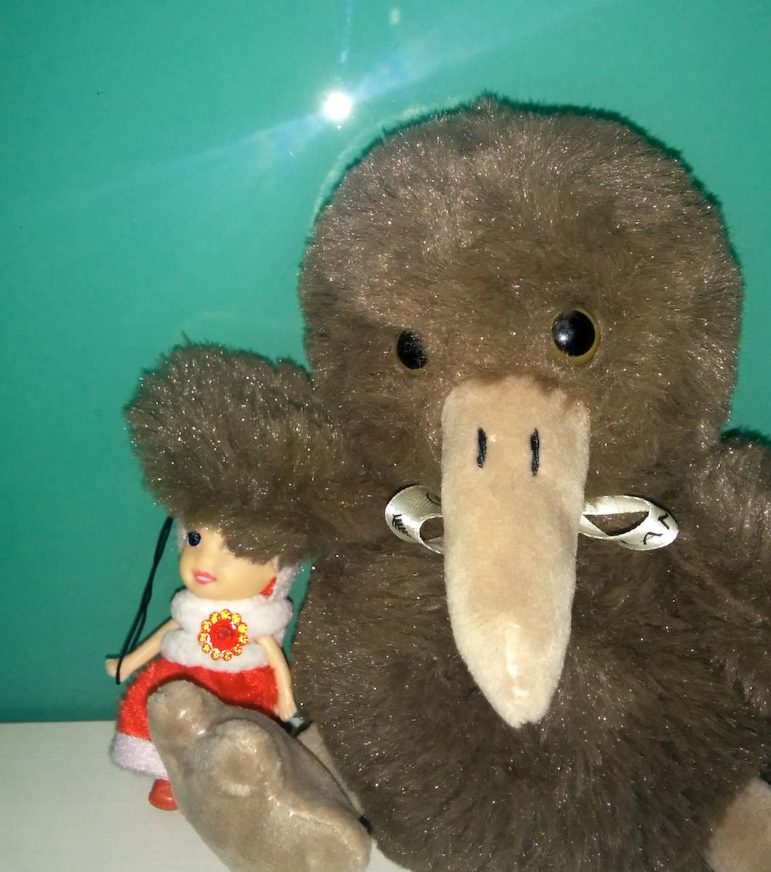

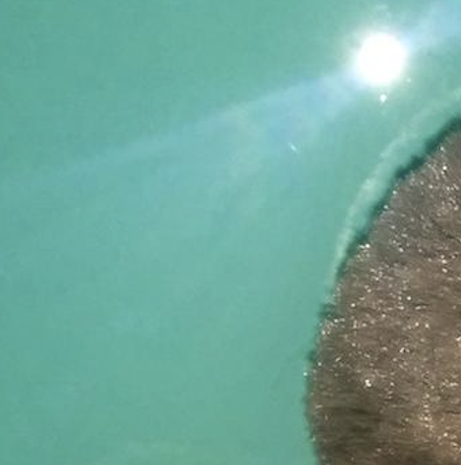

Fig. 2: Image without flash

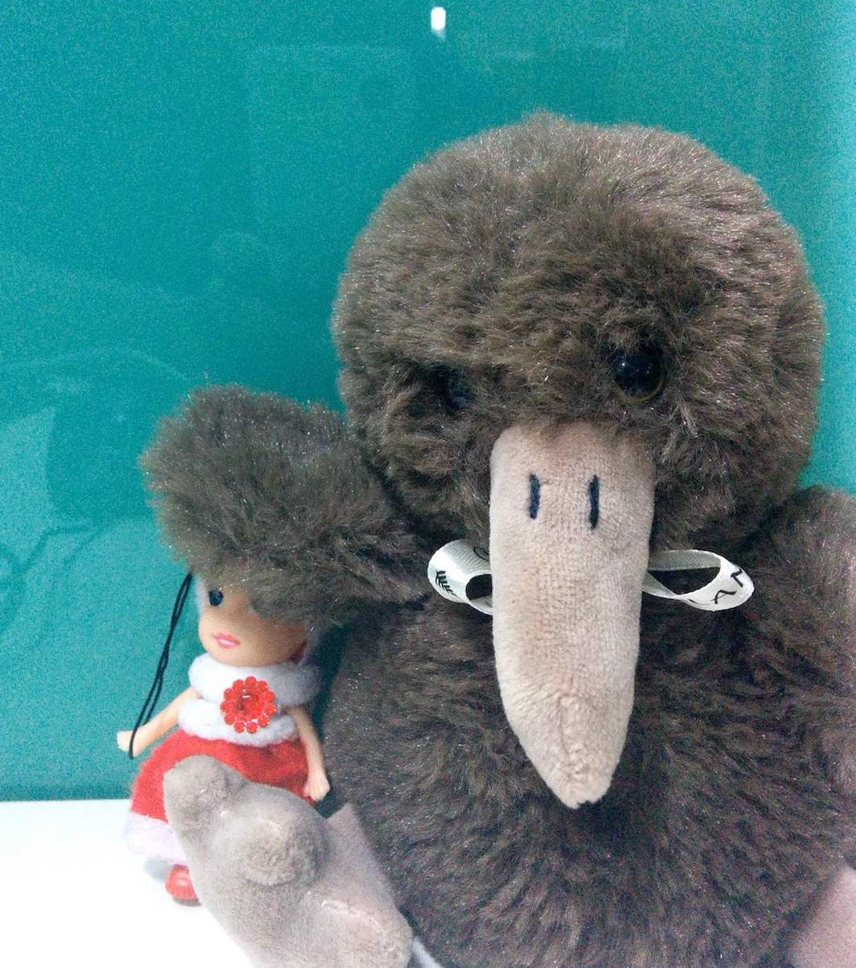

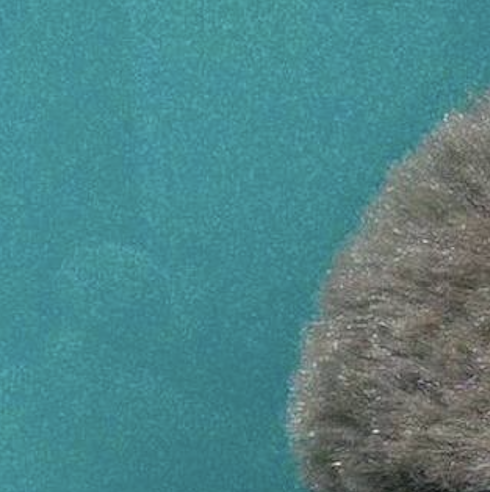

1. **De-noising the No-flash image captured previously**

MATLAB program was created to de-noise the images (HW3.m)

Process:

1. Load images to MATLAB
2. Crop them to required sizes (~1000x800)
3. Convert to double using im2double function.
4. Separate RGB color channels from the image.
5. Apply bilateralFilter() to each channel individually using optimal filter settings.
6. Concatenate them to form the de-noised image.

Optimal Filter Settings:

Values for σS and σR are selected by fine-tuning for best results.

σS = 8

σR = 0.05

Fig.3: De-noised No-flash image

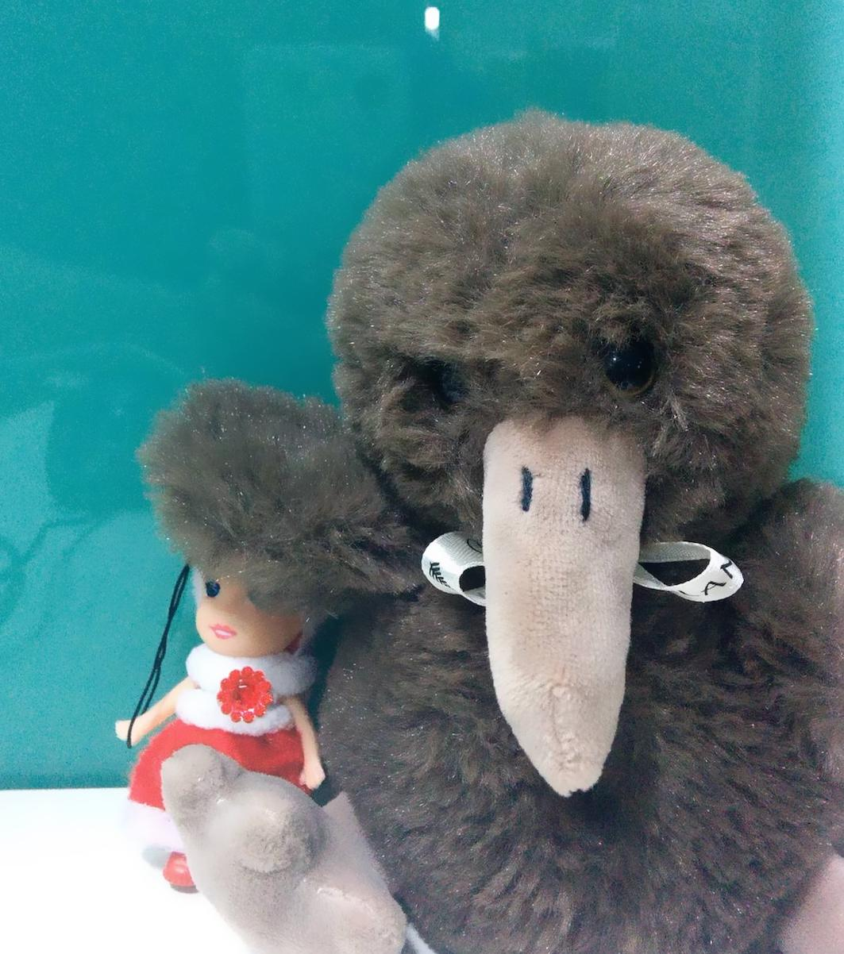

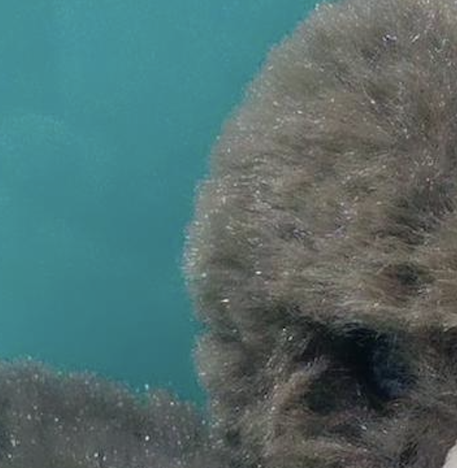

1. **Extract the details from the flash image and fuse the images together**

Bilateral filter applied to image with Flash.

Optimal Filter Settings (For Flash image):

Values for σS and σR are selected by fine-tuning for best results.

σS = 2

σR = 0.05

F is flash image (say)

FD is the de-noised flash image (say)

AD is the de-noised no-flash image (say)

ε = 0.02 (given)

Fusing Image for result:

The images are fused together by using the following equation:

**RESULT:**

Fig.4: Final Fused Image

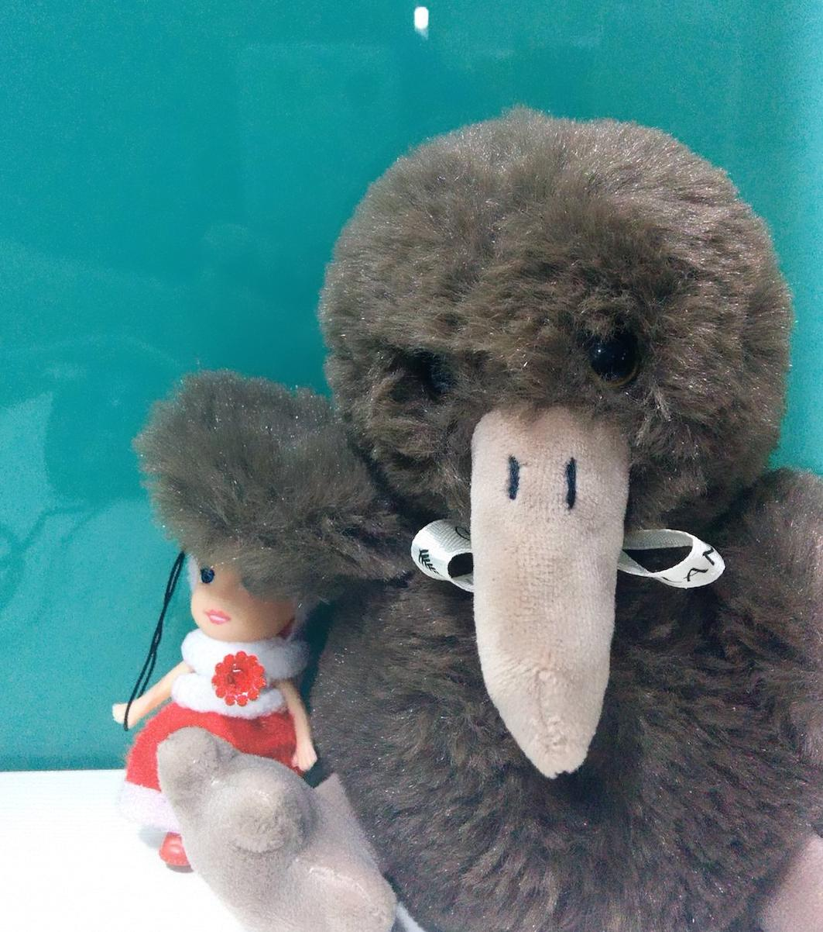

**Comparison:**



No-Flash image with high noise



Flash image with false colors



Fused Image with lower Noise

and right colors