E-commerce Conversion
Funnel Analysis
Project 1 — SyntecXHub Data Analysis Internship

1. Introduction & Objective
This report analyzes user behavior across a typical e-commerce conversion funnel to understand where potential customers drop off, where the biggest opportunities for improvement lie, and what concrete changes could increase the overall conversion rate. The dataset covers 20,000 user sessions across five traffic sources and three device types.
The funnel is defined as four sequential stages a user moves through before completing a purchase:
- Visit — the user lands on the website
- Product View — the user views at least one product page
- Add to Cart — the user adds a product to their shopping cart
- Purchase — the user completes checkout and pays

2. Funnel Overview
The chart below shows how the 20,000-user starting pool shrinks at each stage of the funnel. Only 5.3% of all visitors ultimately complete a purchase.
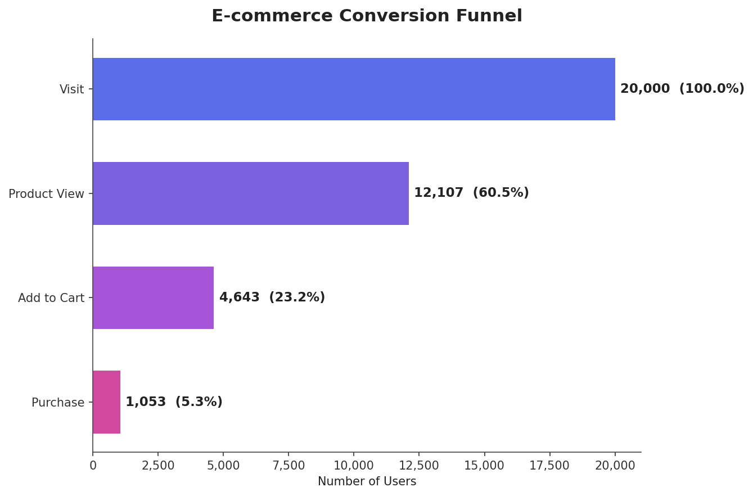
Funnel Stage | Users | % of Initial Visitors
Visit | 20,000 | 100.0%
Product View | 12,107 | 60.5%
Add to Cart | 4,643 | 23.2%
Purchase | 1,053 | 5.3%

3. Drop-off & Conversion Rate Analysis
Conversion rate measures what percentage of users at one stage successfully move to the next. Drop-off rate is the inverse — the percentage who are lost at that step. Both metrics are shown below for each transition in the funnel.
Funnel Step | Entering | Continuing | Drop-off Rate | Conv. Rate
Visit → Product View | 20,000 | 12,107 | 39.5% | 60.5%
Product View → Add to Cart | 12,107 | 4,643 | 61.6% | 38.4%
Add to Cart → Purchase | 4,643 | 1,053 | 77.3% | 22.7%

The chart below visualizes the drop-off rate at each step, making it immediately clear which transition leaks the most users.
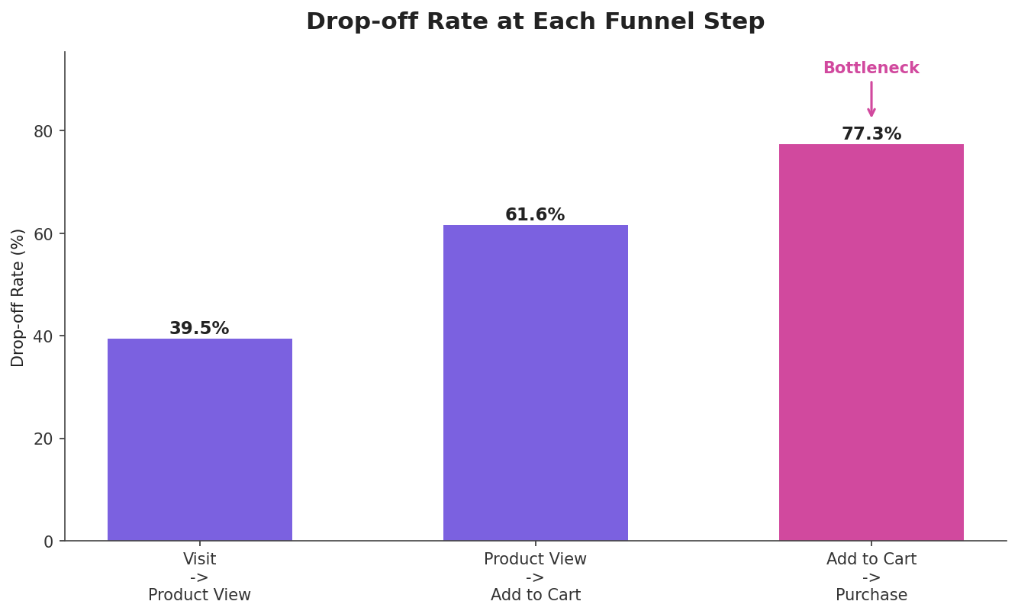

4. Bottleneck Identification
The Add to Cart → Purchase step is the clear bottleneck in this funnel, losing 77.3% of users who had already shown strong purchase intent by placing an item in their cart. This is a far larger leak than either of the earlier, more exploratory stages of the funnel.
To understand why, the same checkout step was broken down by device type, since checkout flows are typically more sensitive to screen size, form complexity, and payment friction than earlier browsing stages.
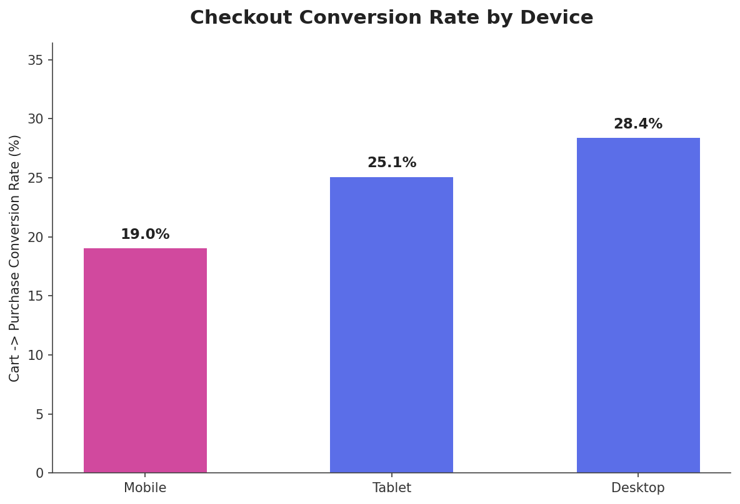
Mobile users convert from cart to purchase at just 19.0%, compared to 28.4% on desktop — a relative gap of roughly 33%. Since mobile accounts for the majority of total traffic (58% of all visitors), this single gap is responsible for a large share of total lost revenue.
A secondary view by traffic source shows that overall (visit-to-purchase) conversion also varies meaningfully by acquisition channel:
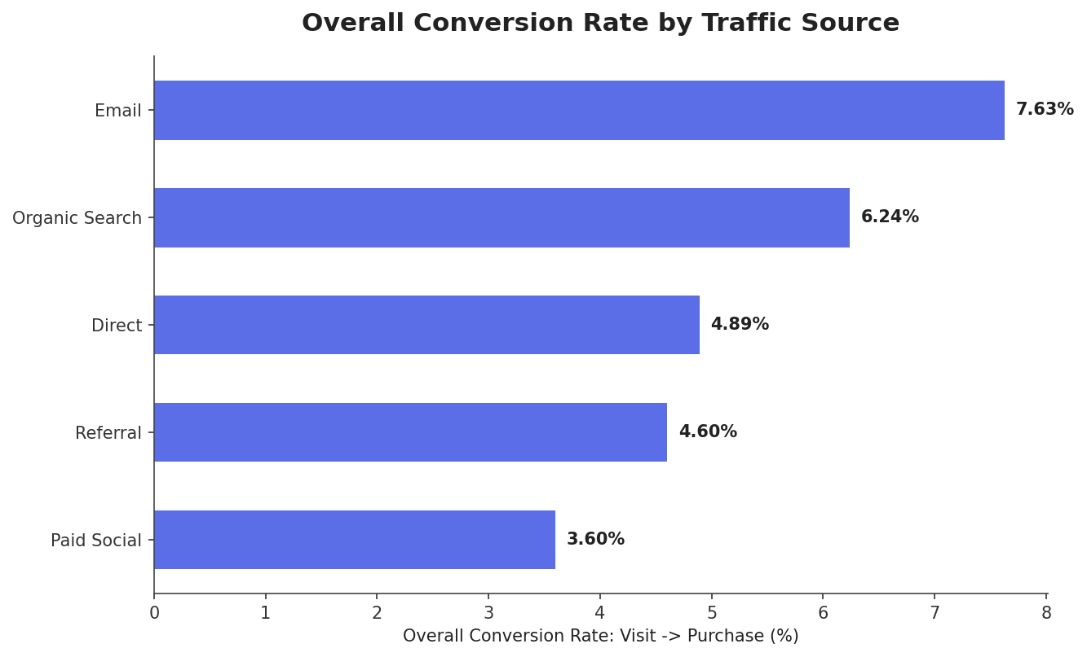
- Email traffic converts best overall (7.63%) — these are warm, pre-qualified users.
- Organic Search performs strongly (6.24%), reflecting high purchase intent from search queries.
- Paid Social converts worst (3.60%) despite high visit volume, suggesting a volume/intent mismatch — many clicks, little buying intent.

5. Recommendations to Improve Conversions
Based on the bottleneck identified above, the following improvements are recommended, ordered by likely impact:
- Simplify mobile checkout: Reduce form fields, enable autofill, and add one-tap payment options (Apple Pay / Google Pay / UPI) to close the mobile-vs-desktop conversion gap, since mobile represents the majority of traffic and the weakest checkout performance.
- Address cart abandonment directly: Introduce abandoned-cart email/SMS reminders, display total cost (incl. shipping) earlier to avoid surprise costs at checkout, and offer guest checkout to remove friction for first-time buyers.
- Build urgency and trust at the cart stage: Add limited-stock indicators, visible security/payment badges, and clear return policies near the 'Add to Cart' and checkout buttons to reduce last-minute hesitation.
- Re-evaluate Paid Social targeting: Since this channel drives high traffic but the weakest conversion, refine audience targeting or ad creative to attract higher-intent users rather than optimizing purely for click volume.
- Double down on what already works: Increase investment in Email and Organic Search channels, which already convert above the channel average, while testing improvements on weaker channels.
- A/B test the checkout flow: Once mobile checkout changes are implemented, A/B test variations (e.g., single-page vs. multi-step checkout) to validate impact before a full rollout.

6. Conclusion
Out of 20,000 visitors, only 5.3% completed a purchase, with the largest single point of loss occurring after users had already added a product to their cart. This indicates the core problem is not attracting interest, but converting that interest into a completed transaction — particularly on mobile devices. Prioritizing checkout simplification and cart-abandonment recovery represents the highest-leverage opportunity to improve overall funnel performance.

Methodology note: This analysis uses a synthetically generated dataset built to reflect realistic e-commerce funnel patterns (mobile checkout friction, channel-level intent differences) for demonstration purposes as part of the SyntecXHub internship program.

