HR Analytics:
Attrition & Retention Analysis
Project 2 — SyntecXHub Data Analysis Internship

1. Introduction & Objective
This report analyzes a 1,500-employee dataset to understand the drivers of employee attrition, quantify it with key HR metrics, and compare outcomes across departments and roles. The goal is to identify which factors most strongly predict attrition so HR and leadership can prioritize retention interventions where they will have the greatest impact.
The dataset includes demographic fields (age, gender), employment fields (department, job role, tenure, salary, performance), and experience fields (job satisfaction, work-life balance, overtime status, commute distance), alongside whether each employee has left the company (attrition).

2. Key HR Metrics (KPIs)
The table below summarizes the core KPIs used to measure organizational health, comparing employees who left against those who stayed.
Metric | Left | Stayed
Headcount | 418 | 1,082
Avg. Tenure (years) | 1.7 | 2.7
Avg. Monthly Salary | $5,654 | $6,377
% Working Overtime | 37.3% | 26.2%
Avg. Job Satisfaction (1-4) | 2.3 | 3.1

Overall Attrition Rate | Overall Retention Rate
27.9% | 72.1%

With nearly 3 in 10 employees leaving, attrition at this level is high enough to materially affect hiring costs, team continuity, and institutional knowledge. The sections below break down exactly where and why.

3. Attrition Patterns

3.1 Job Satisfaction
Job satisfaction shows the clearest and steepest relationship with attrition of any factor studied. Employees reporting low satisfaction leave at more than 5x the rate of those reporting very high satisfaction.
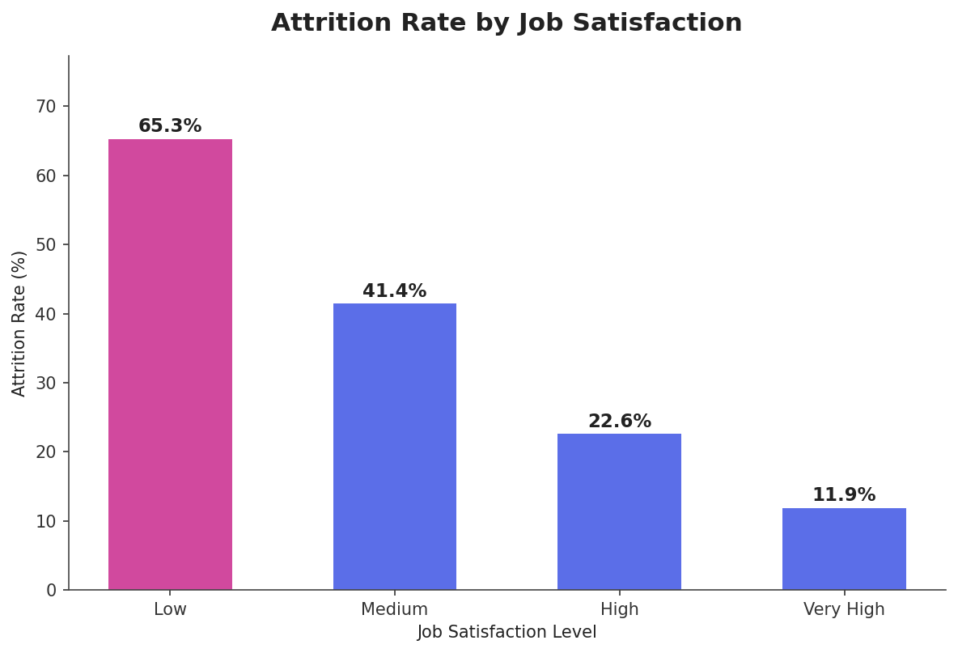

3.2 Overtime
Employees who regularly work overtime leave at a meaningfully higher rate (35.5%) than those who do not (24.7%) — a relative increase of roughly 44%.
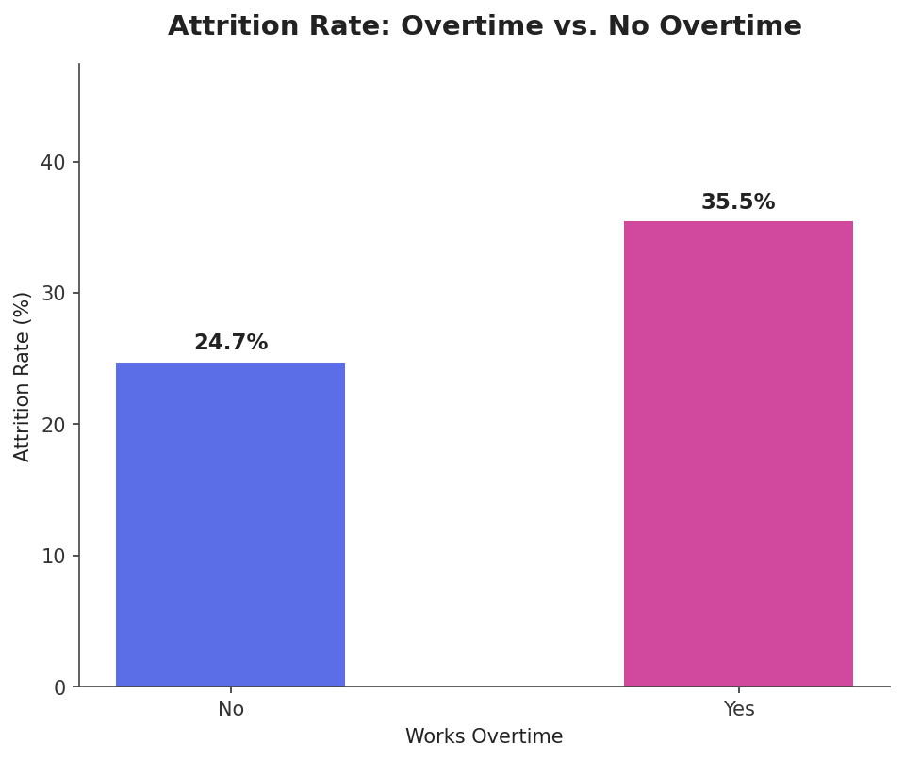

3.3 Tenure
Attrition is heavily concentrated in the early tenure window. Employees in their first year leave at nearly 4x the rate of employees with 9+ years of tenure, consistent with a common 'flight risk' period before employees fully settle into a role.
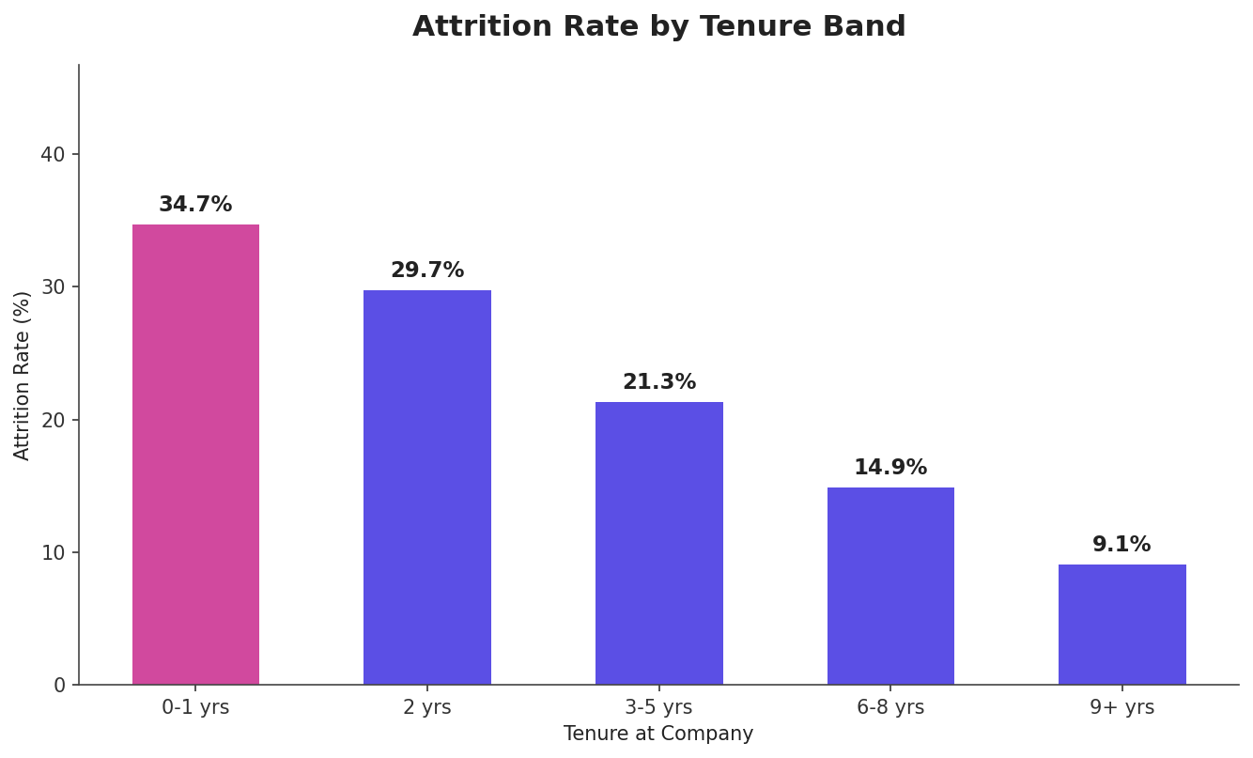

4. Correlation Analysis
To identify which factors matter most, Pearson correlation was calculated between each numeric field and attrition. Negative values mean higher values of that field are associated with lower attrition (e.g., higher satisfaction → less attrition); positive values mean the opposite.
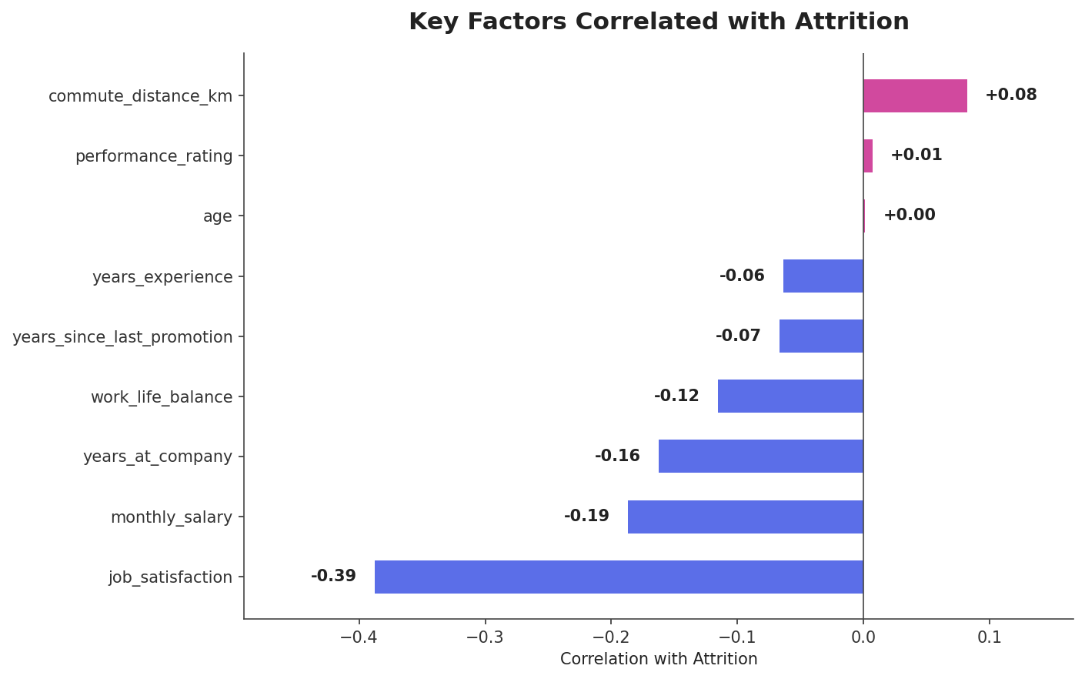
Factor | Correlation | Direction
Job Satisfaction | -0.39 | Strong
Monthly Salary | -0.19 | Moderate
Years at Company | -0.16 | Moderate
Work-Life Balance | -0.12 | Weak-Moderate
Years Since Promotion | -0.07 | Weak
Commute Distance | +0.08 | Weak

Job satisfaction is, by a wide margin, the single strongest predictor of attrition in this dataset — more than double the strength of the next-closest factor (salary). This suggests that compensation alone is unlikely to solve retention; the underlying experience of the job matters more.

5. Department & Role Comparison
Attrition is not evenly distributed across the organization. Customer Support and Sales show the highest attrition rates, more than double that of Engineering and Finance.
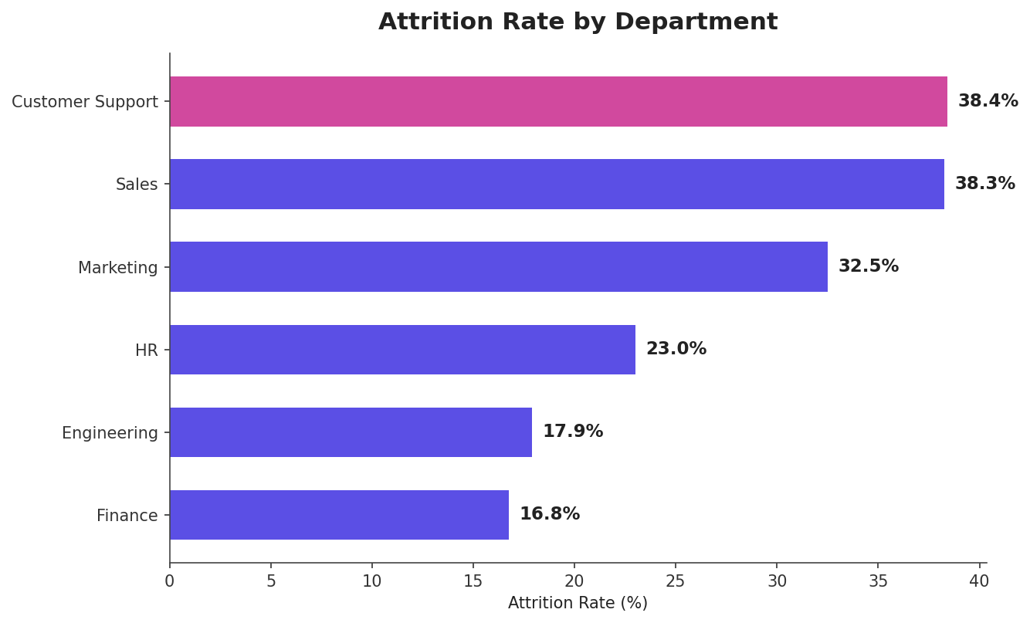
Department | Headcount | Attrition Rate | Avg. Satisfaction
Customer Support | 237 | 38.4% | 2.7
Sales | 330 | 38.3% | 2.7
Marketing | 194 | 32.5% | 2.8
HR | 122 | 23.0% | 3.0
Engineering | 403 | 17.9% | 3.1
Finance | 214 | 16.7% | 3.2

The pattern holds even after accounting for pay: the chart below compares average salary between employees who left and stayed, within each department. Gaps are modest in most departments, reinforcing that satisfaction and role-specific stress — not compensation alone — are the primary drivers of the department-level differences.
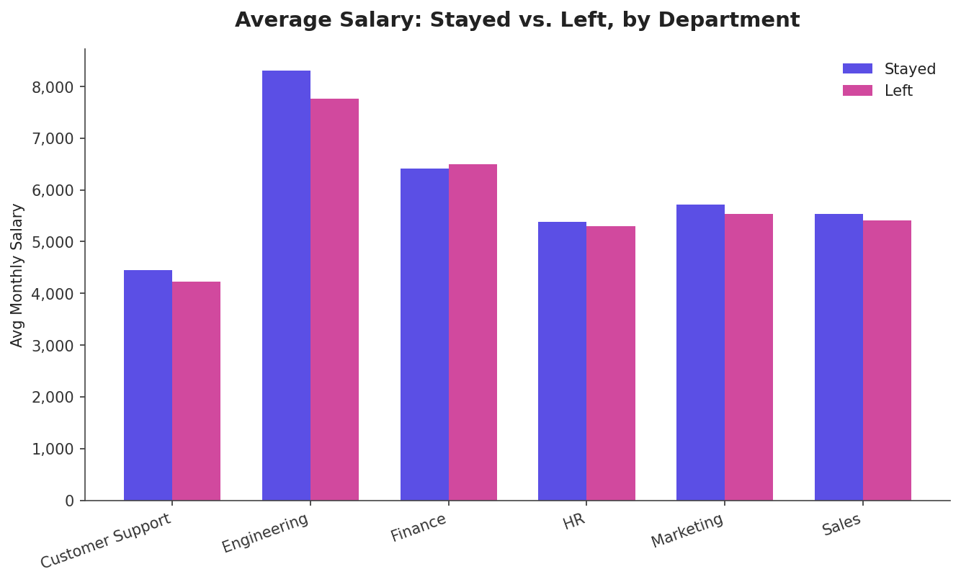

6. Recommendations
Based on the patterns identified above, the following actions are recommended, ordered by likely impact:
- Prioritize job satisfaction directly: Since satisfaction is the strongest predictor of attrition by a wide margin, run regular pulse surveys and act visibly on the feedback, particularly in Sales and Customer Support, where both attrition and dissatisfaction are highest.
- Target overtime reduction in high-risk departments: Review staffing levels and workload distribution in Sales and Customer Support, where overtime is likely compounding dissatisfaction and accelerating attrition.
- Strengthen onboarding and first-year support: With attrition concentrated heavily in year one, invest in structured onboarding, early mentorship, and 30/60/90-day check-ins to improve early retention.
- Review compensation as a secondary lever: While salary is not the strongest factor, it is still meaningful (-0.19 correlation); ensure pay remains competitive, especially in Customer Support and Sales where attrition is highest.
- Investigate role-specific stressors in Customer Support and Sales: Since attrition there is not fully explained by pay, conduct exit interviews and stay interviews to identify the specific day-to-day pain points driving departures.
- Revisit promotion cadence: Years-since-last-promotion has a weaker but still meaningful relationship with attrition; ensure career progression conversations happen on a predictable schedule, particularly for tenured employees who may otherwise feel stagnant.

7. Conclusion
Overall attrition stands at 27.9%, concentrated disproportionately in Sales and Customer Support and among employees in their first year of tenure. Job satisfaction emerged as the dominant predictor of attrition — far stronger than salary, tenure, or any other factor measured. This indicates that retention efforts will be most effective if they focus on the day-to-day employee experience (workload, satisfaction, overtime) rather than compensation increases alone, particularly within the two highest-risk departments.

Methodology note: This analysis uses a synthetically generated dataset built to reflect realistic HR attrition patterns (satisfaction, overtime, tenure, pay) for demonstration purposes as part of the SyntecXHub internship program. An accompanying interactive HTML dashboard (hr_analytics_dashboard.html) provides live filtering and drill-down by department.

