Wearable Sleep Staging Research Prototype
Evidence-focused prediction report
Generated (UTC): 2026-07-18 14:07 UTC
Model af0f2cb49980: HGB context model; 30-s epochs; 9 base features; +/-2 epoch offline context

Predicted stage summary
Predicted stage | Epochs | Duration (min) | Share of analyzed epochs (%)
Wake | 130 | 65.0 | 13.6
NREM | 470 | 235.0 | 49.1
REM | 357 | 178.5 | 37.3

Complete predicted hypnogram
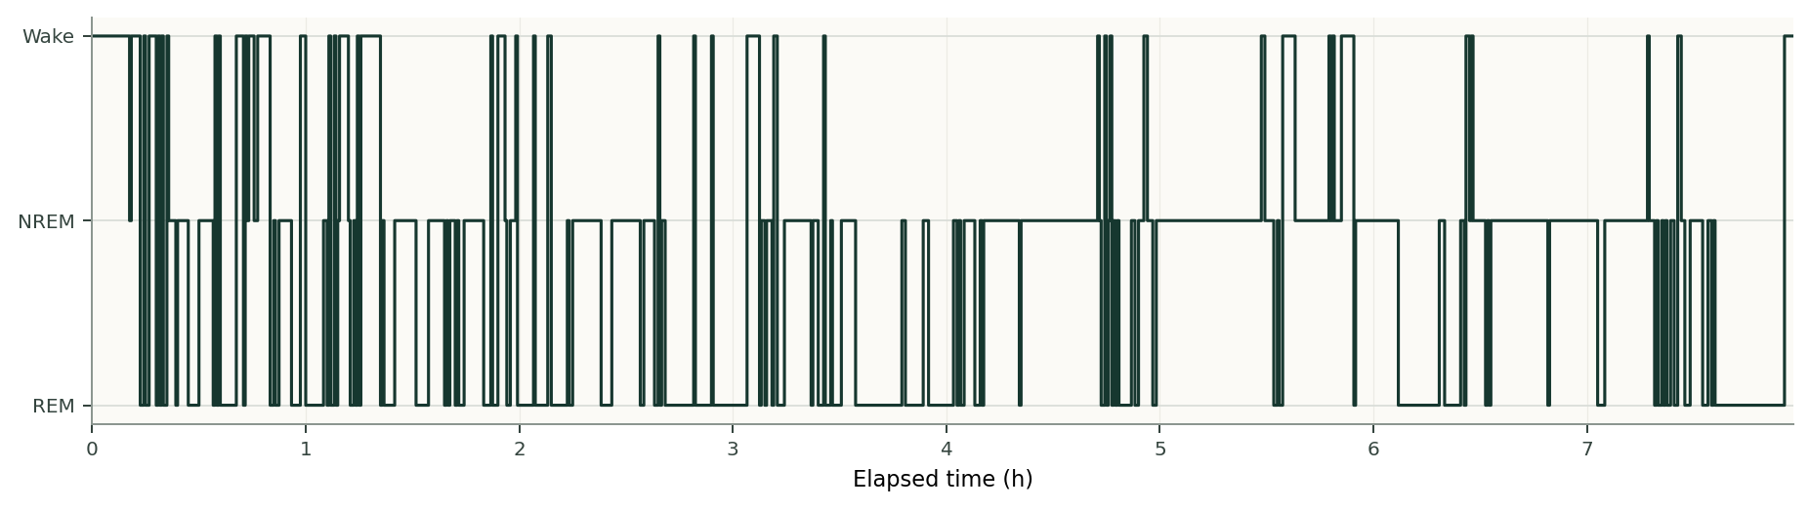

Model-derived exploratory metrics
Input epochs: 961
Analyzed epochs: 957
Predicted total sleep time (min): 413.5
Predicted sleep proportion within analyzed window (%): 86.4
Predicted wake between first and last sleep epochs (WASO-like, min): 51.5
Derived solely from model-predicted Wake/NREM/REM labels; not independently validated clinical sleep measures.

Research limitations
- Three-class Wake/NREM/REM output; this is not five-stage AASM sleep staging.
- Offline inference uses two preceding and two following epochs.
- No online training, tuning, calibration, or clinical diagnostic function is performed.
- Cross-device generalization is limited; results should not guide clinical decisions.
Research use only. Not for diagnosis or clinical decision-making.

