**Java**

**public** **class** BST {

**private** Node root=**null**;

**private** **class** Node{

**private** **int** key;

**private** Node left_child;

**private** Node rightchild;

**private** Node parent;

Node(**int** key){

**this**.key = key;

**this**.left_child=**null**;

**this**.right_child=**null**;

}

} . . .

-public Node search(int key)

**C**

**typedef struct _bTreeNode**

**{**

**BTData data;**

**struct _bTreeNode * left;**

**struct _bTreeNode * right;**

**} BTreeNode;**

**-BTreeNode * BSTSearch(BTreeNode * bst, BSTData target);**

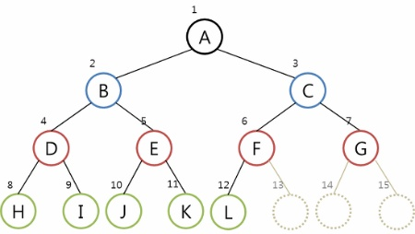

**Function modulation**

BTreeNode * GetLeftSubTree(BTreeNode * bt);

BTreeNode * GetRightSubTree(BTreeNode * bt);

void MakeLeftSubTree(BTreeNode * main, BTreeNode * sub);

void MakeRightSubTree(BTreeNode * main, BTreeNode * sub);

**ex) Insert function**

if(GetData(cNode) > data)

cNode = GetLeftSubTree(cNode);

else

cNode = GetRightSubTree(cNode);

}

nNode = MakeBTreeNode();

SetData(nNode, data);

if(pNode != NULL)

{

if(data < GetData(pNode))

MakeLeftSubTree(pNode, nNode);

else

MakeRightSubTree(pNode, nNode);

}