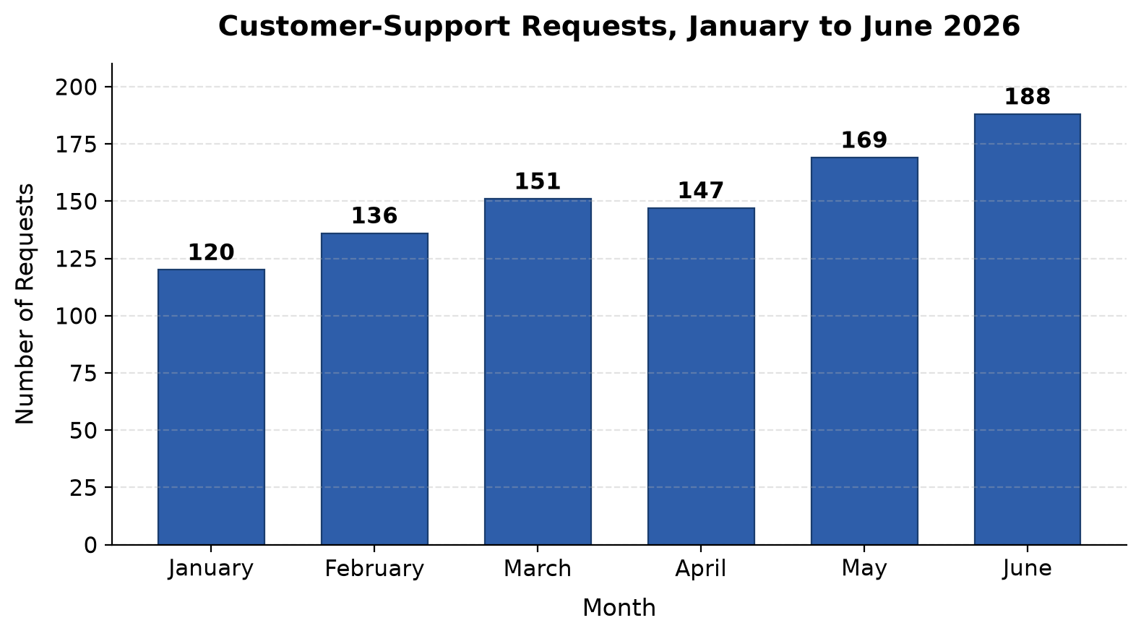
Figure 1: Customer-Support Requests, January to June 2026
Source: Course-provided data.

Figure 1 shows customer-support requests from January to June 2026. Overall, requests followed an upward trend, rising from 120 in January to 188 in June. The only decrease occurred in April, when requests dropped from 151 in March to 147. After that brief dip, volume climbed again in May and June. June recorded the highest number of requests at 188. Together, these figures suggest steadily growing demand for customer support during the first half of the year.

