TEAM 2025109

Index

S No. | Topic | Page No.
1 | Introduction | 2
2 | Exploratory Data Analysis | 2
3 | Statistical Analysis | 5
4 | KPI | 6
5 | Agentic Report Generation | 7
6 | Budget Allocation: MMM Model and Robyn | 10
7 | Sale Calendar | 13
8 | Budget Allocation: Bilevel Optimization | 14
9 | Market Lens | 16
10 | Results | 16

Introduction
In the current era of digital transformation, organizations are generating increasingly vast volumes of data, making data analytics an indispensable component for effective decision-making, especially within the domain of digital marketing. ElectroMart, a prominent Canadian e-commerce company specializing in electronic products, has encountered challenges related to its previous year's marketing expenditures, leading to considerations about budget reductions or reallocation across various marketing channels to enhance revenue outcomes.
To address these challenges, our team developed an innovative analytical solution named "Market Lens". Market Lens is designed to not only provide detailed exploratory data analysis (EDA) and insights generation but also dynamically adapt to user-uploaded datasets to produce real-time market expenditure dashboards. Moreover, by integrating advanced statistical techniques and leveraging the Agentic Framework, Market Lens can autonomously generate comprehensive marketing expenditure analysis reports.
The primary objectives pursued through Market Lens are multifaceted, encompassing performance driver analysis to identify critical Key Performance Indicators (KPIs) influencing revenue, quantitative evaluation of marketing Return on Investment (ROI), optimization of marketing budget allocation, targeted product category analysis, and strategic identification of optimal marketing channels. By deploying Marketing Mix Modeling (MMM), including the Robyn framework and Ridge Regression methods, our solution effectively quantifies the incremental impact of marketing activities and formulates strategic recommendations for optimal budget allocations.
Exploratory Data Analysis
A comprehensive exploratory data analysis (EDA) was conducted using the provided data to uncover critical insights related to customer behavior, product performance, market dynamics, and the influence of external factors such as weather. The analysis was systematically structured into several analytical segments, each addressing specific components of the e-commerce business performance using the tools:
- Matplotlib: Basic plotting and visualization
- Seaborn: Statistical data visualization
- Plotly: Interactive data visualization
Customer Analysis
- Order Frequency Distribution: Analysis indicated variability in customer purchasing frequency, demonstrating distinct segmentation opportunities.
- GMV Distribution: Order value distributions highlighted customer spending patterns, informing pricing strategies.
- Payment Type Preferences: Cash on Delivery (COD) was identified as the dominant payment method, constituting approximately 72.5% of transactions.
- Service Level Agreement (SLA) Analysis: SLA adherence varied across products, influencing customer satisfaction.
- Pincode Distribution: Orders were geographically dispersed, with top pin-code prefixes showing high concentrations.
- Product MRP Analysis: Products within price ranges of 1000-5000 INR constituted the highest order volume.
- FSN ID Analysis: A small fraction of FSNs accounted for the majority of orders, reflecting high product concentration.
Bivariate Analysis
- Price vs. Order Volume: Negative correlation was observed, indicating lower-priced items sold in higher volumes.
- Payment Type vs. GMV: Higher GMV correlated with prepaid transactions, indicating trust dynamics influencing payment method choices.
- Customer Loyalty vs. Spending: Frequent buyers demonstrated increased average spending.
- Regional Spending Patterns: Geographic analysis revealed varied spending behaviors and opportunities for targeted marketing.
- Day of Week vs. Order Volume: Sales peaked on weekends, particularly during promotional periods.
- Time of Day vs. Order Value: Evening hours witnessed increased purchase frequency and order value.
- Category vs. Payment Type: Payment preferences varied significantly by product categories.
Product Analysis
- Category Performance: Performance metrics varied notably across categories, with specific verticals demonstrating robust growth.
- Subcategory Distribution: Certain subcategories disproportionately contributed to revenue.
- Product Hierarchy Visualization: Sunburst and heatmap visualizations clearly outlined product performance and hierarchy.
- Word Clouds: Frequently mentioned terms highlighted product attributes important to customers.
- Product Pricing Analysis: Price sensitivity analysis revealed optimal price points across categories.
Master Data Analysis
- Revenue Trend Analysis: Revenue displayed clear trends and seasonality, peaking during festival and promotional periods.
- Seasonal Decomposition: Seasonal patterns significantly influenced sales, emphasizing the need for seasonal adjustments in budgeting.
- Holiday Impact Analysis: Holidays positively impacted sales volumes, underscoring their importance in marketing campaigns.
- Discount Effectiveness: Effective discount ranges (30%-50%) notably drove higher revenue.
- Market Basket Analysis: Frequently co-purchased items provided cross-selling opportunities.
- Channel Performance: Marketing channel effectiveness varied significantly, with sponsorship investments yielding high ROI.
- Margin Analysis: Profitability analysis revealed key categories that offered higher margins and thus greater promotional focus.
Feature Engineering
- Time-based Feature Creation: Features such as week and month significantly contributed to predictive accuracy.
- Customer Value Metrics: RFM segmentation identified valuable customer segments for targeted marketing.
- Price Elasticity Calculation: Elasticity calculations indicated customer sensitivity towards price fluctuations.
- Seasonal Indices: Adjustments accounted for recurring seasonal trends, improving forecasting accuracy.
- Derived KPIs: Additional KPIs improved decision-making accuracy, particularly in resource allocation.
Weather Impact Analysis
- Temperature Correlation: Strong positive correlations were found between higher minimum temperatures and revenue increases.
- Regional Weather Effects: Regional variations in weather impacts provided insights for geo-targeted marketing campaigns.
Through rigorous application of statistical methods, visual analytics, and predictive modeling, significant insights were derived. This structured EDA approach, facilitated by advanced analytics tools such as Python, Pandas, Plotly, and machine learning libraries, formed the foundational basis for strategic recommendations aimed at optimizing ElectroMart’s marketing effectiveness and resource allocation.

Statistical Analysis
To validate the significance and robustness of findings obtained from exploratory data analysis and predictive modeling, rigorous statistical testing procedures were employed. This statistical examination comprised various non-parametric tests designed to assess investment effectiveness and the impact of marketing strategies across different product categories and marketing channels.
Hypothesis Testing
- Wilcoxon Signed-Rank Test: The Wilcoxon signed-rank test was performed to evaluate whether changes in investment significantly affected sales performance across various product categories and marketing channels. Results from this test provided strong evidence of significant impacts from adjustments in investments, particularly evident in categories like Camera and GameCDDVD, where p-values were consistently below the significance threshold (p < 0.05).
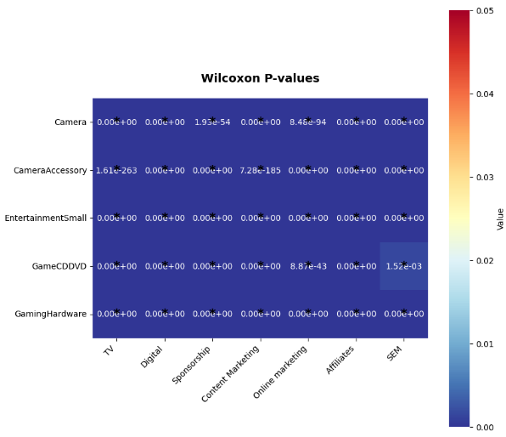
- Mann-Whitney U Test: To examine differences in marketing investment effectiveness between the first and second halves of the fiscal year, the Mann-Whitney U test was conducted. Statistically significant differences (p-values < 0.05) were observed, highlighting distinct effectiveness in marketing investment across these periods, particularly in Digital marketing and Sponsorship channels.
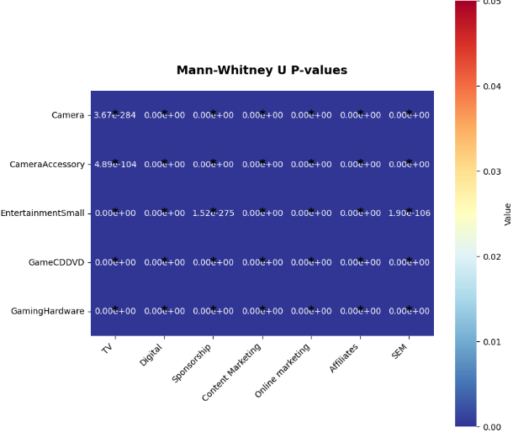
- Kruskal-Wallis Test: A Kruskal-Wallis test was implemented to identify variations in investment effectiveness across multiple product categories. Significant differences were observed (p < 0.05), confirming that marketing channel effectiveness varied considerably by product category, emphasizing the necessity for tailored investment strategies for optimal returns.
- Spearman Correlation Analysis: Spearman correlation coefficients were computed to analyze the relationships between investments in various marketing channels. This analysis revealed strong positive correlations among certain marketing channels, suggesting potential synergy benefits from coordinated investment strategies.
Key Insights from Statistical Tests
Model Interpretability
- LIME Analysis: Local Interpretable Model-agnostic Explanations (LIME) were utilized to interpret predictions at an individual feature level. This analysis consistently highlighted the significant role of TV advertising across predictions, with Digital marketing showing varying importance, and identified negative correlations with specific channels such as Radio advertising.
- SHAP Analysis: SHapley Additive exPlanations (SHAP) were employed to quantify feature contributions to model predictions. Notably, TV and Online marketing significantly influenced Camera product sales, while EntertainmentSmall sales were most responsive to Sponsorship investments. Digital advertising exhibited unique and pronounced effects within the GameCDDVD category.
These comprehensive statistical analyses, integrating hypothesis testing and advanced interpretability techniques, corroborate the robustness of insights obtained from predictive models, further enhancing confidence in strategic marketing recommendations.
Key Performance Indicators (KPIs)
1. NPS Score 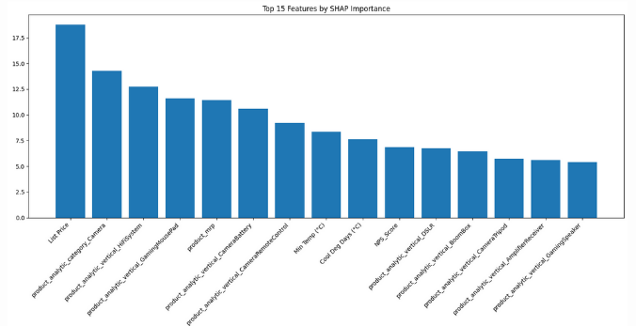
Rationale: NPS exhibits a strong negative correlation with revenue. Lower NPS scores typically lead to decreased customer satisfaction and subsequent reductions in revenue.
2. Minimum Temperature
Rationale: Revenue positively correlates with minimum temperatures. Higher minimum temperatures drive increased sales, indicating weather sensitivity in customer purchasing behavior.
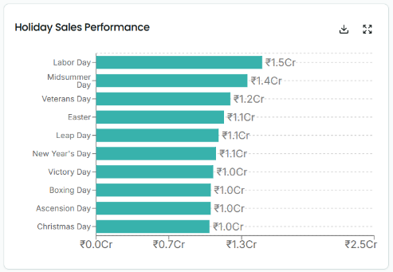
3. %Discount
Rationale: Revenue optimization occurs at discount ranges of approximately 30% to 50%, highlighting strategic discounting effectiveness within this interval.
4. Holiday Week
Rationale: Significant peaks in sales are observed during holiday weeks, underscoring the effectiveness of targeted marketing and promotional strategies during holiday periods.
5. mROAS (Marketing Return on Ad Spend)
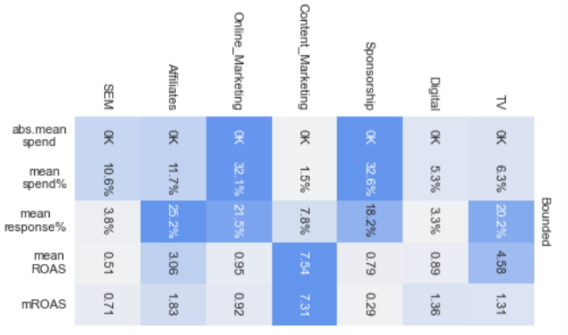
Rationale: An mROAS near 1 indicates an optimized marketing budget allocation. Values approaching 0 signal overspending, whereas values exceeding 1 imply underspending.
6. Sales Days Allocation
Rationale: Strategically accurate and optimized allocation of sales days throughout the year significantly boosts annual revenue performance, emphasizing the importance of precise sales scheduling.
Agentic Report Generation
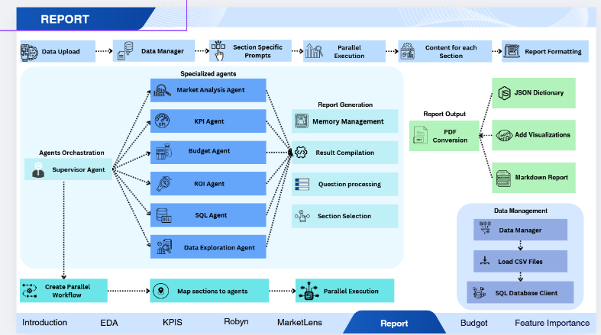
Core Process Flow
- Data Upload: The process begins with the Data Upload interface, where raw business data is ingested into the system.
- Data Management: Once data is uploaded, it is transferred to the Data Manager component. The Data Manager also interfaces with the Data Management Subsystem, which includes:
- The CSV files are then loaded from the database, and SQL database interactions are managed by the Data Manager.
- Distribute the database schema to each agent while centralizing concurrent data management for efficient storage.
- Section-Specific Prompts: Here, the system dynamically allocates the prompts to be assigned to specific agents. These prompts guide agents in executing their specialized tasks and generating relevant analytical outputs.
Agent Orchestration Subsystem
A sophisticated Agent Orchestration Framework is employed and managed by a central Supervisor Agent using the LangGraph Framework with LangChain React Agents. This agent is responsible for coordinating multiple specialized agents, each tasked with a unique analytical function:
KPI Agent
- GMV and SLA Relationship Analysis: Examines correlations between Gross Merchandise Value (GMV) and Service Level Agreement (SLA) metrics at the individual order level, providing insights into how order value potentially influences delivery timeframes.
- NPS Impact Assessment: Analyzes the relationship between Net Promoter Score (NPS) in a given month and the subsequent month's GMV, quantifying how customer satisfaction metrics translate to future revenue performance.
- Discount Effectiveness Evaluation: Investigates the correlation between discount percentages and GMV across all orders, helping determine optimal pricing strategies and promotional effectiveness.
Budget Agent
The Budget Allocation Agent offers four primary functionalities designed to support marketing decision-making processes:
- Budget Optimization: Analyzes channel performance and historical ROI to recommend budget distributions that maximize returns, considering short- and long-term goals.
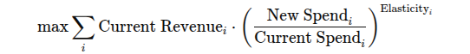
- Product Category Prioritization: Identifies high-value product categories for marketing investment based on revenue, profit margins, and growth potential.
- Forecasted Revenue:
ROI Agent
- Marketing Channel ROI Analysis: Conducts Marketing Mix Modeling (MMM) to evaluate marketing channel efficiency using the current and next month's GMV. It also calculates the Marginal ROI for detailed analysis.
- Customer Satisfaction and ROI: Predictive analysis of NPS's influence on ROI, assisting strategic customer engagement.
- Stock Market Index and ROI: Examines correlations between stock market trends and ROI, informing adaptive marketing strategies.

- Customer Satisfaction and ROI (NPS Analysis)
- Analyzes NPS influence on future ROI to understand how customer satisfaction correlates with revenue growth.
- Identifies key NPS periods affecting revenue, recognizing months where high or low NPS significantly impacts business performance.
- Uses predictive analytics for forecasting trends, helping businesses proactively improve customer engagement strategies.
- Stock Market Index and ROI
  - Examines stock fluctuations’ effect on ROI, studying how economic trends impact marketing performance.
  - Compares ROI during market uptrends and downturns, allowing businesses to adjust marketing investments accordingly.
  - Uses regression models to predict stock-driven ROI, identifying leading indicators for financial planning.
SQL Agent: Generates SQL queries, validated them and then executes them to get the insights from the data in the database.
Data Exploration Agent: Uses Tavily Seach to extract insights about the current market news and conditions along with the competitive analysis of similar companies in the domain.
4. Parallel Processing Implementation
All the allotted agents are executed asynchronously in parallel using a Thread Pool Executre with 8 Cores. This reduces the latency to generate the report to approximately 10s (1.8s per section).
5. Report Generation Subsystem
- Memory Management: Retains contextual continuity across sections.
- Result Compilation: Aggregates outputs from specialized agents into structured narratives.
- Question Processing: Addresses inquiries that arise during report generation.
- Section Selection: Determines the most relevant content sections for the final report.
Marketing Mix Modeling and Robyn
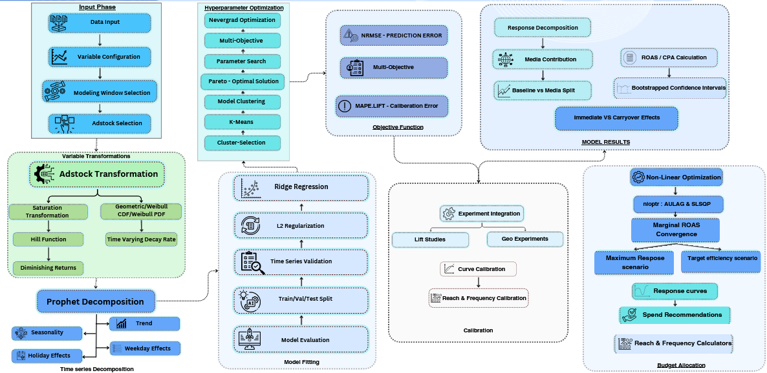
Marketing Mix Modeling is an analytical methodology that quantifies the impact of various marketing activities on business outcomes using statistical analysis. Traditional MMM processes are often resource-intensive, requiring substantial manual intervention and analyst judgment, which can introduce bias and delay insights. Developed by Meta's (formerly Facebook's) marketing science team, Robyn addresses these limitations through advanced automation and modeling techniques.
Core Statistical Methods
- Ridge Regression: Forms the foundation of Robyn's modeling approach, addressing multicollinearity issues common in marketing data by introducing a penalty term to ordinary least squares estimates.
- Prophet Algorithm: Employed for time-series decomposition to detect trends and address seasonal confounding factors. Prophet automatically decomposes time-series data into trend, seasonality, and holiday patterns, isolating marketing impacts from cyclical business patterns.
- Nevergrad: Meta's gradient-free optimization platform enables fast multi-objective optimization.
Multi-Objective Optimization Framework
- NRMSE (Normalized Root Mean Square Error): The "prediction error" that measures how well the model fits historical data. Robyn allows time-series validation with data splitting to ensure the model generalizes well to new data.
- DECOMP.RSSD (Decomposition Root Sum of Squared Distance): The "business error" metric that measures the distance between the model's effect share and the spend share. Minimizing this helps avoid extreme results that deviate significantly from the status quo.
- MAPE.LIFT: The "calibration error" used when aligning models with experimental data, helping ensure the model's predictions correspond with empirical evidence from controlled experiments.
Input Data Structure
How we used Robyn:
- Media Transformation: Applies adstocking (carryover effects) and saturation curves (diminishing returns) to media variables
- Adstock Modeling: Captures how advertising impact persists over time through various decay functions:
  - We have used Geometric Adstock for simple decay patterns
  - Weibull Adstock for more complex patterns with delayed peak effects
- Time-Series Decomposition: Uses Prophet to separate trend, seasonality, and holiday effects
- Regularization: Applies ridge regression to handle multicollinearity and prevent overfitting.
- Ground-Truth Calibration: A standout feature is Robyn's ability to calibrate models based on ground-truth methodologies:
  - This calibration ensures the model's predictions align with empirical evidence, increasing confidence in the insights generated. The calibration process adds MAPE.LIFT is a third optimization objective alongside NRMSE and DECOMP.RSSD.
- Budget Allocation Optimizer
  - Robyn includes a sophisticated budget allocator that uses:
    - Gradient-based constrained non-linear solver (NLOPTR library)
    - NEVEGRAD Optimization algorithms to maximize outcomes
    - The optimizer provides actionable recommendations for redistributing marketing budgets to maximize ROI with two optimization scenarios:
      - Maximum historical response (same spend, optimized allocation)
      - Maximum response for expected spend (optimized allocation for a specified budget)
Sales Calendar
Data Analysis Approach
We projected monthly revenue data spanning from May 2023 through July 2024. These projections serve as the foundation for a data-driven sales planning process that determines:
- When to schedule sales events throughout the year
- How many sales events to run each month
- How long each sale should last
- Which specific days of the week and month are optimal for launching sales
Revenue-Based Sales Duration Strategy
The analysis establishes a direct relationship between projected monthly revenue potential and recommended sale duration. Higher-revenue months warrant longer sales, while lower-revenue periods receive shorter promotions or none at all.
Two different approaches to this relationship were evaluated:
- Initial Approach: Longer sale durations (3-5 days standard, up to 14 days during holidays)
- Refined Approach: Shorter, more targeted sales (0-4 days standard, with slight extensions during holidays)
The refined approach introduces a minimum revenue threshold (4.0) below which no sales are recommended, creating a more selective and strategic sales calendar.
Sales Event Optimization
The analysis determines the optimal number of sales events per month through several methods:
- Revenue Ranking: Months are ranked by projected revenue within each year
- The number of sales days in a month is determined by first fitting a Random Forest Regressor on the monthly aggregated features and revenue. Then, using the importance scores from the model, we decide how many sale days to allocate in a given month.
- Duration of the sales: Duration of the sales is determined by using seasonality of GMV.
- Holiday Season Special Handling: November and December receive additional consideration due to heightened shopping activity
- High-Value Month Prioritization: Top revenue-generating months consistently receive more promotional attention
The refined strategy limits most months to a maximum of two sales events, with some lower-performing months receiving just one event or none at all.
Day-of-Week Optimization
The analysis identifies the optimal days of the week to begin sales based on historical performance:
- Tuesday and Wednesday are determined to be the best-performing starting days
- The strategy alternates between these days for consistent spacing
- Sales are strategically positioned within the month (second and fourth weeks) to maintain rhythm without oversaturation
Implementation Timeline
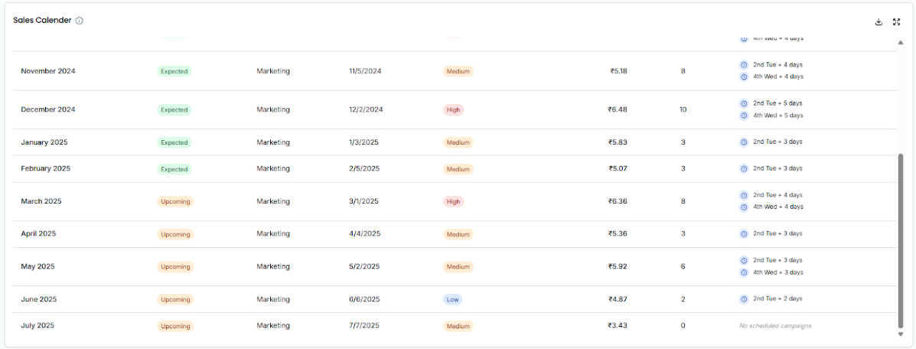
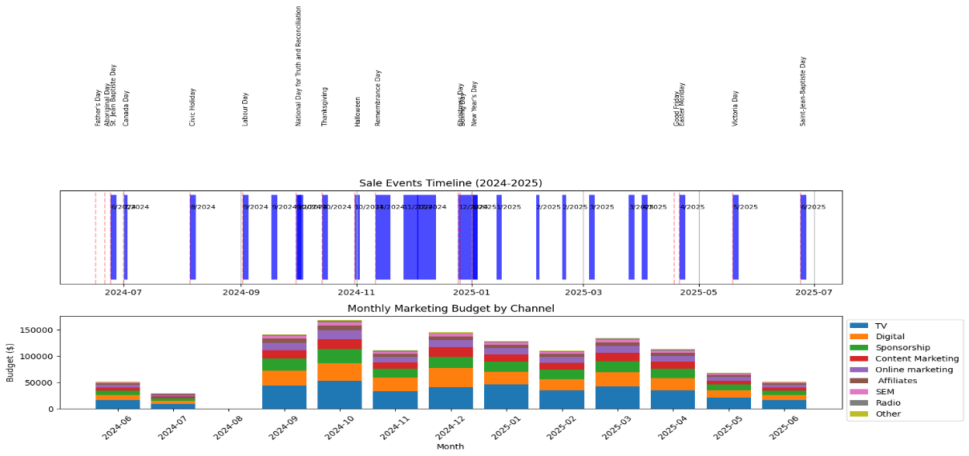
Bilevel Optimized Budget Allocation Method
The bilevel optimization approach addresses two intertwined marketing challenges:
- Determining true channel effectiveness through dynamic weights.
- Optimizing budget allocation based on these learned weights.
Unlike traditional methods relying on static historical weights, bilevel optimization adapts by simultaneously refining weight accuracy and determining the optimal budget distribution, providing a robust solution responsive to complex investment-return relationships.
Mathematical Formulation
The methodology comprises two nested optimization processes:
- Upper-Level Optimization (Leader):
  - Objective: Minimize prediction error between forecasted and actual GMV.
  - Mathematical Formulation:

- Constraints: Weight bounds based on historical data correlations.
- Lower-Level Optimization (Follower):
  - Objective: Maximize total revenue using learned weights.
  - Mathematical Formulation:

- Constraints: Total budget allocation.
Revenue Model
Revenue is modeled logarithmically to reflect diminishing returns on investment: Where:
- is the effectiveness of channel.
- is the budget allocated to channel.
Algorithm Benefits
- Integrated Optimization: Combines learning and optimization phases, enhancing robustness.
- Adaptive Weights: Adjusts effectiveness dynamically based on predictive performance, improving allocation accuracy.
- Practical Constraints: Incorporates real-world limitations ensuring implementable, realistic budget allocations.
- Exploration Within Bounds: Allows exploration within predefined weight ranges to avoid unrealistic allocations.

Market Lens

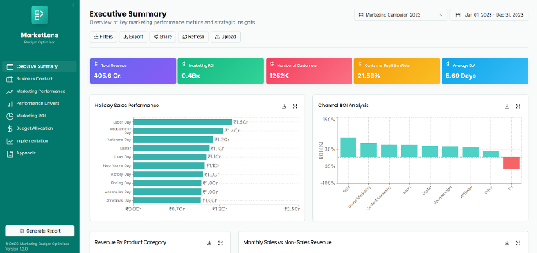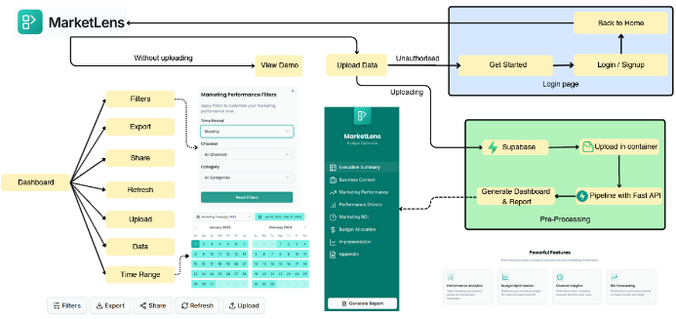

Results
Channel | Current Allocation | Proposed Allocation | Change (%) | Recommendation
TV | 5.7% | 14.2% | +149.1% | Increase
Digital | 3.8% | 8.3% | +118.4% | Increase
Spons | 45.3% | 13.5% | -70.2% | Decrease
Content | 1.1% | 4.3% | +290.9% | Increase
Online | 24.7% | 24.7% | +0.0% | Maintain
Affiliates | 7.8% | 23.4% | +200.0% | Increase
SEM | 11.6% | 11.6% | +0.0% | Maintain
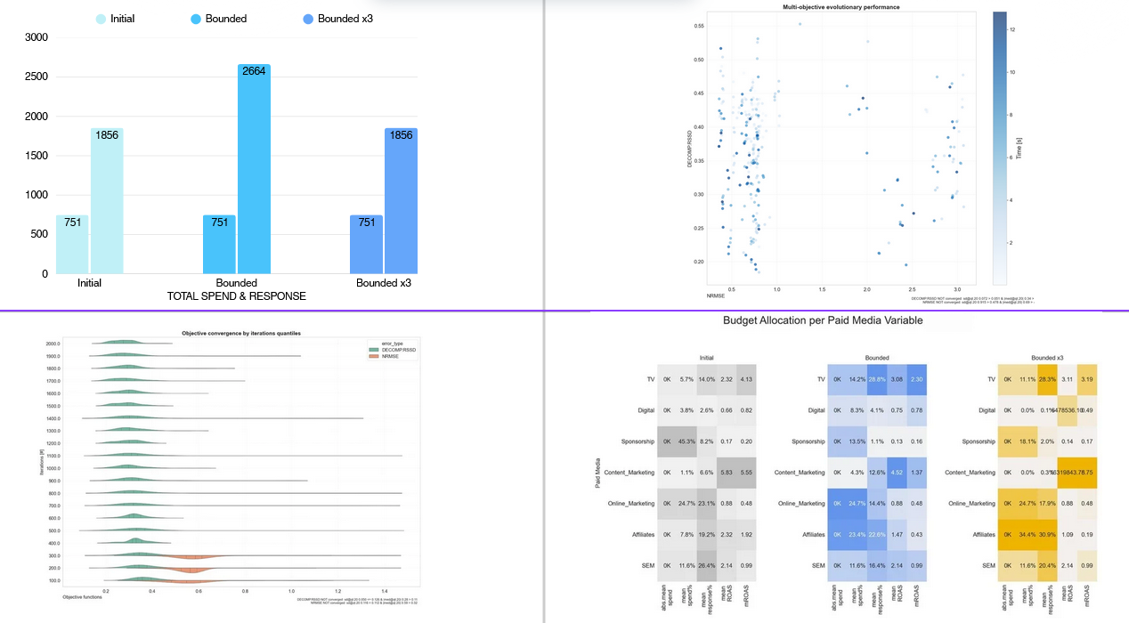

Annexure

Key Insights from Statistical Tests
- TV Advertising demonstrated significant positive impacts across all product categories, especially in Camera and GameCDDVD, with notable returns from moderate to high investment levels.
- Digital Marketing exhibited mixed effectiveness, performing notably less effectively for Camera and CameraAccessory categories and showing negative correlations with GamingHardware.
- Sponsorship significantly benefitted EntertainmentSmall category products, though requiring higher investments to achieve optimal results.
- Online Marketing and Affiliates consistently provided positive returns across product categories, highlighting their cost-effectiveness and potential for enhanced performance through coordinated channel use.
- SEM (Search Engine Marketing) effectiveness varied significantly by category and temporal factors, underscoring the need for carefully targeted investment.TV Advertising demonstrated significant positive impacts across all product categories, especially in Camera and GameCDDVD, with notable returns from moderate to high investment levels.
- Digital Marketing exhibited mixed effectiveness, performing notably less effectively for Camera and CameraAccessory categories and showing negative correlations with GamingHardware.
- Sponsorship significantly benefitted EntertainmentSmall category products, though requiring higher investments to achieve optimal results.
- Online Marketing and Affiliates consistently provided positive returns across product categories, highlighting their cost-effectiveness and potential for enhanced performance through coordinated channel use.
- SEM (Search Engine Marketing) effectiveness varied significantly by category and temporal factors, underscoring the need for carefully targeted investment.
Robyn Input Requirements
Robyn requires time-series data (daily, weekly, or monthly) with dates in "YYYY-MM-DD" format. The minimum required inputs include:
- Dependent Variable: The KPI to be modeled (revenue)
- Paid Media Variables: Marketing channels with both spend metrics and performance indicators
- Date Variable: Time dimension for analysis
Optional variables that can enhance model accuracy include:
- Organic Variables: NPS Scores
- Context Variables: All other monthly feature variables
- Factor Variables: Sales Dates
- Holiday Data: Holiday Dates
Iterative Feature Selection and Feature Importance
SHAP Values
- Compute Contributions of Each Feature
  - For each feature, compute its impact by comparing predictions with and without that feature.
  - This is done for all possible feature combinations.
- Average Over All Feature Orders
  - Since different feature orders can change the impact of a feature, SHAP takes an average contribution across all possible feature orderings.
- This ensures a fair distribution of importance.
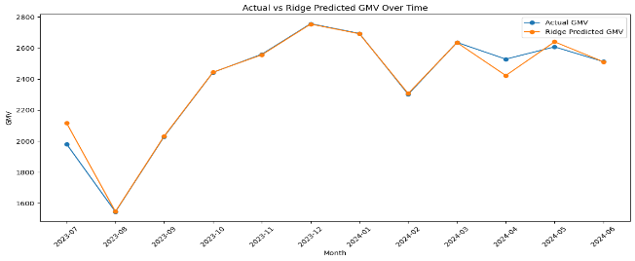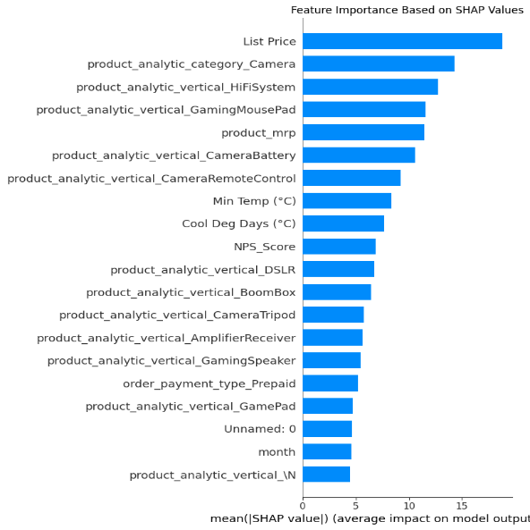
Permutation Importance
Permutation Importance is a technique to measure feature importance by randomly shuffling feature values and observing the effect on model performance. It helps understand which features significantly impact predictions.

Step-by-Step Workflow
- Train a Model
  - Train a machine learning model on your dataset.
  - Ensure it has good predictive performance.
- Evaluate Baseline Performance
  - Measure the model’s baseline metric (accuracy, RMSE, R², etc.) on a validation/test dataset.
- Shuffle One Feature at a Time
  - Pick one feature, randomly shuffle its values while keeping others unchanged.
  - This breaks the relationship between the feature and the target.
- Re-evaluate Model Performance
  - Predict using the modified dataset.
  - Calculate the new performance metric.
- Compute Importance Score
  - The importance of a feature is the difference between baseline and new performance.
  - Larger drops in performance = More important features.
- Repeat for All Features
  - Perform steps 3–5 for each feature in the dataset.
  - Rank features based on their importance scores.
