



Module Code & Module Title
CS6PO5NT – Final Year Project

Assessment Weightage & Type
Final Year Project Proposal (5%)

Year And Semester
2025-26 Autumn

Student Name: Jitendra Sahu
London Met ID: 23049256
College ID: np05cp4a230176
Assignment Submission Date: Friday, November 28, 2025
Internal Supervisor: Mr. Kushal Tamang
External Supervisor: Mr. Samuel Sherpa
Title: CareFleet

I confirm that I understand my coursework needs to be submitted online via Google Classroom under the relevant module page before the deadline for my assignment to be accepted and marked. I am fully aware that late submissions will be treated as non-submission and a mark of zero will be awarded

Table of Contents
1. Introduction 1
1.1 Problems Scenario 1
1.2 Solutions 2
2. Aims And Objective 3
2.1 Aims 3
2.2 Objectives 3
3. Expected Outcomes and Deliverables 4
4. Project Risks, Threats and Contingency Plans 5
5. Methodology 7
6. Resource requirements 9
6.1 Hardware Requirements 9
6.2 Software Requirements 9
7. Work breakdown structure (WBS) 11
8. Milestones 12
9. Project Gantt Chart 14
10. Conclusion 15
11. References 16

Introduction
CareFleet is a modern healthcare platform that simplifies medical interaction process. It provides a centralized online space where patients and doctors can connect easily without physical barriers. The system focuses on making healthcare faster, more organized and available from anywhere. CareFleet supports both hospitals and independent doctors by giving them digital tools to manage appointments and consultations smoothly.
Health services today are becoming more digital because people expect faster and more convenient access to doctors. Visiting hospitals physically for simple consultations creates unnecessary crowds, long waiting lines, and delays. Many patients struggle to get timely appointments, and doctors also deal with mismanaged schedules and communication issues. These problems affect both the patient experience and hospital workflow.
CareFleet aims to improve this experience by offering a smooth online system where patients can book appointments, consult doctors virtually, receive e-prescriptions, and manage their medical history in one place. This system helps reduce delays, makes healthcare more accessible, and supports better communication between doctors and patients.

Problems Scenario
Most healthcare centres still use traditional appointment systems. This causes several problems for both patients and medical staff:
- Long waiting times due to manual registration and scheduling.
- Overcrowded hospitals, even for minor health queries.
- Difficulty in accessing specialist doctors, especially in remote areas.
- Loss or misplacement of paper prescriptions, leading to treatment errors.
- Poor management of patient history, making diagnosis and follow-up harder.
- Limited communication between doctors and patients outside hospital visits.

Solutions
CareFleet aims to solve these problems by providing a complete, easy-to-use digital healthcare system. It will offer:
- Online Appointment Booking
Patients can book appointments based on doctor availability.
- Virtual Consultation
Patients can meet doctors through a secure chat or video call from home.
- E-Prescription System
Doctors can generate and share digital prescriptions instantly.
- Medical History Management
Patients can view past reports, prescriptions, and consultations.
- Doctor Dashboard
Doctors can manage appointments, patient files, and prescriptions.
- Admin Panel
Admins can verify doctor credentials and supervise overall activity.

Aims And Objective

Aims
The aim of the CareFleet project is to develop a user-friendly healthcare management system that supports online appointments, virtual consultations and e-prescriptions to make healthcare faster, more accessible and more efficient.

Objectives
The objective behind the developed the system are given below:
- To create a smooth online appointment booking system.
- To implement virtual consultation using a secure chat and video platform.
- To allow doctors to generate and manage e-prescriptions.
- To provide patients with a personal dashboard for medical history.
- To build a doctor dashboard for managing schedules and patient details.
- To enable admin verification of patient and doctor accounts.
- To create notification features for appointment reminders.
- To maintain proper security for all patient data stored in the system.

Expected Outcomes and Deliverables
Once the project completed it will deliver the fully functional for the CareFleet system with the following features:
- Online Appointment Booking
- View doctor availability
- Choose date and time
- Appointment confirmation notifications

- Virtual Consultation Module
- Video consultation interface
- Chat support
- Doctor notes section

- E-Prescription System
- Doctors can generate prescriptions digitally
- Patients can download or view prescription history
- Automatic record storing

- Patient Dashboard
- Personal medical records
- Past appointments
- E-prescriptions list

- Doctor Dashboard
- Manage daily schedule
- View patient history
- Write notes and prescriptions

- Admin Panel
- Approve doctor accounts
- Manage system-wide activities

Project Risks, Threats and Contingency Plans
During development and after deployment, the project may face several risks. These are listed below:
- Development Risks
Risk: Delays in development due to multiple integrated modules.
Mitigation:
- Divide tasks into sprints using Scrum
- Regular progress tracking

- Technical Risks
Risk: Issues with video consultation module.
Mitigation:
- Test multiple video APIs early
- Use stable and tested libraries

- Data Privacy Risks
Risk: Sensitive patient information may be exposed.
Mitigation:
- Use strong encryption
- Implement strict access control

- Internet Connectivity Risks
Risk: Users may experience low-quality video calls.
Mitigation:
- Provide low-bandwidth mode
- Allow rescheduling of calls

- Fake Doctor Registrations
Risk: Unverified doctors entering the system.
Mitigation:
- Mandatory document upload
- Admin approval required

- Scalability Risks
Risk: System may slow down with too many users.
Mitigation:
- Optimize database queries
- Use cloud hosting for scalability

Methodology
In order to develop the CareFleet system in a structured and flexible way, I have used Agile (Scrum) Methodology for the development.

Scrum methodology is a well taken approach to handling complex projects especially in software development. On the most basic level, Scrum advocates a cooperative method of work and focuses on collaboration, openness, and flexibility. Scrum is based on the concept of the iteration and constant improvement as opposed to the traditional approaches to project management, where the upfront planning is conducted in advance (S, 2025).
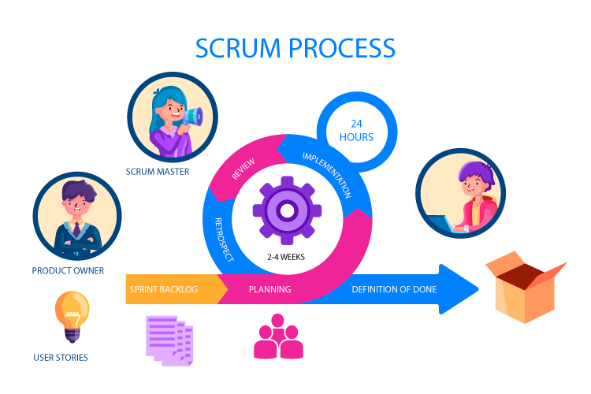
Figure 1: Scrum Image (S, 2025)

Scrum makes the development process easier because it breaks the project into smaller parts and completes them in short cycles called sprints. This approach makes it easier to handle changes, gather feedback, reduce risks and quickly produce a working version of the system.
Scrum is selected for the development of the following reason:
- It gives flexibility to add or change features when needed.
- Work is done in small, manageable sprints, making progress easier to track.
- Continuous feedback improves the system during development.
- It reduces risks by testing features regularly.
- It helps single-developer or small teams stay organized and focused.

Resource requirements

Hardware Requirements
- Laptop/PC with at least Intel i5 processor
- Minimum 8 GB RAM (16 GB recommended)
- Enough storage for development tools and files
- Stable and high-speed internet for video consultation module

Software Requirements
- Project Management Tools
- Trello or Jira will be used to plan tasks, manage sprints, and track overall project progress.

- Frontend Development
- HTML, CSS, JavaScript for building the user interface.
- Bootstrap or tailwind CSS to design a clean and responsive layout.

- Backend Development
- .NET Core framework for building the main backend API and server-side logic.
- C# as the primary programming language for backend development.
- Visual Studio or Visual Studio Code as the development environment.

- Database Management
- Microsoft SQL Server for storing all application data including users, appointments, prescriptions, and consultation records.
- SQL Server Management Studio (SSMS) for managing the database.

- Version Control
- Git for source code management.
- GitHub for code hosting, backup, and team collaboration.

- Testing Tools
- Postman for testing backend APIs.
- Browser testing tools to ensure proper frontend performance.

- Platform and Compatibility
- The system will be developed as a web-based application.
- Fully compatible with modern browsers such as Google Chrome, Microsoft Edge.

Work breakdown structure (WBS)
Work Breakdown Structure (WBS) is a way of dividing a big project into smaller, easier, manage to handle. We do not look at the project as one huge job, we break it down into clear tasks and sub-tasks so the work becomes more organized and manageable. It helps for better planning, clearer responsibilities and an easier way to track progress. WBS of this project is given below.
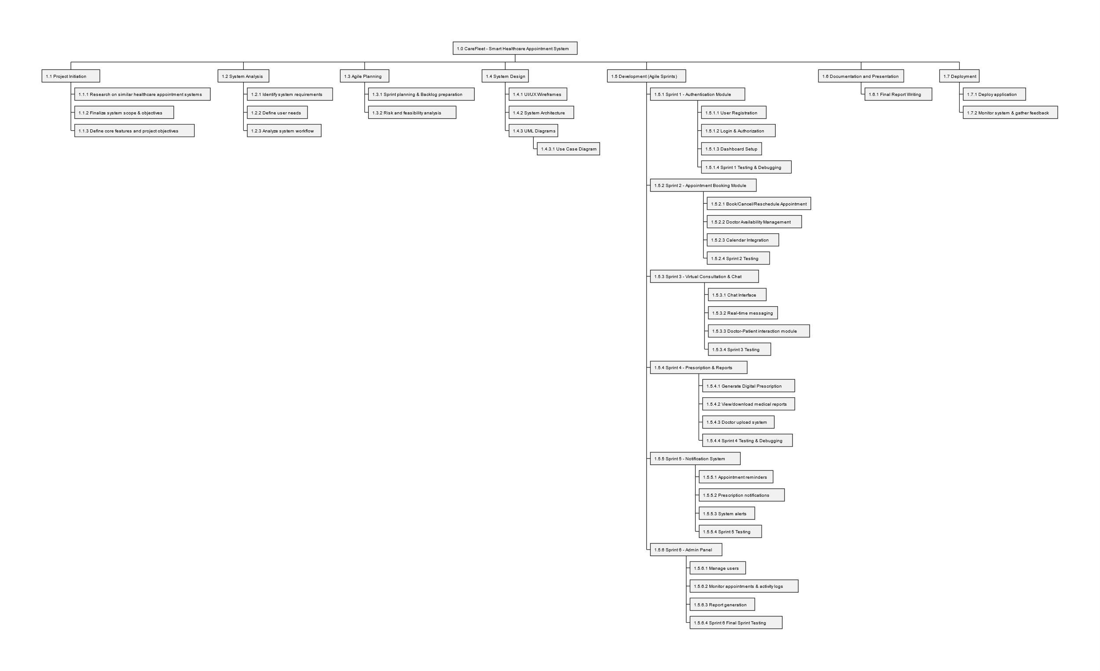
Figure 2: Work breakdown structure (WBS)

Milestones
Project milestones are important points in a project that show how much work has been done and what stage the team has reached. They work like simple check points that help everyone understand if things are going as planned. These points guide the team from the beginning of the project, through the main work, and all the way to the finish, making it easier to stay focused and notice delays or issues early (ProjectManager.com, 2025).

The milestone of this project are given as follows:

- Milestone 1 – Topic Finalization
Choose the project topic and define the scope, focusing on online healthcare services.

- Milestone 2 – Proposal Submission
Prepare and submit the proposal including aims, objectives, WBS, and Gantt chart.

- Milestone 3 – SRS Documentation
Create Software Requirement Specification with detailed functional and non-functional requirements.

- Milestone 4 – User Authentication System
Develop login and registration for patients, doctors, and admins.

- Milestone 5 – Interim Report Submission
Prepare interim report including system design, diagrams, and progress.

- Milestone 6 – Patient Dashboard Development
Build patient dashboard for medical history and appointments.

- Milestone 7 – Doctor Dashboard Development
Create doctor interface for managing appointments and consultations.

- Milestone 8 – Appointment Booking System
Implement appointment scheduling with date and time availability.

- Milestone 9 – Virtual Consultation Module
Integrate video consultation interface.

- Milestone 10 – E-Prescription Module
Implement digital prescription creation and storage.

- Milestone 11 – Notifications System
Add reminders and status updates.

- Milestone 12 – Final Testing and Debugging
Fix bugs, perform testing, and optimize the system.

- Milestone 13 – Deployment
Deploy the system on a cloud platform.

- Milestone 14 – Final Report Submission
Prepare final documentation and submit the complete project.

Project Gantt Chart
A Gantt chart is a graphical representation of a project timetable which is widely utilized. It is a form of bar chart that indicates the beginning and the end date of the elements of a project that includes resources, planning, and dependencies (Grant, 2025).
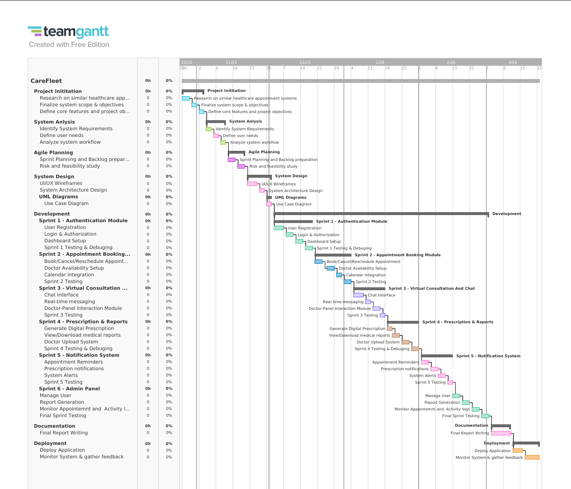
Figure 3: Gantt Chart

Conclusion
CareFleet is designed to simplify and modernize healthcare services by moving key processes online. The system reduces long waiting times, makes consultations more accessible and stores medical information securely in one place. By integrating appointment booking, virtual consultations and e-prescriptions, CareFleet creates a smoother experience for both patients and doctors. With the use of Agile Scrum methodology, the project will develop step-by-step, ensuring continuous improvement and timely delivery.

References
Grant, M. (2025) Gantt Chart: Definition, Benefits, and How It’s Used [Online]. Available from: https://www.investopedia.com/terms/g/gantt-chart.asp [Accessed 28 November 2025].
PM-Partners. (2024) What is Scrum? An overview of Scrum and The Agile Journey [Online]. Available from: https://www.pm-partners.com.au/insights/the-agile-journey-a-scrum-overview/ [Accessed 28 November 2025].
ProjectManager.com. (2025) Work Breakdown Structure (WBS) Guide [Online]. Available from: https://www.projectmanager.com/guides/work-breakdown-structure [Accessed 28 November 2025].
S, B. (2025) scrum-methodology/ [Online]. Available from: https://www.nimblework.com/agile/scrum-methodology/ [Accessed 28 November 2025].

