DESIGN AND DEVELOPMENT OF A TRAFFIC SIGNAL CONTROL OPERATING SYSTEM FOR SMART JUNCTION MANAGEMENT
OS-Based Traffic Signal Management System
Using Process Management, Priority & Round-Robin Scheduling, Synchronization, and IPC for Efficient Traffic Control
OPERATING SYSTEMS – MINI PROJECT REPORT
A MINI-PROJECT REPORT
Submitted By
JITENDAR DHARIWAL V [RA2511026020183]
ADI SURIYA S [RA2511026020176]
in partial fulfilment for the award of the degree
of
BACHELOR OF TECHNOLOGY
in
ARTIFICIAL INTELLIGENCE AND MACHINE LEARNING
of
FACULTY OF ENGINEERING AND TECHNOLOGY

SRM INSTITUTE OF SCIENCE AND TECHNOLOGY
RAMAPURAM CAMPUS, CHENNAI-600089
ACADEMIC YEAR 2026–27
OCTOBER 2026

SRM INSTITUTE OF SCIENCE AND TECHNOLOGY
(Deemed to be University U/S 3 of UGC Act, 1956)
BONAFIDE CERTIFICATE
Certified that this mini project report titled “DESIGN AND DEVELOPMENT OF A TRAFFIC SIGNAL CONTROL OPERATING SYSTEM FOR SMART JUNCTION MANAGEMENT” is the bonafide work of “JITENDAR DHARIWAL V [RA2511026020183] and ADI SURIYA S [RA2511026020176]” who carried out the project work under my supervision. Certified further that, to the best of my knowledge, the work reported herein does not form part of any other project report or dissertation on the basis of which a degree or award was conferred on an earlier occasion on this or any other candidate.
SIGNATURE
Ms. Judy Flavia
Professor
SRM Institute of Science and Technology, Ramapuram, Chennai.

SRM INSTITUTE OF SCIENCE AND TECHNOLOGY
RAMAPURAM, CHENNAI -600089
DECLARATION
We hereby declare that the entire work contained in this mini project report titled “DESIGN AND DEVELOPMENT OF A TRAFFIC SIGNAL CONTROL OPERATING SYSTEM FOR SMART JUNCTION MANAGEMENT” has been carried out by JITENDAR DHARIWAL V [RA2511026020183] and ADI SURIYA S [RA2511026020176] at SRM Institute of Science and Technology, Ramapuram, Chennai - 600089, under the guidance of Ms. Judy Flavia, Extension Professor, Department of Computer Science and Engineering.
Place: Chennai
Date:

ABSTRACT
This project designs and implements an operating system–based traffic signal management system, the Traffic Signal Control Operating System (TSCOS). Each traffic approach (North, South, East, West) is modelled as a process that competes for a shared resource, the green signal, which is analogous to CPU time. Classical OS concepts such as priority scheduling, round-robin scheduling, mutual exclusion, process control blocks, finite state machines and inter-process communication (IPC) are used to control the junction safely and efficiently.
TSCOS supports five use cases: emergency vehicle priority, pedestrian crossing mode, rush-hour timing adjustment, manual police override, and a round-robin fallback when traffic is balanced. A 22-step control algorithm with a strict priority order (Manual > Emergency > Pedestrian > Adaptive density > Round-Robin) governs every decision. A working C simulation using POSIX threads and mutex locks was developed and executed; its output verifies that the correct mode is selected in each scenario and that two approaches are never green at the same time. The project shows how core OS principles can be applied to embedded, real-time, safety-critical systems in smart cities.
Keywords: Operating System, Traffic Signal Control, Priority Scheduling, Round-Robin, Mutual Exclusion, IPC, Emergency Preemption, Smart Junction

TABLE OF CONTENTS
Chapter No. | Title | Page No.
 | ABSTRACT | iv
 | LIST OF FIGURES | vii
 | LIST OF TABLES | vii
 | LIST OF ABBREVIATIONS | viii
1 | INTRODUCTION | 1
 | 1.1 Background | 1
 | 1.2 Problem Statement | 1
 | 1.3 Motivation: Traffic Control as an OS Problem | 1
2 | OBJECTIVES | 2
3 | PROJECT SCOPE, CONSTRAINTS AND ASSUMPTIONS | 3
 | 3.1 In-Scope Deliverables | 3
 | 3.2 Out of Scope (Non-Goals) | 3
 | 3.3 Technical Constraints and Assumptions | 4
4 | SYSTEM ARCHITECTURE AND OS CONCEPT MAPPING | 5
 | 4.1 OS Concepts Mapped to Traffic Control | 5
 | 4.2 High-Level Architecture | 5
 | 4.3 Process Control Block | 6
5 | CONTROL ALGORITHM AND SCHEDULING POLICY | 7
 | 5.1 The 22-Step Algorithm | 7
 | 5.2 Priority Order | 7
 | 5.3 Dynamic Green-Time Calculation | 8
 | 5.4 Signal Phase State Machine | 9
6 | USE CASES IN DETAIL | 10
 | 6.1 Emergency Vehicle Priority | 10
 | 6.2 Pedestrian Crossing Mode | 10
 | 6.3 Rush-Hour Timing Adjustment | 10
 | 6.4 Manual Override for Police Control | 11
 | 6.5 Round-Robin Fallback When Traffic Is Equal | 11
7 | SYNCHRONIZATION AND SAFETY | 12
 | 7.1 Implementation Mechanisms | 12
 | 7.2 Sensor Failure Handling | 12
8 | INTER-PROCESS COMMUNICATION (IPC) DESIGN | 13
 | 8.1 Shared-Memory Structure | 13
 | 8.2 Message Examples | 13
9 | HARDWARE DESIGN AND INTERFACING | 14
 | 9.1 Components | 14
 | 9.2 How the Software Connects to Hardware | 14
10 | SOFTWARE IMPLEMENTATION | 16
 | 10.1 Main Functions | 16
 | 10.2 Build and Run | 16
 | 10.3 Core Scheduler Logic | 16
11 | SIMULATION RESULTS AND TESTING | 17
 | 11.1 Execution Log | 17
 | 11.2 Signal Timeline | 18
 | 11.3 Visual Signal Status Summary | 18
 | 11.4 Test Cases | 19
 | 11.5 Discussion | 19
12 | RELEVANT INDUSTRIES AND APPLICATIONS | 20
13 | ADVANTAGES AND LIMITATIONS | 21
 | 13.1 Advantages | 21
 | 13.2 Limitations | 21
14 | FUTURE ENHANCEMENTS | 22
15 | CONCLUSION | 23
 | REFERENCES | 24
 | APPENDIX A | 25
 | Complete Source Code (tscos.c) | 25
LIST OF FIGURES
Fig. No. | Figure Name | Page No.
4.1 | Layered architecture of TSCOS | 6
5.1 | Flowchart of the scheduler logic | 8
5.2 | State machine for signal phases | 9
9.1 | Hardware connection sketch | 14
11.1 | Timeline of the simulated run (seconds from 08:00:00) | 18
LIST OF TABLES
Table No. | Table Name | Page No.
3.1 | Technical constraints and assumptions | 4
4.1 | OS concepts mapped to traffic control | 5
5.1 | The 22-step control algorithm | 7
5.2 | Priority order of the scheduler | 7
7.1 | Synchronization mechanisms in TSCOS | 12
8.1 | IPC design between the modules | 13
9.1 | Hardware components | 14
10.1 | Main functions of the software | 16
11.1 | Visual signal status summary | 18
11.2 | Test cases and observed results | 19
LIST OF ABBREVIATIONS
Abbreviation | Expansion
CPU | Central Processing Unit
EVP | Emergency Vehicle Preemption
FSM | Finite State Machine
GPIO | General-Purpose Input/Output
I/O | Input / Output
IPC | Inter-Process Communication
IR | Infrared
ITS | Intelligent Transportation Systems
LED | Light-Emitting Diode
OS | Operating System
PCB | Process Control Block
POSIX | Portable Operating System Interface
RFID | Radio-Frequency Identification
TSCOS | Traffic Signal Control Operating System
V2X | Vehicle-to-Everything

CHAPTER 1
INTRODUCTION
1.1 Background
Urban traffic congestion and delayed emergency response are serious problems in modern cities. Traditional fixed-time traffic signals give every approach the same green time regardless of how many vehicles are waiting. This wastes green time on empty roads, increases queues on busy roads, and offers no way to give way to an ambulance or fire engine.
1.2 Problem Statement
To design a software controller for a single four-way junction that can (a) adapt green time to traffic load, (b) give instant priority to emergency vehicles, (c) serve pedestrians safely, (d) allow human officers to take control, and (e) remain fair and predictable when no special condition exists, while guaranteeing that conflicting directions are never green together.
1.3 Motivation: Traffic Control as an OS Problem
A junction is a shared resource that many requesters (lanes) want to use one at a time. This is exactly the problem an operating system solves for the CPU. If each lane is treated as a process and the green signal as CPU time, the well-studied OS toolkit applies directly:
- Priority scheduling decides who goes first (emergency, heavy traffic).
- Round-robin scheduling gives every lane a fair, equal turn.
- Mutual exclusion (mutex/semaphore) guarantees safety.
- IPC lets the sensor, scheduler, driver and operator console cooperate.
- Interrupts model sudden events such as an ambulance or a pedestrian button press.
The design bridges operating system theory with embedded hardware control, which makes it suitable for smart intersection controllers and IoT-based transportation systems.
CHAPTER 2
OBJECTIVES
- To model each junction approach as a process with its own process control block (PCB).
- To implement priority-based preemptive scheduling for emergency and manual-override requests.
- To implement an adaptive, density-based scheduler with rush-hour time-quantum adjustment.
- To implement round-robin scheduling as a fair fallback when traffic is equal or sensors fail.
- To provide a pedestrian crossing phase that is mutually exclusive with vehicle phases.
- To enforce safety through mutual exclusion, a mandatory yellow interval and an all-red clearance.
- To define an IPC design between the sensor, scheduler, hardware-driver and operator modules.
- To build and run a simulation that demonstrates every use case with a verifiable log.
CHAPTER 3
PROJECT SCOPE, CONSTRAINTS AND ASSUMPTIONS
3.1 In-Scope Deliverables
Software and algorithm functions
- Adaptive signal control: real-time dynamic green-phase adjustment based on directional vehicle counts and rush-hour conditions.
- Preemptive override system: immediate preemption for manual operator input (Level 1) and emergency vehicles (Level 2).
- Pedestrian integration: dedicated pedestrian phase triggered by push-buttons or IR/thermal motion detection.
- Fallback mechanisms: equal-density detection or sensor failure triggers cyclic round-robin switching.
- State machine and logic: deterministic priority rules: Manual > Emergency > Pedestrian > Adaptive density > Round-Robin.
Hardware and interface integration
- Sensor interfacing: digital/analog inputs from cameras, inductive loops, radar or infrared sensors on four approaches.
- Actuator control: relay/GPIO signals for 3-colour vehicle lamps and pedestrian WALK / DON'T WALK displays.
- Operator console: a manual override terminal for authorised personnel.
3.2 Out of Scope (Non-Goals)
- Multi-junction networks: city-wide synchronisation (“green corridors”) is reserved for a later phase; this work covers one autonomous junction.
- Sensor manufacturing: off-the-shelf or simulated sensor streams are used.
- Full V2X telemetry: only a standard emergency beacon receiver is assumed.
- Enforcement: licence-plate recognition and automatic fines are not included.
- AI-based long-term learning: listed under future work.
3.3 Technical Constraints and Assumptions
Table 3.1 Technical constraints and assumptions
Constraint | Description
Processing latency | The decision loop (steps 4–20) must complete within 100 ms so that emergency detection is handled instantly.
Fail-safe hardware | A hardware conflict monitor must enforce at least a 3-second yellow and prevent conflicting greens even if the software fails. TSCOS uses 5 s yellow.
Sensor availability | Continuous sensor feeds are assumed. Missing or failed input triggers default timing or round-robin mode.
Single junction | One four-way junction with one green direction at a time (four-phase operation).

CHAPTER 4
SYSTEM ARCHITECTURE AND OS CONCEPT MAPPING
4.1 OS Concepts Mapped to Traffic Control
Table 4.1 OS concepts mapped to traffic control
OS Concept | Traffic System Analogy
Process | A traffic lane/direction (N, S, E, W) and the pedestrian phase
CPU | Green signal: the right to pass through the intersection
Scheduler | Central traffic-controller logic
Priority | Emergency lane, high-density lane, pedestrian request, operator command
Time quantum | Green time slot given to a lane (20–60 s)
Context switch | Green → Yellow → Red transition between lanes
Mutual exclusion | Only one conflicting direction may be green at a time
Semaphore / Monitor | Intersection lock that controls safe phase changes
Interrupt | Ambulance detection, pedestrian button, police override
PCB | Per-lane record: ID, state, priority, density, remaining time
IPC | Communication between sensor, scheduler, driver and console

4.2 High-Level Architecture
The system is divided into three functional layers joined by an IPC mechanism:
- Sensor / input layer: density sensors (IR, ultrasonic, loop or camera), emergency RFID/IR beacon receiver, pedestrian push-buttons and the police override console.
- OS core / scheduler layer: the PCB table, the scheduler that applies the priority rules, and the synchronisation primitives (mutex/semaphore and safety state machine).
- Hardware driver layer: GPIO and relay drivers for the red/yellow/green lamps and the pedestrian WALK / DON'T WALK signals, plus a buzzer for audio cues.
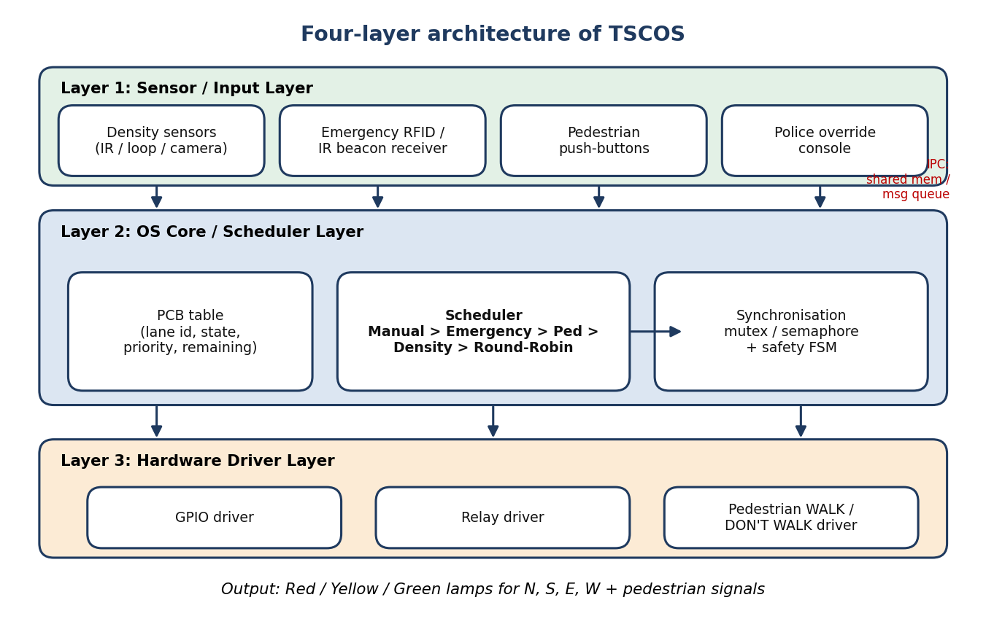
Fig 4.1 Layered architecture of TSCOS
4.3 Process Control Block
Each lane is represented by a PCB structure, defined in the code as:
typedef struct {
int id; // 0=N, 1=S, 2=E, 3=W
State state; // RED, YELLOW or GREEN
int density; // vehicles currently counted
int priority; // scheduling priority
int remaining; // seconds of green left
} PCB;

CHAPTER 5
CONTROL ALGORITHM AND SCHEDULING POLICY
5.1 The 22-Step Algorithm
Table 5.1 The 22-step control algorithm
Step | Action
1–3 | Start the system, initialise default green/yellow/red timings and set mode to AUTOMATIC.
4 | Continuously read traffic sensors for North, South, East and West.
5–6 | Check manual override. If active, follow the operator’s command and skip automatic control.
7–8 | Check for an emergency vehicle. If detected, give green to that direction immediately and keep the others red.
9–10 | Check for a pedestrian request. If present, stop vehicles on the required road and activate the pedestrian signal for the allowed time.
11–12 | Check whether it is rush hour. If so, increase green duration for crowded directions.
13–15 | Measure density in all directions. If different, select the direction with highest density and compute green time from the traffic load.
16–17 | If densities are equal, apply round-robin fallback: give green to each direction one by one in cyclic order.
18–19 | When green time ends, show yellow for a short transition, then switch the direction to red.
20 | Move to the next direction according to the priority rules.
21 | Repeat steps 4 to 20 continuously.
22 | Stop the system when the operator terminates it.

5.2 Priority Order
Table 5.2 Priority order of the scheduler
Level | Condition | Scheduling behaviour
1 | Manual override | Automatic scheduler suspended; operator commands drive the hardware directly.
2 | Emergency vehicle | Preemptive priority: green to the emergency approach after safe transition.
3 | Pedestrian request | Dedicated phase with all vehicle signals red for a fixed walk time.
4 | Adaptive density | Highest-density lane gets green; time quantum scales with load.
5 | Round-robin | Equal densities: fixed 20 s quantum in cyclic order N → E → S → W.

5.3 Dynamic Green-Time Calculation
In normal mode the default green time is 30 s. In rush-hour mode the time quantum for the selected lane is:
green = 20 + (2 * density) / 3 // capped at 60 seconds

For a density of 45 vehicles this gives 20 + 30 = 50 seconds, as shown in the simulation. Densities are treated as equal when the difference between the highest and lowest count is at most one vehicle, which activates round-robin.
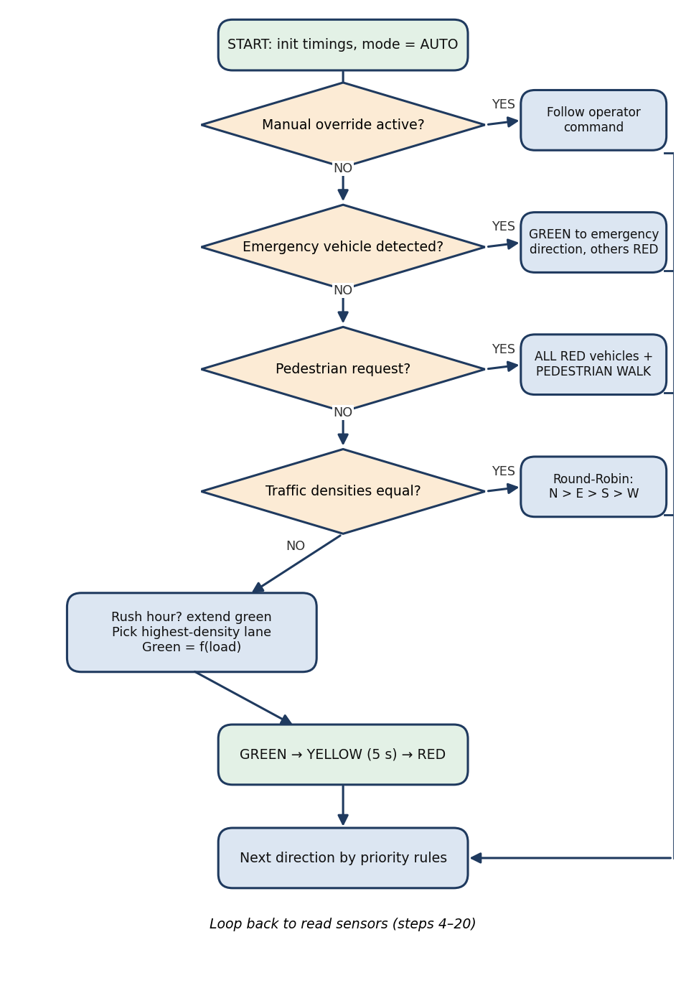
Fig 5.1 Flowchart of the scheduler logic
5.4 Signal Phase State Machine
The controller is implemented as a finite state machine with guarded transitions. Every green state must pass through YELLOW and ALL-RED before the next phase can begin.
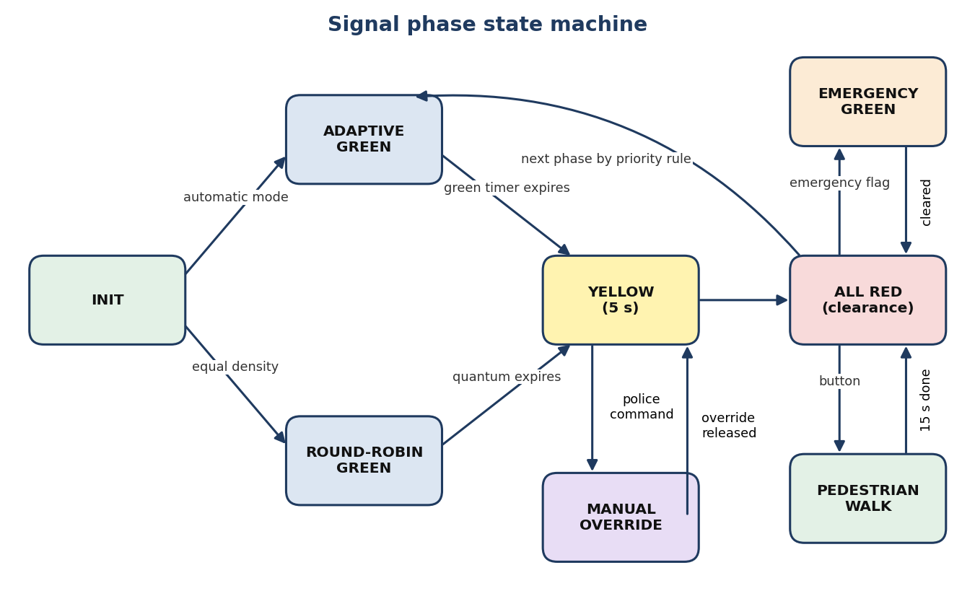
Fig 5.2 State machine for signal phases
CHAPTER 6
USE CASES IN DETAIL
6.1 Emergency Vehicle Priority
Scenario: An ambulance, fire engine or police vehicle approaches the junction.
- The vehicle carries an RFID tag or RF/IR beacon; a receiver at the junction extracts vehicle ID and approach direction.
- The receiver sets an emergency flag in shared memory or sends a message to the scheduler.
- The scheduler treats that lane as the highest-priority process, completes a safe yellow transition, grants green to the emergency lane and holds all other lanes red.
- After the vehicle clears (sensor confirmation or timeout) the system returns to normal scheduling.
OS analogy: Preemptive priority scheduling with interrupt-like behaviour. This matches real Emergency Vehicle Preemption Systems used in many cities.
6.2 Pedestrian Crossing Mode
Scenario: A pedestrian presses the crossing button.
- The button raises an interrupt/event to the controller.
- The scheduler marks the pedestrian phase as high priority; at the next safe boundary all vehicle lanes turn red.
- The WALK signal (with audio/visual cue) is active for a fixed time, then DON'T WALK, then normal operation resumes.
- A semaphore locks the intersection so no vehicle green overlaps the pedestrian phase.
OS analogy: A pedestrian request is an I/O interrupt; the pedestrian phase is a special process with a dedicated time slot and mutual exclusion against vehicle processes.
6.3 Rush-Hour Timing Adjustment
Scenario: During peak hours, certain directions (for example towards the IT corridor in the morning) carry far more traffic.
- Sensors measure vehicle density per lane (IR, ultrasonic or camera counting).
- Two profiles are kept: normal mode with balanced quanta and rush-hour mode with longer green for high-density lanes.
- The scheduler adjusts the green duration (time quantum) per lane from its density, and may favour busy lanes with more frequent greens.
- Rush hour can be detected by a predefined time window or dynamically from sensor data.
OS analogy: Dynamic priority adjustment based on load, similar to a multilevel feedback queue. It improves throughput and reduces average waiting time.
6.4 Manual Override for Police Control
Scenario: Traffic police must control the junction during an accident, event or VIP movement.
- A control panel (buttons or touchscreen) is connected to the controller.
- Police can force a lane green, freeze all signals to red (all-stop) or run a custom sequence.
- While override is active the automatic scheduler is suspended and manual commands drive the hardware layer.
- On release the system performs a yellow-then-red safe transition and resumes automatic scheduling.
OS analogy: Superuser/administrator mode with the highest priority that bypasses the normal scheduler, implemented through a global override flag.
6.5 Round-Robin Fallback When Traffic Is Equal
Scenario: During off-peak hours all lanes have similar, low traffic, or sensors have failed.
- If there is no emergency, no pedestrian request and densities are roughly equal, the scheduler switches to round-robin.
- Each lane gets a fixed quantum (20 s green in this implementation).
- After each quantum the lane goes Green → Yellow → Red and the next lane in the cycle (N → E → S → W) gets green.
OS analogy: Classic round-robin CPU scheduling: each process receives equal CPU time in cyclic order. This is the stable default behaviour of the system.
CHAPTER 7
SYNCHRONIZATION AND SAFETY
Because a mistake could cause an accident, the design guarantees the following properties:
- Mutual exclusion: no two conflicting directions are green at the same time.
- Safe transitions: a lane always passes through YELLOW (5 s) before RED, and an all-red clearance is enforced between phases.
- Determinism: the next phase is always decided by the fixed priority order, so there are no race-dependent outcomes.
7.1 Implementation Mechanisms
Table 7.1 Synchronization mechanisms in TSCOS
Mechanism | Use in TSCOS
Mutex / binary semaphore | pthread_mutex_t intersection_lock is acquired before any state change; only the lock holder may set a lane to GREEN.
Safety check | safe_to_green(l) verifies that every other lane is RED before granting green. If not, the request is blocked and logged.
Monitor style interface | give_green() and end_green() encapsulate the intersection state so callers cannot bypass the safety rule.
Finite state machine | Guarded transitions (Section 5.4) force Green → Yellow → Red ordering.
Hardware conflict monitor | Independent hardware circuit that cuts conflicting greens and enforces minimum yellow even if software fails.

7.2 Sensor Failure Handling
If a sensor feed is missing or invalid, the scheduler does not guess. It falls back to default timing or round-robin so that every approach still receives green in a predictable cycle (graceful degradation).
CHAPTER 8
INTER-PROCESS COMMUNICATION (IPC) DESIGN
The modules exchange data as follows:
Table 8.1 IPC design between the modules
From → To | Data | Mechanism
Sensor module → Scheduler | Vehicle density per lane, emergency detection events, pedestrian button presses | Shared memory + message queue
Scheduler → Hardware driver | Current phase (which lane is G/Y/R) and timing parameters | Shared memory / command message
Override panel → Scheduler | Force green, all-red, release | Signal / event flag + shared flag

8.1 Shared-Memory Structure
typedef struct {
int density[4]; // vehicles per approach
int emergency_lane; // -1 = none, 0..3 = approach
int ped_lane; // -1 = none, 0..3 = crossing
int manual_lane; // -1 = none, 0..3 = force green, 4 = all-red
int rush_hour; // 1 = rush-hour profile active
} Shared;

8.2 Message Examples
- EMERGENCY_DETECTED(lane=EAST)
- DENSITY_UPDATE(lane=NORTH, count=45)
- PED_REQUEST(crossing=WEST)
- OVERRIDE_ON(lane=SOUTH) / OVERRIDE_OFF
Urgent events (emergency, override) are delivered as signals or event flags so that the scheduler reacts at once; regular data such as density is read from shared memory at every loop iteration. On Linux the same design maps to POSIX shared memory (shm_open, mmap), POSIX message queues (mq_open) and signals.
CHAPTER 9
HARDWARE DESIGN AND INTERFACING
9.1 Components
Table 9.1 Hardware components
Block | Components
Controller | Arduino / ESP32 for a basic prototype; Raspberry Pi or other embedded Linux board for the full POSIX version.
Emergency detection | RFID reader with tags on vehicles, or RF/IR receiver with emitter on emergency vehicles.
Density sensing | IR or ultrasonic sensors; camera with OpenCV on a more powerful board; inductive loops or radar in real deployments.
Pedestrian input | Push-buttons with debouncing.
Outputs | Red/Yellow/Green LEDs for N, S, E, W and pedestrian signals; relay module for real lamps; buzzer for audio cues.
User interface | Override panel (buttons or touchscreen) and optional LCD/OLED showing mode and lane status.

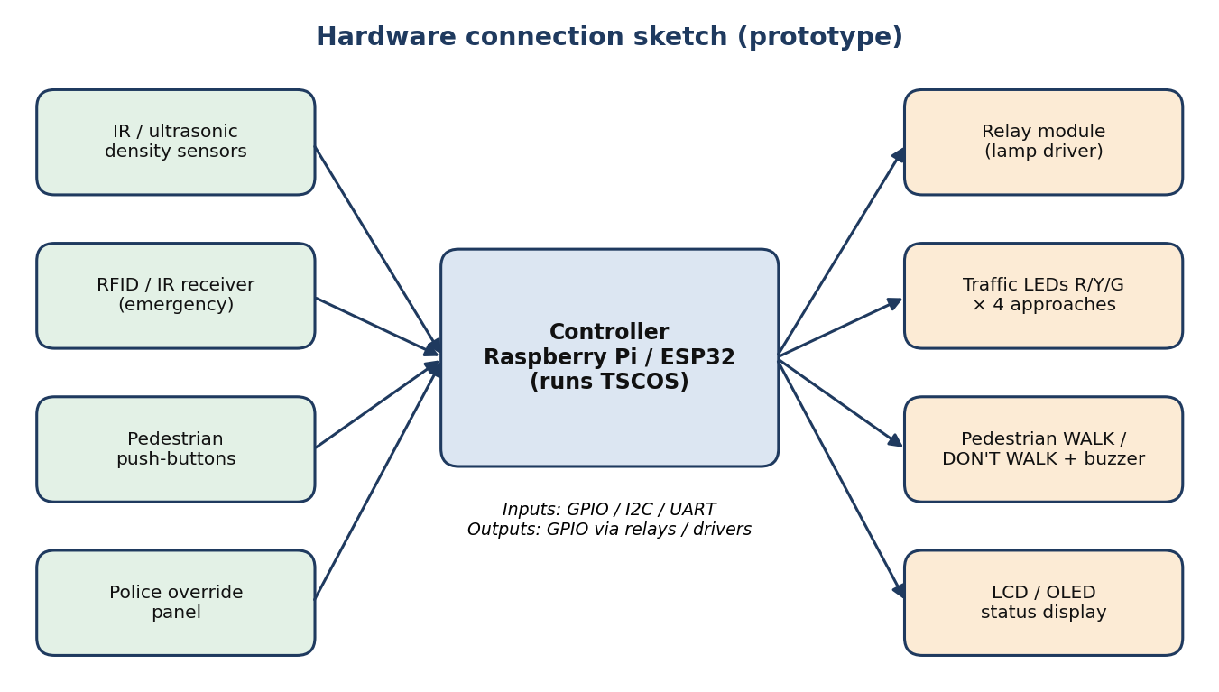
Fig 9.1 Hardware connection sketch
9.2 How the Software Connects to Hardware
- On a microcontroller (Arduino/ESP32): C/C++ code uses digitalWrite() and digitalRead() on GPIO pins; the scheduler runs in the main loop or from timers/interrupts.
- On embedded Linux (Raspberry Pi): a user-space C program drives GPIO through sysfs or libraries such as pigpio, reads sensors via GPIO, I2C, UART or USB, and uses pthread, sem_t, POSIX message queues and shared memory for the OS concepts.
Data-flow example
- A sensor interrupt/thread detects an emergency vehicle and writes to shared memory or sends a message.
- The scheduler wakes up and recomputes the next phase.
- The scheduler writes the new phase to shared memory or sends a command to the driver process.
- The driver process toggles the GPIO pins and the lamps change.
CHAPTER 10
SOFTWARE IMPLEMENTATION
TSCOS is implemented in C (about 130 lines) and compiled with gcc using the -pthread flag. The simulation runs on a virtual clock so that a multi-minute traffic sequence executes instantly while the printed timestamps stay realistic. The complete listing is in Appendix A.
10.1 Main Functions
Table 10.1 Main functions of the software
Function | Role
scheduler_step() | Implements the priority order Manual → Emergency → Pedestrian → Density/Round-Robin for one loop iteration.
give_green(lane, secs, reason) | Locks the intersection mutex, checks safety, sets the lane GREEN and advances the clock.
end_green(lane) | Performs GREEN → YELLOW (5 s) → RED under the same lock.
safe_to_green(lane) | Returns true only if all other lanes are RED (mutual exclusion check).
dyn_green(density, rush) | Computes the green time quantum from traffic load.
say() / show() | Timestamped logging and signal-status display.

10.2 Build and Run
gcc -Wall -pthread -o tscos tscos.c
./tscos

10.3 Core Scheduler Logic
static void scheduler_step(Shared *s) {
if (s->manual_lane >= 0) { /* Level 1: operator controls */ return; }
if (s->emergency_lane >= 0) { give_green(s->emergency_lane, 25, "EMERGENCY_PREEMPT");
end_green(s->emergency_lane); return; }
if (s->ped_lane >= 0) { /* all red + WALK for 15 s */ return; }
/* density comparison */
if (max - min <= 1) round_robin(); // N -> E -> S -> W, 20 s each
else give_green(best, dyn_green(max, rush), "ADAPTIVE_DENSITY");
}

CHAPTER 11
SIMULATION RESULTS AND TESTING
The program was compiled and executed. The listing below is the actual output of the run (virtual clock starting at 08:00:00).
11.1 Execution Log
=== TSCOS v1.0 : Traffic Signal Control Operating System ===
[SYSTEM INIT] [08:00:00] Defaults: Green 30s, Yellow 5s, Red 65s. Mode: AUTOMATIC.

--- Scenario 1: Adaptive control (rush hour) ---
[SENSOR ] [08:00:05] Density -> N:45 S:12 E:8 W:15
[RULE MATCH] [08:00:05] Step 11-15: Rush hour=YES, target NORTH (density 45).
[SIGNAL SET] [08:00:05] NORTH: GREEN (50s) [ADAPTIVE_DENSITY]
N:GREEN S:RED E:RED W:RED
[TRANSITION] [08:00:55] NORTH: YELLOW (5s)
[TRANSITION] [08:01:00] NORTH: RED

--- Scenario 2: Emergency vehicle preemption ---
[SENSOR ] [08:01:00] AMBULANCE detected on EAST approach!
[RULE MATCH] [08:01:00] Step 7-8: Emergency vehicle on EAST. Preempting cycle.
[SIGNAL SET] [08:01:00] EAST: GREEN (25s) [EMERGENCY_PREEMPT]
N:RED S:RED E:GREEN W:RED
[INFO ] [08:01:25] Emergency vehicle cleared intersection.
[TRANSITION] [08:01:25] EAST: YELLOW (5s)
[TRANSITION] [08:01:30] EAST: RED

--- Scenario 3: Pedestrian crossing ---
[SENSOR ] [08:01:30] Pedestrian push-button pressed at WEST crossing.
[RULE MATCH] [08:01:30] Step 9-10: Pedestrian request at WEST crossing.
[SIGNAL SET] [08:01:30] VEHICLES: ALL RED | WEST PEDESTRIAN: WALK (15s)
[TRANSITION] [08:01:45] Pedestrian phase expired. Returning to vehicle loop.

--- Scenario 4: Equal low traffic (round-robin) ---
[SENSOR ] [08:01:50] Density -> N:5 S:5 E:4 W:5
[RULE MATCH] [08:01:50] Step 16-17: Equal density. Round-Robin fallback (20s quantum).
[SIGNAL SET] [08:01:50] NORTH: GREEN (20s) [ROUND_ROBIN]
N:GREEN S:RED E:RED W:RED
[TRANSITION] [08:02:10] NORTH: YELLOW (5s)
[TRANSITION] [08:02:15] NORTH: RED
[SIGNAL SET] [08:02:15] EAST: GREEN (20s) [ROUND_ROBIN]
N:RED S:RED E:GREEN W:RED
[TRANSITION] [08:02:35] EAST: YELLOW (5s)
[TRANSITION] [08:02:40] EAST: RED
[SIGNAL SET] [08:02:40] SOUTH: GREEN (20s) [ROUND_ROBIN]
N:RED S:GREEN E:RED W:RED
[TRANSITION] [08:03:00] SOUTH: YELLOW (5s)
[TRANSITION] [08:03:05] SOUTH: RED
[SIGNAL SET] [08:03:05] WEST: GREEN (20s) [ROUND_ROBIN]
N:RED S:RED E:RED W:GREEN
[TRANSITION] [08:03:25] WEST: YELLOW (5s)
[TRANSITION] [08:03:30] WEST: RED

--- Scenario 5: Manual override by police ---
[OPERATOR ] [08:03:30] Manual override received. Automatic scheduler suspended.
[SIGNAL SET] [08:03:30] SOUTH: GREEN (locked by operator) | OTHERS: RED
N:RED S:GREEN E:RED W:RED
[OPERATOR ] [08:04:30] Override released. Safe transition, resuming automatic mode.
[TRANSITION] [08:04:30] SOUTH: YELLOW (5s)
[TRANSITION] [08:04:35] SOUTH: RED
[SYSTEM ] [08:04:35] Mode: AUTOMATIC. Simulation complete.

11.2 Signal Timeline
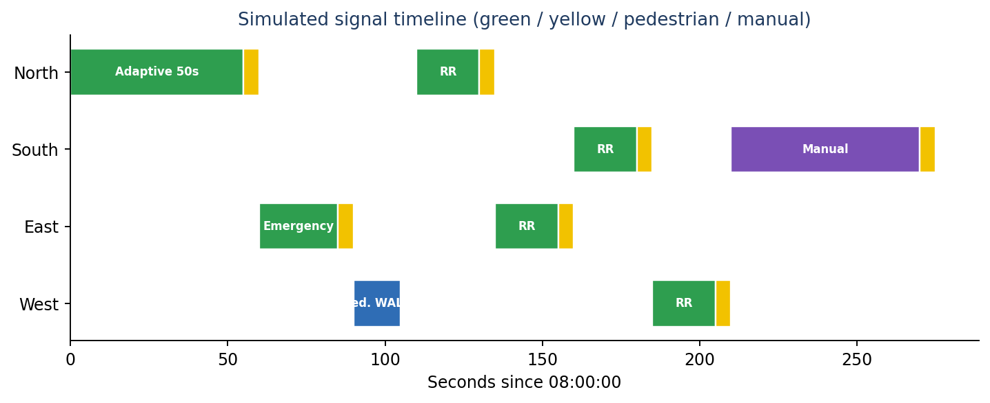
Fig 11.1 Timeline of the simulated run (seconds from 08:00:00)
11.3 Visual Signal Status Summary
Table 11.1 Visual signal status summary
Trigger / Event | Active direction | Vehicle signals (N / S / E / W) | Pedestrian | Mode output
Rush-hour queue | North | GREEN / RED / RED / RED | Don't Walk | ADAPTIVE_DENSITY
Ambulance on East | East | RED / RED / GREEN / RED | Don't Walk | EMERGENCY_PREEMPT
Crosswalk request | None (vehicles) | RED / RED / RED / RED | WALK (West) | PEDESTRIAN_PHASE
Equal traffic | N → E → S → W | Cyclic green switches | Don't Walk | ROUND_ROBIN_FALLBACK
Manual command | Operator choice | Controlled by operator | Manual | MANUAL_OVERRIDE

11.4 Test Cases
Table 11.2 Test cases and observed results
No. | Input | Expected result | Observed result
1 | Density N=45, S=12, E=8, W=15, rush hour | North green, 50 s, then yellow 5 s and red | Pass: North GREEN 50 s at 08:00:05, RED at 08:01:00
2 | Ambulance detected on East | East green immediately; others red; yellow after clearance | Pass: East GREEN 25 s, YELLOW, RED at 08:01:30
3 | Pedestrian button at West | All vehicle signals red; WALK for 15 s | Pass: WALK from 08:01:30 to 08:01:45
4 | Density 5 / 5 / 4 / 5 | Round-robin N → E → S → W, 20 s each | Pass: four green slots from 08:01:50 to 08:03:30
5 | Operator forces South green | Auto mode suspended; South green, others red | Pass: South green until release at 08:04:30
6 | Release of override | Safe yellow → red, then automatic mode | Pass: YELLOW then RED at 08:04:35
7 | Two greens requested together | Second request blocked | Pass: safe_to_green() allows only one green at any time (all log lines show a single GREEN)

11.5 Discussion
The log confirms that the priority rules work as designed. The emergency request preempted the normal cycle, the pedestrian phase kept all vehicle lights red, the rush-hour scheduler gave the heaviest approach a longer green (50 s against the 30 s default), and the equal-load case fell back to fair round-robin. At no point in the run is more than one approach green. The decision logic is a few comparisons and runs in far less than the 100 ms latency target.
CHAPTER 12
RELEVANT INDUSTRIES AND APPLICATIONS
- Smart city / Intelligent Transportation Systems: adaptive controllers at urban intersections, with a path to traffic-management-centre integration.
- Emergency services: faster ambulance, fire and police response and hospital corridor management.
- Traffic-signal manufacturers: embedding OS-based scheduling logic to upgrade fixed-time controllers to adaptive, priority-aware ones.
- IoT and embedded start-ups: low-cost sensor-based controllers and retrofit kits for existing signals.
- Government and municipal bodies: pilot projects for traffic police and transport departments, for example in Chennai and across Tamil Nadu, integrated with existing CCTV networks.
- Academia and research: a testbed for scheduling, synchronisation and real-time systems.
CHAPTER 13
ADVANTAGES AND LIMITATIONS
13.1 Advantages
- Improved emergency response through guaranteed preemptive priority.
- Reduced congestion through density-aware, adaptive scheduling.
- Fairness under normal conditions through the round-robin fallback.
- Flexibility with several modes: pedestrian, rush hour and manual override.
- Safety through mutual exclusion, mandatory yellow and an all-red clearance.
- Educational value as a clear, practical demonstration of OS concepts.
- A scalable foundation for AI-based or networked traffic systems.
13.2 Limitations
- Only a single junction is handled; there is no coordination between junctions.
- Sensor input is simulated in this version; real sensors need calibration and noise handling.
- Rush hour is a configured flag, not yet learned from data.
- Only one approach is green at a time (four-phase), which is simple and safe but less efficient than allowing compatible movements together.
- The hardware conflict monitor is described but not built in this software-only prototype.
CHAPTER 14
FUTURE ENHANCEMENTS
- Multi-intersection coordination: networked controllers that create green waves along a corridor.
- AI/ML-based adaptation: learning traffic patterns over days or weeks to predict rush hours and tune profiles.
- V2X integration: direct communication with connected vehicles for finer control.
- Cloud dashboard: real-time monitoring and analytics for traffic authorities.
- Energy optimisation: reducing idle time and unnecessary signal changes to save power.
- Compatible-phase operation: allowing N–S or E–W pairs to be green together using a conflict matrix.
CHAPTER 15
CONCLUSION
This project showed that fundamental operating system concepts, namely process management, priority and round-robin scheduling, synchronisation and IPC, can be applied directly to a real-world problem: efficient and safe traffic control. By supporting emergency priority, pedestrian mode, rush-hour adaptation, manual police override and a fair round-robin fallback, TSCOS offers a flexible and robust design for smart intersections. The working C simulation verified each use case and the safety rule that only one approach is green at a time. The design can be extended with real sensors, hardware drivers and city-wide coordination in future work.
REFERENCES
- A. Silberschatz, P. B. Galvin and G. Gagne, Operating System Concepts, 10th ed., Wiley, 2018.
- A. S. Tanenbaum and H. Bos, Modern Operating Systems, 4th ed., Pearson, 2014.
- W. Stallings, Operating Systems: Internals and Design Principles, 9th ed., Pearson, 2017.
- The Open Group, POSIX.1-2017: pthread, semaphore, shared memory and message queue interfaces.
- M. Kerrisk, The Linux Programming Interface, No Starch Press, 2010.
- Raspberry Pi Foundation, Raspberry Pi hardware and GPIO documentation, raspberrypi.com.
- Emergency Vehicle Preemption (EVP) systems and Intelligent Transportation Systems literature, as referred to in the project script.
APPENDIX A
Complete Source Code (tscos.c)
/* TSCOS - Traffic Signal Control Operating System (simulation) */
#include <stdio.h>
#include <stdarg.h>
#include <pthread.h>

#define NL 4
typedef enum { RED, YELLOW, GREEN } State;
static const char *LN[] = {"NORTH", "SOUTH", "EAST", "WEST"};
static const char *SN[] = {"RED", "YELLOW", "GREEN"};

typedef struct { int id; State state; int density; int priority; int remaining; } PCB;

/* Shared-memory structure written by sensor module, read by scheduler */
typedef struct {
int density[NL];
int emergency_lane; /* -1 = none */
int ped_lane; /* -1 = none */
int manual_lane; /* -1 = none, 4 = all-red hold */
int rush_hour;
} Shared;

static PCB lane[NL];
static pthread_mutex_t intersection_lock = PTHREAD_MUTEX_INITIALIZER;
static int clk = 8 * 3600;

static void say(const char *tag, const char *fmt, ...) {
va_list a; va_start(a, fmt);
printf("[%-10s] [%02d:%02d:%02d] ", tag, clk/3600, (clk/60)%60, clk%60);
vprintf(fmt, a); printf("\n"); va_end(a);
}

static void show(const char *extra) {
printf(" N:%-6s S:%-6s E:%-6s W:%-6s %s\n",
SN[lane[0].state], SN[lane[1].state], SN[lane[2].state], SN[lane[3].state], extra);
}

/* Mutual exclusion: only one approach may be GREEN at a time */
static int safe_to_green(int l) {
for (int i = 0; i < NL; i++) if (i != l && lane[i].state != RED) return 0;
return 1;
}

static void give_green(int l, int secs, const char *why) {
pthread_mutex_lock(&intersection_lock);
if (!safe_to_green(l)) { say("SAFETY", "Conflict blocked for %s", LN[l]); pthread_mutex_unlock(&intersection_lock); return; }
lane[l].state = GREEN; lane[l].remaining = secs;
say("SIGNAL SET", "%s: GREEN (%ds) [%s]", LN[l], secs, why);
show("");
pthread_mutex_unlock(&intersection_lock);
clk += secs;
}

static void end_green(int l) {
pthread_mutex_lock(&intersection_lock);
lane[l].state = YELLOW; say("TRANSITION", "%s: YELLOW (5s)", LN[l]); clk += 5;
lane[l].state = RED; say("TRANSITION", "%s: RED", LN[l]);
pthread_mutex_unlock(&intersection_lock);
}

static int dyn_green(int d, int rush) {
if (!rush) return 30;
int g = 20 + (d * 2) / 3; /* time quantum grows with load */
return g > 60 ? 60 : g;
}

static void scheduler_step(Shared *s) {
/* Step 5-6: manual override (Level 1) */
if (s->manual_lane >= 0) {
say("OPERATOR", "Manual override received. Automatic scheduler suspended.");
if (s->manual_lane < NL) { lane[s->manual_lane].state = GREEN;
say("SIGNAL SET", "%s: GREEN (locked by operator) | OTHERS: RED", LN[s->manual_lane]); show(""); }
return;
}
/* Step 7-8: emergency preemption (Level 2) */
if (s->emergency_lane >= 0) {
say("RULE MATCH", "Step 7-8: Emergency vehicle on %s. Preempting cycle.", LN[s->emergency_lane]);
give_green(s->emergency_lane, 25, "EMERGENCY_PREEMPT");
say("INFO", "Emergency vehicle cleared intersection.");
end_green(s->emergency_lane); s->emergency_lane = -1; return;
}
/* Step 9-10: pedestrian phase */
if (s->ped_lane >= 0) {
say("RULE MATCH", "Step 9-10: Pedestrian request at %s crossing.", LN[s->ped_lane]);
say("SIGNAL SET", "VEHICLES: ALL RED | %s PEDESTRIAN: WALK (15s)", LN[s->ped_lane]);
clk += 15; say("TRANSITION", "Pedestrian phase expired. Returning to vehicle loop.");
s->ped_lane = -1; return;
}
/* Step 13-17: density / round robin */
int max = 0, min = 1 << 30, best = 0;
for (int i = 0; i < NL; i++) { lane[i].density = s->density[i];
if (s->density[i] > max) { max = s->density[i]; best = i; }
if (s->density[i] < min) min = s->density[i]; }
say("SENSOR", "Density -> N:%d S:%d E:%d W:%d", s->density[0], s->density[1], s->density[2], s->density[3]);
if (max - min <= 1) {
say("RULE MATCH", "Step 16-17: Equal density. Round-Robin fallback (20s quantum).");
int order[NL] = {0, 2, 1, 3}; /* N -> E -> S -> W */
for (int k = 0; k < NL; k++) { give_green(order[k], 20, "ROUND_ROBIN"); end_green(order[k]); }
} else {
say("RULE MATCH", "Step 11-15: Rush hour=%s, target %s (density %d).", s->rush_hour ? "YES" : "NO", LN[best], max);
int g = dyn_green(max, s->rush_hour);
give_green(best, g, "ADAPTIVE_DENSITY"); end_green(best);
}
}

int main(void) {
for (int i = 0; i < NL; i++) { lane[i].id = i; lane[i].state = RED; lane[i].priority = 1; }
printf("=== TSCOS v1.0 : Traffic Signal Control Operating System ===\n");
say("SYSTEM INIT", "Defaults: Green 30s, Yellow 5s, Red 65s. Mode: AUTOMATIC.");
Shared s = {{0}, -1, -1, -1, 1};

printf("\n--- Scenario 1: Adaptive control (rush hour) ---\n");
clk += 5; s.density[0]=45; s.density[1]=12; s.density[2]=8; s.density[3]=15; scheduler_step(&s);

printf("\n--- Scenario 2: Emergency vehicle preemption ---\n");
say("SENSOR", "AMBULANCE detected on EAST approach!"); s.emergency_lane = 2; scheduler_step(&s);

printf("\n--- Scenario 3: Pedestrian crossing ---\n");
clk += 0; say("SENSOR", "Pedestrian push-button pressed at WEST crossing."); s.ped_lane = 3; scheduler_step(&s);

printf("\n--- Scenario 4: Equal low traffic (round-robin) ---\n");
clk += 5; s.density[0]=5; s.density[1]=5; s.density[2]=4; s.density[3]=5; s.rush_hour=0; scheduler_step(&s);

printf("\n--- Scenario 5: Manual override by police ---\n");
s.manual_lane = 1; scheduler_step(&s);
clk += 60; say("OPERATOR", "Override released. Safe transition, resuming automatic mode.");
end_green(1); s.manual_lane = -1;
say("SYSTEM", "Mode: AUTOMATIC. Simulation complete.");
return 0;
}

