
21CSC202J - OPERATING SYSTEMS
LAB MANUAL
II YEAR / III Semester
Academic Year: 2024-2025 ODD SEMESTER
FACULTY OF ENGINEERING AND TECHNOLOGY SRM
INSTITUTE OF SCIENCE AND TECHNOLOGY
RAMAPURAM CHENNAI- 600 089

LIST OF EXPERIMENTS
Ex.No. | Experiment Name
1 | Operating System Installation
1 | Basic Linux Commands
1 | Filters and Admin Commands
2 | Process Creation using fork() and Usage of getpid(), getppid(), wait() Functions
3 | Multithreading
4 | Mutual Exclusion using Semaphore and Monitor
5 | Reader-Writer Problem
6 | Dining Philosophers Problem
7 | Banker's Algorithm for Deadlock Avoidance
8 | FCFS and SJF Scheduling
9 | Priority and Round Robin Scheduling
10 | FIFO Page Replacement Algorithm
11 | LRU and LFU Page Replacement Algorithm
12 | Best Fit and Worst Fit Memory Management Policies
13 | Disk Scheduling Algorithm
14 | Sequential and Indexed File Allocation
15 | File Organization Schemes for Single and Two Level Directory

TABLE OF CONTENTS
Ex.No.1A Operating System Installation 4
Ex.No.1B Basic Linux Commands 12
Ex.No.1C Filters and Admin Commands 16
Ex.No.2 Process Creation using fork() and Usage of getpid(), getppid(), wait() Functions 18
Ex.No.3 Multithreading 21
Ex.No.4 Mutual Exclusion using Semaphore and Monitor 25
Ex.No.5 Reader-Writer Problem 30
Ex.No.6 Dining Philosophers Problem 32
Ex.No.7 Banker's Algorithm for Deadlock Avoidance 34
Ex.No.8 FCFS and SJF Scheduling 38
Ex.No.9 Priority and Round Robin Scheduling 42
Ex.No.10 FIFO Page Replacement Algorithm 45
Ex.No.11 LRU and LFU Page Replacement Algorithm 47
Ex.No.12 Best Fit and Worst Fit Memory Management Policies 50
Ex.No.13 Disk Scheduling Algorithm 53
Ex.No.14 Sequential and Indexed File Allocation 55
Ex.No.15 File Organization Schemes for Single and Two Level Directory 58

Ex.No.1A Operating System Installation
Ubuntu installation guidelines in windows
Installing Ubuntu in windows 10- 64 bit
1. Open the Control Panel by searching for 'control' in the Windows search bar, then open Programs.
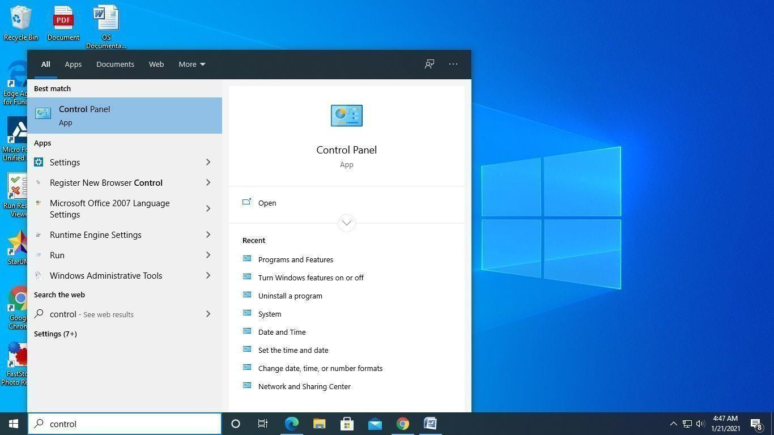
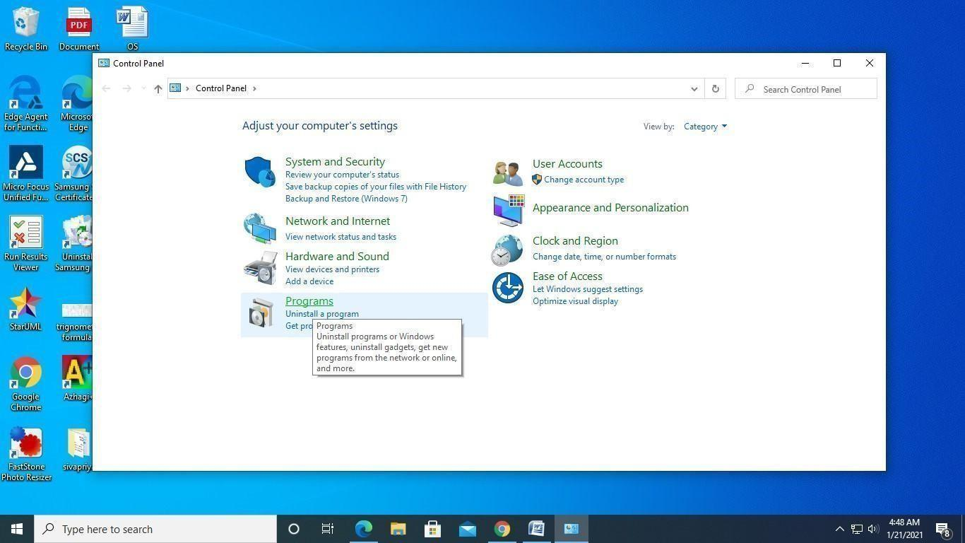
2. Select Turn Windows features On or Off under Programs and Features.
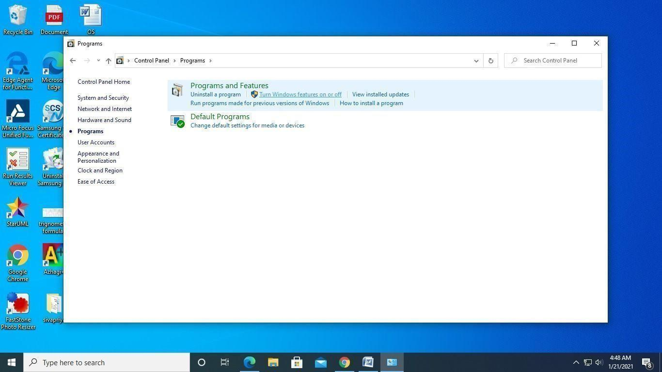
3. Select Windows Subsystem for Linux and press Ok.
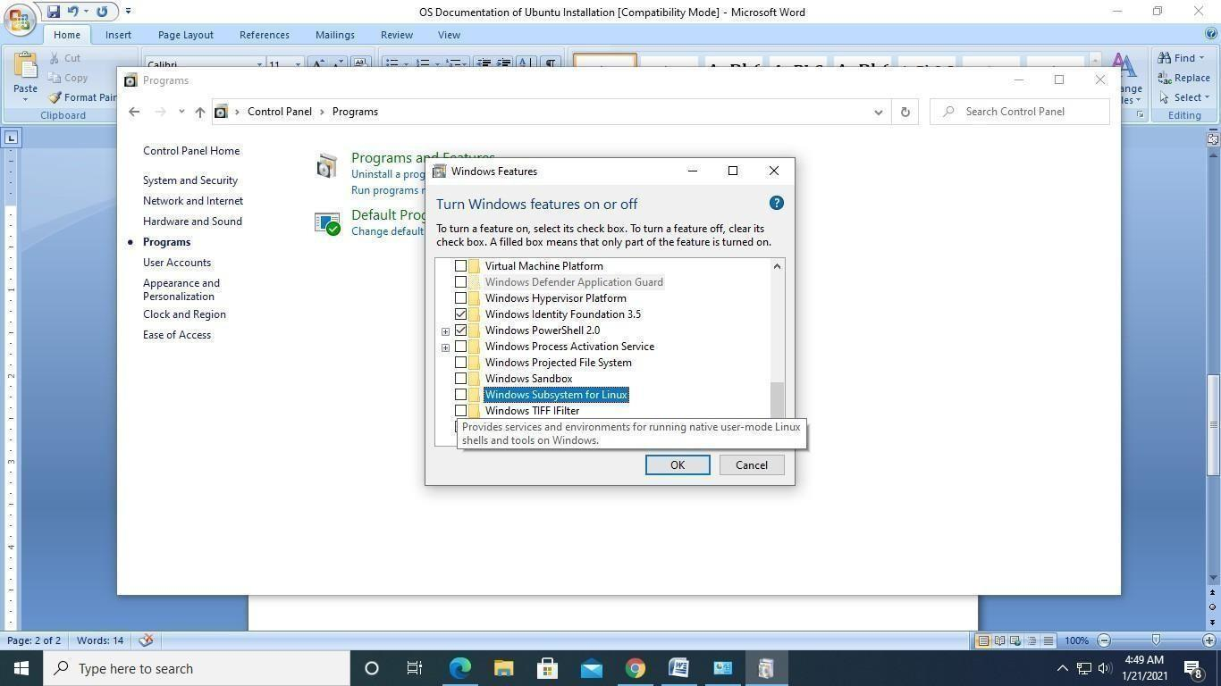
4. Now restart the PC to apply the changes.
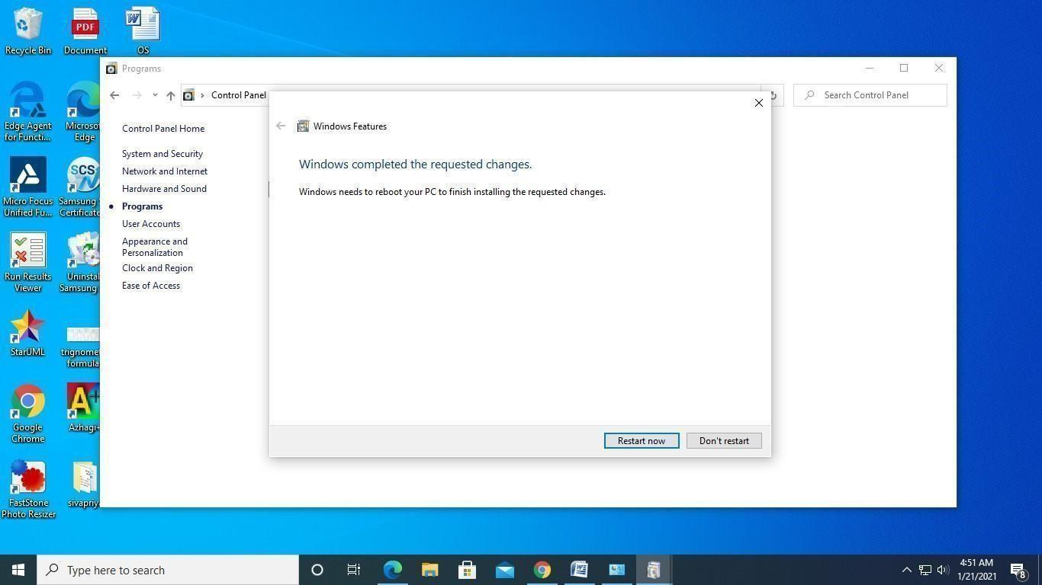
5. Choose Microsoft Store and search for Ubuntu.
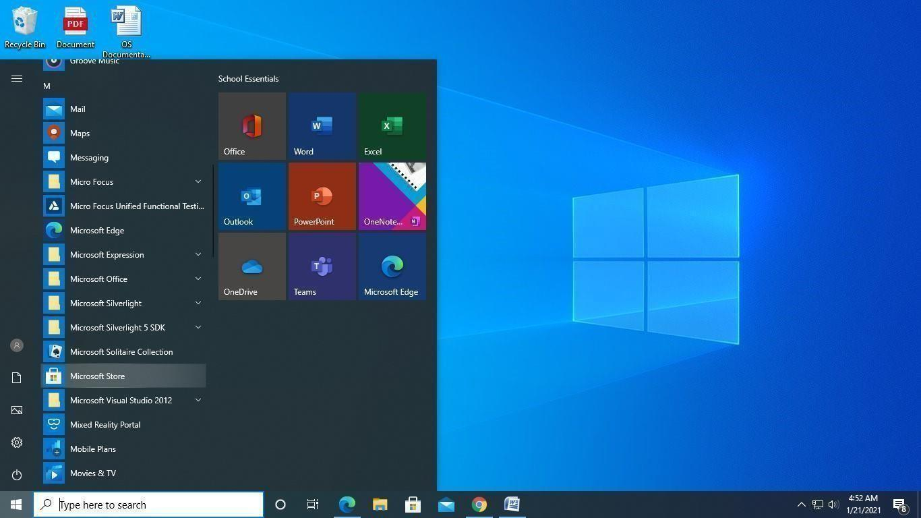

6. Click on Install.
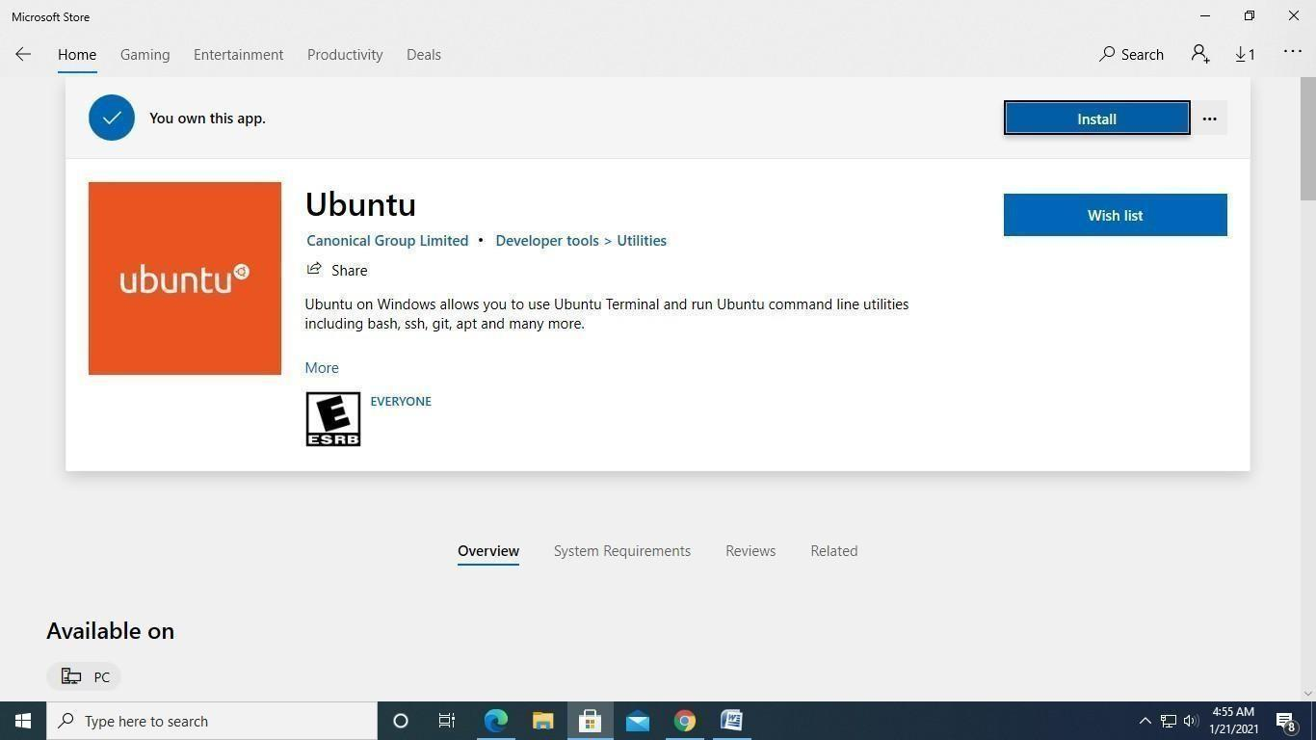
7. Wait for the download to complete.
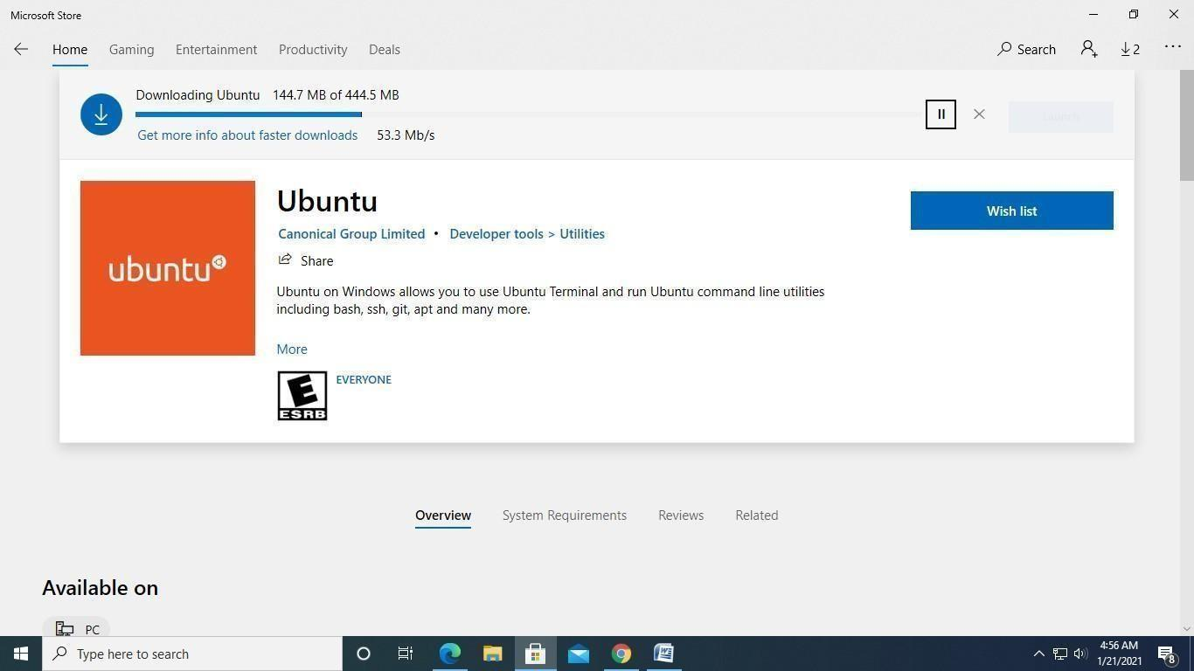
8. Now, Launch the Ubuntu.
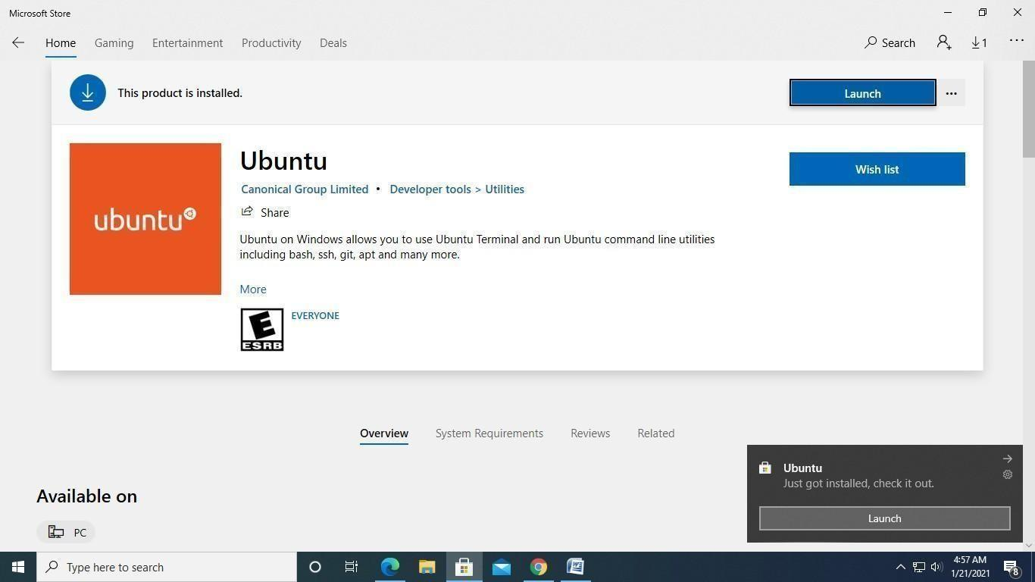
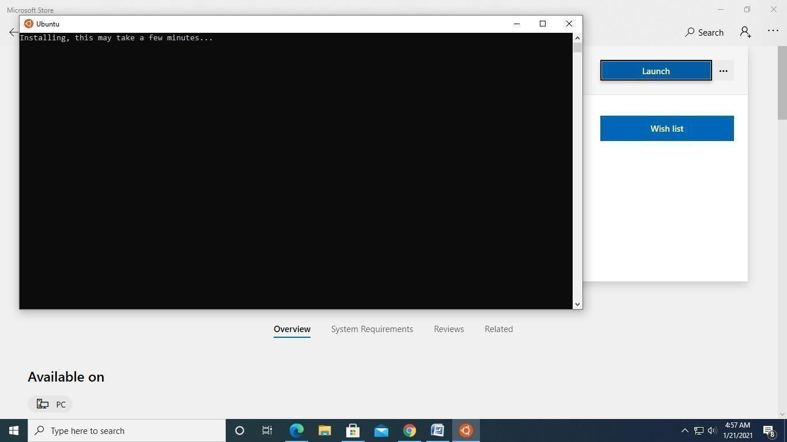
9. Username: any meaningful name. Password: any password.
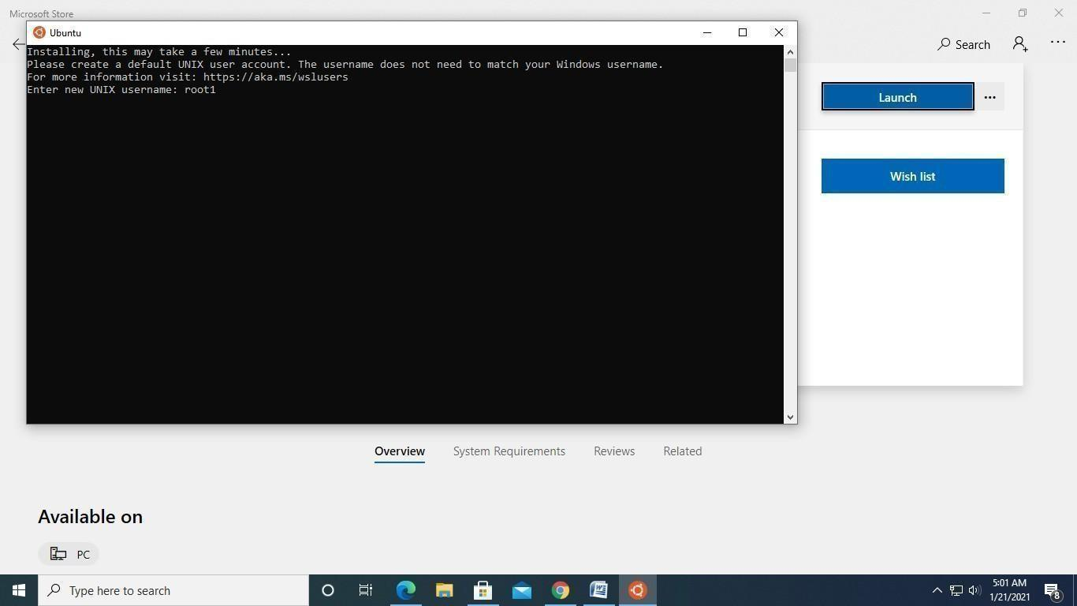
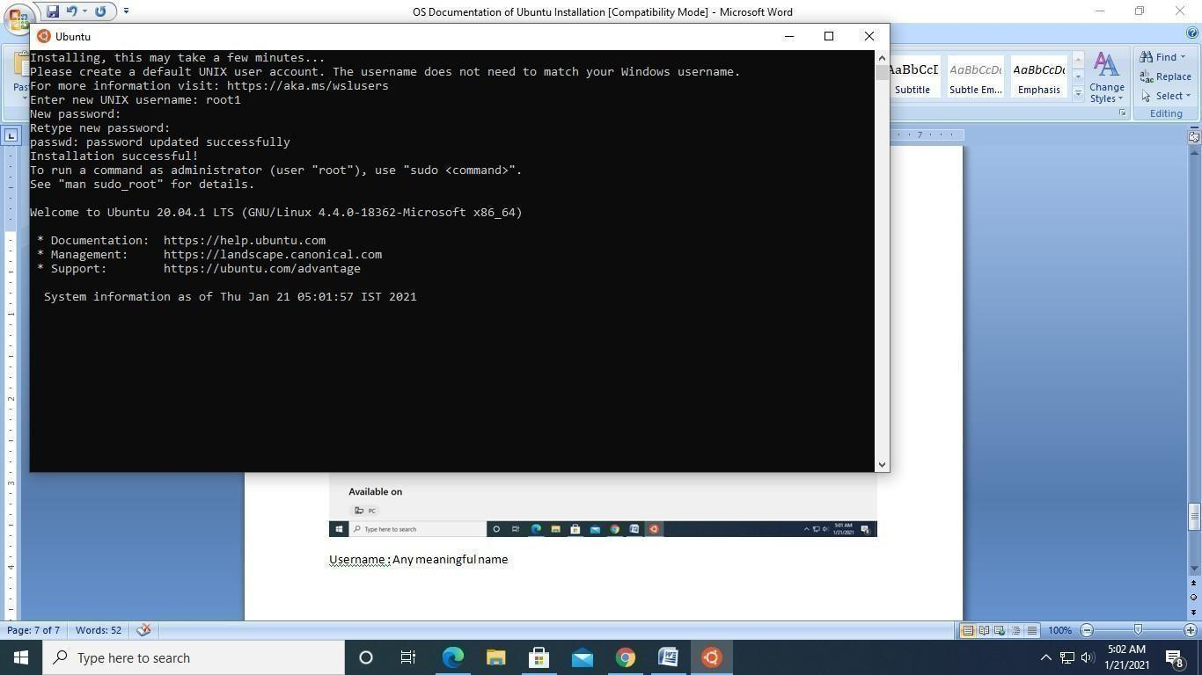
10. Finally, you will get the prompt on successful installation of Ubuntu in windows 10 64 bit.
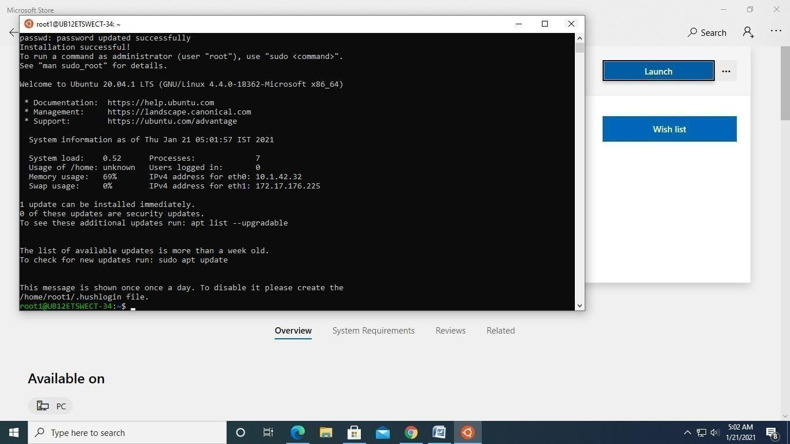

Ex.No.1B Basic Linux Commands

a) Basics
1. echo SRM
-> to display the string SRM
2. clear
-> to clear the screen
3. date
-> to display the current date and time
4. cal 2003
-> to display the calendar of the year 2003
cal 6 2003
-> to display the calendar for June 2003
5. passwd
-> to change password

b) Working with Files
1. ls
-> list files in the present working directory
ls -l
-> list files with detailed information (long list)
ls -a
-> list all files including hidden files
2. cat > f1
-> to create a file (press Ctrl+D to finish typing)
3. cat f1
-> display the content of the file f1
4. wc f1
-> list number of characters, words and lines of file f1
wc -c f1
-> list only number of characters of file f1
wc -l f1
-> list only number of lines of file f1
5. cp f1 f2
-> copy file f1 into f2
6. mv f1 f2
-> rename file f1 as f2
7. rm f1
-> remove the file f1
8. head -5 f1
-> list first 5 lines of the file f1
tail -5 f1
-> list last 5 lines of the file f1

c) Working with Directories
1. mkdir elias
-> to create the directory elias
2. cd elias
-> to change the directory to elias
3. rmdir elias
-> to remove the directory elias
4. pwd
-> to display the path of the present working directory
5. cd
-> to go to the home directory
cd ..
-> to go to the parent directory
cd -
-> to go to the previous working directory
cd /
-> to go to the root directory

d) File Name Substitution
1. ls f?
-> list files starting with 'f' and followed by any one character
2. ls *.c
-> list files with extension '.c'
3. ls [gpy]et
-> list files whose first letter is any one of the characters g, p or y, followed by the word 'et'
4. ls [a-d,l-m]ring
-> list files whose first letter is any one of the characters from a to d and l to m, followed by the word 'ring'

e) I/O Redirection
1. wc -l < ex1
-> input redirection: to find the number of lines of the file 'ex1'
2. who > f2
-> output redirection: the output of 'who' is redirected to file f2
3. cat >> f1
-> to append more content into the file f1

f) Piping
Syntax:
command1 | command2

The output of command1 is transferred to command2 as input. Finally, the output of command2 is displayed on the monitor.
Examples:
cat f1 | more
-> list the contents of file f1 screen by screen
head -6 f1 | tail -2
-> prints the 5th and 6th lines of the file f1

g) Environment Variables
1. echo $HOME
-> display the path of the home directory
2. echo $PS1
-> display the prompt string ($)
3. echo $PS2
-> display the second prompt string (> symbol by default)
4. echo $LOGNAME
-> login name
5. echo $PATH
-> list of pathnames where the OS searches for an executable file

h) File Permission
The chmod command is used to change the access permission of a file.
Method-1
Syntax:
chmod [ugo] [+/-] [rwxa] filename

- u : user, g : group, o : others
- + : add permission, - : remove permission
- r : read, w : write, x : execute, a : all permissions
Example:
chmod ug+rw f1
-> adds read and write permission of file f1 to both user and group members
Method-2
Syntax:
chmod octnum file1

The three-digit octal number represents the permissions as follows: the first digit for the user, the second for the group and the third for others. Each digit is the sum of 4 (read), 2 (write) and 1 (execute).
Example: chmod 754 f1
- Read, write and execute permission for the user: 4 + 2 + 1 = 7
- Read and execute permission for the group members: 4 + 0 + 1 = 5
- Only read permission for others: 4 + 0 + 0 = 4

Ex.No.1C Filters and Admin Commands

Filters
1. cut
- Used to cut characters or fields from a file/input.
- Syntax: cut -c chars filename or cut -f fieldnos filename
- By default, tab is the field separator (delimiter). If the fields are separated by any other character, specify it explicitly using the -d option.
- Syntax: cut -d delimitchar -f fields filename
2. grep
- Used to search one or more files for a particular pattern.
- Syntax: grep pattern filename(s)
- Lines that contain the pattern in the file(s) get displayed.
- The pattern can be any regular expression. More than one file can be searched.
- -v option displays the lines that do not contain the pattern.
- -l option lists only the names of the files that contain the pattern.
- -n option displays the line number along with the lines that match the pattern.
3. sort
- Used to sort the file in order.
- Syntax: sort filename
- Sorts the data as text by default, using the first field by default.
- -r option sorts the file in descending order.
- -u option eliminates duplicate lines.
- -o filename option writes the sorted data into the file filename.
- -tdchar option sorts the file in which fields are separated by dchar.
- -n option sorts the data as numbers.
- +1n option skips the first field and sorts the file by the second field numerically.
4. uniq
- Displays the unique lines of a sorted file.
- Syntax: uniq filename
- -d option displays only the duplicate lines.
- -c option displays unique lines with the number of occurrences.
5. diff
- Used to differentiate two files.
- Syntax: diff f1 f2
- Compares the two files f1 and f2 and prints all the lines that are different between them.

Questions and Commands
Q1. Write a command to cut 5 to 8 characters of the file f1.
$ cut -c 5-8 f1

Q2. Write a command to display the user-id of all the users in your system.
$ cut -d: -f3 /etc/passwd

Q3. Write a command to check whether the user judith is available in your system or not (use grep).
$ grep "^judith:" /etc/passwd

Q4. Write a command to display the lines of the file f1 that start with SRM.
$ grep "^SRM" f1

Q5. Write a command to sort the file /etc/passwd in descending order.
$ sort -r /etc/passwd

Q6. Write a command to display the unique lines of the sorted file f21. Also display the number of occurrences of each line.
$ uniq -c f21

Q7. Write a command to display the lines that are common to the files f1 and f2.
$ comm -12 <(sort f1) <(sort f2)

PROGRAM (4) | OUTPUT (3) | VIVA (3) | TOTAL (10)

Ex.No.2 Process Creation using fork() and Usage of getpid(), getppid(), wait() Functions
Aim:
To write a program for process creation using fork() and usage of getpid(), getppid(), wait() functions.
Program: Process creation using fork()
#include <stdio.h>
#include <sys/types.h>
#include <unistd.h>
int main() {
fork();
fork();
printf("Hello World\n");
return 0;
}

Sample Output:
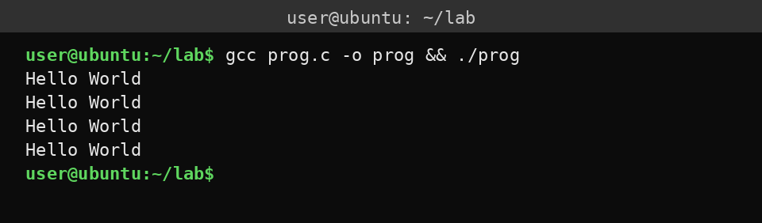

Program: Usage of getpid() and getppid()
#include <stdio.h>
#include <sys/types.h>
#include <unistd.h>
void main() {
int process_id, p_process_id;
/* getpid() returns the process id of the calling function */
process_id = getpid();
/* getppid() returns the process id of the parent function */
p_process_id = getppid();
printf("The process id: %d\n", process_id);
printf("The process id of parent function: %d\n", p_process_id);
}

Sample Output:
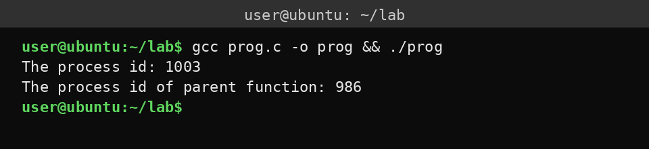

Program: Usage of wait()
#include <stdio.h>
#include <stdlib.h>
#include <sys/wait.h>
#include <unistd.h>
int main() {
pid_t cpid;
if (fork() == 0)
exit(0); /* terminate child */
else
cpid = wait(NULL); /* reaping child */
printf("Parent pid = %d\n", getpid());
printf("Child pid = %d\n", cpid);
return 0;
}

Sample Output:
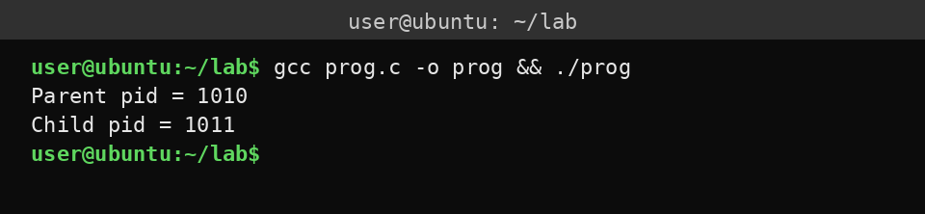

Result:
Thus successfully completed process creation using fork() and usage of getpid(), getppid(), wait() functions.

PROGRAM (4) | OUTPUT (3) | VIVA (3) | TOTAL (10)

Ex.No.3 Multithreading
Threading:
A thread is the smallest unit of execution when a process is running. All threads within a process share the same memory space.
Multi-threading:
It uses multiple threads of similar actions under a single program to perform multiple tasks concurrently. The main objective of multithreading is to make the code more reliable.
Single processor multithreading:
It can perform only one task at a time. Example: music player on our system.
Multi-processor multithreading:
It can perform multiple tasks. If one task is being held, the other one can wait until it is done.
Aim:
To write a simple Linux C program under the concept of multithreading using POSIX thread to find whether a number is even or odd.
Use case: Factory Quality Control
Program: Even or odd using POSIX thread
#include <stdio.h>
#include <pthread.h>
void *check(void *arg) {
int n = *(int *)arg;
printf("%d is %s\n", n, (n % 2 == 0) ? "Even" : "odd");
return NULL;
}
int main() {
pthread_t t;
int num = 15;
pthread_create(&t, NULL, check, &num);
pthread_join(t, NULL);
return 0;
}

Sample Output:
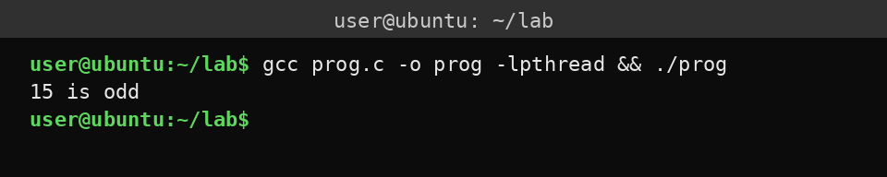

A. Single Processor Multithreading
Algorithm:
1. Initialize shared resource: create a thread-safe product queue, initialize a lock for critical section protection, and set the defective product counter to 0.
2. Create worker threads (3 inspectors). Each thread runs the quality_inspector() function. All threads share the same product queue.
3. Quality inspection process: the inspector dequeues a product from the queue, simulates inspection time (0.1 sec), enters the critical section (acquires lock), applies the quality check (even product IDs are defective), updates the shared counter inside the lock, and releases the lock and marks the task complete.
4. Main thread: enqueues 10 products for inspection, waits for all products to be processed, and prints the final defective count.
Program:
#include <stdio.h>
#include <pthread.h>
pthread_mutex_t lock = PTHREAD_MUTEX_INITIALIZER;
int defective = 0;
void *inspection(void *id) {
int p = *(int *)id;
pthread_mutex_lock(&lock);
if (p % 2 == 0)
defective++;
printf("Product %d: %s\n", p, p % 2 == 0 ? "DEFECTIVE" : "ok");
pthread_mutex_unlock(&lock);
return NULL;
}
int main() {
pthread_t t[5];
int id[5];
for (int i = 0; i < 5; i++) {
id[i] = i + 1;
pthread_create(&t[i], NULL, inspection, &id[i]);
}
for (int i = 0; i < 5; i++)
pthread_join(t[i], NULL);
printf("Defective : %d\n", defective);
return 0;
}

Sample Output:
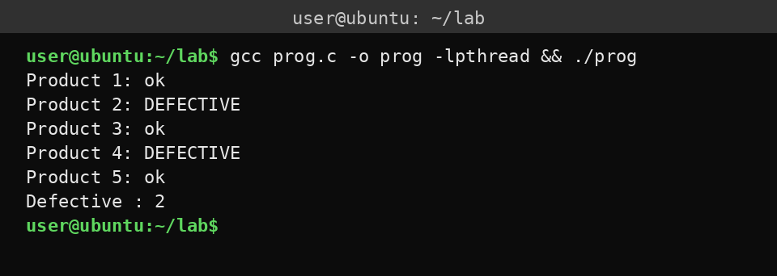

B. Multiprocessor Multithreading
Programmatic algorithm:
1. Define defect counts for each production line.
2. Start one thread per line.
3. Each thread inspects its line.
4. If defects are within the acceptable threshold, it increments the shared total.
5. Use a mutex so that multiple threads do not update the total at the same time.
6. Wait for all threads to finish.
7. Print the final accepted count.
Program:
#include <pthread.h>
#include <stdio.h>
#include <stdlib.h>
#define N 4
int defects[N] = {2, 1, 3, 0};
int total = 0;
pthread_mutex_t m = PTHREAD_MUTEX_INITIALIZER;
void *qc(void *a) {
int i = *(int *)a;
if (defects[i] <= 2) {
pthread_mutex_lock(&m);
total++;
pthread_mutex_unlock(&m);
}
printf("Line %d inspected, defects = %d\n", i, defects[i]);
return NULL;
}
int main() {
pthread_t t[N];
int id[N];
for (int i = 0; i < N; i++) {
id[i] = i;
pthread_create(&t[i], NULL, qc, &id[i]);
}
for (int i = 0; i < N; i++)
pthread_join(t[i], NULL);
printf("Accepted = %d\n", total);
return 0;
}

Sample Output:
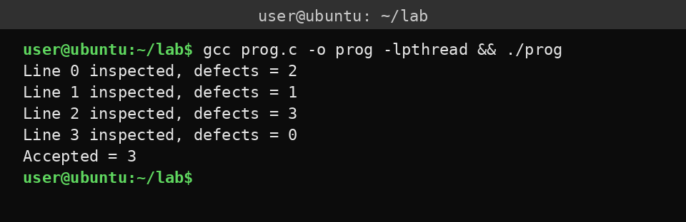

Result:
Successfully implemented multithreading and pthread in C.

PROGRAM (4) | OUTPUT (3) | VIVA (3) | TOTAL (10)

Ex.No.4 Mutual Exclusion using Semaphore and Monitor
Mutual Exclusion:
Mutual exclusion in an operating system is the rule that only one thread can process at a time on the critical section of the program and access the shared resource. The main objective of using mutual exclusion is to avoid race conditions and data corruption. Without mutual exclusion, two threads can hit the same variable at the same time and overwrite each other's changes.
Semaphores:
Semaphores are mainly used for process synchronization, including controlling access to shared resources.
Monitors:
Monitors are also one of the synchronization methods, like semaphores, which are used in concurrent systems. A concurrent system is a computing model where multiple computations or tasks are executed during overlapping time periods.
Mutual exclusion using semaphores
Advantages:
- Easy to implement and widely used for synchronization.
- Useful for both mutual exclusion and coordination between processes.
- Efficient because it can avoid busy waiting in many implementations.
Disadvantages:
- Hard to use correctly; the programmer must manage wait and signal operations manually.
- Does not provide built-in protection or data encapsulation, so shared data is easier to misuse.
Mutual exclusion using monitors
Advantages:
- Easier and safer to use than semaphores.
- Mutual exclusion is automatic: only one process can be active inside the monitor.
Disadvantages:
- Less flexible for very low-level synchronization needs.
- Can be more complex to implement than semaphores in some systems.
Use: Database record update.

A. Mutual Exclusion
Aim:
To implement mutual exclusion using pthread mutex to update a shared EHR record.
Algorithm:
1. Initialize a pthread_mutex_t to protect the shared EHR record.
2. Each thread locks the mutex before entering the critical section (updating EHR), performs the EHR update (e.g., increments a version counter), and unlocks the mutex after the update.
3. Because only one thread can hold the mutex at a time, updates to the EHR are mutually exclusive and race-condition free.
Program:
#include <stdio.h>
#include <pthread.h>
pthread_mutex_t ehr_mutex = PTHREAD_MUTEX_INITIALIZER;
int ehr_version = 0;
void *update_ehr(void *arg) {
pthread_mutex_lock(&ehr_mutex);
printf("Thread %ld updating EHR (v%d -> v%d)\n", (long)arg, ehr_version, ehr_version + 1);
ehr_version++;
pthread_mutex_unlock(&ehr_mutex);
return NULL;
}
int main() {
pthread_t t1, t2;
pthread_create(&t1, NULL, update_ehr, (void *)1);
pthread_create(&t2, NULL, update_ehr, (void *)2);
pthread_join(t1, NULL);
pthread_join(t2, NULL);
printf("Final EHR version: %d\n", ehr_version);
return 0;
}

Sample Output:
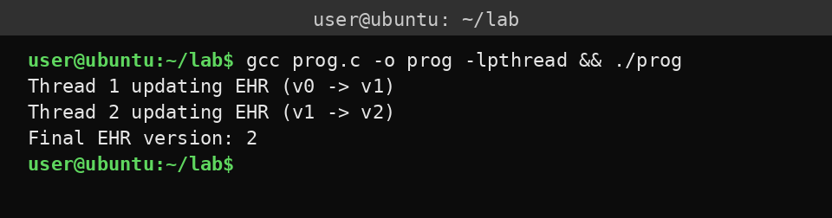

B. Mutual Exclusion using Semaphore
Algorithm:
1. Create/initialize a semaphore ehr_sem with value 1 (binary semaphore).
2. Each thread that wants to update EHR calls sem_wait(&ehr_sem) before entering the critical section, performs the EHR update (e.g., increments a shared version counter), and calls sem_post(&ehr_sem) after the update.
Program:
#include <stdio.h>
#include <pthread.h>
#include <semaphore.h>
sem_t ehr_sem;
int ehr_version = 0;
void *update_ehr(void *arg) {
sem_wait(&ehr_sem);
printf("Thread %ld updating EHR (v%d -> v%d)\n", (long)arg, ehr_version, ehr_version + 1);
ehr_version++;
sem_post(&ehr_sem);
return NULL;
}
int main() {
pthread_t t1, t2;
sem_init(&ehr_sem, 0, 1);
pthread_create(&t1, NULL, update_ehr, (void *)1);
pthread_create(&t2, NULL, update_ehr, (void *)2);
pthread_join(t1, NULL);
pthread_join(t2, NULL);
printf("Final EHR version: %d\n", ehr_version);
sem_destroy(&ehr_sem);
return 0;
}

Sample Output:

C. Mutual Exclusion using Monitors
Algorithm:
1. Use a pthread_mutex_t to protect the shared EHR data (this gives mutual exclusion).
2. Use a pthread_cond_t to model the monitor's condition (optional here, but shows the monitor structure).
3. Each thread that wants to update EHR locks the mutex (enter the monitor), optionally waits on the condition if some EHR condition is not met (here we just proceed), updates the shared EHR state (e.g., increments the version), then signals the condition and unlocks the mutex (exit the monitor).
4. Because only one thread holds the mutex at a time, EHR updates are mutually exclusive.
Program:
#include <stdio.h>
#include <pthread.h>
pthread_mutex_t ehr_mtx = PTHREAD_MUTEX_INITIALIZER;
pthread_cond_t ehr_cond = PTHREAD_COND_INITIALIZER;
int ehr_version = 0;
void *update_ehr(void *arg) {
pthread_mutex_lock(&ehr_mtx);
while (ehr_version < 0)
pthread_cond_wait(&ehr_cond, &ehr_mtx);
printf("Thread %ld updating EHR (v%d -> v%d)\n", (long)arg, ehr_version, ehr_version + 1);
ehr_version++;
pthread_cond_signal(&ehr_cond);
pthread_mutex_unlock(&ehr_mtx);
return NULL;
}
int main() {
pthread_t t1, t2;
pthread_create(&t1, NULL, update_ehr, (void *)1);
pthread_create(&t2, NULL, update_ehr, (void *)2);
pthread_join(t1, NULL);
pthread_join(t2, NULL);
printf("Final EHR version: %d\n", ehr_version);
pthread_mutex_destroy(&ehr_mtx);
pthread_cond_destroy(&ehr_cond);
return 0;
}

Sample Output:

PROGRAM (4) | OUTPUT (3) | VIVA (3) | TOTAL (10)

Ex.No.5 Reader-Writer Problem
Reader-Writer:
It is widely used for synchronization problems where readers are privileged to access a shared resource at the same time, but writers need exclusive access. It is used for managing shared data such as files, databases and memory.
Functions:
- Reader entry: a reader requests access to the shared data.
- Reader exit: a reader leaves after reading.
- Writer entry: a writer requests exclusive access.
- Writer exit: a writer releases the resource after writing.
- Synchronization variables: semaphores and mutexes are used to control access and track active readers.
- Only one writer can write at a time.
- While a writer is writing, no reader is allowed to enter.
- Multiple readers can read simultaneously if no writer is writing.
Advantages:
It improves performance when reads are more frequent than writes, because many reads can work together.
Disadvantages:
- It is more complex to implement than simple mutual exclusion.
- A reader-priority solution can cause writer starvation if readers keep arriving continuously.
Use case: News-Website CMS
Aim:
To write a C program to perform the Reader-Writer problem for the use case News-Website CMS.
Algorithm:
1. Initialize the shared article value.
2. Lock the semaphore before reading or writing.
3. Read or update the article.
4. Unlock the semaphore after finishing.
Program:
#include <stdio.h>
#include <pthread.h>
#include <semaphore.h>
sem_t s;
int article = 100;
void *r(void *arg) {
sem_wait(&s);
printf("Read %d\n", article);
sem_post(&s);
return NULL;
}
void *w(void *arg) {
printf("Writer is requesting for editing\n");
sem_wait(&s);
article += 10;
printf("write %d\n", article);
sem_post(&s);
return NULL;
}
int main() {
pthread_t tr, tw;
sem_init(&s, 0, 1);
pthread_create(&tr, NULL, r, NULL);
pthread_join(tr, NULL);
pthread_create(&tw, NULL, w, NULL);
pthread_join(tw, NULL);
sem_destroy(&s);
return 0;
}

Sample Output:
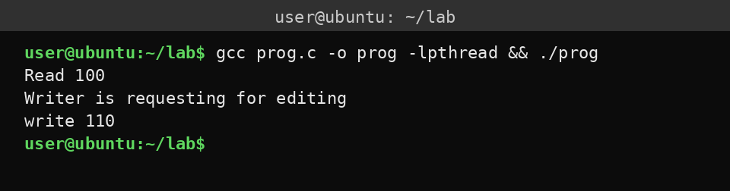

Result:
The above program was successfully implemented in C language.

PROGRAM (4) | OUTPUT (3) | VIVA (3) | TOTAL (10)

Ex.No.6 Dining Philosophers Problem
The Dining Philosophers problem is a classic operating system synchronization problem. Here 5 philosophers sit around a table, and each needs two forks to eat. It explains deadlock, starvation and resource sharing in concurrent systems.
Disadvantages:
1. Deadlocks: processes have to wait forever.
2. Starvation: some processes may never get the resource.
3. Low efficiency: processes spend time waiting.
4. Complex implementation: requires careful synchronization to avoid problems.
Aim:
To write a C program for the Dining Philosophers problem for the use case Movie rendering pipeline.
Use case: Movie rendering pipeline
Algorithm:
1. Initialize two shared resources: gpu and buf.
2. Create two rendering jobs as threads.
3. Each job locks the first resource.
4. Then it locks the second resource.
5. Once both are available, the render job owns them.
6. After rendering, the job releases both resources.
7. Wait for all jobs to finish.
Program:
#include <stdio.h>
#include <pthread.h>
pthread_mutex_t gpu = PTHREAD_MUTEX_INITIALIZER, buf = PTHREAD_MUTEX_INITIALIZER;
void *p(void *a) {
pthread_mutex_lock(&gpu);
pthread_mutex_lock(&buf);
printf("Render job done\n");
pthread_mutex_unlock(&buf);
pthread_mutex_unlock(&gpu);
return NULL;
}
int main() {
pthread_t t1, t2;
pthread_create(&t1, NULL, p, NULL);
pthread_create(&t2, NULL, p, NULL);
pthread_join(t1, NULL);
pthread_join(t2, NULL);
return 0;
}

Sample Output:
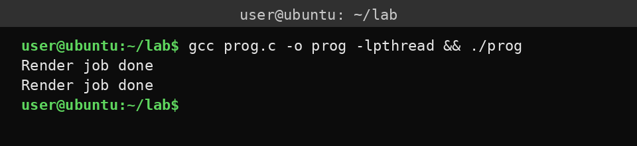

Result:
Thus successfully implemented the concepts of Dining Philosophers problem.

PROGRAM (4) | OUTPUT (3) | VIVA (3) | TOTAL (10)

Ex.No.7 Banker's Algorithm for Deadlock Avoidance
Deadlock:
Deadlock in an operating system refers to the situation where two processes get stuck forever because each one is waiting for a resource held by another process. In general terms, no process can work and the system stalls without any progress.
Deadlock avoidance:
It means that the OS never enters into an unsafe situation where deadlock can happen. There are two common methods for the avoidance of deadlock: 1. Banker's Algorithm, 2. Resource allocation graph method.
Disadvantages of deadlock:
- Processes stop running and remain blocked forever.
- CPU and other resources get wasted because they are held but not used.
- The whole system becomes slow or unresponsive.
- It may force the OS to abort processes or restart work, causing loss of time and data.
Banker's Algorithm:
It is a deadlock avoidance method used in the OS to decide whether a resource should be granted or delayed. It works with: available resources, the maximum resource each process may need, the resources currently allocated to each process, and the remaining need of each process.
Aim:
To work with Banker's Algorithm for deadlock avoidance for the use case Cloud resource management.
Use case: Cloud Resource Management

A. Using Deadlock
Algorithm:
1. Create two mutexes to represent two cloud resources, such as CPU and RAM.
2. Create two threads.
3. In thread 1, lock CPU first, then try to lock RAM.
4. In thread 2, lock RAM first, then try to lock CPU.
5. Both threads wait for the second resource.
6. A circular wait occurs, so deadlock happens.
7. Join both threads.
Program:
#include <stdio.h>
#include <pthread.h>
#include <unistd.h>
pthread_mutex_t cpu, ram;
void *vm1(void *a) {
pthread_mutex_lock(&cpu);
sleep(1);
pthread_mutex_lock(&ram);
return NULL;
}
void *vm2(void *a) {
pthread_mutex_lock(&ram);
sleep(1);
pthread_mutex_lock(&cpu);
return NULL;
}
int main() {
pthread_t t1, t2;
pthread_mutex_init(&cpu, NULL);
pthread_mutex_init(&ram, NULL);
pthread_create(&t1, NULL, vm1, NULL);
pthread_create(&t2, NULL, vm2, NULL);
pthread_join(t1, NULL);
pthread_join(t2, NULL);
return 0;
}

Sample Output:
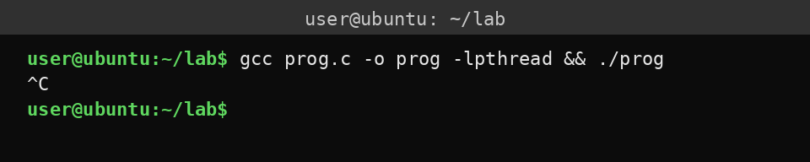

B. Deadlock Avoidance using Banker's Algorithm
Algorithm:
1. Define Allocation, Max, Available, Need, Finish, and Safe Sequence arrays.
2. Compute the Need matrix using Need = Max - Allocation.
3. Set Work = Available, and Finish[i] = false for all processes.
4. Find a process whose Need is less than or equal to Work.
5. If found, add its Allocation back to Work and mark it finished.
6. Store the process in the Safe Sequence.
7. Repeat until all processes finish or no such process exists.
8. If all processes finish, the system is in a safe state.
9. Print the Safe Sequence and stop.
Program:
#include <stdio.h>
int main() {
int p = 3, r = 3;
int a[3][3] = {{0, 1, 0}, {2, 0, 0}, {3, 0, 2}};
int m[3][3] = {{7, 5, 3}, {3, 2, 2}, {9, 0, 2}};
int av[3] = {3, 3, 2};
int n[3][3], f[3] = {0}, s[3], c = 0, i, j, k;
for (i = 0; i < p; i++)
for (j = 0; j < r; j++)
n[i][j] = m[i][j] - a[i][j];
for (k = 0; k < p; k++)
for (i = 0; i < p; i++)
if (!f[i]) {
for (j = 0; j < r && n[i][j] <= av[j]; j++);
if (j == r) {
for (j = 0; j < r; j++)
av[j] += a[i][j];
s[c++] = i;
f[i] = 1;
}
}
printf("Safe sequence: ");
for (i = 0; i < c; i++)
printf("P%d ", s[i]);
printf("\n");
return 0;
}

Sample Output:
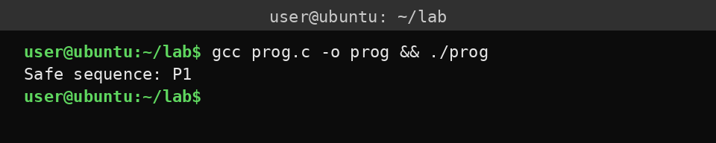

C. Deadlock Avoidance using Resource Allocation Graph
Algorithm:
1. Create a resource allocation graph.
2. Add an edge for current allocation and request relationships.
3. Simulate the new request by adding a request edge.
4. Check whether the new edge creates a cycle.
5. If a cycle appears, deny the request.
6. If no cycle appears, grant the request.
7. Continue for each new request.
8. This avoids deadlocks for single-instance resources.
Program:
#include <stdio.h>
int main() {
int edge[3][3] = {{0, 1, 0}, {0, 0, 1}, {0, 0, 0}};
int req = 0, src = 2, dst = 0;
edge[src][dst] = 1;
if (edge[0][1] && edge[1][2] && edge[2][0])
req = 1;
if (req)
printf("Request denied: cycle detected\n");
else
printf("Request granted: no cycle\n");
return 0;
}

Sample Output:
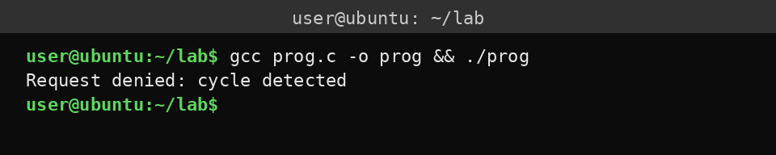

PROGRAM (4) | OUTPUT (3) | VIVA (3) | TOTAL (10)

Ex.No.8 FCFS and SJF Scheduling
Scheduling:
- It is the process in the OS by which the OS decides which process or thread gets access to the CPU (processor) and for how long.
- It selects which ready process will run next on the CPU.
- It removes the currently running process from the CPU when its time slice ends.
- There are 3 types of schedulers: long-term schedulers, short-term schedulers and medium-term schedulers.
FCFS (First Come First Served):
It is a CPU scheduling algorithm in which processes are executed in the same order in which they arrive in the ready queue. It is a non-preemptive algorithm: once a process starts running, it continues until it finishes or voluntarily blocks.
SJF (Shortest Job First):
It is a CPU scheduling algorithm that always selects the waiting process with the smallest execution time. SJF can be implemented as a non-preemptive or a preemptive algorithm.
Aim:
To understand the concept of FCFS and SJF scheduling.
Use case: Virtualization and Cloud Computing

A. FCFS Scheduling
Algorithm:
1. Read the number of VMs (processes) n.
2. For each VM i, read its CPU burst time bt[i] (e.g., in ms).
3. Assume VMs arrive in order 1..n (arrival time = 0 for simplicity).
4. Set the waiting time of the first VM: wt[0] = 0.
5. For i = 1 to n-1: wt[i] = wt[i-1] + bt[i-1].
6. Turnaround time: tat[i] = wt[i] + bt[i].
7. Compute the average waiting time and average turnaround time.
8. Print a table: VM ID, burst, waiting, turnaround.
9. Print the averages.
Program:
#include <stdio.h>
int main() {
int n, bt[10], wb = 0, tat, sum_wb = 0, sum_tat = 0, i;
printf("VMs? ");
scanf("%d", &n);
printf("Burst times:\n");
for (i = 0; i < n; i++)
scanf("%d", &bt[i]);
printf("\nVM\tBurst\tWaiting\tTurnaround\n");
for (i = 0; i < n; i++) {
tat = wb + bt[i];
printf("VM%d\t%d\t%d\t%d\n", i + 1, bt[i], wb, tat);
sum_wb += wb;
sum_tat += tat;
wb = tat;
}
printf("\nAvg wait: %.2f\nAvg Turnaround: %.2f\n", (float)sum_wb / n, (float)sum_tat / n);
return 0;
}

Example input and output:
Input: VMs = 4, burst times = 10 5 8 3
Sample Output:
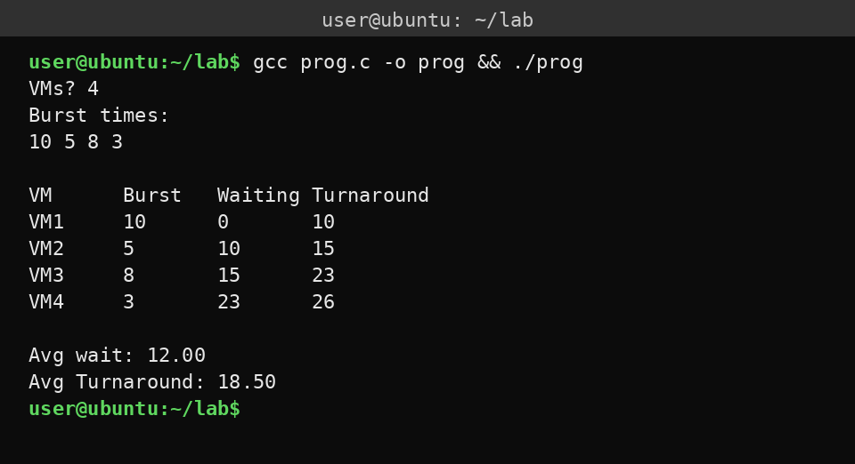

B. SJF Scheduling
Algorithm:
1. Read the number of VMs n.
2. Read the burst time bt[i] for each VM (assume all arrive at time 0).
3. Sort the VMs by burst time in ascending order (shortest job first).
4. Set wt = 0 (waiting time for the first VM).
5. For each VM in sorted order: tat = wt + bt[i] (turnaround time); add wt and tat to the totals; update wt = tat for the next VM.
6. Compute the average waiting and turnaround times.
7. Print the table: VM ID, burst, waiting, turnaround.
8. Print the averages.
Program:
#include <stdio.h>
int main() {
int n, bt[10], id[10], t, wt = 0, sw = 0, sta = 0, i, j;
scanf("%d", &n);
for (i = 0; i < n; i++) {
scanf("%d", &bt[i]);
id[i] = i + 1;
}
for (i = 0; i < n - 1; i++)
for (j = i + 1; j < n; j++)
if (bt[j] < bt[i]) {
t = bt[i]; bt[i] = bt[j]; bt[j] = t;
t = id[i]; id[i] = id[j]; id[j] = t;
}
printf("VM\tBurst\tWait\tTAT\n");
for (i = 0; i < n; i++) {
int tat = wt + bt[i];
printf("VM%d\t%d\t%d\t%d\n", id[i], bt[i], wt, tat);
sw += wt;
sta += tat;
wt = tat;
}
printf("Avg wait: %.2f Avg TAT: %.2f\n", (float)sw / n, (float)sta / n);
return 0;
}

Sample Output:
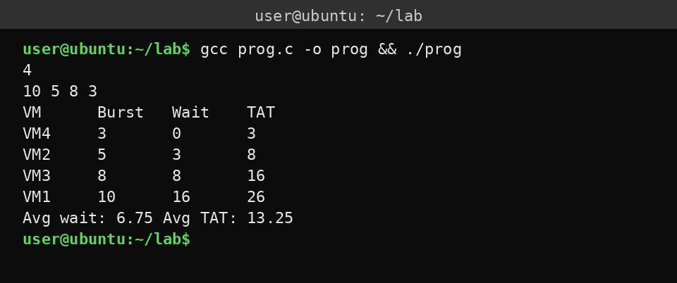

Result:
The above programs on FCFS and SJF were successfully executed in C.

PROGRAM (4) | OUTPUT (3) | VIVA (3) | TOTAL (10)

Ex.No.9 Priority and Round Robin Scheduling
Priority Scheduling:
- Executes the process with the highest priority first.
- Each process has a priority. It can be preemptive or non-preemptive.
- Higher-priority processes get the CPU first, which helps important or urgent processes get CPU time quickly.
Disadvantages:
Low-priority processes may suffer from starvation.
Round Robin Scheduling:
Round Robin gives each process a fixed time quantum and executes them one by one in a circular order.
- Uses a time quantum.
- Fair CPU allocation.
- Preemptive scheduling.
- Provides fair CPU sharing and quick response for multiple users/processes.
Disadvantages:
A too-small time quantum causes many context switches, while a large one reduces responsiveness.
Use case: Car Airbag System
Aim:
To write a Linux C program for the use case car airbag system for priority scheduling and round robin.

A. Priority Scheduling
Algorithm:
1. Store the car tasks in an array.
2. Assign each task a priority.
3. Give the airbag task the highest priority.
4. Compare the priority of two tasks.
5. Swap tasks when the later task has a higher priority.
6. Repeat until the tasks are sorted.
7. Execute tasks from higher to lower priority.
8. Print the execution order.
Program:
#include <stdio.h>
int main() {
char *task[] = {"Music", "Navigation", "Speed", "Collision", "Airbag"};
int pr[] = {5, 4, 3, 1, 0};
int i, j, t;
char *s;
for (i = 0; i < 5; i++)
for (j = i + 1; j < 5; j++)
if (pr[i] > pr[j]) {
t = pr[i]; pr[i] = pr[j]; pr[j] = t;
s = task[i]; task[i] = task[j]; task[j] = s;
}
for (i = 0; i < 5; i++)
printf("Running: %s\n", task[i]);
return 0;
}

Sample Output:
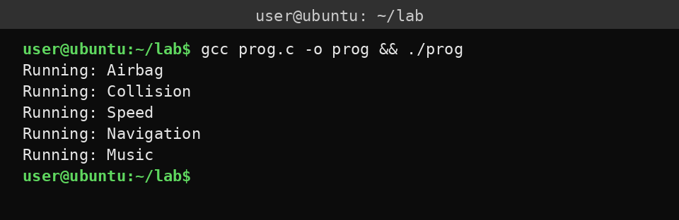

B. Round Robin Scheduling
Algorithm:
1. Store the normal car tasks in a circular list.
2. Assign each task a remaining execution limit.
3. Set the time quantum to 1 unit.
4. Select the first task.
5. Execute it for one time quantum.
6. Decrease its remaining time.
7. Move to the next task.
8. Repeat until all tasks finish.
Program:
#include <stdio.h>
int main() {
char *task[] = {"Speed", "Navigation", "Music", "Display"};
int time[] = {2, 1, 3, 2};
int n = 4, q = 1, i, done;
do {
done = 1;
for (i = 0; i < n; i++) {
if (time[i] > 0) {
done = 0;
printf("Running: %s\n", task[i]);
time[i] = time[i] > q ? time[i] - q : 0;
}
}
} while (!done);
return 0;
}

Sample Output:
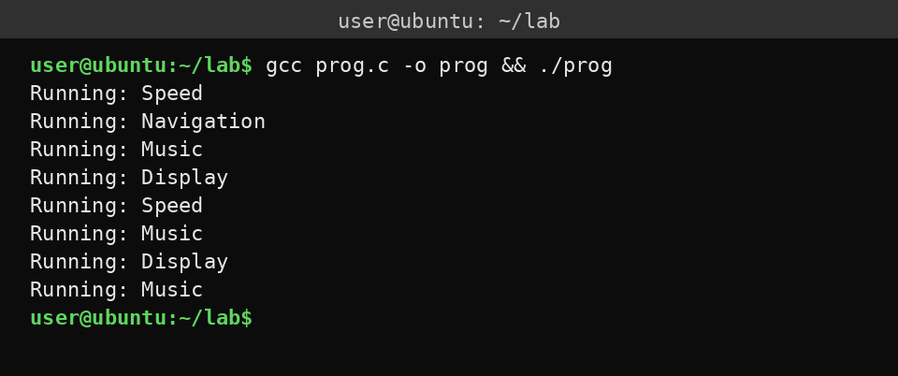

Result:
The above C Linux programs have been executed successfully.

PROGRAM (4) | OUTPUT (3) | VIVA (3) | TOTAL (10)

Ex.No.10 FIFO Page Replacement Algorithm
When memory is full and a new page is needed, a page replacement algorithm decides which existing page should be removed.
FIFO (First In First Out):
It replaces the page that entered memory first. The pages are maintained in a queue. When replacement is needed, the oldest page is removed and the new page is inserted at the rear.
Disadvantages:
It can suffer from Belady's anomaly, where increasing the number of memory frames can sometimes cause more page faults.
Use case: Supermarket Inventory System
Algorithm:
1. Initialize the inventory queue with milk, bread and rice.
2. Display all added items.
3. Remove and display the first item.
4. Display the remaining items.
5. Display that new items are added at the end.
Program:
#include <stdio.h>
int main() {
char *inv[] = {"Milk", "Bread", "Rice"};
int i, n = 3;
printf("Supermarket Inventory Queue (FIFO)\n");
for (i = 0; i < n; i++)
printf("Added: %s\n", inv[i]);
printf("Removed first: %s\n", inv[0]);
for (i = 1; i < n; i++)
printf("Next: %s\n", inv[i]);
printf("New item comes at the end\n");
return 0;
}

Sample Output:
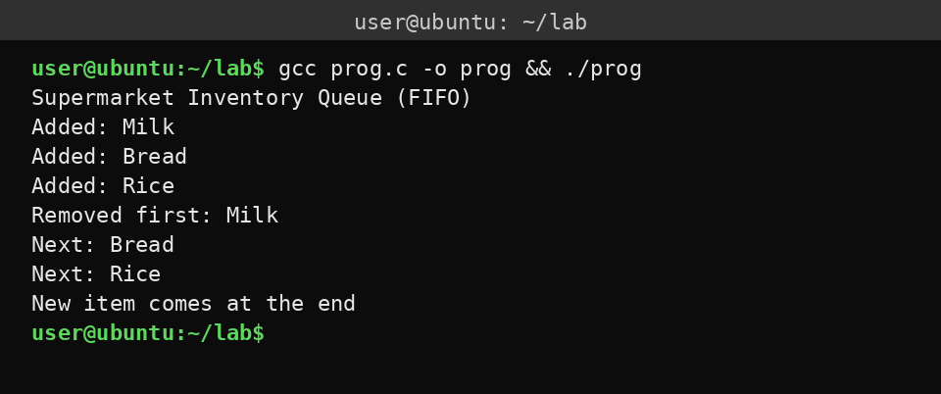

Result:
The above program has been executed successfully.

PROGRAM (4) | OUTPUT (3) | VIVA (3) | TOTAL (10)

Ex.No.11 LRU and LFU Page Replacement Algorithm
LRU and LFU are page replacement algorithms used in virtual memory. When a page fault occurs and all the RAM frames are full, the OS chooses one existing page to remove so that the required page can be loaded.
- LRU (Least Recently Used): replaces the page that has not been accessed for the longest time.
- LFU (Least Frequently Used): replaces the page with the smallest number of accesses. LFU is used in Domain Name System (DNS) and network routers.
Aim:
To implement page replacement using LRU and LFU.

A. LRU Page Replacement
Algorithm:
1. Initialize memory and variables.
2. Process each page request in a loop for i from 0 to n-1: search each page in the memory frames (set hit = -1, loop over frame index j, and set hit = j if frames[j] == pages[i]).
3. Handle a page hit: if hit != -1, update the recency timestamp (time[hit] = i + 1) and print the current page, the frames and the status 'Hit'.
4. Handle a page fault and LRU eviction: otherwise, set lru_index = 0, loop over frame index j from 1 to frames-1 to find the frame with the smallest timestamp, replace that frame with the requested page, update its timestamp and count the fault.
5. Output the summary: print the total page fault count.
6. Stop program execution.
Program:
#include <stdio.h>
int main() {
int pages[] = {1, 2, 3, 2, 4, 1, 3};
int frames[3] = {0}, time[8] = {0}, faults = 0;
int np = sizeof(pages) / sizeof(pages[0]);
for (int i = 0; i < np; i++) {
int hit = -1, lru = 0;
for (int j = 0; j < 3; j++)
if (frames[j] == pages[i])
hit = j;
if (hit != -1) {
time[hit] = i + 1;
} else {
for (int j = 1; j < 3; j++)
if (time[j] < time[lru])
lru = j;
frames[lru] = pages[i];
time[lru] = i + 1;
faults++;
}
}
printf("Total page faults: %d\n", faults);
return 0;
}

Sample Output:
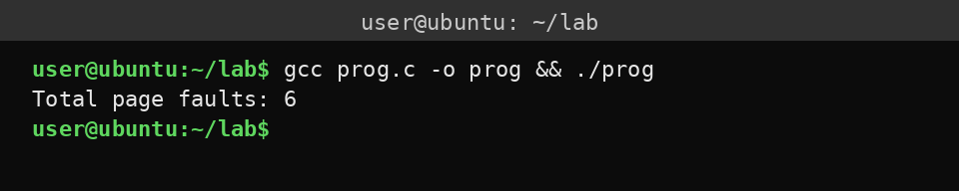

B. LFU Page Replacement
Algorithm:
1. Initialize the cache and frequency arrays to 0, and set faults = 0.
2. Process each request in a loop for i from 0 to n-1: search the cache for a hit (set hit = -1, loop over slots j, and set hit = j if cache[j] == req[i]).
3. Handle a hit: if hit != -1, increment its frequency.
4. Handle a miss and eviction: otherwise, set lfu_index = 0, loop over slots j from 1 to C-1 to find the slot with the smallest frequency, replace that slot with the requested page, set its frequency to 1 and count the fault.
5. Display the step output: print the current request, all cache slots with their frequencies, and the status.
6. Print the total number of faults and stop program execution.
Program:
#include <stdio.h>
int main() {
int req[] = {101, 101, 102, 103, 104};
int cache[3] = {0}, freq[3] = {0}, faults = 0;
printf("Query | cache[ID(freq)] | status\n");
for (int i = 0; i < 5; i++) {
int hit = -1, lfu = 0;
for (int j = 0; j < 3; j++)
if (cache[j] == req[i])
hit = j;
if (hit != -1) {
freq[hit]++;
} else {
for (int j = 1; j < 3; j++)
if (freq[j] < freq[lfu])
lfu = j;
cache[lfu] = req[i];
freq[lfu] = 1;
faults++;
}
printf("%3d | [%d(%d)] [%d(%d)] [%d(%d)] | %s\n", req[i],
cache[0], freq[0], cache[1], freq[1], cache[2], freq[2],
hit != -1 ? "Hit" : "Miss");
}
printf("Total Cache Misses: %d\n", faults);
return 0;
}

Sample Output:
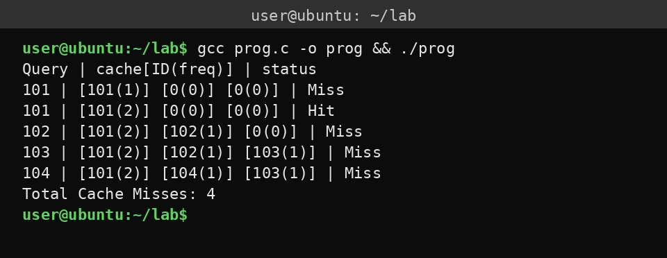

Result:
The above programs have been executed successfully.

PROGRAM (4) | OUTPUT (3) | VIVA (3) | TOTAL (10)

Ex.No.12 Best Fit and Worst Fit Memory Management Policies
Best fit and worst fit are contiguous dynamic memory allocation strategies used by the operating system to assign processes to variable-sized free memory blocks (holes).
Best Fit:
The best fit algorithm allocates a process to the smallest free block that is large enough to accommodate it.
Worst Fit:
The worst fit algorithm allocates a process to the largest available free memory block.
Use case: Operating system kernel and heap memory allocation (best fit)

A. Best Fit
Algorithm:
1. Process each memory request: loop for index i from 0 to N-1.
2. Initialize the best candidate index: best_index = -1.
3. Scan all blocks for the tightest fit: loop for block index j from 0 to M-1. If blocks[j] >= request[i], and best_index == -1 or blocks[j] < blocks[best_index], set best_index = j.
4. Perform the allocation or flag a failure: if best_index != -1, deduct the memory from the block (blocks[best_index] -= request[i]) and print the allocation; otherwise print that the request failed.
5. Display the current state: print the remaining capacities of all blocks.
6. Stop execution.
Program:
#include <stdio.h>
int main() {
int blocks[] = {100, 500, 200, 300, 600};
int requests[] = {212, 110, 420};
int n = 3, m = 5;
for (int i = 0; i < n; i++) {
int best = -1;
for (int j = 0; j < m; j++)
if (blocks[j] >= requests[i] && (best == -1 || blocks[j] < blocks[best]))
best = j;
if (best != -1) {
blocks[best] -= requests[i];
printf("Request %d KB -> Allocated to block %d | Block sizes: %d %d %d %d %d\n",
requests[i], best, blocks[0], blocks[1], blocks[2], blocks[3], blocks[4]);
} else {
printf("Request %d KB -> Allocation failed\n", requests[i]);
}
}
return 0;
}

Sample Output:
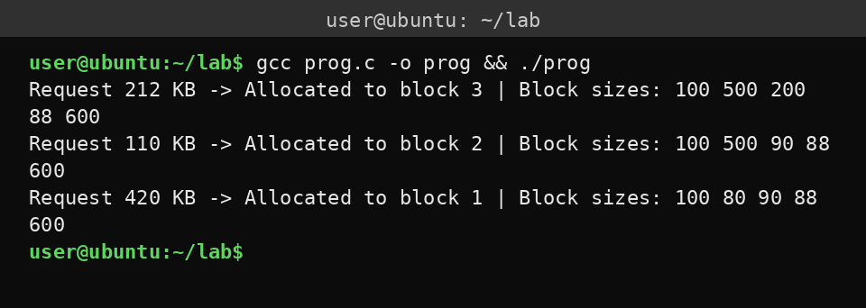

B. Worst Fit
Algorithm:
1. Process each VRAM request: loop for index i from 0 to N-1.
2. Initialize the worst candidate index: worst_index = -1.
3. Scan all blocks for the largest hole: loop for block index j from 0 to M-1. If blocks[j] >= request[i], and worst_index == -1 or blocks[j] > blocks[worst_index], set worst_index = j.
4. Perform the allocation or flag a failure: if worst_index != -1, deduct the memory from the block (blocks[worst_index] -= request[i]) and print the allocation; otherwise print that the allocation failed.
5. Stop execution.
Program:
#include <stdio.h>
int main() {
int blocks[] = {128, 512, 256, 1024};
int requests[] = {200, 400};
int n_req = 2, m = 4;
for (int i = 0; i < n_req; i++) {
int worst = -1;
for (int j = 0; j < m; j++)
if (blocks[j] >= requests[i] && (worst == -1 || blocks[j] > blocks[worst]))
worst = j;
if (worst != -1) {
blocks[worst] -= requests[i];
printf("VRAM Request %d MB -> Allocated to Block %d (%d MB left)\n",
requests[i], worst, blocks[worst]);
} else {
printf("VRAM Request %d MB -> Allocation Failed\n", requests[i]);
}
}
return 0;
}

Sample Output:
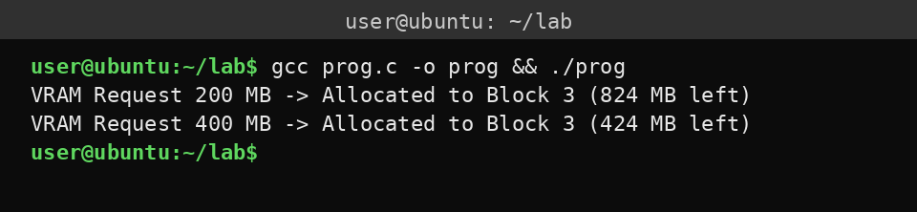

Use case: GPU and high-performance graphics rendering (worst fit)
Result:
The above C programs have been executed successfully.

PROGRAM (4) | OUTPUT (3) | VIVA (3) | TOTAL (10)

Ex.No.13 Disk Scheduling Algorithm
Disk scheduling is a method for choosing the order in which pending disk read/write requests are served. It matters most for HDDs, because their mechanical read/write head must physically move between tracks.
Several programs may request disk access together, for example a browser loading cache files or a database reading records. Since a disk device can handle only a limited number of I/O operations at a time, requests wait in an I/O queue.
Aim:
To write a C program on the disk scheduling algorithm.
Use case: CCTV and Surveillance Records
A DVR/NVR continuously writes video streams from multiple cameras and may simultaneously read older footage for playback. Request ordering and buffering help reduce interruptions, especially with rotating hard disks. Security staff may seek and replay historical footage.
Algorithm:
1. Store all CCTV video read/write requests in an array.
2. Set the initial disk-head position to 50.
3. Sort the requests in ascending order.
4. Service every request whose track number is greater than or equal to 50.
5. Add the head movement for each serviced request.
6. Move the head to the final disk track, 199.
7. Wrap the head from track 199 back to 0.
8. Service all remaining requests below track 50.
9. Display the servicing order and the total head movement.
Program:
#include <stdio.h>
int main() {
int a[] = {82, 170, 43, 140, 24, 16, 190};
int n = 7, h = 50, i, j, t, total = 0;
for (i = 0; i < n - 1; i++)
for (j = 0; j < n - i - 1; j++)
if (a[j] > a[j + 1]) {
t = a[j]; a[j] = a[j + 1]; a[j + 1] = t;
}
printf("CCTV request Served: ");
for (i = 0; i < n; i++)
if (a[i] >= h) {
printf("%d ", a[i]);
total += a[i] - h;
h = a[i];
}
total += 199 - h + 199;
h = 0;
printf("199 0 ");
for (i = 0; i < n; i++)
if (a[i] < 50) {
printf("%d ", a[i]);
total += a[i] - h;
h = a[i];
}
printf("\nTotal head movement = %d tracks\n", total);
return 0;
}

Sample Output:
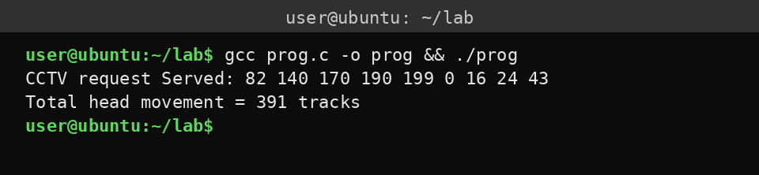

Result:
The above C program has been executed successfully.

PROGRAM (4) | OUTPUT (3) | VIVA (3) | TOTAL (10)

Ex.No.14 Sequential and Indexed File Allocation
Sequential File Allocation:
In sequential allocation, each file occupies a set of contiguous blocks on the disk. For example, if a file requires 3 blocks and starts at block 5, it will occupy blocks 5, 6 and 7.
Indexed File Allocation:
To solve the limitations of contiguous allocation (such as external fragmentation and rigid file sizing), indexed allocation brings all pointers together into one location called the index block. Each file has its own index block, which contains an array of disk block addresses.
Aim:
To implement and study Sequential and Indexed File Allocation.

I. Sequential File Allocation
Program:
#include <stdio.h>
int main() {
int start, len, i;
printf("Enter start block and length: ");
scanf("%d %d", &start, &len);
printf("Allocated blocks: ");
for (i = 0; i < len; i++)
printf("%d ", start + i);
printf("\n");
return 0;
}

Sample Output:
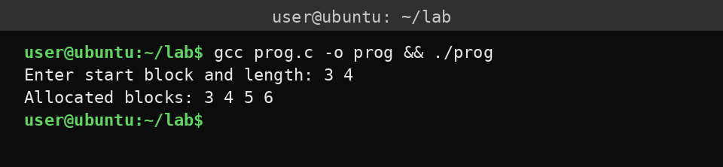

Algorithm:
1. Initialize the starting block address and file length.
2. Verify that the requested contiguous block range is free on the disk.
3. Update the file allocation table or bitmap.
4. Record the starting block address and length.
5. Output the sequence of allocated physical disk blocks to the user.

II. Indexed File Allocation
Program:
#include <stdio.h>
int main() {
int ind, n, i, b[10];
printf("Enter index block and count: ");
scanf("%d %d", &ind, &n);
printf("Enter %d block numbers: ", n);
for (i = 0; i < n; i++)
scanf("%d", &b[i]);
printf("Index %d -> Blocks: ", ind);
for (i = 0; i < n; i++)
printf("%d ", b[i]);
printf("\n");
return 0;
}

Sample Output:
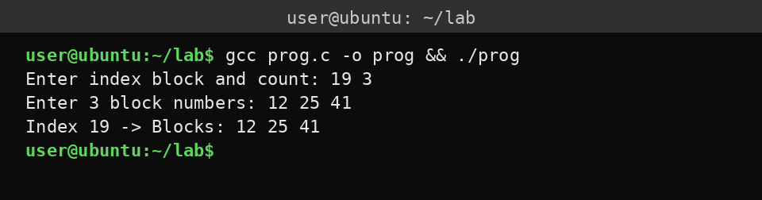

Algorithm:
1. Allocate an empty disk block to function as the index block and record its address.
2. Accept the total block count and the individual block numbers from the user.
3. Write the pointers to the allocated data blocks directly into the index block.
4. Store only the index block's address in the file's directory entry.
5. Output the index block reference along with the linked data block pointers.
Result:
Successfully implemented and studied Sequential and Indexed File Allocation.

PROGRAM (4) | OUTPUT (3) | VIVA (3) | TOTAL (10)

Ex.No.15 File Organization Schemes for Single and Two Level Directory
Single-Level Directory:
In a single-level directory structure, all files are contained within a single, flat directory for the entire system. There is only one directory table listing all files.
Two-Level Directory:
To overcome the major limitations of the single-level directory, the two-level directory structure introduces user isolation. In this scheme each user gets their own distinct directory.
Aim:
To implement and study file organization schemes for single-level and two-level directories.

I. Single-Level Directory (Use case: Digital Camera Storage)
Program:
#include <stdio.h>
#include <string.h>
int main() {
char dir[5][20];
int n, i;
printf("Enter number of photos: ");
scanf("%d", &n);
printf("Enter %d photo names:\n", n);
for (i = 0; i < n; i++)
scanf("%s", dir[i]);
printf("\nSD Card Directory (single-level):\n");
for (i = 0; i < n; i++)
printf("- %s\n", dir[i]);
return 0;
}

Sample Output:
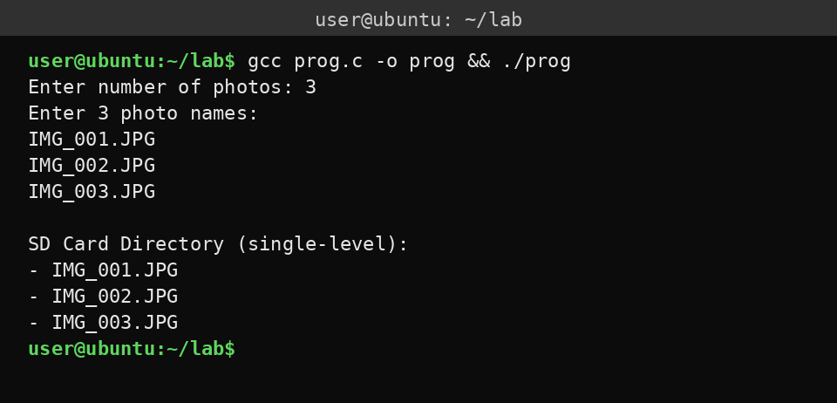

Algorithm:
1. Prompt the user to enter the total number of photo files.
2. Initialize a string array to store the photo file names.
3. Loop n times to accept each individual photo file name from the user.
4. Print the header for the single-level camera directory.
5. Loop n times to display all stored photo file names in a flat list.

II. Two-Level Directory (Legacy Educational Lab Computers)
Program:
#include <stdio.h>
#include <string.h>
int main() {
char u[2][10] = {"Alice", "Bob"};
char f[2][2][10] = {{"lab1.c", "notes"}, {"prog.c", "data"}};
char name[10];
int i, j;
printf("Enter user (Alice/Bob): ");
scanf("%s", name);
for (i = 0; i < 2; i++)
if (strcmp(name, u[i]) == 0)
for (j = 0; j < 2; j++)
printf("- %s/%s\n", u[i], f[i][j]);
return 0;
}

Sample Output:
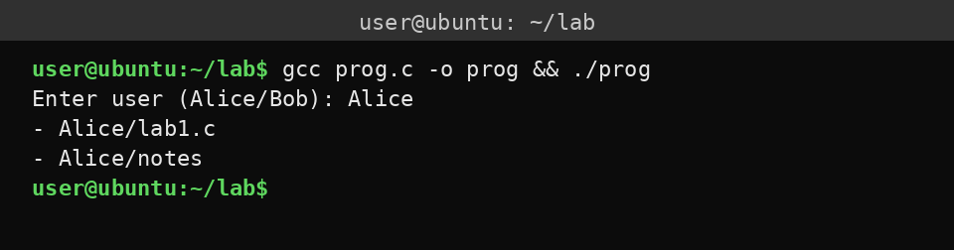

Algorithm:
1. Initialize the master file directory with the user accounts and their file arrays.
2. Prompt the user to input a matching account name.
3. Search the user list to find a matching account name.
4. Once matched, iterate through that user's file list.
5. Output each file name formatted with its user directory path.
Result:
Successfully implemented file organization schemes for single-level and two-level directories.

PROGRAM (4) | OUTPUT (3) | VIVA (3) | TOTAL (10)

