Surajit Paul

510-474-8531 ⧫ paul.surajit@gmail.com ⧫ Sunnyvale, CA

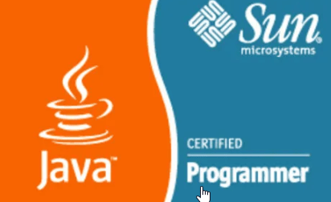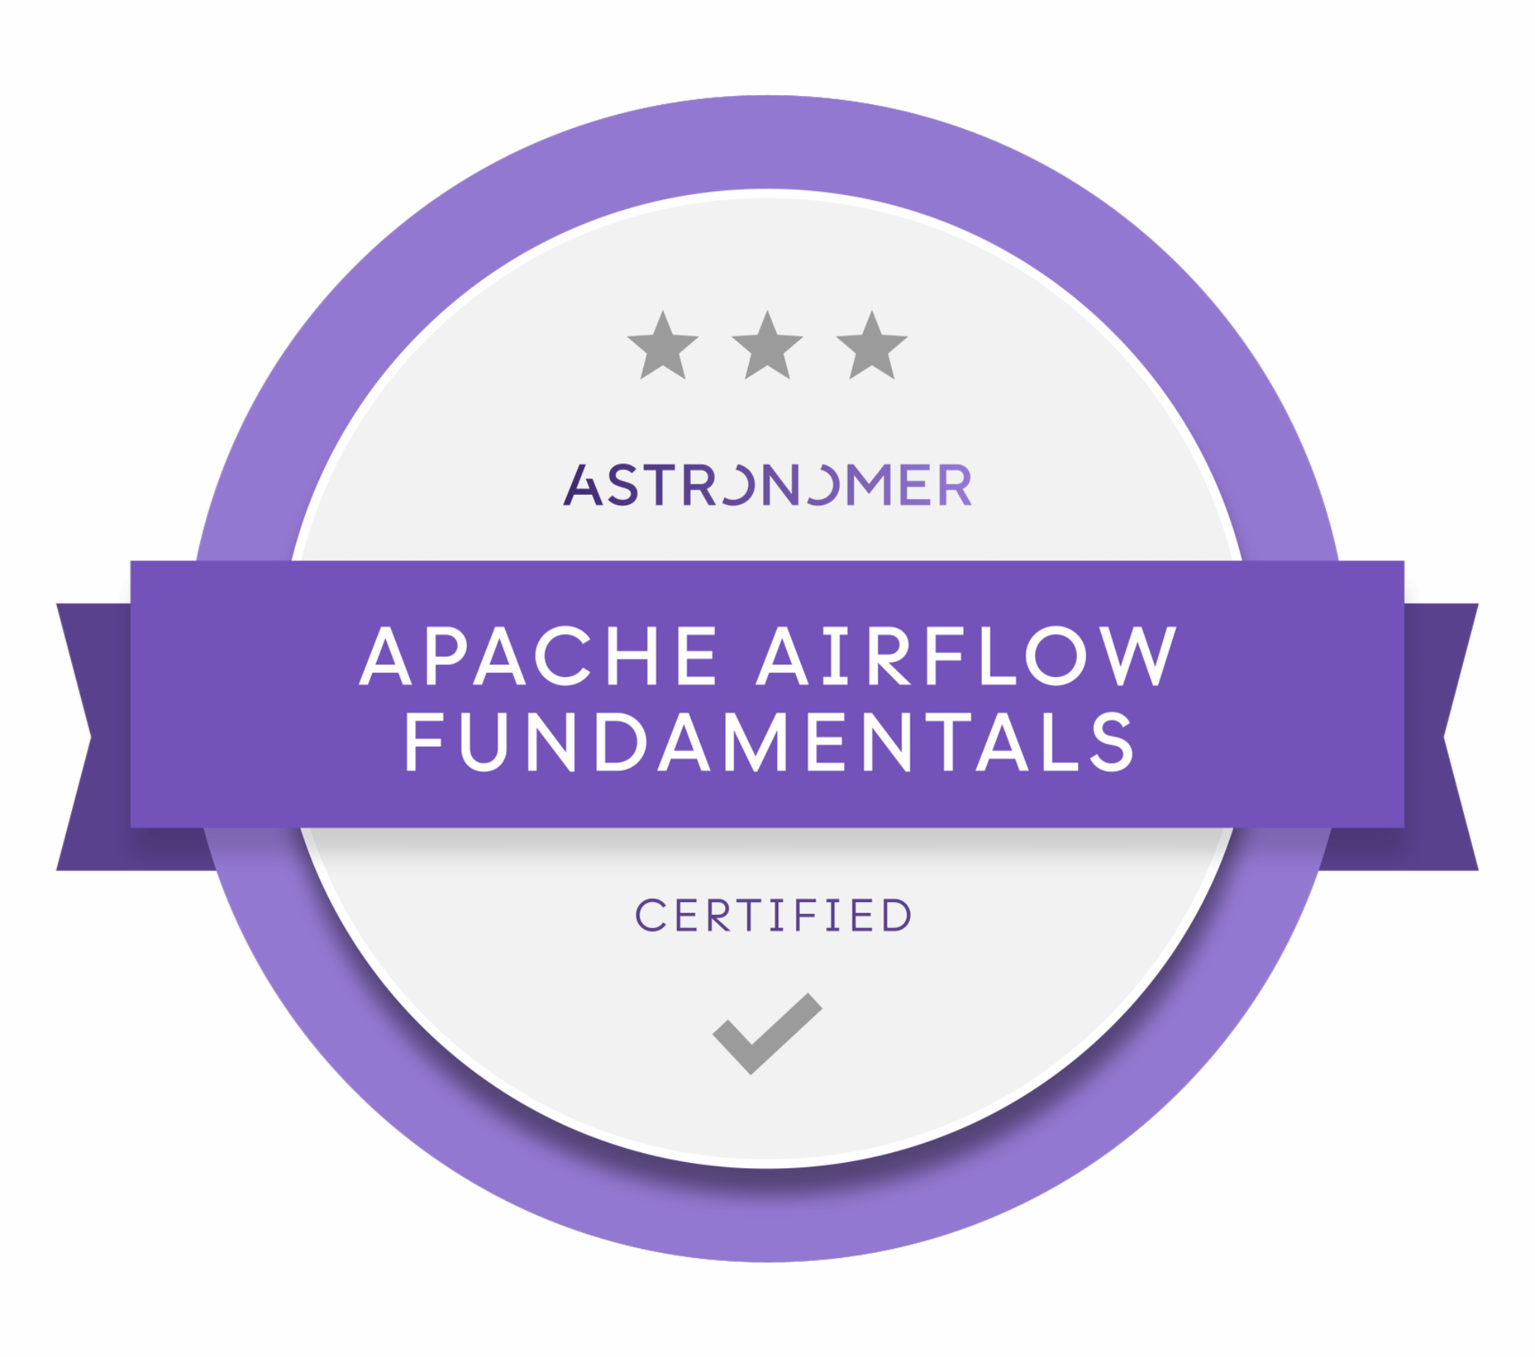

PROFESSIONAL SUMMARY

Innovative AI Data Platform Architect with a strong background in designing and deploying LLM-powered solutions on cloud platforms like AWS. Skilled in fine-tuning models, Gen AI workflow automation, and Agentic AI orchestration using MCP protocols, with a deep understanding of vector databases, Retrieval-Augmented Generation (RAG), and scalable AI architectures. Passionate about leveraging cutting-edge AI frameworks to drive business efficiency and enhance user experiences. Adept at translating complex AI concepts into production-ready solutions that optimize performance, reduce costs, and unlock new possibilities in AI-driven automation.

KEY HIGHLIGHT

- Expertise in Agentic AI frameworks - LangGraph, LlamaIndex, CrewAI, AutoGen
- Expertise in LLM Fine-Tuning (PEFT, LoRA), LLM Inference framework (vLLM, TensorRT-LLM)
- Familiar with advanced RAG techniques and adaptive Prompt Engineering
- Expertise in LLM evaluation using LangSmith, DeepEval, Ragas, TruLens
- Familiarity with vector databases - Pinecone, Qdrant, Chroma, Weaviate, Milvus
- Expertise in LLMOps and LLMSecOps processes and best practices
- Experienced with LLM from OpenAI, Google Gemini, Meta Llama, Anthropic, Groq, NVIDIA
- Familiar with multi-agents architecture including Model Context Protocol (MCP) and Agent-to-Agent (A2A) Protocol
- Expertise in distributed data technologies - Hadoop, Spark, and Kafka
- Extensive experience with infrastructure setup on AWS cloud platform

SKILLS

- AWS
- Airflow
- Spark
- Kubernetes
- Hive
- Redshift
- Kafka
- MongoDB
- Cursor
- Claude Code
- Python
- JAVA
- Scala
- Golang
- JavaScript
- TypeScript
- SQL
- PyTorch
- Terraform
- NumPy
- Pandas
- scikit-learn
- LangChain
- LangGraph
- Qdrant
- Amazon Bedrock
- CrewAI

EXPERIENCE
Together Labs, Redwood City, CA (09/2021 - till date)
Together Labs is the creator of IMVU, WithMe and crypto currency VCOIN.
The platform empowers people worldwide to connect, create and earn in the virtual world.
Role: Lead AI/Data Engineer / Architect
- Created end-to-end Gen AI architecture blueprint of the backend infrastructure of the chatbot application
- Defined the data ingestion, processing, storage, and governance strategies necessary for fine tuning and deploying (CI/CD) Gen AI models
- Collaborated with data engineers on data cleaning, augmentation, and feature engineering pipelines
- Designed and deployed agentic workflows using LangChain, LangGraph, leveraging autonomous task execution, memory chains, and feedback loops to coordinate multi-step interactions in virtual chat environments.
- Enabled observability and agent behavior evaluation using LangSmith and Ragas, providing
performance visibility at the agent level in production.
- Managed production cluster for Room Recommendation ML pipeline
- Worked with AI engineers on LLM model (Anthropic, Llama, OpenAI, Gemini, Groq) selection and customization using fine tuning
- Architected and led the development of a scalable and robust Retrieval-Augmented Generation (RAG) application pipeline, integrating large language models (LLMs) with proprietary knowledge bases.
- Integrated MCP servers for Slack, Redis, PostgreSQL database with agentic workflow.
- Implemented advanced retrieval strategies including vector similarity search keyword matching, and hybrid retrieval methods to optimize context relevance.
- Designed and optimized embedding generation processes using state-of-the-art models (e.g., OpenAI embeddings, custom fine-tuned models) for various data types (text, images)
- Developed data indexing and chunking strategies (e.g. semantic chunking, recursive chunking) to improve retrieval precision and manage token limits for LLMs
- Developed sophisticated prompt engineering techniques, including few-shot prompting, chain-of-thought prompting, and dynamic prompt construction based on retrieved context, to guide LLM behavior
- Implemented post-generation processing techniques such as response re-ranking, summarization, and safety filters to refine and validate LLM outputs
- Established comprehensive evaluation frameworks for RAG pipelines, measuring retrieval accuracy, generation quality (e.g., factual consistency, coherence), and overall user satisfaction
- Implemented A/B testing methodologies to compare different retrieval strategies, embedding models, and LLM configurations
- Optimized RAG pipeline performance for latency and throughput, reducing average response time by 20% through specific optimizations, e.g., caching, parallel processing
- Developed monitoring and alerting systems for RAG pipeline health, identifying and resolving issues related to data freshness, LLM API stability, and retrieval failures
- Crafted Terraform scripts supporting several AWS infrastructure components

Environment: AWS, Java, Python, LangChain, LlamaIndex, LangSmith, Qdrant, Kubernetes, Docker, Kafka, Spark, Airflow, AWS SageMaker, AWS Bedrock.

Client: Autodesk Inc., San Francisco, CA (04/2017 – 09/2021)
Autodesk, Inc. is an American multinational software corporation that makes software for the architecture, engineering, construction, manufacturing, media, and entertainment industries.

Role: Principal Engineer & Solutions Architect
Spearheaded ADP project is a big data implementation initiative which facilitates an integrated platform composed of data from various enterprise applications.
- Crafted Hadoop MapReduce jobs to anonymize 3TB of Identity dataset in an efficient way
- Designed and built a data streaming pipeline using AWS ELB, Apache Kafka, Flume, and Zookeeper on EC2 instances.
- Designed and built several micro services using AWS Lambda functions supporting API rate limit, client side caching and OAuth2 authentication and authorization features to extract and transform data from various API sources.
- Designed and built several serverless data streaming pipelines using AWS cloud to sunset legacy streaming platforms built on EC2 containers, improving productivity at lower AWS operational cost.
- Built ELT pipeline using Snowflake, dbt, Fivetran

Environment: Java, Python, Golang, AWS Kinesis Stream/Firehose, AWS Lambda/Step function, Apache Spark-2.4, Oozie-4.0.0, Amazon S3, Amazon Cloud Formation.

Client: Autodesk (10/2013 – 04/2017)
Role: Principal Data Engineer (Consultant)
- Designed and built various data compaction pipelines using Apache Spark API & scheduled using Oozie workflow.
- Designed and built data streaming pipeline consuming source transaction log events from Apache Kafka channel, extracted a stream of source data in various formats e.g., XML, CSV, JSON via REST API, transformed into JSON format on applying data enrichment e.g., Null/Boolean/Timestamp standardization.
- Designed and built several Hadoop solutions around Amazon Web Services such as Amazon S3, Amazon EMR, Amazon EC2, Amazon RDS, Amazon Redshift, Amazon Cloud Watch etc.
- Designed and built data ingestion workflow on Hadoop cluster using apache Sqoop, and Oozie workflow management engine.

Environment: Java, Python, Apache Spark-1.5.2, Apache Kafka, Apache Flume-1.7.0, Oozie-4.0.0, Amazon EC2, Amazon S3, Amazon Redshift, Amazon RDS, Docker container, Mesosphere, Marathon, Amazon Cloud Formation and Jenkins.

IBM, Client: MYER (03/2011 – 10/2013)
Myer is Australia's largest department store chain, retailing a broad range of merchandise including women's, men's and children's clothing, footwear, and accessories.

Role: Advisory System Analyst
Mainframe Transformation Product - Gift Registry [GR]
- Installed and configured Flume, Hive, Pig, Sqoop and Oozie on the Hadoop cluster.
- Used Flume to collect, aggregate, and store the web log data from different sources like web servers, network devices and pushed to HDFS.
- Developed recommendation engine using collaborative filtering in Apache Mahout

Environment: Hadoop-1.1.2, MongoDB-2.0.9, Hive-0.10.0, Pig-0.11.1, Sqoop-1.4.3, Zookeeper-3.4.5, Flume-1.2.0, HBase-0.94.5, Oozie-3.3.2, Red Hat Enterprise Linux 6, Eclipse Juno, JDK-1.7.21, Clear Case.

Web Migration of Gift Registry
- Gathered user requirements, analyzed business needs and derived functional and technical specifications.
- Designed and developed applications using Java, and J2ee technologies
- Developed front-end applications using JavaScript, JQuery, AJAX

Environment: Spring Framework (core, JDBC, security, LDAP), Websphere-5.1, XML, JSON, REST Web Services, log4j-1.2.14, Junit-4.9, apache-ant-1.8.3, JMS, Oracle9i, JSTL, React, JQuery, PL/SQL, RSA.v7, Http Watch, IBM Rational Clear Case.

Lennox International Inc. (06/2008 - 05/2010)
Lennox International Inc. through its subsidiaries is a provider of climate control products for the heating, ventilation, air conditioning, and refrigeration markets around the world.

Role: Logistics Analyst [Systems]
- Prepared documentation on business process blueprint, product specification
- Tracked project implementation
- Performed UAT testing and stakeholders training.
Environment: Java, J2ee, SPRING, Hibernate, Axis2, JBOSS, XML, Junit, Ant, JMS, Oracle9i

University of Texas at Dallas, Dallas, TX (03/2007 - 06/2008)
Role: Research Assistant for Students Record Management System
- Designed and built web based student records management system
Environment: Java, J2ee, SPRING, JDBC, Junit, Ant, XML, MS SQL Server 2000

EDUCATION

Master of Science in Information Technology and Management, University of Texas at Dallas, TX, 2008
Bachelor of Technology in Civil Engineering, National Institute of Technology, India, 2003

LINKEDIN PROFILE

linkedin.com/in/surajitpaul

GITHUB REPOSITORY

github.com/rexian/ML

PUBLISHED PAPERS

https://www.linkedin.com/pulse/ai-vulnerabilities-protective-guardrails-surajit-paul-zyzrf https://www.linkedin.com/pulse/vertical-scaling-hadoop-using-amazon-memory-optimized-surajit-paul

