FEATURE LIST
i) Home Page
- Header Section: Banners, Top Navigation, Search Bar, cart icon (shopping basket) and social media links.
- Featured products - Product Name, Product Price, Product Image, Rating and short Description
- New Arrivals
- Products on Sale.
- Hot Deals
- Newsletter management
ii) Product Listing
a) Sidebar
- Categories Listing
- Filter - Filter based on - Stock Availability, Attributes like colour, size and price.
b) Main Content
- Category Banner & the sub category
- Product Listing- Product Name, Product Price, Product Image, Rating and short Description, add to wish list, Compare.
- Product Listing

iii) Product Detail Page
a) Sidebar
- Categories Listing
- Filter - Filter based on - Stock Availability, Attributes like colour, size and price.
b) Main Content
- Main Product image along with thumbnails of images added from admin. Clicking on any thumbnail will change the main image.
- Product Name, Product Price, Attributes and Product Description
- Add to wish list
- Recently viewed products
- Stock availability
- Product Option Selection based on attributes.
- Send to a friend with email
- Share on Facebook, or twitter
- Reviews - User who has purchased the products will be able to post reviews. However, website users will have the option to see all the reviews added so far.

iii) Cart Page
- Product Name, Product Price, Quantity (option to change) , Actions (delete or update )
- Coupons - User can apply coupons.
- Product Total - which includes and shipping charges

iv) Checkout Page:
We will be installing one step checkout, which will provide user to do the following
- Login/Register/Guest checkout
- Guest checkout and checkout with account to use address book
- Logged in user will only be allowed to purchase the order. Either he has to register or do a guest checkout.
- Shipping/Billing
User can choose the addresses saved in his address book as well. Shipping address is the address where his product will be shipped.
- Order confirmation
- Payment
- Thank You
Once order is confirmation an order confirmation email will be send to customer as well as to admin. Email will have Shipping and billing Address details, Purchased products and Total Price.
An order will be placed automatically on dropshipper account using there api.
V) My Account Section:
- Account dashboard - Provides option to change/update profile.
- Address book with unlimited addresses
- Wish list - View wish list items.
- Order status and history
- Product reviews submitted

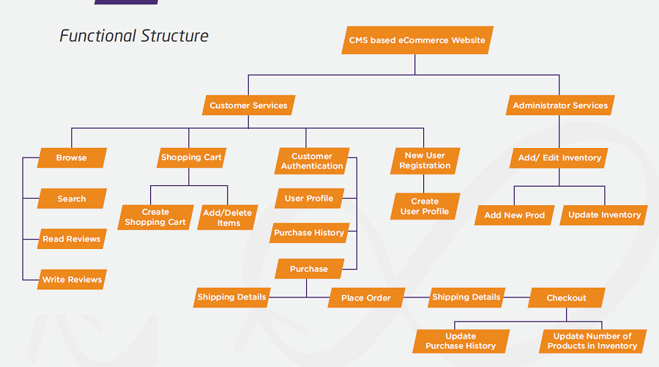

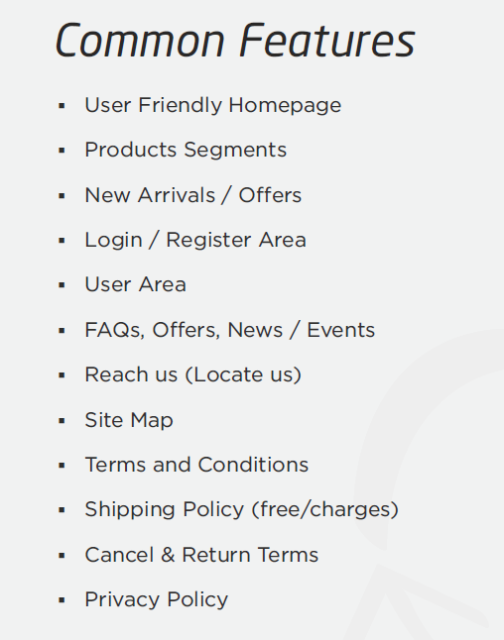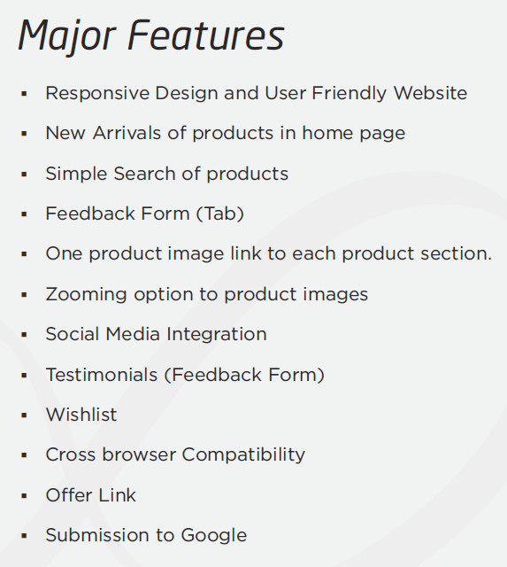

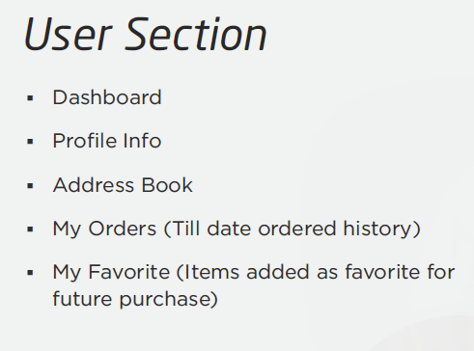

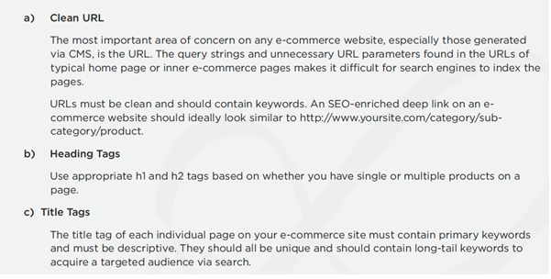
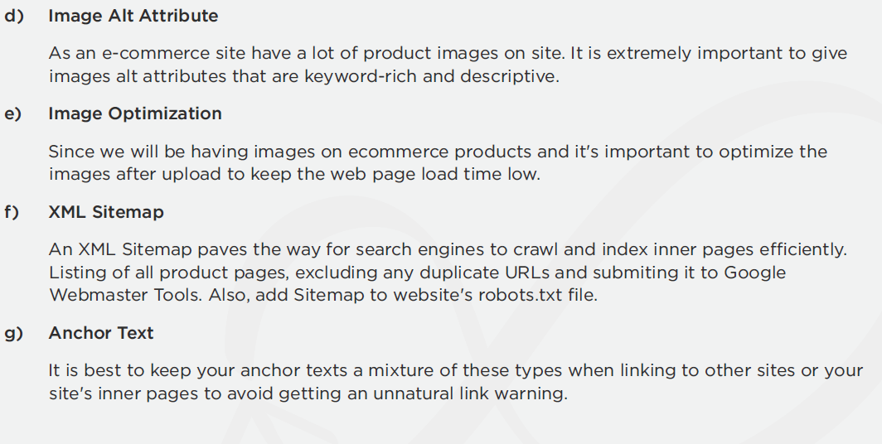

Performance Management Tool
We will be using below tools and website will be optimized based on following tools:-
- GTMETRIX
- Google Page Speed

Technology
We will be using Wordpress & Wocommerce to build ecommerce store.
We will be using https://wordpress.org/plugins/product-lister-walmart/ to setup walmart integration, if there is any other functionality required which doesn't exist on plugin then let us know we will update the estimates accordingly.

