AI-Assisted E-commerce Return Analysis
Project Closure Document | Business Requirements | Data Dictionary

1. Business Problem & Objectives
Business Problem: The e-commerce operation carries a 24.03% order return rate, eroding ~18% of Net Sales through refunds (₹44,07,029 against ₹2,14,48,492 Net Sales). Return drivers were not quantified or prioritized, blocking targeted intervention.
Objectives:
- Build a governed semantic model of order/return data to enable repeatable KPI reporting.
- Quantify return volume, rate, and financial impact by reason, category, and channel.
- Identify the top return problems and likely root-cause areas (Product, Listing, Packaging, Logistics, Customer).
- Deliver prioritized, measurable recommendations for stakeholders.

2. Data & Model Overview
Star-schema semantic model built in Power BI: one denormalized fact table plus six dimension tables, connected via the Power BI Modeling MCP server.
Table | Grain | Role
Fact_Orders | 1 row per order line item | Central fact table — orders, returns, pricing, dates
Dim_Product / Dim_Customer | 1 row per product / customer | Descriptive attributes
Dim_Return_Reason / Dim_Channel / Dim_Payment_Method | 1 row per category value | Lookup dimensions
Dim_Date | 1 row per calendar date | Time intelligence

3. Data Dictionary (Key Fields)
Field | Table | Definition
Order_ID / Order_Line_ID | Fact_Orders | Order and order-line identifiers
Return_Flag | Fact_Orders | Yes/No — whether the line was returned
Return_Reason | Fact_Orders | Stated reason for return (8 categories)
Return_Quantity | Fact_Orders | Units returned on the line
Refund_Deduction_Pct | Fact_Orders | % deducted from refund (restocking/handling fee)
Category / Sales_Channel | Fact_Orders | Product category and channel of sale

4. Key KPIs & Findings
KPI | Value
Total Orders | 3,100
Returned Orders | 745
Return Rate % | 24.03%
Returned Units | 1,113
Refund Amount | ₹44,07,029
Net Sales | ₹2,14,48,492
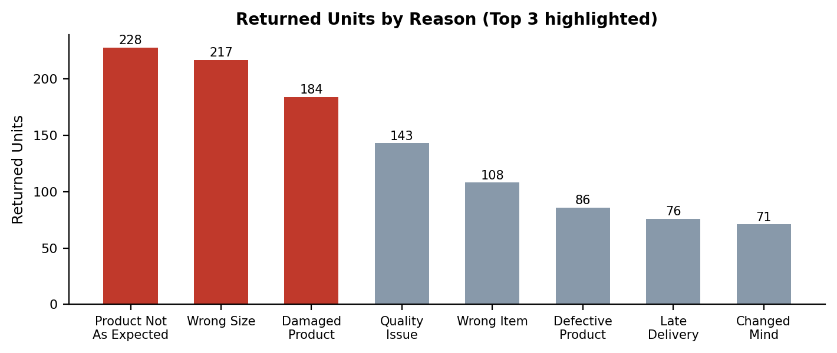
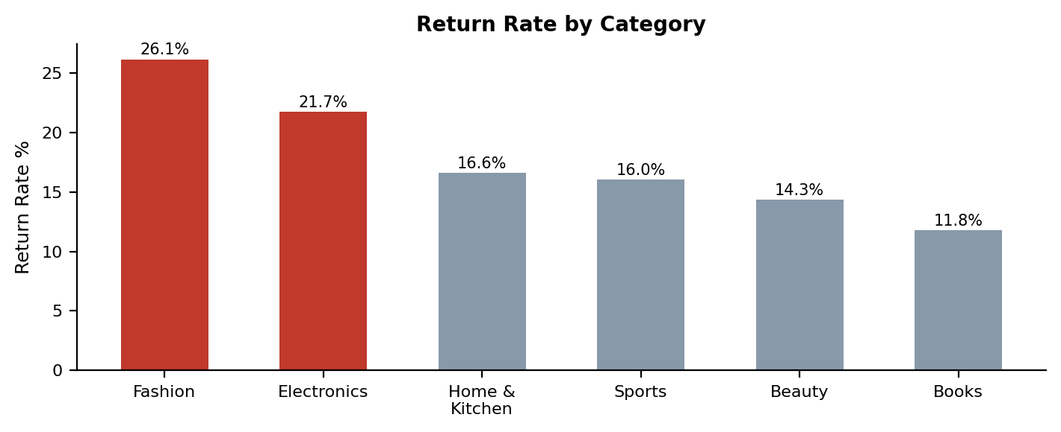

5. Top 3 Return Problems & Business Impact
Problem | Impact | Root Cause (hypothesis)
Product Not As Expected | 228 units, ₹7,94,928 — spread across all categories | Listing (PDP description/images) — unproven
Wrong Size | 217 units, ₹5,87,415 — 88% Fashion | Listing (size chart/fit guide) — unproven
Damaged Product | 184 units, ₹9,35,685 (highest ₹) — 76% Electronics + Home & Kitchen | Packaging/Logistics — unproven
Note: All figures above are directly measured facts from the model. Root-cause labels are pattern-based hypotheses from category concentration — the model does not contain PDP-content, size-chart-version, or carrier/packaging data required to confirm causation.

6. Recommendations & Success KPIs
Priority | Recommended Action | Success KPI
1 | Audit & rewrite descriptions/images for top 10 SKUs driving 'Product Not As Expected' | -15% returned units for this reason next quarter
2 | Rebuild Fashion size chart + add fit-guide tool | Fashion return rate 26.1% -> ~18% in 2 quarters
3 | Upgrade protective packaging + audit courier handling (Electronics, H&K) | -20% Damaged Product refund value next quarter

7. Project Closure Summary & Next Steps
Status: Objectives met. Semantic model, KPI/measure layer, and root-cause analysis delivered without modifying the underlying Power BI report or existing visuals.
- Deliverables: semantic model, DAX KPI & Return Reason measure files, organized 'Return Reason Analysis' folder, this closure document.
- Next steps: capture PDP-content, size-chart-version, and carrier/packaging data to convert root-cause hypotheses into confirmed causes.
- Next steps: pilot fix #1 (listing rewrite) on top 10 SKUs and re-measure return rate after one cycle.

Appendix — Detailed Executive Findings (Full Evidence Table)
Problem | Evidence | Likely Root Cause | Business Impact | Recommended Fix | Pri. | Success KPI
1. Product Not  As Expected | 228 units returned (highest of all reasons), 155 return events, Rs.7,94,928 refunded. Spread across every category (Fashion 68, H&K 52, Electronics 39, Beauty 36) — not isolated to one product line. [Fact] | Listing — cross-category spread rules out a single product/vendor defect; pattern points to description/image accuracy on PDP. [Hypothesis — not proven; no PDP-content or review-text data in model] | 20.5% of returned units; largest single refund driver alongside Damaged Product | Audit and rewrite product descriptions/images for the top 10 SKUs driving this reason | 1 | Reduce 'Product Not As Expected' returned units by 15% next quarter
2. Wrong Size | 217 units, 151 return events, Rs.5,87,415 refunded. 88% concentrated in Fashion (192 of 217 units); Sports a distant second (25 units). [Fact] | Listing — near-total concentration in Fashion strongly implicates size chart/fit-guide accuracy on Fashion PDPs specifically. [Hypothesis on exact cause — model has no size-chart-version data to confirm] | 19.5% of returned units; Fashion carries the highest category return rate (26.1%) | Rebuild size chart and add a fit-guide / size-recommendation tool on all Fashion PDPs | 2 | Cut Fashion category return rate from 26.1% toward category average (~18%) within 2 quarters
3. Damaged  Product | 184 units, 130 return events, Rs.9,35,685 refunded — highest Rs. impact of any single reason. Concentrated in Electronics (79) + Home & Kitchen (60) = 76% of this reason's units — both fragile-item categories. [Fact] | Packaging / Logistics — concentration in fragile-goods categories suggests in-transit damage from inadequate packaging or rough handling. [Hypothesis — model has no carrier, packaging-type, or transit-damage-location data to confirm] | Highest refund value of any reason (Rs.9.36L); Electronics has 2nd-highest category return rate (21.7%) | Upgrade protective packaging for Electronics + Home & Kitchen SKUs and audit courier handling | 3 | Reduce Damaged Product refund value by 20% next quarter
Note: Facts are directly measured from the model. Root causes labeled Listing / Packaging-Logistics are pattern-based inferences from category concentration, not confirmed causes — the model does not contain PDP-content, size-chart-version, or carrier/packaging-type fields needed to prove causation. No existing measures, visuals, or report structure were modified to produce this analysis.

