OPENCV

INSTALL- In ubuntu 2012/14- https://help.ubuntu.com/community/OpenCV
this link provides the installation process .

INTRO- This software is extensively used for image processing.

APPLICATIONS- Facial recognition system
Gesture recognition
Human–computer interaction (HCI)
Mobile robotics
Motion understanding
Object identification
Segmentation and Recognition
Stereopsis Stereo vision: depth perception(2cameras)
Structure from motion (SFM)
Motion tracking
Augmented reality

LANGUAGE- OpenCV is written in C++ and its primary interface is in C++, but it still retains a less comprehensive though extensive older C interface. There are now full interfaces in Python, Java and MATLAB/OCTAVE (as of version 2.5).

SUMMER-WORK- The task which i was assigned to do is that i have four pioneer robots and i have to find relative coordinates of these bots w.r.t a reference robot and also the angular displacement.
The method i used is image processing and software is opencv. As i have mentioned in its application of object identification,i used color as a feature. There are various other features also on the basis of which we can identify objects like shape etc.
I have written various basic programmes of opencv first to understand it better. These all programmes are on github. https://github.com/jitenderss/Summer14/tree/master/progm and https://github.com/jitenderss/Summer14/tree/master/hsv
I have converted RGB into HSV as primary step in all programmes.
Now there is a threshold for each color but these threshold varies with brightness or intensity of light of environment. May be the threshol values which i have used for color extraction may not work for you. So what i have done is , i have uploade a programm (which was available on internet ) .
https://github.com/jitenderss/Summer14/tree/master/hsv/hsvrange
This programm has various trackbar for hue, saturation and value and using these trackbar, you can find threshold values for any color in any environment.

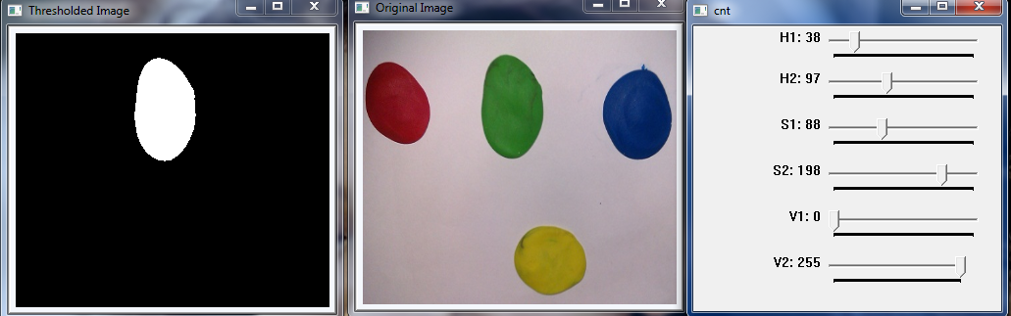
Threshol values which i used for various colors are in main.cpp file at https://github.com/jitenderss/Summer14/tree/master/hsv/vid .

IMPORTANT POINT- how to run programmes.
in terminal go to the desired folder for eg
cd
cd progm
cd dup
cd build
cmake ..
make
./DisplayImage ../name.jpg
cmake file is same for each code which you have to paste it alongside main.cpp . You don't need to make build folder after some change in code . Once it is made ,then no need to worry about it. You have to type make everytime when even a single change u have made in your main.cpp .
../name.jpeg - ../ is for image location .since your image is one step behind build folder and name.jpeg is for image which you use.

What about video file??
in github, i have written some programmes for video input also..https://github.com/jitenderss/Summer14/tree/master/hsv/vid ..just take a look and you will know how to take input of video.
What about external camera video input????
hmm.. you just have to change a single argument in your code
VideoCapture cap(1) – for external camera
VideoCapture cap(0)- for inbuilt webcam.

Main programm of mine is also in github folder in progm directotry.
PROBLEMS- 1. you have to change your threshold depending on environment.
            - i was facing problems in angular displacement calculation
So i used another library which is called as aruco (AUGMENTED REALITY )library. More details are at http://www.uco.es/investiga/grupos/ava/node/26
How to install????
http://maztories.blogspot.com.es/2013/07/installing-aruco-augmented-reality.html will help you.
I have used these markers as an identification. Each marker is uniquely determined by these librarys.
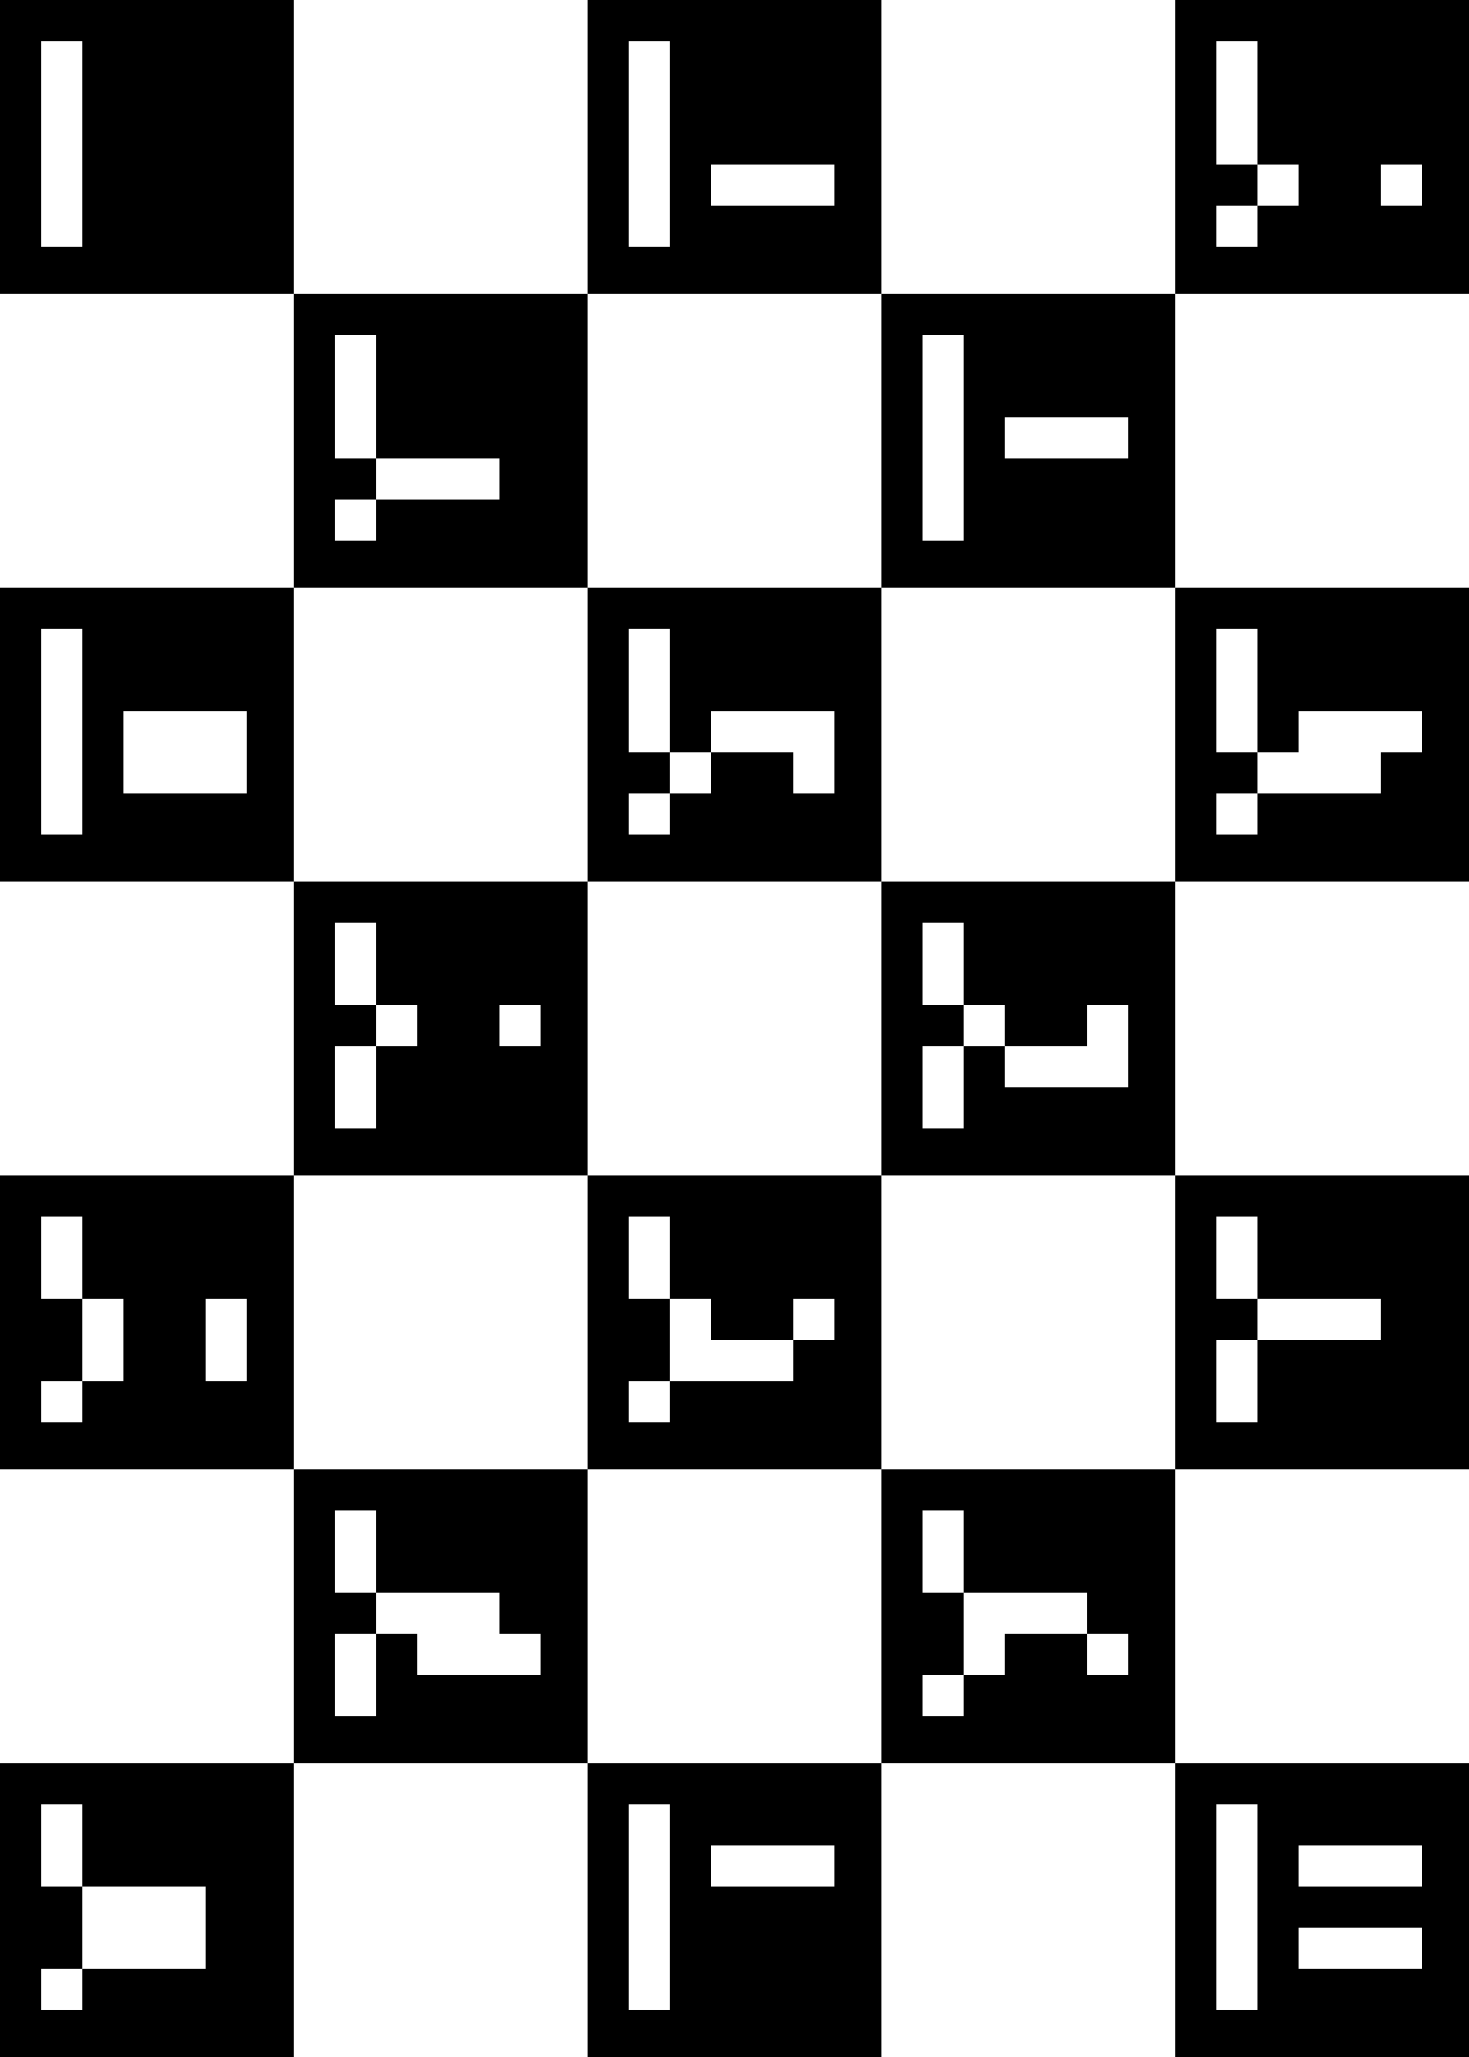

Id of first is 0 and then of next one is 4 and so on..
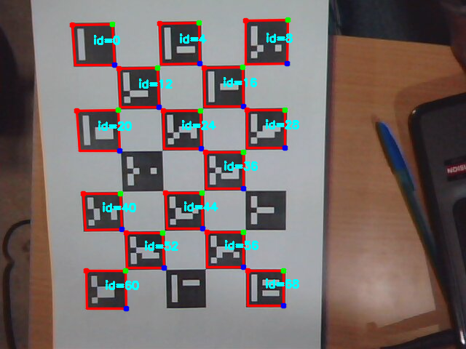
How to run????
same commands on terminal as mentioned earlier except for last line .
./aruco_simple ../name.jpeg
cmake file is uploaded on github https://github.com/jitenderss/Summer14/blob/master/ar_jitendra%20__testproject/CMakeLists.txt~

The codes for these are on github https://github.com/jitenderss/Summer14/tree/master/ar_jitendra%20__testproject
You see these codes and you will understand how to use it.
https://github.com/jitenderss/Summer14
So that's how i have done my task, hopefully this may help you.

