TECHNICAL SRS

SarkariLinks Government
Jobs & Services Portal
  - React + Laravel reference architecture with production-grade Dockerization
Document | Value
Version | 1.0 - Implementation Baseline
Prepared for | Product owner, engineering, QA, DevOps and operations teams
Prepared on | 05 September 2026
Technology baseline | React 19.2 | TypeScript | Laravel 13 | PHP 8.3+ | MySQL 8.4 | Redis | Docker Compose
Classification | Internal project specification

Purpose Define a build-ready, secure and scalable portal matching the supplied design direction while keeping all content, categories, alerts and tools manageable from an administration console.
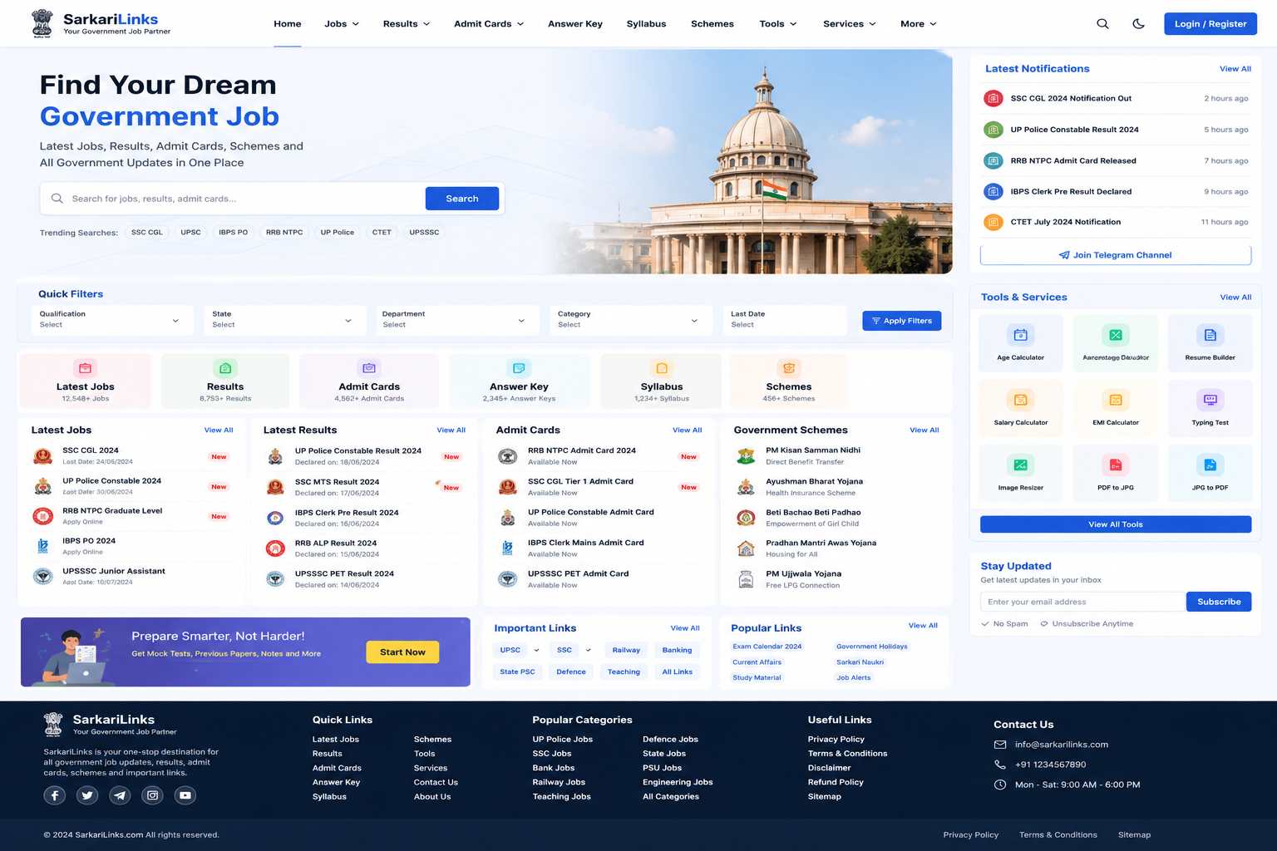
Reference interface supplied by the product owner; final screens will be implemented as responsive components.

Document Control
Field | Definition
Document owner | Product Owner / Engineering Lead
Primary audience | Stakeholders, solution architect, frontend/backend engineers, QA, DevOps, content operations
Approval authorities | Product Owner, Technical Lead, Security/Compliance Owner
Change control | All requirement changes shall be recorded with version, owner, date, impact and approval.
Normative language | “Shall” = mandatory; “should” = recommended; “may” = optional.

Revision History
Version | Date | Author/Owner | Summary | Status
0.1 | 05 Sep 2026 | Solution team | Initial scope and architecture | Draft
1.0 | TBD | Product Owner | Approved delivery baseline | Pending approval

Contents
- 1. Executive Summary
- 2. Purpose, Scope and Assumptions
- 3. Product Overview and User Roles
- 4. Functional Modules
- 5. Information Architecture and UI/UX
- 6. Functional Requirements
- 7. Business Rules and Workflows
- 8. Solution Architecture
- 9. API Specification
- 10. Data Model
- 11. Non-Functional Requirements
- 12. Security and Privacy
- 13. Dockerization and Environments
- 14. CI/CD, Operations and Recovery
- 15. Testing Strategy
- 16. Delivery Roadmap
- 17. Risks, Acceptance and Traceability
- Appendices

1. Executive Summary
SarkariLinks is a content-rich public portal for Indian government opportunities and citizen utilities. It aggregates jobs, results, admit cards, answer keys, syllabi, schemes, important links and calculator/conversion tools. A responsive React frontend consumes a versioned Laravel REST API. An independent administration console manages structured content, moderation, publishing, SEO, subscriptions and audit history.
Recommended architecture Start as a modular monolith: one Laravel codebase organized by bounded modules, one React application with public and admin route groups, MySQL for durable data, Redis for cache/queues, and object storage for files. This preserves fast delivery while allowing later service extraction.
- Mobile-first, fast and accessible public experience.
- Search-engine-friendly canonical pages and structured metadata.
- Role-based content operations with draft, review, schedule, publish and archive states.
- Secure, observable and repeatable deployments using immutable Docker images.
- Clear APIs and stable data contracts suitable for future mobile applications.

2. Purpose, Scope and Assumptions

2.1 Objectives
- Provide one trusted destination for government job and public-service updates.
- Reduce time to find relevant notices through taxonomy, search and filters.
- Enable the content team to publish quickly without developer involvement.
- Allow registered users to bookmark items and receive consent-based alerts.
- Operate reliably during traffic spikes caused by major results or admit-card releases.

2.2 In Scope
- Public portal and responsive navigation
- Global search, quick filters and trending searches
- Jobs, results, admit cards, answer keys, syllabus and schemes
- Notification feed, newsletter and Telegram/other outbound channel links
- User registration, login, profile, bookmarks and saved alerts
- Tools directory with calculators and document/image utilities
- Admin CMS, RBAC, approvals, scheduled publishing and audit logs
- SEO, analytics hooks, caching, queues, file storage and observability
- Docker-based local, staging and production deployment

2.3 Out of Scope for Release 1
- Government application submission or fee collection on behalf of departments.
- Guaranteed verification of third-party government data unless an official source is integrated.
- Native Android/iOS applications; APIs remain mobile-ready.
- AI-generated eligibility/legal advice.
- Automated scraping of sites without documented permission and source-specific controls.

2.4 Assumptions and Constraints
- English and Hindi are planned; Release 1 may launch English first while all content models remain localization-ready.
- Every public item links to or stores an authoritative source URL/document and displays a verification timestamp.
- The supplied desktop UI is a visual direction, not a pixel-locked layout; mobile layouts shall reflow and prioritize search/content.
- Production shall use managed database/object storage where available; Docker Compose is acceptable for development and single-host deployment.
- No production secret shall be committed to source control or baked into images.

3. Product Overview and User Roles
Role | Primary capabilities
Guest | Browse, search, filter, open details, use public tools, subscribe and follow external channels.
Registered User | Guest capabilities plus profile, bookmarks, saved searches, alert preferences and history.
Content Author | Create and edit assigned content; upload documents; submit drafts for review.
Reviewer/Editor | Validate sources, return/revise, approve, schedule and publish content.
Tool Manager | Configure eligible calculators/converters, help text, limits and availability.
Support/Operations | Manage inquiries, failed jobs, cache refreshes and operational dashboards without content approval rights.
Administrator | Manage taxonomy, users, roles, settings, integrations, audit logs and all content.
System Services | Execute schedules, queues, indexing, notifications, link checks, backups and health checks.

3.1 Permission Model
Authorization shall use least-privilege RBAC enforced on the server. Frontend route visibility is a convenience and never the security boundary. Permissions shall be granular (for example jobs.create, jobs.review, jobs.publish, users.manage, settings.manage, audit.view) and may be grouped into roles.

4. Functional Modules
ID / Module | Scope
M01 Public Shell | Header, mega/dropdown navigation, search, theme preference, responsive menu, breadcrumb, footer and policy links.
M02 Search & Discovery | Global keyword search, autosuggest, filters, sort, pagination, trending terms, typo tolerance and empty-state guidance.
M03 Government Jobs | Listing/detail pages, qualification/state/department/category/date filters, vacancies, eligibility, important dates, fees, links and attachments.
M04 Results | Listing/detail pages, declaration date, result status, official links, cutoff/merit documents and related jobs.
M05 Admit Cards | Availability status, exam date/shift, download link, instructions and linked job/application context.
M06 Answer Keys | Provisional/final status, objection window, answer-key documents, response-sheet links and revisions.
M07 Syllabus | Exam/role taxonomy, sections, downloadable documents, updated date and related resources.
M08 Government Schemes | Eligibility, benefits, documents, application method, official URL, department, state/central scope and last verification.
M09 Notifications | Latest stream, priority/pinned items, publish time, view-all page and optional push/email/Telegram distribution.
M10 User Account | Registration/login, verified email or mobile, profile, bookmarks, saved searches, alerts, sessions and account deletion.
M11 Tools & Services | Age/salary/EMI calculators, typing test, image resize, PDF/JPG conversions, resume builder and extensible tool catalog.
M12 Subscription & Alerts | Consent capture, category/region preferences, double opt-in email, unsubscribe, delivery history and suppression list.
M13 Content & SEO | Static pages, important/popular links, banners, metadata, canonical URLs, sitemap, schema markup, redirects and link health.
M14 Admin CMS | Dashboards, content CRUD, preview, review workflow, scheduling, bulk actions, taxonomy, media, users, settings and audit trail.
M15 Platform Operations | Queues, cache, indexing, scheduler, metrics, logs, backups, health checks and incident diagnostics.

5. Information Architecture and UI/UX

5.1 Public Routes
Route pattern | Screen | Key elements
/ | Home | Hero search, quick filters, category cards, latest lists, notifications, tools, links and subscription.
/jobs | Job listing | Filter drawer/sidebar, result count, sort, pagination, saved search.
/jobs/{slug} | Job detail | Overview, dates, eligibility, fees, vacancies, process, official links, attachments, related items.
/results | /admit-cards | /answer-keys | /syllabus | Category listings | Consistent list/detail pattern using type-specific metadata.
/schemes | Scheme listing | State/central, category, beneficiary and department filters.
/tools | Tools directory | Searchable grid, categories, usage limits and privacy notice.
/search?q= | Global results | Grouped or unified results, filters, highlighting and no-result recovery.
/account/* | User workspace | Profile, bookmarks, alerts, preferences, sessions and account controls.
/pages/{slug} | Managed page | About, contact, policies, disclaimer and editorial standards.

5.2 Responsive Behaviour
- Desktop: content plus right rail, as shown in the reference.
- Tablet: right-rail cards move below primary content; filters become a compact two-column region.
- Mobile: single column, sticky search/filter action, collapsible navigation, horizontal category chips and touch targets of at least 44 by 44 CSS pixels.
- Cards shall not rely on hover for essential actions. Text and controls shall remain usable at 200% zoom.

5.3 Visual System
- Primary palette: navy/royal blue with white surfaces, pale-blue backgrounds and limited semantic status colors.
- 8-point spacing system, 10-12 px card radii, restrained shadows and consistent icon containers.
- Clear heading hierarchy, high-contrast body text, visible focus states, skeleton loading and actionable error/empty states.
- Dark theme may be provided; user preference shall be stored locally and must preserve contrast.

6. Functional Requirements

6.1 Public Search and Discovery
Requirement | Statement | Priority | Acceptance
FR-SRCH-001 | The system shall search published, non-expired content across supported content types by title, identifier, organization, tags and normalized body text. | Must | Relevant results are returned within the performance target; drafts never appear.
FR-SRCH-002 | The system shall support filters for content type, qualification, state, department, category and date/last date where applicable. | Must | Multiple filters combine predictably and are represented in the URL.
FR-SRCH-003 | The system shall provide autosuggestions for queries of at least two characters with throttling and keyboard navigation. | Should | Suggestions can be selected with mouse, touch or keyboard.
FR-SRCH-004 | The system shall support relevance, newest and closing-soon sort options. | Must | Sort selection persists while filters/pagination change.
FR-SRCH-005 | Trending searches shall be admin-curated or analytics-derived with an expiry window and moderation control. | Should | Expired or disabled terms are not displayed.
FR-SRCH-006 | Public filters and search state shall be shareable through canonical query parameters. | Must | Reloading a copied URL restores the same search state.

6.2 Content Listings and Detail Pages
Requirement | Statement | Priority | Acceptance
FR-CNT-001 | Each content type shall provide paginated listing and unique slug-based detail pages. | Must | Canonical URL resolves and unpublished records return 404 to guests.
FR-CNT-002 | Every published record shall show source attribution, last verified date, updated date and official link/document. | Must | Required metadata is visible and stored in audit history.
FR-CNT-003 | Editors shall link related records, such as a job to its admit card, answer key and result. | Must | Related journey appears bidirectionally where configured.
FR-CNT-004 | Records shall support scheduled publish, expiry and archive without deletion. | Must | Scheduler changes state at configured UTC time and logs the action.
FR-CNT-005 | Attachments shall be versioned, validated, virus-scanned where supported and served with safe content disposition. | Must | Rejected file types cannot be uploaded or served.
FR-CNT-006 | The system shall provide social sharing and copy-link actions using canonical URLs. | Should | Shared link contains no private tracking data.

6.3 Accounts, Bookmarks and Alerts
Requirement | Statement | Priority | Acceptance
FR-USR-001 | Users shall register and authenticate using email/password; optional social/mobile authentication may be enabled later. | Must | Email uniqueness, verification and secure recovery are enforced.
FR-USR-002 | Users shall bookmark any published content and view/remove bookmarks from their account. | Must | Repeated bookmark calls are idempotent.
FR-USR-003 | Users shall save search criteria and choose email/web alert frequency. | Should | Alerts only include new matching published records.
FR-USR-004 | Users shall view and revoke active sessions and change password. | Must | Revoked session cannot access protected APIs.
FR-USR-005 | Users shall export or request deletion of account data subject to retention rules. | Must | Request is authenticated, logged and completed through an auditable workflow.
FR-USR-006 | Subscription actions shall record consent source, timestamp, policy version and unsubscribe state. | Must | Suppressed users receive no marketing alert.

6.4 Admin CMS and Publishing
Requirement | Statement | Priority | Acceptance
FR-ADM-001 | Authorized staff shall create, edit, preview, duplicate and submit content using type-specific forms. | Must | Validation explains errors and preserves entered values.
FR-ADM-002 | Content shall follow Draft -> In Review -> Approved/Scheduled -> Published -> Archived, with return-to-author transitions. | Must | Unauthorized transitions are rejected server-side.
FR-ADM-003 | Publishing shall require mandatory source fields and reviewer identity for configured high-risk categories. | Must | Incomplete records cannot be approved.
FR-ADM-004 | Admins shall manage taxonomies, menus, banners, tools, external links, SEO defaults and redirects. | Must | Changes are validated, permission-checked and audited.
FR-ADM-005 | The CMS shall support bulk tag, schedule, archive and export actions with confirmation and job progress. | Should | Bulk work runs asynchronously and reports per-record failures.
FR-ADM-006 | Every create/update/delete/permission/publish action shall generate an immutable audit record. | Must | Audit view shows actor, time, IP, action and before/after summary.
FR-ADM-007 | Dashboard shall show drafts awaiting review, scheduled posts, broken links, failed jobs and recent activity. | Should | Counts link to filtered management screens.

6.5 Tools and File Processing
Requirement | Statement | Priority | Acceptance
FR-TOL-001 | Each tool shall declare input types, maximum size, rate limit, retention and privacy text. | Must | Requests exceeding limits fail before heavy processing.
FR-TOL-002 | Simple calculators shall execute client-side where practical and validate all inputs. | Should | No unnecessary personal data is transmitted.
FR-TOL-003 | File conversions shall use isolated asynchronous jobs with generated random object keys and time-limited downloads. | Must | Input/output objects expire automatically after the retention window.
FR-TOL-004 | The system shall reject executable, polyglot or malformed input according to MIME and signature checks. | Must | Renamed prohibited files are rejected.
FR-TOL-005 | Admins shall enable/disable tools and set global/per-user limits without a deployment. | Should | Disabled tools show a managed unavailable state.

7. Business Rules and Workflows

7.1 Publishing Workflow
- Author creates a structured draft and supplies at least one official source.
- System validates required fields, link format, dates, duplicate candidates and attachment policy.
- Author submits the draft; record becomes read-only to the author unless returned.
- Reviewer verifies source, accuracy, SEO preview and relationships; reviewer approves, schedules or returns with comments.
- Scheduler publishes approved scheduled items using UTC and clears affected caches/search documents.
- System distributes configured alerts asynchronously, records delivery outcomes and monitors official links.
- Expired records are labeled or archived according to type-specific rules; history remains available.

7.2 Core Business Rules
Rule | Definition
BR-001 | Only Published records are visible to guests or included in public search/sitemaps.
BR-002 | A content slug is unique per locale and content type; historical slugs produce permanent redirects.
BR-003 | Dates are stored in UTC and displayed in the user/site timezone; date-only government deadlines preserve their declared timezone/context.
BR-004 | Official URLs use HTTPS where supported and are checked periodically; a failed check does not silently delete content.
BR-005 | An item may be marked New for a configurable period after publication or material update.
BR-006 | One user may have at most one bookmark per content record and one active subscription per channel/address.
BR-007 | Deleting content in CMS performs soft deletion unless a privileged retention workflow permits permanent deletion.
BR-008 | Any published-content correction records correction reason, editor and timestamp; material corrections may trigger an updated alert.

8. Solution Architecture
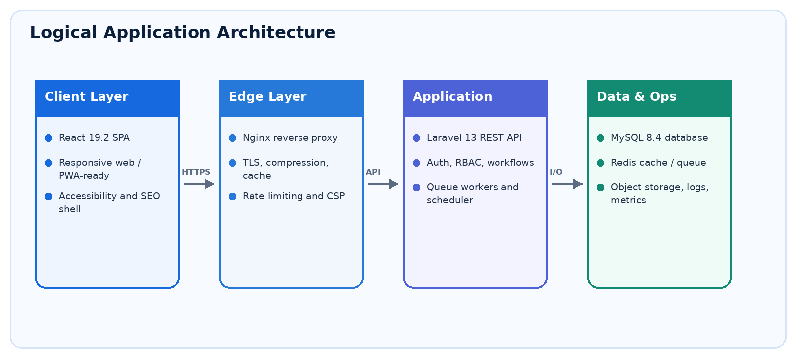
Figure 1. Logical architecture and trust boundaries.

8.1 Frontend Architecture
- React 19.2 with TypeScript, Vite, React Router and feature-based modules.
- TanStack Query (or equivalent) for API server state; local UI state kept close to components.
- Design-system primitives for typography, buttons, forms, cards, badges, dialogs, tables and feedback states.
- Route-level lazy loading, image optimization, error boundaries and analytics abstraction.
- Public content may use prerendering/SSR at the edge or generated metadata endpoints when organic SEO requires full HTML; decision to be validated with a crawl test before launch.
- API client centralizes base URL, CSRF/token handling, retries for safe requests, cancellation, error normalization and correlation IDs.

8.2 Backend Architecture
- Laravel 13 on PHP 8.3+, organized into Domain/Application/Infrastructure/HTTP concerns by module.
- Controllers remain thin; Form Requests validate; policies/gates authorize; services/actions implement use cases; resources serialize APIs.
- Repository abstraction is optional and shall only be introduced where multiple persistence implementations or complex query boundaries justify it.
- Events and queued listeners handle indexing, notifications, link checks, exports and heavy tool jobs.
- Laravel scheduler dispatches due publications, cleanup, link checking and operational housekeeping.
- Database transactions protect multi-record state transitions; idempotency keys protect retryable write endpoints.

8.3 Caching and Search
- Redis stores application cache, rate-limit counters, queue state and short-lived locks.
- Cache keys are namespaced by environment and content version; publish/update events invalidate dependent keys.
- Release 1 may use MySQL full-text/search-index tables for moderate scale. Meilisearch/OpenSearch can be introduced behind a search service interface when relevance, typo tolerance or volume requires it.
- Public GET responses may use CDN/reverse-proxy caching with safe cache headers and surrogate invalidation. Authenticated/private responses are never publicly cached.

9. API Specification

9.1 API Conventions
- Base path: /api/v1; HTTPS and JSON UTF-8 only.
- Resource names are plural nouns; query strings control filters, includes, sort and pagination.
- Success envelopes are consistent; errors use machine code, human message, field errors and correlation_id.
- Cursor pagination is preferred for large/change-prone feeds; page pagination is acceptable for SEO listings.
- Versioning is additive within v1; breaking changes require v2 and a documented deprecation window.
- OpenAPI 3.1 specification shall be generated/maintained and validated in CI.
- Sanctum cookie authentication is preferred for same-site SPA; token authentication is reserved for external/mobile clients.

9.2 Representative Endpoints
Method | Endpoint | Access | Purpose
GET | /api/v1/home | Public | Home payload, category counts, latest lists, notifications and tool highlights.
GET | /api/v1/search | Public | Global search with q, type, state, department, qualification, category, date and sort.
GET | /api/v1/jobs | Public | Paginated published job listing.
GET | /api/v1/jobs/{slug} | Public | Job detail with related resources.
GET | /api/v1/results/{slug} | Public | Result detail.
GET | /api/v1/schemes/{slug} | Public | Scheme detail.
POST | /api/v1/auth/register | Guest | Create account and issue verification workflow.
POST | /api/v1/auth/login | Guest | Authenticate with throttling.
DELETE | /api/v1/auth/sessions/{id} | User | Revoke a user session.
POST | /api/v1/bookmarks | User | Create idempotent bookmark.
GET | /api/v1/saved-searches | User | List saved searches/alert settings.
POST | /api/v1/subscriptions | Public/User | Create double-opt-in subscription.
POST | /api/v1/admin/jobs | Author | Create draft.
POST | /api/v1/admin/content/{type}/{id}/submit | Author | Submit draft for review.
POST | /api/v1/admin/content/{type}/{id}/publish | Publisher | Publish or schedule approved content.
GET | /api/v1/admin/audit-logs | Auditor/Admin | Filter immutable audit events.
POST | /api/v1/tools/{slug}/jobs | Public/User | Start eligible asynchronous tool job.
GET | /api/v1/tool-jobs/{id} | Owner | Read tool job status/download metadata.

9.3 Standard Error Shape
{ "error": { "code": "VALIDATION_FAILED", "message": "Please correct the highlighted fields.", "fields": { "email": ["Invalid email address."] }, "correlation_id": "01..." } }

10. Data Model

10.1 Core Entities
Entity | Purpose
users | Identity, verification state, locale, status, timestamps; sensitive fields minimized.
roles / permissions | RBAC assignments and granular capability definitions.
content_items | Shared publication fields: type, slug, title, summary, body, state, dates, source, SEO and owner/reviewer.
job_details | Organization, vacancy, qualification, age, fees, dates, application method and selection process.
result_details | Declaration date, result status, cutoff/merit metadata and linked job.
admit_card_details | Release date, exam date/shift, instructions and linked job.
answer_key_details | Provisional/final state, objection window and linked exam/job.
syllabus_details | Exam taxonomy, sections and linked document.
scheme_details | Scope, department, benefits, eligibility, documents and application method.
taxonomies / terms | State, department, qualification, category, exam and tags, with locale-ready labels.
content_term | Many-to-many content classification.
attachments | Versioned file metadata, storage key, MIME, size, checksum, scan status and retention.
content_relations | Typed links among job/result/admit-card/answer-key/syllabus/scheme records.
bookmarks | Unique user-content link.
saved_searches | User query/filter JSON, channel, cadence and active state.
subscriptions | Destination hash/encrypted value, consent data, status and preferences.
notifications / deliveries | Template/event, audience, channel, status, attempts and provider response metadata.
tools / tool_jobs | Tool catalog/configuration and isolated processing job lifecycle.
redirects | Historical path to target path with status code.
audit_logs | Actor, action, target, IP/user agent, correlation ID and change summary.
settings | Versioned operational/site settings with typed validation.

10.2 Data Integrity Rules
- Use bigint/UUID/ULID identifiers consistently; ULID is recommended for externally visible asynchronous jobs and audit events.
- Foreign keys enforce ownership and relationships; deletion actions are explicit (restrict, cascade or set null) per entity.
- Unique indexes cover slug+locale+type, bookmark user+content and active subscription channel+destination identity.
- Composite indexes follow real query patterns such as state+published_at, type+status+published_at and closing_date+status.
- JSON is limited to variable metadata/preferences; searchable business fields remain typed columns.
- Migrations are forward-only in production and tested against a recent anonymized schema snapshot.

11. Non-Functional Requirements
ID | Requirement / Target | Verification
NFR-PERF-001 | Public cached API P95 <= 300 ms; uncached read P95 <= 800 ms under agreed normal load. | APM/load-test report.
NFR-PERF-002 | Largest Contentful Paint <= 2.5 s at the 75th percentile for key mobile pages under representative conditions. | RUM/Lighthouse evidence.
NFR-SCALE-001 | Architecture shall support horizontal web/app/worker scaling with no local session or uploaded-file dependency. | Two-instance deployment test.
NFR-AVL-001 | Monthly production availability target: 99.9%, excluding approved maintenance. | External uptime report.
NFR-REL-001 | Queue jobs shall be idempotent or safely retryable, with exponential backoff, dead-letter handling and operator visibility. | Fault-injection test.
NFR-SEC-001 | OWASP Top 10 controls, dependency scanning, secret scanning and authorization tests shall pass release gates. | Security pipeline/review.
NFR-A11Y-001 | Public core journeys shall conform to WCAG 2.2 AA. | Automated and manual audit.
NFR-COMP-001 | Pages shall work on current and previous major versions of Chrome, Edge, Firefox and Safari, plus common Android Chrome widths. | Compatibility matrix.
NFR-SEO-001 | Indexable pages shall expose unique title/description, canonical URL, robots directives, sitemap entries and relevant schema.org JSON-LD. | Crawler/SEO audit.
NFR-OBS-001 | All requests/jobs shall emit structured logs with correlation IDs; key SLOs shall have dashboards and alerts. | Observability checklist.
NFR-DR-001 | Target RPO <= 24 hours and RTO <= 4 hours for initial release; stricter targets may be adopted after business-impact review. | Restoration drill.
NFR-MNT-001 | Code shall meet agreed lint, static analysis, test and architecture checks before merge. | CI results.

12. Security and Privacy

12.1 Security Controls
- TLS 1.2+; HSTS after domain validation; secure, HttpOnly and SameSite cookies.
- CSRF protection for cookie-authenticated writes; strict CORS allowlist; server-side authorization on every protected object/action.
- Argon2id/bcrypt password hashing using reviewed parameters; login, recovery, OTP and public-tool rate limits.
- Multi-factor authentication required for privileged administrators; optional for users.
- Validated/escaped input, parameterized queries/ORM, output encoding and a restrictive Content Security Policy.
- Attachment allowlist, MIME/signature validation, randomized names, malware scanning hook and isolated conversion workers.
- Secrets supplied by an orchestrator/secret store; rotation procedure and separate credentials per environment.
- Immutable audit trail for privileged actions; alert on repeated authentication failures, role changes and suspicious publishing.
- Automated dependency/container scanning; signed or provenance-attested images where platform support exists.

12.2 Privacy and Retention
- Collect only data necessary for accounts, alerts and support.
- Document consent purpose and privacy-policy version; provide unsubscribe and preference controls in every eligible notification.
- Encrypt sensitive personal fields when operationally required; hash destinations for deduplication/search where practical.
- Define retention by record class: application logs, audit logs, subscriptions, tool uploads and deleted-account data.
- Tool uploads are private, never used for unrelated purposes and automatically deleted after the configured short retention period.
- Production data shall not be copied to development; test fixtures must be synthetic or anonymized.
Legal review required Before launch, the owner should validate privacy notices, cookie/analytics consent, messaging practices, terms, disclaimer and retention against applicable Indian law and provider policies. This SRS is a technical baseline, not legal advice.

13. Dockerization and Environments
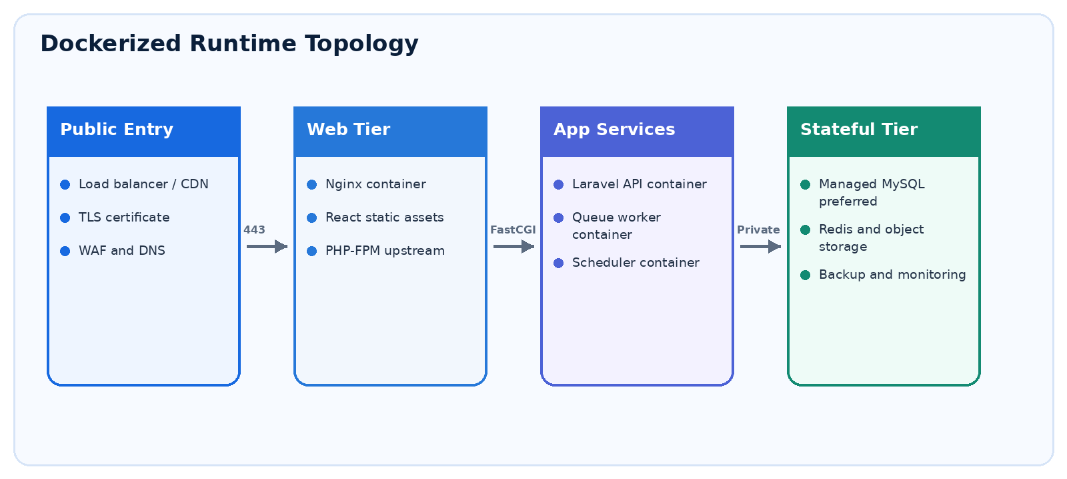
Figure 2. Recommended container topology.

13.1 Container Services
Service | Responsibility | Rules
nginx | Public entry, React assets, API routing, compression, security headers and static caching. | Stateless; read-only config; non-root where practical.
php-fpm | Laravel HTTP application. | Immutable image; OPcache; health check; no scheduler inside.
queue-worker | Laravel queue consumers. | Same app image, dedicated command, graceful stop and bounded retries.
scheduler | Runs schedule:work or one-minute schedule runner. | Single active instance/lock; same app image.
frontend-build | Node-based multi-stage build producing static artifacts. | Build stage only; Node not required in final Nginx image.
mysql | Local/staging database; production managed service preferred. | Named volume in local only; private network; backups.
redis | Cache, rate limiting, locks and queues. | Persistence mode chosen by queue durability need; private network.
optional-search | Meilisearch/OpenSearch when accepted by scale/relevance decision. | Private service with persistent storage and backup/rebuild procedure.

13.2 Docker Build Standards
- Separate multi-stage Dockerfiles for frontend and Laravel runtime/build stages.
- Pin major/minor base image versions and update through automated dependency review; use minimal trusted images.
- Run application processes as a non-root user; drop unnecessary Linux capabilities; use read-only filesystem where compatible.
- Use .dockerignore; copy lockfiles before source to maximize cache; install production dependencies with deterministic lockfiles.
- Do not bake .env, credentials, user uploads or mutable logs into images.
- Expose explicit health checks; route startup through a small, fail-fast entrypoint without silently running risky migrations.
- Development uses bind mounts and debug tooling; production override removes them, disables debug and sets resource/logging policies.
- Build and scan images in CI. Promote the same immutable image digest from staging to production.

13.3 Compose Profiles
File/Profile | Purpose | Notable differences
compose.yaml | Shared service graph | Networks, volumes, health dependencies and safe defaults.
compose.dev.yaml | Developer workstation | Bind mounts, Vite HMR, Mailpit, optional DB admin and debug settings.
compose.test.yaml | CI/integration tests | Ephemeral database/Redis, test command, no persistent volumes.
compose.prod.yaml | Single-host production override | Prebuilt images, restart/resource/log policies, no source mounts, production secrets and external stateful services.

13.4 Required Environment Variables
Group | Examples | Handling
Application | APP_ENV, APP_URL, APP_KEY, LOG_LEVEL | APP_KEY generated per environment; debug false outside local.
Database | DB_HOST, DB_DATABASE, DB_USERNAME, DB_PASSWORD | Injected secret; least-privilege user; TLS where supported.
Redis/Queue | REDIS_HOST, REDIS_PASSWORD, QUEUE_CONNECTION | Private endpoint; queue names prefixed by environment.
Mail/Alerts | MAIL_*, provider API keys, sender identity | Verified sender; secret store; sandbox provider in non-production.
Storage | FILESYSTEM_DISK, object endpoint/bucket/keys | Private bucket, lifecycle rules, signed downloads.
Telemetry | OTEL_*, SENTRY_DSN or equivalent | No secret/PII in events; separate project per environment.

14. CI/CD, Operations and Recovery

14.1 Pipeline Gates
- Install locked frontend/backend dependencies and verify lockfiles.
- Run formatting/linting, TypeScript checks, PHP static analysis and architecture checks.
- Run unit, feature/API, policy/authorization and frontend component tests.
- Build production frontend assets and Docker images using multi-stage builds.
- Run container/dependency/secret scans and generate an SBOM.
- Start the Compose test stack; run migrations and integration/smoke tests.
- Publish immutable versioned images after main/release approval.
- Deploy to staging, run end-to-end/accessibility/performance smoke tests and request production approval.
- Deploy with rolling/blue-green strategy where supported, run safe migrations, warm caches and verify health.
- Automatically roll back application image on failed health checks; database rollback follows an explicit forward-fix/restore plan.

14.2 Observability
- JSON logs to stdout with timestamp, level, service, environment, route/job name, user pseudonymous ID and correlation ID.
- Metrics: request rate/error/latency, PHP-FPM saturation, queue depth/age/failures, DB latency/connections, cache hit rate, storage errors and scheduled-publication lag.
- Traces across Nginx/Laravel/database/queue for sampled requests; redact credentials, tokens, query bodies and personal content.
- Alerts are actionable, severity-based and linked to runbooks. Health endpoints distinguish liveness from readiness.

14.3 Backup and Disaster Recovery
- Automated encrypted database backups with retention and off-host copies.
- Object storage versioning/lifecycle rules for managed documents as required.
- Configuration, Compose files and infrastructure definitions in version control; secrets backed up through the approved secret system.
- Quarterly restore drill to an isolated environment, with measured RPO/RTO and corrective actions.
- Documented response for accidental publish, credential compromise, database loss, queue outage and external-provider failure.

15. Testing Strategy
Level | Coverage | Exit expectation
Unit | Domain rules, validators, calculations, policies and transformation helpers. | Fast; required on every merge.
Backend Feature/API | Auth, RBAC, CRUD, workflow transitions, filters, pagination, error contracts and idempotency. | Database-backed isolated tests.
Frontend Component | Design-system components, forms, filters, loading/error/empty states. | React Testing Library or equivalent.
Contract | OpenAPI schema and frontend client compatibility. | Fail on breaking/unapproved changes.
End-to-End | Search -> detail; register -> bookmark; author -> reviewer -> publish; tool upload -> download -> expiry. | Playwright on staging/CI.
Accessibility | Automated rules plus keyboard, focus, screen-reader landmarks and 200% zoom checks. | WCAG 2.2 AA target.
Performance | Home/list/detail/search APIs, surge traffic and queue throughput. | Baseline and pre-release load tests.
Security | SAST, dependency/container/secret scans, DAST and manual authorization/file-upload checks. | Release gate for critical/high issues.
Recovery | Backup restore, worker restart, provider outage and rollback smoke tests. | Scheduled operational exercise.
Content QA | Source URL, date logic, mandatory fields, slug/SEO preview and broken links. | CMS validation + reviewer checklist.

15.1 Definition of Done
- Acceptance criteria and tests pass; no unresolved critical/high defect.
- Authorization and validation are server-side; logs contain no secrets or unnecessary personal data.
- API/OpenAPI, user-facing help and operational runbook are updated.
- Responsive, accessibility, browser and performance checks pass for affected journeys.
- Migration has rollback/forward-fix and backup considerations; deployment and monitoring changes are included.
- Product Owner and QA accept the story in staging.

16. Delivery Roadmap
Phase | Indicative duration | Outcome
Phase 0 - Foundation | 1-2 weeks | Repository, standards, UI tokens, Compose dev stack, CI, auth/RBAC skeleton, taxonomy and shared content model.
Phase 1 - Public MVP | 3-5 weeks | Home, search, jobs/results/admit cards, detail pages, navigation/footer, core CMS and SEO baseline.
Phase 2 - Content Expansion | 2-4 weeks | Answer keys, syllabus, schemes, notifications, relationships, scheduling, redirects and link checks.
Phase 3 - Accounts & Alerts | 2-3 weeks | Registration, bookmarks, saved searches, subscriptions, email delivery and preferences.
Phase 4 - Tools & Hardening | 3-5 weeks | Priority calculators/converters, isolated jobs, accessibility, performance, security, DR drill and production readiness.
Phase 5 - Growth | Continuous | Hindi/localization, advanced search, analytics experiments, PWA/push and mobile clients based on evidence.

Planning note Durations are indicative for a small cross-functional team and must be recalculated after backlog estimation, content-migration volume, tool complexity and integration decisions are known.

17. Risks, Acceptance and Traceability

17.1 Key Risks
Risk | Severity | Mitigation
Incorrect/outdated government information | High | Mandatory official source, reviewer approval, visible verification date, link checks and correction workflow.
Traffic spike on major results | High | CDN/cache, horizontal stateless app tier, queue alerts and load testing.
SEO loss with client-only rendering | High | Crawler proof-of-concept; prerender/SSR/static strategy for indexable pages; canonical/sitemap validation.
Unsafe file-conversion inputs | High | Strict signatures/limits, isolated workers, malware hook, private storage and automatic deletion.
Notification spam/compliance failure | High | Consent logs, double opt-in, frequency caps, suppression and one-click unsubscribe.
Admin account compromise | High | MFA, least privilege, audit alerts, session controls and network restrictions where suitable.
Content model becomes too generic | Medium | Shared core fields plus typed detail tables and module-specific validation.
Single-host production failure | Medium | Managed stateful services, backups, restart policies, documented restore and later multi-node migration path.

17.2 System Acceptance Criteria
- All Must functional requirements are implemented, traced to tests and accepted in staging.
- Core guest journey from home/search/filter to a detail page works on agreed devices/browsers and meets accessibility/performance targets.
- Author-reviewer publishing workflow, scheduled publishing, expiry and audit logs work with denied-transition tests.
- Registered users can verify identity, bookmark, save an alert, unsubscribe and revoke sessions.
- Docker development environment starts from documented commands; test and production images build reproducibly.
- Production readiness review confirms monitoring, alerts, backups, restore evidence, runbooks, secrets and security findings.
- Content/SEO review confirms canonical URLs, metadata, sitemap, robots policy, redirects, source attribution and crawlability.

17.3 Traceability Matrix (Sample)
Business goal | Modules | Requirement groups | Primary verification
Fast discovery | M01-M03, M09 | FR-SRCH, FR-CNT, NFR-PERF | API, E2E, performance and UX tests.
Trusted information | M03-M08, M14 | FR-CNT, FR-ADM, BR-002/004/008 | Workflow, content QA and audit tests.
Personal relevance | M10-M12 | FR-USR, FR-SRCH | Auth, bookmark, alert and consent E2E tests.
Safe utilities | M11 | FR-TOL, NFR-SEC | Upload security, isolation and retention tests.
Reliable operation | M15 | NFR-SCALE/AVL/REL/OBS/DR | Load, failover, monitoring and restore evidence.

Appendix A - Suggested Repository Structure
sarkarilinks/
frontend/ # React + TypeScript
src/app/ # router, providers, bootstrap
src/features/ # jobs, results, schemes, search, account, admin
src/components/ # shared design-system components
src/api/ # generated/typed clients and contracts
backend/ # Laravel application
app/Domain/ # domain modules and rules
app/Application/ # use cases/actions
app/Http/ # controllers, requests, resources, middleware
app/Policies/ # authorization policies
database/migrations/ # forward migrations
tests/ # unit and feature tests
docker/ # nginx, php and entrypoint configuration
compose.yaml
compose.dev.yaml
compose.test.yaml
compose.prod.yaml
docs/ # SRS, ADRs, OpenAPI and runbooks
.github/workflows/ # or equivalent CI pipeline

Appendix B - Glossary
Term | Meaning
API | Application Programming Interface.
CMS | Content Management System.
CSP | Content Security Policy.
RBAC | Role-Based Access Control.
RPO | Maximum acceptable data loss measured in time.
RTO | Target time to restore service after disruption.
SPA | Single-Page Application.
SSR | Server-Side Rendering.
SLO | Service-Level Objective.
ULID | Universally Unique Lexicographically Sortable Identifier.
WCAG | Web Content Accessibility Guidelines.

Appendix C - Technical Baseline References
The following official references support the selected platform baseline and container practices:
- Laravel 13 release notes and deployment requirements: https://laravel.com/docs/13.x/releases and https://laravel.com/docs/13.x/deployment
- React version documentation (19.2 at preparation time): https://react.dev/versions
- Docker build best practices: https://docs.docker.com/build/building/best-practices/
- Docker Compose production guidance: https://docs.docker.com/compose/how-tos/production/

Appendix D - Open Decisions Before Sprint Planning
ID | Decision | Options / Question | Owner
D-01 | SEO rendering strategy | CSR + prerender, SSR framework, or static generation for public pages. | Product + Tech Lead
D-02 | Source ingestion | Manual CMS only vs. approved feeds/importers; scraping policy per source. | Product + Legal/Ops
D-03 | Search engine | MySQL full text for MVP vs. Meilisearch/OpenSearch at launch. | Tech Lead
D-04 | Authentication channels | Email only, mobile OTP, or social providers for Release 1. | Product + Security
D-05 | Priority tools | Which calculators/converters launch first and their retention/limits. | Product Owner
D-06 | Localization | English-first date vs. parallel Hindi content workflow. | Product + Content
D-07 | Hosting topology | Single host Compose vs. managed container platform; database/storage choices. | Tech + Budget Owner
D-08 | Analytics/consent | Provider selection, event taxonomy and consent approach. | Product + Privacy Owner

Approval Sign-off
Approver | Name | Decision / Date
Product Owner | ________________________ | Approved / Changes required: __________________
Technical Lead | ________________________ | Approved / Changes required: __________________
QA / Security Owner | ________________________ | Approved / Changes required: __________________

