DBMS Project Report
On
ParkEase – Parking Management System
Submitted By
Sr. No. Name of Student Class Div. Roll No.
- Jayesh Landage TY-Comp B 34
Under the Guidance of
Prof. M. M. Deshmukh
T. Y. Computer Engineering (2025-2026)
Department of Computer Engineering
K. K. Wagh Institute of Engineering Education & Research
Haridas Vidyanagari, Amrutdham, Panchavati,
Nashik – 422 003
TABLE OF CONTENTS
Sr. No. | Name of Topic | Page No.
1 | Abstract | 1
2 | Introduction | 1
3 | Problem Statement | 1
 | Objectives | 2
 | Outcomes | 2
4 | Scope | 2
5 | Requirement Analysis | 3
 | Functional Requirements | 3
 | Non-Functional Requirements | 4
6 | UML Diagram | 5
 | Use Case | 5
 | Activity Diagram | 6
 | Class Diagram | 7
7 | Software Requirement | 8
 | Front End | 8
 | Back End | 8
 | Database Connectivity | 8
8 | GUI | 9
9 | Source Code | 12
10 | Estimation of Project | 13
11 | Testing | 14
12 | Conclusion | 15

1. ABSTRACT
ParkEase is a client–server Parking Management System developed in Java to automate the operation of a parking facility. Many parking lots still depend on paper tickets, manual registers and verbal slot assignment. This causes queues at the gate, disputes about timing and charges, no real-time view of free slots and no reliable record of revenue. The proposed system replaces these manual steps with a centralized digital platform.
The application consists of a JavaFX desktop client that communicates with a Spring Boot REST backend and a MySQL database. A single login screen serves three roles. Customers register vehicles, book a slot by vehicle type, receive a ticket with a QR code, extend or cancel bookings, rate the service and download receipts. Parking staff record walk-in entries and exits, watch a live zone-wise slot layout and see overstayed vehicles. Administrators manage staff, view and search all bookings, track revenue on a seven-day chart and export data to CSV.
Passwords are stored as BCrypt hashes, access is controlled with JWT tokens and roles, and forgotten passwords are recovered with an e-mailed one-time password (OTP). Fares are calculated automatically from the parking duration and an hourly rate for each vehicle type. Overall, ParkEase is a reliable and user-friendly solution that reduces manual work, prevents double allocation of slots and gives management accurate, real-time information.

2. INTRODUCTION
Parking space is a limited resource in colleges, markets, offices and residential complexes. Traditional parking management relies on an attendant who issues paper tickets, remembers which slots are free and calculates charges by hand. Such methods are slow, error-prone and not transparent, and they become unmanageable as the number of vehicles grows.
ParkEase solves these problems with a computerized, role-based system. Users, vehicles, slots, bookings and notifications are stored in one MySQL database and exposed through a secured REST API. The JavaFX client gives every type of user a dedicated dashboard: customers can book without visiting the gate, staff can handle walk-in vehicles quickly and administrators can supervise the whole operation.
Slot status is updated automatically on every entry, exit and cancellation, and the fare is computed by the system. The project demonstrates the practical use of JavaFX, Spring Boot, Spring Security, JPA/Hibernate and JDBC to solve a real-world management problem.

3. PROBLEM STATEMENT
In many parking facilities, slot allocation and record keeping are still done manually. The attendant cannot see free and occupied slots at a glance, so drivers circle the lot or are sent to a slot that is already taken. Entry and exit times are written on paper tickets that are easily lost or altered, which leads to disputes about duration and charges.
There is also no reliable data. Vehicle details, bookings and collections are kept in notebooks or spreadsheets, so searching a past record, finding who has overstayed or calculating the day’s revenue is slow and inaccurate. Customers cannot reserve a slot in advance, view their parking history or obtain a receipt on demand.
Therefore, there is a need for a smart parking management system that automates slot allocation, calculates fares automatically, keeps digital records of vehicles and bookings, restricts each user to permitted functions and provides real-time occupancy and revenue information.

a. Objectives
The main objectives of ParkEase are:
- To design and develop a client–server application for managing a fixed-capacity parking area.
- To provide one login for customers, staff and administrators with role-based dashboards.
- To maintain slot records (slot number, vehicle type, occupancy) and prevent allocation of an occupied slot.
- To let customers register vehicles, book slots and receive a ticket with a QR code.
- To calculate fares automatically from the duration and a vehicle-type specific hourly rate.
- To support walk-in entry and exit handled by parking staff.
- To detect overstay and notify customers of booking events.
- To secure data using hashed passwords, JWT authentication and OTP-based password recovery.
- To give administrators staff management, booking search, revenue reports, charts and CSV export.

b. Outcomes
- A centralized system now manages vehicles, slots, bookings and users in one database.
- Slot allocation is faster and more accurate than the manual method; an occupied slot cannot be assigned again.
- Customers can book, extend, cancel, rate and download receipts without staff assistance.
- Staff can see live occupancy, handle walk-ins and identify overstayed vehicles instantly.
- Administrators can view all bookings and revenue and export the data for further analysis.
- Unauthorized access is blocked because every protected API call needs a valid token with the correct role.
- The client is packaged as a standalone Windows application that bundles its own Java runtime.

4. SCOPE
The scope of ParkEase covers the following modules.

Customer Module
Sign up, log in and recover a forgotten password with OTP; manage profile (name, phone, address, photo) and password; add and delete vehicles; book a slot and view the ticket with QR code; extend, complete or cancel a booking; view history, rate a completed booking and download a receipt; read notifications and switch between light and dark themes.

Staff Module
Log in with an account created by the administrator; view quick statistics (total, occupied and available slots, today’s entries and exits, overstayed vehicles) and the live slot layout; record walk-in entry and process exit with automatic fare calculation.

Admin Module
Create and remove staff accounts; view and search all bookings; view the revenue summary and the seven-day revenue chart; export bookings to CSV.

Slot Management Module
Maintains the fixed layout of 24 slots (12 car, 8 bike and 4 truck), tracks free and occupied slots and updates them on every booking event.

Booking and Billing Module
Creates bookings with entry, expected exit and exit times, computes the fare (minimum one hour, rounded up to the next full hour), tracks the status ACTIVE, COMPLETED or CANCELLED and generates notifications.
The Payments page is a demonstration only. Real payment processing, a mobile application and multiple parking locations are outside the present scope.

5. REQUIREMENT ANALYSIS
Requirement analysis identifies what the system must do and how well it must perform. For ParkEase it helps in understanding the needs of customers, parking staff and administrators, and it ensures that the application satisfies practical parking-management requirements in terms of functionality, security, reliability and usability. The requirements are divided into functional and non-functional requirements.

5.1 Functional Requirements
Sr.  No. | Function | Input | Process | Output
1 | User Authentication | E-mail, password | Verify BCrypt hash, issue JWT | Role-based dashboard
2 | Customer  Registration | Name, e-mail, phone, password | Validate 10-digit phone and unique e-mail, hash password, save | Account created
3 | Password Recovery | E-mail, OTP, new password | Send 6-digit OTP, verify within  10 minutes, update hash | Password reset
4 | Vehicle Management | Vehicle number, type, model | Validate, store and link to owner | Updated vehicle  list
5 | Slot Booking | Vehicle, vehicle type | Pick a free slot of that type, mark it occupied, create booking | Ticket with QR code
6 | Extend / Complete /  Cancel | Booking ID | Check owner and ACTIVE  status, update times, free slot | Updated booking, fare
7 | Walk-in Entry and  Exit (Staff) | Vehicle number and type / Booking ID | Allocate slot, compute fare on exit | Entry recorded, fare shown
8 | Overstay Detection | Expected exit time | Compare with current time for  ACTIVE bookings | Overstay badge and count
9 | Notifications | Booking events | Store message for the user | Notification list
Sr.  No. | Function | Input | Process | Output
10 | Staff Management  (Admin) | Name, e-mail, password, phone | Create user with role staff, or delete | Updated staff list
11 | Reports (Admin) | Booking data | Aggregate fares and daily revenue | Revenue summary, chart,  CSV

5.2 Non-Functional Requirements

Performance Requirements
- Screens and dashboard data should load within a few seconds under normal usage.
- Network calls run on background threads so that the interface never freezes.
- Booking, exit and report operations should respond quickly.

Security Requirements
- Only authenticated users may use protected APIs, and each role may use only its permitted functions.
- Passwords are stored as BCrypt hashes and login tokens expire after 30 minutes.
- A customer can view, change or cancel only his or her own data.
- Database and e-mail credentials are kept in environment variables, not in source code.

Reliability Requirements
- Slot status and booking records must stay consistent after every operation.
- Unique constraints prevent duplicate e-mail addresses and slot numbers.
- Regular database backups should be taken to avoid data loss.

Usability Requirements
- A clean sidebar-based interface with a consistent color for each role.
- Confirmation dialogs for destructive actions and loading states on buttons.
- Clear error messages, and scrolling so that all content is reachable on small screens.

6. UML DIAGRAM

a. Use Case
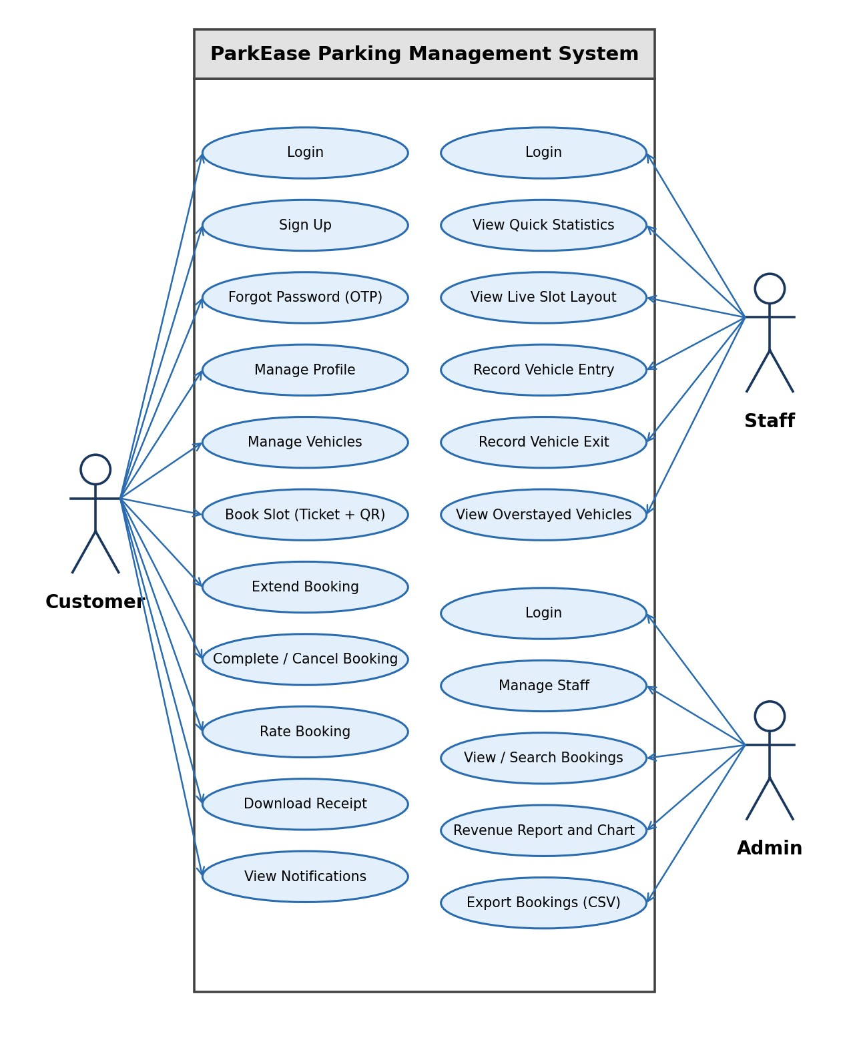
Figure 6.1: Use Case Diagram of ParkEase

b. Activity Diagram
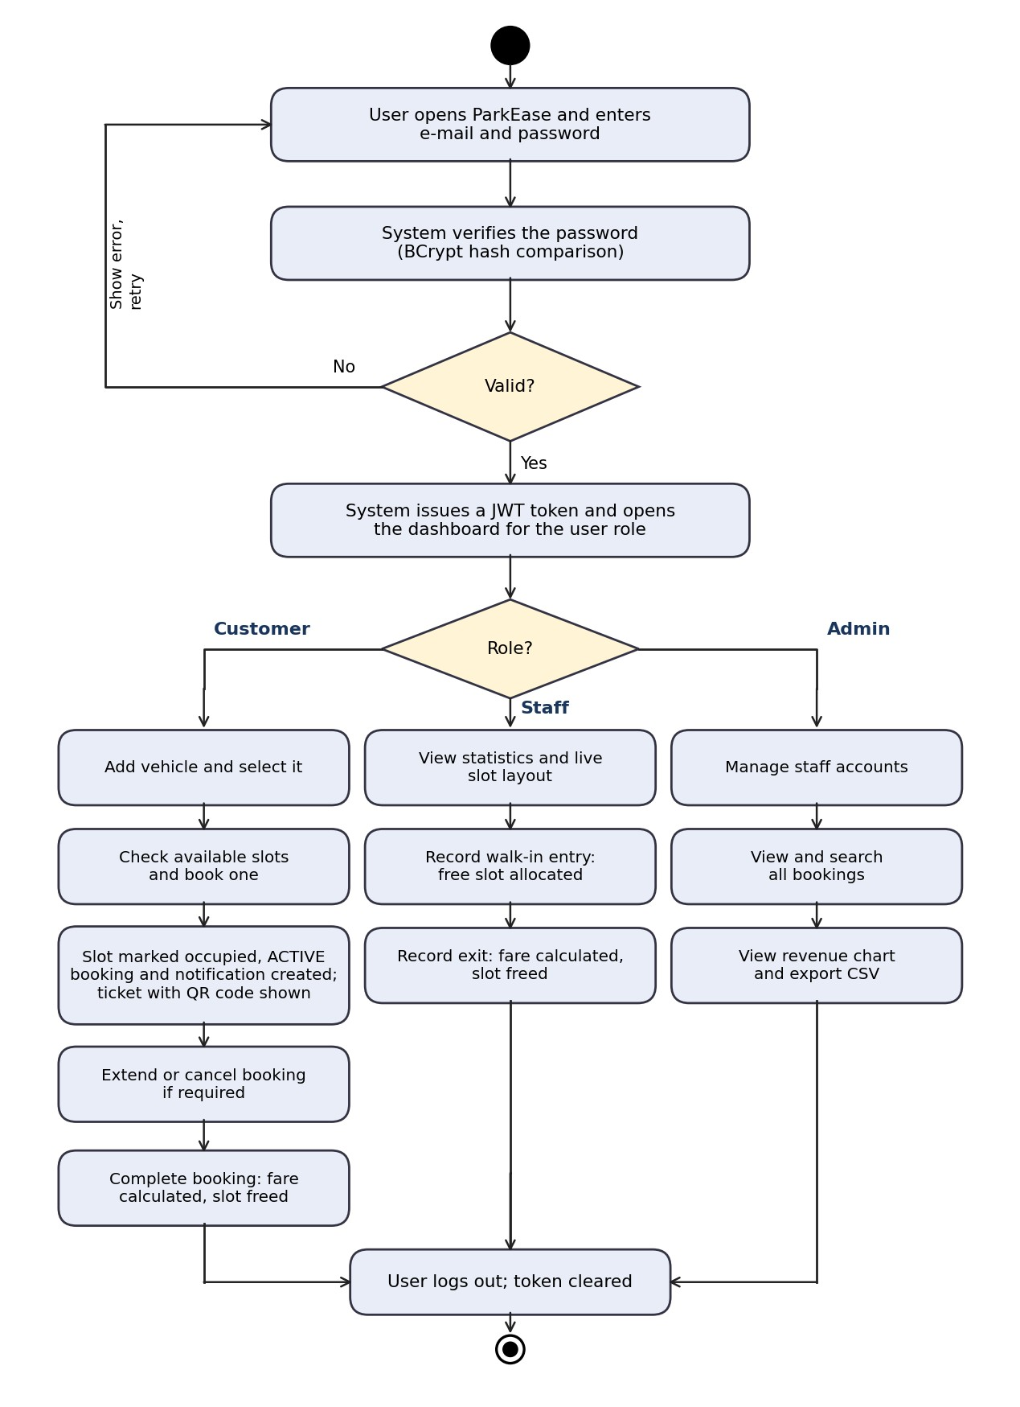
Figure 6.2: Activity Diagram of ParkEase

c. Class Diagram
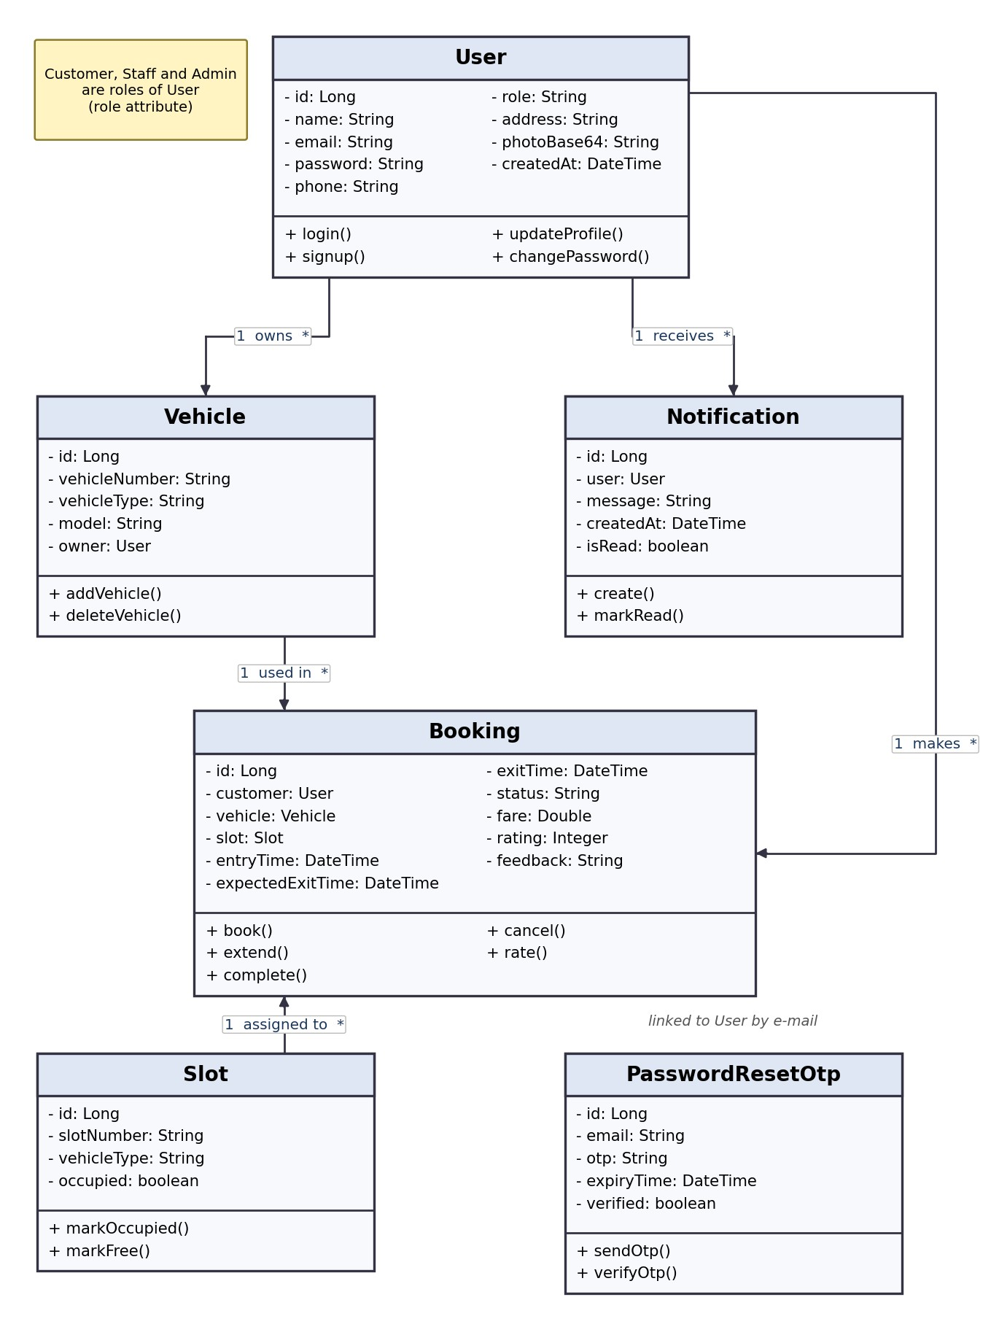
Figure 6.3: Class Diagram of ParkEase

7. SOFTWARE REQUIREMENT
Architecture: ParkEase follows a three-tier client–server architecture – JavaFX client → Spring Boot REST API → MySQL database. The client sends a JWT in the Authorization header of every request.

7.1 Front-End Technologies
The front end is responsible for displaying the interface and enabling user interaction.
- JavaFX 21 and FXML – builds the desktop screens: login, dashboards, tables, slot grid and charts.
- JavaFX CSS – defines colors, cards, sidebar, tables and the dark theme.
- OkHttp 4.12 – HTTP client that sends JSON requests with the Bearer token to the backend.
- Gson 2.10 – converts JSON responses into Java objects.
- ZXing 3.5 – generates the QR code shown on the booking ticket.

7.2 Back-End Technologies
The back end manages application logic, security and data processing.
- Spring Boot 3.3 (Java 17+) – REST controllers, services and application configuration.
- Spring Security and JWT (jjwt 0.11.5) – stateless authentication, BCrypt password hashing and role-based access control.
- Spring Data JPA / Hibernate – object-relational mapping; tables are created and updated automatically.
- Spring Mail – sends OTP e-mails through Gmail SMTP.
- Maven – build and dependency management.

7.3 Database Connectivity
MySQL / JDBC. The database stores users, vehicles, slots, bookings, notifications and OTP records. Hibernate runs over JDBC (mysql-connector-j) and Spring Data repositories execute the SQL queries. The database is named parking_management and contains the tables users, vehicles, slots, bookings, notifications and password_reset_otp. Database and e-mail credentials are read from environment variables.
Tools and platform: VS Code, Postman, MySQL Workbench and jpackage (for the Windows application); Windows 11 and JDK 21.

8. GUI (Graphical User Interface)
The GUI of ParkEase is a clean, card-based interface with a fixed sidebar and a scrolling content area. Each role has its own accent color – blue for customers, amber for staff and purple for administrators – and every screen supports a dark theme.

1. Login Page
The login page shows the ParkEase logo, e-mail and password fields, and Forgot Password and Create account links. One page serves all roles; after login the dashboard of the user’s role opens.

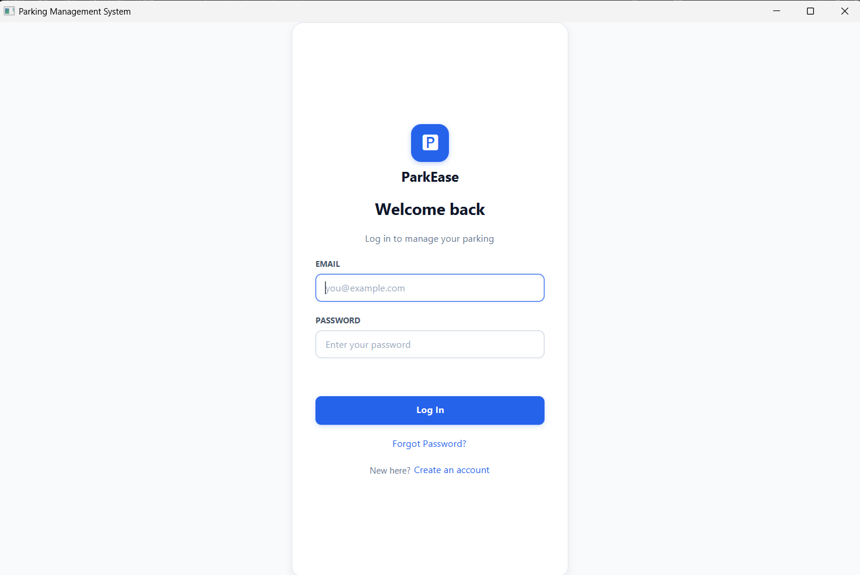

2. Customer Dashboard
The dashboard shows an avatar with role chip, three statistic cards (active bookings, total bookings, total spent) and the Find Parking / Book a Slot button. The sidebar gives access to Profile, Vehicles, Book Slot, Bookings, Paym ents, Notifications, Settings and Logout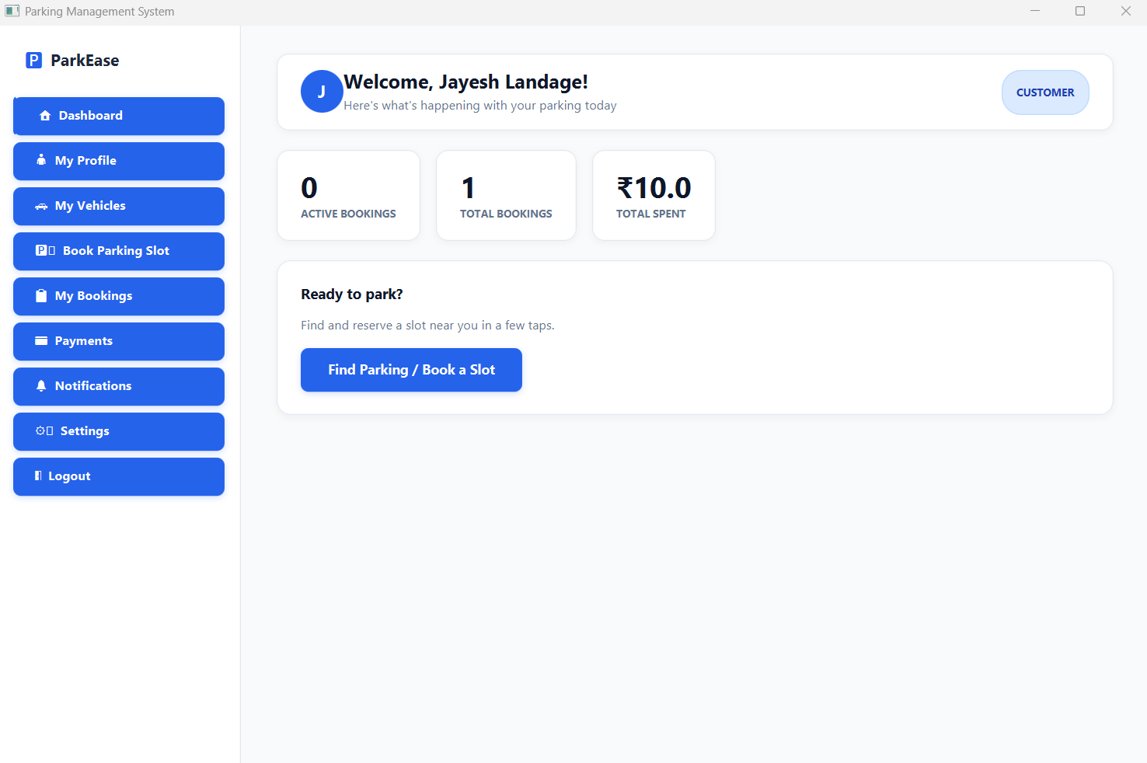3. Book Parking Slot PageThe customer selects a vehicle, sees its hourly rate, checks available slots on a colored grid and books one. A ticket with Ticket ID, slot, valid-until time and QR code is displayed. 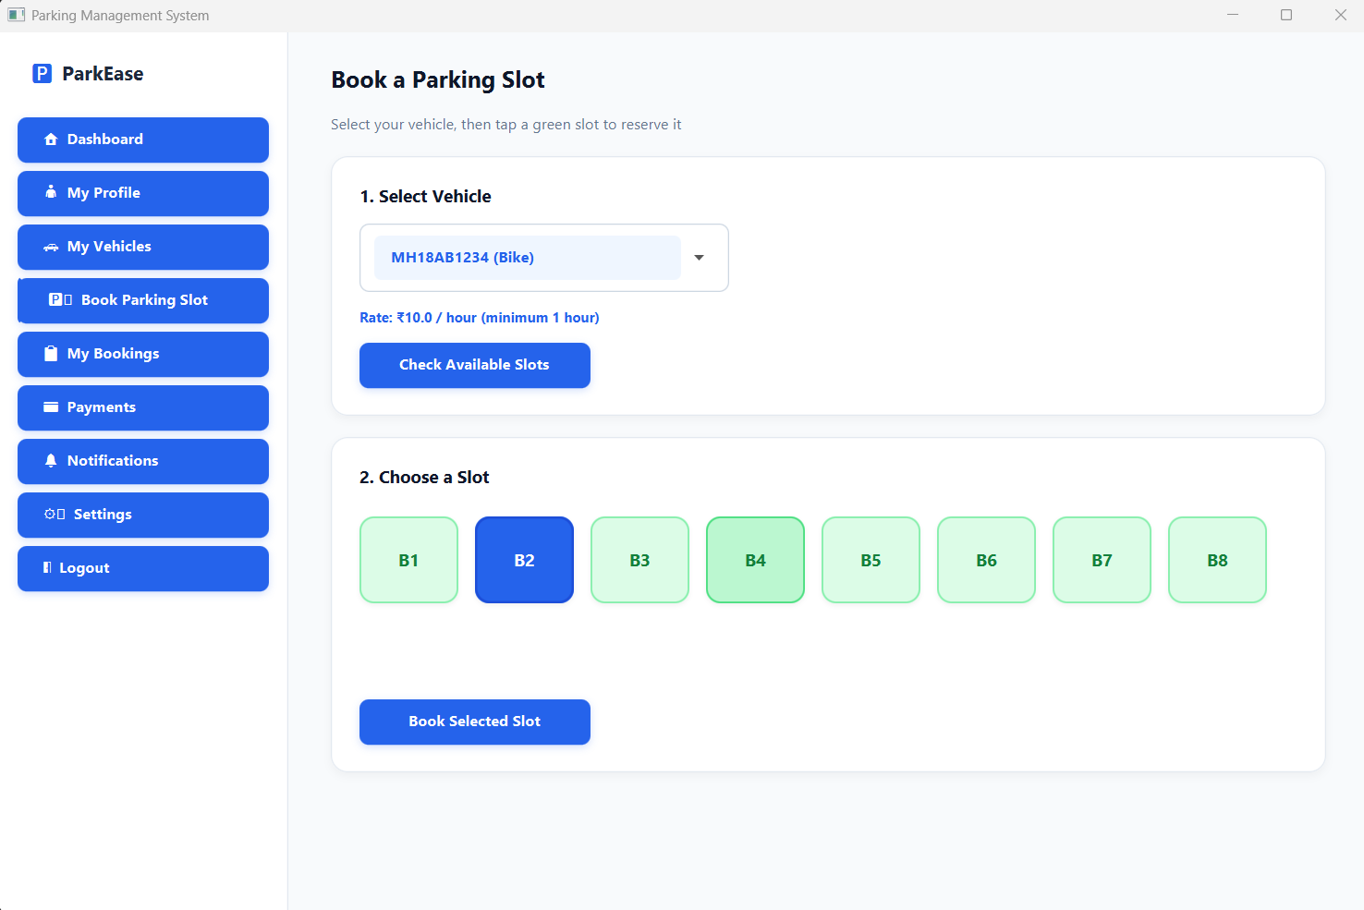

4. My Bookings Page
The Active tab shows the expected exit time with +1 hr, Complete and Cancel actions. The History tab provides search, fare, star rating, Rate and Download receipt.

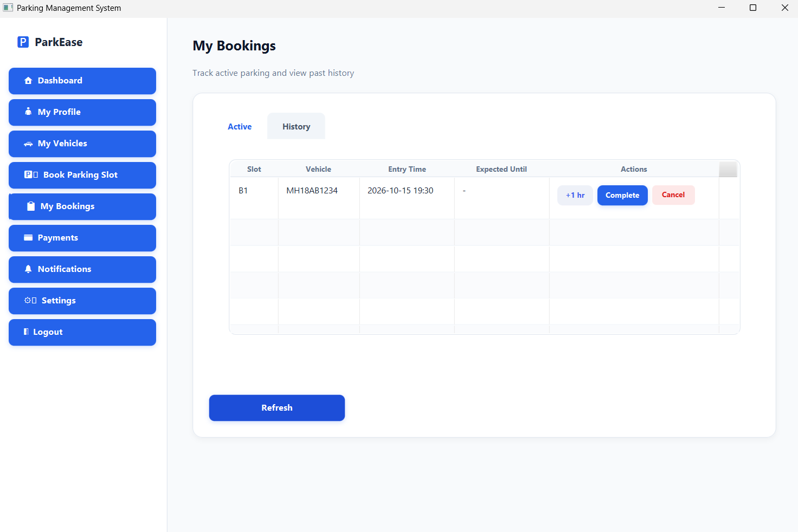5. Staff Dashboard
Six statistic cards, the live layout grouped into Car, Bike and Truck zones (green = free, red = occupied), a vehicle entry form and the active bookings table with Overstay badge and Exit button.

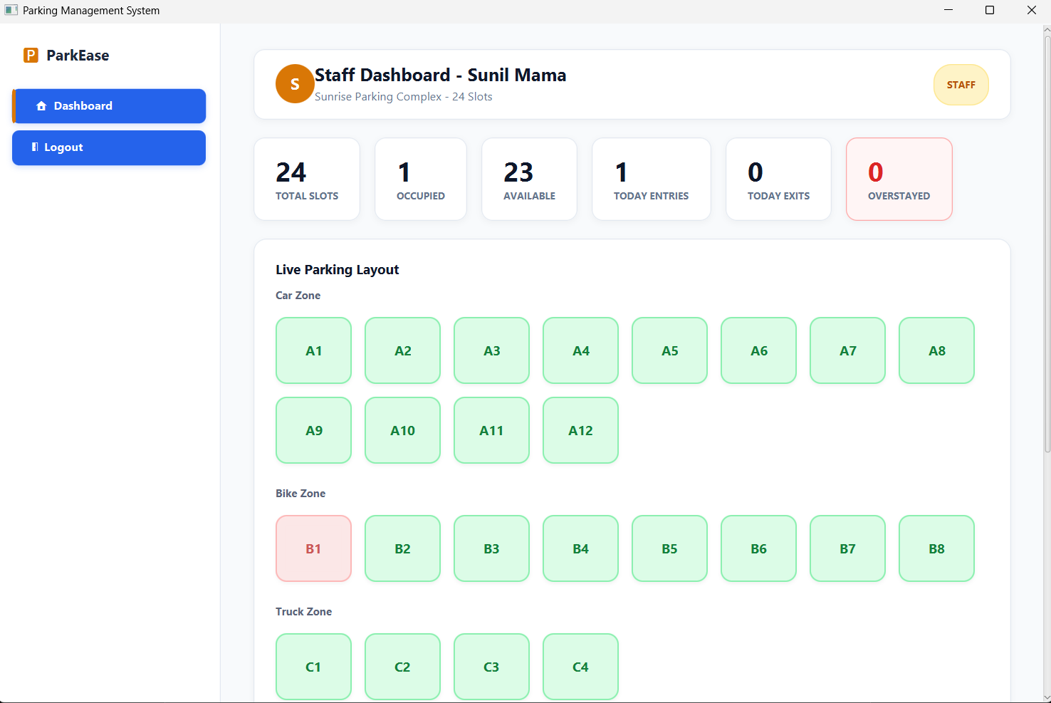6. Admin Dashboard
Revenue overview with a seven-day bar chart, staff management table, all-bookings table with search and the Export to CSV button.

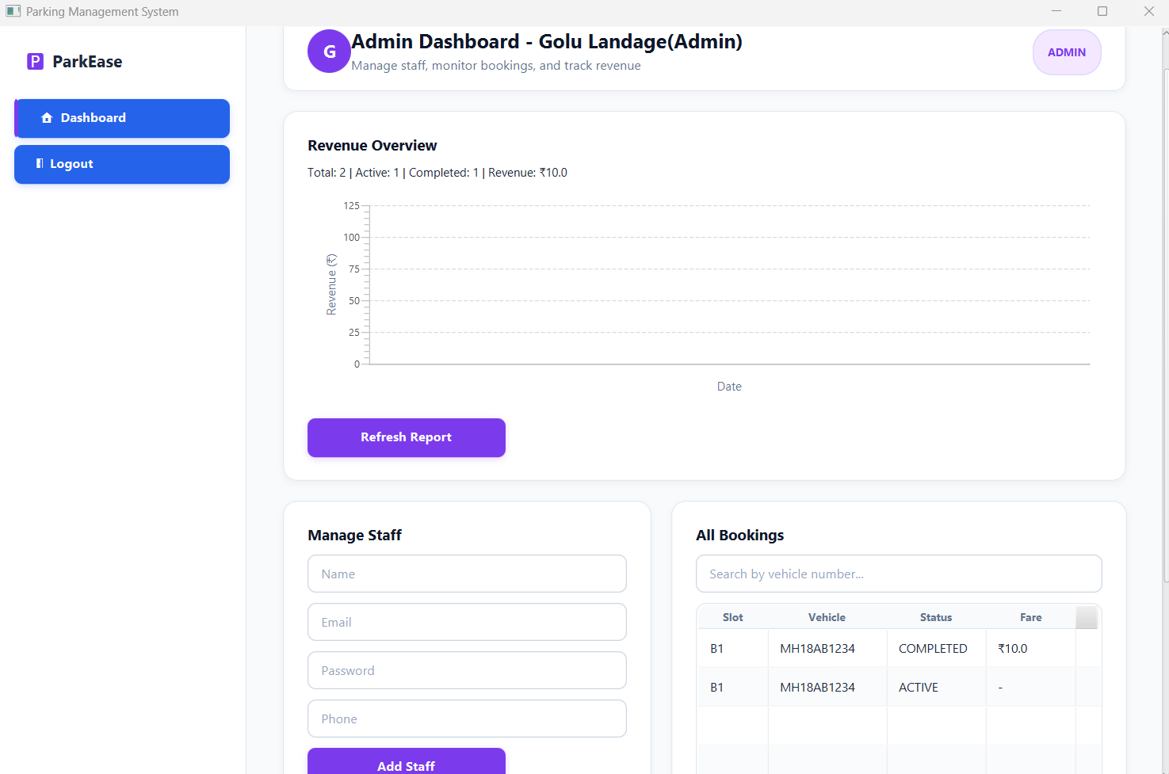7. Profile, Notifications and Settings
Photo upload, address and password change; unread notifications highlighted with a dot and a Mark Read button; dark theme toggle.

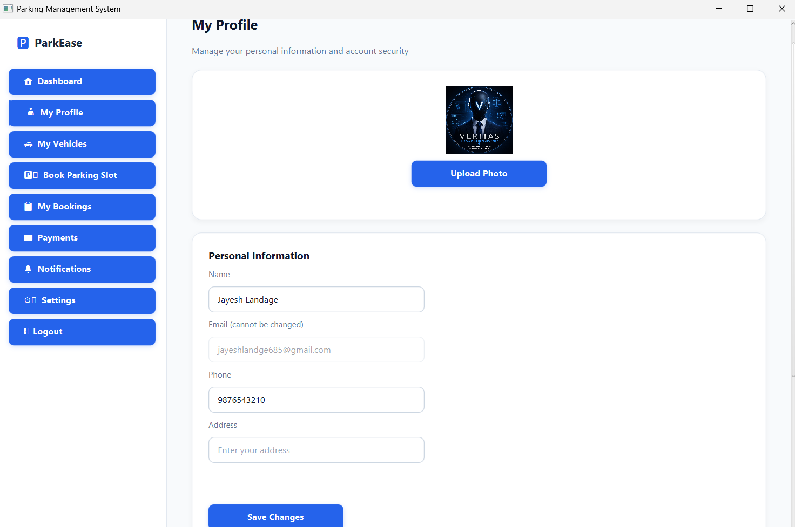9. SOURCE CODE
Key excerpts from the backend (Spring Boot) and the desktop client (JavaFX) are given below.

1. AuthService.java – login with BCrypt verification and JWT
public AuthResponse login(LoginRequest request) { User user = userRepository.findByEmail(request.getEmail()) .orElseThrow(() -> new RuntimeException("Invalid email or password"));
if (!passwordEncoder.matches(request.getPassword(), user.getPassword())) { throw new RuntimeException("Invalid email or password"); }
String token = jwtUtil.generateToken(user.getEmail(), user.getRole()); return new AuthResponse(token, user.getName(), user.getEmail(), user.getRole()); }

2. JwtUtil.java – token generation
public String generateToken(String email, String role) { return Jwts.builder() .setSubject(email)
.claim("role", role)
.setIssuedAt(new Date())
.setExpiration(new Date(System.currentTimeMillis() + expirationMs))
.signWith(secretKey)
.compact();
}

3. SecurityConfig.java – role-based access control
http .csrf(csrf -> csrf.disable()) .sessionManagement(session -> session.sessionCreationPolicy(SessionCreationPolicy.STATELESS)) .authorizeHttpRequests(auth -> auth
.requestMatchers("/api/auth/**").permitAll()
.requestMatchers("/api/admin/**").hasRole("ADMIN")
.requestMatchers("/api/staff/**").hasAnyRole("STAFF", "ADMIN")
.anyRequest().authenticated()
)
.addFilterBefore(jwtAuthFilter, UsernamePasswordAuthenticationFilter.class);

4. BookingService.java – booking a slot (excerpt)
List<Slot> availableSlots = slotRepository.findByVehicleTypeAndOccupiedFalse(request.getVehicleType()); if (availableSlots.isEmpty()) { throw new RuntimeException("No available slots for " + request.getVehicleType()); }
Slot slot = availableSlots.get(0); slot.setOccupied(true); slotRepository.save(slot);
Booking booking = new Booking(); booking.setCustomer(customer); booking.setVehicle(vehicle); booking.setSlot(slot); booking.setEntryTime(LocalDateTime.now()); booking.setExpectedExitTime(LocalDateTime.now().plusHours(2)); booking.setStatus("ACTIVE"); bookingRepository.save(booking);

5. Fare calculation (completeBooking) with PricingConfig
long minutes = Duration.between(booking.getEntryTime(), exitTime).toMinutes(); double hours = Math.max(1, Math.ceil(minutes / 60.0)); // minimum 1 hour double rate = PricingConfig.getRateForType(booking.getVehicle().getVehicleType()); double fare = hours * rate; // Car 30, Bike 10, Truck 50 per hour

6. ApiClient.java (JavaFX client) – sending the JWT with every request
private static void addAuthHeader(Request.Builder builder) { String token = SessionManager.getToken(); if (token != null) { builder.addHeader("Authorization", "Bearer " + token); }
}

7. LoginController.java – role-based navigation
if (result.role.equals("staff")) { MainApp.switchScene("/fxml/staff_dashboard.fxml");
} else if (result.role.equals("admin")) {
MainApp.switchScene("/fxml/admin_dashboard.fxml");
} else {
MainApp.switchScene("/fxml/dashboard.fxml");
}

10. ESTIMATION OF PROJECT
The effort and development time of ParkEase are estimated using function points and the COCOMO model (organic mode).

Step 1: Unadjusted Function Points (UFP)
Component | Count | Weight | Total
External Inputs (sign-up, login, OTP, profile, vehicle, booking, entry/exit, staff management, etc.) | 20 | 3 | 60
External Outputs (ticket with QR code, receipt, CSV, revenue report, chart, OTP e-mail, notifications) | 7 | 4 | 28
External Inquiries (profile, vehicle list, bookings, slots, statistics, notifications, staff list) | 12 | 3 | 36
Internal Logical Files (users, vehicles, slots, bookings, notifications, password_reset_otp) | 6 | 7 | 42
External Interface Files (Gmail SMTP service) | 1 | 5 | 5
UFP |  |  | 171

Step 2: Technical Complexity Factor
Considering role-based access, database connectivity, security, client–server processing and reusability, the sum of the 14 adjustment factors is estimated as 45. TCF = 0.65 + 0.01 × 45 = 1.10
Step 3: Adjusted Function Points
FP = UFP × TCF = 171 × 1.10 = 188.1

Step 4: KLOC
Assuming about 30 lines of Java per function point (framework-assisted development with Spring Boot and JavaFX):
KLOC = 188.1 × 30 / 1000 ≈ 5.6

Step 5: Effort Estimation
1.05 1.05
Using organic mode: Effort = 2.4 × (KLOC) = 2.4 × (5.6) ≈ 2.4 × 6.10 ≈ 14.7 person-months

Step 6: Development Time
0.38 0.38
Tdev = 2.5 × (Effort) = 2.5 × (14.7) ≈ 2.5 × 2.78 ≈ 6.9 months
Hence the estimated development time is approximately 7 months, with an average team size of about 2 persons (14.7 / 6.9).

11. TESTING
Testing ensures that the system works correctly, meets user requirements and is free from critical errors. The test cases executed on ParkEase are listed below.
Sr.  No. | Test Case | Input / Description | Expected Output | Actual Output
1 | Customer sign-up  (valid) | Name, new e-mail,  10-digit phone, password | Account created, dashboard opens | Successful
2 | Sign-up with invalid phone | 9-digit phone number | Validation error shown | Successful
3 | Login (valid) | Correct e-mail and password | Role-based dashboard displayed | Successful
4 | Login (invalid) | Wrong password | Error: Invalid email or password | Successful
5 | Forgot password | Registered e-mail, OTP, new password | OTP e-mailed, verified, password reset | Successful
6 | Protected API without token | Request without  Authorization header | Access denied (403) | Successful
7 | Role restriction | Customer token on a staff  API | 403 Forbidden (staff token gets 200 OK) | Successful
8 | Add vehicle  (duplicate) | Same vehicle number twice | Second attempt rejected | Successful
9 | Book slot | Registered vehicle | Slot occupied, ticket with QR code shown | Successful
10 | Complete booking | Active booking ID | Fare = hours × rate, slot freed | Successful
11 | Extend / cancel booking | Active booking ID | Expected time +1 hour / slot freed | Successful
12 | Staff walk-in entry and exit | Vehicle number and type | Slot allocated, fare shown on exit | Successful
13 | Overstay detection | Expected exit time in the past | Overstay badge and count shown | Successful
Sr.  No. | Test Case | Input / Description | Expected Output | Actual Output
14 | Admin reports | Admin login | Revenue summary, chart and  CSV file | Successful
15 | Add / remove staff | Staff details | Staff list updated | Successful

12. CONCLUSION
ParkEase is an effective and practical software solution for managing a parking facility digitally. It reduces the dependency on paper tickets and manual records and improves the speed and accuracy of slot allocation, billing and reporting.
The system successfully supports the major parking activities: customer and vehicle management, slot booking with QR tickets, walk-in handling by staff, overstay detection, notifications, revenue reporting and secure role-based access. By providing a centralized platform, it ensures better organization, transparency and accuracy in parking operations. The project shows how Java technologies can be combined into a complete client–server application, and it offers a scalable base for future improvements.

Benefits
- Centralized management of vehicles, slots, bookings and users
- Faster and more accurate slot allocation
- Automatic fare calculation and downloadable receipts
- Real-time occupancy and overstay tracking
- Secure, role-based access with hashed passwords and JWT
- Revenue reports, charts and CSV export for administrators

Challenges and Future Enhancements Challenges
- Maintaining accurate real-time slot status
- Preventing two simultaneous bookings of the same slot (database-level locking can be added)
- Keeping database and e-mail credentials out of the source code
- Packaging a JavaFX desktop client as a standalone application
- Hosting the backend and database for access beyond the local network

Future Enhancements
- Online payment gateway (UPI / cards) and wallet
- Advance booking with date and time selection
- Mobile application (Android) using the same REST API
- Cloud deployment of the backend with a hosted database
- Automatic number-plate recognition and QR scan at the gate
- SMS / e-mail reminders before a booking expires
- Multiple parking locations and dynamic pricing

