# Research-and-development

13-07-2022:
Code in pyToch for age-detection
________________________________________________

14-07-2022:
learning deep learning, started with basic concepts
started with https://www.youtube.com/playlist?list=PLZoTAELRMXVPGU70ZGsckrMdr0FteeRUi this playlist.
________________________________________________

15-07-2022:
supervised ML(known o/p) -> regression and classification
regression -> when output is continuous
classification -> when output has fixed no of categories
classification -> binary, multiclass, multilable classification

binary -> 1 o/p with two categories eg,
height + weight => gender(o/p)
_ _ M
_ _ F

so here we can see that there is only one o/p i.e, gender
that has two categories.

multicalss -> 1 o/p with more than two categories eg,
height + weight => gender(o/p)
_ _ M
_ _ F
_ _ N
so here we can see that there is only one o/p i.e, gender
but it has three categories.

Multilable -> It has many o/ps eg,
Movies | Action Romance thriller suspense
Endgame : 1 0 1 1
So, here we have more than one o/p i.e, more than one o/p categories.

Unsupervised ML(unknown o/p) -> clustering, segmentation, reduce dimension

semi-supervised ML

Deep learning -> ANN and CNN and RNN
ANN -> inputs are in the form of tabular kind of datasets
features1 | features2 | .... o/p
| |
| |

CNN -> Images, videos

RNN -> text, time series, sequential data
____________________________________________________

18-07-2022:
Artificial Neural Network -> it consist of input layer, hidden layers and output layers.
input layers gets the features then every input node is connected with every connected consecutive hidden layers.

forward propagation:

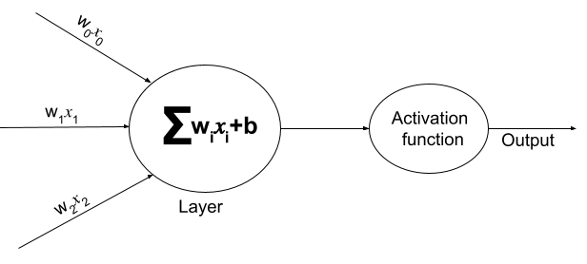
y = x1w1 + x2w2 + ... + bias
o/p = activation function(y)

Activation Functions:

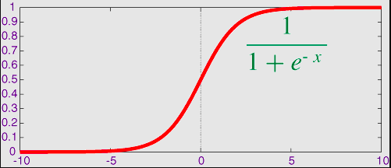

1. Sigmoid: 1/1+(e^-y) , if o/p is less than 0.5 then o/p will be 0 and if o/p is greater than or equals to 0.5 then o/p will be 1.

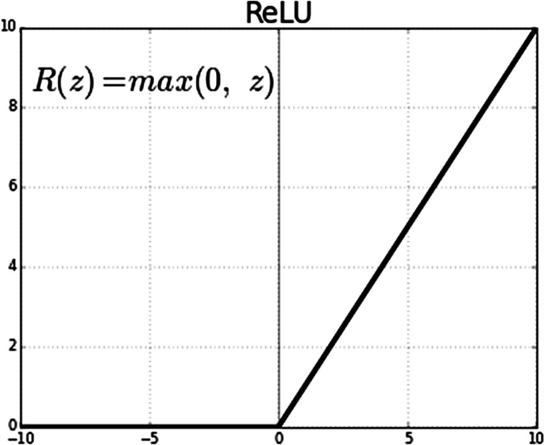

2. RelU: o/p = max(y,0), if y is negative then o/p is 0 and otherwise o/p = y (linear)

NOTE: when there is a regression prblem we should use relU in hidden or o/p layers both
when there is a classification problem we should use relU in hidden layers and sigmoid in o/p layer.

y -> actuall output
y'-> o/p from NN.

therefore, loss = (y-y')^2
So, we need to minimize the loss as much as possible such that accuracy would be maximum
for that we need to update the weights which is done with the help of OPTIMIZER.

new Weight = old Weight - n*d(loss)/dw , n = learning rate, that should be very small

eg, W2 new = W2 - n*d(loss)/dw2

Gradient descent: It is an optimizer which is used to back Propagate.

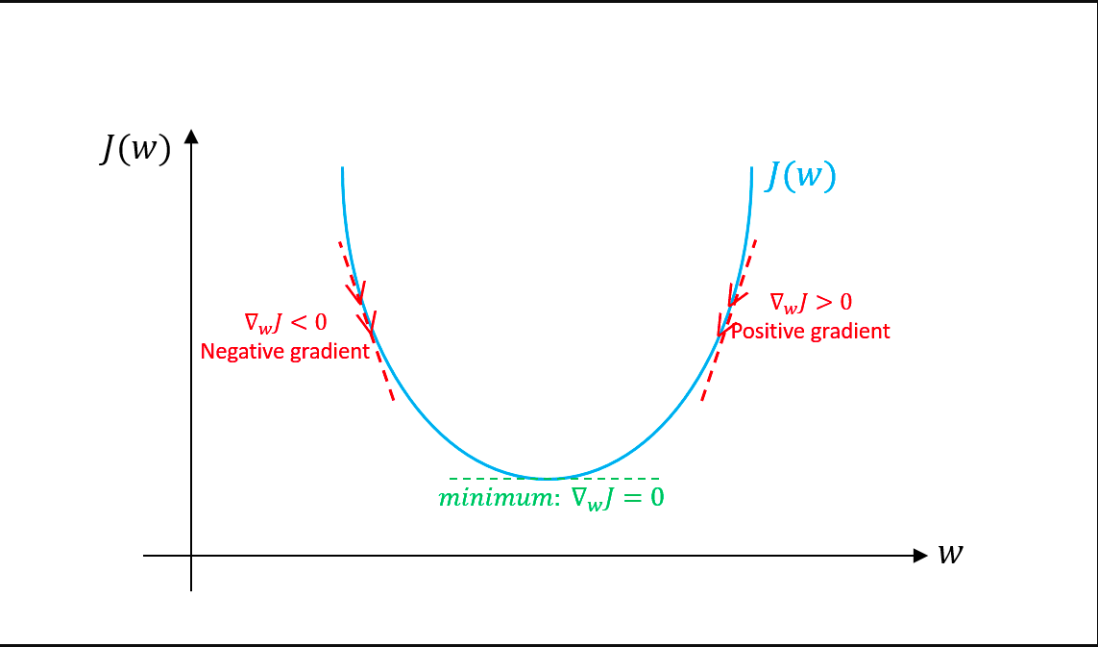

_________________________________________________________________________

19-07-2022:
Chain rule in back propagation: For finding the derivative of loss function wrt to weights chain rule is applied.

Vanishing Gradient Problem: It happens when sigmoid function is used in hidden layers so when we take derivative, the derivative become very small that will cause Weight(new) will equal to Weight(old) even after propagating back.

Exploding Gradient Problem: It happens when weights are very large numbers.

Leaky RelU:

Derivative of RelU = { 1 , z > 0
{ 0 , z <= 0

So for new Weight = old Weight - n*d(loss)/dw , this when z > 0 there will be some change in weights,
But for the rest of the case as derivative part will be 0 that cause newWeight = oldWeight and this will cause a dead node.

So, this can be solved with the help of leaky RelU.

Leaky RelU = { z , z > 0
{ 0.001*z, z<=0

Now the derivative of this = { 1 , z > 0
{ 0.001 , z <= 0

