- OBJECTIVE

The project titled “WEB USAGE MINING FOR IMPROVING THE PERFORMANCE OF WEBSITE” is tool for extracting web usage patterns.

1.1 Motivation:

As the number of persons visiting the websites and the number of websites increasing day by day there is a necessity to analyze the experience of the persons while visiting those website which can be used for personalization, website reorganization and website evaluation thereby attracting more number of users to those websites.

1.2 Goals and Objectives:

The main goal of this application is to extract web usage patterns which can help the website manager to improve the performance of the website.

The functionalities provided by our project are as follows:

- Reading Log Files
- Cleaning the log information
- Identifying the users
- Identifying the sessions
- Path Completion
- Generating statistical reports
- Generating usage patterns
- Analyzing the patterns

1.3 Project Description:

a. Data Collection
- Reading Log Files: The raw data in log file is retrieved and stored in the database.

- Data Preprocessing
- Cleaning the log information: The data that is stored in the database contains both useful and unnecessary fields. The fields that are useful for analysis must only be considered. For every page request that is sent to the server a separate request is sent for each and every element that is embedded in that page .Each page may contain image files, flash files, scripts, etc. We have to remove all these records from our log information. We must also remove the bot requests that are stored in the log data which are sent by the search engines to the server.

- Identifying the Users: The next task is to identify the number of users who visited the website on a particular day or week or month. This can be done by using the IP address, user agent and cookie fields.

- Identifying the Sessions: Every time the user visits the website a separate session is created for that user. The next task is to identify the total number of sessions and the path visited by the user in that session which can be later used for applying mining techniques. This can be done by using the IP address, user agent, and referrer.

- Path Completion: Due to caching of web pages at client side every request is not sent to the server. So the cached requests are not stored in the log files due to which the path that we extracted in sessions may not contain the complete path browsed by the user. Therefore we have to complete the path browsed by user which can be done by making use of the referred field.

- Pattern Discovery
- Generating usage patterns using Association: The main task of this module is to find group of associated web pages that are frequently visited so that we may provide direct links to these web pages. This is done using Apriory algorithm.

- Generating statistical reports: Based on the information acquired in preprocessing we can obtain statistics like number of users, number of sessions, number of errors, most visited pages, etc.

- Pattern Analysis
Based on the patterns mined we can make crucial decisions like rectifying the pages with errors, providing direct links to the most visited pages, redesigning the pages to help user navigation, eliminating or combining low visited pages, etc which will be helpful in improving the performance of the website.

- SYSTEM ANALYSIS

2.1 Introduction

World Wide Web (WWW) is very popular and interactive. It has become important source of information and services. The web is huge, diverse and dynamic. Extraction of
interesting information from Web data has become more popular and as a result of that web mining has attracted lot of attention in recent time [18]. Web mining is an application of data mining to large web data repositories [19].It can be divided in to three categories namely web structure mining, web content mining and web usage mining. Cooley et al. [3] introduced the term web usage mining in 1997 and according to their definition; it is the automatic discovery of user access patterns from web servers. Web usage mining is an important technology for understanding user’s behaviors on the web and is one of the favorite area of many researchers in the recent time. Obtained user access patterns can be used in variety of applications, for example, one can keep track of previously accessed pages of a user. These pages can be used to identify the typical behavior of the user and to make prediction about desired pages [4]. Thus personalization for a user can be achieved through web usage mining. Mass customization and personalization performed by dynamic Content Web site by making clusters of users with similar access patterns and by adding navigational links [20]. Frequent access behavior for the users can be used to identify needed links to improve the overall performance of future accesses. Prefetching and caching policies can be made on the basis of frequently accessed pages to improve latency time .In addition to modifications to the linkage structure, common access behaviors of the users can be used to improve the actual design of web pages and for making other modifications to a Web site. Moreover, usage patterns can be used for business intelligence in order to improve sales and advertisement. Many commercial web log analyzer tools are available in the market that analyzes the web server log data to reduce different kinds of statistics. In this study, web log expert program has been used to analyze server log data of a website. Program generated different types of reports on server log data that can be useful from effectiveness of the site. It is important to note that preprocessing [21] is a necessary step in web usage mining before applying any technique on usage data to discover user access patterns. As far as mining of knowledge from the data is concerned, quality of data is a key issue. Nearly 80% of mining efforts often spend to improve the quality of data [22]. The data which is obtained from the logs may be incomplete, noisy and inconsistent. The attributes that for in quality data includes accuracy, completeness, consistency, timeliness, believability, interpretability and accessibility. So preprocessing of data is required to make it have the above mentioned attributes and to make it easier for mining.

There are three kinds of data that can be used in Web Mining.
1. Content: The visible data in the Web pages or the information which was meant to be imparted to the users. A major part of it includes text and graphics (images).Mining content is called Web content mining.
2. Structure: Data which describes the organization of the website. It is divided into two types. Intra-page structure information includes the arrangement of various HTML or XML tags within a given page. The principal kind of inter-page structure information are the hyper-links used for site navigation. Mining structure is called Web Structure mining
3. Usage: Data that describes the usage patterns of Web pages, such as IP addresses, page references, and the date and time of accesses and various other information depending on the log format. Mining usage data is called Web Usage mining.

Web pages are transferred using HTTP protocol which works as follows.
Hypertext Transfer Protocol
Hypertext Transfer Protocol (HTTP) [23] is a standard method for transmitting information through the Internet. A Web is interconnections between hypermedia documents and these documents are delivered by hypertext transfer protocol. Transfer
Control Protocol (TCP) work as a transport layer for hypertext transfer protocol to retrieve distributed hypermedia. HTTP is a very simple protocol. Initially a connection is established between client and server .Client issue a request to server .Server processes
the request, returns a response and then closes the connection. A method (GET, PUT, POST, etc.) is used to get an object. HTTP request specifies a method, the object to which method is to be applied, and a string specify HTTP level (e.g. HTTP/1.0) that
client can accept. Object types and methods the client or server supports may be specified in MIME, RFC-822 format. A HTTP status code is returned by server to the client as a response. Such status codes of Hypertext Transfer Protocol are listed in [24].Some of them are 100(Continue), 200(OK), 300(Multiple Choice), 400(Bad Request), 403(Forbidden), 404(Not Found), 503(Out of Resources) etc. In this study we have mainly focused on 403,404 and 503 status codes.

Access log files at server side are the basic information source for Web usage mining. These files record the browsing behavior of site visitors. Data can be collected from multiple users on a single site. Log files are stored in various formats such as Common log [8] or combined log formats. The initial data comes from various input files such as server logs, site files and usage statistics. The Access Log file contains HTTP server information stored in Common Log Format(CLF) specified by CERN and NCSA.

Every log entry conforming to the CLF contains these fields:

- Client IP Address or hostname.
- User Id ('-' if anonymous).
- Access Time.
- HTTP Request Method (GET, POST, HEAD).
- Path of the resource on the Web server (identifying the URL).
- Protocol used for the transmission (HTTP/1.0, HTTP/1.1).
- Status Code returned by the server as response
(200 for OK, 404 for not found, ...).
- Number of Bytes transmitted.

These are only a minimum set of fields in every access log entry. In addition to this, there are other fields which make up to the Combined Log Format (CLF).
They are :

- User Agent which identify the client application used to retrieve the resource.
- Referrer or referring resource, which contains the URL of the document issuing
the link to the current requested page.

2.2 Existing System and Disadvantages

In the present scenario, website manager has to analyze the log files manually for drawing various statistics about the website without any preprocessing and mining tool. The log file contains several thousands of records which will be very difficult to analyze without any proper tool and in the process it also consumes lot of time. Also performing the task manually may result in erroneous statistics which could lead to drawing out wrong conclusions.

2.3 Proposed System

2.3.1 Overview

Any system which could automate a process is always appreciated. Our proposed system will automate the manual work done by website manager. It is a preprocessing tool which will extract useful information from the abundant information available in the log files followed by drawing web usage patterns and statistics. In order to mine accurate usage patterns there must be appropriate preprocessed data available with us before mining. This tool exactly does that. It extracts only the useful information to website manager from the available raw data which can further be used to apply any mining technique.

2.3.2 Advantages

- User friendly GUI.
- Website manager can automatically generate website statistics.
- Log files can be easily appended to the database.
- It can obtain statistics easily for lacks of records.
- Any mining technique can be applied to the preprocessed data.
- Additional features can be added without affecting the existing functionalities.

2.4 Applicability of the Project

This tool can be used for improving the performance and reorganizing the structure of any website. It is a standalone tool which can work in any system in which it is deployed.

2.5 Feasibility Study

All projects are feasible – given unlimited resources and infinite time! Unfortunately, the development of computer-based system or product is more likely plagued by a scarcity of resources and difficult delivery dates. It is both necessary and prudent to evaluate the feasibility of a project at the earliest possible time. Months or years of efforts, thousands or millions of rupees and untold professional embarrassment can be averted if an ill-conceived system is recognized early in the definition phase.

The key considerations involved in the feasibility study are:

- Economical feasibility
- Technical feasibility
- Operational feasibility

2.5.1 Economical feasibility

This project is developed within the college, which is well equipped with all the latest software and hardware. Since there is no special hardware required, this project is economically feasible.

2.5.2 Technical feasibility

As the application has been developed using java and back end as Oracle, which utilizes minimum resources of the personal computer, this project is technically feasible.

2.5.3 Operational feasibility

This project has been implemented by java and it satisfies all the conditions and norms of the organization and the users.

2.6 Software Requirements Specification

Software requirements comprises of:

- Functional Requirements
- Hardware Requirements
- Software Requirements
- Performance Requirements

2.6.1 Functional Requirements

“Web usage mining for improving the performance of website” is divided into 4 modules. They are:

1. Data Collection
2. Data Preprocessing
3. Pattern Discovery
4. Pattern Analysis

Module 1: Data Collection

This module deals with raw log files which contain fields like IP address, user agent, URL, cookie, status code, version, date, time, referrer.

Functionality

- Gathering the server level log files.
- Storing the log data in the database.

Module 2: Data Preprocessing

This module deals with data present in the database obtained from module 1. It has sub modules like data cleaning, user identification, session identification, path completion.

Functionality

- Data Cleaning

- Removing unnecessary fields from log information and storing only required fields.
- Removing all the records that contain requests of type image, flash, bot, and scripts.

- User Identification

- Identifying the users by making use of the fields IP address, user agent, version, and cookie.
- Finding the path of users which contains the sequence of browsed pages.

- Session Identification

- Identifying the sessions of users by making use of IP address, user agent, version, and referrer.
- Finding the path visited by the users in each session by making use of referrer field.
- Path Completion

- Completing the path visited by the users which along with the normal requests also contains the cached requests. This can be done by making use of referrer field.

Module 3: Pattern Discovery

This module deals with data present in the sessions table obtained from the previous module.

Functionality

Finding group of associated web pages that are frequently visited with the help of apriory algorithm. It also deals with finding statistical reports.

Module 4: Pattern Analysis

This module deals with the patterns and the statistical data obtained from the previous module.

Functionality

We can make decisions like providing direct links or providing shortest path to the web pages which are frequently visited. We can rectify the errors present in the web pages and we can reorganize the website based on user interest.

2.6.2 Performance requirements

Performance is measured in terms of the output provided by the application. Requirement specification plays an important part in the analysis of system. Only when the requirement specifications are properly given, it is possible to design a system which will fit into required environment. It rests largely with the users of the existing system to give the requirement specification because they are the people who finally use the system. This is because the requirements have to be known during the initial stages so that the system can be designed according to those requirements. It is very difficult to change the system once it has been designed and on the other hand designing a system, which does not cater to the requirements of the user, it’s of no use.

- The requirement specification for any system can be broadly stated as given
below.
- The system should be able to interface with existing system.
- The system should be accurate.
- The system should be better than the existing system.
2.6.3 Hardware Requirements

RAM : 512 MB or more
Processor : P4

2.6.4 Software Requirements
.
Operating System : Windows
Platform : Java
Database : Oracle

- DESIGN

3.1 Architecture design

Architecture design concentrates mainly on different components, their placement and technologies required for communication between them.

3.2 ER DIAGRAM

ER diagram stands for Entity Relationship diagram. It shows the relationship between the set of entities and their relationships. ER diagram show the system database design.

- Entity: An entity is a business object that represents a group, or category of data.

- Relationship: A relationship is an association that exists between two entities. The relationship may be one-one, one-many, many-one, many-many.

- Attribute: An attribute is a property or descriptor of an entity.

Entity sets are drawn as rectangles, relationship sets as diamonds. If an entity set participates in a relationship set, they are connected with a line.

Attributes are drawn as ovals and are connected with a line to exactly one entity or relationship set

ER diagram has a great prominence in maintaining the database, consistently at its right granularity.

LITERATURE SURVEY

Web usage mining applies data mining techniques to
mine Web access patterns [7, 25]. Mining Web access patterns
is useful when building user profiles which in turn are
used for the personalization and tuning ofWeb services, the
presentation of promotional contents, and other applications
for which user interests, preferences, requirements, and behavioral
conventions must be assessed and served [6]. MiningWeb
access patterns is also useful when improvingWeb
structure and Web server performance [9].

Web usage mining involves following steps

- Data Collection
- Preprocessing
- Pattern Discovery
- Pattern Analysis

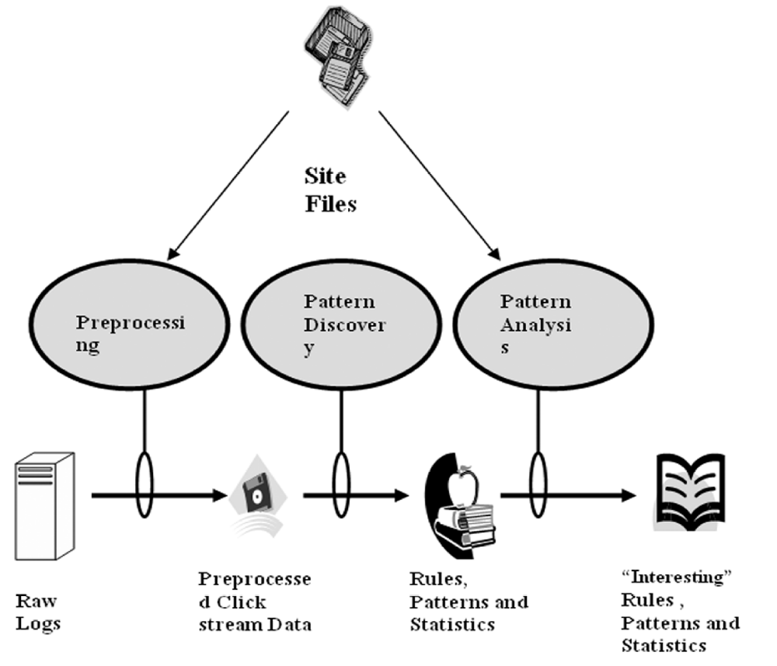

Fig-1: Structure of Web Usage Mining

DATA COLLECTION :

Source of Data for Web Usage Mining :

Web data can be classified as content data, structure data, user profile data and usage data. Web usage data is the collection of data that describes the usage of web resources. The usage data which is used for mining purposes can be collected at different levels i.e. Server level, Client level or Proxy level. “In this study we will take the case of web server”.

Server Level Collection :

Access log files at server side are the basic information source for Web usage mining. These files record the browsing behavior of site visitors. Data can be collected from multiple users on a single site. Log files are stored in various formats such as Common log [8] or combined log formats. The initial data comes from various input files such as server logs, site files and
usage statistics. The Access Log file contains HTTP server information stored in Common Log Format(CLF) specified by CERN and NCSA.

Every log entry conforming to the CLF contains these fields:

  - Client IP Address or hostname.
  - User Id ('-' if anonymous).
  - Access Time.
  - HTTP Request Method (GET, POST, HEAD).
  - Path of the resource on the Web server (identifying the URL).
  - Protocol used for the transmission (HTTP/1.0, HTTP/1.1).
  - Status Code returned by the server as response (200 for OK, 404 for not found, ...).
  - Number of Bytes transmitted.

These are only a minimum set of fields in every access log entry. In addition to this, there are other fields which make up to the Combined Log Format (CLF).
They are :

  - User Agent which identify the client application used to retrieve the resource.
  - Referrer or referring resource, which contains the URL of the
document issuing the link to the current requested page.

The pre-processing phase processes the available sources of information (HTTP server and auxiliary ones) leading to the creation of a formatted dataset. This can be used for pattern discovery through the application of data mining techniques such as statistical analysis, association rules, sequential patterns and clustering. The two output files created from HTTP server log files are user session file and transaction file (derived from the previous one). However, the processing of auxiliary information such as site topology, page classification and demographic information of users creates more accurate output files.

203.30.5.145 www.acr-news.org – [01/Jun/1999:03:09:21 - 0600] “GET /Calls/OWOM.html HTTP/1.0” 200 3942 “http://www.lycos.com/cgi -bin/ pursuit? Query= advertising+ psychology & maxhits =20&cat=dir”
“Mozilla/4.5 [en] (Win98; I) “

Client Level :

It is the client itself which sends information to a repository regarding the users behavior. This is done either with an ad-hoc browsing application or through client side application running standard browsers. Various browsers like Mozilla, Internet Explorer etc. can be
modified or various JavaScript and Java applets can be used to collect client side
data. This implementation of client-side data collection requires user cooperation,
either in enabling the functionality of the JavaScript and Java applets, or to
voluntarily use the modified browser. Client-side collection scores over server-side
collection because it reduces both the bot and session identification problems.

Proxy Level :

A Web proxy is a caching mechanism which lies between
client browsers and Web servers. It helps to reduce the load time of Web pages as
well as the network traffic load at the server and client side. Proxy server logs
contain the HTTP requests from multiple clients to multiple Web servers. This may
serve as a data source to discover the usage pattern of a group of anonymous users,
sharing a common proxy server.
This Log Files are used for comparing the performance of their own site with those of competitors.

PRE-PROCESSING :

It is important to understand that mining process gives better results with quality data. In order to improve the quality of data, approximately 80% of mining efforts are required[11]. So preprocessing is necessary to build complete and robust data file.Following are the main preprocessing activities.

The pre-processing phase of HTTP server information is made up of the following five steps:

- Data cleaning.
- User identification.
- User session identification.
- Path completion (creation of user session file).

Association
Access Logs
Cleaning
User
Identification
Session
Identification
Path Completion

Fig-2: Preprocessing Activity.

Data Cleaning :

Access log files consist of large amounts of HTTP server information. Analyzing, this information is very slow and inefficient without an initial cleaning task. Irrelevant information which is useless for mining purposes [12, 13,14]can be removed from the HTTP server log files.
e.g. access performed by :

spiders
crawlers
robots

these are automatic agents that surf the Web to collect and store the information e.g. search engine spiders.
Every time a Web browser downloads a HTML document on the Internet, the images are also downloaded and stored in the log file. This is because, though a user does not explicitly request graphics that are on a Web page, they are automatically downloaded due to the HTML tags. Therefore, if a user requests to view a specific page, several log entries such as graphics and scripts are also downloaded in addition to the required HTML file. Mostly, only the log entry of the HTML file request is required and should be kept for the user session file.

Image files with extension name gif, jpeg, GIF, JPEG, jpg, JPG.
Audio and Video files with extension mp3,avi,flv,mp4,wmv.
Flash files with extension .swf
url containing robots.txt, favicon
User agent containing .com
common scripts such as “count.cgi” , files with extension .js.
and files with extension .css has to be removed.

The process of Data Cleaning is to remove outliers and / or irrelevant data. Since the main objective of Web Usage Mining is to obtain a pattern of the user’s behavior, it is not necessary to include all the irrelevant entries which the user did not explicitly request. Checking the suffix of the URL name can do eliminating the items considered irrelevant as given above. There are various techniques to clean a server log to eliminate irrelevant items. The cleaned log reflects the accurate picture of the user accesses to the Web site. This is important to apply the techniques and useful for Web log analysis.

User Identification :

IP address, User agents ,cookies and Username fields of log file are
used to identify user.

For web usage mining, to get knowledge about each user’s identity is not necessary. However, a mechanism
to distinguish different users is still required for analyzing user access behaviour [25]. Since users are treated as
anonymous in most Web servers, two heuristic strategies, the proactive strategy and the reactive strategy, have
been proposed to help differentiate users [25]. The proactive strategy tries to unambiguously associate each
request to a site visitor before or during the visitor’s interaction with the site, while the reactive strategy
attempts to associate requests with the visitor after the interaction with the site, based on the existing, incomplete
records. As a rule, a cookie-based identifier is a must for applications of proactive strategy [25]. However,
the use of cookie needs to comply with existing laws [26], at least that users must be clearly made aware of its
presence. Therefore, the proactive strategy is not always a feasible option.
In our system, we apply the reactive strategy to web logs, and approximate users in terms of IP address,
type of operating system and browsing software. In other words, requests are treated as from the same user
and put into the same group under that user only if these requests possess the same IP address, operating system
and browsing software.
This is a very complex task because of the existence of local caches, corporate firewalls and proxy servers. These can severely distort the overall picture of user traversals through a Web site. Information about local caches can be obtained by the use of cookies and cache busting. Cache busting is prevents browsers from using stored local versions of a page. As a result, there is a new download of a page from the server every time it is viewed. But there are drawbacks for these methods. Cookies can be deleted by the user and cache busting does not satisfy the advantage of speed which it was required to provide. Caching problem can be solved using methods such as site topology or referrer logs, along with temporal information to infer missing references
Still there are some problems which can arise in user identification [4]. ISP’s which uses DHCP technology, it is difficult to identify same user through different TCP/IP connections because IP address changes dynamically (single IP address/multiple server session). It is also possible that IP address
of a user changes from connection to connection (multiple IP address/single user). Different IP address can be assigned for every single request performed by the user.

IP address :

Unfortunately, the IP address of the client is not sufficient to identify a user correctly because there may be many hosts to the HTTP server under the same IP address or hostname (proxies). Another alternative is the machine name to uniquely identify users. This can result in several users being erroneously grouped together as one user. An algorithm presented in [3] verifies to see if each HTTP request method is reachable from the pages already visited. If a page is requested that is not directly linked to the previous pages, multiple users are assumed to exist on the same machine.

User agent :

Since there can be single user/multiple users under the same IP address, the IP address alone is not sufficient and not reliable, accuracy to the process of
user identification is enhanced by the value of another field i.e. the user agent. This gives a name to the browser used by the client. Different values of the user agent field on the same client represent different users. Even if the IP address is the same, if the agent log shows a change in browser software or operating system, it can be assumed that each different agent type for an IP address represents a different user.

Username :

When a user registers with a website his username is stored in the Username field of Log File. This can be used for identifying users uniquely.if the user in not a registered person this field remains empty.so it is only useful when users registered with website.

Cookies :

this field is used in proactive strategy for user identification. Each time for a request sent by a new user a cookie is created by webserver . Disadvantage with this approach is users may disable cookies at browser side.

User session identification :

Session Identification divides all pages accessed by a user into sessions. The previous output file, as discussed in User Identification, obtained by different users and time of request, may consist of requests put forth in long periods of time and also performed by the same users. Hence, it is necessary to divide the log entries of the same users in sessions or visits[1].

User sessions are extracted from the Web server log, the
primary source of data in which the activities of Web users
are captured. More reliable Web usage mining results need
more reliable reconstructed user session results. However,
it is difficult to tell when a user has left a Web site because
there is no record of users leaving. Aside from the lack of
information, some other problems also exist. For example,
an IP sharing problem exists because several users may access
a site through the same host or proxy and may employ
the same software agent. An empty referrer may appear inside
a session due to the following reasons: a) the user has
typed the URL directly; b) requests are made by agents, and
agents do not necessarily follow the page links; and c) some
frames belong to the same page [17].
Several approaches are devised to address these problems.
Two time-oriented heuristics for session identification
are described in [16, 17]: the session duration heuristic (h1)
and the page-stay time heuristic (h2). The heuristic h1 states
that the duration of a session must not exceed a threshold.
The heuristic h2 is based on the assumption that the duration
of a visited page must not exceed a threshold. Due to
users’ irregular navigation behavior, the performance of the
time-oriented heuristics (h1 and h2) with fixed thresholds
in reconstructing the sessions have not been satisfactory. In
this paper we propose three extensions to h1 and h2 heuristics
in order to improve their performance.

Commonly used time thresholds for h1 and h2 are 30
and 10 minutes, respectively. A 30-minute cutoff time for
session duration is proposed by [27] and used commonly
in many applications. A 10-minute threshold for page-stay
time is mentioned by [17] as a very conservative maximum
cutoff.We believe that differentWeb site structures and different
user groups should have different thresholds for h1
and h2. A statistical-based approach is employed in [28]
to determine appropriate thresholds for h1 and h2.
The main aim of the proposed approach is to improve the
performance of h1 and h2. In the implementation we have
used the following notations:
• Fh1: h1 heuristic with 30 minutes fixed threshold.
• Fh2: h2 heuristic with 10 minutes fixed threshold.
• Dh1: h1 heuristic with variable threshold.
• Dh2: h2 heuristic with variable threshold.

