Report submitted by

Declaration

Acknowledgement

Contents

Introduction have to take from:

What is web mining,types,what we are using for mining server log files and its formats,fields it contains and their description
Web usage mining applies data mining techniques to
mine Web access patterns [7, 10]. Mining Web access patterns
is useful when building user profiles which in turn are
used for the personalization and tuning ofWeb services, the
presentation of promotional contents, and other applications
for which user interests, preferences, requirements, and behavioral
conventions must be assessed and served [6]. MiningWeb
access patterns is also useful when improvingWeb
structure and Web server performance [9].

“Analysis of Server Log by Web Usage Mining for
Website Improvement”

TITLE : WEB USAGE MINING

Following are the steps to be done

- Data Collection
- Preprocessing
- Pattern Discovery
- Pattern Analysis
- Applications

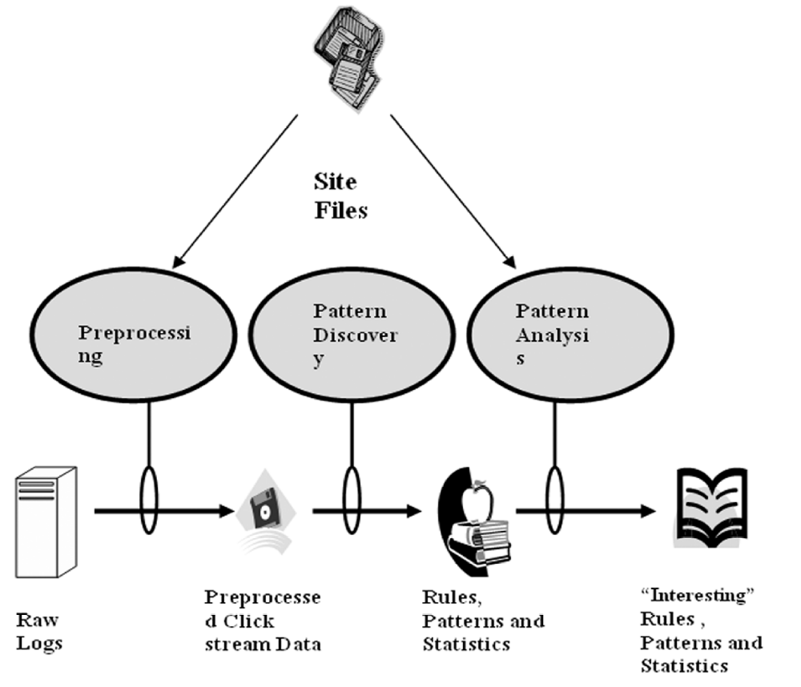

Fig-1: Structure of Web Usage Mining

DATA COLLECTION :

Source of Data for Web Usage Mining :

Web data can be classified as content data, structure data, user profile data and usage data. Web usage data is the collection of data that describes the usage of web resources. The usage data which is used for mining purposes can be collected at different levels i.e. Server level, Client level or Proxy level. “In this study we will take the case of web server”.

Server Level Collection :

Access log files at server side are the basic information source for Web usage mining. These files record the browsing behavior of site visitors. Data can be collected from multiple users on a single site. Log files are stored in various formats such as Common log [8] or combined log formats. The initial data comes from various input files such as server logs, site files and
usage statistics. The Access Log file contains HTTP server information stored in Common Log Format(CLF) specified by CERN and NCSA. An
example of access log in Common Log Format:

db01.grohe.it - [19/Sep/2001:03:23:53 +0100] "GET / HTTP/1.0" 200 4096

Every log entry conforming to the CLF contains these fields:

- Client IP Address or hostname.
- User Id ('-' if anonymous).
- Access Time.
- HTTP Request Method (GET, POST, HEAD).
- Path of the resource on the Web server (identifying the URL).
- Protocol used for the transmission (HTTP/1.0, HTTP/1.1).
- Status Code returned by the server as response
(200 for OK, 404 for not found, ...).
- Number of Bytes transmitted.

These are only a minimum set of fields in every access log entry. In addition to this, there are other fields which make up to the Combined Log Format (CLF).
They are :

- User Agent which identify the client application used to retrieve the resource.
10. Referrer or referring resource, which contains the URL of the
document issuing the link to the current requested page.

The pre-processing phase processes the available sources of information (HTTP server and auxiliary ones) leading to the creation of a formatted dataset. This can be used for pattern discovery through the application of data mining techniques such as statistical analysis, association rules, sequential patterns and clustering. The two output files created from HTTP server log files are user session file and transaction file (derived from the previous one). However, the processing of auxiliary information such as site topology, page classification and demographic information of users creates more accurate output files.

203.30.5.145 www.acr-news.org – [01/Jun/1999:03:09:21 - 0600] “GET /Calls/OWOM.html HTTP/1.0” 200 3942 “http://www.lycos.com/cgi -bin/ pursuit? Query= advertising+ psychology & maxhits =20&cat=dir”
“Mozilla/4.5 [en] (Win98; I) “

Client Level :

It is the client itself which sends information to a repository regarding the users behavior. This is done either with an ad-hoc browsing application or through client side application running standard browsers.

Proxy Level :

Information regarding user behavior is stored at proxy side, thus web data is collected from multiple users on several web sites, but only users whose web clients pass through the proxy.

PRE-PROCESSING :

It is important to understand that mining process gives better results with quality data. In order to improve the quality of data, approximately 80% of mining efforts are required[11]. So preprocessing is necessary to build complete and robust data file.Following are the main preprocessing activities.

The pre-processing phase of HTTP server information is made up of the following five steps:

- Data cleaning.
- User identification.
- User session identification.
- Path completion (creation of user session file).
- Transaction Identification (creation of transaction file)

Association
Access Logs
Cleaning
User
Identification
Session
Identification
Path Completion

Fig-2: Preprocessing Activity.

Data Cleaning :

Access log files consist of large amounts of HTTP server information. Analyzing, this information is very slow and inefficient without an initial cleaning task. Irrelevant information which is useless for mining purposes [12, 13,14]can be removed from the HTTP server log files.
e.g. access performed by :

spiders
crawlers
robots

these are automatic agents that surf the Web to collect and store the information e.g. search engine spiders.
Every time a Web browser downloads a HTML document on the Internet, the images are also downloaded and stored in the log file. This is because, though a user does not explicitly request graphics that are on a Web page, they are automatically downloaded due to the HTML tags. Therefore, if a user requests to view a specific page, several log entries such as graphics and scripts are also downloaded in addition to the required HTML file. Mostly, only the log entry of the HTML file request is required and should be kept for the user session file.

Files with extension name gif, jpeg, GIF, JPEG, jpg, JPG,js
And URL containing .com, favicon, etc.. has to be removed.
In addition, common scripts such as “count.cgi” can also be removed.

The process of Data Cleaning is to remove outliers and / or irrelevant data. Since the main objective of Web Usage Mining is to obtain a pattern of the user’s behavior, it is not necessary to include all the irrelevant entries which the user did not explicitly request. Checking the suffix of the URL name can do eliminating the items considered irrelevant as given above. There are various techniques to clean a server log to eliminate irrelevant items. The cleaned log reflects the accurate picture of the user accesses to the Web site. This is important to apply the techniques and useful for Web log analysis.

An algorithm for cleaning the entries of server logs is presented below -

Read record in database.
For each record in database
Read fields (URI – stem,UserAgent) //URI- stem indicates
The target URL//
If fields = {*.gif,*.jpg,*.css,%PNG%,%favicon%,%.com%,/robots.txt,%.JPG,%png} then
Remove records
Else
Save records
End if
Next record

User Identification :

IP address, User agents and referring URL, cookies fields of log file are
used to identify user.
This is a very complex task because of the existence of local caches, corporate firewalls and proxy servers. These can severely distort the overall picture of user traversals through a Web site. Information about local caches can be obtained by the use of cookies and cache busting. Cache busting is prevents browsers from using stored local versions of a page. As a result, there is a new download of a page from the server every time it is viewed. But there are drawbacks for these methods. Cookies can be deleted by the user and cache busting does not satisfy the advantage of speed which it was required to provide. Caching problem can be solved using methods such as site topology or referrer logs, along with temporal information to infer missing references

Still there are some problems which can arise in user identification [4]. ISP’s which uses DHCP technology, it is difficult to identify same user through different TCP/IP connections because IP address changes dynamically (single IP address/multiple server session). It is also possible that IP address
of a user changes from connection to connection (multiple IP address/single user). Different IP address can be assigned for every single request performed by the user.

IP address :

Unfortunately, the IP address of the client is not sufficient to identify a user correctly because there may be many hosts to the HTTP server under the same IP address or hostname (proxies). Another alternative is the machine name to uniquely identify users. This can result in several users being erroneously grouped together as one user. An algorithm presented in [3] verifies to see if each HTTP request method is reachable from the pages already visited. If a page is requested that is not directly linked to the previous pages, multiple users are assumed to exist on the same machine.

User agent :

Since there can be single user/multiple users under the same IP address, the IP address alone is not sufficient and not reliable, accuracy to the process of
user identification is enhanced by the value of another field i.e. the user agent. This gives a name to the browser used by the client. Different values of the user agent field on the same client represent different users. Even if the IP address is the same, if the agent log shows a change in browser software or operating system, it can be assumed that each different agent type for an IP address represents a different user.

Referring URL :

It is also possible to use the referring URL information to discover different users who have the same client host and the same browser, by watching the path they followed in order to get to a resource. The heuristic for user identification is to use the access log along with the referrer log and site topology to construct browsing paths for each user. If a page is requested that is not directly reachable by a hyperlink from any of the pages visited by the user, the heuristic assumes that there is another user with the same IP address.

User session identification :

Session Identification divides all pages accessed by a user into sessions. The previous output file, as discussed in User Identification, obtained by different users and time of request, may consist of requests put forth in long periods of time and also performed by the same users. Hence, it is necessary to divide the log entries of the same users in sessions or visits[1].

User sessions are extracted from the Web server log, the
primary source of data in which the activities of Web users
are captured. More reliable Web usage mining results need
more reliable reconstructed user session results. However,
it is difficult to tell when a user has left a Web site because
there is no record of users leaving. Aside from the lack of
information, some other problems also exist. For example,
an IP sharing problem exists because several users may access
a site through the same host or proxy and may employ
the same software agent. An empty referrer may appear inside
a session due to the following reasons: a) the user has
typed the URL directly; b) requests are made by agents, and
agents do not necessarily follow the page links; and c) some
frames belong to the same page [17].
Several approaches are devised to address these problems.
Two time-oriented heuristics for session identification
are described in [16, 17]: the session duration heuristic (h1)
and the page-stay time heuristic (h2). The heuristic h1 states
that the duration of a session must not exceed a threshold.
The heuristic h2 is based on the assumption that the duration
of a visited page must not exceed a threshold. Due to
users’ irregular navigation behavior, the performance of the
time-oriented heuristics (h1 and h2) with fixed thresholds
in reconstructing the sessions have not been satisfactory. In
this paper we propose three extensions to h1 and h2 heuristics
in order to improve their performance.

Path completion :

To identify unique user sessions, it is necessary to determine if there are important accesses that are not recorded in the access log. Path Completion refers to inclusion of important page access records that are missing in the access log due to browser and proxy server caching. This involves the use of referring URLs and auxiliary information (site topology in particular). If a page request is made that is not directly linked to the last page a user requested, the referrer log can be referred to see which page the request came from. If the page is in the user’s recent request history, it is assumed that the user backtracked with the “back” button, using cached versions of the pages until a new page was requested. If the referrer log is not clear, the site topology can be used.. If more than one page in the user’s history contains a link to the requested page, it is assumed that the page closest to the previously requested page is the source of the new request. Missing page references that are inferred through this method are added to the user session file.

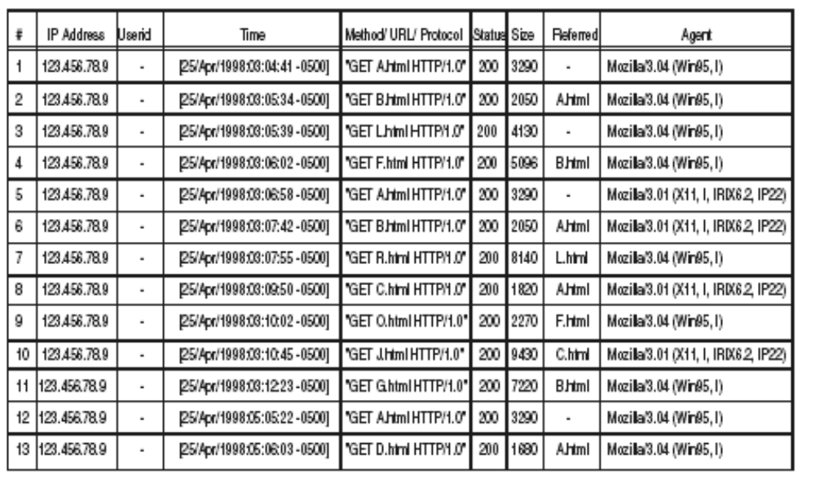
Fig-3: Sample Web Log File
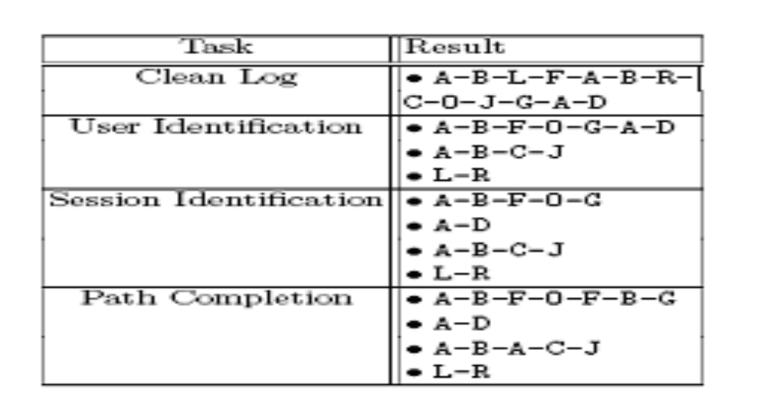
Fig-4: Result after Preprocessing.

Pattern Discovery :

A number of techniques deduced from diversified fields such as statistics; machine learning, data mining, pattern recognition are applied to web usage data for pattern discovery. Statistical Analysis can be performed by a number of tools and its main goal is to give a description of the traffic on a web site e.g. most visited pages, average daily hits etc. Most of the commercial applications of Web Usage Mining exploit consolidated statistical analysis techniques. In contrast, research in this area is mainly focused on the development of knowledge discovery techniques specifically designed for the analysis of Web usage data. Most of this research effort focuses on three main paradigms[2]:

- Association Rules
- Sequential Patterns and
- Clustering

Association Rules consider every URL requested by a user in a visit as item and find out relationships between them with a minimum support level. Sequential Patterns are used to discover time ordered sequence of URL’s
followed by past users in order to predict future ones. Clustering forms meaningful clusters of URL’s by discovering similar attributes between them according to user behavior.

1. Association rules. These are probably the most elementary data mining technique and, at the same time, the most used technique in Web Usage Mining. Association rules are implications of the form X) Y where the rule body X and the rule head Y are set of items within a set of transactions.
The rule X)Y states that the transactions which contain the items in X are likely to contain also the items in Y. When applied to Web Usage Mining, association rules are used to find associations among Web pages that frequently appear together in users_ sessions.

The typical resulthas the form:

\A:html; B:html ) C:html"

which states that if a user has visited page A.html and page B.html, it is very likely that in the same session the same user has also visited page C.html. This type of result is for instance produced by [15] and [40] by

using a modification of the Apriori algorithm [39]. Ref. [41] proposes and
230 F.M. Facca, P.L. Lanzi / Data & Knowledge Engineering 53 (2005) 225–241
evaluates measures of interest to evaluate the association rules mined from Web usage data. Ref.
[42] exploits a mixed technique of association rules and fuzzy logic to extract fuzzy association
rules from Web logs.

APPLICATIONS:

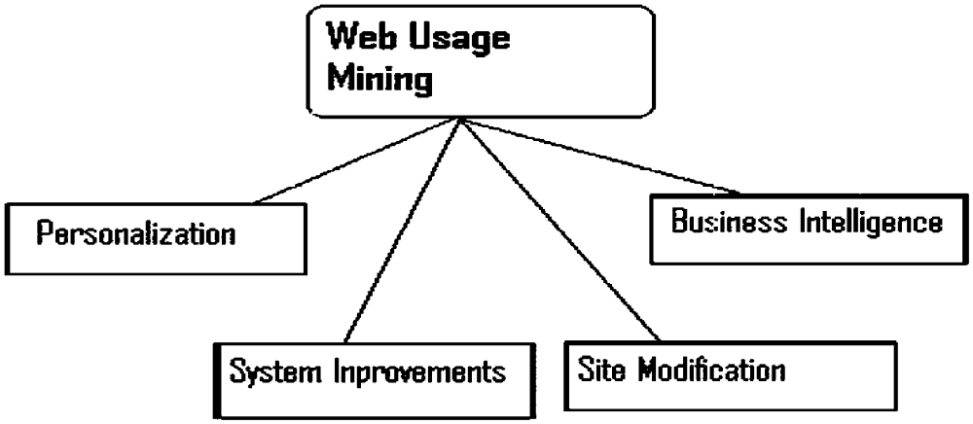

Fig-5: Web Usage Mining Applications.

Personalization :

Personalization for a user is achieved by keeping track of previously accessed pages e.g. individualized marketing for E-Commerce[10].Making dynamic recommendations to a web server on the basis of her/his profile in addition to usage behavior is very attractive to many applications e.g. cross sales and up sales in E-Commerce[11]. Web usage mining is an excellent approach for achieving this objective as described in [12] existing recommendation systems.

System Improvement :

Performance and other service quality factors are crucial to user satisfaction from services like databases, networks etc. Similar qualities can be expected from the user of web services. Web usage mining could provide the key to understand web traffic behavior, which can in term be used for developing policies for web coaching, Network Transmission [14].

Site Modification :

The attractiveness of a web site, in term of both content and structure, is crucial to many applications e.g. a product catalog for E-Commerce. Web usage mining provides detailed feedback on user behavior and it can provide the web site designer information. This information can be used to take redesign decisions. In adaptive website [13,14] structure of a Website changes automatically on the basis of usage patterns discovered from server logs.

Business Intelligence :

Information on how customers are using a website is crucial for marketers of e-tailing businesses. Buchner et. al [15] have presented a knowledge discovery process to discover marketing intelligence from web data. They defined a web log data hyper cube that would combine web usage data with marketing data for e-commerce applications. Four distinct steps in customer relationship life cycle are identified which can be supported by their knowledge discovery techniques: Customer attention, Customer retention, cross sales and customer departure.

[1] An Overview of Data Preprocessing in Data and Web Usage Mining
R.M. Suresh, R. Padmajavalli
RMK Engineering College, Kavaraipettai – 601206.
rmsuresh@hotmail.com

[2]Mining interesting knowledge from weblogs: a survey
Federico Michele Facca, Pier Luca Lanzi *
Dipartimento di Elettronica e Informazione, Artificial Intelligence and Robotics Laboratory,
Politecnico di Milano, 20133 Milano, Italy

[3] Cooley.R, Mobasher.B, Srivatsa.J,1997(b) “Web Mining:
Information and Pattern Discovery on the World Wide
Web”, Proceedings of the IEEE International Conference
on Tools with Artificial Intelligence (ICTAI'97)

[4] Jaideep Srivastava, Robert Cooley, Mukund
Deshpande, and Pang-Ning Tan, “Web usage
mining: Discovery and applications of usagepatterns from Web data”, SIGKDD Explorations, 2000,
Vol.1.pp. 12-23

. [6] M. Kilfoil, D. A. Ghorbani, W. Xing, Z. Lei, J. Lu, J. Zhang,
and X. Xu. Toward an adaptive web: The state of the art
and science. In Proceedings of Communication Network and
Services Research (CNSR) 2003 Conference, pages 108–119,
Moncton, NB, Canada, May 15–16 2003.

[7] R. Kosla and H. Blockeel. Web mining research: A survey.
SIG KDD Explorations, 2(15):1–15, July 2000.

[10] S. K. Pal, V. Talwar, and P. Mitra. Web mining in soft computing
framework : Relevance, state of the art and future directions.
IEEE Trans. Neural Networks, 13(5):1163–1177,
2002.

[25] M. Spiliopoulou, B. Mobasher, B. Berendt, and M. Nakagawa.
A framework for the evaluation of session reconstruction
heuristics in web usage analysis. INFORMS Journal of
Computing, Special Issue on Mining Web-Based Data for EBusiness
Applications, 15(2), 2003.

[9] J. Pei, J. Han, B. Mortazavi-asl, and H. Zhu. Mining access
patterns efficiently from web logs. In Pacific-Asia Conference
on Knowledge Discovery and Data Mining, pages
396–407, 2000.

[8] http://www.w3.org/Daemon/User/Config/
Logging.htm#common-log file-format

[11] Ophir Frieder, and David A. Grossman, Information
Retrieval: Algorithms and Heuristics. The Information
Retrieval Series, 2nd Edition, 2004.

[12] Boris Diebold, and Michael Kaufmann, “Usage based
Visualization of web localities”, in Australian symposium
on information visualization, 2001, pp. 159-164.

[13] Corin R. Anderson,” A machine Learning Approach to
Web Personalization”,Ph. D. Thesis, university of
Washington, 2002.

[14] Pang-Ning Tan, and Vipin Kumar, “Discovery of Web
robot sessions based on their navigational patterns. Data
mining and knowledge discovery”, 2002, 6(1), pp. 9-35.

[15] K.P. Joshi, A. Joshi, Y. Yesha, On using a warehouse to analyze web logs, Distributed and Parallel Databases 13
(2) (2003) 161–180.

[16] B. Berendt, B. Mobasher, M. Nakagawa, and
M. Spiliopoulou. The impact of site structure and user
environment on session reconstruction in web usage analysis.
In Proceedings of the 4th WebKDD 2002 Workshop,
at the ACM-SIGKDD Conference on Knowledge Discovery
in Databases, Edmonton, Alberta, Canada, July
2002.

[17] M. Spiliopoulou, B. Mobasher, B. Berendt, and M. Nakagawa.
A framework for the evaluation of session reconstruction
heuristics in web usage analysis. INFORMS Journal of
Computing, Special Issue on Mining Web-Based Data for EBusiness
Applications, 15(2), 2003.

[39] J. Han, M. Kamber, Data Mining Concepts and Techniques, Morgan Kaufmann, 2001.

[40] A. Nanopoulos, D. Katsaros, Y. Manolopoulos, Exploiting web log mining for web cache enhancement, in: R.
Kohavi, B. Masand, M. Spiliopoulou, J. Srivastava (Eds.), WEBKDD 2001—Mining Web Log Data Across All
Customers Touch Points, Third International Workshop, San Francisco, CA, USA, August 26, 2001. Revised
papers, vol. 2356 of Lecture Notes in Computer Science, Springer, 2002, pp. 68–87.

[41] X. Huang, N. Cercone, A. An, Comparison of interestingness functions for learning web usage patterns, in:
Proceedings of the Eleventh International Conference on Information and Knowledge Management, ACM Press,
2002, pp. 617–620.

[42] S.S.C. Wong, S. Pal, Mining fuzzy association rules for web access case adaptation, in: Workshop on Soft
Computing in Case-Based Reasoning, International Conference on Case-Based Reasoning (ICCBR_Ol), 2001.

[18] Cooley, R., Mobasher, B., and Srivastava, J, “Web
mining: information and pattern discovery on the
World Wide Web”, International Conference on
Tools with Artificial Intelligence, Newport Beach,
IEEE, 1997, pp. 558-567.

[19] Robert Cooley, Bamshad Mobasher, and Jaideep
Srivastava,” Data preparation for mining World
Wide Web browsing patterns”, Journal of
Knowledge and Information System,1999,pp. 1-27.

[20] F. Masseglia, P. Poncelet, and M.Teisseire,”Using data
mining techniques on Web access logs to dynamically
improve Hypertext structure”, 1999.

[21] Gabriek. Web usage mining and discovery of association
rules from HTTP server logs.

[22] David A. Grossman, and Ophir Frieder, Information
Retrieval: Algorithms and Heuristics (The Information
Retrieval Series) (2nd Edition) (Paperback - Dec 20,
2004)

[23] James Rubarth-Lay, “Optimizing Web Performance”,
1996.

[24] Internet: Hypertext Transfer Protocol Overview,
http://www.w3.org/Protocol/rfc2616/rfc216-
sec1.html,1995

[25] M. Spiliopoulou, B. Mobasher, B. Berendt, M. Nakagawa, A framework for the evaluation of session reconstruction heuristics in
web-usage analysis, INFORMS Journal on Computing 15 (2) (2003) 171–190.

[26] The Personal Information Protection and Electronic Documents Act (PIPEDA), <http://www.privcom.gc.ca/legislation/
02_06_01_e.asp> (accessed June 2005).

[27] L. Catledge and J. Pitkow. Characterizing browsing behaviors
on the world wide web. In Computer Networks and
ISDN Systems, volume 26, pages 1065–1073. 1995.

[28] The Reconstruction of User Sessions from a Server Log
Using Improved Time-oriented Heuristics
Jie Zhang and Ali. A. Ghorbani
Faculty of Computer Science
University of New Brunswick
Fredericton, NB, E3B 5A3, Canada

