- OBJECTIVE

The project titled “WEB USAGE MINING FOR IMPROVING THE PERFORMANCE OF WEBSITE” is tool for extracting web usage patterns.

1.1 Motivation:

As the number of persons visiting the websites and the number of websites increasing day by day there is a necessity to analyze the experience of the persons while visiting those website which can be used for personalization, website reorganization and website evaluation thereby attracting more number of users to those websites.

1.2 Goals and Objectives:

The main goal of this application is to extract web usage patterns which can help the website manager to improve the performance of the website.

The functionalities provided by our project are as follows:

- Reading Log Files
- Cleaning the log information
- Identifying the users
- Identifying the sessions
- Path Completion
- Generating statistical reports
- Generating usage patterns
- Analyzing the patterns

1.3 Project Description:

a. Data Collection
- Reading Log Files: The raw data in log file is retrieved and stored in the database.

- Data Preprocessing
- Cleaning the log information: The data that is stored in the database contains both useful and unnecessary fields. The fields that are useful for analysis must only be considered. For every page request that is sent to the server a separate request is sent for each and every element that is embedded in that page .Each page may contain image files, flash files, scripts, etc. We have to remove all these records from our log information. We must also remove the bot requests that are stored in the log data which are sent by the search engines to the server.

- Identifying the Users: The next task is to identify the number of users who visited the website on a particular day or week or month. This can be done by using the IP address, user agent and cookie fields.

- Identifying the Sessions: Every time the user visits the website a separate session is created for that user. The next task is to identify the total number of sessions and the path visited by the user in that session which can be later used for applying mining techniques. This can be done by using the IP address, user agent, and referrer.

- Path Completion: Due to caching of web pages at client side every request is not sent to the server. So the cached requests are not stored in the log files due to which the path that we extracted in sessions may not contain the complete path browsed by the user. Therefore we have to complete the path browsed by user which can be done by making use of the referred field.

- Pattern Discovery
- Generating usage patterns using Association: The main task of this module is to find group of associated web pages that are frequently visited so that we may provide direct links to these web pages. This is done using Apriory algorithm.

- Generating statistical reports: Based on the information acquired in preprocessing we can obtain statistics like number of users, number of sessions, number of errors, most visited pages, etc.

- Pattern Analysis
Based on the patterns mined we can make crucial decisions like rectifying the pages with errors, providing direct links to the most visited pages, redesigning the pages to help user navigation, eliminating or combining low visited pages, etc which will be helpful in improving the performance of the website.

- SYSTEM ANALYSIS

2.1 Introduction

World Wide Web (WWW) is very popular and interactive. It has become important source of information and services. The web is huge, diverse and dynamic. Extraction of
interesting information from Web data has become more popular and as a result of that web mining has attracted lot of attention in recent time [18]. Web mining is an application of data mining to large web data repositories [19].It can be divided in to three categories namely web structure mining, web content mining and web usage mining. Cooley et al. [3] introduced the term web usage mining in 1997 and according to their definition; it is the automatic discovery of user access patterns from web servers. Web usage mining is an important technology for understanding user’s behaviors on the web and is one of the favorite area of many researchers in the recent time. Obtained user access patterns can be used in variety of applications, for example, one can keep track of previously accessed pages of a user. These pages can be used to identify the typical behavior of the user and to make prediction about desired pages [4]. Thus personalization for a user can be achieved through web usage mining. Mass customization and personalization performed by dynamic Content Web site by making clusters of users with similar access patterns and by adding navigational links [20]. Frequent access behavior for the users can be used to identify needed links to improve the overall performance of future accesses. Prefetching and caching policies can be made on the basis of frequently accessed pages to improve latency time .In addition to modifications to the linkage structure, common access behaviors of the users can be used to improve the actual design of web pages and for making other modifications to a Web site. Moreover, usage patterns can be used for business intelligence in order to improve sales and advertisement. Many commercial web log analyzer tools are available in the market that analyzes the web server log data to reduce different kinds of statistics. In this study, web log expert program has been used to analyze server log data of a website. Program generated different types of reports on server log data that can be useful from effectiveness of the site. It is important to note that preprocessing [21] is a necessary step in web usage mining before applying any technique on usage data to discover user access patterns. As far as mining of knowledge from the data is concerned, quality of data is a key issue. Nearly 80% of mining efforts often spend to improve the quality of data [22]. The data which is obtained from the logs may be incomplete, noisy and inconsistent. The attributes that for in quality data includes accuracy, completeness, consistency, timeliness, believability, interpretability and accessibility. So preprocessing of data is required to make it have the above mentioned attributes and to make it easier for mining.

There are three kinds of data that can be used in Web Mining.
1. Content: The visible data in the Web pages or the information which was meant to be imparted to the users. A major part of it includes text and graphics (images).Mining content is called Web content mining.
2. Structure: Data which describes the organization of the website. It is divided into two types. Intra-page structure information includes the arrangement of various HTML or XML tags within a given page. The principal kind of inter-page structure information is the hyper-links used for site navigation. Mining structure is called Web Structure mining
3. Usage: Data that describes the usage patterns of Web pages, such as IP addresses, page references, and the date and time of accesses and various other information depending on the log format. Mining usage data is called Web Usage mining.

Web pages are transferred using HTTP protocol which works as follows.

Hypertext Transfer Protocol
Hypertext Transfer Protocol (HTTP) [23] is a standard method for transmitting information through the Internet. A Web is interconnections between hypermedia documents and these documents are delivered by hypertext transfer protocol. Transfer Control Protocol (TCP) work as a transport layer for hypertext transfer protocol to retrieve distributed hypermedia. HTTP is a very simple protocol. Initially a connection is established between client and server .Client issue a request to server .Server processes
the request, returns a response and then closes the connection. A method (GET, PUT, POST, etc.) is used to get an object. HTTP request specifies a method, the object to which method is to be applied, and a string specify HTTP level (e.g. HTTP/1.0) that client can accept. Object types and methods the client or server supports may be specified in MIME, RFC-822 format. A HTTP status code is returned by server to the client as a response. Such status codes of Hypertext Transfer Protocol are listed in [24].Some of them are 100(Continue), 200(OK), 300(Multiple Choice), 400(Bad Request), 403(Forbidden), 404(Not Found), 503(Out of Resources) etc. In this study we have mainly focused on 403,404 and 503 status codes.

Access log files

Access log files at server side are the basic information source for Web usage mining. These files record the browsing behavior of site visitors. Data can be collected from multiple users on a single site. Log files are stored in various formats such as Common log [8] or combined log formats. The initial data comes from various input files such as server logs, site files and usage statistics. The Access Log file contains HTTP server information stored in Common Log Format(CLF) specified by CERN and NCSA.

Every log entry conforming to the CLF contains these fields:

- Client IP Address or hostname.
- User Id ('-' if anonymous).
- Access Time.
- HTTP Request Method (GET, POST, HEAD).
- Path of the resource on the Web server (identifying the URL).
- Protocol used for the transmission (HTTP/1.0, HTTP/1.1).
- Status Code returned by the server as response
(200 for OK, 404 for not found, ...).
- Number of Bytes transmitted.

These are only a minimum set of fields in every access log entry. In addition to this, there are other fields which make up to the Combined Log Format (CLF).They are :
- User Agent which identify the client application used to retrieve the resource.
- Referrer or referring resource, which contains the URL of the document issuing
the link to the current requested page.

2.2 Literature Survey
Web Usage Mining Process
Web usage mining involves following steps

- Data Collection
- Preprocessing
- Pattern Discovery
- Pattern Analysis
- Applications
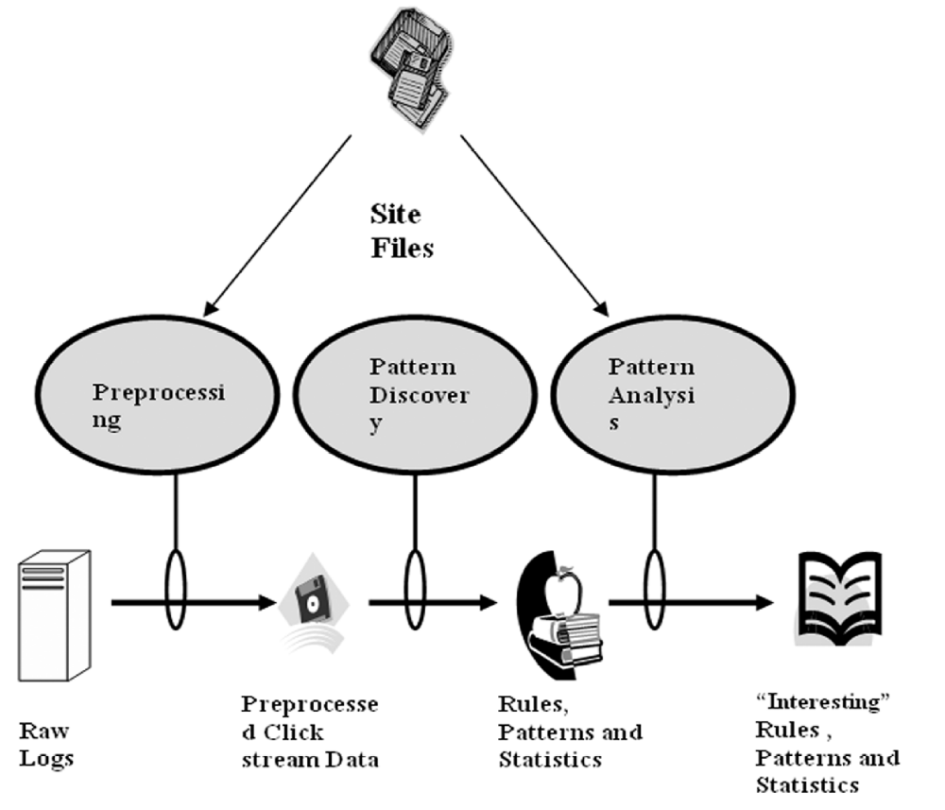
Figure 2.2.1: Structure of Web Usage Mining

2.2.1 Data Collection:

Source of Data for Web Usage Mining :

Web data can be classified as content data, structure data, user profile data and usage data. Web usage data is the collection of data that describes the usage of web resources. The usage data which is used for mining purposes can be collected at different levels i.e. Server level, Client level or Proxy level. “In this study we will take the case of web server”.

Server Level Collection:
Access log files at server side are the basic information source for Web usage mining. These files record the browsing behavior of site visitors. Data can be collected from multiple users on a single site. Log files are stored in various formats such as Common log [8] or combined log formats. The initial data comes from various input files such as server logs, site files and usage statistics. The format of Log record is explained earlier.

Client Level :
It is the client itself which sends information to a repository regarding the users behavior. This is done either with an ad-hoc browsing application or through client side application running standard browsers. Various browsers like Mozilla, Internet Explorer etc. can be modified or various JavaScript and Java applets can be used to collect client side data. This implementation of client-side data collection requires user cooperation, either in enabling the functionality of the JavaScript and Java applets, or to voluntarily use the modified browser. Client-side collection scores over server-side collection because it reduces both the bot and session identification problems.

Proxy Level :
A Web proxy is a caching mechanism which lies between client browsers and Web servers. It helps to reduce the load time of Web pages as well as the network traffic load at the server and client side. Proxy server logs contain the HTTP requests from multiple clients to multiple Web servers. This may serve as a data source to discover the usage pattern of a group of anonymous users, sharing a common proxy server. This Log Files are used for comparing the performance of their own site with those of competitors.

2.2.2 Preprocessing:
It is important to understand that mining process gives better results with quality data. In order to improve the quality of data, approximately 80% of mining efforts are required[11]. So preprocessing is necessary to build complete and robust data file. Following are the main preprocessing activities.
The pre-processing phase of HTTP server information is made up of the following five steps:
Data cleaning.
User identification.
User session identification.
Path completion (creation of user session file).

Access Logs
Cleaning
User
Identification
Session
Identification
Path Completion
Association
Figure 2.2.2: Preprocessing Activity.

2.2.2.1 Data Cleaning:

Access log files consist of large amounts of HTTP server information. Analyzing, this information is very slow and inefficient without an initial cleaning task. Irrelevant information which is useless for mining purposes [12, 13,14] can be removed from the HTTP server log files. e.g. access performed by :
spiders
crawlers
robots
these are automatic agents that surf the Web to collect and store the information e.g. search engine spiders. Every time a Web browser downloads a HTML document on the Internet, the images are also downloaded and stored in the log file. This is because, though a user does not explicitly request graphics that are on a Web page, they are automatically downloaded due to the HTML tags. Therefore, if a user requests to view a specific page, several log entries such as graphics and scripts are also downloaded in addition to the required HTML file. Mostly, only the log entry of the HTML file request is required and should be kept for the user session file.

Image files with extension name gif, jpeg, GIF, JPEG, jpg, JPG.
Audio and Video files with extension mp3,avi,flv,mp4,wmv.
Flash files with extension .swf
url containing robots.txt, favicon
User agent containing .com
common scripts such as “count.cgi” , files with extension .js.
and files with extension .css has to be removed.

The process of Data Cleaning is to remove outliers and / or irrelevant data. Since the main objective of Web Usage Mining is to obtain a pattern of the user’s behavior, it is not necessary to include all the irrelevant entries which the user did not explicitly request. Checking the suffix of the URL name can do eliminating the items considered irrelevant as given above. There are various techniques to clean a server log to eliminate irrelevant items. The cleaned log reflects the accurate picture of the user accesses to the Web site. This is important to apply the techniques and useful for Web log analysis.

2.2.2.2 User Identification:
IP address, User agents, cookies and Username fields of log file are used to identify user.
For web usage mining, to get knowledge about each user’s identity is not necessary. However, a mechanism to distinguish different users is still required for analyzing user access behavior [25]. Since users are treated as anonymous in most Web servers, two heuristic strategies, the proactive strategy and the reactive strategy, have been proposed to help differentiate users [25]. The proactive strategy tries to unambiguously associate each request to a site visitor before or during the visitor’s interaction with the site, while the reactive strategy attempts to associate requests with the visitor after the interaction with the site, based on the existing, incomplete records. As a rule, a cookie-based identifier is a must for applications of proactive strategy [25]. However, the use of cookie needs to comply with existing laws [26], at least that users must be clearly made ware of its presence. Therefore, the proactive strategy is not always a feasible option. In our system, we apply the reactive strategy to web logs, and approximate users in terms of IP address, type of operating system and browsing software. In other words, requests are treated as from the same user and put into the same group under that user only if these requests possess the same IP address, operating system and browsing software. This is a very complex task because of the existence of local caches, corporate firewalls and proxy servers. These can severely distort the overall picture of user traversals through a Web site. Information about local caches can be obtained by the use of cookies and cache busting. Cache busting is prevents browsers from using stored local versions of a page. As a result, there is a new download of a page from the server every time it is viewed. But there are drawbacks for these methods. Cookies can be deleted by the user and cache busting does not satisfy the advantage of speed which it was required to provide. Caching problem can be solved using methods such as site topology or referrer logs, along with temporal information to infer missing references. Still there are some problems which can arise in user identification [4]. ISP’s which uses DHCP technology, it is difficult to identify same user through different TCP/IP connections because IP address changes dynamically (single IP address/multiple server session). It is also possible that IP address
of a user changes from connection to connection (multiple IP address/single user). Different IP address can be assigned for every single request performed by the user.

IP address :
Unfortunately, the IP address of the client is not sufficient to identify a user correctly because there may be many hosts to the HTTP server under the same IP address or hostname (proxies). Another alternative is the machine name to uniquely identify users. This can result in several users being erroneously grouped together as one user. An algorithm presented in [3] verifies to see if each HTTP request method is reachable from the pages already visited. If a page is requested that is not directly linked to the previous pages, multiple users are assumed to exist on the same machine.

User agent :
Since there can be single user/multiple users under the same IP address, the IP address alone is not sufficient and not reliable, accuracy to the process of user identification is enhanced by the value of another field i.e. the user agent. This gives a name to the browser used by the client. Different values of the user agent field on the same client represent different users. Even if the IP address is the same, if the agent log shows a change in browser software or operating system, it can be assumed that each different agent type for an IP address represents a different user.

Username :
When a user registers with a website his username is stored in the Username field of Log File. This can be used for identifying users uniquely. if the user in not a registered person this field remains empty. so it is only useful when users registered with website.

Cookies :
This field is used in proactive strategy for user identification. Each time for a request sent by a new user a cookie is created by web server. Disadvantage with this approach is users may disable cookies at browser side.

2.2.2.3 User session identification:
Session Identification divides all pages accessed by a user into sessions. The previous output file, as discussed in User Identification, obtained by different users and time of request, may consist of requests put forth in long periods of time and also performed by the same users. Hence, it is necessary to divide the log entries of the same users in sessions or visits[1].
User sessions are extracted from the Web server log, the primary source of data in which the activities of Web users are captured. More reliable Web usage mining results need more reliable reconstructed user session results. However, it is difficult to tell when a user has left a Web site because there is no record of users leaving. Aside from the lack of information, some other problems also exist. For example, an IP sharing problem exists because several users may access a site through the same host or proxy and may employ the same software agent. An empty referrer may appear inside a session due to the following reasons: a) the user has typed the URL directly; b) requests are made by agents, and agents do not necessarily follow the page links; and c) some frames belong to the same page [17]. Several approaches are devised to address these problems. Two time-oriented heuristics for session identification are described in [16, 17]: the session duration heuristic (h1) and the page-stay time heuristic (h2). The heuristic h1 states that the duration of a session must not exceed a threshold. The heuristic h2 is based on the assumption that the duration of a visited page must not exceed a threshold. Due to users’ irregular navigation behavior, the performance of the time-oriented heuristics (h1 and h2) with fixed thresholds in reconstructing the sessions have not been satisfactory. In this paper we propose three extensions to h1 and h2 heuristics in order to improve their performance. Commonly used time thresholds for h1 and h2 are 30 and 10 minutes, respectively. A 30-minute cutoff time for session duration is proposed by [27] and used commonly in many applications. A 10-minute threshold for page-stay time is mentioned by [17] as a very conservative maximum cutoff. Different Web site structures and different user groups should have different thresholds for h1 to determine appropriate thresholds for h1 and h2[28]. The variables used in [28] are:
• Fh1: h1 heuristic with 30 minutes fixed threshold.
• Fh2: h2 heuristic with 10 minutes fixed threshold.
• Dh1: h1 heuristic with variable threshold.
• Dh2: h2 heuristic with variable threshold

Referrer based approach
There is also another approach by using referrer If the referrer field contains regular expressions like ‘-‘, ’com’, ‘google’, etc it means that it is a new session. Regular expressions other than these means that referrer contains a web page from which the user has visited the current web page.

2.2.3 Pattern Discovery:
Most known data mining techniques described in this section can be applied to any data Mining task. In this paper, these algorithms are presented from a web log mining perspective. Use of these algorithms in web log mining is illustrated by relevant literature sources

Clustering
Clustering is suitable for huge datasets and is the first data mining technique to examine the structure and patterns in data (Berry & Linoff, 1997). For example, clustering might be the first step in consolidating perspective customers or visitors which contains similar browsing behavior and characteristics into groups (Hand et al., 2001; Jain, Han, Mobasher, & Srivastava, 1997; Kanth & Siva, 2002; Xiao & Zhang, 2001). These groups of related clients are called clusters. For example, a group could be described by customers having income more than £25000 per year and age between 30 and 45. Clusters can be related page occurrences as well. For example a cluster can be composed of users browsing pages A, B, C from Mondays to Fridays. If there is a group of users behaving similarly it will be highlighted as a cluster. The similarity between cluster objects (data samples) can be measured utilising any metric function but Euclidean distance is one of the most popular (Duda, Hart, & Stork, 2000). Clustering techniques are widely used in web personalization. Personalization means adoption to an individual user’s needs. Usually personalization withdraws historical data about similar visitors’ behaviour and suggests individual navigation paths to those groups. Dai et al. utilized clustering to discover overlapping profiles which are later used by recommendation systems for real-time web site personalization (Dai, Luo, Mobasher, Nakagawa, & Witshire, 2000). Cooley et al. (1999a) used a full spectrum of data mining algorithms for web personalization based on transaction clustering and usage clustering. They proposed an approach for web personalization based on past users activities. This information is later used for online recommendations.

Classifications
Classification task allows developing a profile of pages accessed by certain user groups and thereby allowing this profile to be used in classifying new users according to their attributes (Han, Cai, & Cercone, 1993; Weiss & Kulikowski, 1991). In other words based on user browsing pattern and some additional information a user can automatically be assigned to one of the predefined classes (i.e., customer, guest). For example, potential buyers are users between age 25 and 40 and accessing the web site from the United Kingdom. Classification is usually performed using one of the well known techniques like neural networks or decision trees (Pabarskaite, 2003).

Associations
Due to an increasing number of transactions in real world datasets, fast and efficient association rules are becoming more and more popular. They are able to discover related
items occurring together in the same transaction (or session in web log mining) (Kanth &
Siva, 2002). Rules are very useful in web log mining and have already been applied in
some research works, e.g., Kato, Hiraishi, and Mizoguchi (2001). In practice it is impossible to test all possible combinations of items in transactions, as this number is huge. Therefore, association rule algorithms significantly reduce the number of combinations for examination. One of the most popular association rules algorithm’s is Apriori, introduced by Agarawal, Imielinski, and Swami (1993) and Agrawal and Srikant (1994). The output of this algorithm produces human understandable rules of the form X ⇒Y, where X and Y are sets of items—itemsets.
Apriori uses a lot of a priori information to reduce the number of combinations to be
examined. The algorithm consists of two phases. Firstly, frequent (sometimes called large) itemsets (a.k.a. baskets) are generated. Next, these itemsets are used to generate rules. Frequent itemsets as well as rules are output of majority association rule algorithms. They are both useful and important. However, the number of rules produced can be very large. For this reason, minimum support and minimum confidence are used. These measures determine the importance and quality of the rules. At the same time, the amount of results is reduced dramatically (to human acceptable amount) and speed is increased. As a matter of fact, some authors contradict such an approach of rule generation (Padmanabhan & Tuzhilin, 2000; Piatetsky-Shapiro & Matheus, 1994; Silberschatz & Tuzhilin, 1995). They argue that subjective measures such as unexpectedness and actionability and finding interesting patterns depend on the decision maker and not solely on the statistical measure (Adomavicius, 1997). The algorithm of discovering unexpected rules is presented in Padmanabhan and Tuzhilin (1999). The most applicable association rules area in the retail sector where sets of items purchased together are computed. However association rules are successfully used in web usage mining as well. Apriori algorithm has been used in a number of research works (Cooley et al., 1997a, b; Cooley et al., 1999a; Fong, Hughes, & Zhu, 2000; Han et al., 2000; Jain et al., 1997). Example 1 Denote Si as a session, where i is session’s identification number. Say there are number of sessions made by the same user:
S1 ("Products.html", "Software.html");
S2 ("Products.html","Software.html","Hardware.html","Services.html");
S3 ("Software.html"," Hardware.html", "Services.html");
S4 ("Products.html", "Software.html", "Hardware.html", "Contacts.html").
The first session S1 includes two visited pages “Products.html” and “Software.html”, the
second contains four pages etc. From the data above the following rule “IF Software.html
and Hardware.html THEN Services.html” can be derived with the support s=2/4=50% (the number of such transactions occurring across all transactions) and confidence c=2/3=66% (transactions on the first part of the rule supporting the rule divided by transactions on the first part which do not necessary support the rule).Yang, Wang, & Zhang (2002) propose to extend the traditional association rules paradigm by imposing new temporal information and the confidence of each rule in relation to the prediction if certain page in a certain time moment will occur.

Sequential rules
Another group of rules is based on sequential items. These items follow consecutively in
the time ordered set (Agrawal & Srikant, 1995; Mannila, Toivonen, & Verkamo, 1995; Pirjo, 2000). 96 J Intell Inf Syst (2007) 28:79–104.
Definition 1: Let say I is a set of items. A transaction is a pair (i, t), where i ∈ I is a type of the item and t € T, t is the time stamp of the event. Then itemset S is an ordered sequence of transactions, e.g.,:
S = ((i1,t1),(i2,t2)…………(im,tm))
where ik € I for all k=1, ..., m and tk≤tk +1 for all k=1, ..., m−1. The length of the sequence S is denoted as |S|=m.
An empty sequence of items is denoted as S=().
The problem of mining sequential patterns is to find the maximal frequent sequences
among all sequences that have a certain user specified minimum support (see for details
Srikant & Agrawal, 1996).

Definition 2: The support is defined as a percentage of patterns among all data containing the sequence S. Each maximal sequence represents a sequential pattern if supp(S) ≥ minsupp, when minsupp is defined by the analyst and S is considered as a frequent sequential pattern.
Example 2 Requested web pages may represent a sequential pattern. For example, 45% of users accessed /Jobs_Online which was followed by the page /About_company and /Careers. Standard algorithms usually discover only frequent sequential rules. This limits the ability to detect rare but still valuable web usage patterns. Spiliopoulou proposed to extend sequential mining not merely identifying frequent itemsets but also by discovering
“interesting” rules (Spiliopoulou, 1999). The author developed PostMine algorithm. It
transforms frequent sequences of accessed pages into a set of sequential rules and then
filters this set using various statistical measures and heuristics.

2.2.4 Pattern Analysis:
Based on the patterns mined we can make crucial decisions like rectifying the pages with errors, providing direct links to the most visited pages, redesigning the pages to help user navigation, eliminating or combining low visited pages, etc which will be helpful in improving the performance of the website.

2.2.5 Applications:

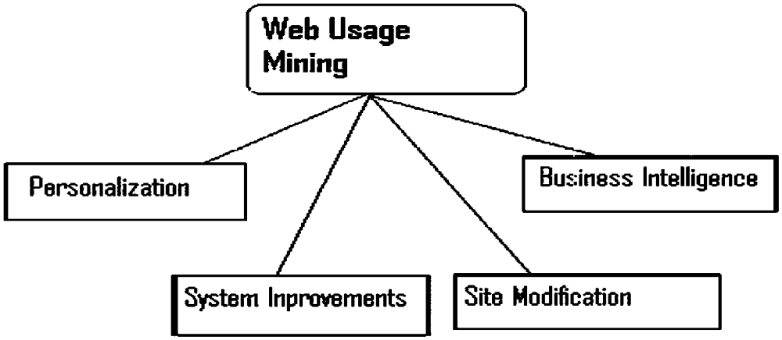

Figure 2.2.3: Web Usage Mining Applications.

Personalization :

Personalization for a user is achieved by keeping track of previously accessed pages e.g. individualized marketing for E-Commerce[10].Making dynamic recommendations to a web server on the basis of her/his profile in addition to usage behavior is very attractive to many applications e.g. cross sales and up sales in E-Commerce[11]. Web usage mining is an excellent approach for achieving this objective as described in [12] existing recommendation systems.

System Improvement :

Performance and other service quality factors are crucial to user satisfaction from services like databases, networks etc. Similar qualities can be expected from the user of web services. Web usage mining could provide the key to understand web traffic behavior, which can in term be used for developing policies for web coaching, Network Transmission [14].

Site Modification :

The attractiveness of a web site, in term of both content and structure, is crucial to many applications e.g. a product catalog for E-Commerce. Web usage mining provides detailed feedback on user behavior and it can provide the web site designer information. This information can be used to take redesign decisions. In adaptive website [13,14] structure of a Website changes automatically on the basis of usage patterns discovered from server logs.

Business Intelligence :

Information on how customers are using a website is crucial for marketers of e-tailing businesses. Buchner et. al [15] have presented a knowledge discovery process to discover marketing intelligence from web data. They defined a web log data hyper cube that would combine web usage data with marketing data for e-commerce applications. Four distinct steps in customer relationship life cycle are identified which can be supported by their knowledge discovery techniques: Customer attention, Customer retention, cross sales and customer departure.

2.3 Existing System and Disadvantages

In the present scenario, website manager has to analyze the log files manually for drawing various statistics about the website without any preprocessing and mining tool. The log file contains several thousands of records which will be very difficult to analyze without any proper tool and in the process it also consumes lot of time. Also performing the task manually may result in erroneous statistics which could lead to drawing out wrong conclusions.

2.4 Proposed System

2.4.1 Overview

Any system which could automate a process is always appreciated. Our proposed system will automate the manual work done by website manager. It is a preprocessing tool which will extract useful information from the abundant information available in the log files followed by drawing web usage patterns and statistics. In order to mine accurate usage patterns there must be appropriate preprocessed data available with us before mining. This tool exactly does that. It extracts only the useful information to website manager from the available raw data which can further be used to apply any mining technique.

2.4.2 Advantages

- User friendly GUI.
- Website manager can automatically generate website statistics.
- Log files can be easily appended to the database.
- It can obtain statistics easily for lacks of records.
- Any mining technique can be applied to the preprocessed data.
- Additional features can be added without affecting the existing functionalities.

2.5 Applicability of the Project

This tool can be used for improving the performance and reorganizing the structure of any website. It is a standalone tool which can work in any system in which it is deployed.

2.6 Feasibility Study

All projects are feasible – given unlimited resources and infinite time! Unfortunately, the development of computer-based system or product is more likely plagued by a scarcity of resources and difficult delivery dates. It is both necessary and prudent to evaluate the feasibility of a project at the earliest possible time. Months or years of efforts, thousands or millions of rupees and untold professional embarrassment can be averted if an ill-conceived system is recognized early in the definition phase.

The key considerations involved in the feasibility study are:

- Economical feasibility
- Technical feasibility
- Operational feasibility

2.6.1 Economical feasibility
This project is developed within the college, which is well equipped with all the latest software and hardware. Since there is no special hardware required, this project is economically feasible.

2.6.2 Technical feasibility
As the application has been developed using java and back end as Oracle, which utilizes minimum resources of the personal computer, this project is technically feasible.

2.6.3 Operational feasibility

This project has been implemented by java and it satisfies all the conditions and norms of the organization and the users.

2.7 Software Requirements Specification

2.7.1 Functional Requirements

“Web usage mining for improving the performance of website” is divided into 4 modules. They are:

1. Data Collection
2. Data Preprocessing
3. Pattern Discovery
4. Pattern Analysis

Module 1: Data Collection

This module deals with raw log files which contain fields like IP address, user agent, URL, cookie, status code, version, date, time, referrer.

Functionality

- Gathering the server level log files.
- Storing the log data in the database.

Module 2: Data Preprocessing

This module deals with data present in the database obtained from module 1. It has sub modules like data cleaning, user identification, session identification, path completion.

Functionality

- Data Cleaning

- Removing unnecessary fields from log information and storing only required fields.
- Removing all the records that contain requests of type image, flash, bot, and scripts.

- User Identification

- Identifying the users by making use of the fields IP address, user agent, version, and cookie.
- Finding the path of users which contains the sequence of browsed pages.

- Session Identification

- Identifying the sessions of users by making use of IP address, user agent, version, and referrer.
- Finding the path visited by the users in each session by making use of referrer field.
- Path Completion

- Completing the path visited by the users which along with the normal requests also contains the cached requests. This can be done by making use of referrer field.

Module 3: Pattern Discovery

This module deals with data present in the sessions table obtained from the previous module.

Functionality

Finding group of associated web pages that are frequently visited with the help of apriory algorithm. It also deals with finding statistical reports.

Module 4: Pattern Analysis

This module deals with the patterns and the statistical data obtained from the previous module.

Functionality

We can make decisions like providing direct links or providing shortest path to the web pages which are frequently visited. We can rectify the errors present in the web pages and we can reorganize the website based on user interest.

2.7.2 Performance requirements

Performance is measured in terms of the output provided by the application. Requirement specification plays an important part in the analysis of system. Only when the requirement specifications are properly given, it is possible to design a system which will fit into required environment. It rests largely with the users of the existing system to give the requirement specification because they are the people who finally use the system. This is because the requirements have to be known during the initial stages so that the system can be designed according to those requirements. It is very difficult to change the system once it has been designed and on the other hand designing a system, which does not cater to the requirements of the user, it’s of no use.

- The requirement specification for any system can be broadly stated as given
below.
- The system should be able to interface with existing system.
- The system should be accurate.
- The system should be better than the existing system.

2.7.3 Hardware Requirements

RAM : 512 MB or more
Processor : P4

2.7.4 Software Requirements
.
Operating System : Windows
Platform : Java (Swings Framework)
Database : Oracle

- DESIGN

3.1 Architecture design

Architecture design concentrates mainly on different components, their placement and technologies required for communication between them.

3.1.1 Software Architecture:
Software architecture (as shown in figure below) gives the logical building blocks of the solution. The description of the architecture is given below.

Client Tier Data Tier




Data Request

Data Response

Application Database Server
Figure 3.1.1 Software Architecture

- It shows the entire block diagram of the application from front end application to back end database server.
- It is a standalone application using two tier architecture
- Application provides User Interface and performs Business Logic with interactive environment.
- Database Server stores the required data for processing and final processed results.
- It also shows that application requests database server for data using JDBC connection.
- The response is given by database server to the application.
- It also shows that Database server is independent from application, i.e. we can use any database server (oracle, mysql, etc.).

3.2 ER DIAGRAM

ER diagram stands for Entity Relationship diagram. It shows the relationship between the set of entities and their relationships. ER diagram show the system database design.

- Entity: An entity is a business object that represents a group, or category of data.

- Relationship: A relationship is an association that exists between two entities. The relationship may be one-one, one-many, many-one, many-many.

- Attribute: An attribute is a property or descriptor of an entity.

Entity sets are drawn as rectangles, relationship sets as diamonds. If an entity set participates in a relationship set, they are connected with a line.

Attributes are drawn as ovals and are connected with a line to exactly one entity or relationship set

ER diagram has a great prominence in maintaining the database, consistently at its right granularity.

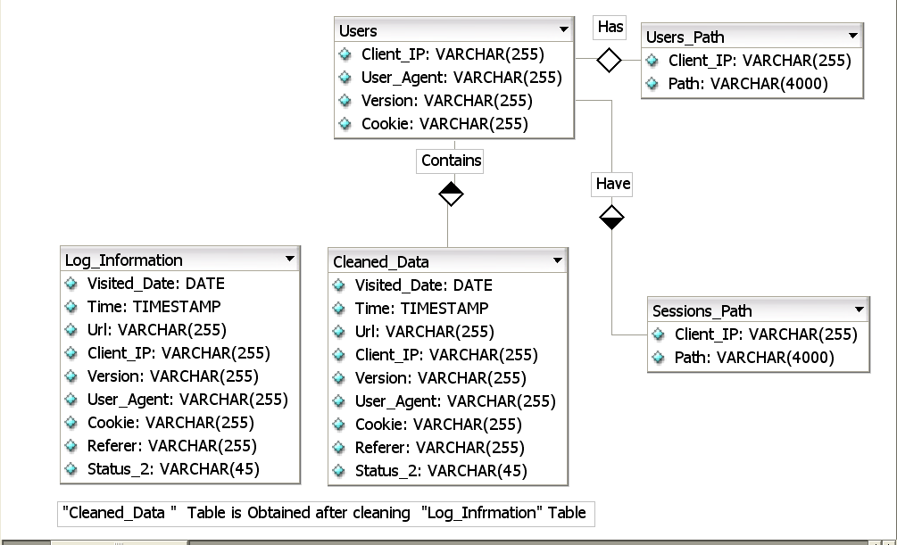

Figure 3.2.1 ER Diagram

3.3 Tables:

SNo | Attributes | Type
1 | Visited_Date | Date
2 | Time | Timestamp
3 | Url | Varchar2
4 | Client_IP | Varchar2
5 | Version | Varchar2
6 | User_Agent | Varchar2
7 | Cookie | Varchar2
8 | Referrer | Varchar2
9 | Status | Varchar2

Table 3.3.1: Log_Information

SNo | Attributes | Type
1 | Visited_Date | Date
2 | Time | Timestamp
3 | Url | Varchar2
4 | Client_IP | Varchar2
5 | Version | Varchar2
6 | User_Agent | Varchar2
7 | Cookie | Varchar2
8 | Referrer | Varchar2
9 | Status | Varchar2

Table 3.3.2:Cleaned_Data

SNo | Attributes | Type
1 | Client_IP | Varchar2
2 | Version | Varchar2
3 | User_Agent | Varchar2
4 | Cookie | Varchar2

Table 3.3.3: Users

SNo | Attributes | Type
1 | Client_IP | Varchar2
2 | Path | Varchar2

Table 3.3.4:Users_Path

SNo | Attributes | Type
1 | Client_IP | Varchar2
2 | Path | Varchar2

Table 3.3.5:Sessions_Path

3.4 UML Design

3.4.1 Use case diagram:

A usecase diagram that shows set of usecases and actors and their relationships. It addresses static view of the system. These diagrams are especially important in organizing and modeling the behaviours of a system.

3.4.2 Class diagram:

A class is a description of the set objects that share the same attributes, operations, relationships, and semantics. Graphically a class is rendered as a rectangle.

A class diagram shows a set of classes, interfaces and collaborations and their relationships.
3.4.3 Sequence diagram:

A sequence diagram is an interaction diagram that emphasizes the time ordering of the messages. An interaction diagram shows an interaction, consisting of a set of objects and their relationships, including the messages that may be dispatched among them interaction diagram shows the dynamic view of system.

3.4.4 Collaboration diagram:

A collaboration diagram is an interaction diagram that emphasizes the structural organization of the objects that send and receive messages.

3.4.5 Activity diagram:

An activity diagram is a special kind of the statechart diagram that shows the flow of activity within a system. Activity diagrams address the dynamic view of the system. They are especially important in modeling the function of the system and emphasize the flow of control among objects.

3.4.6 State chart diagram:

A state chart diagram shows a state machine, consisting of states, transitions, events and activities. A state chart diagram addresses the dynamic view of the system. They are especially important in modeling the behavior of an object, interface, and class.

3.4.7 Component Diagram:

A component diagram shows the organization and dependencies among the set of components. A component diagram addresses the static implementation view of a system.

3.4.8 Deployment diagrams:

A deployment diagram shows the configuration of run time processing nodes and the components that live on them. Deployment diagrams address the static deployment view of architecture.

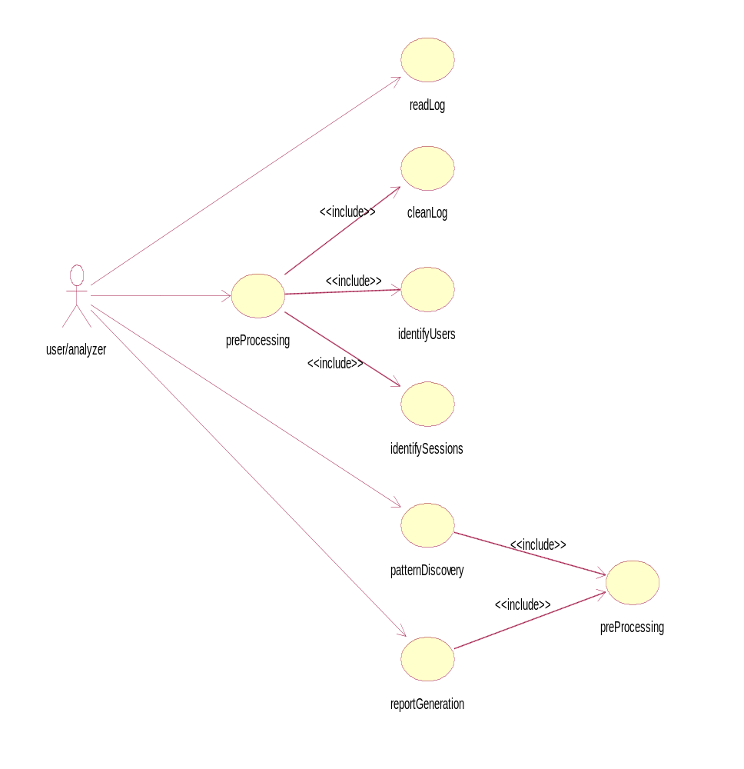

Figure 3.4.1: Use Case Diagram

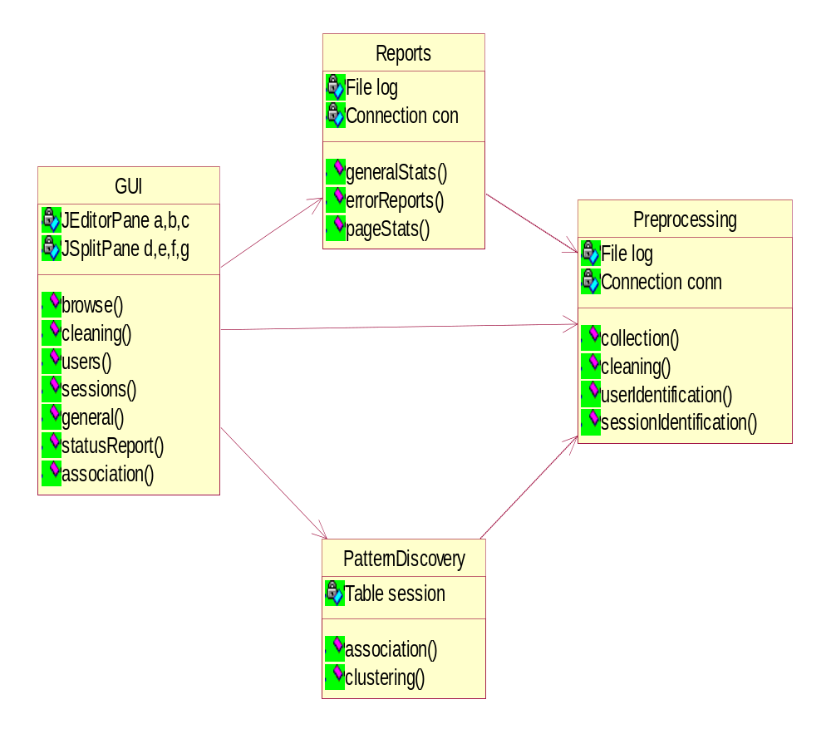

Figure 3.4.2: Class Diagram

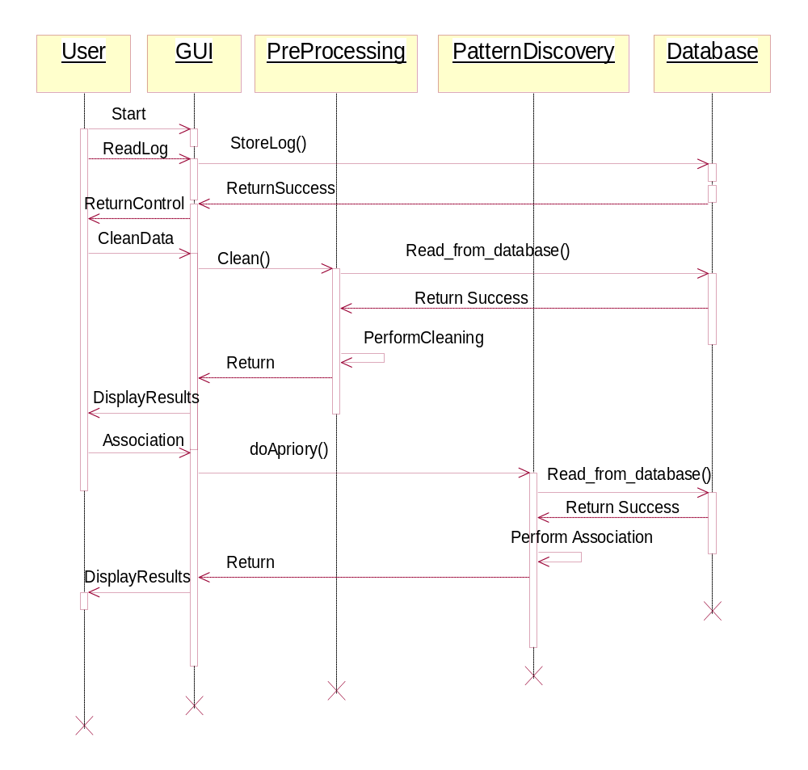

Figure 3.4.3: Sequence Diagram

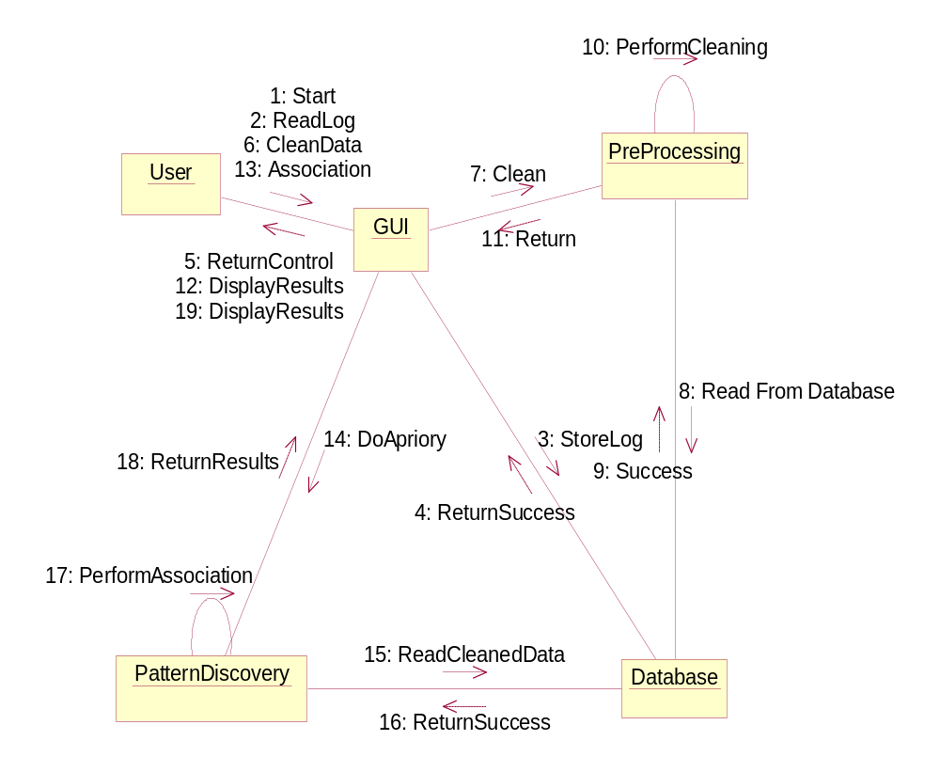

Figure 3.4.4: Collaboration Diagram

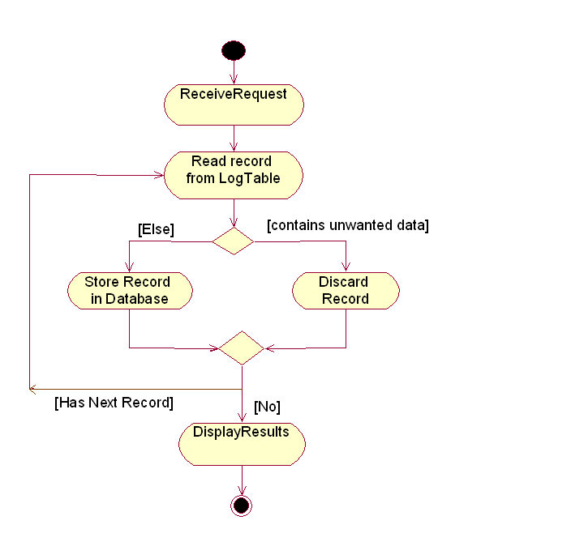

Figure 3.4.5: Activity Diagram (clean Log)

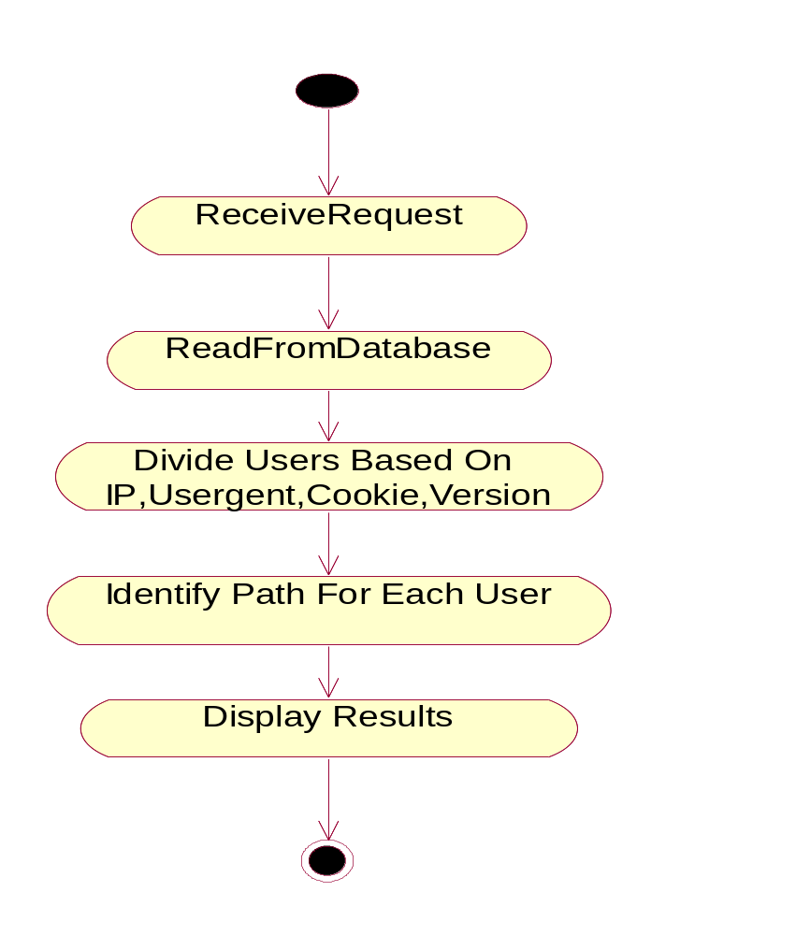

Figure 3.4.6: Activity Diagram (identify Users)

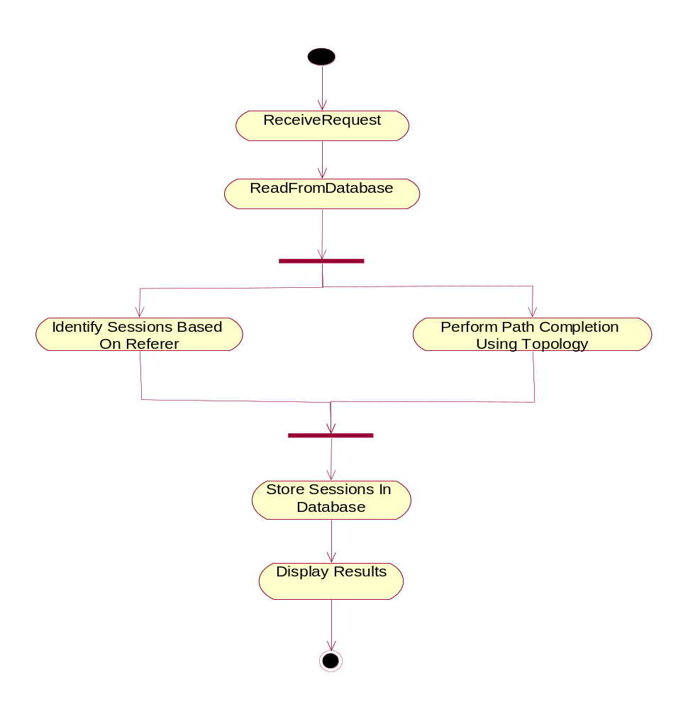
Figure 3.4.7: Activity Diagram (identify Sessions)

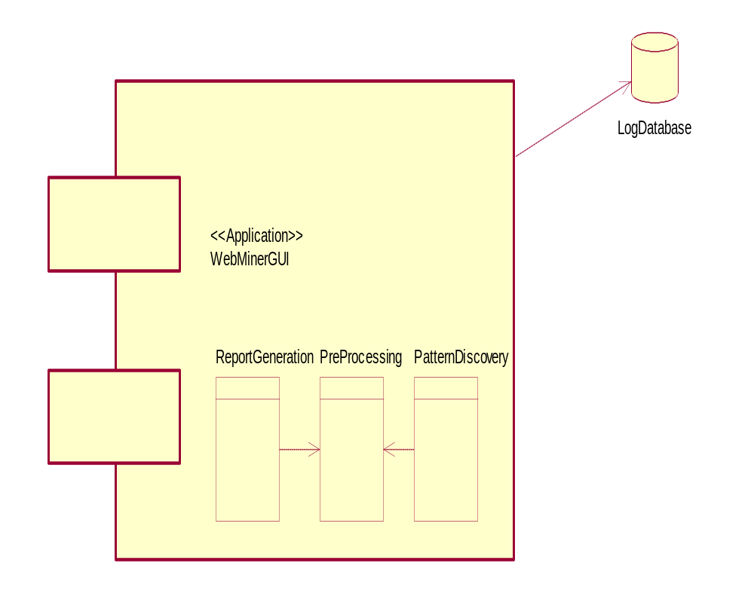

Figure 3.4.8: Component Diagram

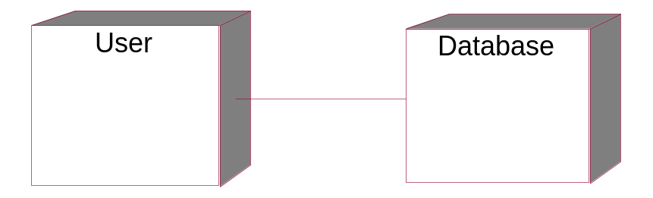

Figure 3.4.9: Deployment Diagram

4. METHODOLOGY

4.1 Technologies Involved:

4.1.1 Java:

Java technology is an object-oriented, platform-independent, multithreaded programming environment. It is the foundation for Web and networked services, applications, platform-independent desktops, robotics, and other embedded devices. Three main technology values of Java include:

- A Richer User Experience- Whether you are using a Java technology-powered mobile phone to play a game or to access your company’s network, the Java platform provides the foundation for true mobility. The unique blend of mobility and security in Java technology makers it the ideal development and deployment vehicle for mobile and wireless solutions.
- The Ideal Execution Environment for Web Services – The Java and XML languages are the two most extensible and widely accepted computing languages, providing maximum reach to everyone, everywhere, every time, to every device and platform
- Enabling Business from End to End – Java technology offers a single, unifying programming model that can connect all elements of a business infrastructure.

One characteristic of Java is portability , which means that computer programs written in the Java language must run similarly on any supported hardware/operating-system platform. This is achieved by compiling the Java language code to an intermediate representation called Java bytecode, instead of directly to platform-specific machine, but are intended to be interpreted by virtual machine (VM) written specifically for the host hardware. End-users commonly use Java Runtime Environment (JRE) installed on their own machine for standalone Java applications, or in a Web browser for Java applets.

4.1.2 Swing Architecture:

Swing is a platform-independent, Model-View-Controller GUI framework for Java. It follows a single-threaded programming model, and possesses the following traits:

Foundations
Swing is platform independent both in terms of expression (Java) and implementation (Look-and-Feel).

Extensible
Swing is a highly partitioned architecture, which allows for the "plugging" of various custom implementations of specified framework interfaces: Users can provide their own custom implementation(s) of these components to override the default implementations. In general, Swing users can extend the framework by extending existing (framework) classes and/or providing alternative implementations of core components.

Customizable
Given the programmatic rendering model of the Swing framework, fine control over the details of rendering of a component is possible in Swing. As a general pattern, the visual representation of a Swing component is a composition of a standard set of elements, such as a "border", "inset", decorations, etc. Typically, users will programmatically customize a standard Swing component (such as a JTable) by assigning specific Borders, Colors, Backgrounds, opacities, etc., as the properties of that component. The core component will then use these properties (settings) to determine the appropriate renderers to use in painting its various aspects. However, it is also completely possible to create unique GUI controls with highly customized visual representation.

Lightweight UI
Swing's configurability is a result of a choice not to use the native host Operating System’s GUI controls for displaying itself. Swing "paints" its controls programmatically through the use of Java 2D APIs, rather than calling into a native user interface toolkit. Thus, a Swing component does not have a corresponding native OS GUI component, and is free to render itself in any way that is possible with the underlying graphics APIs.

Loosely-Coupled and MVC
The Swing library makes heavy use of the Model/View/Controller software design pattern, which conceptually decouples the data being viewed from the user interface controls through which it is viewed. Because of this, most Swing components have associated models (which are specified in terms of Java interfaces), and the programmer can use various default implementations or provide their own. The framework provides default implementations of model interfaces for all of its concrete components. The typical use of the Swing framework does not require the creation of custom models, as the framework provides a set of default implementations that are transparently, by default, associated with the corresponding JComponent child class in the Swing library. In general, only complex components, such as tables, trees and sometimes lists, may require the custom model implementations around the application-specific data structures.

Relationship to AWT
Since early versions of Java, a portion of the Abstract Window Toolkit (AWT) has provided platform-independent APIs for user interface components. In AWT, each component is rendered and controlled by a native peer component specific to the underlying windowing system. By contrast, Swing components are often described as lightweight because they do not require allocation of native resources in the operating system's windowing toolkit. The AWT components are referred to as heavyweight components.

4.1.3 The Java Database Connectivity:
JDBC API is the industry standard for database-independent connectivity between the Java programming language and a wide range of databases – SQL databases and other tabular data sources, such as spreadsheets or flat files. The JDBC API provides a call-level API for SQL-based database access.
JDBC technology allows you to use the Java programming language to exploit “Write Once, Run Anywhere” capabilities for applications that require access to enterprise data. With a JDBC technology-enabled driver, you can connect all corporate data even in a heterogeneous environment.

JDBC connections support creating and executing statements. These may be update statements such as SQL’s CREATE, INSERT, UPDATE and DELETE, or they may be query statements such as SELECT. Additionally, stored procedures may be invoked through a JDBC connection. JDBC represents statements using one of the following classes:
- Statement – the statement is sent to the database server each and every time.
- Prepared Statement – the statement is cached and then the execution path is pre determined on the database server allowing it to be executed multiple times in an efficient manner.
- Callable Statement – used for executing stored procedure on the database.
Update statements such as INSERT, UPDATE and DELETE return an update count that indicates how many rows were affected in the database. These statements do not return any other information.
Query statements return a JDBC row result set. The row result set is used to walk over the result set. Individual columns in a row are retrieved either by name or by column number. There may be any number of rows in the result set. The row result set has metadata that describes the names of the columns and their types.

4.1.4 ORACLE 9i:
Introduction To ORACLE:
Any programming environment used to create containers, to manage human data, in the conceptualization as a Data Management System. Traditionally, the block of human data being managed is called a Database. Hence, in very simple terms, these programming environments can be conceptualized as Database Management Systems, in short DBM systems.
Striking features of ORACLE data-base:
- It represents a complex relationship between data.
- Keeps a tight control of debtor redundancy.
- Enforces user-defined rules to ensure integrity of table data.
- Has a centralized data dictionary for the storage of information pertaining to data and its manipulation.
- Ensures that data can be shared across applications.
- Enforces data access authorization has automatic, intelligent backup and recovery procedures for data.
- Have different interfaces via which users can manipulate data.
It supports the high scalability requirements of the most demanding internet based and tradition mission-critical applications, as well as the highest availability requirements.
The oracle 9i database as evolved more than 20 years from the earliest from relational database providing ad-hoc SQL, through to the internet era, supporting internet business applications. It has been designed to provide most complete and low cost solution for any business information management requirement and is only solution available today. That can
- Guarantee that critical business information is available when need.
- Consolidate and manage all your internet content.
- Enable an organization to develop and deploy business solutions quickly.
With the oracle 9i database, oracle offers all the features and capability necessary to develop deploy and maintain most scalable and performing internet based and traditional mission critical applications. Oracle provides the most powerful database for secure reliable high capacity internet application, data ware houses and e-commerce websites. It scales to support the most demanding, high throughput applications.

5. IMPLEMENTATION

5.1 Data Collection:

5.1.1 Storing the log file.txt in the database:

Read the raw log file line by line and retrieve the fields by making use of split method in java. The split method here splits based on the empty spaces between the fields. After obtaining the fields store them in the log table.

Pseudo code

Read the log file
Go to line 5 // as the first four lines contain other information
For each line
Split the words in the line based on the empty spaces between the words and store it in a string
With the help of that string which contains the fields store those fields in the database

5.2 Data Preprocessing:

5.2.1 Data Cleaning:

The data that is stored in the database contains both useful and unnecessary fields. The fields that are useful for analysis must only be considered. For every page request that is sent to the server a separate request is sent for each and every element that is embedded in that page .Each page may contain image files, flash files, scripts, etc. We have to remove all these records from our log information. We must also remove the bot requests that are stored in the log data which are sent by the search engines to the server

We have to remove those records which have URL containing expressions like

    - Image requests( jpg, png, gif,)
    - Robot Requests (robots.txt)
    - Favorite Icon (favicon)
    - Scripts (.js,.cgi)
    - Flash files (.swf)
    - other files like .css

We should also remove those records whose user agent contains expressions like ‘.com’

Pseudo code

Read log. text file
Remove fields (s-computername, s-ip, cs-method, cs-host, cs-bytes, sc-bytes, time-taken)
Strore remaining fields in database
Read record in database.
For each record in database
Read fields (Url, User_agent) //URI- stem indicates. The target URL//
If fields = { .gif, .jpg, .css, favicon, /robots.txt, .com, .js, .cgi, .swf}
then
Remove record

Else
Save record

End if
Next record

5.2.2 User Identification:

The next task is to identify the number of users who visited the website on a particular day or week or month. This can be done by using the IP address, version, user agent and cookie fields.

Pseudo Code

Read from cleaned data table
group fields (client_ip, user agent ,version, cookie) having cookie not equal to ‘-’
for each record
store the grouped data in the users table
find the corresponding path visited by the users by appending the URL of each and every record of that user in the log file.

5.2.3 Session Identification and Path Completion:

Identifying the Sessions: Every time the user visits the website a separate session is created for that user. The next task is to identify the total number of sessions and the path visited by the user in that session which can be later used for applying mining techniques. This can be done by using the IP address, user agent, and referrer.

Path Completion: Due to caching of web pages at client side every request is not sent to the server. So the cached requests are not stored in the log files due to which the path that we extracted in sessions may not contain the complete path browsed by the user. Therefore we have to complete the path browsed by user which can be done by making use of the referred field.
Pseudo Code

Read from cleaned data table
Group fields(IP Address,Version,User Agent)
For each record
read from cleaned data
for each record
if IP, Version, User Agent matches
if referer is like “com”, ”google”, ”-”
then create new session
else
add to existing session
in the session that we are adding find the position where the referrer is.
If the referrer is at the last position
then add the url to that session path
else
add to session path the previous pages of that session till the referrer is
encountered
else
go to next record

5.3 Pattern Discovery:

Association (using apriory)

Finding group of associated web pages that are frequently visited so that we may provide direct links to these web pages

Pseudo code

Read from Sessions
for each record
find the frequency of each page visited individually store it in candidate item set C1
go to next record
remove from C1 if frequency is less than minimum support count to form frequent 1 itemset L1
While Ck not null
BEGIN
find Ck+1 by joining Lk with itself
find frequency of each transactions in Ck+1
remove from Ck+1 if frequency is less than minimum support count to form frequent k+2 itemset Lk+2
END
The frequent pages that are visited will be present in Lk.

- EXPERIMENTAL RESULTS

Output screens for this application are shown below:

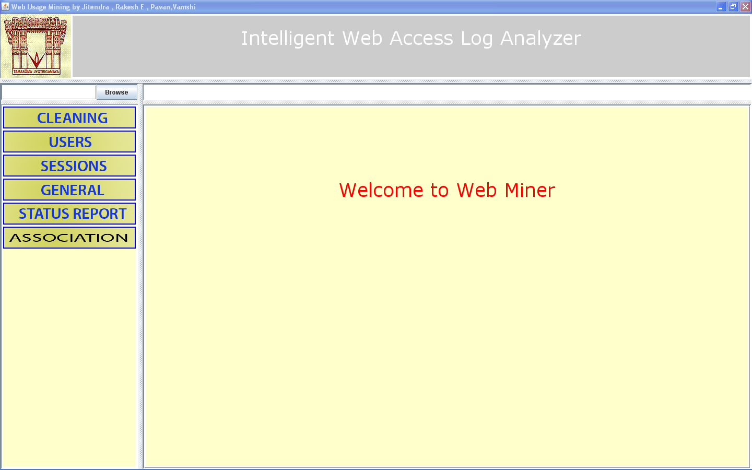

Figure 6.1: GUI of Web Access Log Analyzer

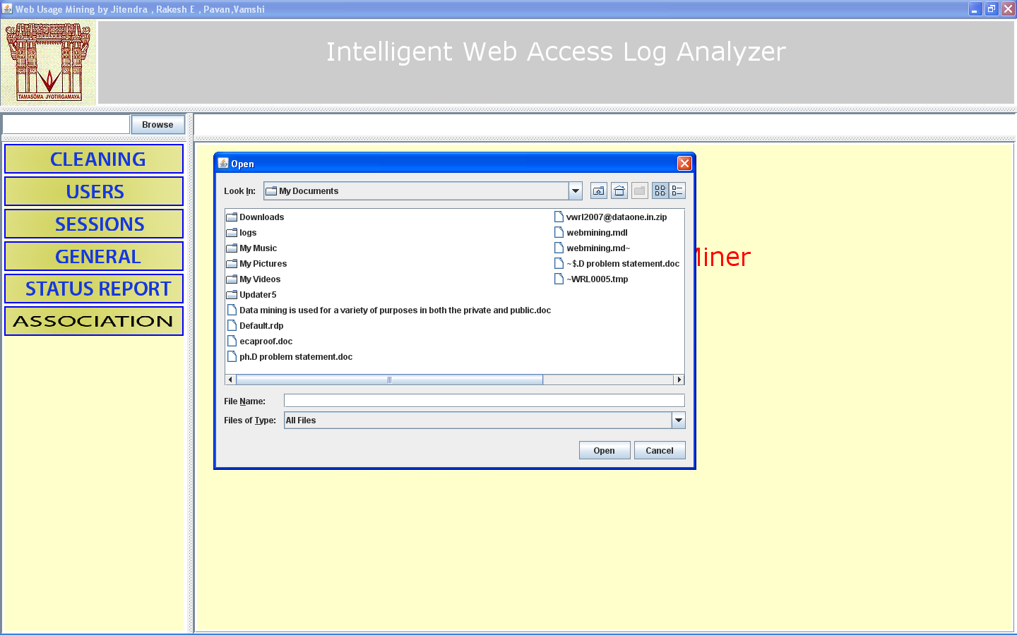

Figure 6.2: Selecting a log file

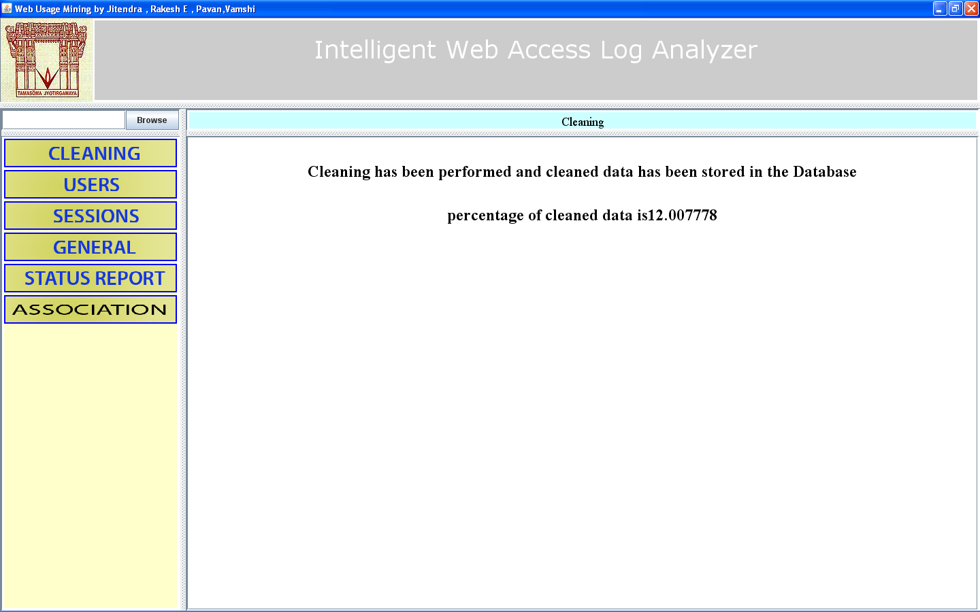

Figure 6.3: Cleaning the log data

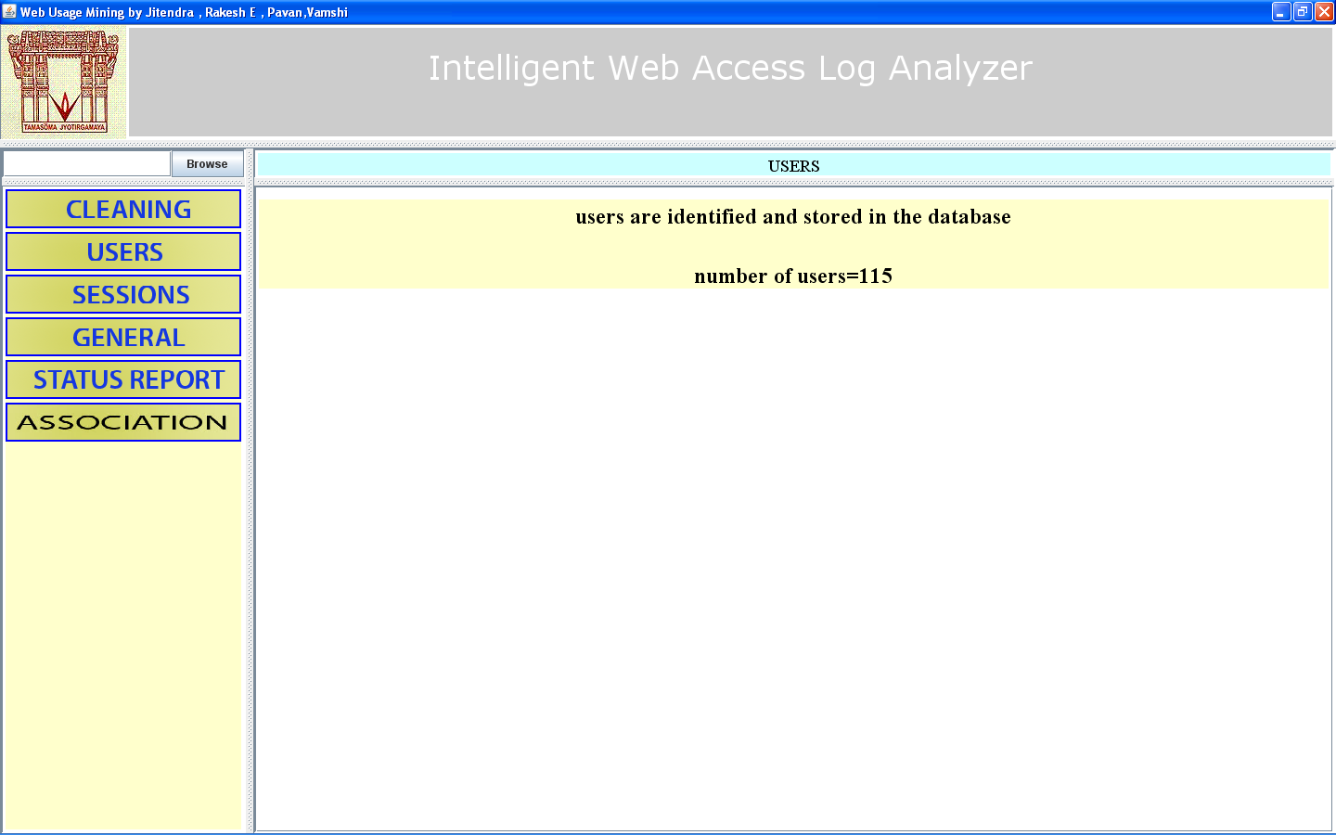

Figure 6.4: Identifying Users

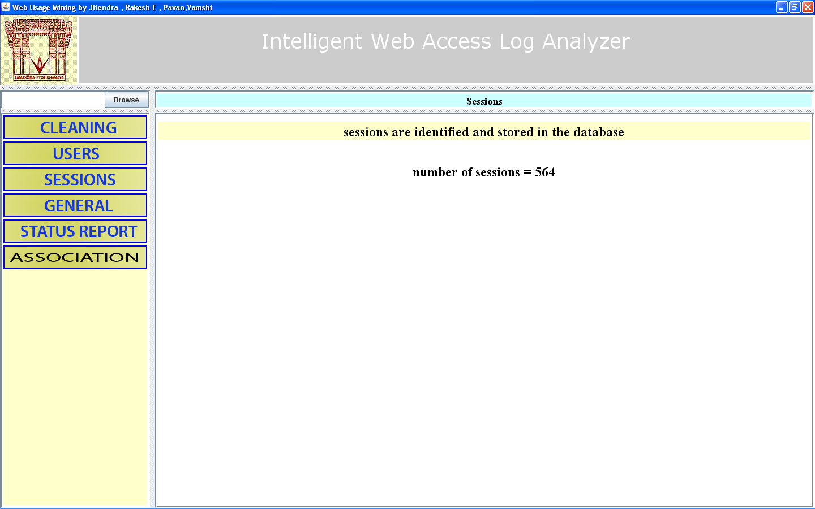

Figure 6.5: Identifying Sessions

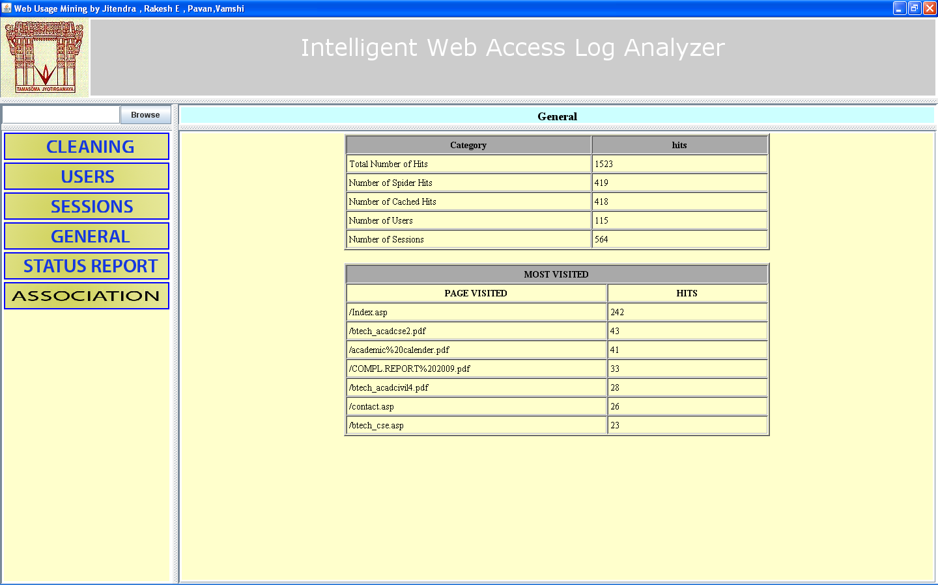

Figure 6.6: Computing General Statistics

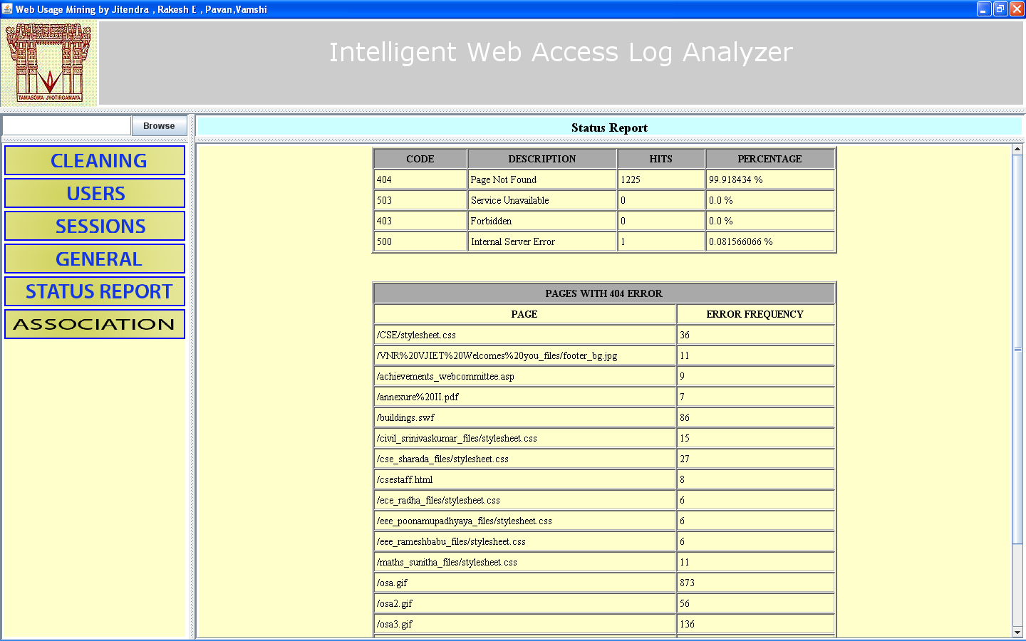

Figure 6.7: Computing Error Statistics

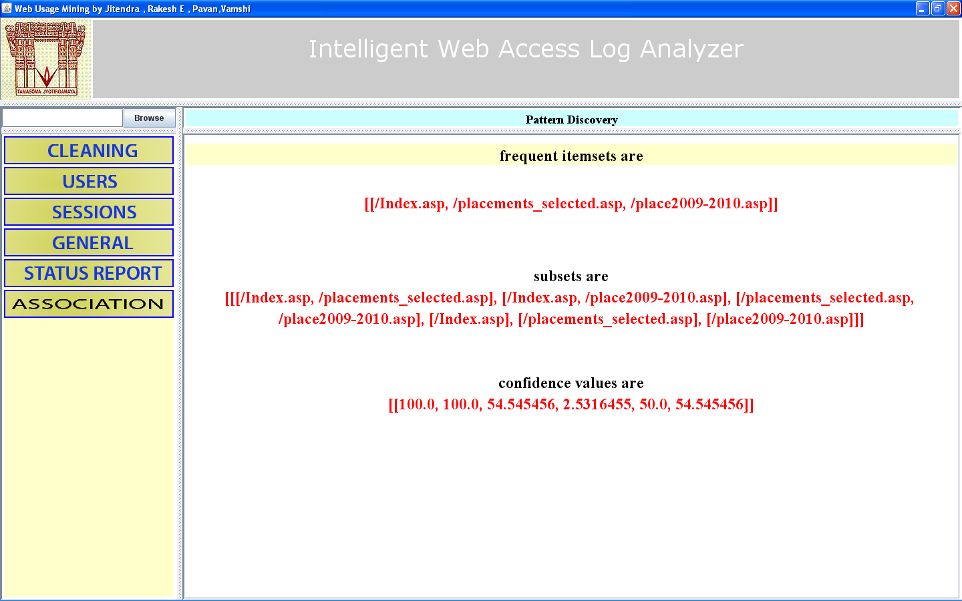

Figure 6.8: Mining Association Rules

7. TESTING

We performed manual testing and the reports are shown below:
Test case 1: Reading log file |  | Priority (H, L): High
Test Objective: To check whether log file is stored in database or not.
Test Description: The User clicks the “browse” button and selects the log file for performing analysis.
Requirements Verified: Yes
Test Environment: Oracle 9i, JRE 1.6
Test Setup/Pre-Conditions: Te services of the database should be started.
Actions | Expected Results
1. User clicks the browse button.  2. User selects the log file. | 1. File chooser window will be opened.  2. The path of the file will be displayed in the text field
Pass: Yes Conditions pass: Yes Fail: No
Problems / Issues: NIL
Notes: Successfully Executed

Test case 2: Cleaning log file. |  | Priority (H, L): High
Test Objective: To check whether log data is cleaned or not.
Test Description: User clicks the “cleaning” button.
Requirements Verified: Yes
Test Environment: Oracle 9i, JRE 1.6.
Test Setup/Pre-Conditions: The services of the database should be started.
Actions | Expected Results
1.User clicks cleaning button. | 1. Cleaning is performed and percentage of cleaned data is displayed.
Pass: Yes Conditions pass: Yes Fail: No
Problems / Issues: NIL

Test case 3: Identifying users. |  | Priority (H, L): High
Test Objective: To check whether users are identified.
Test Description: User clicks “users” button .
Requirements Verified: Yes
Test Environment: Oracle 9i, JRE 1.6
Test Setup/Pre-Conditions: The services of the database should be started.
Actions | Expected Results
1. User clicks users button | 1. Users are identified and number of users are displayed to user.
Pass: Yes Conditions pass: Yes Fail: No
Problems / Issues: NIL

Test case 4: Identifying sessions |  | Priority (H, L): High
Test Objective: To check whether sessions are identified.
Test Description: User clicks “sessions” button .
Requirements Verified: Yes
Test Environment: Oracle 9i, JRE 1.6
Test Setup/Pre-Conditions: The services of the database should be started.
Actions | Expected Results
1. User clicks the sessions button. | 1. Sessions are identified, the browsed path in that session by the user is identified and numbers of sessions are displayed to user.  .
Pass: Yes Conditions pass: Yes Fail: No
Problems / Issues: NIL
Notes: Successfully Executed

Test case 5: Finding general statistics. |  | Priority (H, L): High
Test Objective: To check whether the statistics are computed properly.
Test Description: User clicks the general button.
Requirements Verified: Yes
Test Environment: Oracle 9i, JRE 1.6
Test Setup/Pre-Conditions The services of the database should be started.
Actions | Expected Results
1. User clicks “general” button. | 1. Statistics are computed from log database and displayed to the user.
Pass: Yes Conditions pass: Yes Fail: No
Problems / Issues: NIL
Notes: Successfully Executed

Test case 6: Finding error statistics. |  | Priority (H, L): High
Test Objective: To check whether the error statistics are computed properly.
Test Description: User clicks the “error” button.
Requirements Verified: Yes
Test Environment: Oracle 9i, JRE 1.6
Test Setup/Pre-Conditions: The services of the database should be started.
Actions | Expected Results
1. User clicks the “error_stats” button. | 1. Statistics are computed from log database and displayed to user.
Pass: Yes Conditions pass: Yes Fail: No
Problems / Issues: NIL
Notes: Successfully Executed

Test case 7: Finding Association rules. |  | Priority (H, L): High
Test Objective: To check whether Association rules are mined properly or not.
Test Description: The user clicks the “Association” button.
Requirements Verified: Yes
Test Environment: Oracle 9i, JRE 1.6
Test Setup/Pre-Conditions: The services of the database should be started.
Actions | Expected Results
1. User clicks the “association” button. | 1. Frequently visited associated web pages are identified and their corresponding association rules are mined.
Pass: Yes Conditions pass: Yes Fail: No
Problems / Issues: NIL
Notes: Successfully Executed

8. CONCLUSION

In this project we have analyzed the log files of www.vnrvjiet.in. Literature Survey has been carried out to generate experimental results. Primary source of information server log files of website from 01-02-2011 to 28-02-2011 are collected. Preprocessing step involves cleaning, User Identification, Session Identification and Path Completion. Cleaning step removes unwanted records like image requests, script files, audio and video files etc.. The total size of log files gathered is 209 MB, after performing cleaning we got 30 MB of cleaned data which was stored in relational database. User identification is performed based on IP Address, User Agent and Cookie. Referrer based approach is used for session identification and path completion. Finally Pattern Discovery step is carried out to generate Association rules using Apriory algorithm. We also generated various Statistical reports which are very useful to know the traffic on a website. The following results are displayed.
- Different users and the path visited by them.
- Different sessions visited by users.
- Association rules which gives the association between pages visited by users in different sessions..
- Various statistical reports like total hits, visits performed by spiders and crawlers, most visited pages, pages resulted in error, total errors in page requests, etc. .
Pattern Analysis is performed on these rules and statistical reports are analyzed to make necessary changes in the website to improve its performance like page merging, providing direct link to mostly visited pages, error removal, etc.

9. FUTURE ENHANCEMENTS

Web Mining and particularly Web Usage Mining has got lot of attention in recent days. Lot of research work is going on in this area. Most of the commercial applications of Web Usage Mining exploit consolidated statistical analysis techniques. In contrast, research in this area is mainly focused on the development of knowledge discovery techniques specifically designed for the analysis of Web usage data. Most of this research effort focuses on three main paradigms: association rules, sequential patterns, and clustering. Additional functionalities can be added as follows

- Sequential patterns and Clusters are generated in Pattern Discovery.
- We used referrer based approach for session identification, instead a combined approach i.e. referrer and time oriented heuristics can be used for more improved results.
- Server logging pattern can be changed in order to assist web usage mining by Web Server providers.

Ex: Generation of cookie for a new user/session independent of client side settings.

10. BIBLIOGRAPHY
[1] An Overview of Data Preprocessing in Data and Web Usage Mining
R.M. Suresh, R.Padmajavalli, RMK Engineering College, Kavaraipettai – 601206.
rmsuresh@hotmail.com

[2] Mining interesting knowledge from weblogs: a survey, Federico Michele Facca, Pier Luca Lanzi * Dipartimento di Elettronica e Informazione, Artificial Intelligence and Robotics Laboratory, Politecnico di Milano, 20133 Milano, Italy

[3] Cooley.R, Mobasher.B, Srivatsa.J, 1997(b) “Web Mining: Information and Pattern Discovery on the World Wide Web”, Proceedings of the IEEE International Conference
on Tools with Artificial Intelligence (ICTAI'97)

[4] Jaideep Srivastava, Robert Cooley, Mukund Deshpande, and Pang-Ning Tan, “Web usage mining: Discovery and applications of usagepatterns from Web data”, SIGKDD Explorations, 2000, Vol.1.pp. 12-23

. [6] M. Kilfoil, D. A. Ghorbani, W. Xing, Z. Lei, J. Lu, J. Zhang, and X. Xu. Toward an adaptive web: The state of the art and science. In Proceedings of Communication Network and Services Research (CNSR) 2003 Conference, pages 108–119, Moncton, NB, Canada, May 15–16 2003.

[7] R. Kosla and H. Blockeel. Web mining research: A survey. SIG KDD Explorations, 2(15):1–15, July 2000.

[10] S. K. Pal, V. Talwar, and P. Mitra. Web mining in soft computing framework : Relevance, state of the art and future directions. IEEE Trans. Neural Networks, 13(5):1163–1177, 2002.

[25] M. Spiliopoulou, B. Mobasher, B. Berendt, and M. Nakagawa. A framework for the evaluation of session reconstruction heuristics in web usage analysis. INFORMS Journal of Computing, Special Issue on Mining Web-Based Data for EBusiness Applications, 15(2), 2003.

[9] J. Pei, J. Han, B. Mortazavi-asl, and H. Zhu. Mining access patterns efficiently from web logs. In Pacific-Asia Conference on Knowledge Discovery and Data Mining, pages
396–407, 2000.

[8] http://www.w3.org/Daemon/User/Config/ Logging.htm#common-log file-format

[11] Ophir Frieder, and David A. Grossman, Information Retrieval: Algorithms and Heuristics. The Information Retrieval Series, 2nd Edition, 2004.

[12] Boris Diebold, and Michael Kaufmann, “Usage based Visualization of web localities”, in Australian symposium on information visualization, 2001, pp. 159-164.

[13] Corin R. Anderson,” A machine Learning Approach to Web Personalization”,Ph. D. Thesis, university of Washington, 2002.

[14] Pang-Ning Tan, and Vipin Kumar, “Discovery of Web robot sessions based on their navigational patterns. Data mining and knowledge discovery”, 2002, 6(1), pp. 9-35.

[15] K.P. Joshi, A. Joshi, Y. Yesha, On using a warehouse to analyze web logs, Distributed and Parallel Databases 13 (2) (2003) 161–180.

[16] B. Berendt, B. Mobasher, M. Nakagawa, and M. Spiliopoulou. The impact of site structure and user environment on session reconstruction in web usage analysis.
In Proceedings of the 4th WebKDD 2002 Workshop, at the ACM-SIGKDD Conference on Knowledge Discovery in Databases, Edmonton, Alberta, Canada, July 2002.

[17] M. Spiliopoulou, B. Mobasher, B. Berendt, and M. Nakagawa. A framework for the evaluation of session reconstruction heuristics in web usage analysis. INFORMS Journal of Computing, Special Issue on Mining Web-Based Data for EBusiness Applications, 15(2), 2003.

[39] J. Han, M. Kamber, Data Mining Concepts and Techniques, Morgan Kaufmann, 2001.

[40] A. Nanopoulos, D. Katsaros, Y. Manolopoulos, Exploiting web log mining for web cache enhancement, in: R. Kohavi, B. Masand, M. Spiliopoulou, J. Srivastava (Eds.), WEBKDD 2001—Mining Web Log Data Across All Customers Touch Points, Third International Workshop, San Francisco, CA, USA, August 26, 2001. Revised papers, vol. 2356 of Lecture Notes in Computer Science, Springer, 2002, pp. 68–87.

[41] X. Huang, N. Cercone, A. An, Comparison of interestingness functions for learning web usage patterns, in: Proceedings of the Eleventh International Conference on Information and Knowledge Management, ACM Press, 2002, pp. 617–620.

[42] S.S.C. Wong, S. Pal, Mining fuzzy association rules for web access case adaptation, in: Workshop on Soft Computing in Case-Based Reasoning, International Conference on Case-Based Reasoning (ICCBR_Ol), 2001.

[18] Cooley, R., Mobasher, B., and Srivastava, J, “Web mining: information and pattern discovery on the World Wide Web”, International Conference on Tools with Artificial Intelligence, Newport Beach, IEEE, 1997, pp. 558-567.

[19] Robert Cooley, Bamshad Mobasher, and Jaideep Srivastava,” Data preparation for mining World Wide Web browsing patterns”, Journal of Knowledge and Information System,1999,pp. 1-27.

[20] F. Masseglia, P. Poncelet, and M.Teisseire,”Using data mining techniques on Web access logs to dynamically improve Hypertext structure”, 1999.

[21] Gabriek. Web usage mining and discovery of association rules from HTTP server logs.

[22] David A. Grossman, and Ophir Frieder, Information Retrieval: Algorithms and Heuristics (The Information Retrieval Series) (2nd Edition) (Paperback - Dec 20, 2004)

[23] James Rubarth-Lay, “Optimizing Web Performance”, 1996.

[24] Internet: Hypertext Transfer Protocol Overview, http://www.w3.org/Protocol/rfc2616/rfc216- sec1.html, 1995

[25] M. Spiliopoulou, B. Mobasher, B. Berendt, M. Nakagawa, A framework for the evaluation of session reconstruction heuristics in
web-usage analysis, INFORMS Journal on Computing 15 (2) (2003) 171–190.

[26] The Personal Information Protection and Electronic Documents Act (PIPEDA), <http://www.privcom.gc.ca/legislation/ 02_06_01_e.asp> (accessed June 2005).

[27] L. Catledge and J. Pitkow. Characterizing browsing behaviors on the world wide web. In Computer Networks and ISDN Systems, volume 26, pages 1065–1073. 1995.

[28] The Reconstruction of User Sessions from a Server Log Using Improved Time-oriented Heuristics Jie Zhang and Ali. A. Ghorbani Faculty of Computer Science University of New Brunswick Fredericton, NB, E3B 5A3, Canada

