##### INDUSTRIAL TRAINING

##### (PHASE-I)

**Undergone at**

**INDIAN INSTITUTE OF TECHNOLOGY**

***KANPUR***

##### A PRESENTATION REPORT

On

**Artificial Intelligence, Internet of Things and Robotics**

###### ***Submitted by***

##### JITENDRA PRAKASH GULATY

RA1711003011344

***in partial fulfillment for the award of the degree***

***of***

##### BACHELOR OF TECHNOLOGY

IN

**COMPUTER SCIENCE ENGINEERING**



AUGUST,2019

**BONAFIDE CERTIFICATE**

Certified that the report on Artificial Intelligence, Internet of Things and Robotics is a proof of successful completion of Industrial Training Phase–I programme undergone by JITENDRA P.GULATY (Register no. RA1711003011344) in the institution Indian Institute of Technology located at Kanpur during the period **3rd June 2019** to **12th July 2019.**

**Date Signature of the**

**Industrial Training In-charge**

**DECLARATION**

I hereby declare that the presentation report submitted titled “**Artificial Intelligence, Internet of Things and Robotics**”, is a record of my industrial training programme which I had undergone in Indian Institute of Technology, Kanpur during the end of the fourth semester between the period **3rd June 2019 to 12th July 2019.**

Date : **14th August 2019**

Name : **JITENDRA P. GULATY**

Register Number : **RA1711003011344**

**Signature of the Student**

**TABLE OF CONTENTS**

|  |  |  |
| --- | --- | --- |
| **S.No** | **Title** | **Pg.No.** |
| I. | Industrial Training Report | 1 |
| II. | Company Details | 2 |
| III. | Project Overview | 3 |
| IV. | Vehicle Position Tracking System | 4 |
| V. | Surveillance Robot | 5 |
| VI. | Training | 6 |
| VII. | Weights Calculation | 7 |
| VIII. | Reverse Function | 10 |
| IX. | Surveillance Feature | 10 |
| X. | Conclusion | 13 |

ACKNOWLEDGEMENT

First of all, I would like to thank my Institute SRM Institute of Science and Technology, for providing an opportunity of the internship program for me. I am also grateful to **IIT KANPUR & ISMRITI** for recruiting me as an intern.

I take this opportunity to express my profound gratitude and deep regards to my Team Leader **HIMANSHU SINGH** for their exemplary guidance, monitoring and constant encouragement throughout the course of this internship. The blessing, help and guidance given by him time to time shall carry me a long way in the journey of life on which I am about to embark.

I would like to express my heartfelt gratitude to **Dr.C.MUTHAMIZCHELVAN, Director, Faculty of Engineering and Technology, SRM Institute of Science and Technology**

for his kind support and inspiration which has immensely strengthened my confidence during my internship program.

I am extremely grateful and remain indebted to members of **ISMRITI** for being a source of inspiration and for his constant support in intern.

I am obliged to all my Team members, for the valuable information provided by them in their respective fields. I am grateful for their cooperation during the period of my internship.

I'm thankful to them for their continual constructive criticism and invaluable suggestions and help, which benefited me a lot at my intern.

Surveillance Robot

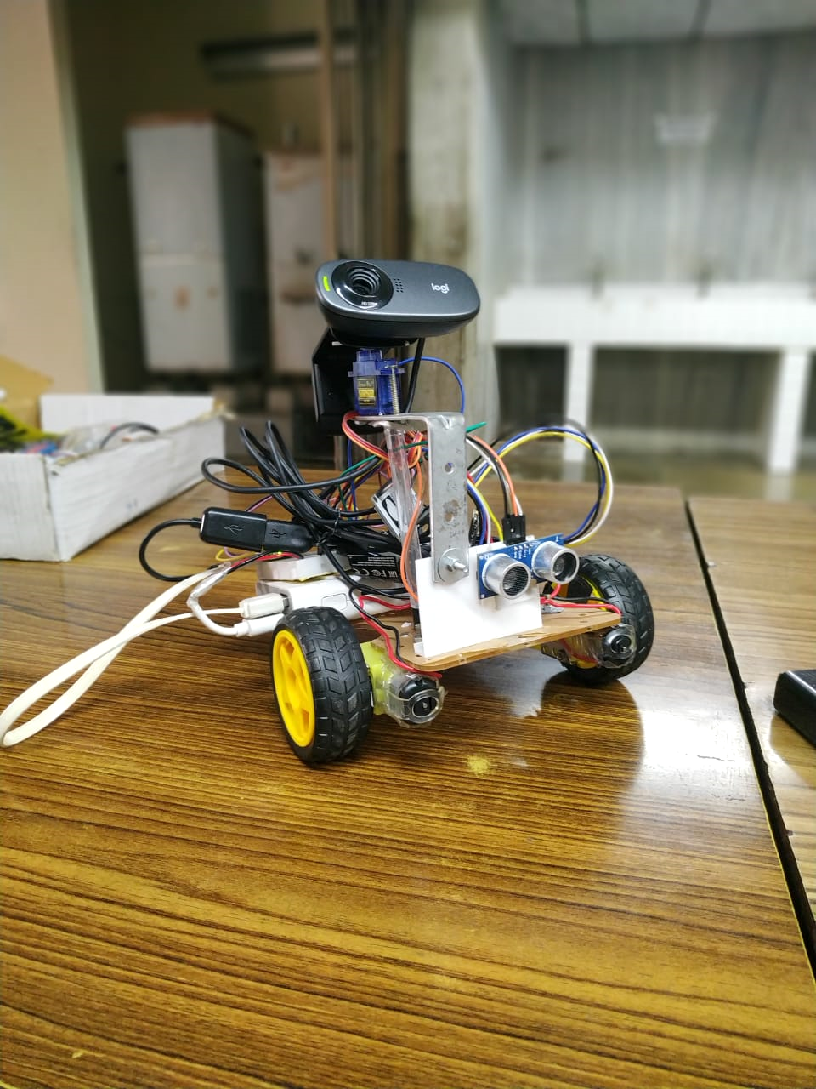

**INDIAN INSTITURE OF TECNOLOGY, KANPUR**

**INTRODUCTION**

IIT Kanpur in collaboration with MHRD and iSMRITI conducted training courses on Introduction to AI, IoT & Robotics.

iSmriti works in the field of IoT, AI, Robotics and Control both as educational enterprise as well as consultancy firm. Several such workshops have been conducted in the past by iSmriti in various other IITs and private institutions.

The courses were conducted to provide hands on experience in the field of Artificial Intelligence, IoT, & Robotics to orient students towards the present industrial scenario. The course is designed to impart value addition for all students who are pursuing their relevant degrees. Students were taught basic foundations with the aid of well developed theoretical modules and lab-oriented experiments. At the end of the course the students were able to build a small prototype that is powered by IoT and AI principles. The course modules were designed by iSMRITI with the help of experts from IITs.

* **PROJECT OVERVIEW:**

A vehicle tracking system combines the use of automatic vehicle location in individual vehicles with software that collects data for a comprehensive picture of vehicle location. Real time tracking system can transmit the collected information about the vehicles location after regular intervals. The real time location of vehicle can be viewed on Google Map .The vehicle tracking system is fitted inside the car that provides effective real time location and that data can be stored and retained. This system is an essential device for tracking vehicle and any time the owner can monitor it.

* **FEATURES:**
* The robot has an obstacle avoidance feature.
* The robot contains a Position Tracking Device which will provide us the live location.
* The robot is installed with a web camera which will give us live footage of the surrounding.
* **COMPONENTS**:
* NodeMCU
* RaspberryPi-ZeroW
* GPS Module –Neo6M
* Servo Motor
* L298 Motor Driver
* DC Motors
* Ultrasonic Sensor
* Logitek C310 Web Camera
* **SOFTWARE USED:**
* Arduino IDE
* Google Firebase Cloud service
* MIT App Inventor
* MobaXterm

**VEHICLE POSITION TRACKING DEVICE**

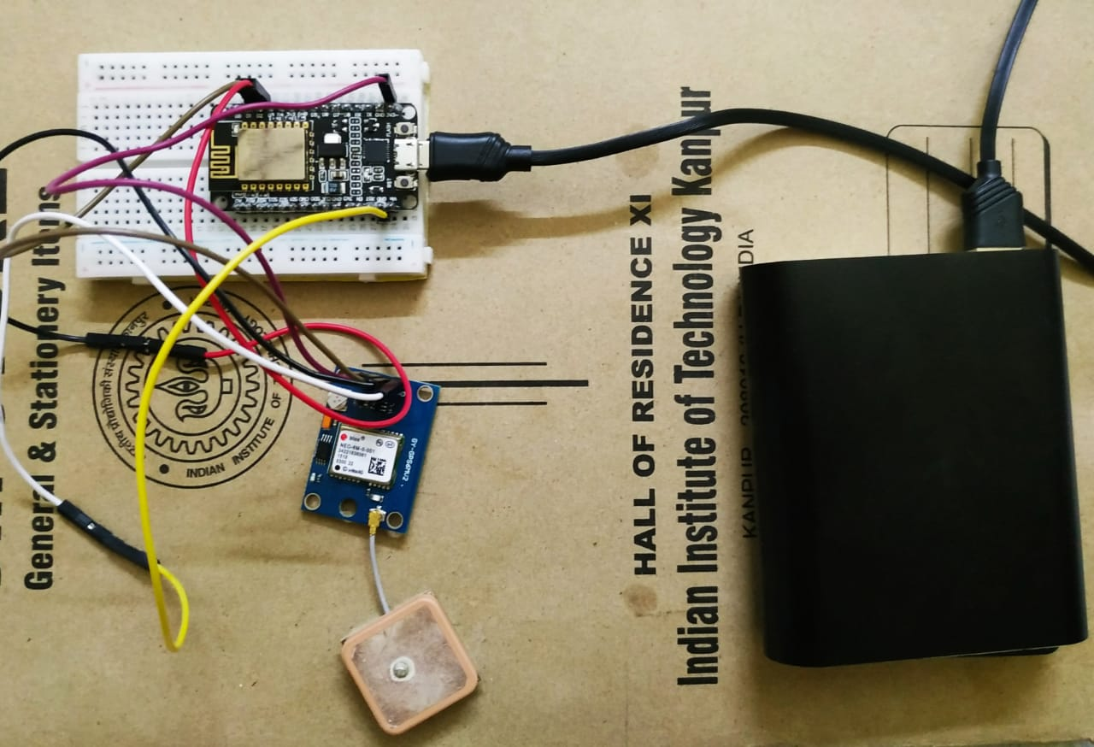

* **GPS Module –Neo6M**

New improved GPS Module with built-in antenna and memory back-up for OEM and hobbyists projects. This unit features low power consumption, high sensitivity. The unit is ideal for navigation systems, distance measurements, vehicle monitoring and recording, boating direction and location, together with hiking and cross country exploring.   
This module includes high precision surface mount technology to provide both high accuracy and very compact

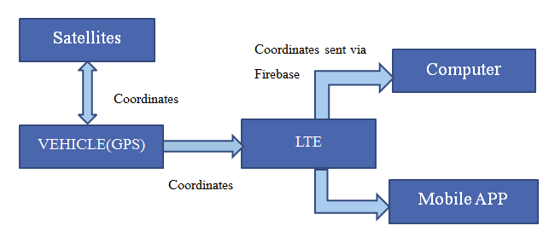

* **Working:**
* Here we have used GPS Neo6m module for getting the live location of our vehicle.
* As soon as the module is activated, it receives the values of the latitude, longitude, time and the date via satellites.
* Using the library of Tinygps++, we extract the latitude and longitude and send them directly to the Google Firebase cloud service.
* This Firebase stores the data so that it can be extracted by the android application globally.
* The coordinates obtained is then passed to the Google Maps which displays the live location of vehicle.

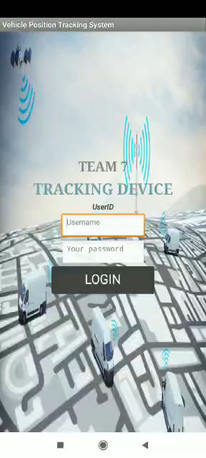 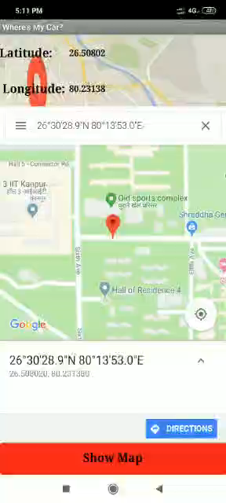

**(Android Application)**

**This GPS module is then attached to the surveillance robot for getting the live location in the android app.**

**Surveillance Robot**

* **Connections:**

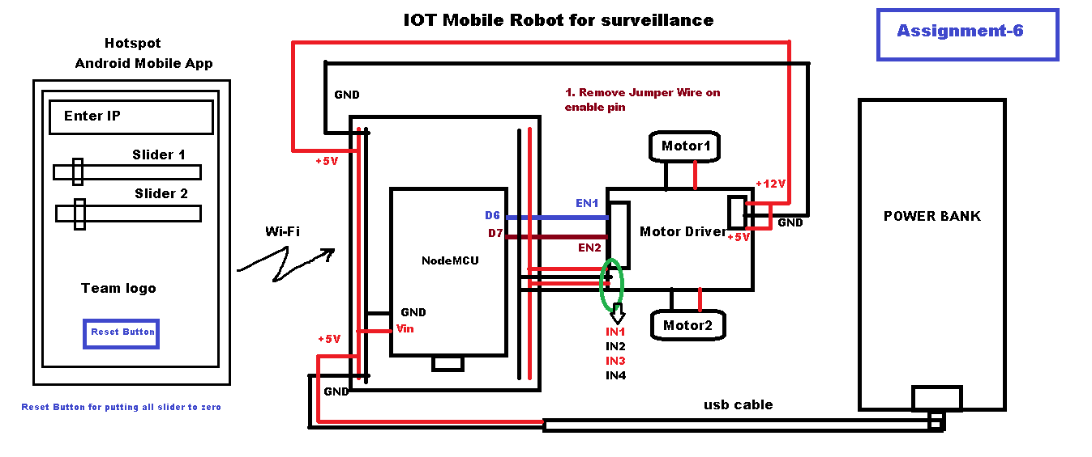

* **OVERVIEW**
* For making the robot avoid obstacles in path so that it can be self-driven, we make use of Artificial Intelligence.
* In this process, we initially train the robot by our self by manually operating it in a particular area with some obstacles.
* We ourselves turn the robot in a desired direction when the robot approaches any obstacle.
* In this way we get a large number of learning data which shows the instantaneous speeds of both the left wheel and right wheel with the respective distances between SONAR and the obstacle. A piece of learning data is shown below:

### **Linear Regression Machine Learning Algorithm**

Linear Regression algorithm shows the relationship between 2 variables and how the change in one variable impacts the other. The algorithm shows the impact on the dependent variable on changing the independent variable. The independent variables are referred as explanatory variables, as they explain the factors the impact the dependent variable. Dependent variable is often referred to as the factor of interest or predictor.

#### **Advantages of Linear Regression Machine Learning Algorithm**

* It is one of the most interpretable machine learning algorithms, making it easy to explain to others.
* It is easy of use as it requires minimal tuning.
* It is the mostly widely used machine learning technique that runs fast.

#### **Applications of Linear Regression**

* **Estimating Sales**

Linear Regression finds great use in business, for sales forecasting based on the trends. If a company observes steady increase in sales every month - a linear regression analysis of the monthly sales data helps the company forecast sales in upcoming months.

* **Risk Assessment**

Linear Regression helps assess risk involved in insurance or financial domain. A health insurance company can do a linear regression analysis on the number of claims per customer against age. This analysis helps insurance companies find, that older customers tend to make more insurance claims. Such analysis results play a vital role in important business decisions and are made to account for risk.

Data Science Libraries in Python to implement Linear Regression – statsmodel and SciKit

Data Science Libraries in R to implement Linear Regression – stats

* **TRAINING**

While training of the robot we built a maze so that our robot could get all the possible type of data in a way that it could learn every type of scenario.

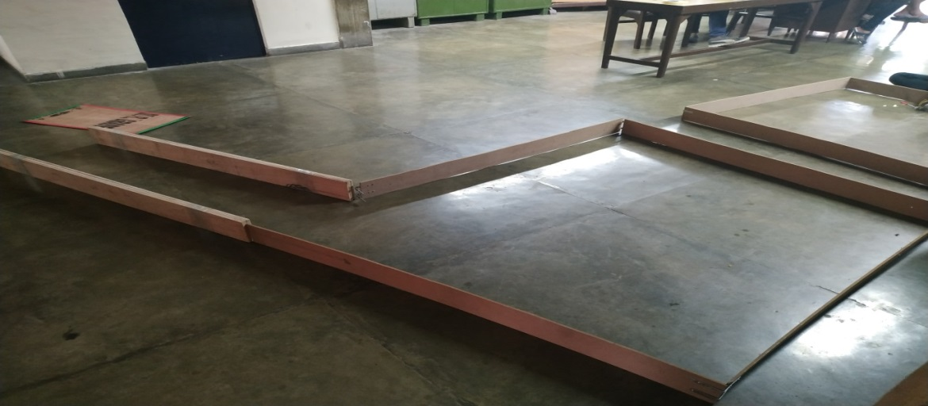

**CALCULATING THE WEIGHTS:**

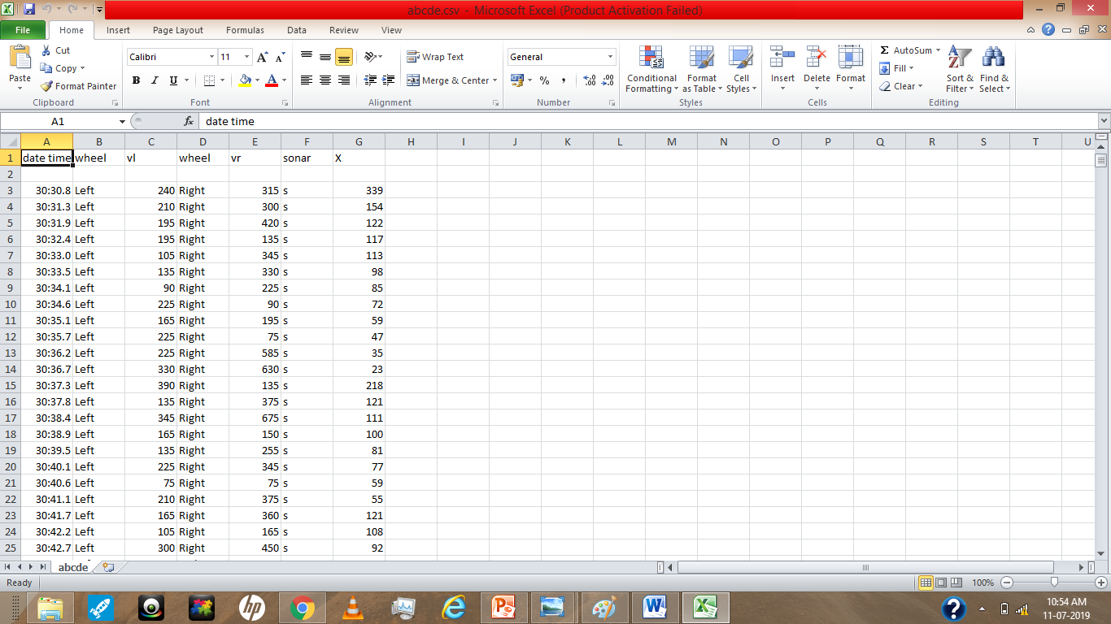

* Here after getting the learning data , we use it for calculating the weights by linear separatrix method.

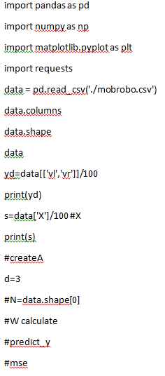

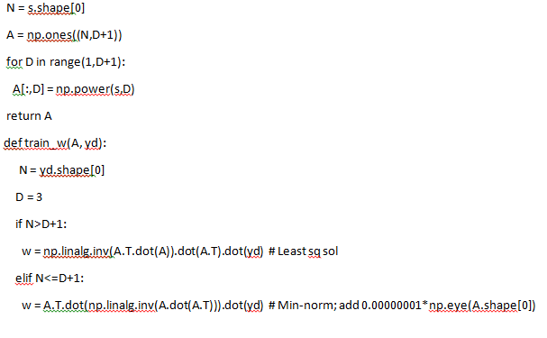

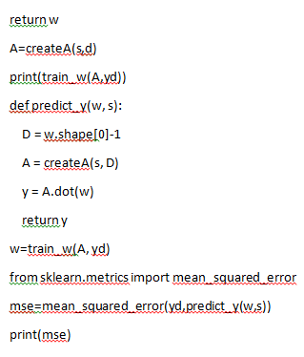

* Now, these weights are used in the AI algorithm for predicting the next values of speeds of both the left and right wheel.

Therefore as the instantaneous values of the ‘S’ parameter i.e. the distance between the SONAR and the object vary, the values of the speeds varies automatically.

**Here are the weight that has been calculated:**

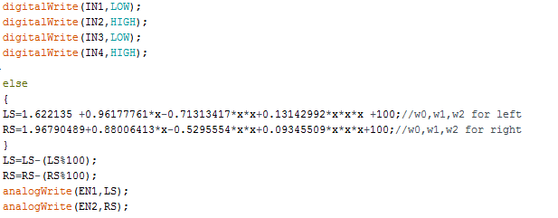

* **REVERSE FUNCTION**

We have added another feature of reversing the robot when  suddenly an object comes in front of it or if the robot gets too closer to any object.  
It can be reversed back in two possible ways depending on the distance of the obstacle that could be a full left reverse or a straight reverse.  
We also interfaced our project of Vehicle Positioning Tracking System to know the real time position of the robot.

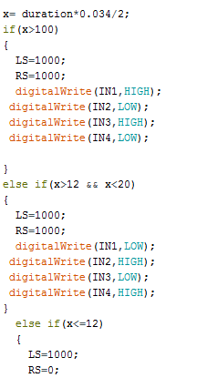

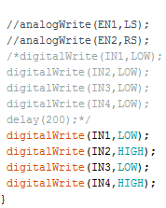

* **SURVELLIANCE FEATURE:**
* We have added a feature of visual surveillance to the robot as well so that it can be used for surveilling the surrounding of the robot.
* Here we have used a Servo motor for aligning the web camera accordingly so that can be controlled from anywhere globally.

Here’s the full Arduino code for the Surveillance Robot.

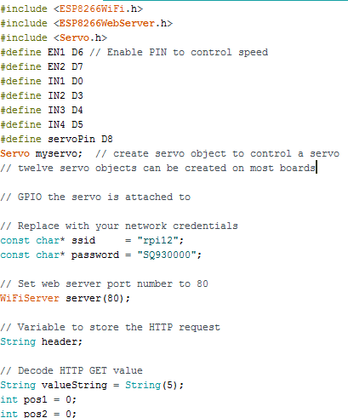

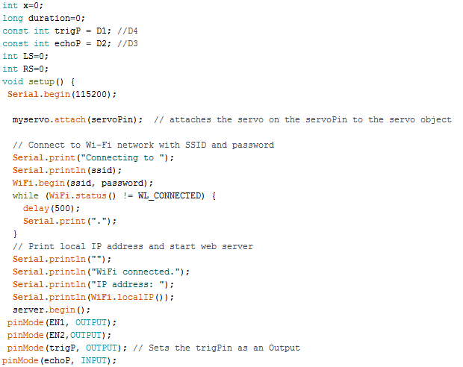

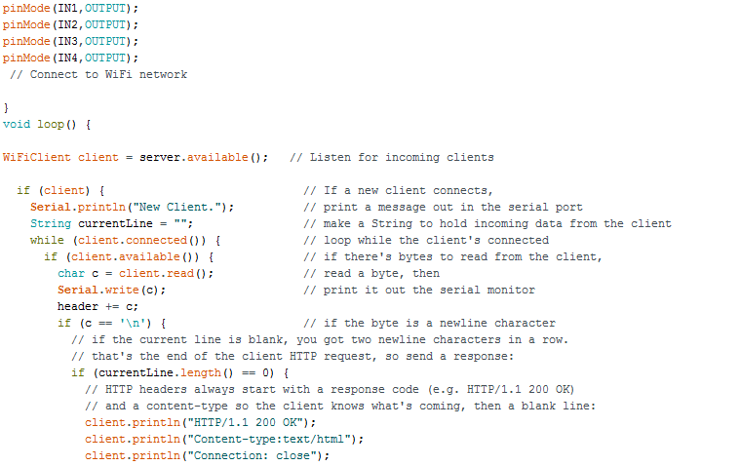

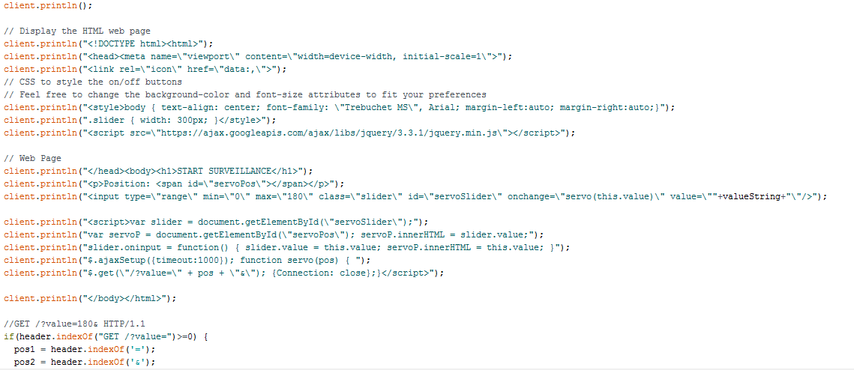

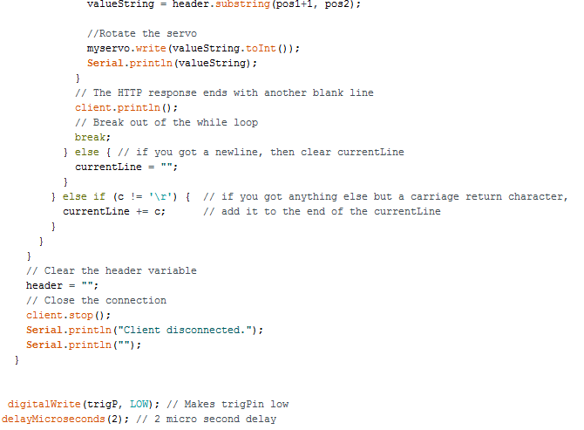

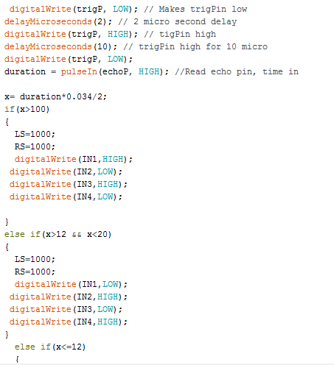

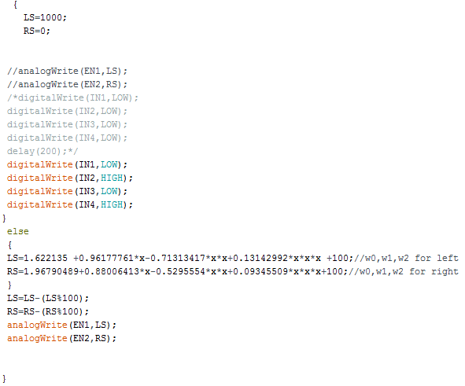

**Conclusion**

This device can update live location of our system and can show us the direction .We have installed this device in the robot by which we get updated with the live location that will help us in tracking our robot.

We have also installed web cam which will give us live footage and will help in getting real time footage of the surrounding.

This project gives the deep knowledge of the ARTIFICIAL INTELLIGENCE, MACHINE LEARNING and INTERNET OF THINGS.

All the above mentioned domains are properly applicable in the small model of the Survillance Robot.

* **Refrences:**

**HIMANSHU SINGH**

ISMRITI,CEO

Contact: **iit.himanshu@gmail.com**

***+91 8587-855-881***

**Prof. LAXMIDHAR BEHRA**

COURSE COORDINATOR