**Steps to Delete a B2C tenant.**

1. Login to your **Azure AD B2C Tenant**

2. Navigate to the **B2C settings** by typing “**b2c**” in the main search box in the Azure portal and select the **Azure AD B2C** link under **Services**.

*[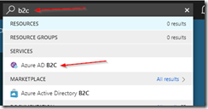](https://www.wintellect.com/wp-content/uploads/2018/08/image.png)*

3.  Navigate to **Applications**, **Identity Providers**, and **All Policies** and **delete all entries** under each of them.

*[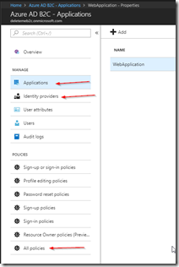](https://www.wintellect.com/wp-content/uploads/2018/08/image-1.png)*

4. Navigate to **Azure Active Directory** / **All Users** and then **delete each of the users** (except the one you are logged in as).

*[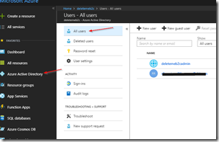](https://www.wintellect.com/wp-content/uploads/2018/08/image-2.png)*

5. Navigate to**Azure Active Directory** / **App Registrations** and make sure to select **All apps** from the dropdown (the default selection is ‘**My Apps**’ which hides the app we want to delete).

*[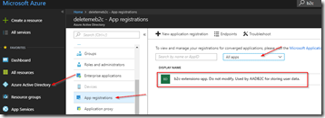](https://www.wintellect.com/wp-content/uploads/2018/08/image-3.png)*

6. Select the **b2c-extensions-app** App and then click **Delete** and confirm the deletion when prompted.

*[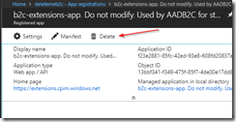](https://www.wintellect.com/wp-content/uploads/2018/08/image-4.png)*

7. Navigate to **Azure Active Directory** / **Overview** and click the **Delete Directory** button.

*[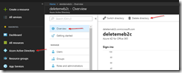](https://www.wintellect.com/wp-content/uploads/2018/08/image-5.png)*

8.  Here you will be prompted with a list of things that must be resolved before you can delete the directory.

*[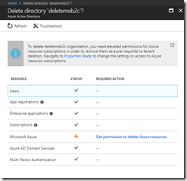](https://www.wintellect.com/wp-content/uploads/2018/08/image-6.png)*

9.  To resolve the **Microsoft Azure** entry that appears in the **Resource** column, click the link.  Then, change the permissions to **Yes** in the**Properties blade** and click **Save**.

*[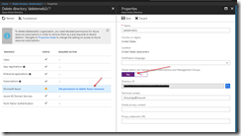](https://www.wintellect.com/wp-content/uploads/2018/08/image-7.png)*

10. Once Azure is complete with that operation, click the **Refresh** button and the issues should all be resolved allowing you to now click the **Delete** button to delete the directory.

*[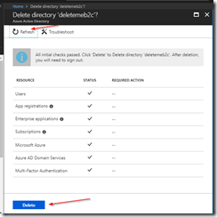](https://www.wintellect.com/wp-content/uploads/2018/08/image-8.png)*

Required Actions still listed for Enterprise Applications

If you are still seeing issues for Enterprise Applications, the culprit is likely **VSTS**. The issue is that sign-ons are still allowed for the VSTS Enterprise Application, so you have to turn this off.

*[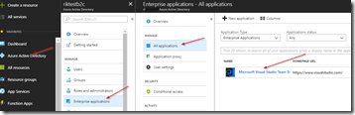](https://www.wintellect.com/wp-content/uploads/2018/08/image-9.png)  
[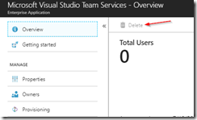](https://www.wintellect.com/wp-content/uploads/2018/08/image-10.png)*

Navigate to the **Properties** blade and set the **Enabled users for sign-in** switch to **No** and then click **Save**.

*[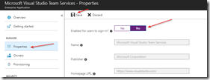](https://www.wintellect.com/wp-content/uploads/2018/08/image-11.png)*

Back on the **Overview** tab, the **Delete** button is still disabled.  However, if you repeat **Step 10** above you should now have the **Required Action** column empty for Enterprise applications and should be able to delete the directory now.