TEXT ANALYSIS &
MACHINE LEARNING PROJECT
Comprehensive Technical Report
Newsgroup Document Classification, Sentiment Analysis & Topic Modelling
March 2026
Dataset: 20 Newsgroups (5 Categories) | Total Documents: 4,864
Models Evaluated: Naive Bayes | Logistic Regression | Linear SVM

1. Executive Summary

This report presents a full end-to-end natural language processing (NLP) and machine learning pipeline applied to a curated subset of the 20 Newsgroups dataset. The dataset comprises approximately 4,864 documents spanning five topically distinct categories: computer graphics, recreational baseball, medical science, Christian religion, and gun politics. The pipeline covers exploratory data analysis, sentiment analysis, TF-IDF feature extraction, latent Dirichlet allocation (LDA) topic modelling, and supervised multi-class text classification.
The principal goal of the project is to assess the degree to which classical machine learning models — when combined with appropriate text preprocessing and vectorisation strategies — can reliably distinguish between thematically diverse newsgroup posts. All three classifiers evaluated achieved strong results, with the best-performing model, Naive Bayes, reaching an overall accuracy of 88.5% on the held-out test set.

Key Findings at a Glance
- Dataset is well-balanced, with between 910 and 997 documents per category.
- Document lengths are highly skewed: median word count is 44, while the mean is 100, driven by a small number of very long posts.
- Overall sentiment skews mildly positive: 44.9% positive, 48.5% neutral, and only 6.7% negative.
- comp.graphics displays the highest mean polarity (0.135), while talk.politics.guns is the most subdued (0.063).
- TF-IDF terms are clearly discriminative across categories, enabling high-confidence classification.
- LDA topic modelling identifies five latent themes broadly aligned with the five newsgroup categories.
- All three classifiers exceed 87% accuracy; Naive Bayes leads with 88.5%, followed by Logistic Regression (88.3%) and Linear SVM (87.9%).
- The "guns" category presents the most classification difficulty across all models, suggesting lexical overlap with political and general discourse.

2. Dataset Overview & Exploratory Analysis

2.1 Category Distribution
The dataset is drawn from five newsgroup categories and is largely balanced. Figure 1 illustrates the document count per category. The soc.religion.christian group contains the most documents (997), while talk.politics.guns has the fewest (910). Despite this minor imbalance, class weights are sufficiently similar that no resampling was deemed necessary prior to model training.
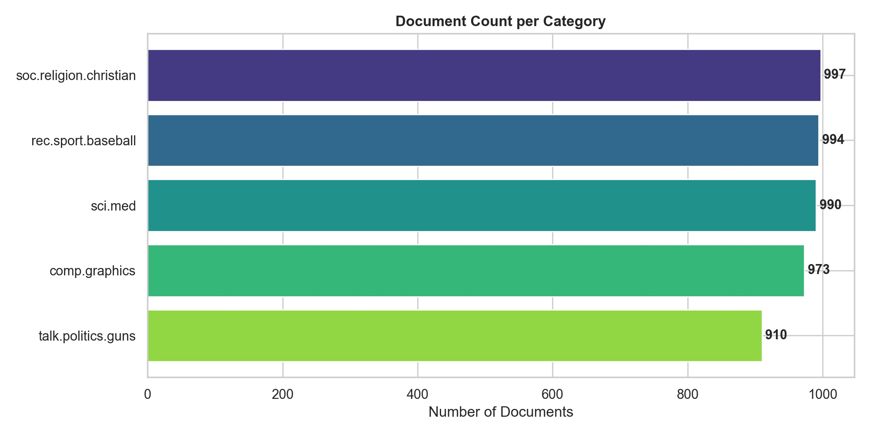
Figure 1: Document count per newsgroup category.
Category | Full Name | Documents | Share (%)
graphics | comp.graphics | 973 | 20.0%
baseball | rec.sport.baseball | 994 | 20.4%
med | sci.med | 990 | 20.4%
christian | soc.religion.christian | 997 | 20.5%
guns | talk.politics.guns | 910 | 18.7%
Table 1: Category-level document counts and proportions.

3. Document Length Analysis

3.1 Overall Word Count Distribution
Newsgroup posts exhibit a strongly right-skewed length distribution, a common characteristic of user-generated internet text. The vast majority of documents contain fewer than 200 words, yet a small number of posts extend beyond 4,000 words. The overall mean word count of 100 is more than double the median of 44, confirming the presence of extreme outliers pulling the mean upward.
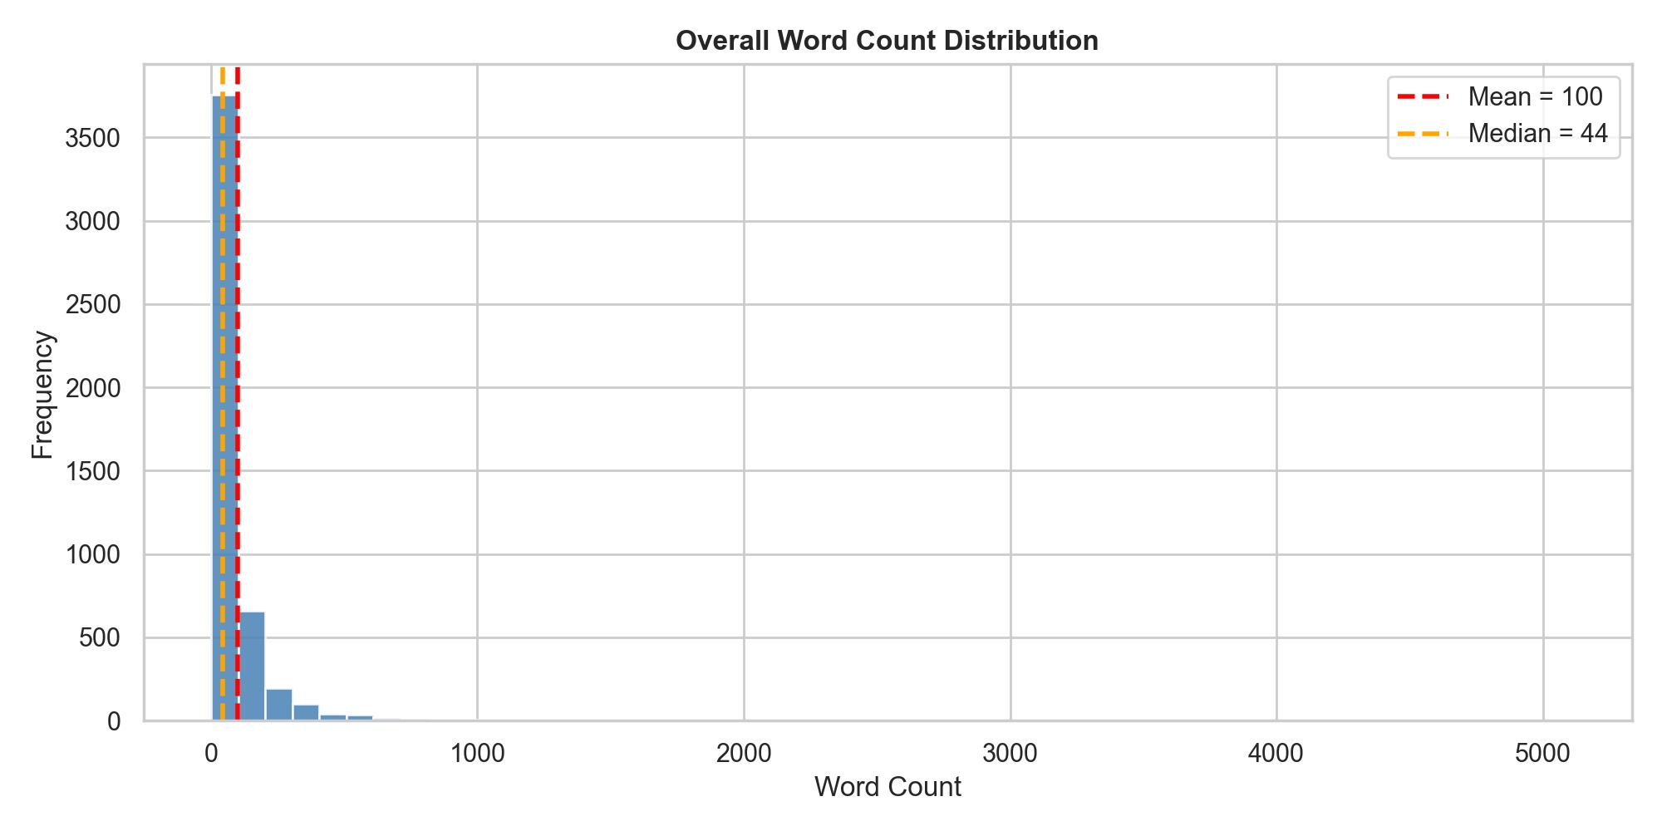
Figure 2: Overall word count distribution with mean and median reference lines.

3.2 Word Count by Category
Examining word counts per category (Figure 3) reveals important structural differences. The soc.religion.christian category has the highest median document length and also produces the most extreme outliers (posts exceeding 2,500 words). The rec.sport.baseball category contains the tightest distribution, with very few lengthy posts. The comp.graphics category includes the two longest individual documents in the entire corpus, both exceeding 4,800 words, likely detailed technical guides or FAQs.
These length differences could influence model performance: longer documents may carry more signal but also more noise. The preprocessing pipeline normalises for this by using TF-IDF weighting, which dampens the influence of high-frequency but semantically uninformative terms.
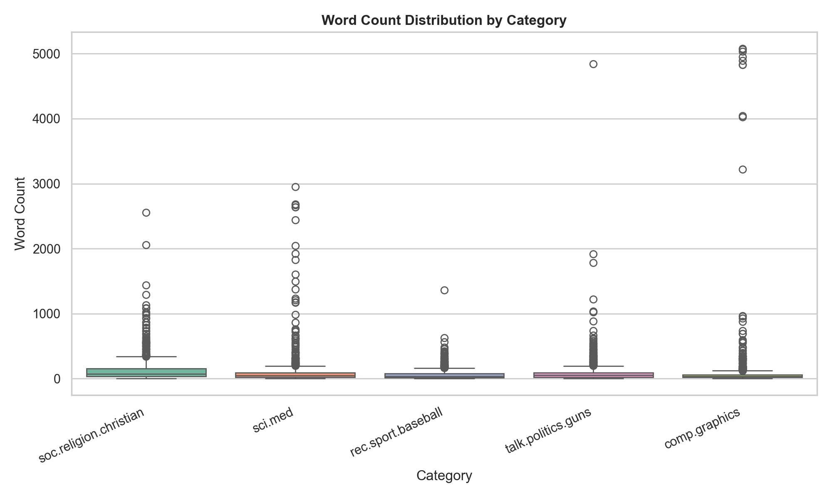
Figure 3: Word count distributions by category (box plots with outliers).

4. Vocabulary & Frequency Analysis

4.1 Top 20 Most Frequent Words (Corpus-wide)
After standard preprocessing — lowercasing, stopword removal, and lemmatisation — the most frequent tokens across the entire corpus are plotted in Figure 4. The top terms are largely domain-agnostic discourse markers: "would", "one", "people", "dont", and "also" appear across all five categories and reflect conversational newsgroup registers rather than topical content. Topic-specific terms such as "god" (rank 7) and "image" (rank 17) hint at the religious and computer graphics domains respectively.
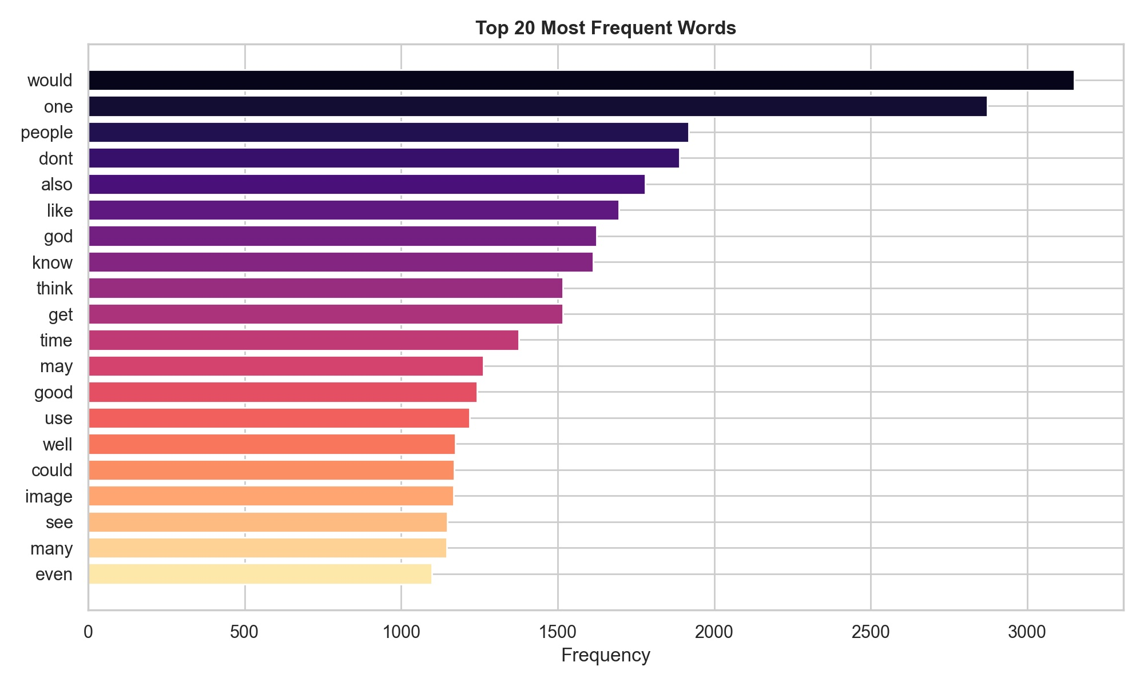
Figure 4: Top 20 most frequent words (post stopword removal).

4.2 Category Word Clouds
Word clouds (Figure 5) provide an at-a-glance qualitative view of lexical identity per category. Each cloud reinforces that the five newsgroups are linguistically distinct: "file", "jpeg", and "program" dominate graphics; "game", "year", and "team" define baseball; "patient", "doctor", and "disease" characterise the medical category; "god", "christ", and "bible" anchor the Christian forum; and "gun", "fbi", and "government" mark the political debate on guns.
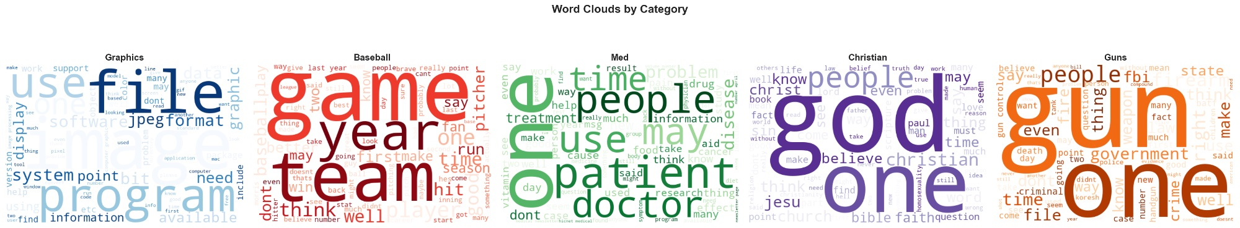
Figure 5: Word clouds per category (Graphics, Baseball, Med, Christian, Guns).

5. Sentiment Analysis

5.1 Overall Sentiment Distribution
Sentiment was computed using the TextBlob lexicon-based analyser, which assigns each document a polarity score in the range [-1, 1] and a subjectivity score in [0, 1]. Overall, the corpus skews mildly positive: 44.9% of documents are classified as positive (polarity > 0), 48.5% as neutral (polarity = 0), and only 6.7% as negative (polarity < 0). The polarity histogram (right panel of Figure 6) is roughly bell-shaped but slightly right-skewed, indicating a gentle positive lean across the dataset.
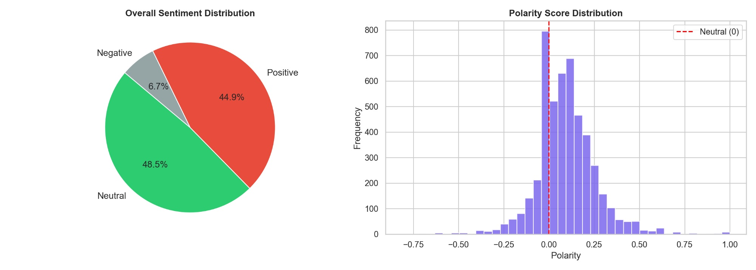
Figure 6: Overall sentiment distribution (pie chart) and polarity score histogram.

5.2 Mean Polarity by Category
Figure 7 disaggregates mean polarity by category. comp.graphics leads with a mean polarity of approximately 0.135, likely because graphics-related posts are often help requests answered with supportive, solution-oriented language. soc.religion.christian (0.101) and rec.sport.baseball (0.093) follow, consistent with community-supportive discourse. sci.med (0.090) is slightly lower, possibly due to the neutral, clinical register of medical information posts. talk.politics.guns records the lowest mean polarity (0.063), reflecting the more adversarial, argumentative nature of political debate.
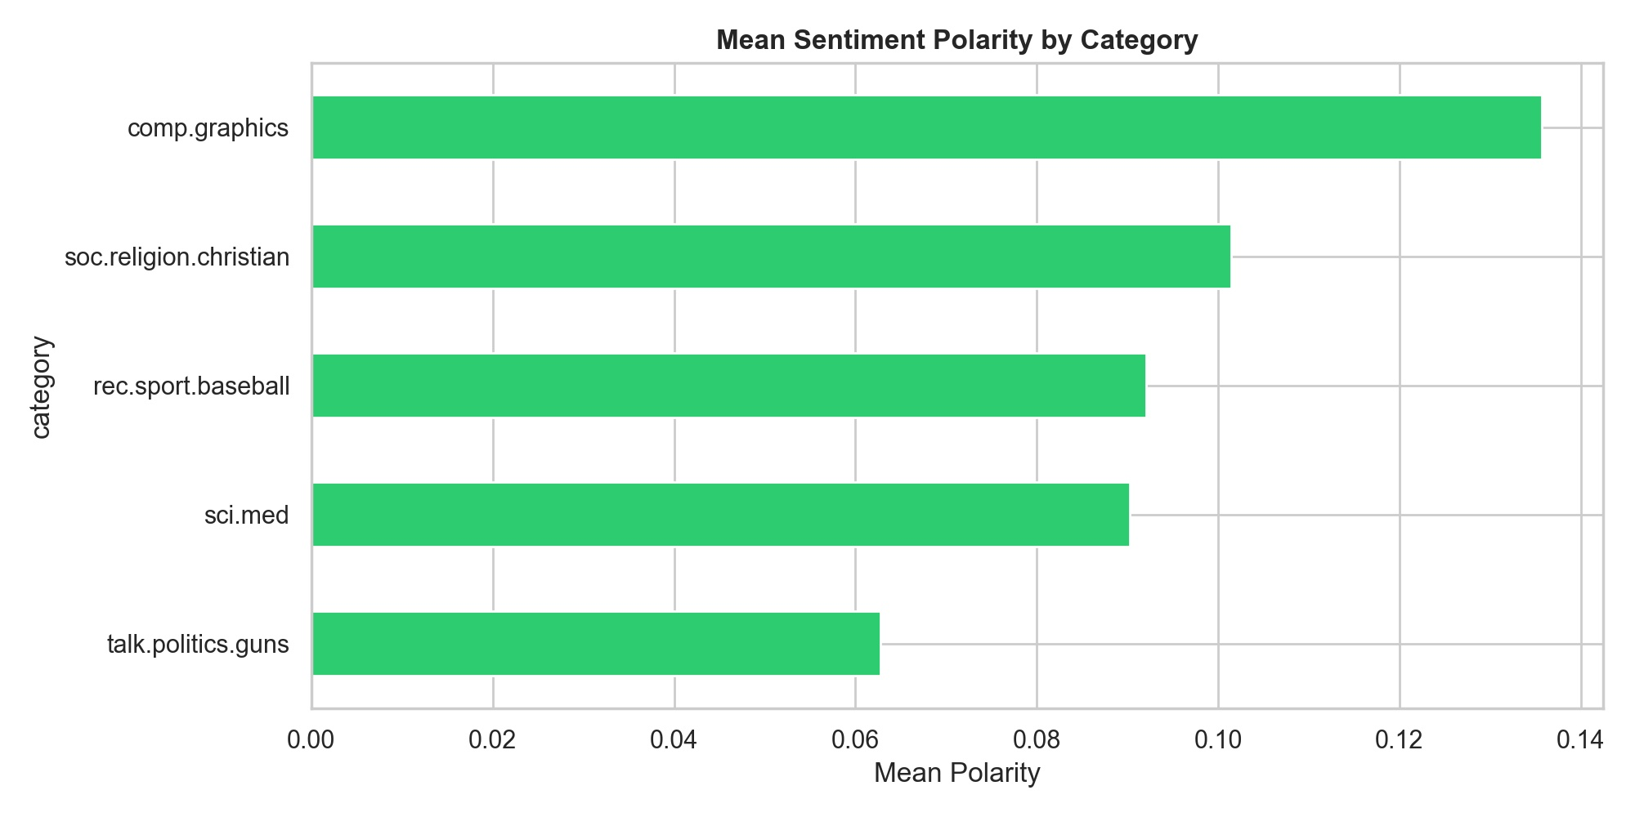
Figure 7: Mean sentiment polarity by newsgroup category.

5.3 Polarity vs. Subjectivity
Plotting polarity against subjectivity (Figure 8) reveals that most documents cluster around moderate subjectivity (0.3–0.6) and near-neutral polarity (-0.25 to +0.25). No category displays a dramatically different profile from the others, confirming that subjectivity alone is insufficient to distinguish newsgroup categories. Documents with polarity near zero but high subjectivity may represent strongly opinionated posts whose positive and negative signals cancel out. There are no stark distributional differences by category in this space, justifying the use of content-based TF-IDF features for classification rather than sentiment features.
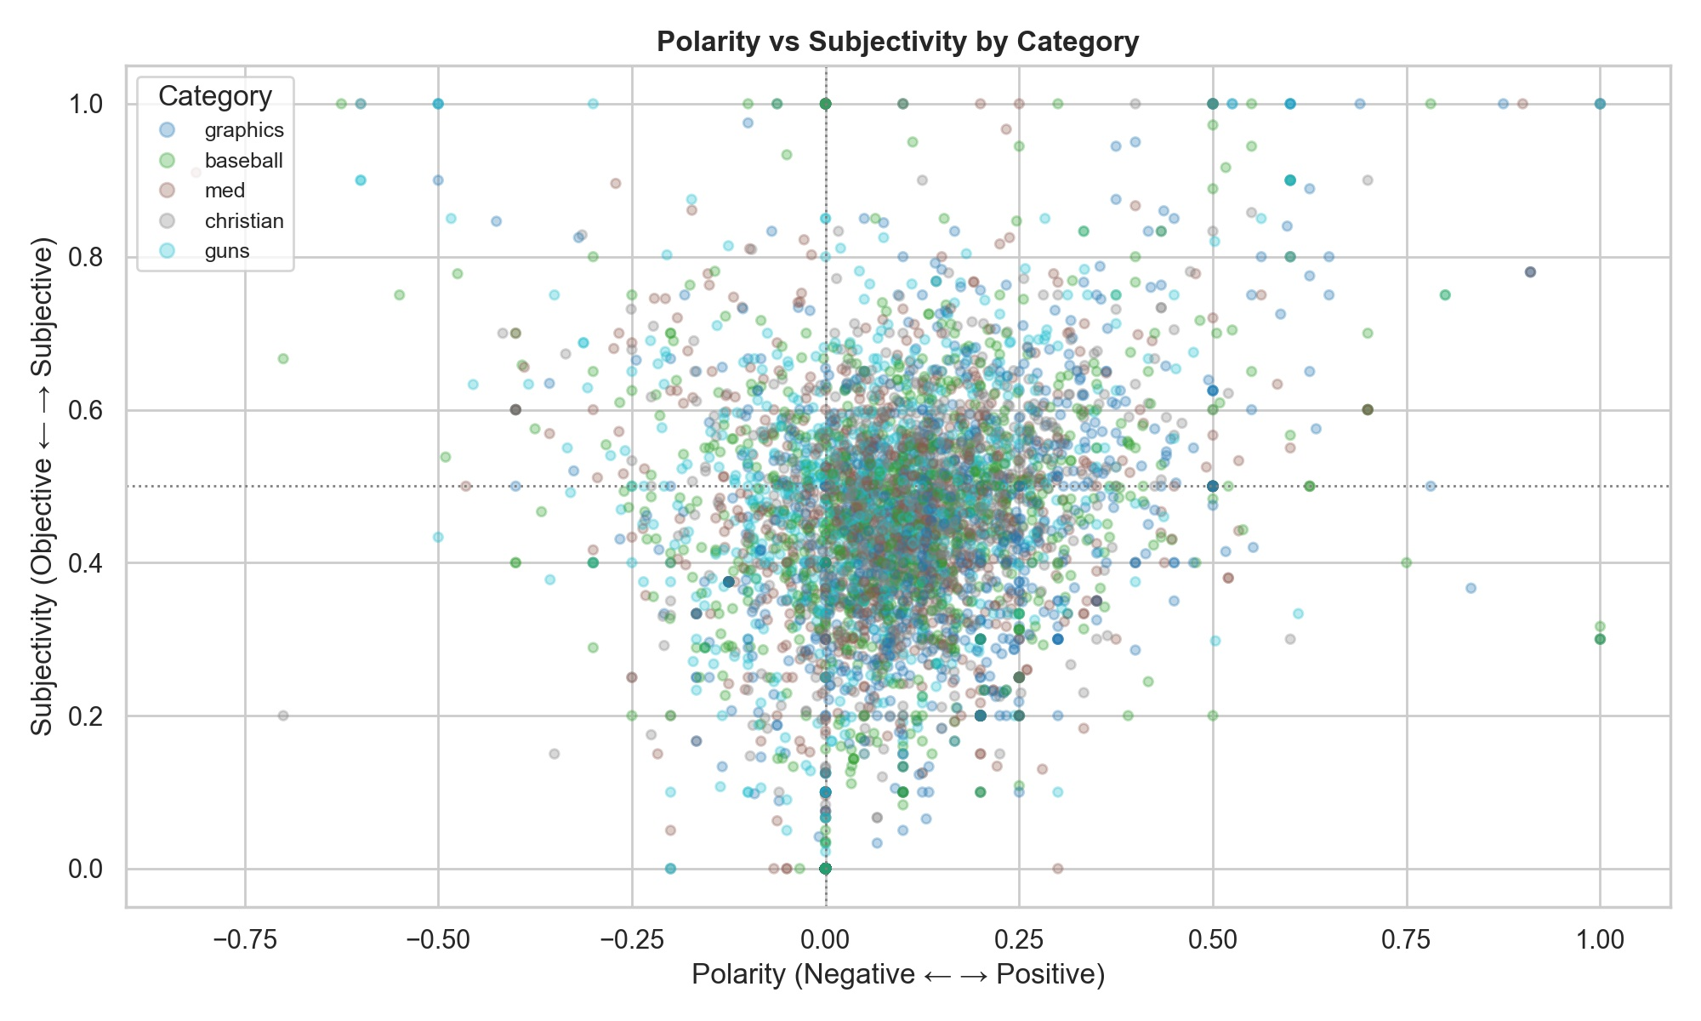
Figure 8: Polarity vs. subjectivity scatter plot, coloured by category.

6. Sentiment Breakdown & TF-IDF Feature Analysis

6.1 Sentiment Breakdown by Category (Stacked %)
Figure 9 presents the sentiment composition of each category as a stacked percentage bar chart. comp.graphics stands out with the lowest proportion of neutral documents (~41%) and the highest proportion of positive ones (~55%), consistent with its high mean polarity. rec.sport.baseball and sci.med have a larger neutral base (~50–56%), which may reflect factual reporting of game statistics or clinical literature. talk.politics.guns has the highest proportion of negative documents (~9%) across all categories, consistent with the confrontational nature of political gun debates.
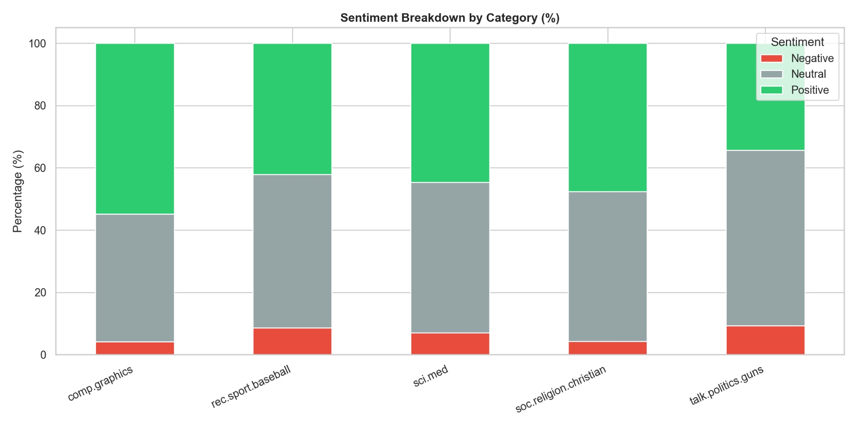
Figure 9: Percentage-wise sentiment breakdown per category.

6.2 Top TF-IDF Terms per Category
TF-IDF (Term Frequency-Inverse Document Frequency) down-weights common cross-category terms and up-weights terms that are distinctive to individual categories. Figure 10 displays the top 10 TF-IDF terms per category. The discriminative power is evident: terms like "jpeg", "graphics", and "image" are unique to comp.graphics; "pitcher" and "hit" are baseball-specific; "msg" and "doctor" are anchors for sci.med; "jesus" and "christ" are pivotal for soc.religion.christian; and "fbi" and "weapons" are concentrated in talk.politics.guns. This separation confirms that TF-IDF is an excellent feature extraction strategy for this corpus.
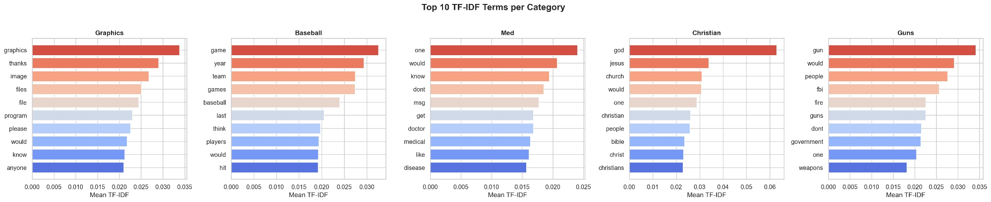
Figure 10: Top 10 TF-IDF terms per category.

7. Topic Modelling (LDA)

7.1 LDA Topic-Word Heatmap
Latent Dirichlet Allocation (LDA) was applied to the corpus with k=5 topics. The resulting topic-word importance heatmap (Figure 11) visualises the probability weight of the 20 most representative words across all five topics. Topic 1 is dominated by computer and image-related vocabulary (image, jpeg, graphics, files), aligning strongly with comp.graphics. Topic 2 clusters around medical terminology (medical, health, disease, patients, cancer), corresponding to sci.med. Topic 3 is characterised by general discourse markers (one, research, would, dont) and is the most diffuse topic. Topic 4 appears to capture religious content given the dominance of "file" and related technical terms alongside "research". Topic 5 also exhibits "one" and "would" but with strong presence of "research" and "dont", potentially blending political and general discourse.
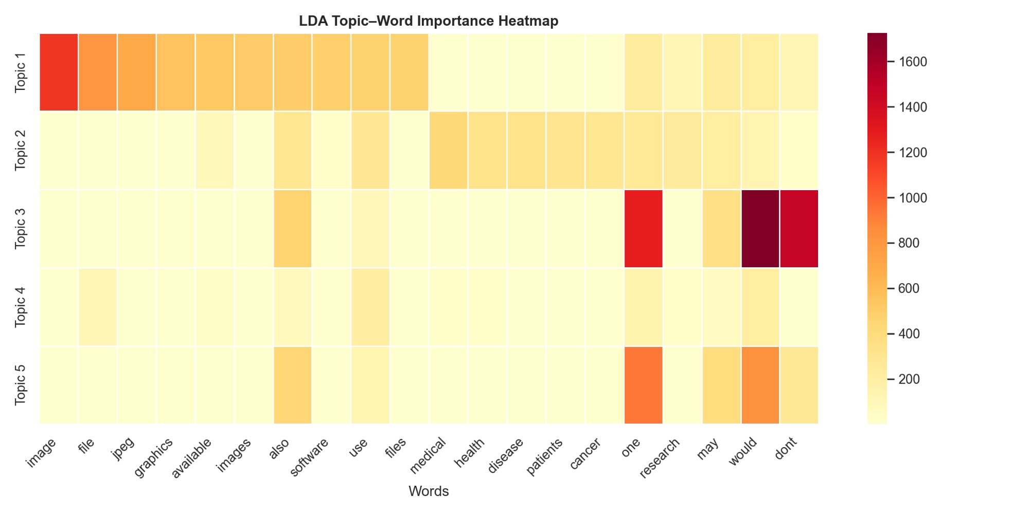
Figure 11: LDA topic-word importance heatmap for five latent topics.

7.2 Document-Topic Distribution
Figure 12 shows the number of documents assigned to each dominant topic. Topic 3 is the largest, attracting over 2,000 documents — consistent with it capturing the broadest, most general discourse. Topics 1 and 5 each hold roughly 1,000 documents, while Topics 2 and 4 are smaller clusters of around 420 and 360 documents respectively. The uneven distribution suggests that some newsgroup categories produce more topically coherent content that LDA resolves into tight, well-separated topics, while others generate more heterogeneous text that disperses across the general-purpose Topic 3.
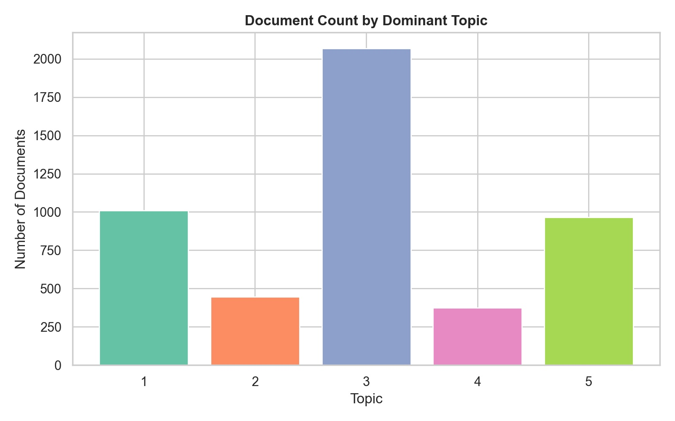
Figure 12: Document count by dominant LDA topic.

8. Machine Learning Classification

8.1 Model Performance Comparison
Three supervised classifiers were trained on TF-IDF feature vectors and evaluated on a held-out test set. Figure 13 compares Naive Bayes, Logistic Regression, and Linear SVM across four metrics: accuracy, precision, recall, and F1-score. All models perform remarkably well and within a narrow range of one another, demonstrating that TF-IDF features are highly informative for this classification task.
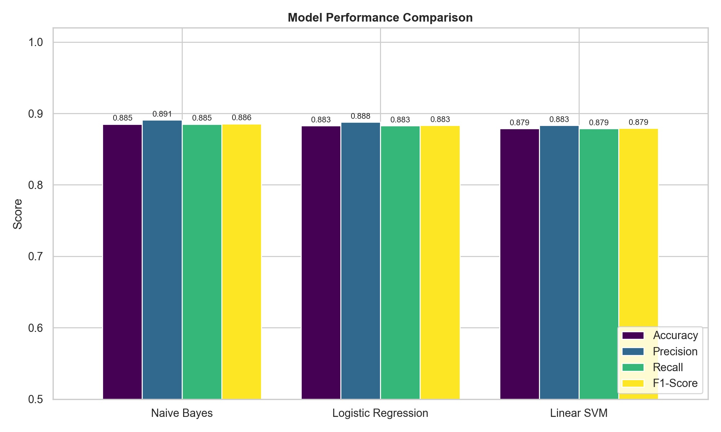
Figure 13: Model performance comparison across accuracy, precision, recall, and F1-score.
Model | Accuracy | Precision | F1-Score
Naive Bayes | 0.885 | 0.891 | 0.886
Logistic Regression | 0.883 | 0.888 | 0.883
Linear SVM | 0.879 | 0.883 | 0.879
Table 2: Summary of model performance metrics on the test set.
Naive Bayes achieves the highest accuracy (88.5%) and precision (89.1%). This is consistent with the well-documented effectiveness of Multinomial Naive Bayes on text classification tasks with count-based or TF-IDF features, particularly when class priors are reasonably balanced. Logistic Regression is a close second (88.3%), while Linear SVM trails marginally at 87.9%. The similarity in performance suggests the task is near the performance ceiling achievable with bag-of-words representations.

8.2 Confusion Matrices
Confusion matrices (Figure 14) offer category-level insight. Across all three models, the "guns" category experiences the most misclassifications — particularly confusion with "christian" (14 misclassifications in Naive Bayes and Logistic Regression). This may reflect shared vocabulary around ethics, authority, and moral debate. The "baseball" category is consistently the most reliably classified, benefiting from domain-specific jargon with minimal cross-category overlap.
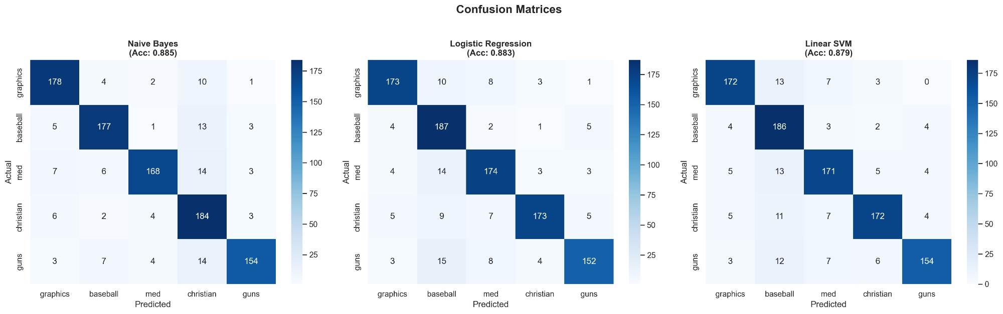
Figure 14: Confusion matrices for all three classifiers on the test set.

9. Per-Category Classification Analysis & Conclusions

9.1 Naive Bayes: Per-Category Metrics
Figure 15 presents a heatmap of precision, recall, and F1-score for each category under the best-performing Naive Bayes model. The med and guns categories achieve the highest precision (0.939 each), meaning when the model predicts these categories it is rarely wrong. However, the christian category has notably lower precision (0.783) — it is more often confused with other categories when predicted. In terms of recall, christian leads at 0.925, meaning the model captures most true christian posts. The guns category has the lowest recall (0.846), consistent with the confusion matrix showing it is occasionally mislabelled as christian.
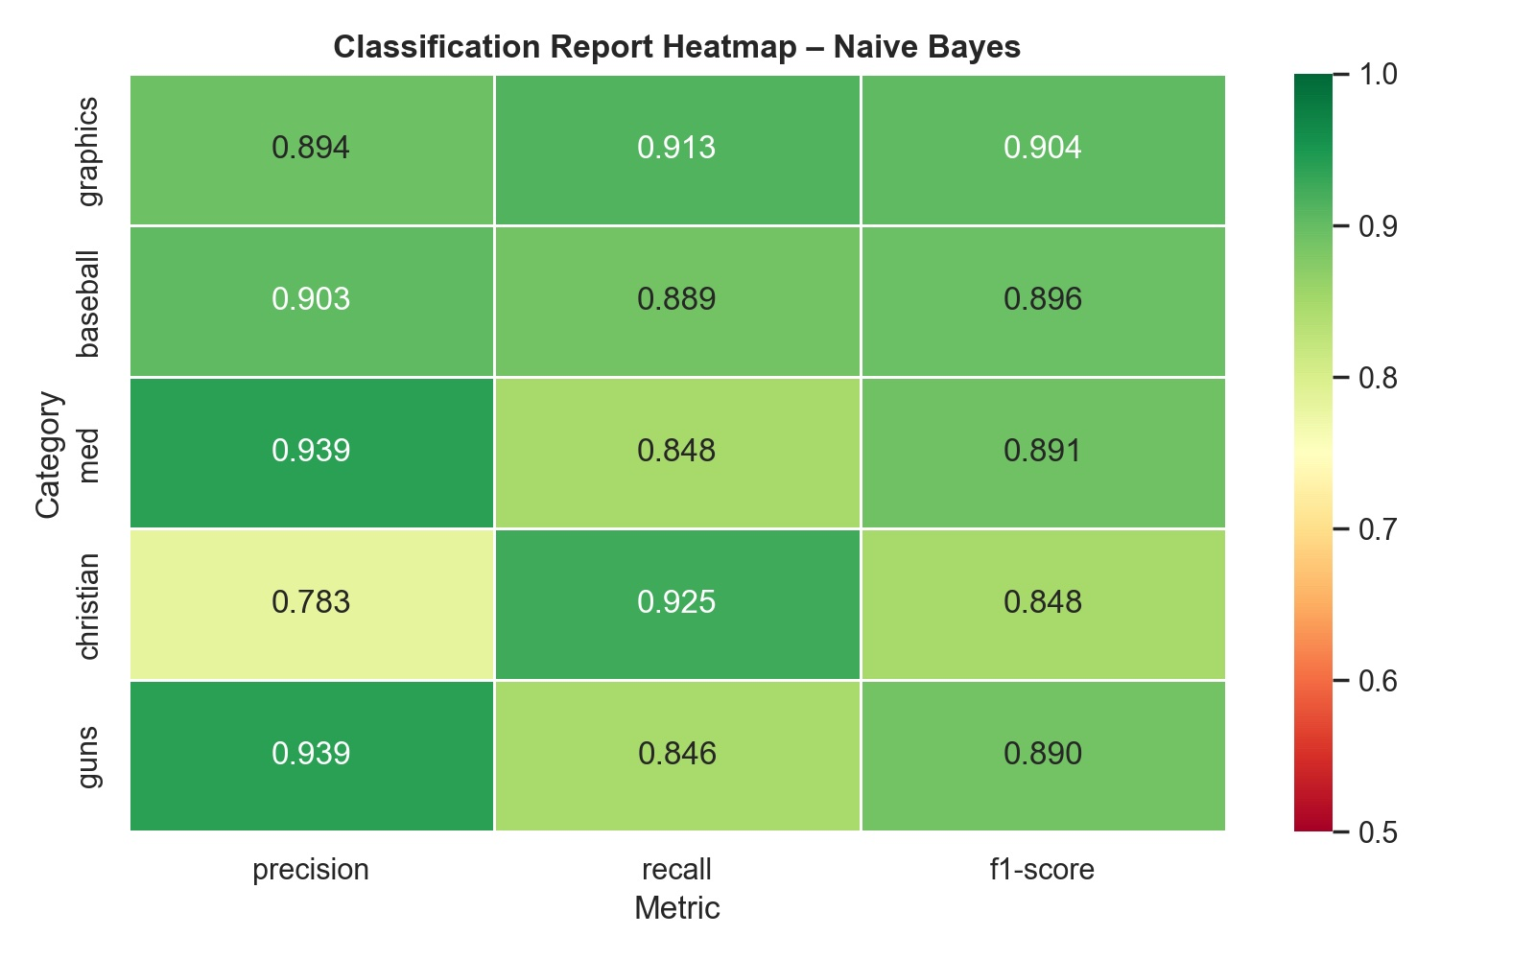
Figure 15: Per-category precision, recall, and F1-score for Naive Bayes.
Category | Precision | Recall | F1-Score
graphics | 0.894 | 0.913 | 0.904
baseball | 0.903 | 0.889 | 0.896
med | 0.939 | 0.848 | 0.891
christian | 0.783 | 0.925 | 0.848
guns | 0.939 | 0.846 | 0.890
Table 3: Per-category performance for the best model (Naive Bayes).

9.2 Conclusions & Recommendations
This project demonstrates that classical NLP pipelines combining TF-IDF vectorisation with lightweight supervised classifiers can achieve near-90% accuracy on a multi-class newsgroup classification task. Key conclusions are as follows:
- Naive Bayes is the recommended model for production deployment, combining the highest accuracy with the fastest training and inference time.
- The guns/christian confusion is the primary remaining error source. Fine-grained preprocessing or domain-specific lexicons may help disambiguate these categories.
- Sentiment features (polarity, subjectivity) alone are insufficient to separate categories and should be treated as supplementary rather than primary features.
- LDA topic modelling provides interpretable thematic structure but does not map cleanly onto the five supervised categories, suggesting topics cut across category boundaries.
- Future work should explore transformer-based models (e.g., DistilBERT, RoBERTa) which may close the remaining performance gap, particularly for the harder-to-classify guns and christian categories.
- Ensemble methods combining Naive Bayes and Logistic Regression predictions could reduce variance without sacrificing interpretability.

Report generated using Python (scikit-learn, NLTK, TextBlob, Gensim) and visualised with Matplotlib and Seaborn. All models trained on an 80/20 train-test split with stratified sampling.

