MINI-PROJECT REPORT

SMART CANTEEN PRE-ORDER SYSTEM
(Conceptual Software Product for Module-Based Learning)

PAGE 1 – TITLE PAGE
B.Tech – 1st Year (CSE)
Course Title: Crafting Products
Mini Project: Smart Canteen Pre-Order System
Student Name: K NARSIMHA
Roll Number: 25RBAIM0008
Section: “A”
Faculty: MAHMOOD HUSSAIN SIR
College Name: MNR UNIVERSITY
Academic Year: 2025–2026

PAGE 2 – AIM / OBJECTIVE & ABSTRACT
AIM / OBJECTIVE (2–3 Lines)
The aim of this mini-project is to design a conceptual digital pre-ordering system that reduces long queues in the campus canteen by allowing students to order food in advance and pick it up instantly.

ABSTRACT
Long queues in college canteens lead to time wastage, overcrowding, and inconvenience for students, especially during short breaks. Most students miss meals or arrive late to class due to waiting time at the canteen.
This mini-project proposes a Smart Canteen Pre-Order System, a conceptual digital solution that allows students to select food, pay online, and collect orders without standing in queues.
The project applies Design Thinking, Computational Logic, and Product Thinking concepts. It also includes basic software architecture, UI/UX sketches, Agile & Scrum planning, testing strategies, and cloud deployment ideas.
The outcome is a queue-less, efficient, and student-friendly canteen experience, developed conceptually without actual coding.

PAGE 3 – INTRODUCTION
Canteens are an essential part of campus life, but they often face problems such as:
• Long queues during lunch breaks
• Time loss between classes
• Overcrowding and confusion
• Manual order handling
• Stress for students and staff
The Smart Canteen Pre-Order System solves these issues by allowing students to pre-order meals using a mobile or web application.
The system helps students:
• Save time
• Avoid queues
• Receive food instantly
• Experience faster service
This project integrates all 5 modules of the Crafting Products course, focusing on problem identification, logic design, system thinking, and product planning.

PAGE 4 – PROBLEM STATEMENT
Students face long waiting times in college canteens due to manual ordering systems, limited counters, and peak-hour crowding.
Common problems include:
• Standing in long queues
• Missing classes due to delays
• Uncertainty about food availability
• Inefficient order management
• Poor user experience
There is a need for a digital pre-ordering solution that makes food ordering fast, simple, and organized.

PAGE 5 – OBJECTIVES
The objectives of this mini-project are:
- To design a conceptual canteen pre-order system.
- To apply Design Thinking to understand student problems.
- To use Computational Logic for order flow design.
- To create a simple 3-tier software architecture.
- To design student-friendly UI screens.
- To apply Agile & Scrum methodology.
- To define basic testing strategies.
- To propose a cloud-based deployment model.

PAGE 6 – DESIGN THINKING APPLICATION
1. Empathize
Interviews and observations revealed that students need:
• Faster food service
• Less waiting time
• Clear order confirmation
• Reliable pickup timing

2. Define
Students lack a queue-free and time-efficient system to order food during peak hours.

3. Ideate
Proposed ideas:
• Pre-order food before break
• Online payment
• Pickup token system
• Order status notification

4. Prototype (Conceptual)
• UI screen sketches
• Order flow design
• Pickup process design

5. Test (Conceptual)
• Ask students if it reduces waiting time
• Improve flow based on feedback

PAGE 7 – COMPUTATIONAL LOGIC
Inputs
• Selected food items
• Quantity
• Payment method
• Pickup time
Logic Flow
- Select food
- Confirm order
- Make payment
- Generate pickup token
- Collect food
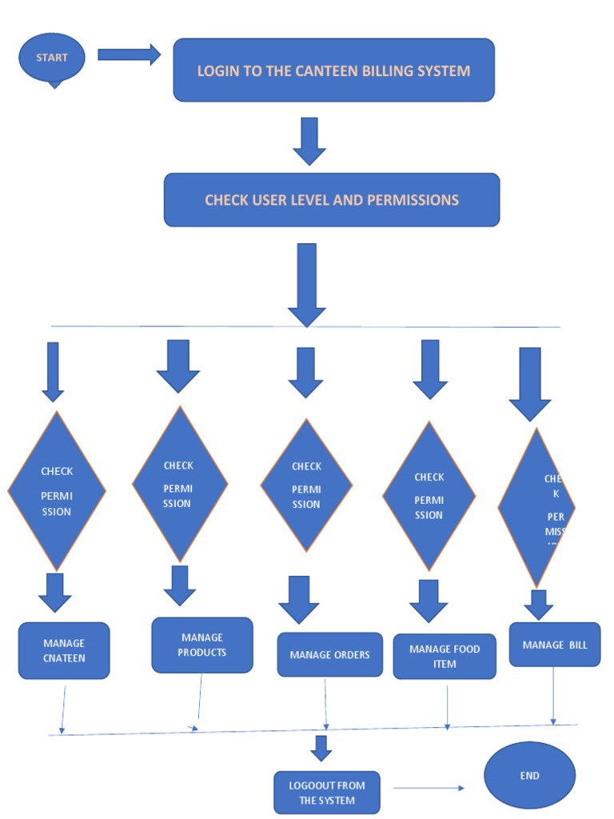
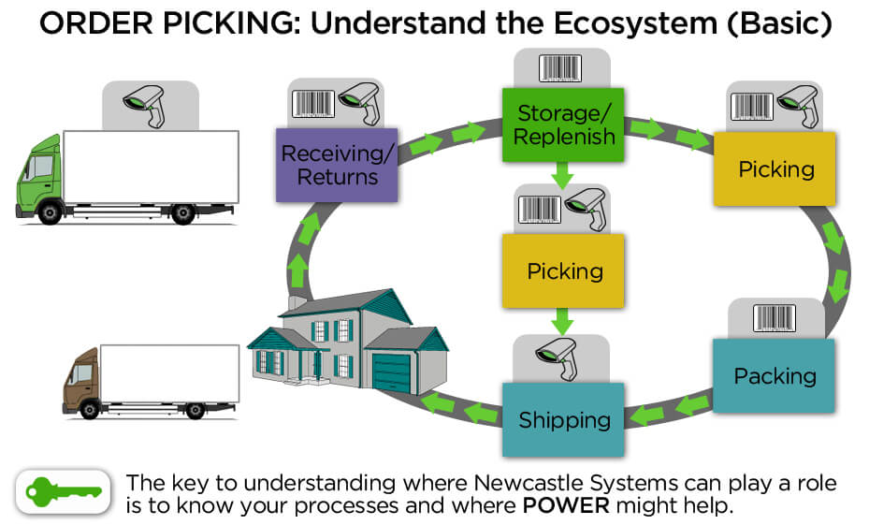
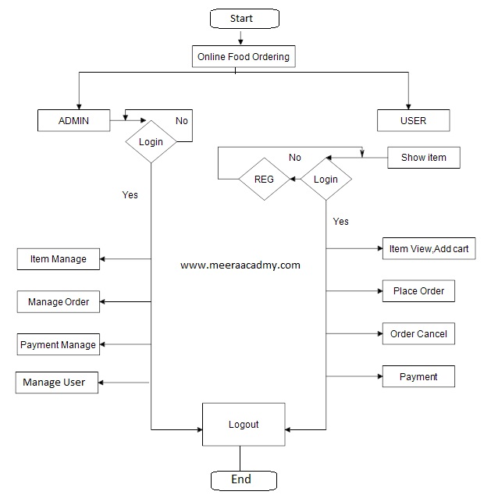

Algorithmic Steps (Simplified)
- Start
- Display menu
- User selects items
- Confirm total amount
- Process payment
- Generate order ID
- Notify canteen
- User picks up food
- End

PAGE 8 – SOFTWARE ENGINEERING APPROACH
SDLC Model Used: Agile
Why Agile?
• Frequent menu changes
• Fast feedback from students
• Small improvements possible

Functional Requirements
• F1: Display canteen menu
• F2: Food selection
• F3: Online payment
• F4: Order confirmation
• F5: Pickup token generation

Non-Functional Requirements
• N1: Fast response
• N2: Easy UI
• N3: Secure payment
• N4: Mobile friendly

PAGE 9 – SYSTEM ARCHITECTURE
3-Tier Architecture (Conceptual)
- Presentation Layer
• Mobile App / Web App
- Application Layer
• Order processing logic
• Payment handling
- Data Layer
• Menu database
• Order database

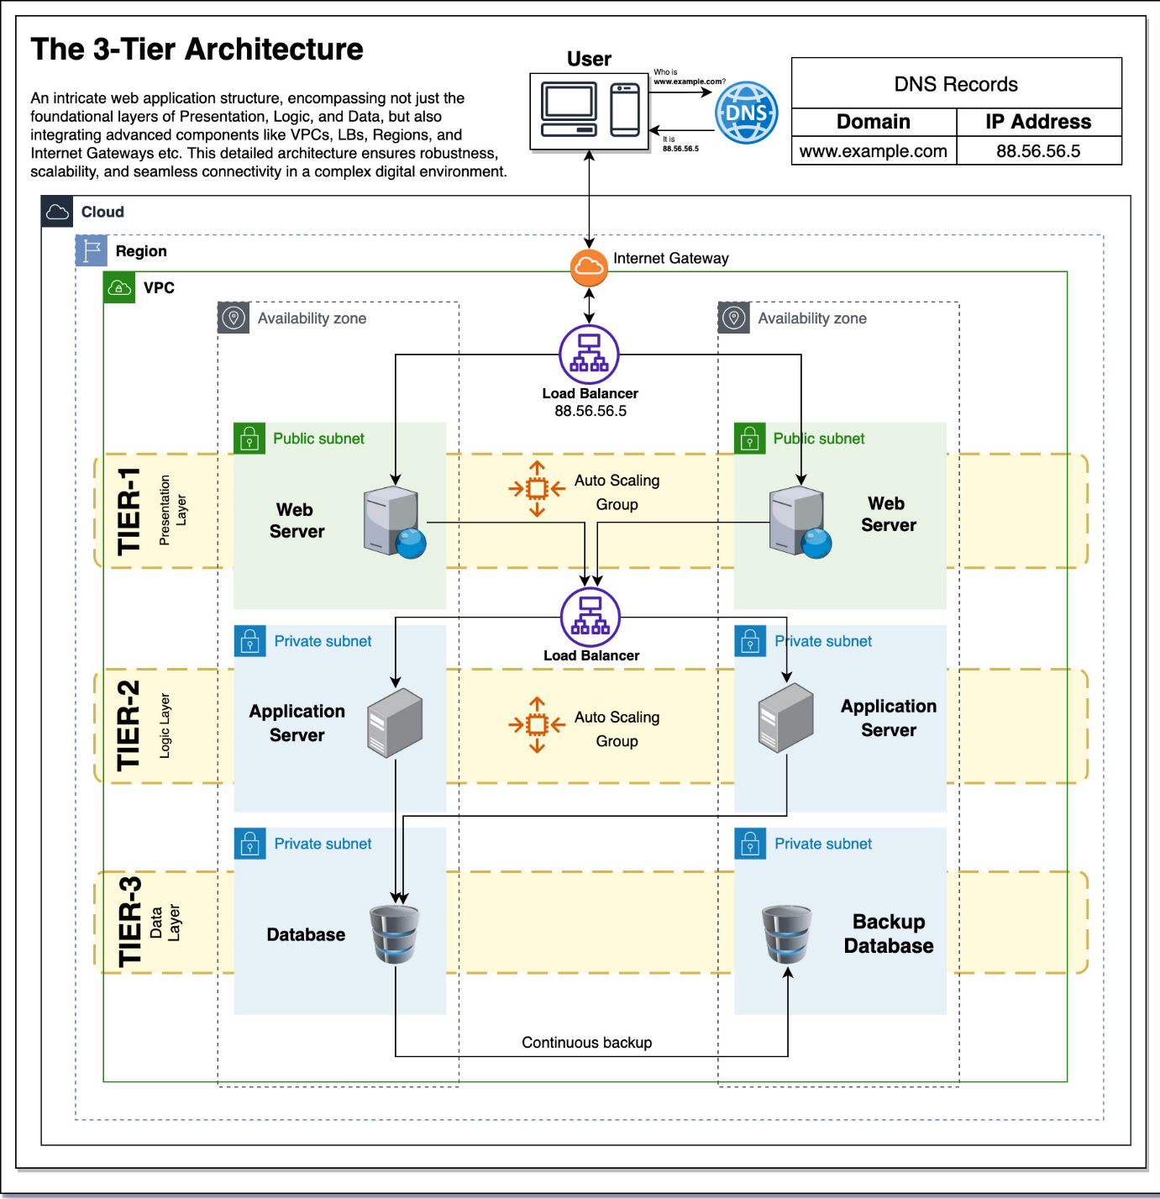
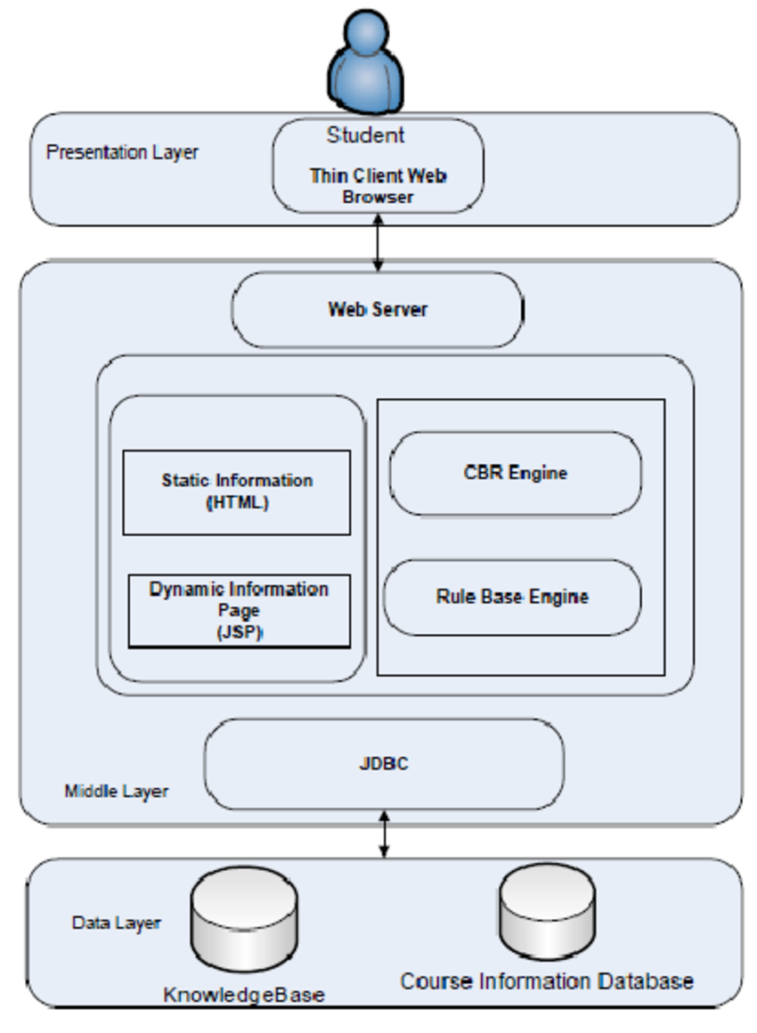

PAGE 10 – USER JOURNEY MAP
Persona: First-year student “Rahul”
Stage | Action | Emotion | Pain Points
1 | Opens app | Neutral | Hungry
2 | Selects food | Interested | Price concern
3 | Pays online | Relieved | Network
4 | Picks food | Happy | None

PAGE 11 – UI / UX DESIGN
Screens (Conceptual)
- Home Screen
• Menu
• Pre-Order
• My Orders
- Menu Screen
• Food items
• Price
• Add to cart
- Payment Screen
• Total amount
• Payment option
- Order Status Screen
• Order ID
• Pickup time
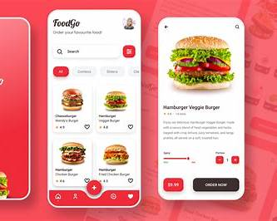

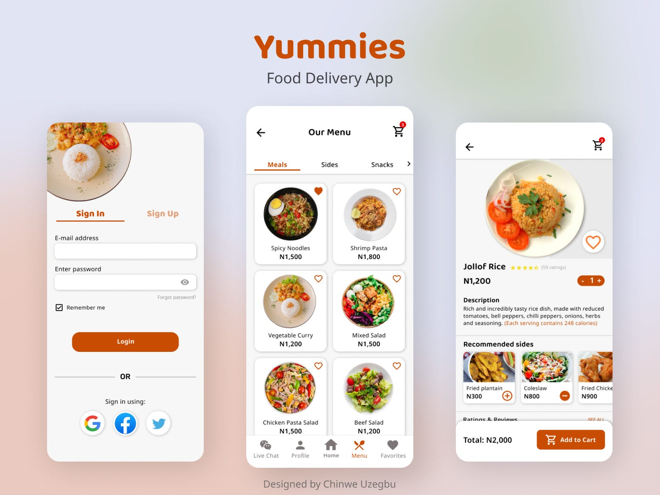

PAGE 12 – AGILE & SCRUM PLAN
Scrum Roles
• Product Owner: Student
• Scrum Master: Student
• Developer: Student
Sprint Duration
1 Week Sprint
Task | Description
T1 | Collect menu
T2 | Design flow
T3 | Architecture
T4 | UI sketches
T5 | Documentation

PAGE 13 – TESTING STRATEGIES
Functional Testing
• Order placement works
• Payment confirmation
• Correct order display
Usability Testing
• Simple navigation
• Clear buttons
Feedback
• Collect feedback from 3–5 students

PAGE 14 – CLOUD & DEPLOYMENT PLAN
Cloud Services (Conceptual)
• Backend: AWS Lambda
• Database: Firebase / AWS DynamoDB
• Frontend: Netlify
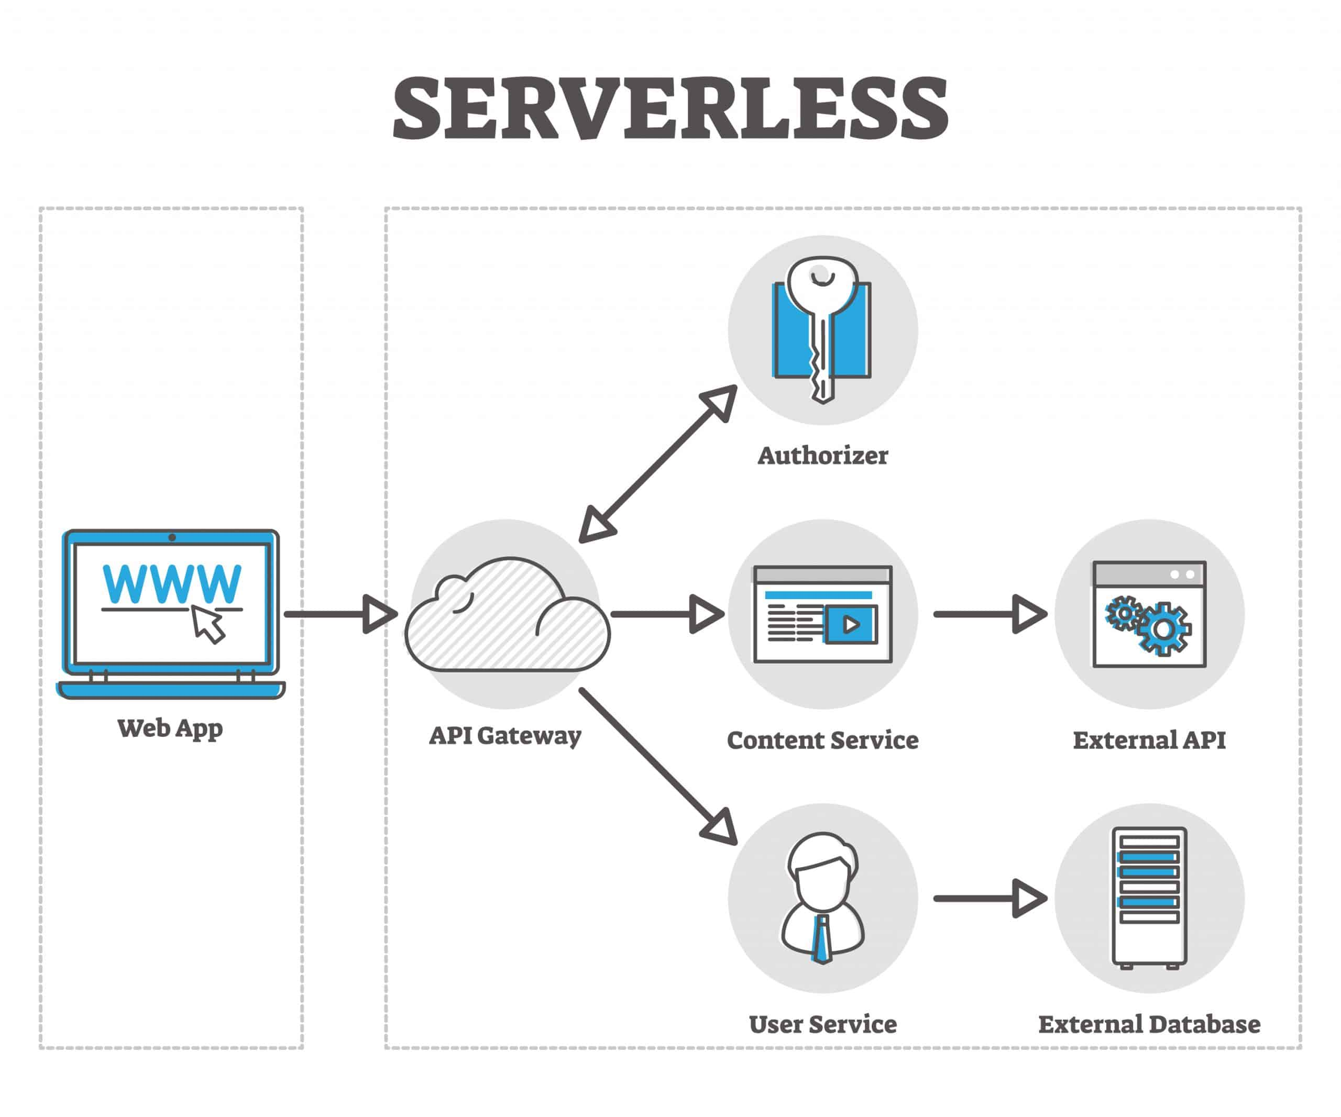
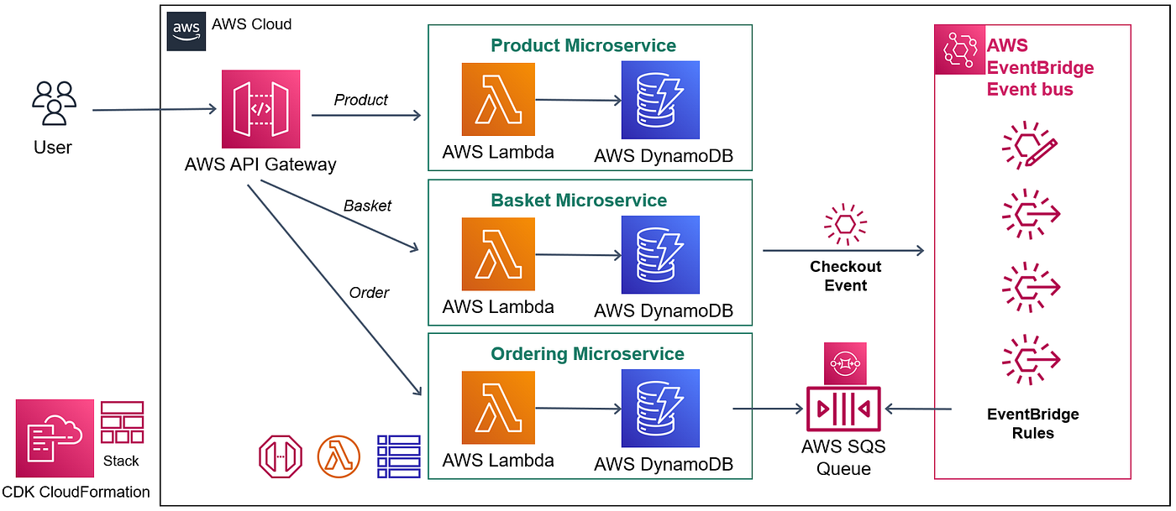
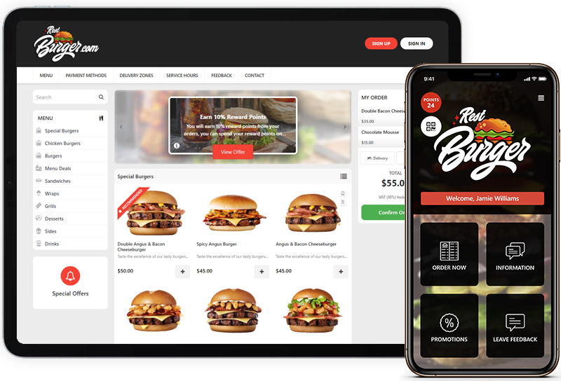

PAGE 15 – EXPECTED OUTCOME
Students will be able to:
• Pre-order food
• Avoid queues
• Save time
• Pick food instantly
Final Deliverable:
A conceptual Smart Canteen Pre-Order System that improves campus dining efficiency.

PAGE 16 – CONCLUSION
The Smart Canteen Pre-Order System shows how a real-world problem can be converted into a structured product idea using product thinking and design principles.
This project proves that coding is not mandatory to understand system design, logic, architecture, and cloud concepts—making it ideal for first-year students.

PAGE 17 – REFERENCES
- Google Material Design Guidelines
- Agile Manifesto
- Nielsen Norman Group – UX
- AWS Documentation – Serverless
- Figma UI Tutorials
- Swiggy / Zomato Ordering Flow
- Crafting Products Course Notes

