Advanced Analytics can help Retailer X get more market penetration and retain existing customer through effective loyalty program while attracting new customers by segmented marketing.

Customer Profile (Retailer X):
- Retailer X is boutique retailer with only one physical location in the Midwest
- They believe that their niche in the market is attributable to their unique flair on affordable everyday items including health and beauty, electronics, specialty treats and apparel
- Their marketing has been mostly word-of-mouth with a “surprise value” coupon sent to loyalty members, and an occasional coupon offered in support of local school fundraising efforts
- The retailer has interest in growing and potentially opening up their products via new channels, and is looking for some direction on an expansion strategy – they have heard about analytics, and want to see what it can do for them
Workshop outcome:
  - Customer wants to know what factors are associated with increased levels of spending in their stores
  - Customer also wants to know what drives participation in their coupon and loyalty programs
A recent survey conducted by the customer revealed the following:
  - poorer than expected store experience scores were driven by the stores failure to have appropriate amounts of stock on the shelves when demanded by their customers

Customer shared a sample data to help start analytics project –
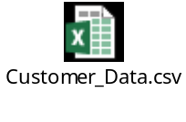
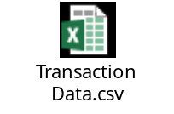
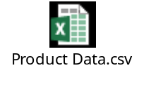

Project objective:
Taking advantage from the insights of the analytics project and operationalizing the top ranked recommendations would be the key to growth for customer (Retailer X).

