**Setup GitHub Local Workspace:**

Copy .git repo url from GitHub by clicking button as mentioned in this below image.

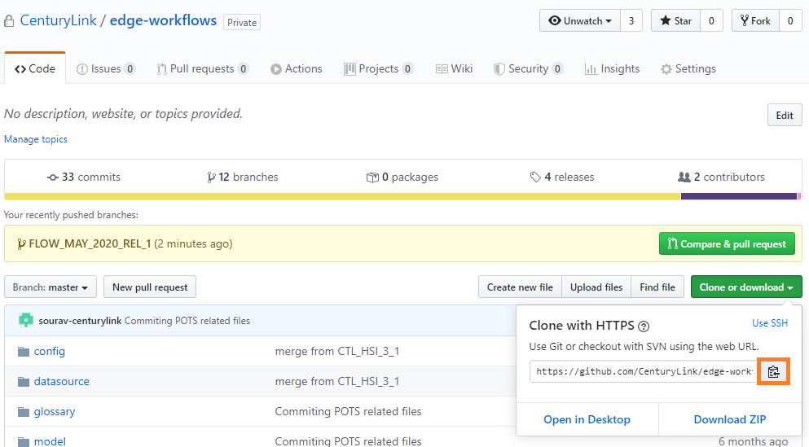

Checkout project with this below command, it will popup to enter credential for GitHub account. Once this is done, we should go to this page(<https://github.com/settings/tokens>) to Enable SSO on making handshake between GitHub and your local machine.

(e.g.) : git clone <https://github.com/CenturyLink/edge-workflows.git>

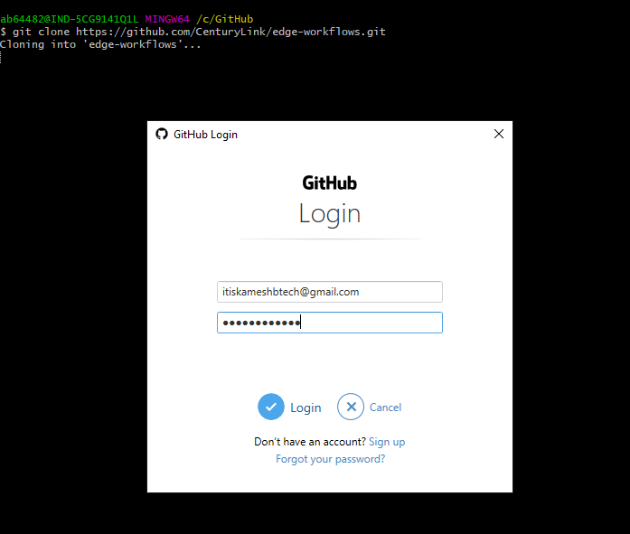

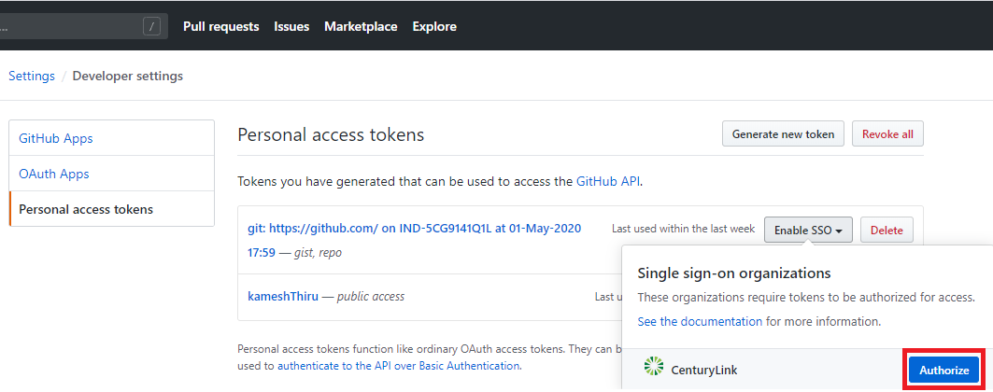

After this above step, you can see now checkout happened in the below Screenshot without any issues. Now we are good in this local setup.

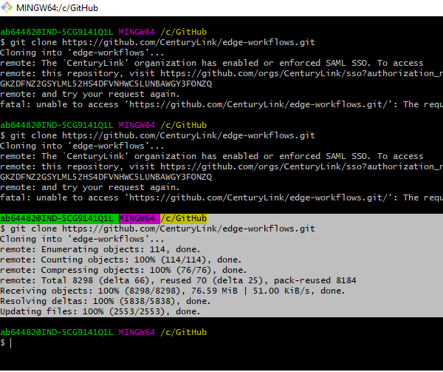

**GIT Commit Process:**

1. To list branches available in repo

git branch -a

1. Checkout branch based on which release you are going to work, basically every release has two branches one for developers and other one for release. Always developers should commit to developer branch **(e.g. *DEV*).**

Below command will switch to this mentioned branch in local.

git checkout FLOW_MAY_2020_DEV_1

1. Get all changes from remote before starting work on that US, by using this below command. To get all latest changes from remote.

git pull origin <BRANCH_NAME>

1. Once you done your changes and validated in you local you need to follow some steps before pushing that changes to remote repository.

|  |  |
| --- | --- |
| git status | Will list all the changed files |
| git diff <file name with path> | We can compare and see what changes made this step required always to confirm our changes. |
| git add <file name with path> | This will add files in stage, means these are all the only files will be pushed to repository |
| git commit -m “<always mention JIRA Task No>” | This command commits all the changes which we staged, always execute this command once all you good with your changes. |
| git push origin <branch_name> | Command to push our committed changes to remote repository |