Session 12 - Lambda, Map, Filter, Reduce: Task Report

Task 1: Lowercase song titles (lambda + map)
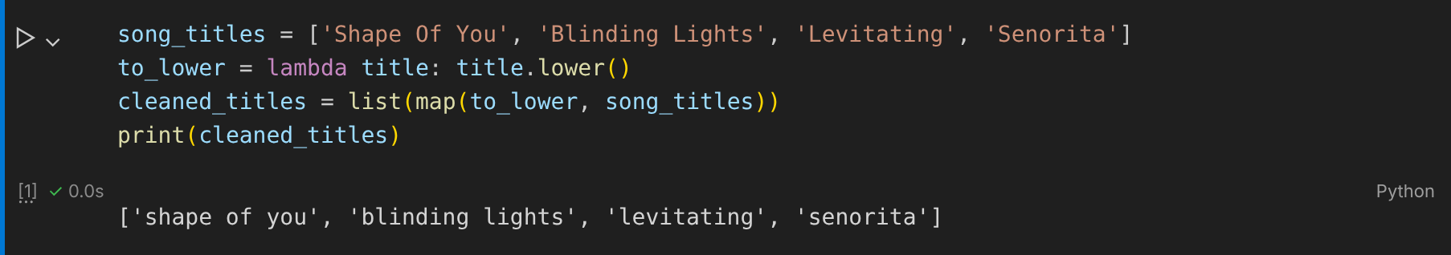

Task 2: Restaurants rated above 4.0 (filter)
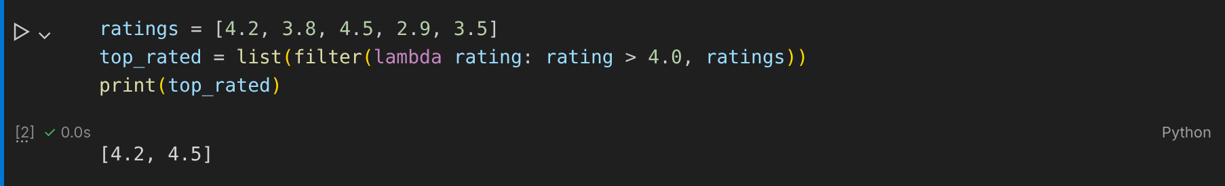

Task 3: Flipkart cart total (reduce)
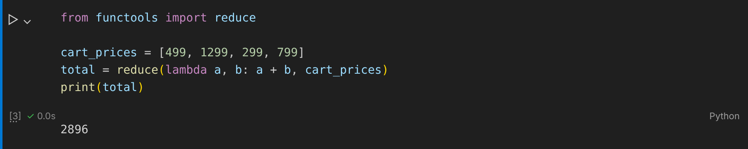

Task 4: format_followers() with map
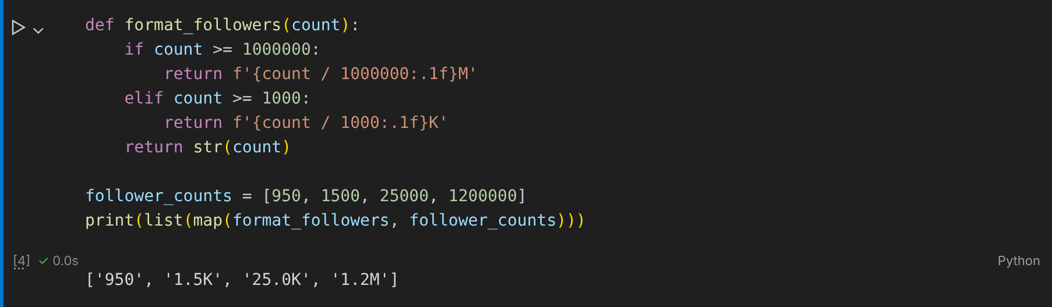

Task 5: Filter out odd IPL scores (lambda)
