Session 14 - File Handling (Text, CSV, JSON): Task Report

Task 1: Write Playlist File
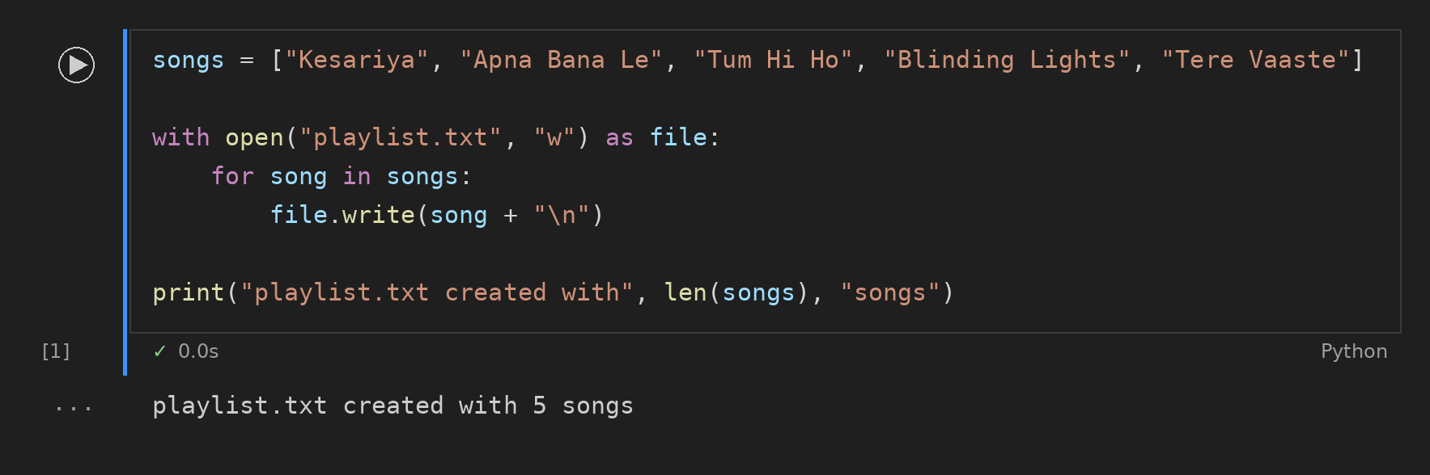

Task 2: Read Songs in Uppercase
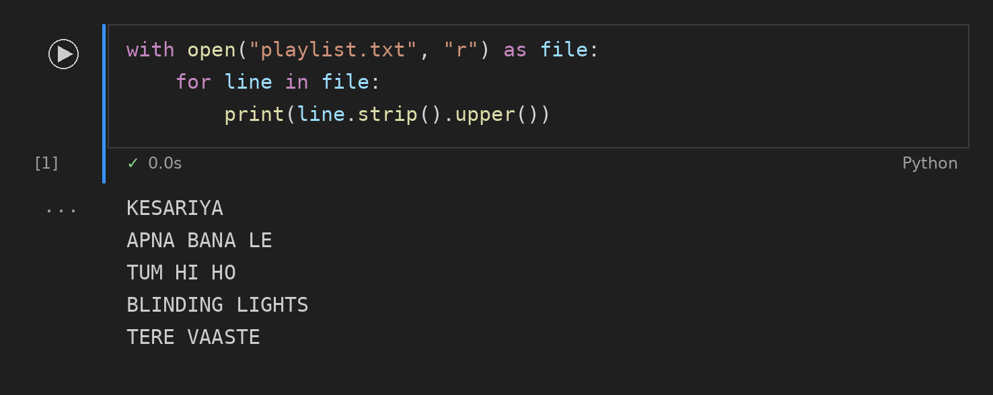

Task 3: IPL Match Winners (CSV)
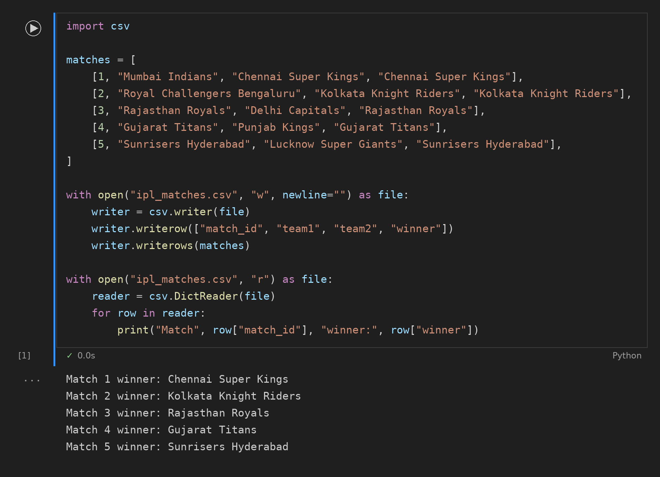

Task 4: Movies JSON
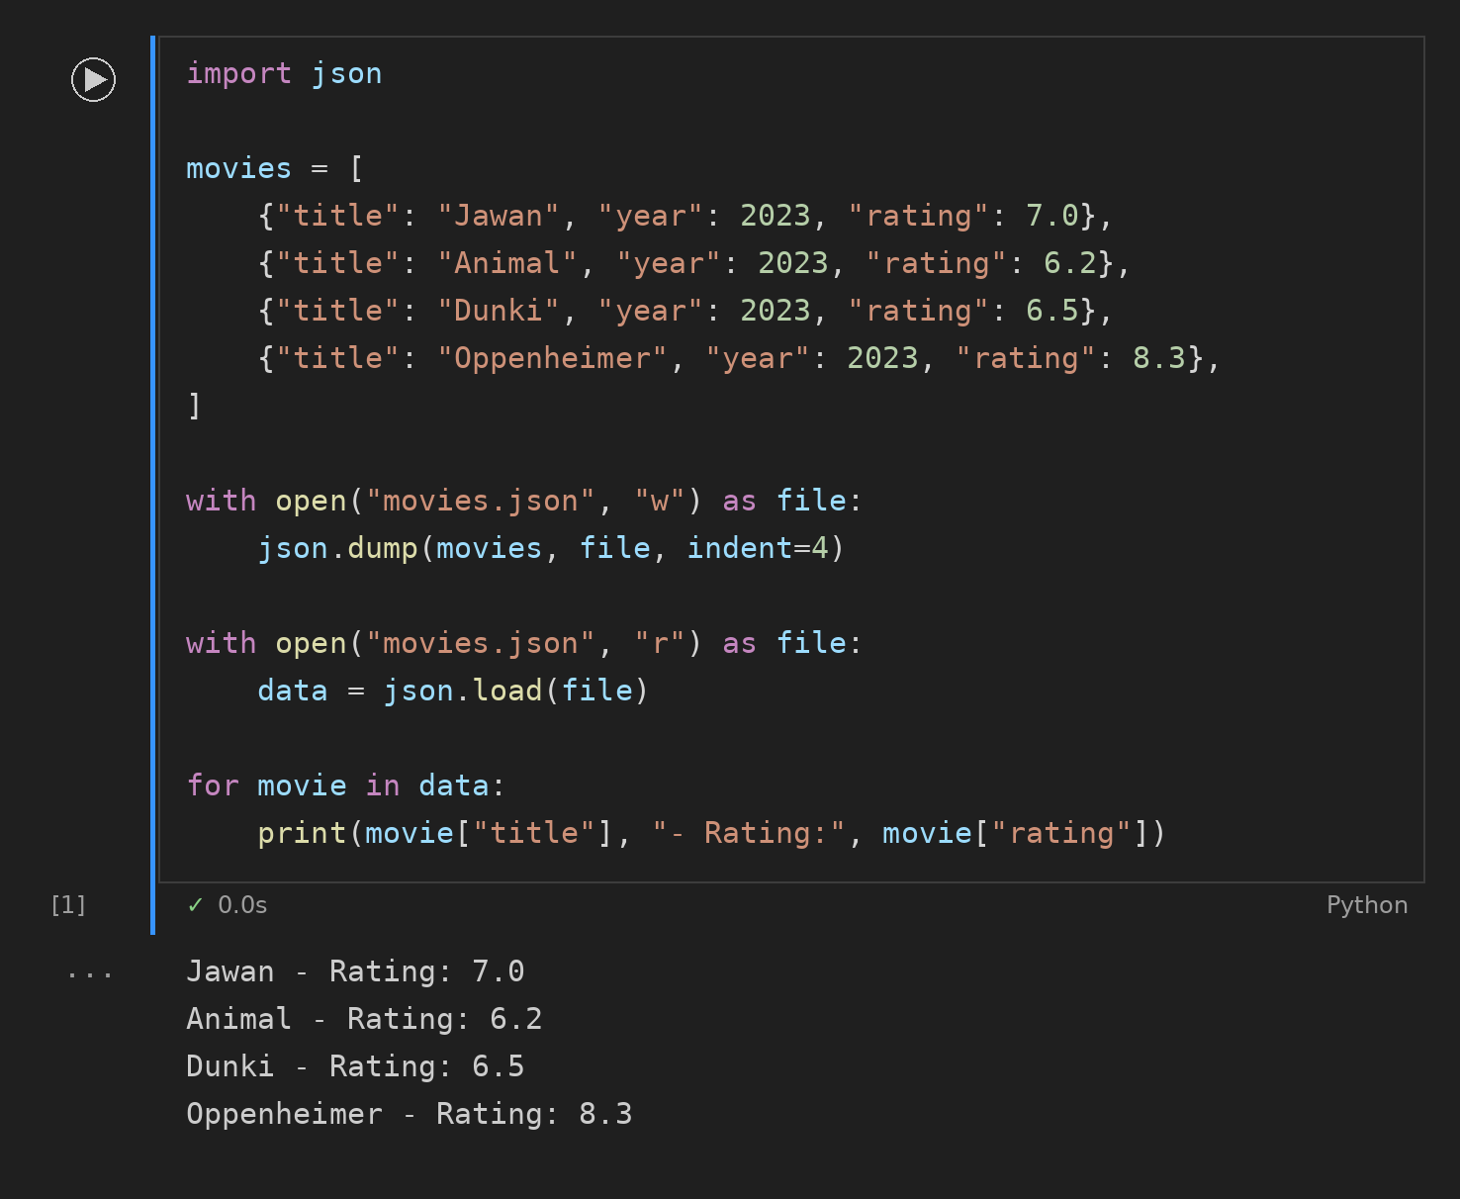

Task 5: Favourite Apps JSON with pathlib
