Session 15 - Error & Exception Handling: Task Report

Task 1: Song Duration Per Minute
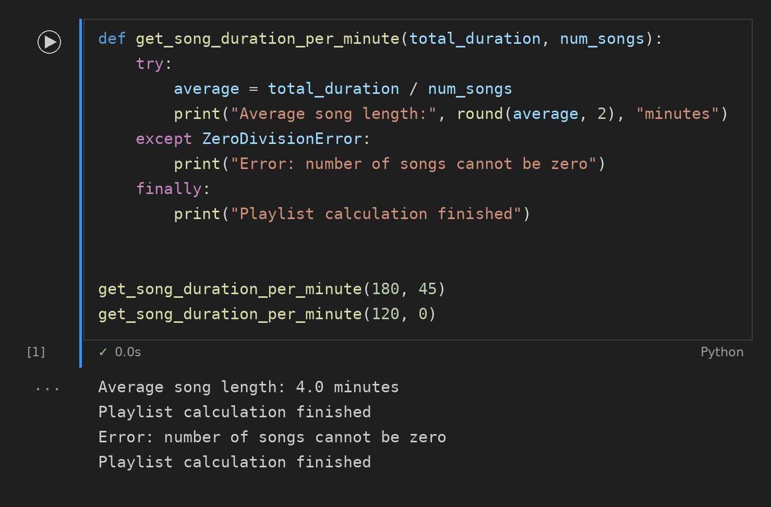

Task 2: Flipkart Price Per Item
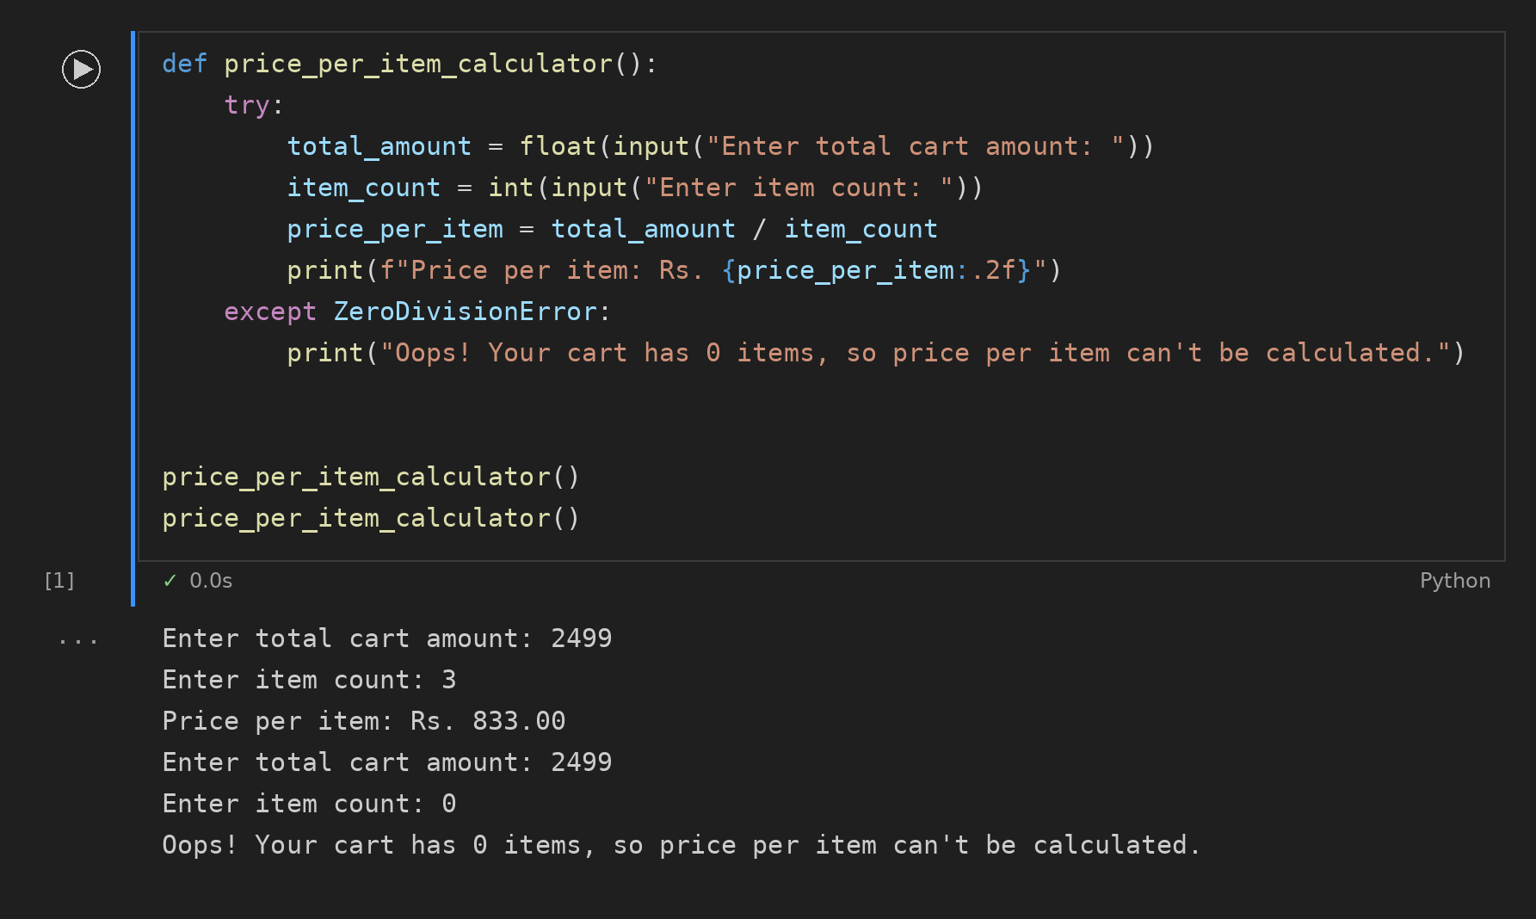

Task 3: Paytm Cashback Calculator
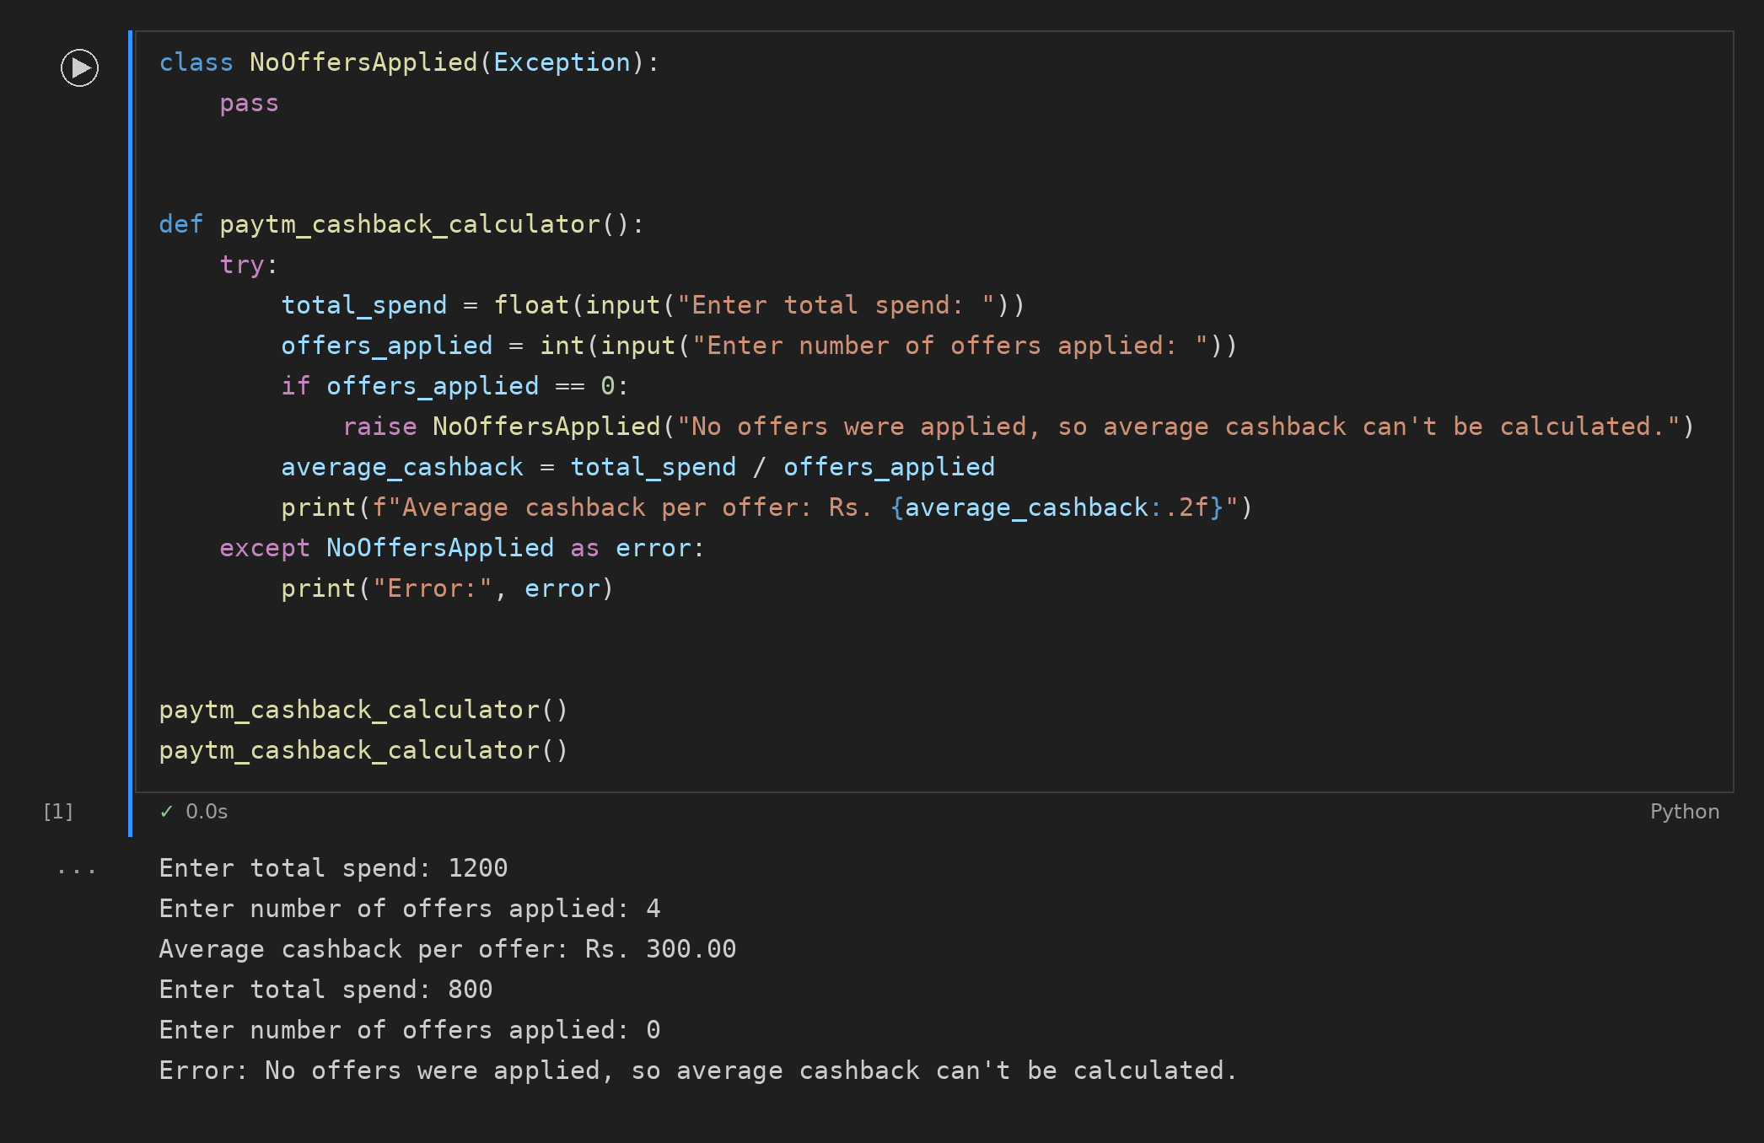

Task 4: Refactored Average Rating Code
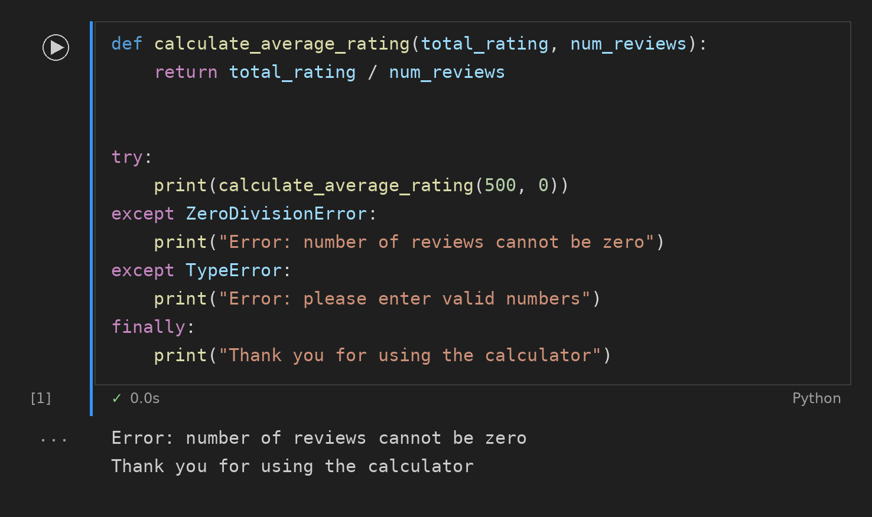

Task 5: Safe Divide for Zomato
