Session 16 - Iterators & Generators: Task Report

Task 1: Food Apps with iter() and next()
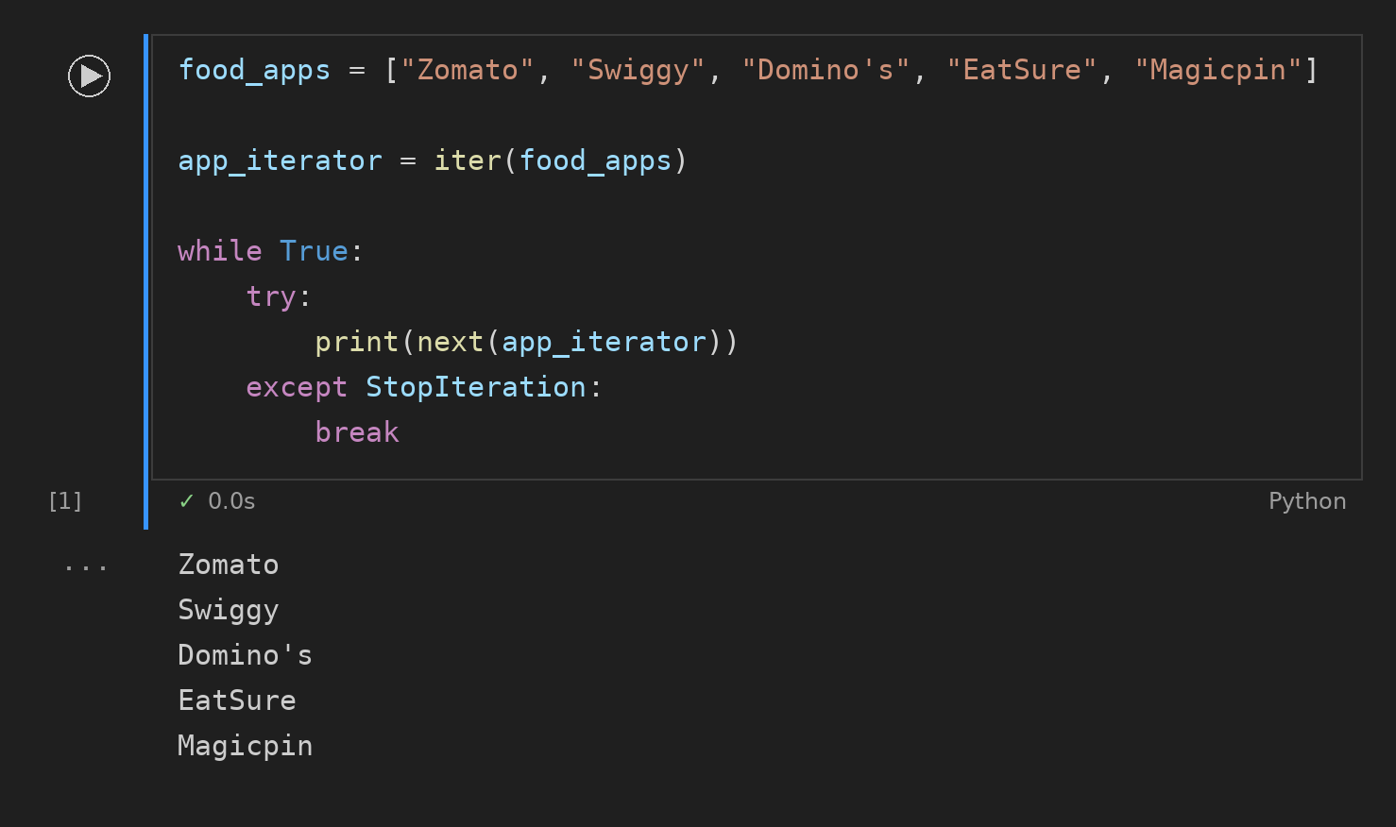

Task 2: Playlist Generator
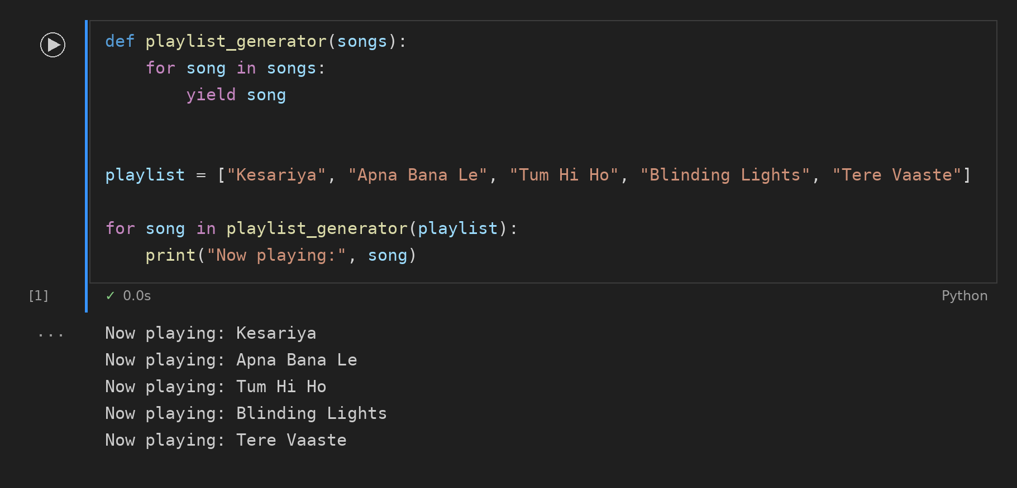

Task 3: Cart Items with enumerate()
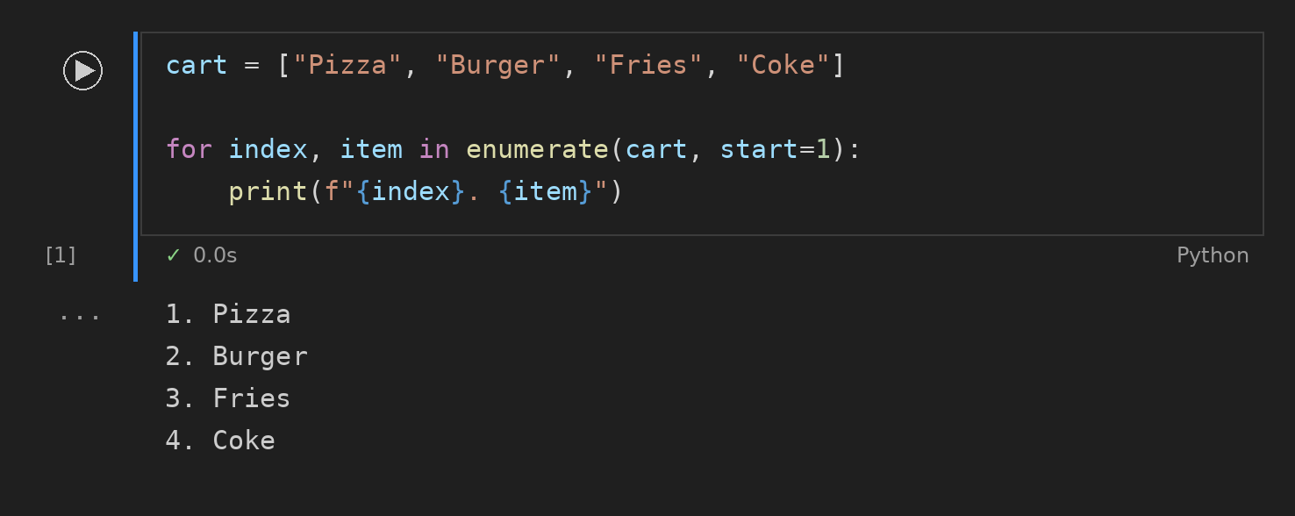

Task 4: IPL Points with zip()
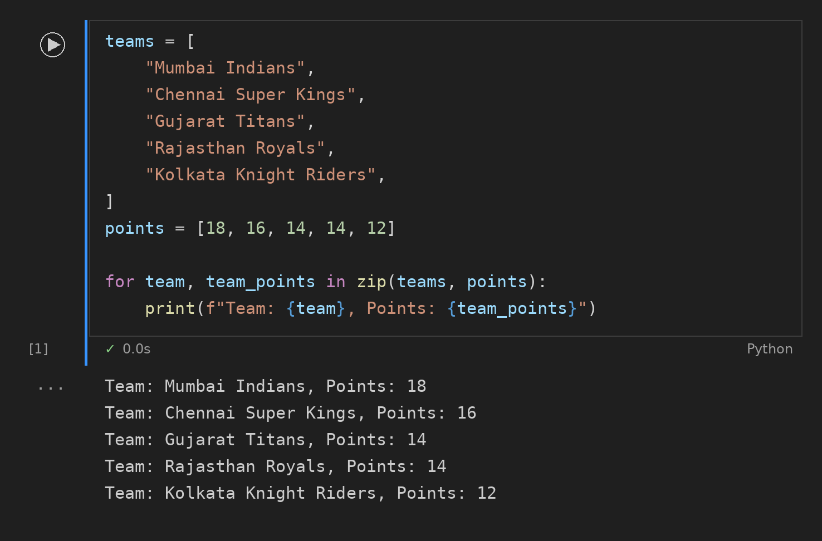

Task 5: Order ID Generator
