Session 17 - Modules & Packages: Task Report

Task 1: Square Root with math.sqrt()
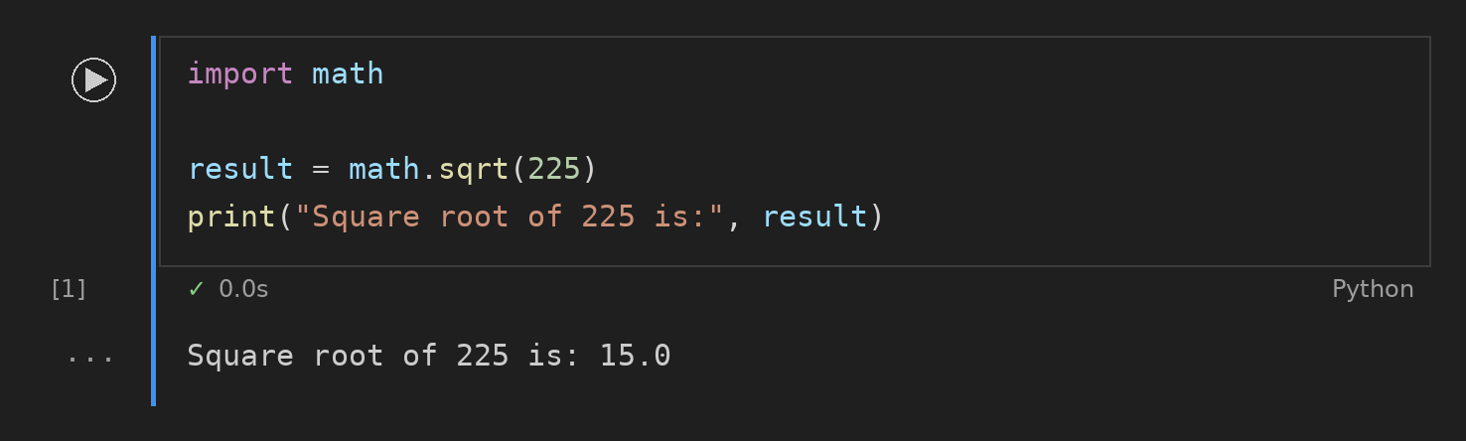

Task 2: Create Folder with os Module
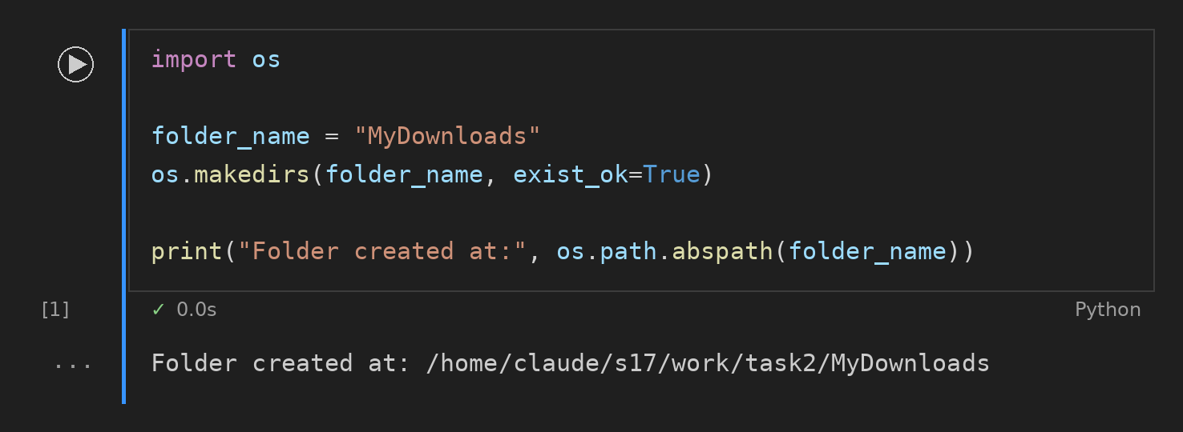

Task 3: Date and Time with strftime()
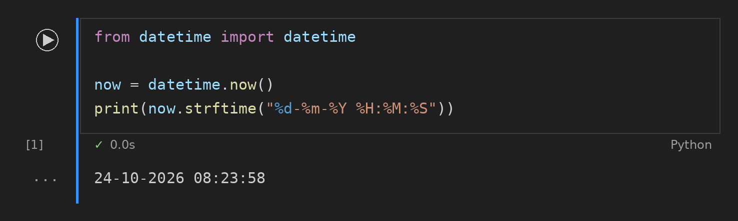

Task 4: Custom playlist_utils Module
