Session 18 - Regular Expressions (Regex): Task Report

Task 1: Phone Numbers with re.findall()
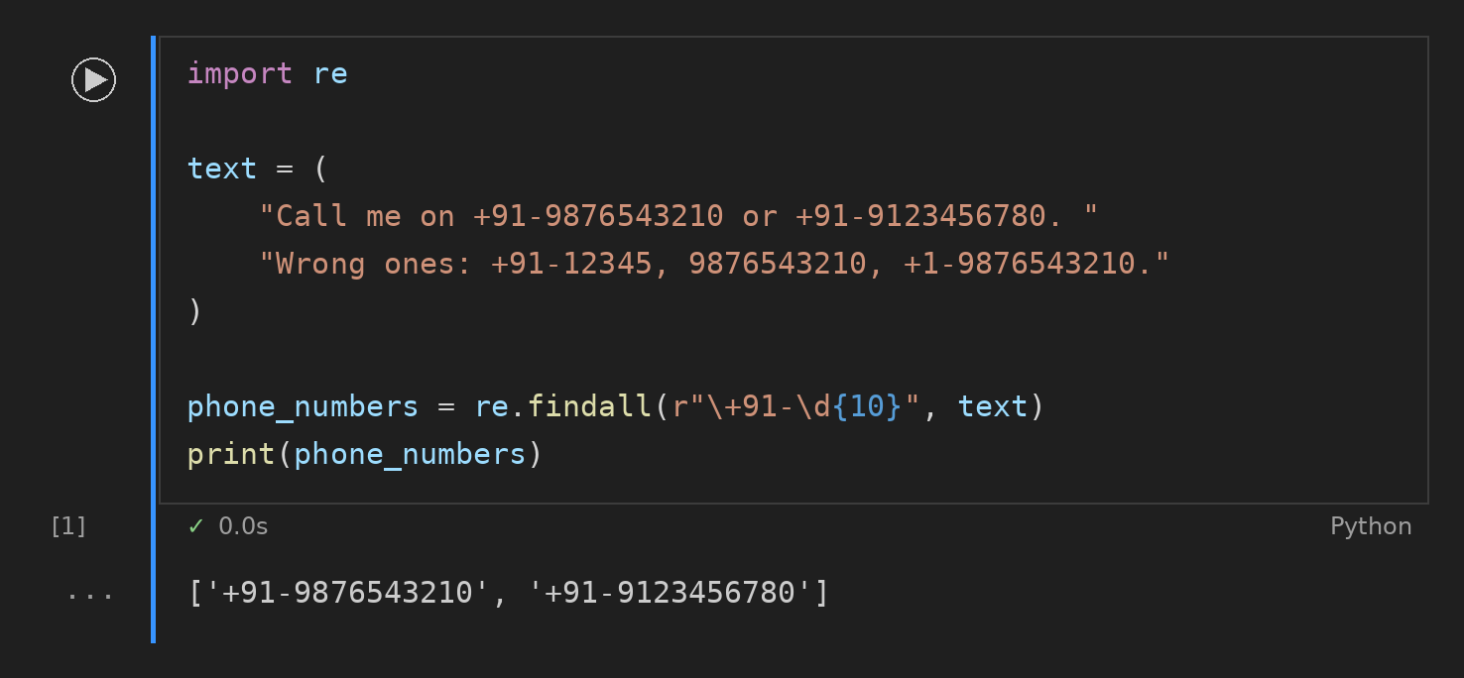

Task 2: Date Check with re.search()
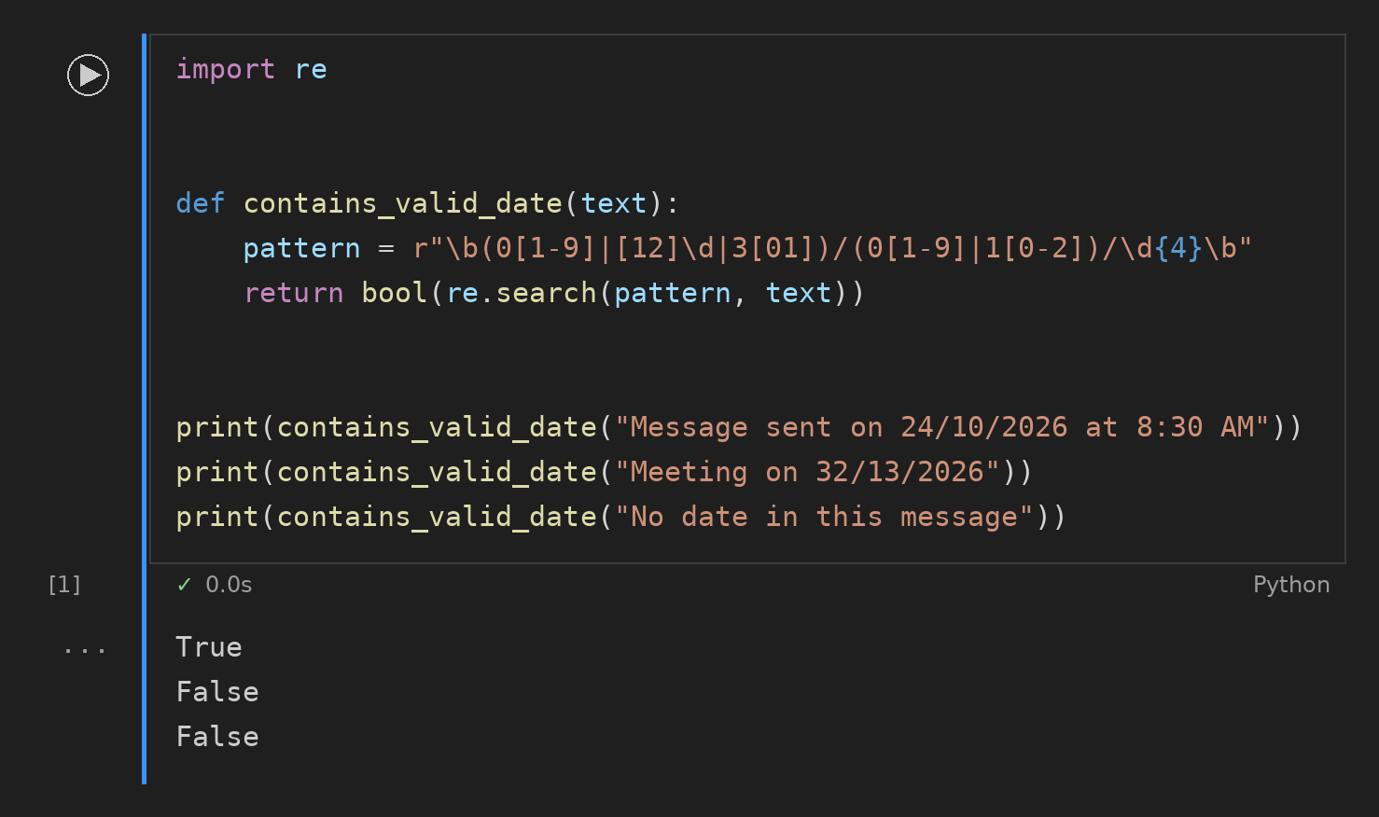

Task 3: Sum of Prices
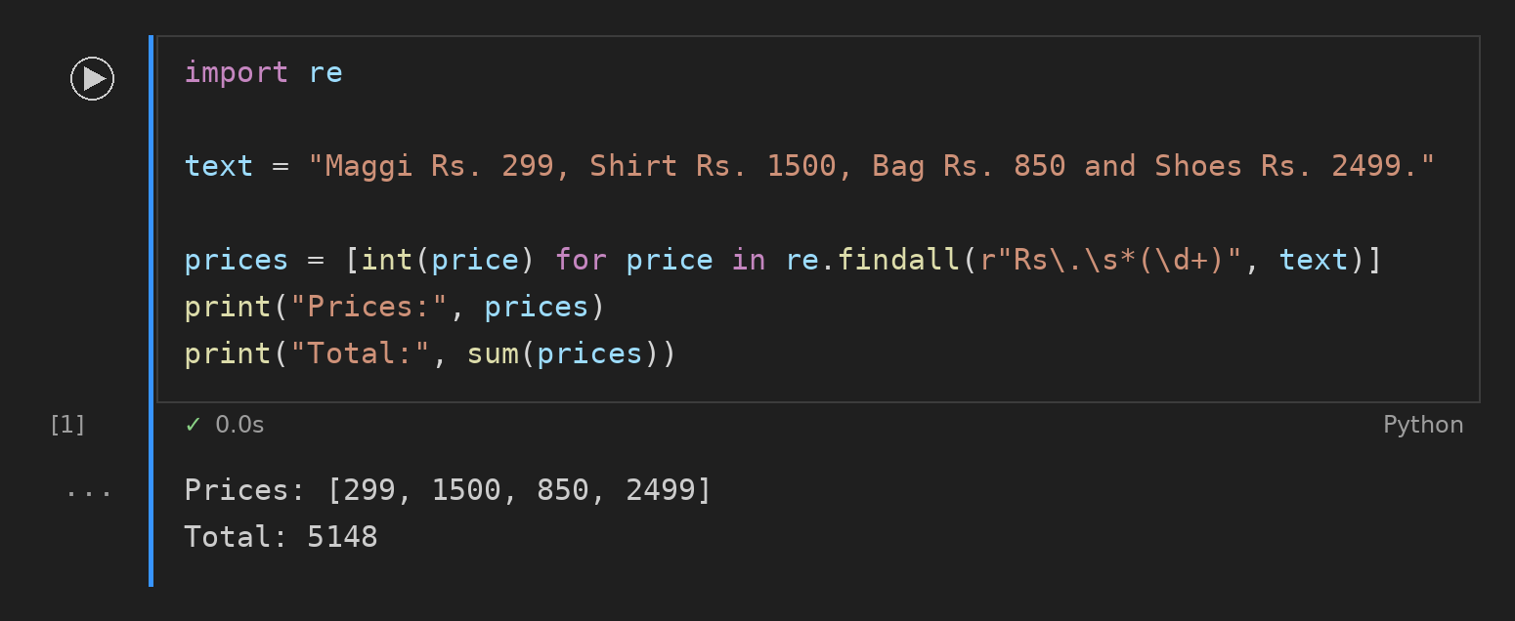

Task 4: Hide Emails with re.sub()
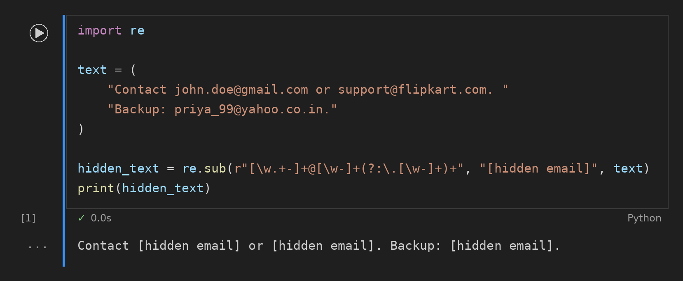

Task 5: Unique Instagram Usernames
