Session 19 - OOP Basics (Classes, Objects, __init__): Task Report

Task 1: Song Class
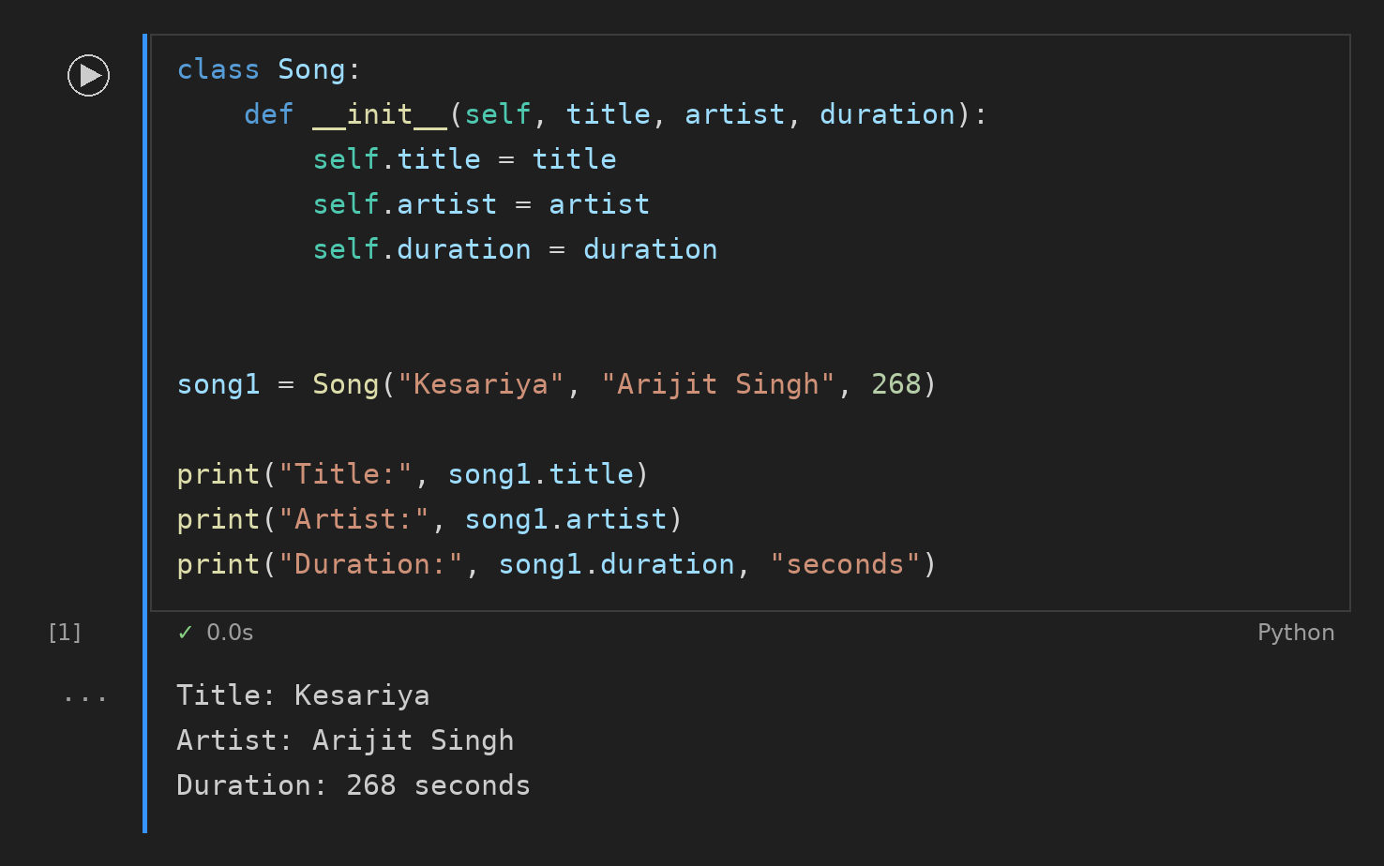

Task 2: play_preview() Method
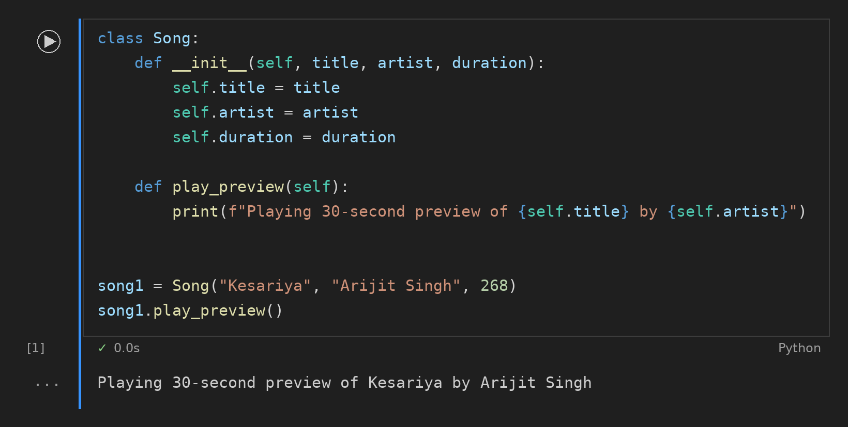

Task 3: FoodOrder Class
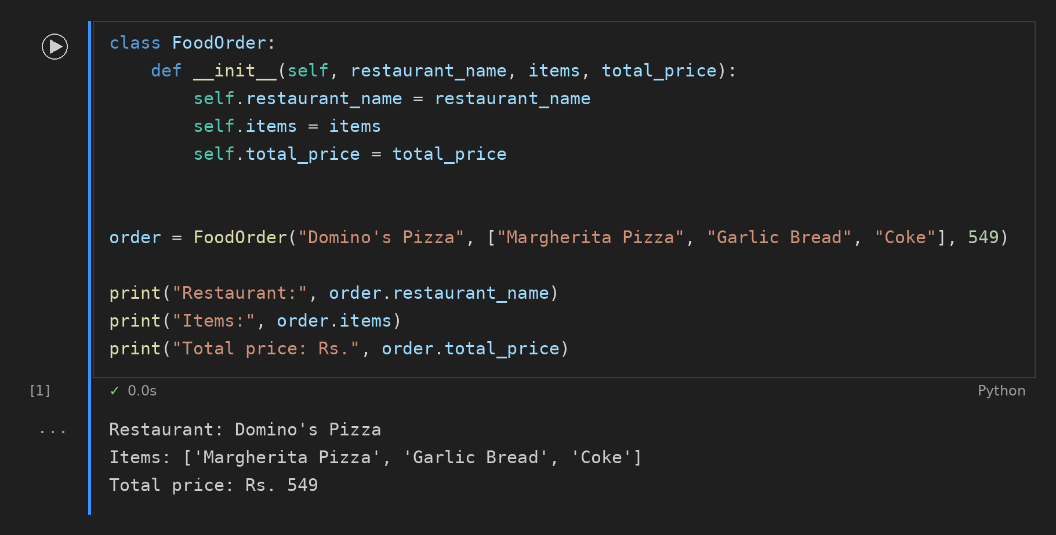

Task 4: add_item() Method
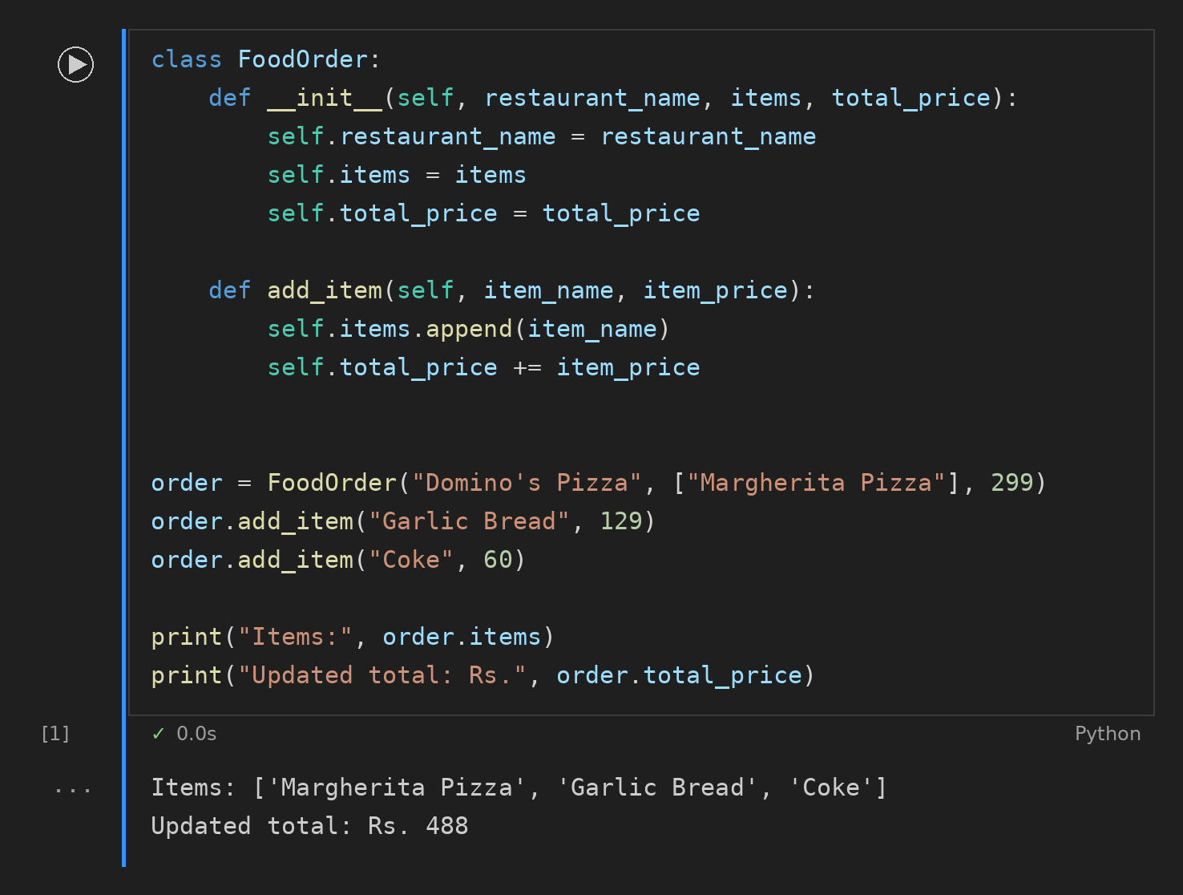

Task 5: Optional Duration in Song
