Session 1 - Introduction to Python & Installation: Task Report

Task 1: Install Anaconda and launch Jupyter Notebook
Anaconda is installed and Jupyter Notebook is launched from Anaconda Navigator.
[Screenshot 1: Anaconda Navigator with Jupyter Notebook launched]

Task 2: insta_intro.ipynb
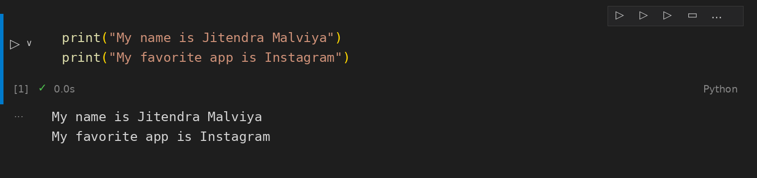

Task 3: Welcome message
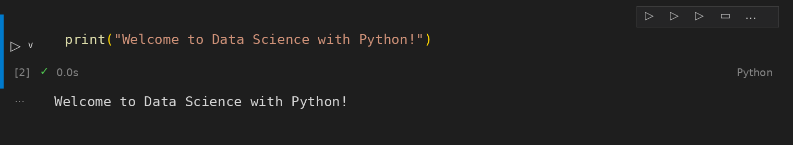

Task 4: hello_app.py
