Session 20 - Encapsulation & Abstraction: Task Report

Task 1: Playlist with Private _songs
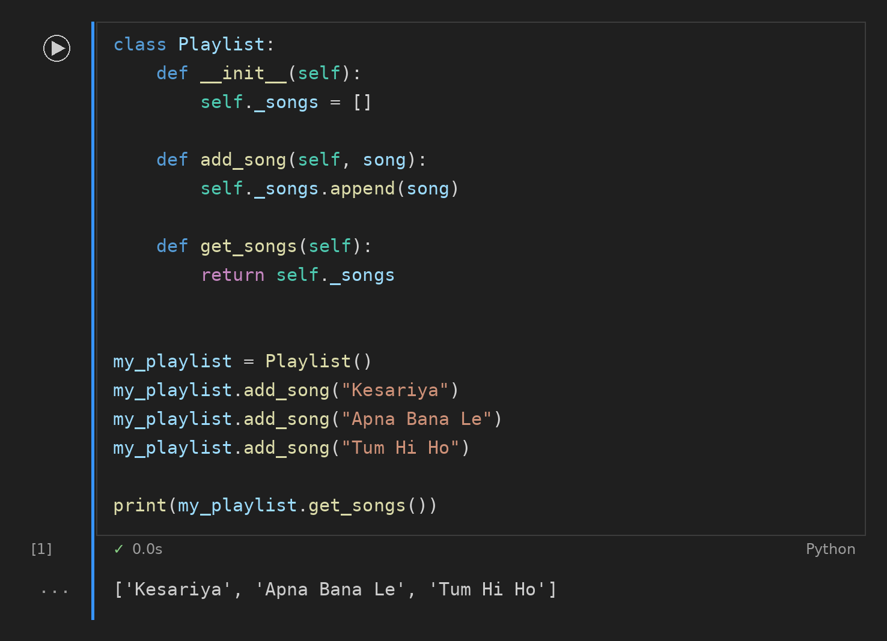

Task 2: Product with get_price() and set_price()
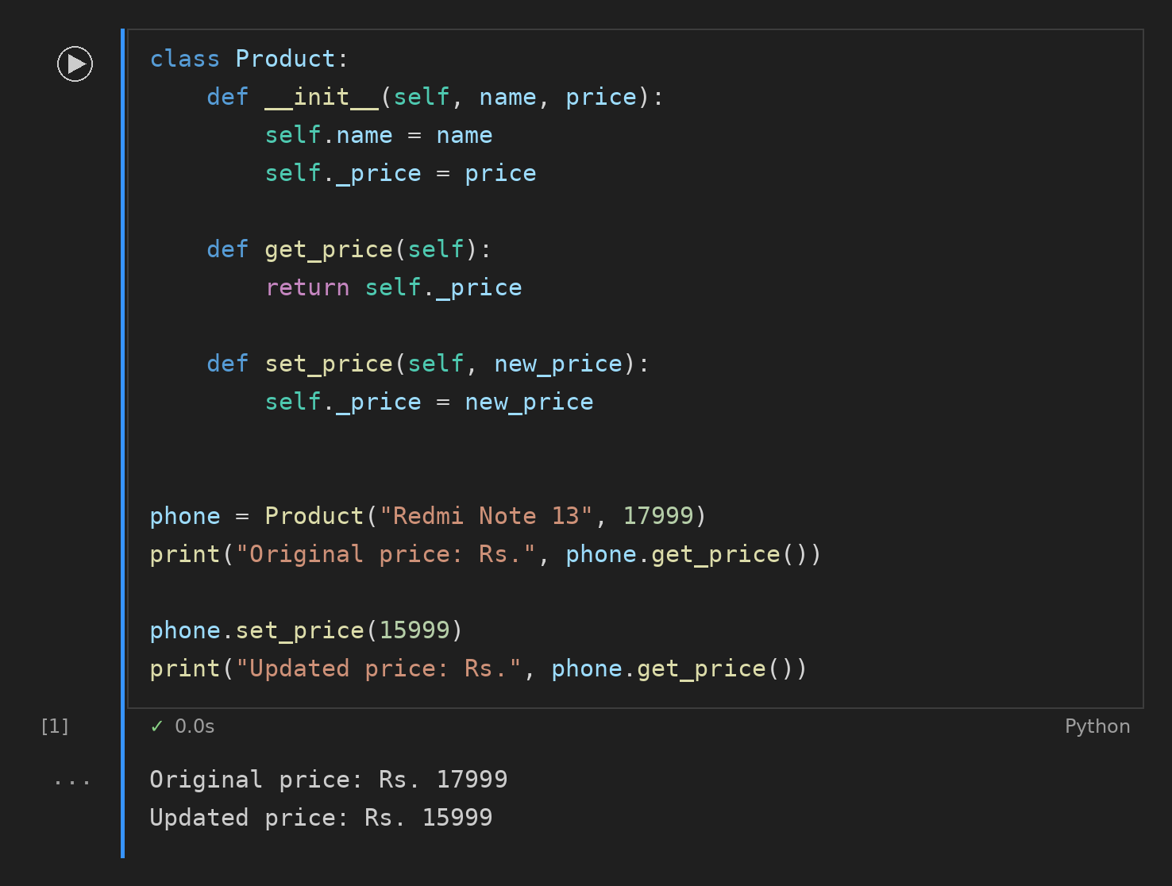

Task 3: Movie Rating with Validation
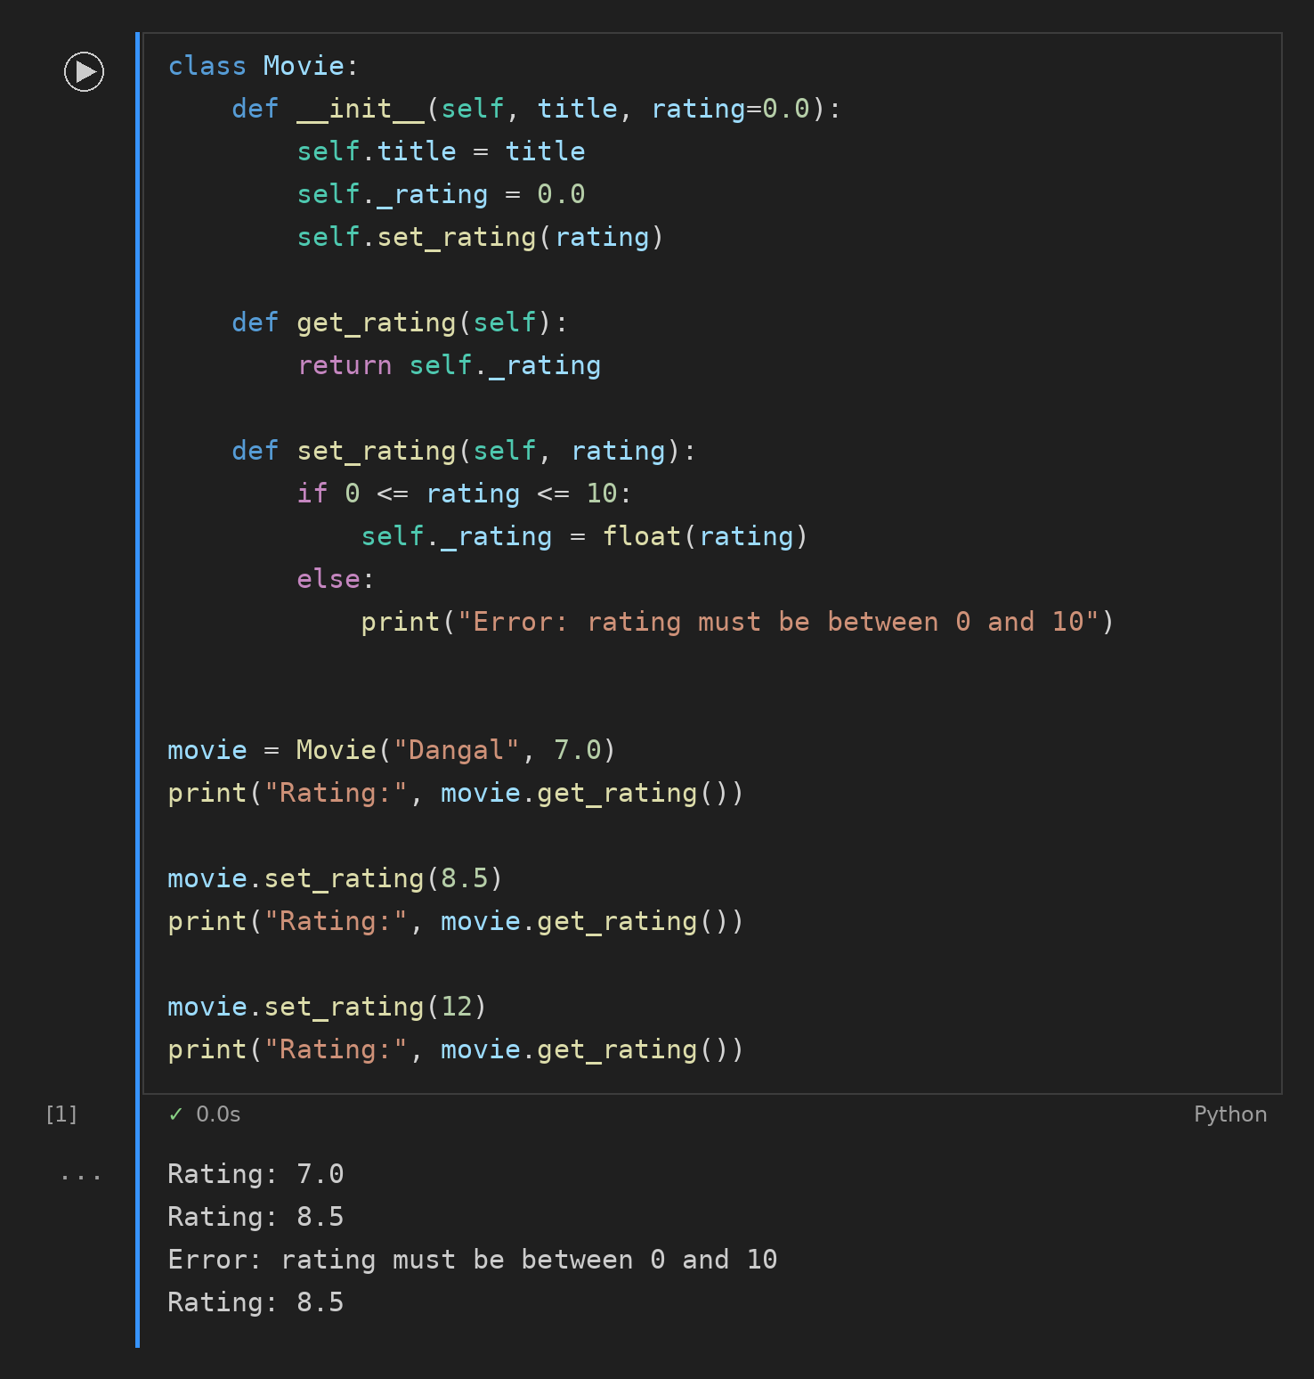

Task 4: Abstract Class PaymentMethod
