Session 21 - APIs Using Requests (Part 2): Task Report

Task 1: POST with JSON Payload
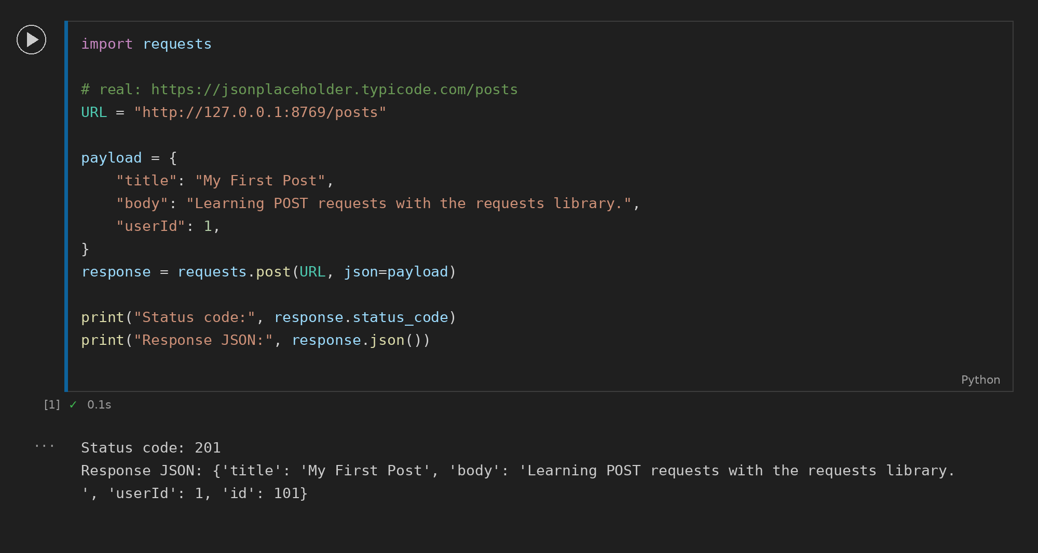

Task 2: Playlist POST Request
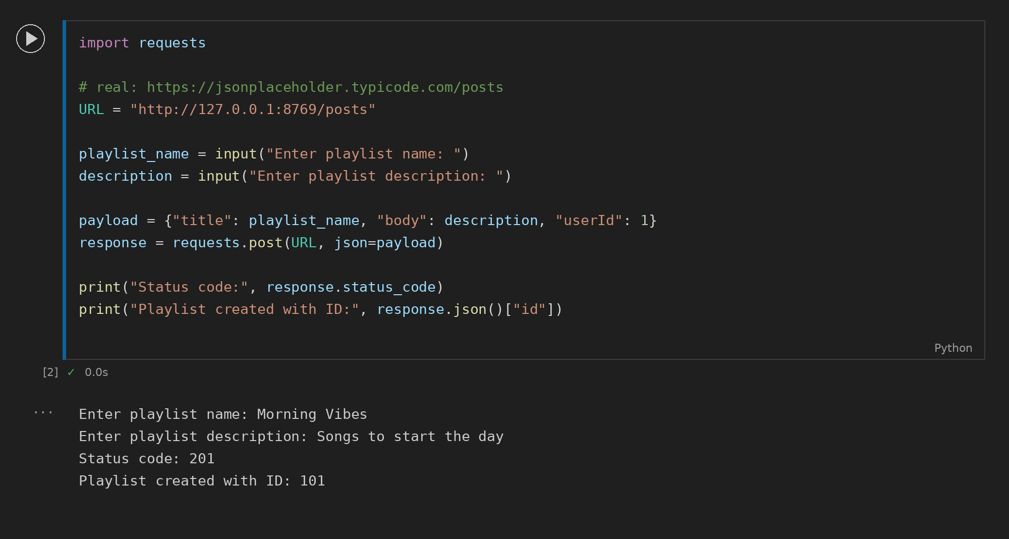

Task 3: Create User
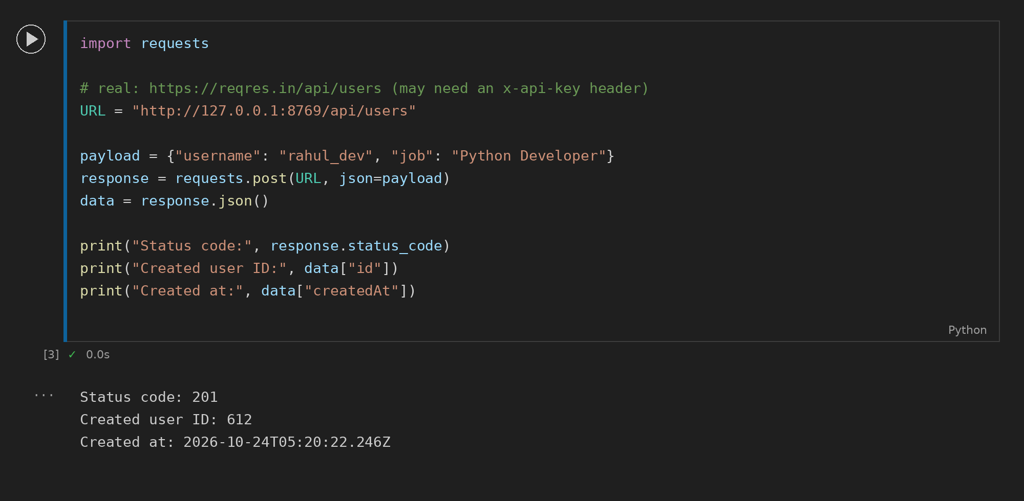

Task 4: Save Posts to CSV
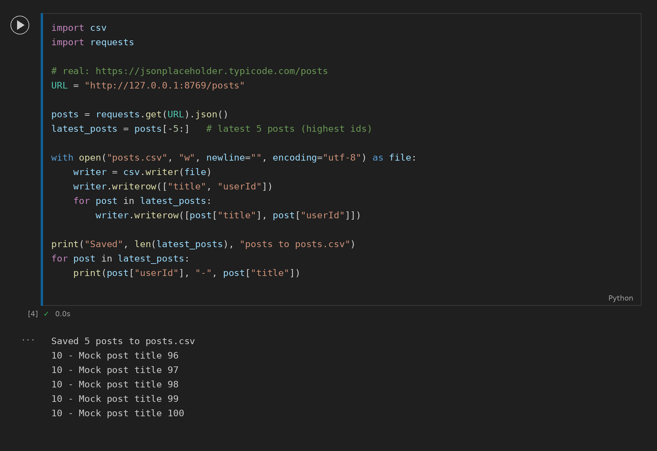

Task 5: Save Posts to JSON
