Session 22 - Advanced APIs: Task Report

Task 1: Session Cookies
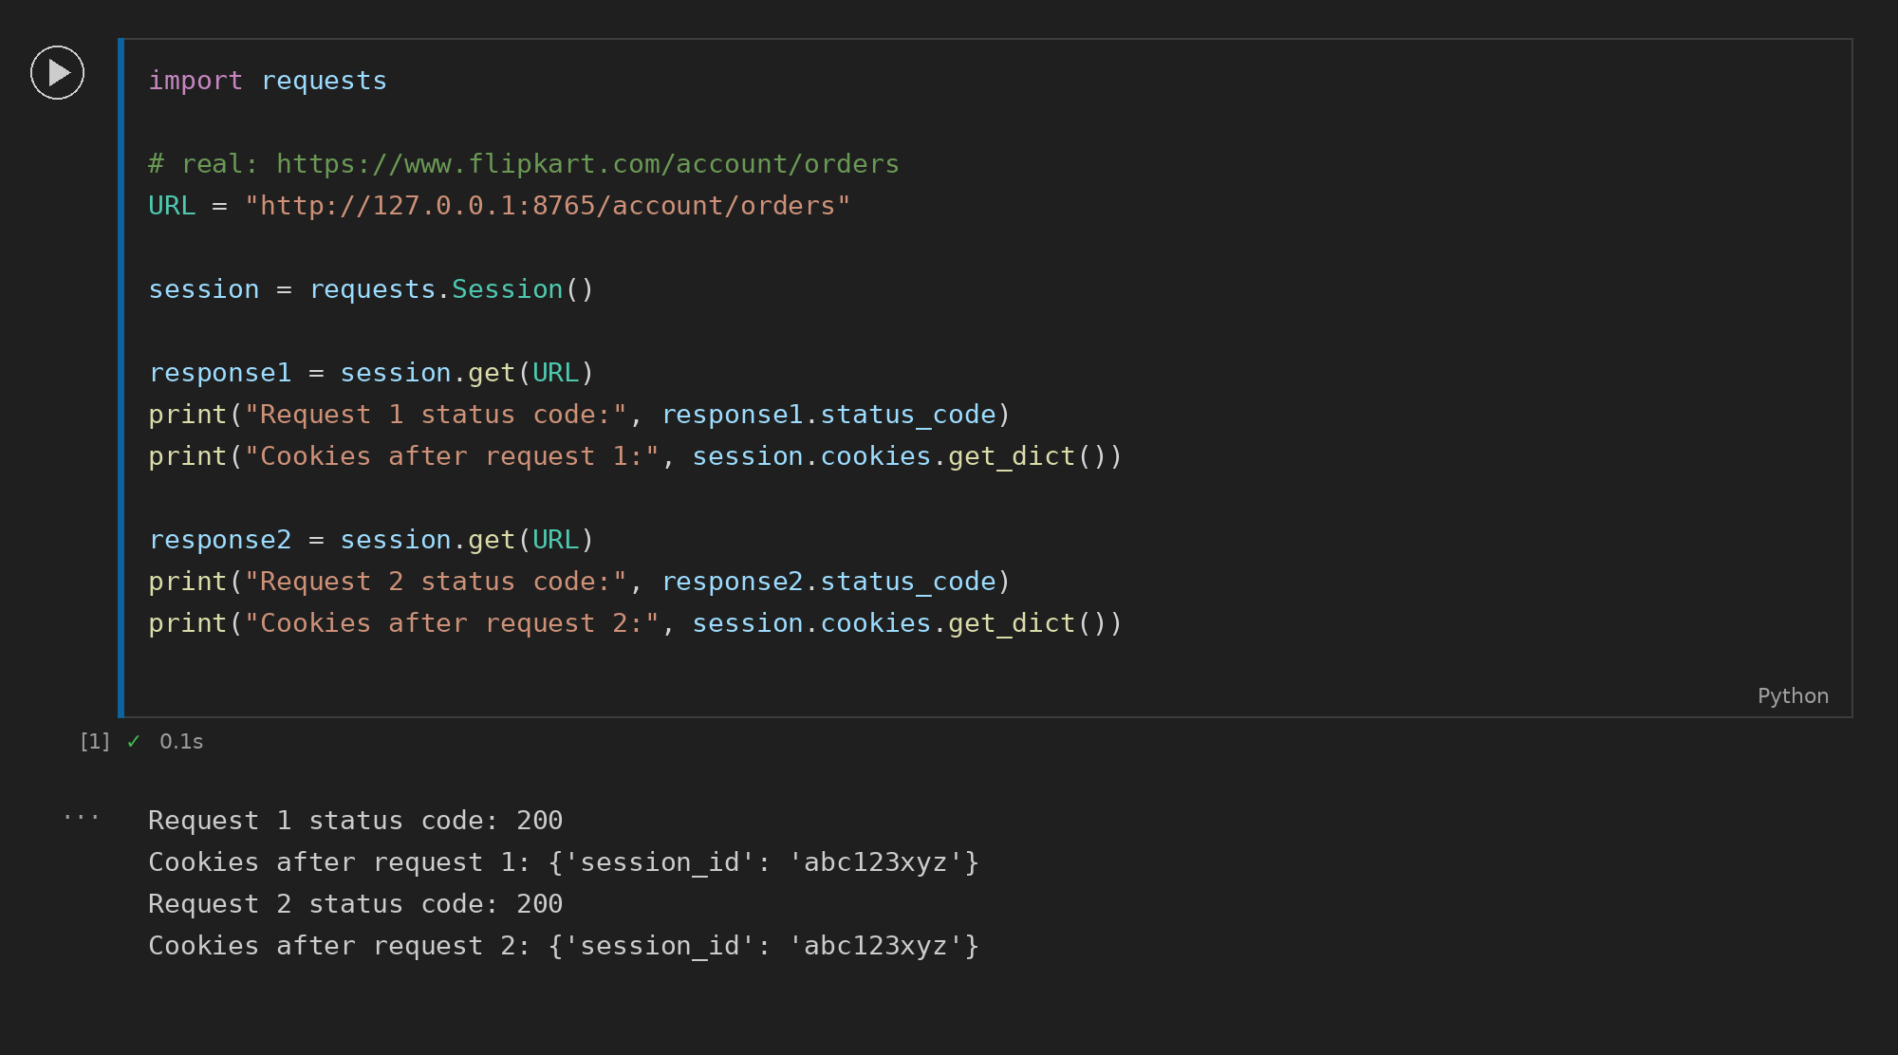

Task 2: OpenWeatherMap API
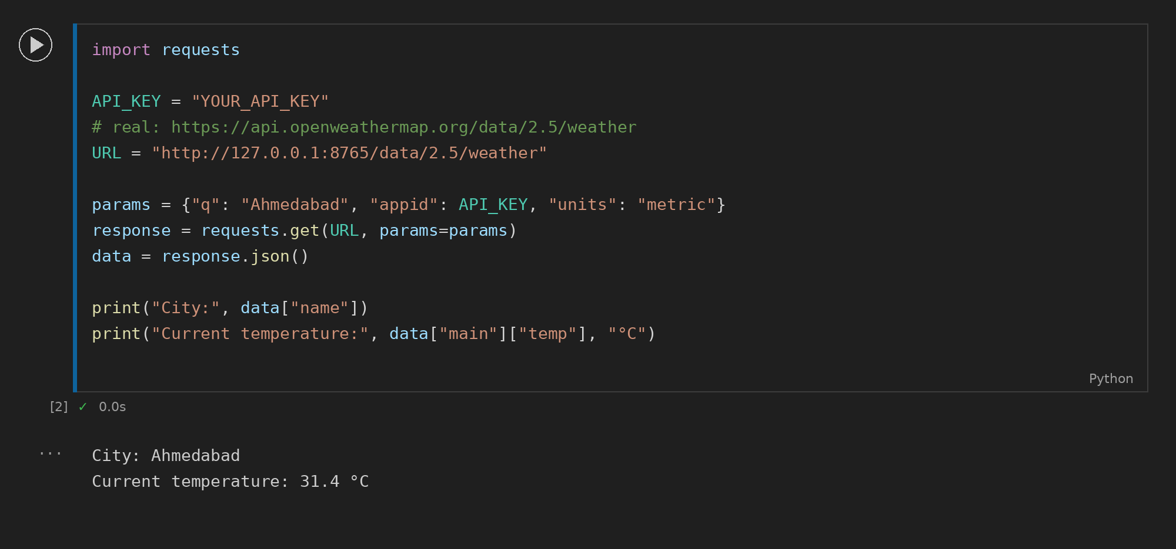

Task 3: Async Fetch with asyncio.gather()
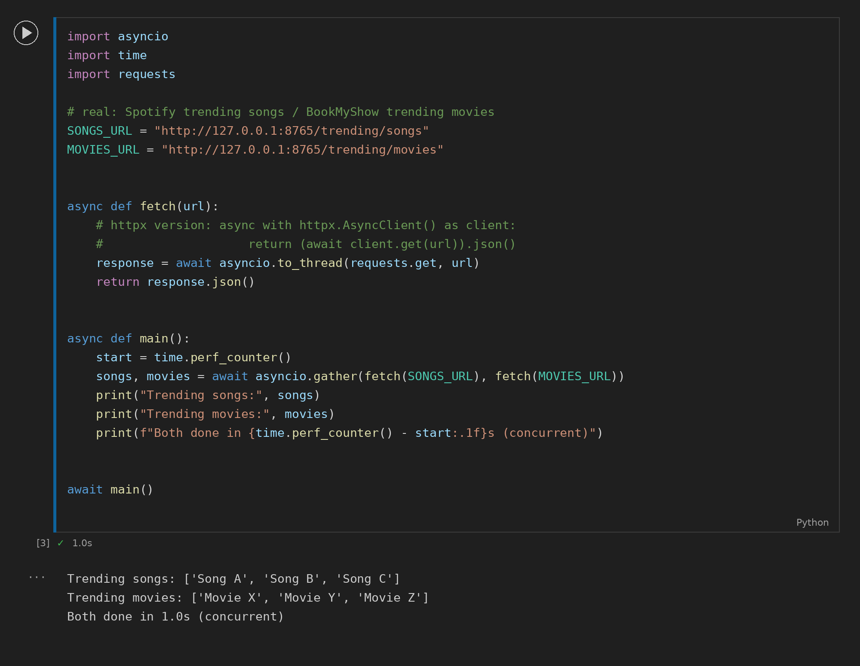

Task 4: Bearer Token Profile
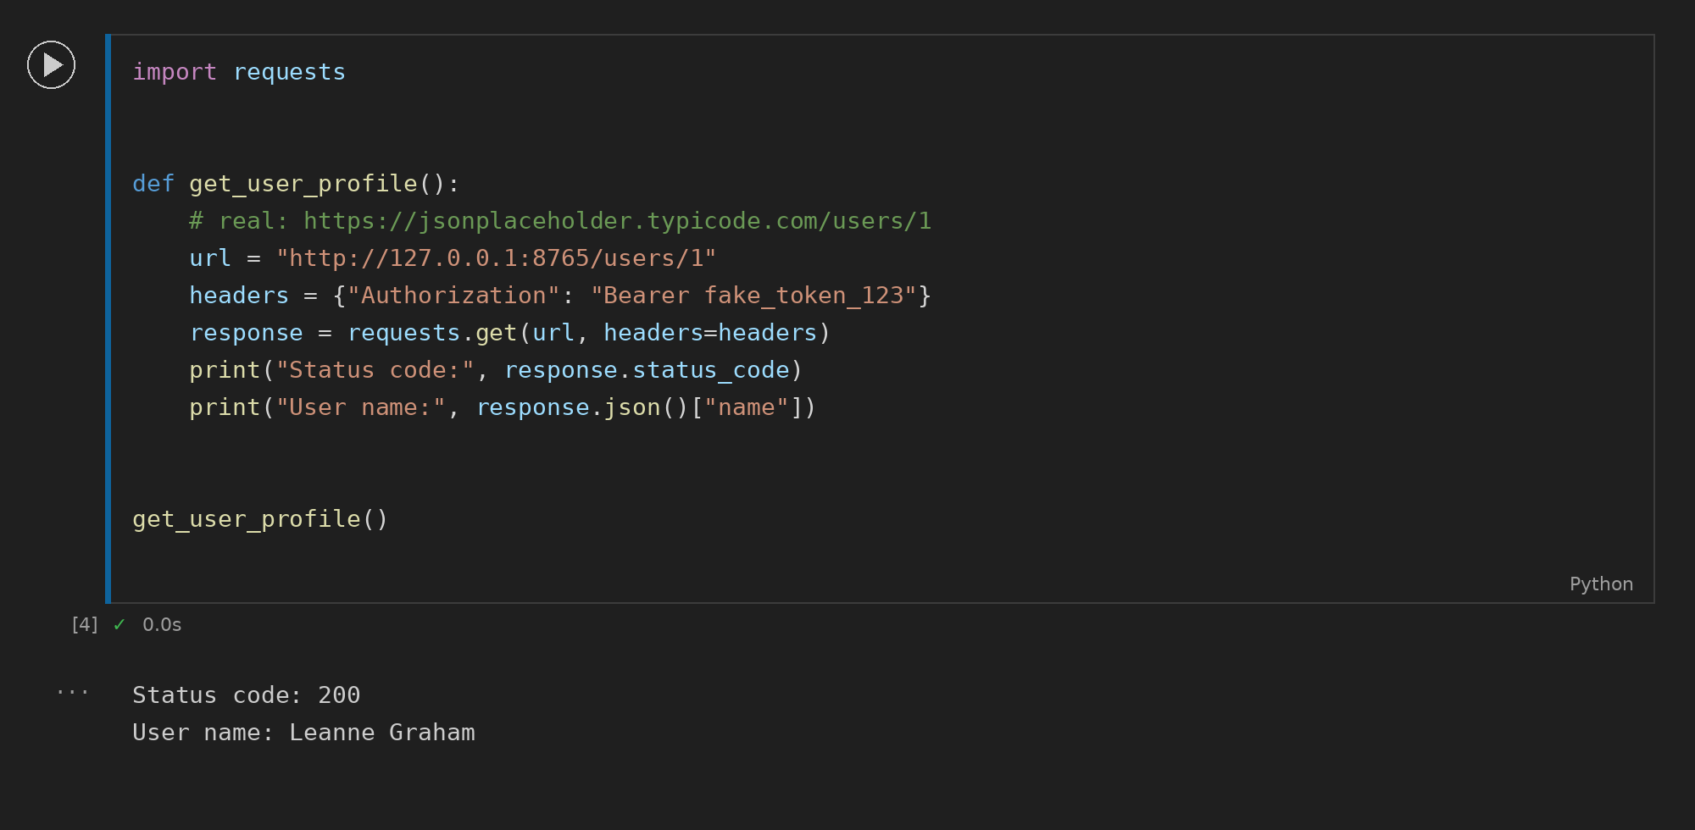

Task 5: OAuth 2.0 Login URL
