Session 23 - API Mini Projects: Task Report

Task 1: Weather Report
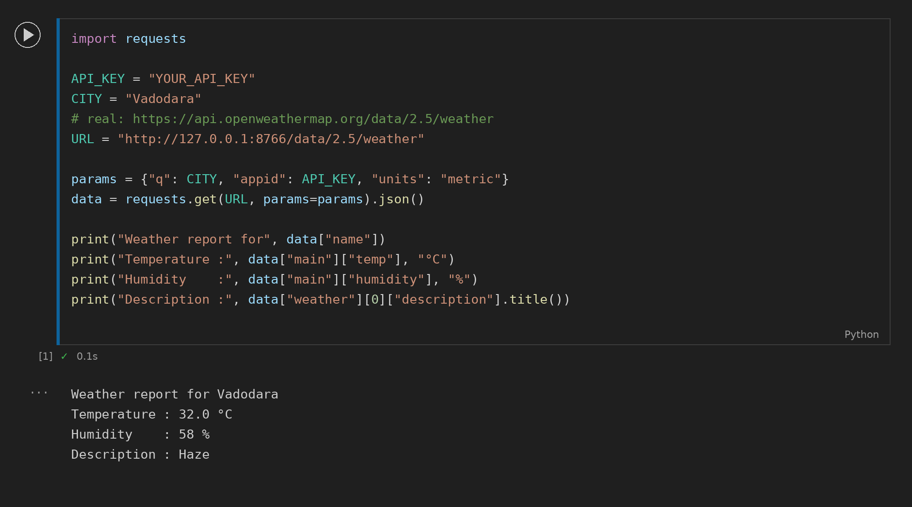

Task 2: Crypto Prices
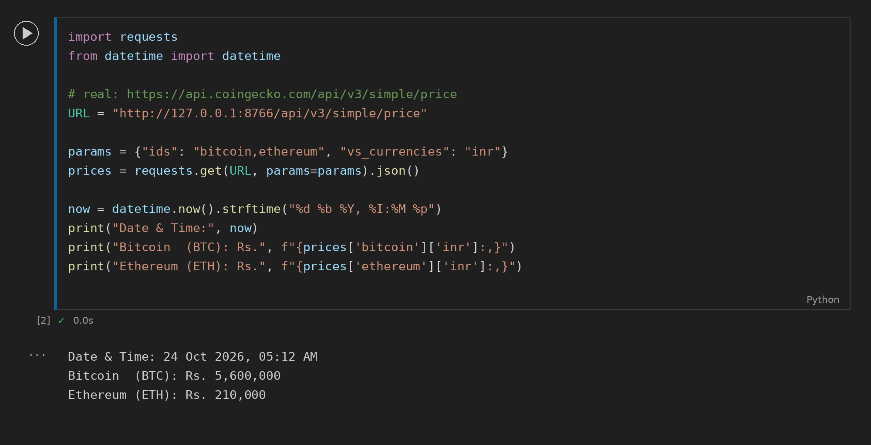

Task 3: NASA APOD
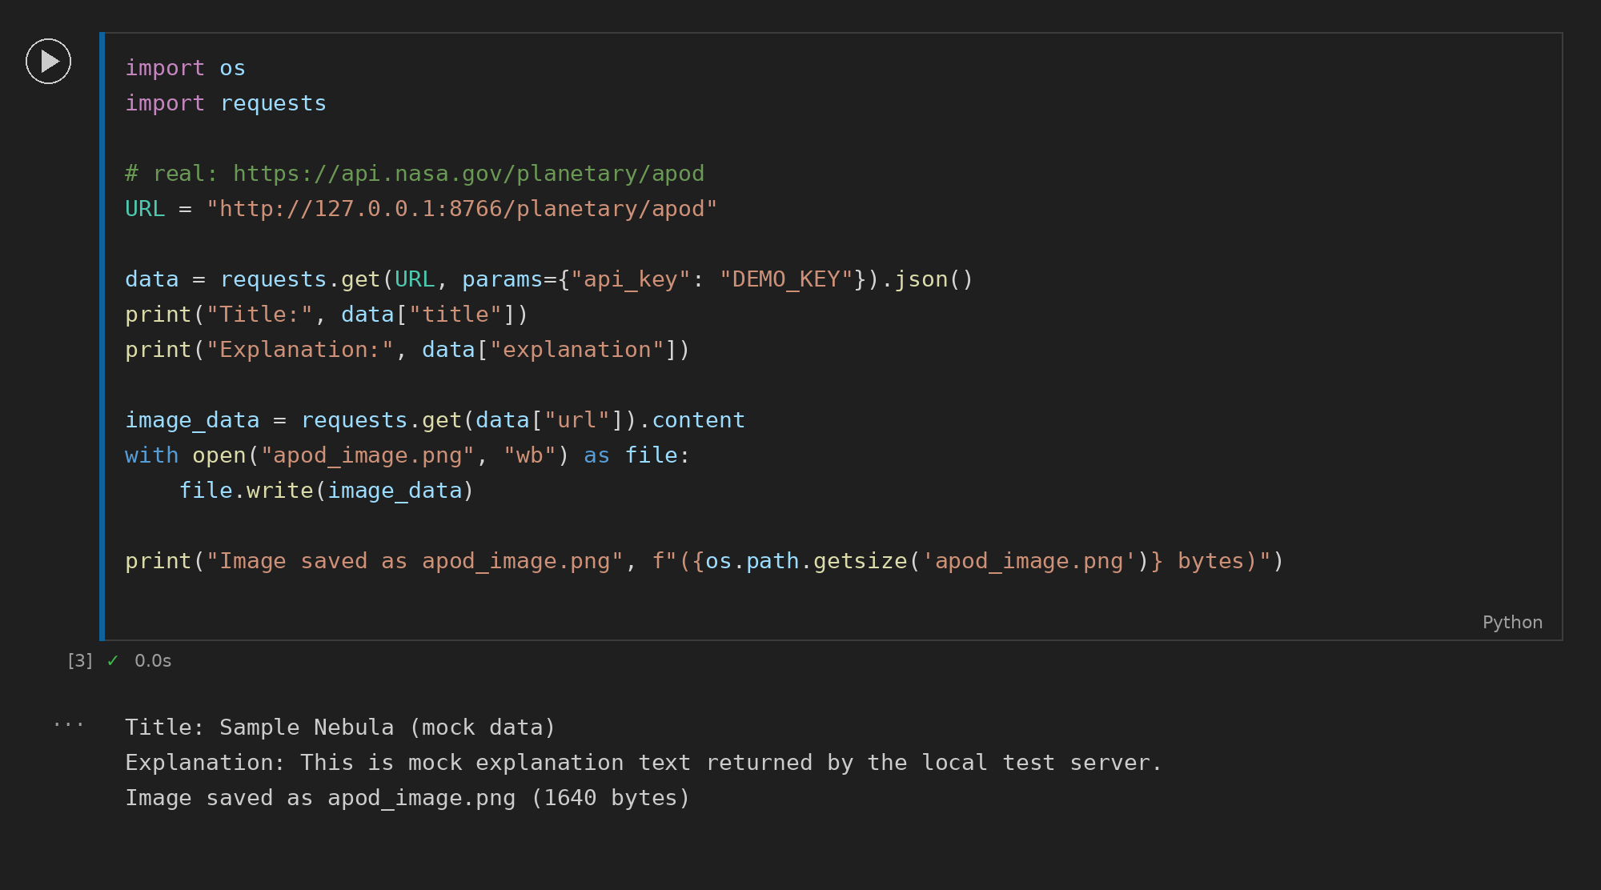

Task 4: COVID Data for India
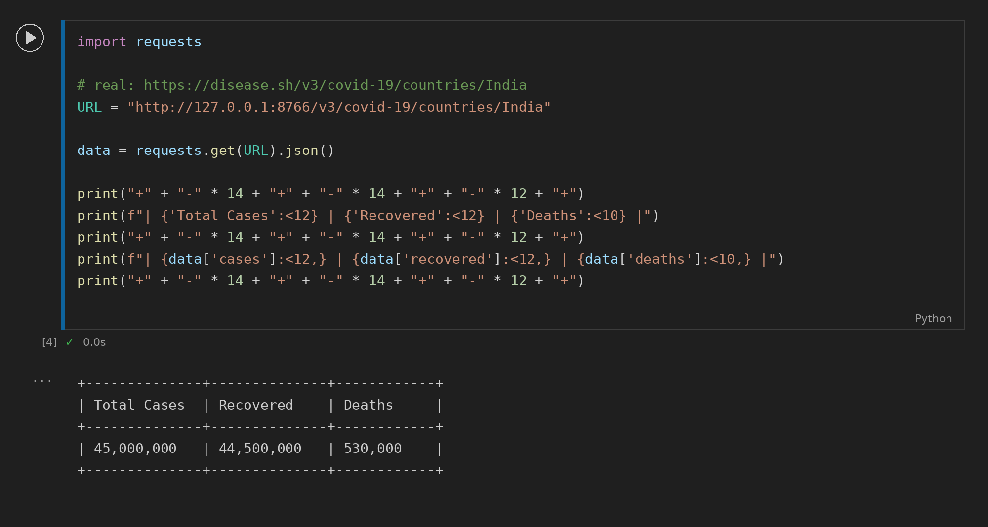

Task 5: Weather + Bitcoin Combined
