Session 24 - Binance Crypto Price Tracker (Part 1): Task Report

Task 1: Fetch Top 10 Crypto Prices
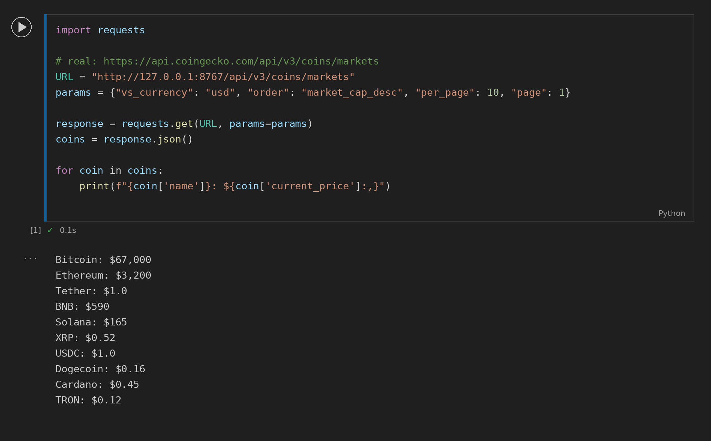

Task 2: 24h Change, High and Low
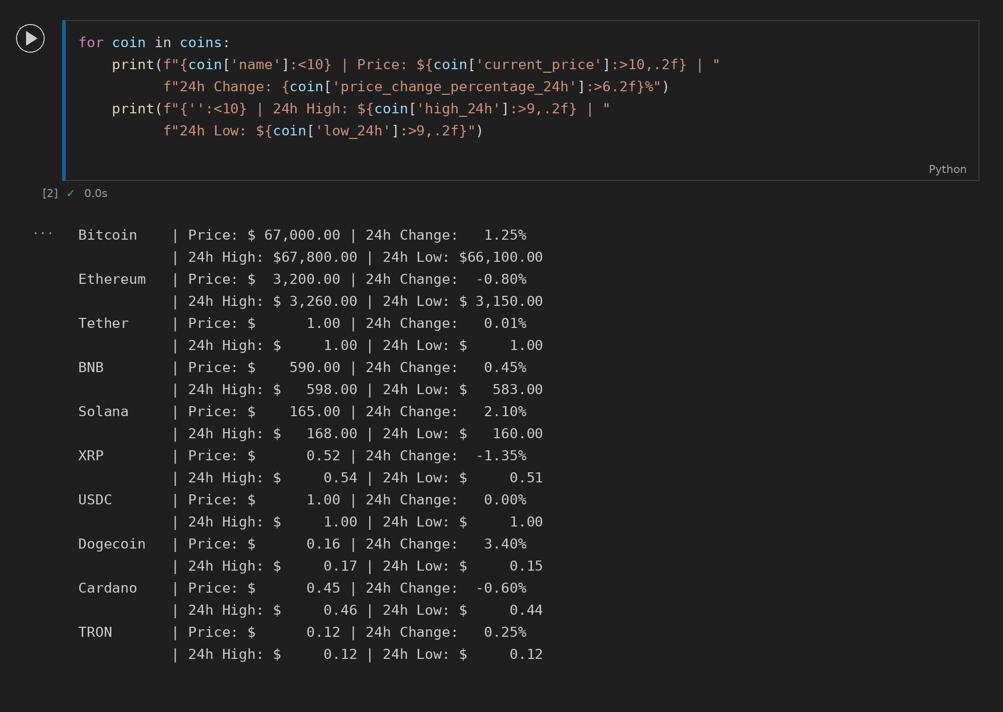

Task 3: Save Data to CSV
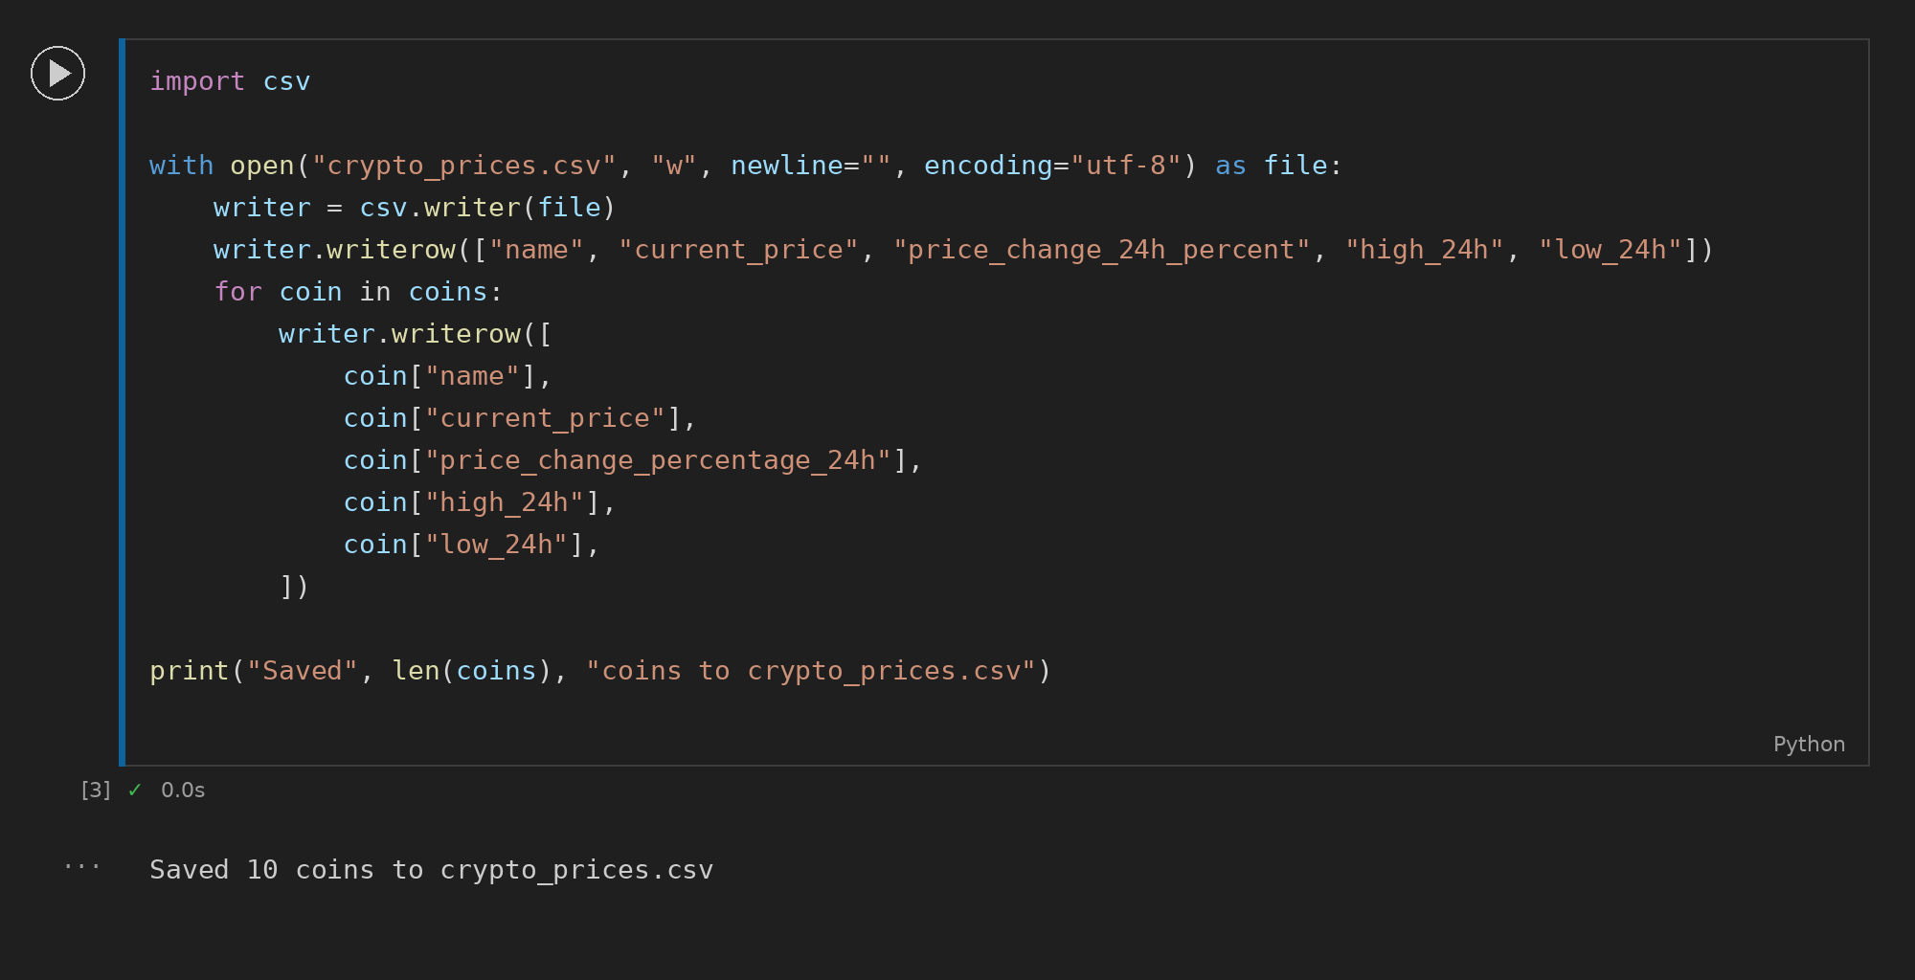

Task 4: Error Handling
