Session 25 - Binance Crypto Price Tracker (Part 2): Task Report

Task 1: Fetch and Save Binance Data
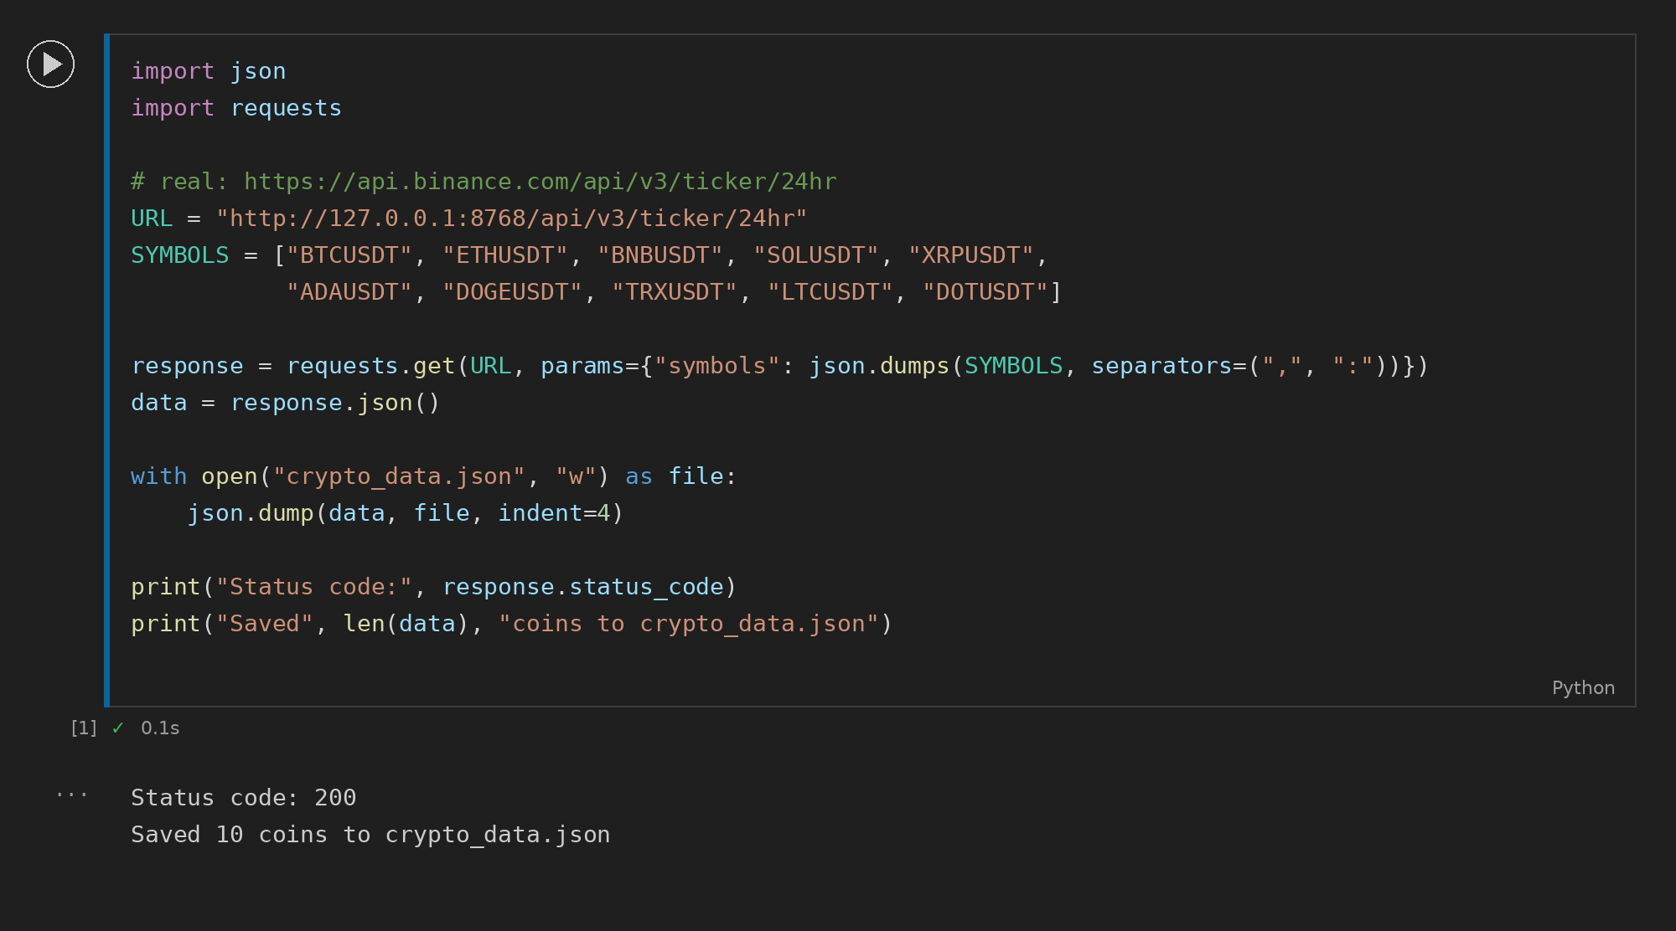

Task 2: Most Volatile Coin
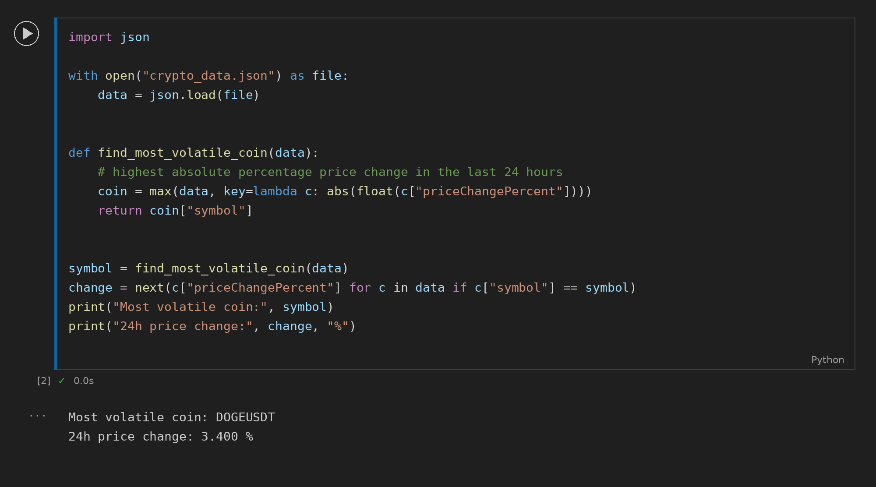

Task 3: Coins Below Average Price
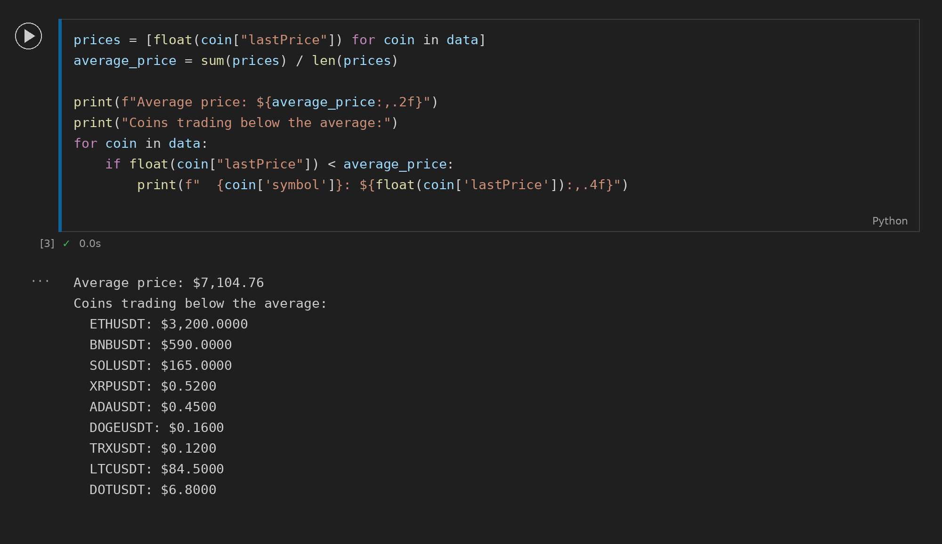

Task 4: Rank Coins by Volume
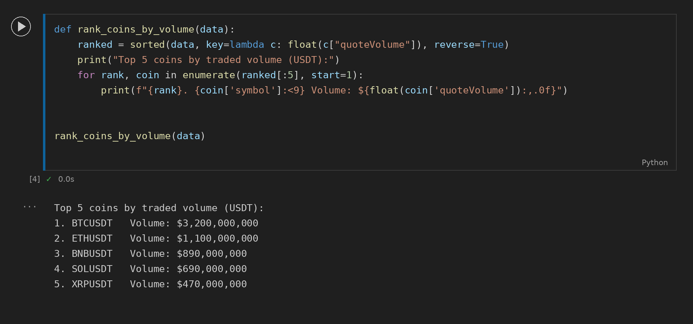

Task 5: Hourly Automation with Retry
